Task 0 : Explain what you are doing/ going to accomplish

In version 3 I the website should have a functioning product page. No need to purchase success or anything else. It should list the test data products as cards with availability

Task 1: Sketch interface design

*Draft a rough design for the interface that allows the user to trigger functionality in task 1, while also annotating where the information in task 2 will be displayed. Create another sketch listing the interface widgets used to create the interface.*

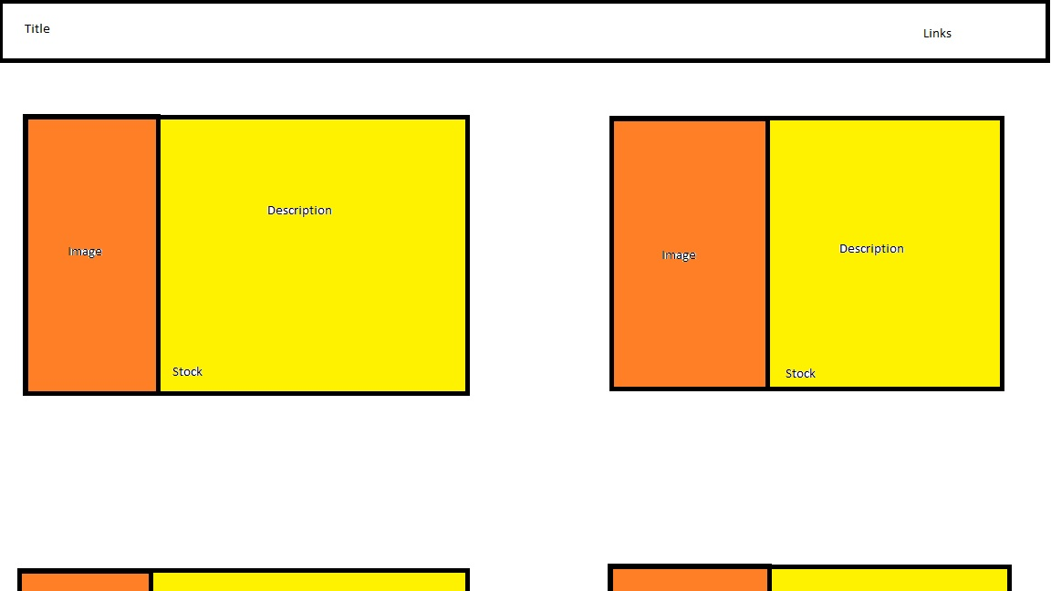

Task 2: Identify any classes required

*Bro Class*

Task 3: Identify information to be displayed

*Name, description, image and stock of each bro*

Task 4: Identify user inputs

*Ability to click on links*

Task 5: Identify any constants or existing data if required

*Test Data*

Task 6: Identify indexed data structures

*Array of bros, currently filled with test data. It will hold all of the objects for the bros*

Task 7: Determine what calculations are necessary

*N/A*

Task 8: Develop a modular structure for your program

*Describe any functions that the computer program will have, identifying any sub-functions where required.*

There will be a function for every page as well as each routing static file.

Run will also be used to launch bottle application.

Task 9: Define the functions identified

*Describe the functions for both the main program and any classes in terms of input and/or output where required. You may choose to do this with flow charts or pseudo-code (not Python code!). Add in additional steps or explanations using sequential, conditional, iterative statements where required. Identify global and/or local variables.*

Import bottle functions

Create Bro class:

Create constructor method passing name, description, image link, cost, stock and booked details(set to “” by default):

*Set all self.variables to passed varaibles*

*Self.name = name*

*Self.description = description*

…

Create bros class holding all bro objects:

Fill with test data

*Bro("Tom","…”,” tom.jpg", 970, True),*

…

Create index page function and routing using (‘/’)

Create product page function and routing using (‘/products.html’)

Return bros array to page to be displayed

Route images from folder “./Images” using route “/img/<filename>”

Route Css files from folder “./Css” using route “/css/<filename>”

Route Script from folder “./Script” using route “/script/<filename>”

Call ‘run’ function passing port 399

Task 10: Address any relevant implications such as usability, functionality, legal/ethical requirements.

*The images need to be family friendly and none copy righted. Each person needs to approve of the images used in the test data*

Task 11: Document test cases for testing the program

*Document any testing that can be used to test your program. If any input is inputted using the keyboard, describe the expected input, plus any exceptional, boundary or invalid cases.*

Try clicking the back and forth buttons, use the links in the navigation bar and try adding and deleting test data.

Task 12: Refine the plan

*Note any modifications here when iterating through the development cycles.*

Changed the navigation bar to a more simple option.

Task 13: Document testing

*Show screenshots of your program working with descriptions of each image. These images should test the tests cases listed above.*

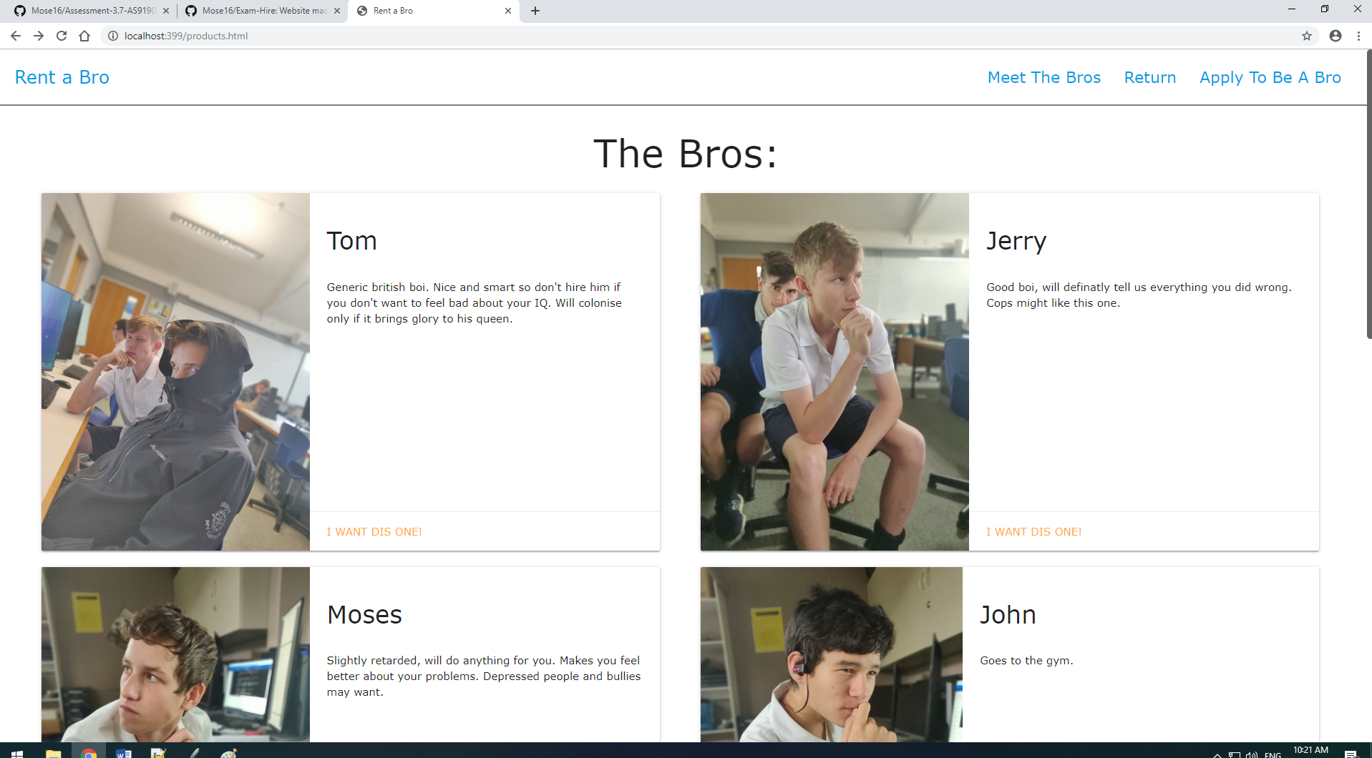

Task 14 : Evaluation

*How did your version turn out*

Works perfectly, links all function, bros all list and back and forth buttons work.

This fills all requirements mentioned at the beginning of the document and is a successful program that has all of the functionality needed for this version.