--- In example “Loader loader = **new** Loader();” Loader is giving the type of data (‘int’, ‘float’) ‘loader’ is the new objects name, or variable name. ‘new Loader();’ creates new Loader object

Tutorial 1:

Set up class ‘DisplayManager’ using OpenGL display class:

* createDisplay – | Don’t understand attribs | Gave display width height | created display passing it ‘attribs’ (?object?) | Gave tittle | Using glu created the render viewport as 100% of the display |
* updateDisplay – | Synced | Refreshed |
* closeDisplay -- | Destroy display |

Created ‘MainGameLoop’ class:

* Set up while loop -- | Simpy updates the display every time it runs
* Closes display

Tutorial 2:

Vertex Array Objects (VAO):

* Slots of data (attribute lists)
* Stores different types of data in separate list positions
* Each list position is called a VBO – Vertex buffer objects
* Each VAO has unique ID
* Must bind to use and unbind at end

VBO:

* Array of data representing colours, positions, normal (anything)
* Stored in separate attrib lists

Example – Storing vertex positions as x,y,z coordinates in a VBO while another attrib list represents the face colours. Together they are put into one VAO representing a character model.

Remember models are made of triangles (3 vertex’s)

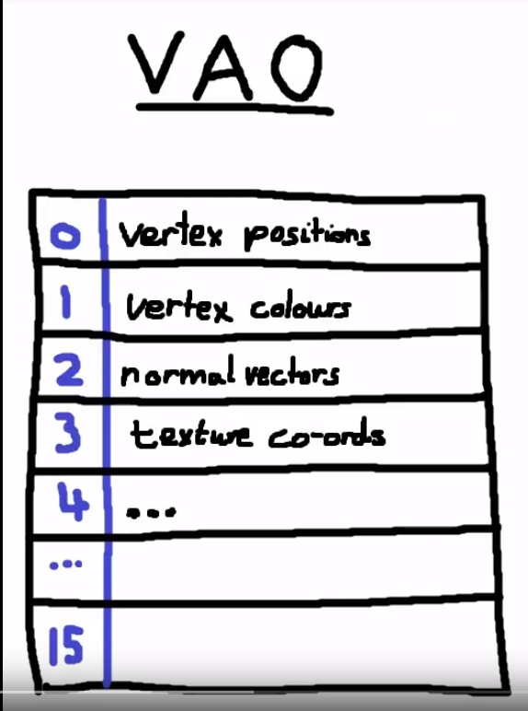

Tutorial 3:

Index buffer:

* Stores positions of vertex’s to reduce data
* Because it is split into triangles and it is read counter clockwise this is needed to increase efficiency

Example: ((1,2,3), (,3,2,4), (1,3,2), (1,2,3), (1,7,3), (1,5,3)) -> (0,1,3,3,1,2)

Tutorial 4:

Shaders:

https://www.youtube.com/watch?v=AyNZG_mqGVE&list=PLRIWtICgwaX0u7Rf9zkZhLoLuZVfUksDP&index=4

* Shader = self made rendering functions – Using languahe glsl
* Vertex shader: One time per vertex. Uses VAO as input. Decides where to put vertexs using coordinates, uses input – excecutes program – outputs something to be used as inputs to Fragment shader.
* Fragment shader runs one time per pixel. Uses output of vertex shader to figure out the final colour of that pixel. Output is always RGB.
* VAO -> Vertex shader -> Fragment shader -> pixels
* Complicated

Tutorial 4:

Textures:

* Texures are aligned using (u,v) coordinates. Basiccaly x,y
* 0,0 = top right 1,1 = bottom right
* Stored in VAO as VBO (pos 1)