Evaluation of the quality of deposited datasets in the Metabolomics Workbench data repository.
Robert M Flight, P Travis Thompson and Hunter NB Moseley
2026-09-25

Abstract
Introduction: While depositing omics data into public repositories is frequently required by grant funders and journals, the quality of deposited data and metadata is not uniform, limiting their reuse in large meta-analyses. Here we present a comprehensive evaluation of both data and experimental design metadata quality across all available datasets in Metabolomics Workbench.
Methods: We downloaded 7240 datasets from Metabolomics Workbench in July 2026. Needed harmonizations and repairs were made to downloaded analysis files.
For each dataset, we attempted to:
- convert to a summarized experiment R object containing metabolite metadata, abundances, and sample metadata;
- detect any quality-control samples;
- determine if the data were log-transformed;
- evaluate the number of metabolite features and usable samples in each group of subject-sample-factors (SSF);
- calculate sample-sample information-content-informed Kendall-$τ$ (ICI-Kt) correlations;
- calculate the relative standard deviations (RSD) within each SSF group;
- perform principal component analysis (PCA) and calculate an analysis of variance (ANOVA) for sample PC scores based on SSF groups.
For each successful step, we assigned a color-based data quality grade: red, think twice before using; yellow, probably OK; and green, looks good for that step. In addition, we generated an HTML QC/QA report for each of the datasets.
Results: Of the 7240 parsable datasets, 167 (2.3%) could not be coerced into a summarized experiment object for various reasons; 622 (8.6%) had <3 samples, and therefore could not undergo PCA and RSD calculations; another 5 (0.069%) started correlation but could not complete all steps, and 6446 (89%) were able to go through all steps to PCA. For successful PCA, 247 had either a single SSF group, or every sample was its own SSF group, making them inappropriate for differential analyses. Among the 6199 remaining, 2016 (33%) had all green statuses; 2543 (41%) had one or more yellow statuses; and 1640 (26%) had one or more red statuses across the QC/QA evaluations.

Introduction
Data repositories, and in particular, -omics level data repositories are a net good. Theoretically, they encourage and allow the reuse of data that has historically been expensive to obtain (although most costs have dropped significantly). Notable -omics data repositories include the gene expression omnibus (GEO) and sequence read archive (SRA) for transcriptomics, and the Metabolomics Workbench (MW) and Metabolights for metabolomics. Various groups have found ways to reuse and reanalyze transcriptomics data, for example, by combining and aggregating datasets for single diseases, among others [need refs like TCGA]. However, as with all data, and most especially -omics level data, there are issues both with the ability to reuse the data that is there, and the data quality. While some data quality assessments have been carried out on RNA-Seq repositories, to our knowledge no such assessment has been attempted for a metabolomics repository. Our lab has previously developed the mwtab python package for parsing and validating mwTab-formatted files and downloading MW-deposited datasets [https://doi.org/10.3390/metabo16010076 , https://doi.org/10.3390/metabo11030163 , https://doi.org/10.1007/s11306-018-1356-6] the MESSES package for generating mwTab-formatted datasets ready for MW deposition [https://doi.org/10.3390/metabo13070842 ], and the Metabolomics Workbench File Status Website [https://doi.org/10.3390/metabo16010076 , https://doi.org/10.1186/s12859-023-05423-9] . Now, we have performed a comprehensive quality-control and quality-assurance assessment analysis of all datasets (analyses) available from the MW.
We used the following measures to assess the data and experimental design metadata quality of each dataset:
- The number of subject sample factor (SSF) groups;
- The number of features with non-missing values in at least one sample, and the number of biological samples with $≥$ 10 non-missing features;
- The number of biological samples within each SSF grouping;
- The presence of quality-control samples;
- The percent missing values across samples, and the results of a test for missingness being due to left-censorship;
- Observed relative standard deviations of biological samples;
- Median sample-sample correlation;
- Results of principal components analysis of each dataset;
- Comparing within SSF correlations of biological samples to between SSF correlations.
We also provide HTML quality-control reports and the processed, analysis ready summarized experiment in serialized *.rds files for all of the datasets.

Methods

We developed a QC/QA analysis pipeline as a series of R scripts that totals approximately X lines of code. The pipeline uses the targets vXXX package for workflow management of the execution of pipeline steps. Use of the targets package greatly speeded up the many development and testing cycles needed to generate a robust pipeline by minimizing unnecessary recalculation of steps where code had not changed. Figure X provides an overview of the QC/QA analysis pipeline. Individual analysis steps of the pipeline are described below.

Parsing and Transformation to Summarized Experiment
After datasets were repaired and ancillary data files downloaded, parsed, and integrated, the pipeline attempts to read in the jsonized data and transform it into an R SummarizedExperiment object, which is ideal for holding feature metadata, abundances, and sample metadata, as well as hold any extra data that does not map directly to features and samples in the metadata slot.

Matching Samples and Features Between Data Blocks
The mwtab format contains a subject sample factors (SSF) block, detailing the samples, their metadata (and possible additional sample data) as well as data blocks containing the abundances and metabolite metadata. Alternatively, the abundance data may be available in a separate ancillary file with no uniform data structure.
After cleaning sample IDs and metabolite feature IDs, only the samples matching between the SSF and metabolite data blocks are kept. In addition, if a metabolite metadata block was present, only the metabolite features that matched between the abundances and the metadata are kept.
Sample IDs are cleaned in a two step process. 1 - The IDs are checked for “+” and “-” signs. Although “-” is often used merely as a delimiter, it is sometimes used to indicate the removal of something, and if both “+” and “-” are present, there is information about the sample status that is encoded in the ID. Therefore, the location of both are determined, and if necessary, they are replaced with the string “pos” and “neg”, respectively.
When reading in the metabolite abundances, the string “.E” had to be replaced with “E” for exponents, and “<” and “>” replaced with “-” to account for two issues that impeded the creation of numeric values in R.

Removing Factors That Cause Single Sample Grouping
For later correlation and principal component analysis (PCA), it is important to know the experimental groupings of biological samples. The groupings are constructed from the various subject-sample-factors (SSF) into a single character string representing the overall SSF for each sample, easily allowing them to be grouped by a single variable in the data associated with each biological sample. However, some datasets include the replicate (biological, technical, etc) number in one of the SSF, causing each sample to have it’s own distinct SSF, i.e. each SSF has only single samples. This is sometimes the design of the experiment, but in our investigation, more often than not it was not the intention of those running the experiment, but rather a misunderstanding of how the SSF vs additional sample data should be defined in the sample metadata of the mwTab formatted analysis file
The pipeline attempts to mitigate these by checking the sample to SSF mapping as soon as the data moves from long to wide format (multiple rows per sample, how it is read in from the mwtab JSON, to single rows per sample), by checking for individual SSF columns that result in single sample SSF grouping, removing trailing numbers if possible, and then attempting to remove one of the SSF factors, and subsequently checking the change in the number of samples per SSF grouping.

Detecting Possible Quality-Control Samples
Possible quality-control samples were determined by searching the regular expressions ".*pool.*|.*qc.*|.*blank.*|.*quality.*" (ignoring case) in the sample ID, subject ID, and item description for each sample. If all samples in the dataset matched the regular expression, we removed the additional sample data from the sample information, and tried detecting them again. If all samples were still noted as quality-control, we deemed this incorrect, and the pipeline sets all the samples to be experimental samples.

Detection of Log-Transformed Datasets
To detect previously log-transformed data, the pipeline calculates the overall mean and median of the non-missing data, as well as the maximum value observed. If the maximum observed value is $≤$ 1000, and the ratio of the mean to median is between 0.8 and 1.2, the values are exponentiated.

Negatives to Missing
The pipeline treats negative and zero values as missing and replaces them with the missing value indicator in R of “NA”. Next, the pipeline calculates percent data missingness as the fraction of NA values over the total number of features and samples. The missingness being the result of left-censorship is tested using the left_censorship_test function from the ICIKendallTau package (vXXX)[reference]. This test calculates the ranks of every feature in every sample, and checks the non-missing rank of features that have missingness in any sample, and records their rank as above or below the median rank in the non-missing instances. The test function aggregates above and below counts across the features and evalutes them using a binomial test. We expect if features are not being left-censored, then being above or below the median rank would have a probability of 0.5. Deviation from that probability indicates that the missing features are due to left-censorship.
Next, the pipeline evalutes the percentage of missing values across each dataset, and uses the distribution of non-zero percentages to calculate a standard deviation and set cutoffs at two and four times the standard deviation for yellow and red statuses, respectively.

Detecing Technical Replicates
Some datasets clearly indicate technical replicates in the sample metadata. However, many other datasets may have technical replicates but have no metadata to identify technical replicate sets, and / or the metadata is not consistently structured. Using a dataset with clearly indicated technical replicates, we derived correlation distance and string distance based distributional cutoffs, in combination with the hierarchical dendrogram reordering to determine likely technical replicates.
The correlation distance is calculated as 1 - ICI-Kt, and the string distance is the cosine based distance between sample IDs. After removal of self distances, the mean, and standard deviation of each set of distances are calculated. Those sample-sample correlation distances $≤μ_{cor}-sd_{cor}×2.5$ and $≤μ_{string}-sd_{string}$ are considered possible replicates (red points in Figure X, black lines indicate cutoffs).
With the pairwise distances ordered according to the hierchical clustering performed for the sample-sample correlation heatmaps, the pipeline then looks for runs of technical replicate distances, which naturally define the sets. However, if the process groups the same sample in multiple technical replicate sets, we assume something has gone wrong and don’t report them. Additionally, for most datasets, we expect that technical replicates will encompass the majority of samples, unless they are a small number of pooled or quality-control samples. Therefore, if the technical replicate sets include pooled or quality-control samples, the pipeline reports them, otherwise, they must account for $>$ 50% of the samples to be reported.

Calculating Relative Standard Deviation
For each feature, the pipeline calculates the standard deviation (SD), mean, and then relative standard deviation (RSD) across samples within the same SSF group, for both the raw abundances and median normalized abundances.
Next, the pipeline calculates one median RSD within each SSF group, for those cases where there were $≥$ 3 feature values, for both raw and normalized abundances. The pipeline uses the median RSD for plotting in the QC/QA reports, as well as generating the distribution of median RSDs to evaluate the RSD based color status of each dataset (see Quality Control Cutoffs). A second median total RSD was calculated across all features per SSF group, for comparison with the median technical replicate RSD mode.
A technical replicate median RSD was calculated using all features in all technical replicate groups detected in a dataset, after removing missing, infinite, and zero values.

Calculating Sample-Sample Correlations
The pipeline calculates sample-sample correlations using the information-content-informed Kendall-$τ$ (ICI-Kt)[reference], which incorporates missing values directly into the correlation coefficient. We used the R package ICIKendallTau vXXX for all ICI-Kt calculations.

Removing Outliers and QC/QA Samples
Using the median sample-sample ICI-Kt correlation values within each SSF group, we define outliers as samples that fall outside the lower interquartile range of median ICI-Kt correlation values within the SSF group, using the boxplot.stats function wrapped in visualizationQualityControl::determine_outliers (vXXX)[reference].

Principal Component Analysis
The pipeline performs principal component analysis (PCA) in three steps if applicable. Using all samples, after removing outlier samples, after removing QC/QA samples, and after removing outlier and QC/QA samples. In every case, the prcomp function was used with mean centering and no unit variance scaling.
The pipeline extracts the scores for each sample from the output of PCA and adds the corresponding score to the sample metadata as well as the absolute and relative variance contributions of each principal component (PC) computed, and then the association of sample PC scores with sample group metadata using ANOVA (from the visualizationQualityControl::visqc_test_pca_scores function). The specific metadata tested by ANOVA included the individual subject-sample factors, the overall SSF group definition, as well as any additional sample data and the combination of SSF and additional sample data. All p-values were adjusted to control the family wise error rate using the Dunn-Bonferroni procedure across PCs tested within each metadata tested.

Deriving Data Based Cutoffs
We used the distribution of values from the datasets to derive cutoffs for four measures: 1) percent missingness; 2) relative standard deviation (RSD); 3) median sample-sample correlations; and 4) principal component (PC) at which 90% of the cumulative variance is accounted for. For the percent missingness, we removed any missing or zero values, and calculate the standard deviation (SD) of the distribution, treating zero as the mean of a one sided distribution. This works even after removing zero, as so many datasets have either a zero or low percentage of missing values. Cutoffs use two and four times the SD. In the case of RSD, we use all of the recorded median RSDs across datasets, and calculate the median, and SD, and then use the median plus two and four times the SD as cutoffs. For median sample-sample correlations, we use the maximum observed median correlation in the dataset to create the distribution across all datasets, and calculate the median and SD. In this case, lower values are worse, so we use the median subtracting two and four times the SD to set cutoffs. For the PC at which 90% of the cumulative variance is accounted for, this is a direct number from the data. Based on the overall distribution, we decided to treat it as a one sided distribution with a median of 10. After removing datasets with values $<$ 10, we log-transform the values and calculate the SD, setting cutoffs at two and four times the SD.

Quality Control Cutoffs

- >
- ≤≤

- <

Number of Features and Samples
The number of features and samples in a dataset directly indicates the quantity of data present.
n-features:
- n $≤$ 9 ~ low;
- 10 $≤$ n $<$ 30 ~ medium;
- n $≥$ 30 ~ high
n-samples:
- n $≤$ 3 ~ low;
- 3 $<$ n $<$ 10 ~ medium;
- n $≥$ 10 ~ high

Experimental Design Metadata Issues
The number of SSF groups indicates the complexity of the experimental design and the correctness of the experimental design metadata.
Number of SSF Groups (can indicate missing or incorrect sample metadata):
- N SSF > 20 ~ red;
- 10 ≤ N SSF ≤ 20 ~ yellow;
- N SSF = 1 ~ yellow;
- N SSF < 10 ~ green

Number of Samples in Subject Sample Factors and Number of Subject Sample Factor Groups
Number of samples per SSF group indicates if the experimental design is statistically powerful or not.
Number of samples within each SSF group:
- all SSF groups have $≤$ 2 samples per group ~ red;
- 3 $≤$ all SSF $≤$ 4 ~ yellow;
- all SSF $≥$ 5 samples ~ green;

Quality Control Samples
The presence of quality control samples indicates rigor in the experiment.
- Has none ~ yellow;
- Has some ~ green

Percent Missing and Left-Censorship
High percent missing, especially without the indication of left-censorship indicates the presence of data quality issues.
- percent missing $≤$ 2 x SD ~ green;
- 2 x SD $<$ percent missing $≤$ 4 x SD limit ~ yellow;
- percent missing $>$ 4 x SD limit ~ red
- percent missing $>$ 10% & lc test p-value $≤$ 0.05 ~ green;
- percent missing $>$ 10% & lc test p-value $>$ 0.05 ~ yellow;

Maximum Observed Median RSD
High maximum observed median RSD indicates high variability in the measurements.
- median RSD $≤$ median of medians + 2 x SD ~ green;
- median of medians + 2 x SD $<$ median RSD $≤$ median of medians + 4 x SD ~ yellow;
- median RSD $>$ median of medians + 4 x SD ~ red

Median Correlations
Low maximum median ICI-Kt correlation indicates high biological variance between samples.
- max median ICI-Kt $≥$ median of max median - 2 SD ~ green;
- median of Max med) - 4 SD $≥$ max median ICI-Kt $<$ median of max median - 2 SD ~ yellow;
- max median ICI-Kt $<$ median of max median - 4 SD ~ red

PCA Scores
For the number of PCs that account for 90% of variance, we took all the values from the analyses present, log10-transformed the values, and considered only those with a log10(PC-90) >= 1. This results in a one sided distribution that is roughly log-normal, that we can calculate the standard deviation of. We assume a median of 1, and then calculate the standard deviation. To get actual cutoffs, we convert the values to raw space and floor them to the nearest integer. A high PC-90 indicates weak signal variance within the dataset in comparison to other sources of variance present.
- PC-90 $≤$ median + 2 SD ~ green ;
- median + 2 SD $<$ PC-90 $≤$ median + 4 SD ~ yellow;
- PC-90 $>$ median + 4 SD ~ red.
Lack of separation of SSF groups across meaningful PCs indicates weak signal variance within the dataset.
ANOVA p-adjusted:
- p-adjust $≤$ 0.05 & PC-perc $≥$ 5% & factor is SSF or derived ~ green;
- p-adjust $≤$ 0.05 & PC-perc $≥$ 5% & factor is additional sample-data or combination of SSF and additional sample-data ~ yellow;
- p-adjust $≤$ 0.05 & 1% $≤$ PC-perc $<$ 5% ~ yellow;
- p-adjust $≤$ 0.05 & PC-perc $<$ 1% ~ red;
- p-adjusted $>$ 0.05 ~ red.

Median Within vs Inter SSF ICI-Kt
The expectation is that within SFF group median ICI-Kt correlations should generally be better (i.e., higher positive correlation) than inter-group correlations.
SSF group size <= 5:
- inter better == 0 ~ green;
- 0 < inter better <= 1 ~ yellow;
- inter better > 1 ~ red;
SSF group size <= 10:
- inter better <= 1 ~ green;
- 1 < inter better <= 3 ~ yellow;
- inter better > 3 ~ red;
SSF group size > 10:
- inter better fraction <= 0.1 ~ green;
- 0.1 < inter better fraction <= 0.3 ~ yellow;
- inter better fraction > 0.3 ~ red;

Number of Sample Group Sizes by Hiearchical Clustering Compared to Actual
The expectation is that data clustering should mirror the experimental design.
SSF group size <= 5:
- size difference == 0 ~ green;
- 0 < size difference < 2 ~ yellow;
- size difference > 2 ~ red;
SSF group size <= 10:
- size difference <= 1 ~ green;
- 1 < size difference <= 4 ~ yellow;
- size difference > 4 ~ red;
SSF group size > 10:
- size fraction <= 0.25 ~ green;
- size fraction > 0.25 ~ yellow;
- size fraction > 0.5 ~ red;

Detection of Possible Confounding Factors
When a dataset has a yellow or red status due to the ANOVA test of sample SSF and sample scores from the principal component analysis (PCA), it is possible that there is a confounding factor present that is not listed in the SSF or additional sample metadata. We attempt to detect the presence of possible confounding factors by independently clustering the samples using hierarchical clustering of their PC scores, splitting them into two clusters, and testing the PC scores against cluster membership by ANOVA. This is carried out for both PC1 and PC2.
As the clusters are always completely separated (due to using heiarchical clustering and cutting into two clusters), the p-values are generally small. Therefore, we use some heuristic cutoffs across overall color grade, ANOVA p-value, ANOVA statistic, and percent variance accounted for by the PC being tested to detect the presence of possible confounding factors.
In this analysis, we used:
- PCA ANOVA color grade of yellow or red;
- ANOVA p-value $≤1×{10}^{-10}$;
- ANOVA statistic $≥$ 300;
- PC percent variance $≥$ 30%.

Creation of QC/QA Reports
After providing color grade statuses and determining possible confounding factors, calculating total and technical replicate RSDs, an HTML quality-control / quality-assurance report was generated for each and every dataset. A template report and alternative sections were drafted as quarto documents [reference]. From the set of completed analysis steps for the dataset, and which varieties of PCA (all samples, QC removed, outliers removed, etc), different report sections are included, and written to a temp file, as well as the analysis data itself, so that the report loads only the required dataset analysis for display in the report.

Comparison of Dataset Statuses Within Studies
For each study with multiple datasets, the datasets were ordered by their internal ID (Analysis ID), and then the overall statuses compared among them, starting with dataset one through however many datasets were present, increasing the count for each intersection of green with yellow, green with red, yellow with red, and so on.

Results

Datasets Removed Along The Process
As the data were parsed and transformed into R and Bioconductor data structures, some datasets were removed for various reasons. The most common reason for rejecting a dataset was for their being $<$ 3 samples, which precluded many of the analyses we wanted to do, including calculating relative standard deviations (RSD), sample-sample correlations, and principal component analysis. The next most common was a dataset being classified as “gray PCA”, where the ANOVA test of sample scores vs SSF returns a missing value, either due to every sample being in it’s own SSF, or there being a single SSF. Finally, there were the datasets with no metabolite feature abundance data (167).
The counts and reasons for missing feature abundance data are shown in Figure XB. The most common reason for no feature abundance data is that there was no feature data, as in no abundance data in the MWTab file, and no ancillary text data found (115). It may be that for many of those, there was data contained in an Excel file or zipped directory, but we limited our search to ancillary text files available on the MW ftp server, as they could be easily examined and loaded. Another common reason for no data was not having matching sample identifiers in the SSF block and the abundance data block or ancillary file (30). Surprisingly, there are 16 datasets where trying to convert all of the abundances from a character to numeric value results in no numeric values. The other reasons for no data include there being no subject sample factor block (3); no matching features between the metabolites abundance data and metadata blocks (2); and duplicated subject sample factor attributes that couldn’t be programmatically rectified (1).
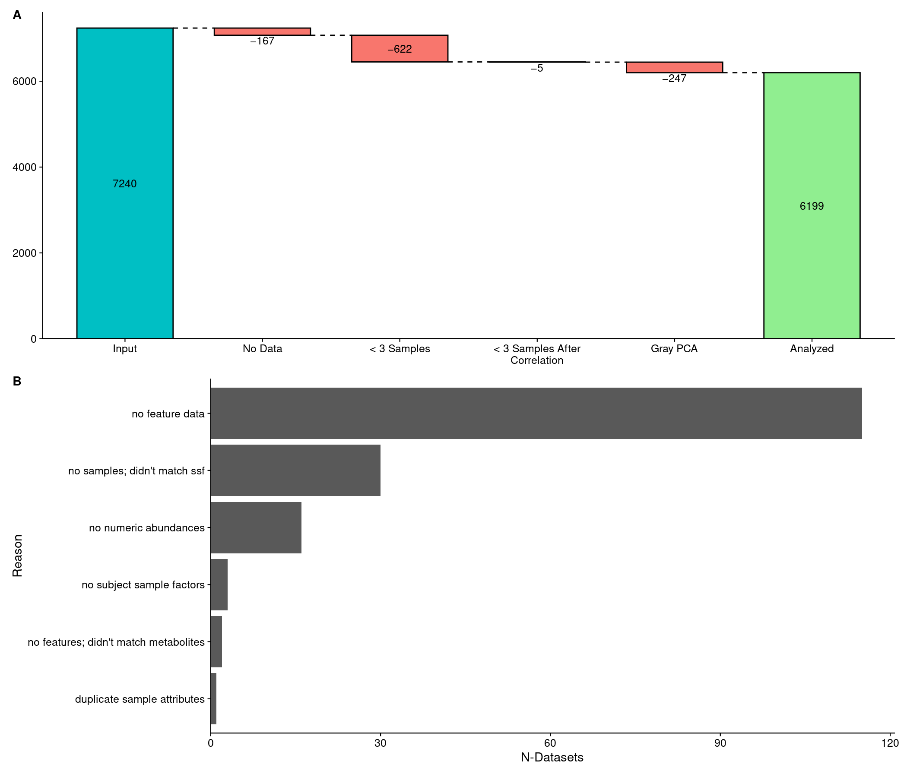
Figure X. A: Waterfall loss plot showing how many datasets were initially processed (7240), and then how many were removed as the analysis progressed along each stage. No Data: -167, there was no data to construce the summarized experiment object; < 3 Samples: -622, datasets had less than three samples after checking that each sample had $≥10$ non-missing feature abundances; < 3 Samples After Correlation: -5, datasets had less than three samples after removing samples that generated missing sample-sample correlation values; Gray PCA: -247, datasets that had a single SSF for all samples, or each sample had their own SSF, resulting in missing values in the ANOVA test of SSF vs sample scores on principal components; Analyzed: 6199, the number of datasets analyzed. B: Counts of the various reasons that the 167 datasets had “No Data”, and therefore couldn’t create a summarized experiment object to be used for further analysis.

Datasets and Their Sizes
The 6199 more useful datasets downloaded from Metabolomics Workbench come in a range of sizes, as shown in Figure X.
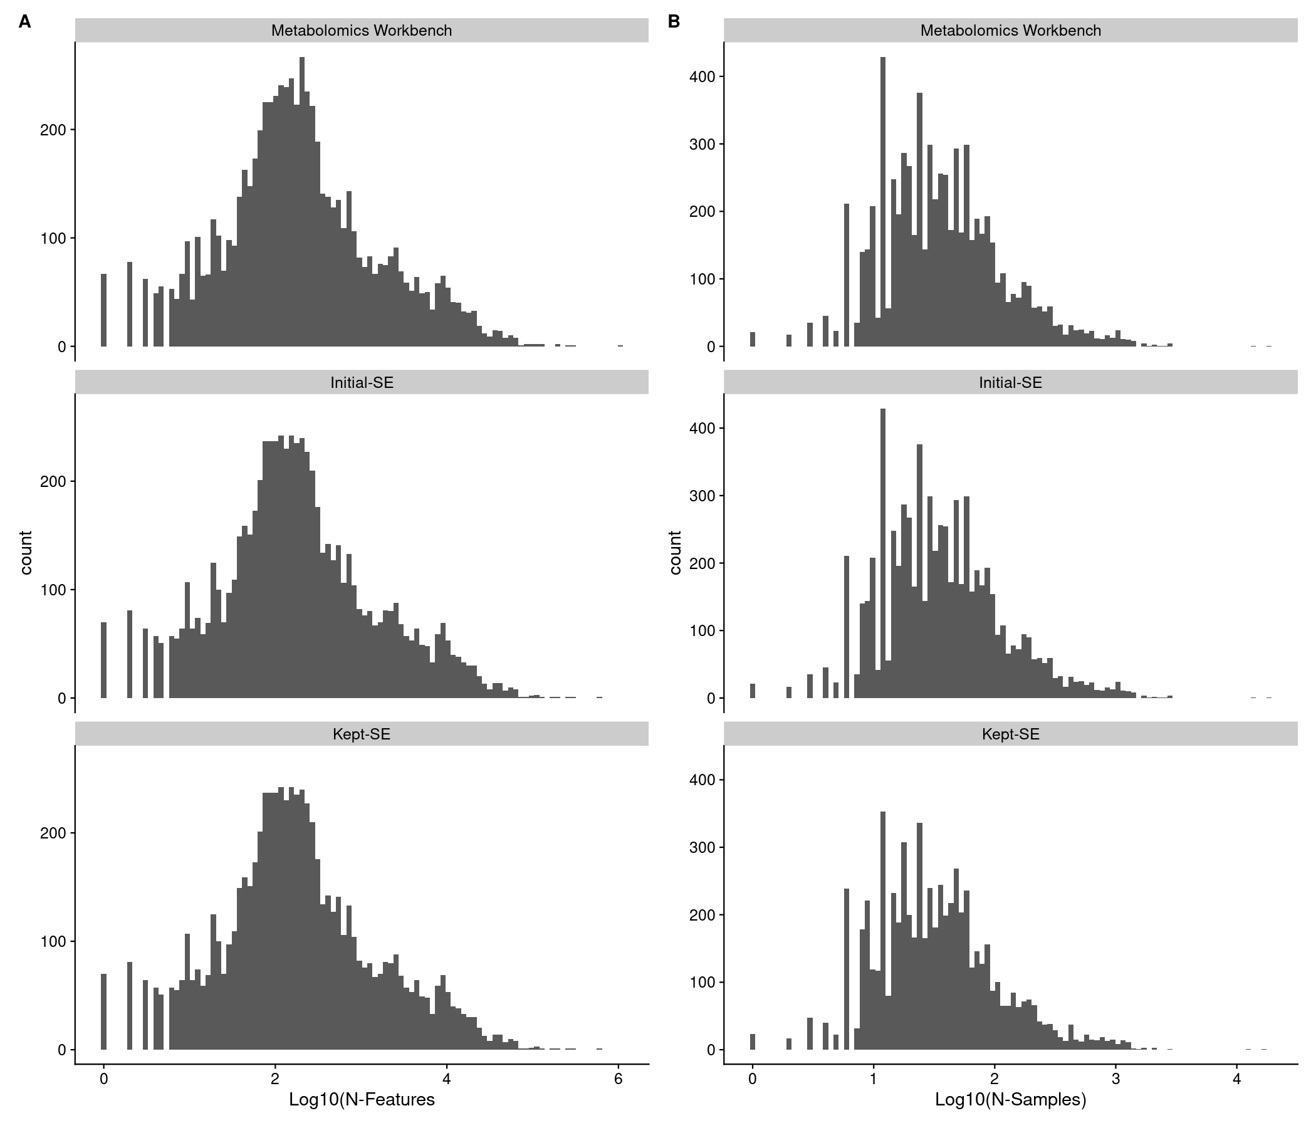
Almost 3/4 of the datasets are measured using mass spectrometry (MS) with the rest measured by nuclear magnetic resonance (NMR), and it is more likely that the abundance data is actually embedded in the MWTab file itself, rather than deposited as a separate ancillary file (see Table Y).
Table Y. Number of datasets by measurement type (MS or NMR) and abundance data source (MWTab or ancillary).
measurement_type | ancillary | mwtab | Total
MS | 25.6% (1,524) | 74.4% (4,440) | 100.0% (5,964)
NMR | 19.6% (46) | 80.4% (189) | 100.0% (235)
Total | 25.3% (1,570) | 74.7% (4,629) | 100.0% (6,199)

Overall Statuses
Using the following quality statuses:
- number of samples within each subject-sample-factor (SSF);
- percent missingness;
- left-censorship test;
- median ICI-Kt correlation;
- relative-standard deviation;
- principal components accounting for 90% of the variance;
- ANOVA test of SSF to PC scores;
We obtained the following breakdown of statuses shown in Table X. Although the most common category of statuses contain one or more yellow, two sets of statuses there dominate all others: 1) datasets where one or more SSF groupings have only 3 or 4 samples (1132 or 44%); and 2) datasets where the PCA ANOVA p-value received a status of yellow (379, 15%). In both of those cases, all other statuses are green. For the red statuses, the most common category was that the PCA ANOVA p-value received a red status (503, 30%), or PCA ANOVA red status and SSF groupings with only 3 or 4 samples (yellow) (343, 21%) with all other statuses being green.
Table X. Number of datasets with all green across the statuses, one or more yellow statuses, and one or more red statuses.
Overall Status | N | %
green | 2016 | 33%
yellow | 2543 | 41%
red | 1640 | 26%
In Figure X, we show a heatmap of the statuses for those that account for 90% of the datasets analyzed (with all statuses shown in Supplemental Figure X).
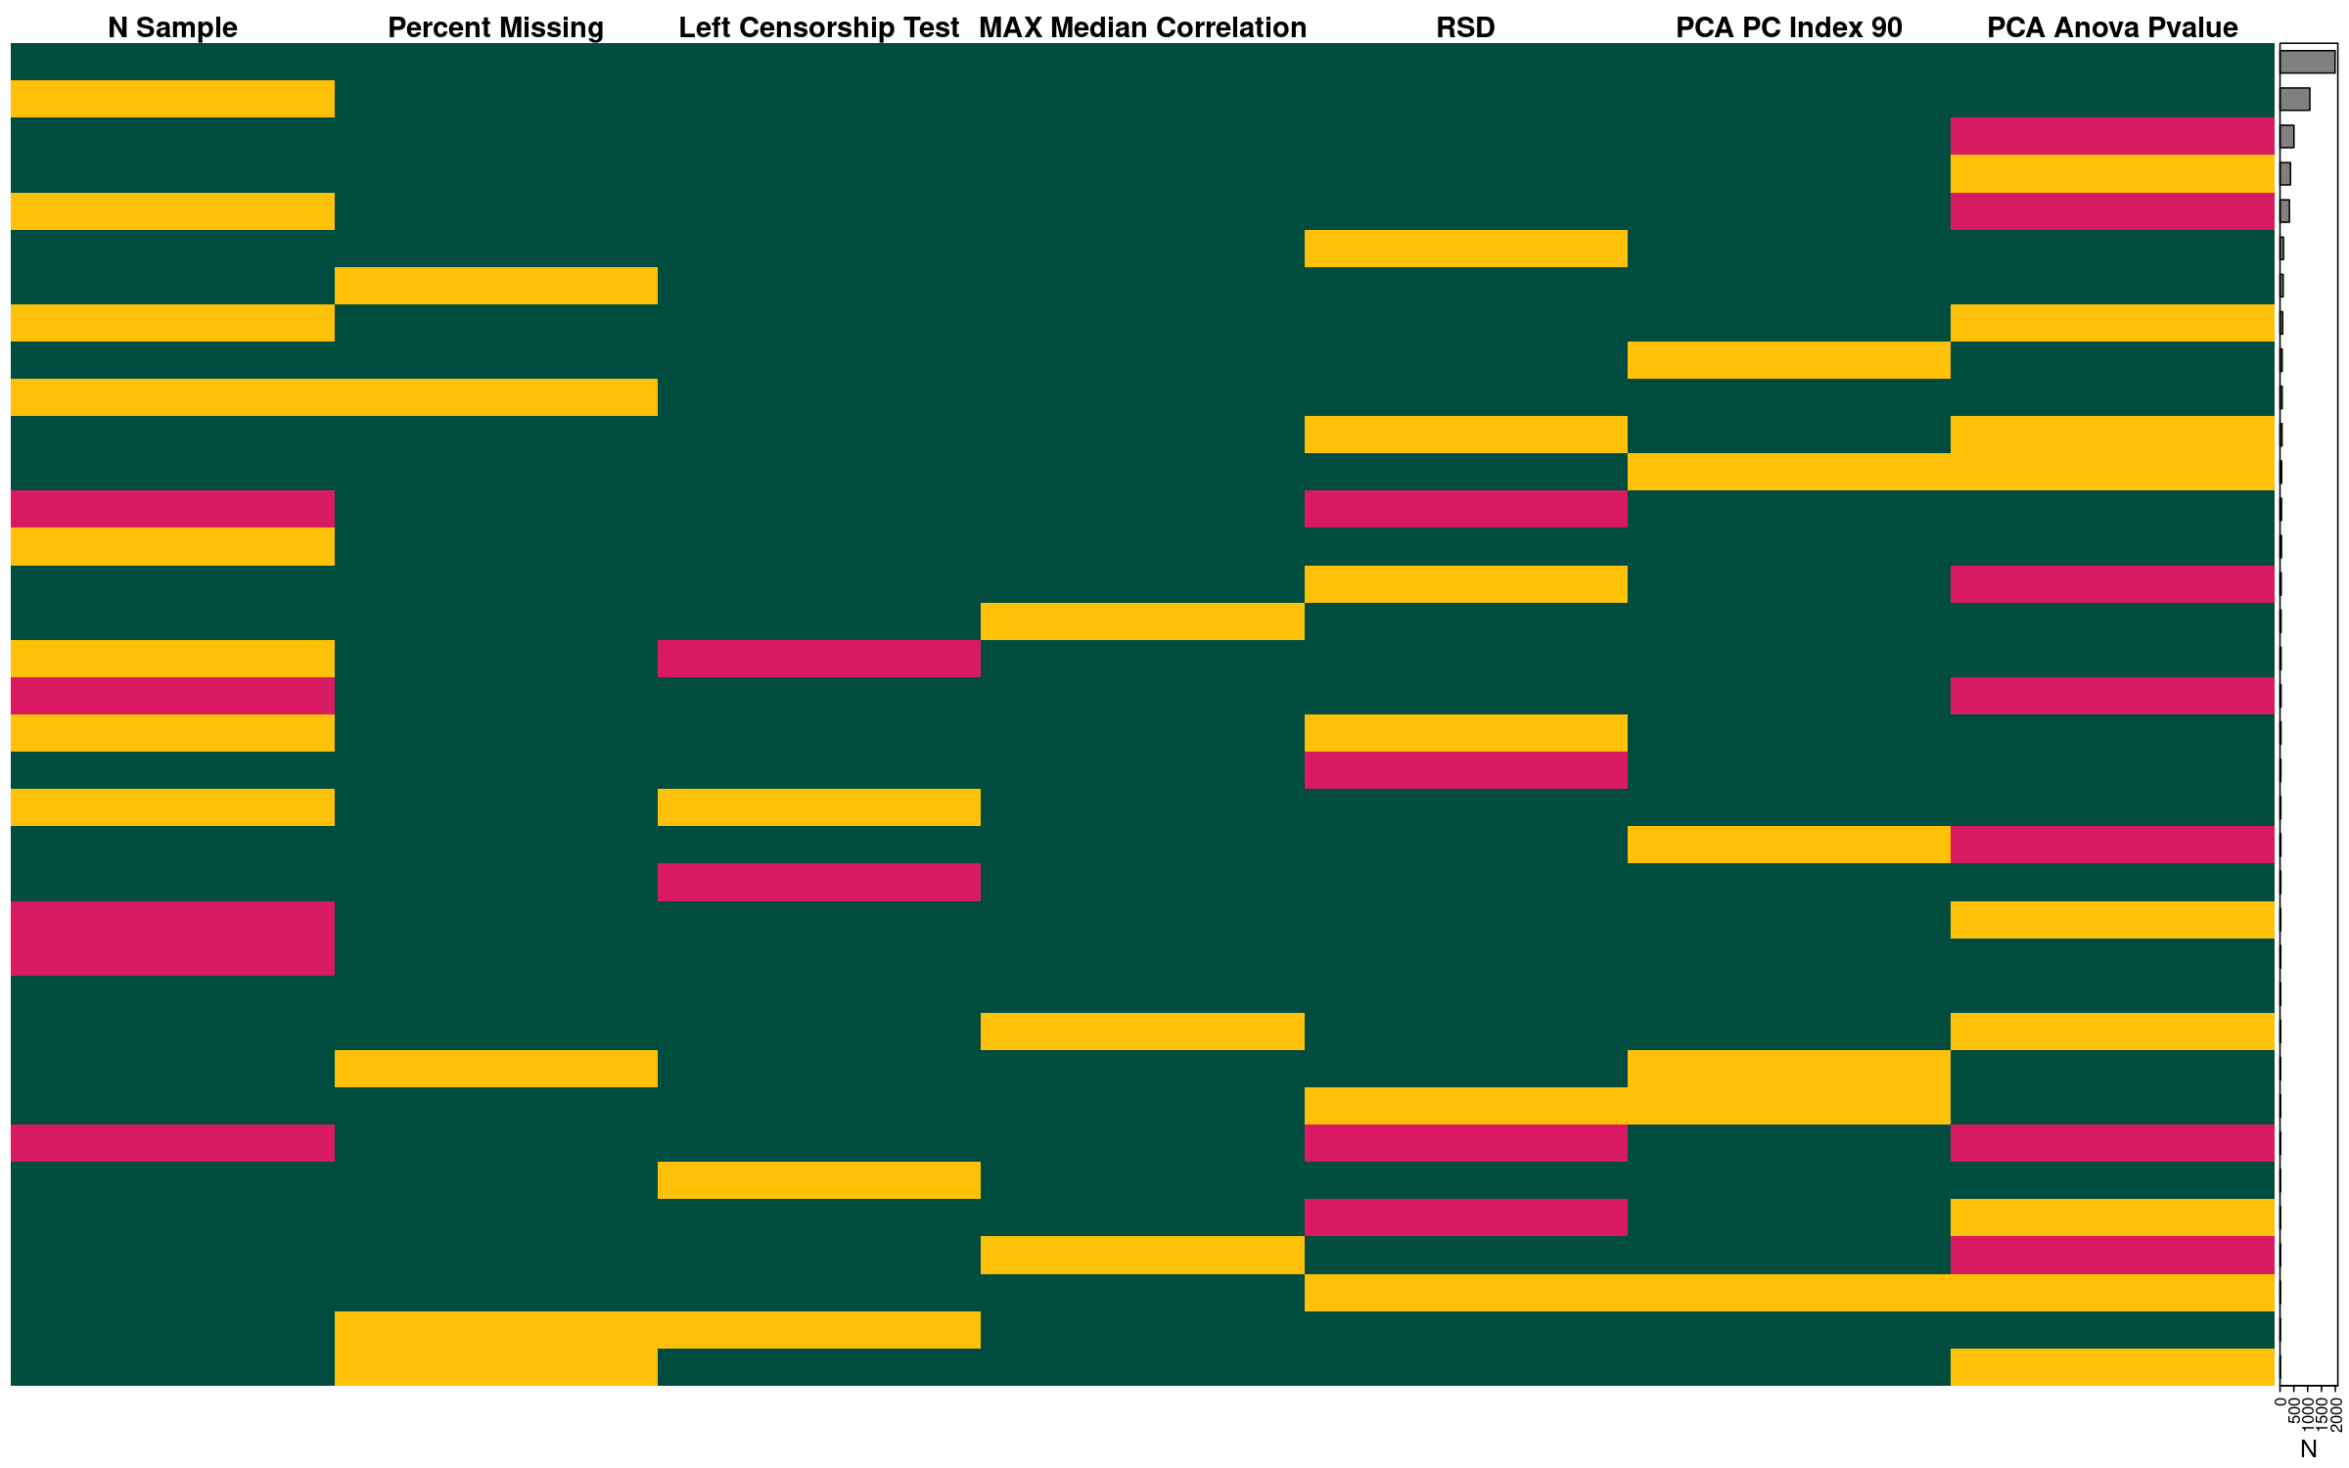

Detection of Log-Transformation
Some deposited dataset abundances are already log-transformed. We want to be able to detect them, un-transform them (exponentiate with base 2), and evaluate them in their un-transformed state. In our experience, non-transformed dataset distributions tend to be heavily skewed with long-tailed distributions, i.e. look much like a log-normal distribution, and then the log-transformed data appears much more “normal-like”. Therefore, we can detect already log-transformed data by determining if it is “normal”. However, tests for normality are notoriously fickle and prone to return non-significant values if the data is at all different from expectations, which is highly likely for these real world datasets. One common element of normally distributed data is that the mean and median of the data are relatively close together, whereas for skewed or long-tailed data the mean and median, by definition, are very different. Note that we did also investigate a simple definition of skewness $\left(μ-ν\right)/σ$, however it did not provide the discrimination needed for this application.
We calculated the mean-median-ratio (MMR) across all 7073 datasets that created a summarized experiment object, as well as the number and fraction of negative values, the maximum observed abundance, and the dynamic range (maximum / minimum values). The dynamic range calculated in the presence of negative values involves first adding the absolute value of the minimum value, + 1, to transform all values to be positive, and subsequently calcuating the ratio of the maximum and minimum of the transformed values.
This investigation resulted in first checking if the maximum observed value in a dataset is less than 1000, then calculating the mean and median of the data, and if the MMR was between 0.8 and 1.2, the data was exponentiated before further use.
There were a total of 316 (4.5%) datasets that the values were exponentiated before further analysis.
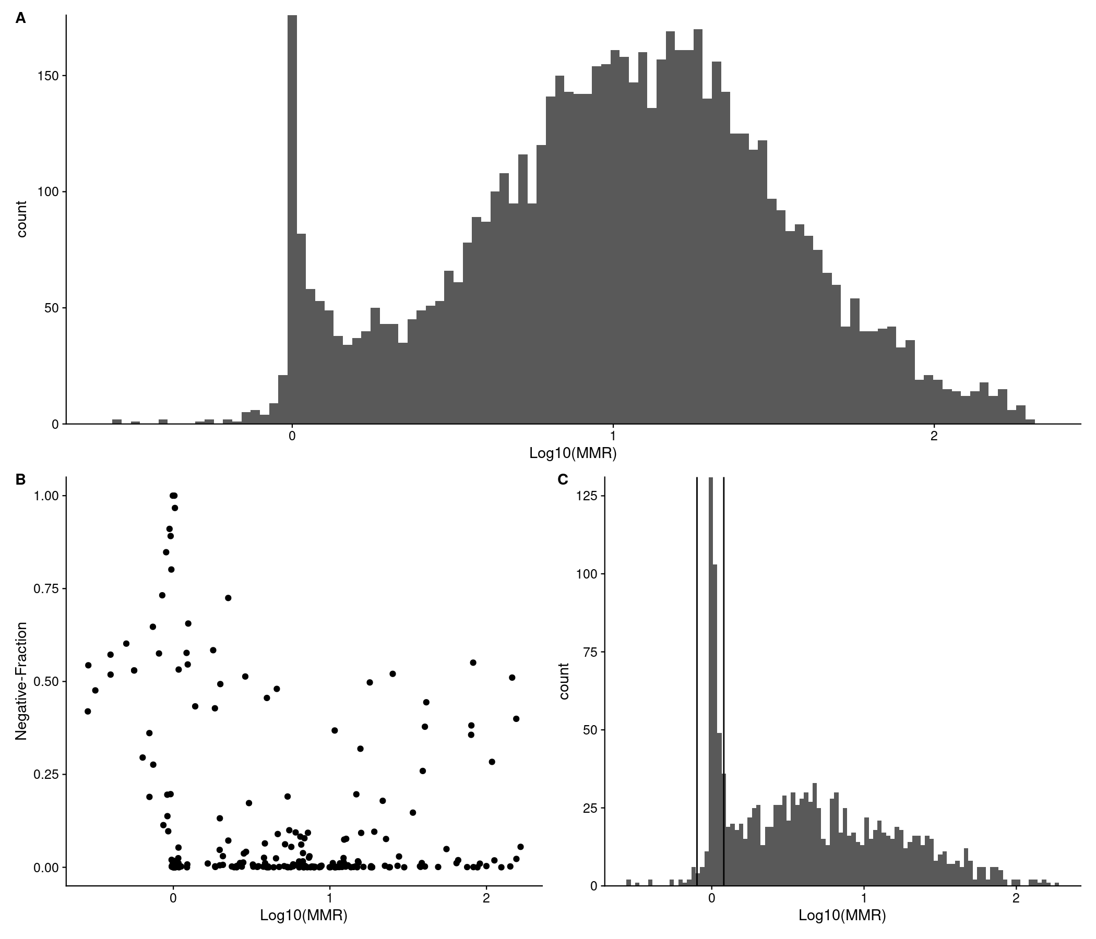
Figure X. All plots used datasets with an MMR $≥$ 0.2 and MMR $≤$ 200. A: Histogram of Log10(MMR). B: Log10(MMR) vs fraction of negative data values, after excluding all datasets with zero negative values. C: Histogram of Log10(MMF) for datasets with a maximum observed intensity $≤$ 1000. Vertical lines indicate the MMR cutoffs used of 0.8 and 1.2 to decide that a dataset should undergo exponentiation.

Deriving Data Based Cutoffs
Figure X shows the distribution, calculated median, and cutoffs used to determine green, yellow, and red statuses for percent missingness, relative standard deviation (RSD), median sample-sample correlation, and PC that accounts for 90% of the cumulative variance, respectively.
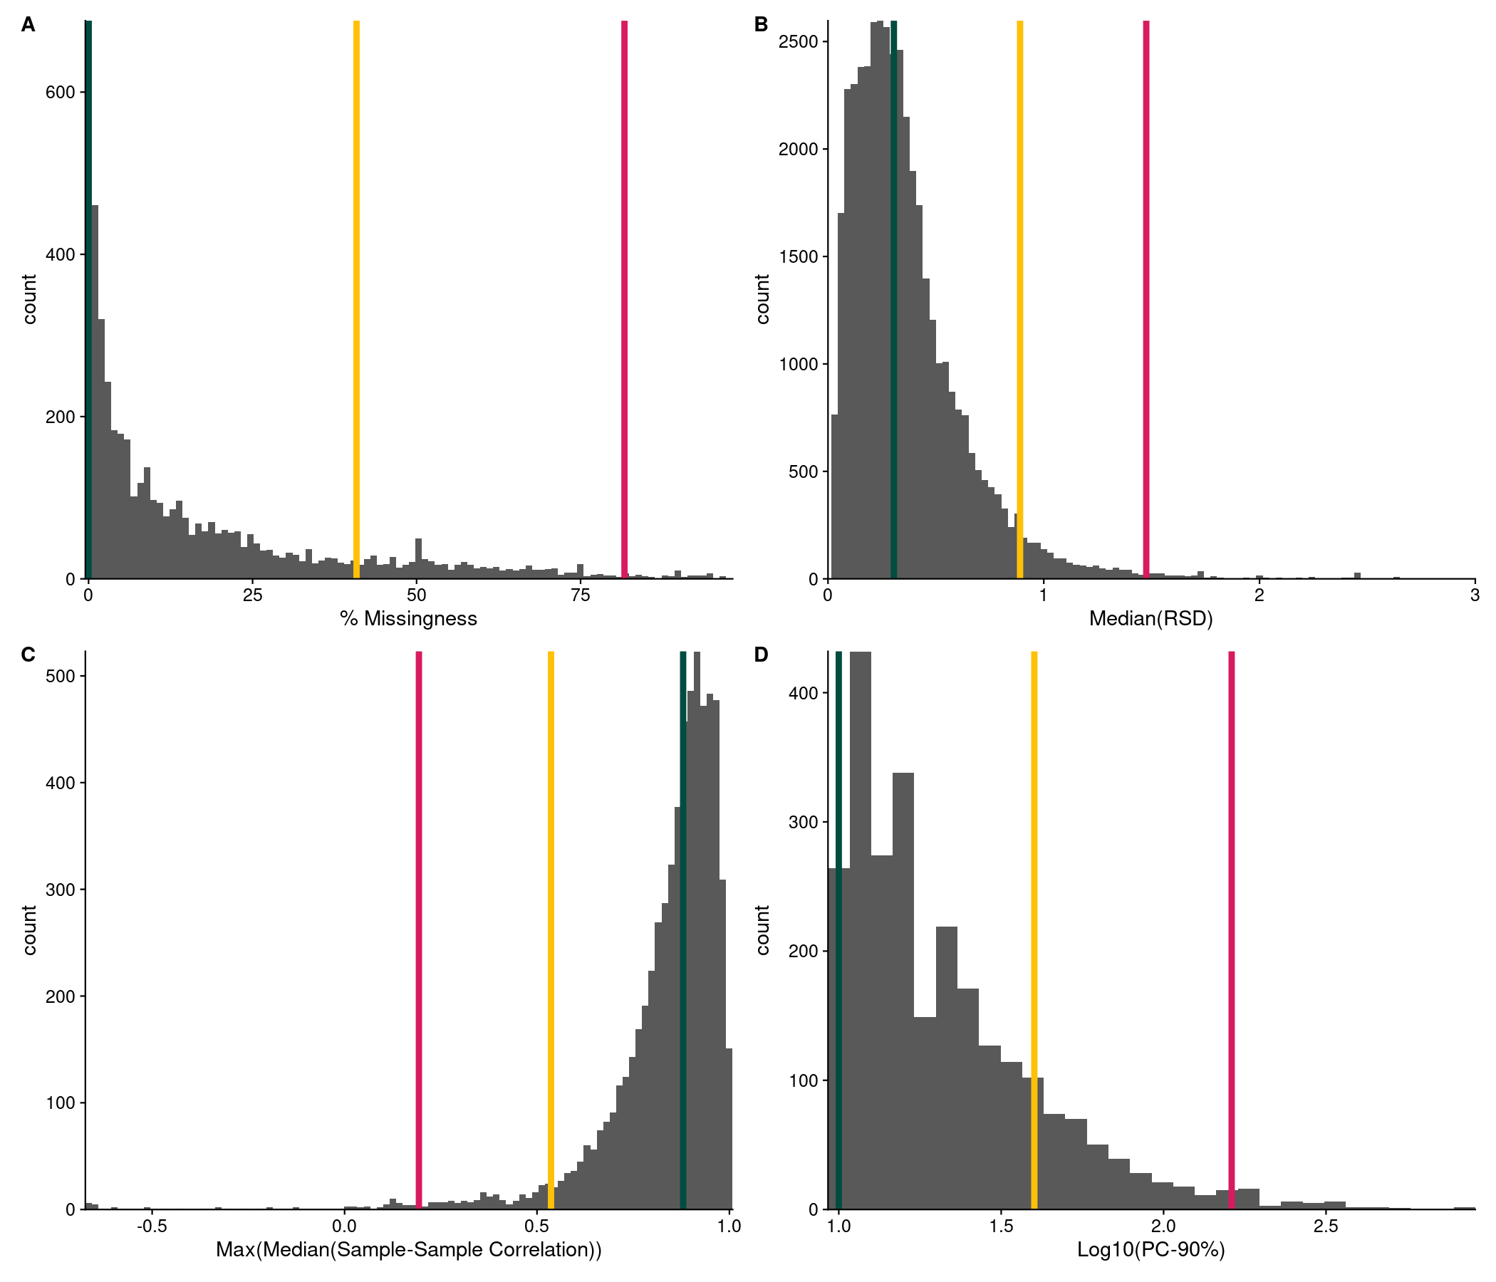
Figure X. Distributions and cutoff limits for (A) percent missingness; (B) Relative standard deviation; (C) Maximum median sample-sample correlation; (D) PC accounting for 90% of the cumulative variance.

Negative Values, Missingness and Left-Censorship
The detection of log-transformed datasets and exponentiating them back to raw space removes any negative values present. This is important, as measuring physical entities should not result in negative values. However, only a small fraction of datasets containing negative values match the criteria we used to detect log-transformation. Given that negative values should be theoretically impossible, we decided that they should be interpreted as missing values for all subsequent calculations.
Previously, we developed a test for missingness being the result of left-censorship [ref], where we posit that the most likely reason for a value to be missing in metabolomics is the result of left-censorship, where the missing value is the result of being below the limit of detection. To verify that the negative values could be interpreted as “missing”, for each dataset with at least two negative values present, we calculated the left-censorship test statistic before and after setting values $≤$ 0 to missing. We then calculated the ratio of the binomial test p-values and statistic values before and after setting negatives to missing, and calculated a binomial test of the log-ratio, where positive values indicate that treating negative values as missing results in more significant p-values or larger estimates in the binomial test. Using a binomial test on the ratios equates to a simple toin coss of direction, where we expect if treating negatives as missing would result in a fraction of positive to negative ratios of 0.5, without including the size of the effect on p-values and estimates. The results of the binomial test are shown in Table Y.
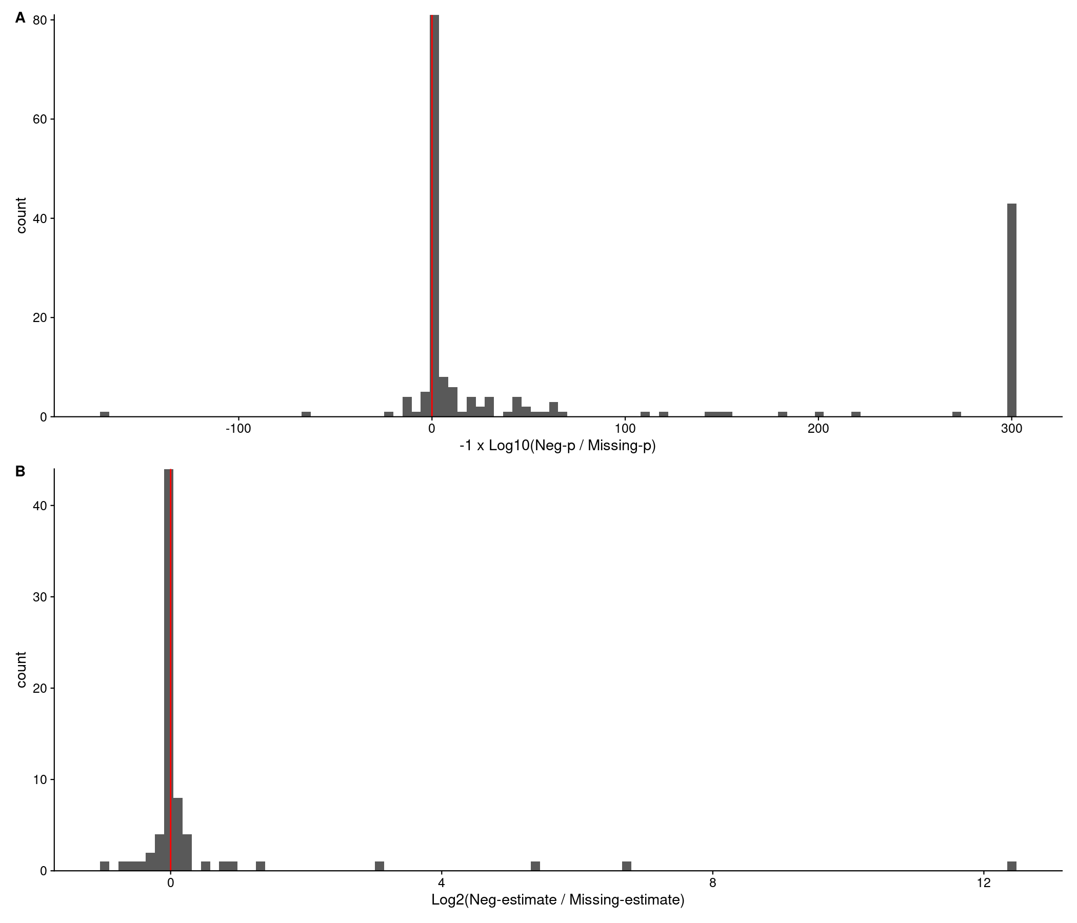
Figure X. A: Histogram of the $Log_{10}$ ratio of the left-censorship p-values when considering negative values as missing (Neg-p) compared to just having missing values (Missing-p). Red line indicates a log-ratio of 0, or no change. B: Histogram of the $Log_{2}$ ratio of the left-censorship test estimates when considering negative values as missing (Neg-p) compared to just having actual missing values (Missing-p). Red line indicates a log-ratio of 0, or no change.
Table Y. Results of binomial test on the log-ratios of p-value and estimate of treating negatives as missing vs not in the left-censorship test.
Variable | N-Pos | N-Neg | P-Value
P-Value | 142 | 31 | 3.54 × 10^-18
Estimate | 147 | 32 | 8.16 × 10^-19
Figure X shows a sina plot of the percent missingness observed in the analyzed datasets. NMR measured datasets range from 0 to 73% missingness, while MS datasets range from 0 to 98% missingness.
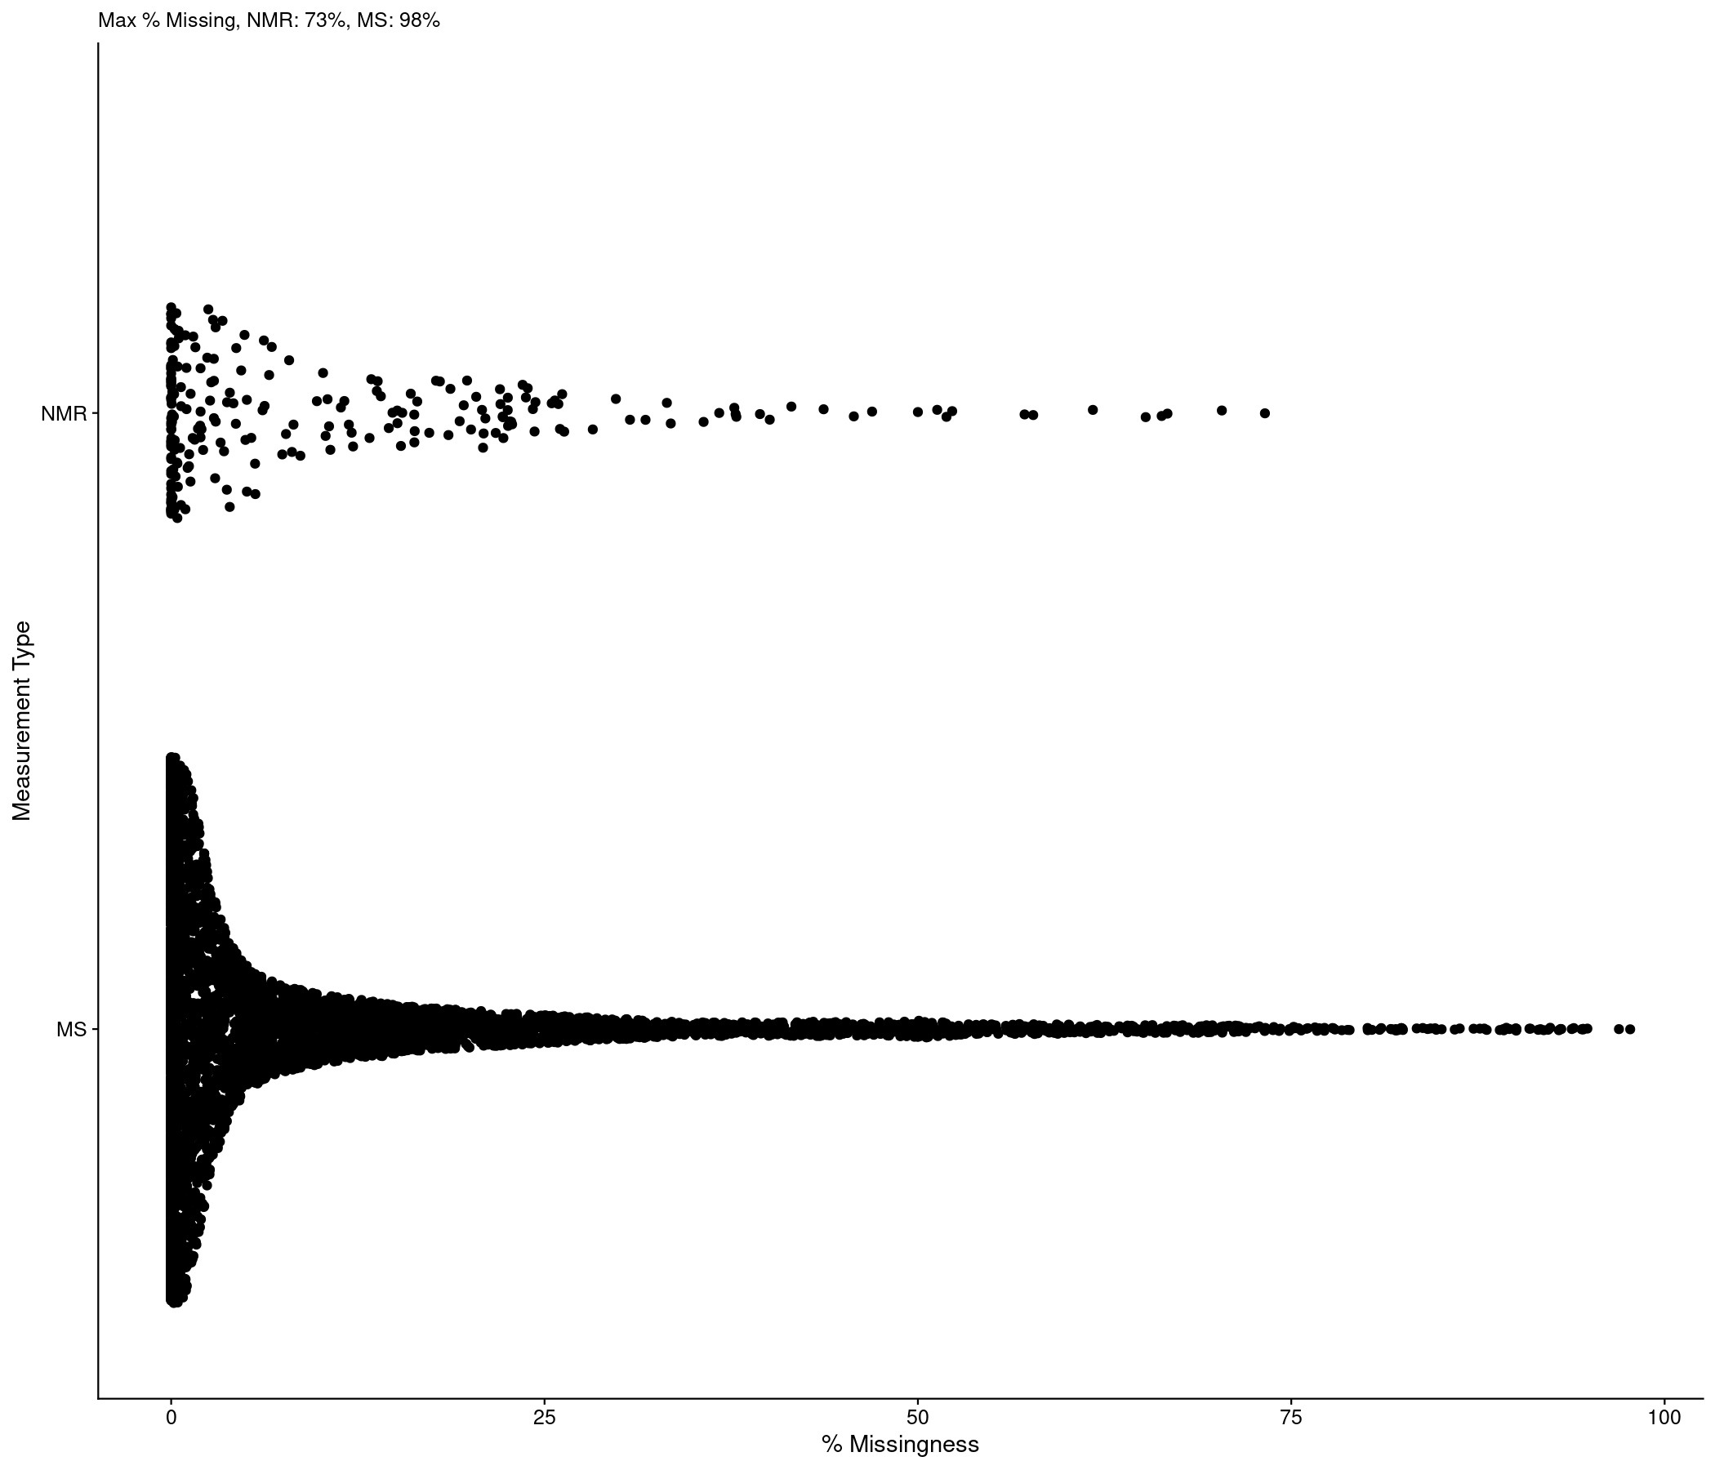
Figure X: Sina plot of the percent missing values by measurement type, either NMR or MS.

Possible Confounding Factors
From the datasets with a yellow or red status for the PCA ANOVA p-value, we used a series of ad-hoc cutoffs and clustering to try and determine if their might be a potential confounding factor present (see Methods). For the 2855 datasets with yellow or red PCA ANOVA p-value statuses, 318 (11%) likely have a confounding factor present. Figure X shows the sample PC scores plot for dataset AN000454. Here, the samples separate into four distinct groups along PC1 and PC2, with all of the groupings containing a mixture of Control and CLFS SSF groups. In addition, none of the sample PC scores scored highly on the ANOVA test. The combination of this distinct grouping (detected by the confounding factor test we developed), and lack of SSF association with PC scores, indicates there is likely a confounding factor present that is not noted in the metadata. Moreover, Figure X is a prime example of a dataset with a potential confounding factor that is likely due to multiple processed batches being present, since each cluster includes samples from the two SSF groups in arrangements that cannot be separated into the two SSF groups.
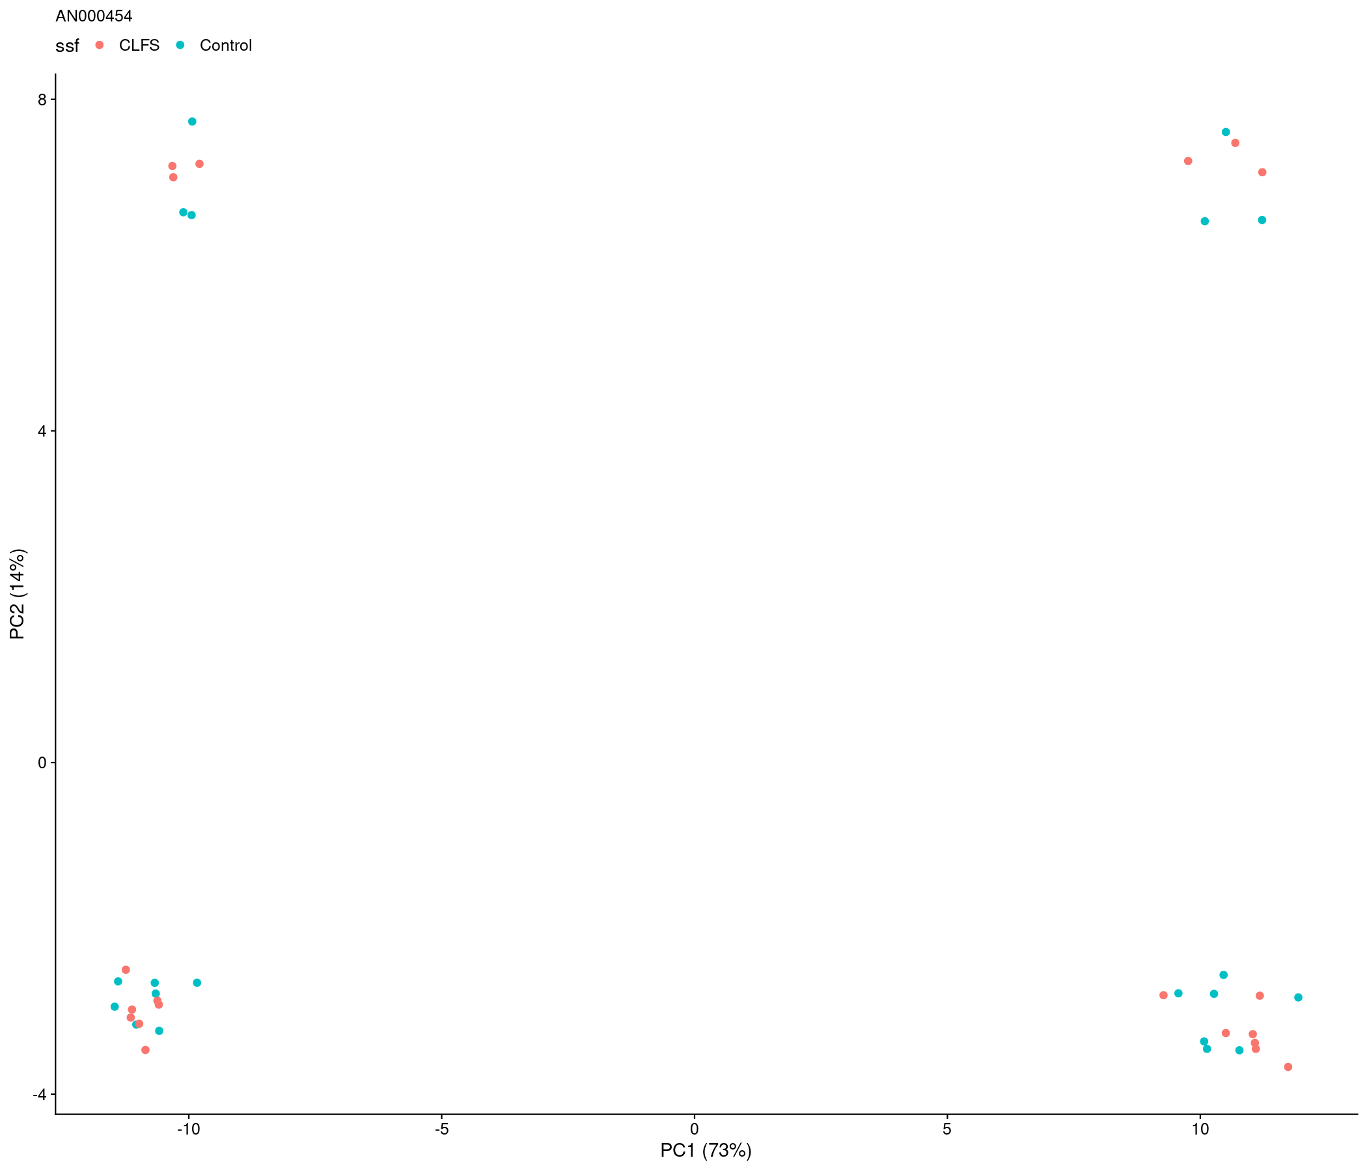
Figure X. Sample PC scores plot for dataset AN000454, with samples colored by their SSF.

Technical Replicates
In addition to the RSD of the technical replicates, we also calculate the RSD of the SSF grouped samples (total RSD). The median technical replicate and total RSD values from each dataset are shown in Figure XC. As expected, the mode of the technical replicate RSD is much lower than the total RSD (0.061 vs 0.243), implying that methods for detecting them is likely correct (if somewhat conservative).
With the technical replicate RSD and total RSD available for 200 datasets, we can subtract them to determine the RSD due to non-technical sources. The histogram of this RSD is shown in Figure XD.
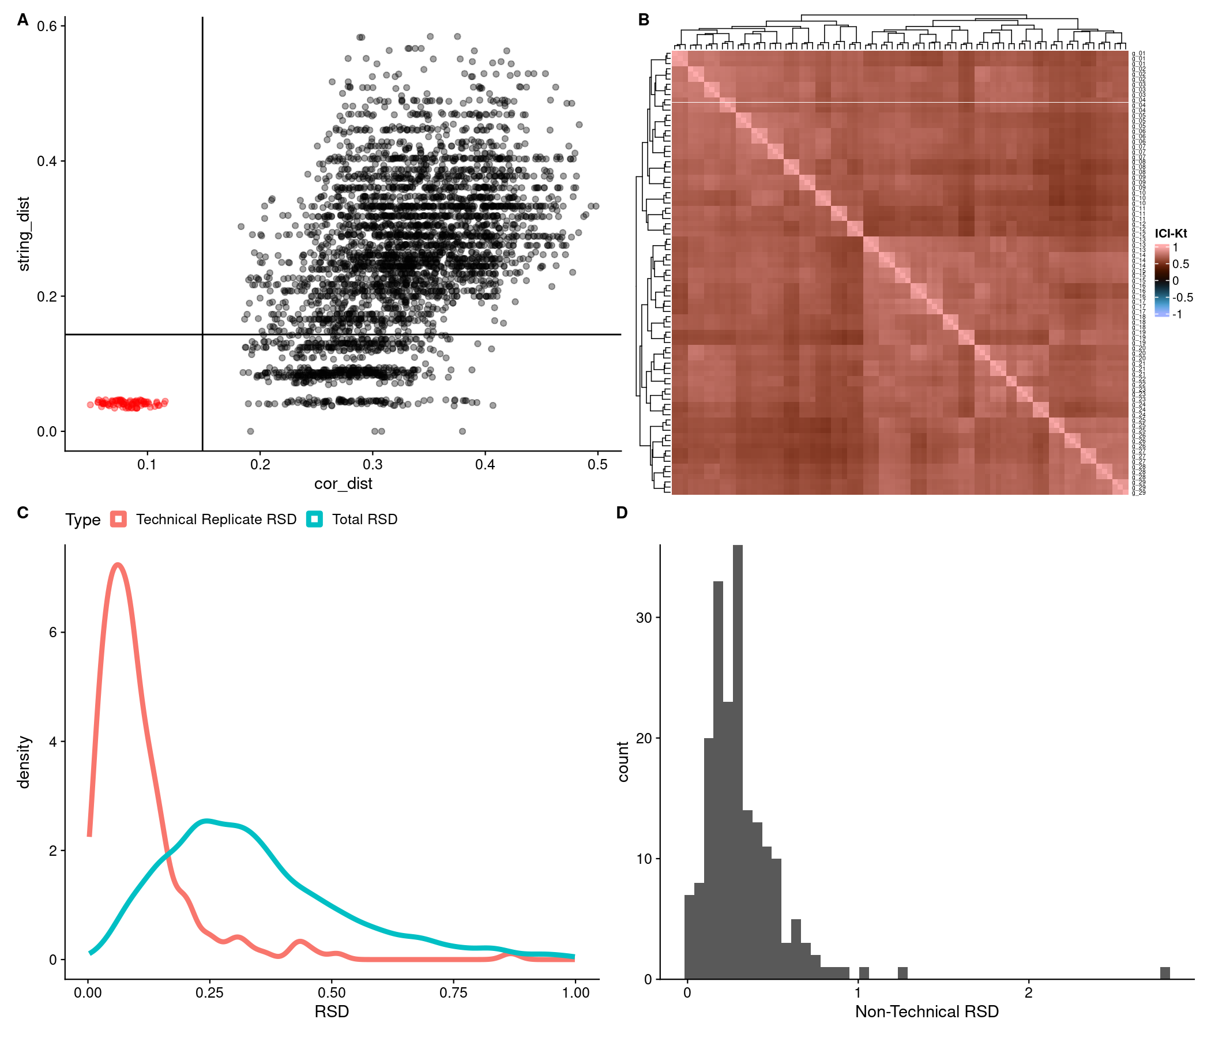
Figure X. A: Sample-sample ICI-Kt correlation based distances and cosine string distances between all samples in dataset AN006191. Black lines indicate cutoffs for correlation and string distances, respectively. Red dots are distances that indicate possible technical replicates. B: Sample-sample ICI-Kt correlation heatmap, with technical replicate groups indicated on the rows. C: Density plot of the median technical replicate RSD from each dataset where technical replicates were detected, and the total RSD using SSF groups from each dataset. D: Histogram of non-technical-rsd, i.e. the total RSD minus the technical-replicate RSD.

Comparison of Dataset Statuses
The counts were aggregated across all dataset comparisons for the 1657 studies that had multiple datasets. Table Y shows that in general, whatever the status a dataset has, the other datasets within that study will more than likely share that same status (70 - 75% in each case). Interestingly, starting with a green status, is 2x more likely to encounter a yellow status than a red, and starting with a red status is 2x more likely to share a study with a yellow status than a green.
Table Y. Number of datasets that share the initial-status color with another dataset in the same study.
initial_status | green | yellow | red
green | 813 | 209 | 111
yellow | 174 | 1177 | 205
red | 90 | 201 | 630

Weirdness Encountered
With any repository wide analysis, there will be datasets encounted that are difficult to parse and determine what is going on. However, due to how submitters submit data to the Metabolomics Workbench, there are some very peculiar looking datasets. Examples we have seen include:
- the sample IDs in the metabolites measurement block having extra characters tacked onto them, making them impossible to computationally match to the sample IDs used in the subject-sample-factors (SSF) block (AN000112);
- positive and negative symbols in sample IDs, that when converted to R safe names were lost, this required writing custom code to handle their presence, which is especially important if the symbols stand for presence and absence of a factor;
- duplicated columns of measurements, sometimes several replicated columns, with and without actual values data;
- quality-control samples in the metabolite measurements block, but those samples are not included in the SSF (AN000139);
- using “.E” instead of “E” to denote exponents; metabolite ratios in the metabolite measurements (AN005958);
- metabolite ratios included in the data block, not just metabolite abundances (AN000645);
- biological replicate information or number included in the subject-sample-factors or the subject-sample-factor name for each sample, creating groups with one sample each, instead of the three or more samples in each group that is actually present (AN002454, and so, so many others)

