BLOCKCHAIN BASED SMART MONITORING FRAMEWORK FOR THE DEFENSE INDUSTRY

Project Report Submitted to the Alagappa University in Partial Fulfillment
of the Requirements for the Award of the Degree of

MASTER OF COMPUTER APPLICATIONS

Submitted By
F. JOHN MOSES
(REG.NO:2023541024)

Under the Guidance of
Dr. P. ESWARAN, M.Sc., M. Tech., Ph.D.
Associate Professor



DEPARTMENT OF COMPUTER APPLICATIONS
ALAGAPPA UNIVERSITY
(A State University Accredited with 'A++' Grade by NAAC (CGPA:3.59) in the Fourth Cycle,
Under Dual Mode Category)
KARAIKUDI-630003
MAY-2025

CERTIFICATE

This is to certify that the Main project entitled, "BLOCKCHAIN BASED SMART MONITORING FRAMEWORK FOR THE DEFENSE INDUSTRY" is a bonafide work done by F. JOHN MOSES (Reg.No:2023541024) is submitted in partial fulfillment of the requirements for the award of the degree of MASTER OF COMPUTER APPLICATIONS, has been carried out under our supervision and guidance from December 2024 to May 2025.

HEAD OF THE DEPARTMENT
Dr. V. PALANISAMY, MCA., MTech., PhD.
Senior Professor & Head,

Department of Computer Applications, Alagappa University,
Karaikudi.
INTERNAL GUIDE

Dr. P. ESWARAN, M.Sc., MTech., Ph.D.
Associate Professor,
Department of Computer Applications,
Alagappa University,

Karaikudi.

Submitted for Viva-Voce examination held on

INTERNAL EXAMINER EXTERNAL EXAMINER

COMPLETION CERIFICATE

ACKNOWLEDGEMENT

I acknowledge my sincere gratitude to the Almighty who sustained me with his powerful blessings to complete various to stages of this project work.

I wish to extend my sincere thanks and gratitude to Dr. V. PALANISAMY, MCA, M. Tech., Ph.D., Senior Professor and Head, Department of Computer Applications, Alagappa University, Karaikudi for permitting me to take up this project.

I wish to extend my sincere thanks to my guide Dr. P. ESWARAN, M. Sc, M. Tech., Ph.D., Associate Professor, Department of Computer Applications, Alagappa University, Karaikudi, for his enthusiastic, Valuable support and timely suggestions in indispensable situation during my project work.

I would also like to extend my sincere thanks to all staff members of the Department of Computer Applications who encouraged me to finish this project.

Finally, I wish to thank my family members and friends for their constant encouragement and valuable suggestions.

F. JOHN MOSES

ABSTRACT

The defense industry demands highly secure and intelligent monitoring systems to safeguard sensitive data, infrastructure, and personnel. As defense operations grow more digitized, traditional security measures are proving insufficient in handling modern cyber and physical threats. This project presents a comprehensive smart monitoring framework that integrates Blockchain, Internet of Things (IoT), Digital Twin technology, and AI-powered facial recognition to enhance national defense security.
The proposed system uses high-resolution camera systems and biometric analysis to perform real-time identification and access control. Biometric data is securely stored on a blockchain ledger, ensuring tamper-proof records and decentralized verification. Every access event—whether successful or unauthorized—is logged immutably, creating a robust audit trail for accountability and compliance.
To further enhance operational intelligence, the system employs a hybrid deep learning model combining Convolutional Neural Networks (CNN) with Gated Recurrent Units (GRU) for detecting anomalous behavior among defense personnel. Digital Twin integration enables virtual simulation of real-world scenarios, providing predictive insights for proactive threat management.
Experimental validation using public datasets demonstrates the system’s high accuracy and efficiency, achieving 95.24% precision, 95.00% recall, and a 94.11% F-measure in activity recognition, with low latency (7.45 seconds) and optimal data processing complexity of θ((n–1) log n). The results confirm that the framework can significantly enhance the quality of defense services and provide a scalable, secure, and intelligent platform for national security monitoring.

TABLE OF CONTENT

CHAPTER | TITLE | PAGE NO
 | ABSTRACT
1 | INTRODUCTION | 1
 | 1.1 Project Overview | 1
 | 1.2 System Environment | 2
 | 1.2.1 Hardware Requirements | 2
 | 1.2.2 Software Requirements | 2
 | 1.3 Software Description | 3
 | 1.3.1 Front End | 3
 | 1.3.2 Back End | 6
 | 1.4 Problem Statement | 10
2 | SYSTEM ANALYSIS | 11
 | 2.1 Existing System | 11
 | 2.2 Proposed System | 12
 | 2.3 Feasibility Study | 14
 | 2.3.1 Economic Feasibility | 14
 | 2.3.2 Technical Feasibility | 14
 | 2.3.3 Social Feasibility | 15
 | 2.3.4 Behavioural Feasibility | 15
3 | SYSTEM DESIGN | 16
 | 3.1 Input Design | 16
 | 3.2 Output Design | 17
 | 3.3 Database Design | 17
 | 3.4 Data Flow Diagram | 18
 | 3.5 Module Description | 24
 | 3.5.1 Defense Data Security Framework | 24
 | 3.5.2 Camera Based Face Registration Module | 24
 | 3.5.3 Face Recognition and Access Control | 25
 | 3.5.4 Registration Module | 25
 | 3.5.5 Login Module | 25
 | 3.5.6 Data Transmission Module | 26
 | 3.5.7 Data Reception Module | 26
 | 3.5.8 Multi-Node Communication Module | 26
4 | SYSTEM TESTING & IMPLEMENTATION | 27
 | 4.1 Testing Process | 27
 | 4.1.1 Unit Testing | 28
 | 4.1.2 Integration Testing | 28
 | 4.1.3 Functional Testing | 28
 | 4.1.4 System Testing | 29
 | 4.1.5 Acceptance Testing | 29
 | 4.2 Implementation | 31
5 | CONCLUSION | 32
 | 5.1 Future Enhancement | 33
6 | APPENDIX | 34
 | 6.1. Screenshots | 34
 | 6.2. Source Code | 46
7 | BIBLIOGRAPHY | 86

1. INTRODUCTION
  - PROJECT OVERVIEW
The objective of the is to create a secure, intelligent, and integrated framework for defense monitoring and management. The system aims to enhance security by employing advanced face recognition technology for robust access control, ensuring only authorized personnel gain access to sensitive areas. By leveraging IoT-enabled devices, the project facilitates real-time monitoring and data collection to detect anomalies, potential threats, and unauthorized activities efficiently. Blockchain technology is incorporated to secure data transactions, ensuring transparency, immutability, and protection against cyber threats. Additionally, Digital Twin technology enables real-time simulations and predictive maintenance, providing valuable insights for proactive decision-making. Together, these technologies aim to revolutionize defense security systems, offering a scalable, resilient, and highly effective solution to evolving defense challenges. The scope of the project includes the development and implementation of a cutting-edge security framework designed to address the complex needs of modern defense systems. It focuses on providing robust access control through advanced face recognition technology, ensuring seamless and secure identity verification while eliminating the limitations of traditional methods such as ID cards or passwords. The project also integrates IoT-enabled sensors and devices for real-time surveillance, offering continuous monitoring of critical zones to detect unauthorized access or potential threats promptly. Blockchain technology is utilized to secure data transactions and logs, ensuring transparency, immutability, and protection against cyberattacks. Furthermore, the use of Digital Twin technology allows for real-time system simulations and predictive maintenance, enabling proactive decision-making and system optimization. The project is designed to be scalable, adaptable to future advancements, and capable of meeting evolving defense security requirements.

  - SYSTEM ENVIRONMENT

1.2.1 HARDWARE REQUIREMENTS
Component | Minimum | Recommended
Processor | Intel Core i5 / AMD Ryzen 5 | Intel Core i7+ / Ryzen 7+
RAM | 8 GB | 16 GB or more
Storage | 256 GB SSD | 512 GB SSD or more
Network | Stable Internet (for testing nodes) | LAN/Wi-Fi, Secure Defense Network
Display | 1366x768 resolution | Full HD (1920x1080) or higher
GPU (Optional) | Integrated GPU | Dedicated GPU (for data viz)

1.2.2 SOFTWARE REQUIREMENTS
Operating System
Windows 10 or 11 (64-bit)
Development Environment
Tool | Version | Notes
Python | 3.8 or later | Required for backend (Flask)
PyCharm | Community or Pro Edition | IDE for Python development
WAMP Server | Latest (3.3.0 or above) | MySQL + Apache
MySQL | 5.7+ | Used via WAMP
Node.js | 14+ | Required for Truffle and Ganache
Ganache GUI | Latest | Local Ethereum blockchain

1.3 SOFTWARE DESCRIPTION
1.3.1 FRONT END
Frond End: Python
Python is an interpreted high-level programming language for general-purpose programming. Created by Guido van Rossum and first released in 1991, Python has a design philosophy that emphasizes code readability, notably using significant whitespace. It provides constructs that enable clear programming on both small and large scales. In July 2018, Van Rossum stepped down as the leader in the language community. Python features a dynamic type system and automatic memory management. It supports multiple programming paradigms, including object-oriented, imperative, functional and procedural, and has a large and comprehensive standard library. Python interpreters are available for many operating systems. CPython, the reference implementation of Python, is open source software and has a community-based development model, as do nearly all of Python's other implementations. Python and CPython are managed by the non-profit Python Software Foundation. Rather than having all of its functionality built into its core, Python was designed to be highly extensible. This compact modularity has made it particularly popular as a means of adding programmable interfaces to existing applications. Van Rossum's vision of a small core language with a large standard library and easily extensible interpreter stemmed from his frustrations with ABC, which espoused the opposite approach. While offering choice in coding methodology, the Python philosophy rejects exuberant syntax (such as that of Perl) in favor of a simpler, less-cluttered grammar. As Alex Martelli put it: "To describe something as 'clever' is not considered a compliment in the Python culture. "Python's philosophy rejects the Perl "there is more than one way to do it" approach to language design in favour of "there should be one—and preferably only one—obvious way to do it".
Python's developers strive to avoid premature optimization, and reject patches to non-critical parts of CPython that would offer marginal increases in speed at the cost of clarity.[ When speed is important, a Python programmer can move time-critical functions to extension modules written in languages such as C, or use PyPy, a just-in-time compiler. CPython is also available, which translates a Python script into C and makes direct C-level API calls into the Python interpreter. An important goal of Python's developers is keeping it fun to use. This is reflected in the language's name a tribute to the British comedy group Monty Python and in occasionally playful approaches to tutorials and reference materials, such as examples that refer to spam and eggs (from a famous Monty Python sketch) instead of the standard for and bar.
A common neologism in the Python community is pythonic, which can have a wide range of meanings related to program style. To say that code is pythonic is to say that it uses Python idioms well, that it is natural or shows fluency in the language, that it conforms with Python's minimalist philosophy and emphasis on readability. In contrast, code that is difficult to understand or reads like a rough transcription from another programming language is called un pythonic. Users and admirers of Python, especially those considered knowledgeable or experienced, are often referred to as Pythonists, Pythonistas, and Pythoneers. Python is an interpreted, object-oriented, high-level programming language with dynamic semantics. Its high-level built in data structures, combined with dynamic typing and dynamic binding, make it very attractive for Rapid Application Development, as well as for use as a scripting or glue language to connect existing components together. Python's simple, easy to learn syntax emphasizes readability and therefore reduces the cost of program maintenance. Python supports modules and packages, which encourages program modularity and code reuse. The Python interpreter and the extensive standard library are available in source or binary form without charge for all major platforms, and can be freely distributed. Often, programmers fall in love with Python because of the increased productivity it provides. Since there is no compilation step, the edit-test-debug cycle is incredibly fast. Debugging Python programs is easy: a bug or bad input will never cause a segmentation fault. Instead, when the interpreter discovers an error, it raises an exception. When the program doesn't catch the exception, the interpreter prints a stack trace. A source level debugger allows inspection of local and global variables, evaluation of arbitrary expressions, setting breakpoints, stepping through the code a line at a time, and so on. The debugger is written in Python itself, testifying to Python's introspective power. On the other hand, often the quickest way to debug a program is to add a few print statements to the source: the fast edit-test-debug cycle makes this simple approach very effective.
Python’s initial development was spearheaded by Guido van Rossum in the late 1980s. Today, it is developed by the Python Software Foundation. Because Python is a multiparadigm language, Python programmers can accomplish their tasks using different styles of programming: object oriented, imperative, functional or reflective. Python can be used in Web development, numeric programming, game development, serial port access and more.
There are two attributes that make development time in Python faster than in other programming languages:
- Python is an interpreted language, which precludes the need to compile code before executing a program because Python does the compilation in the background. Because Python is a high-level programming language, it abstracts many sophisticated details from the programming code. Python focuses so much on this abstraction that its code can be understood by most novice programmers.
- Python code tends to be shorter than comparable codes. Although Python offers fast development times, it lags slightly in terms of execution time. Compared to fully compiling languages like C and C++, Python programs execute slower. Of course, with the processing speeds of computers these days, the speed differences are usually only observed in benchmarking tests, not in real-world operations. In most cases, Python is already included in Linux distributions and Mac OS X machines.
1.3.2 BACK END
MY SQL
MySQL is the world's most used open source relational database management system (RDBMS) as of 2008 that run as a server providing multi-user access to a number of databases. The MySQL development project has made its source code available under the terms of the GNU General Public License, as well as under a variety of proprietary agreements. MySQL was owned and sponsored by a single for-profit firm, the Swedish company MySQL AB, now owned by Oracle Corporation.
MySQL is a popular choice of database for use in web applications, and is a central component of the widely used LAMP open source web application software stack—LAMP is an acronym for "Linux, Apache, MySQL, Perl/PHP/Python." Free-software-open-source projects that require a full-featured database management system often use MySQL.
For commercial use, several paid editions are available, and offer additional functionality. Applications which use MySQL databases include: TYPO3, Joomla, Word Press, phpBB, MyBB, Drupal and other software built on the LAMP software stack. MySQL is also used in many high-profile, large-scale World Wide Web products, including Wikipedia, Google(though not for searches), Imagebook, Twitter, Flickr, Nokia.com, and YouTube.
- Interimages
MySQL is primarily an RDBMS and ships with no GUI tools to administer MySQL databases or manage data contained within the databases. Users may use the included command line tools, or use MySQL "front-ends", desktop software and web applications that create and manage MySQL databases, build database structures, back up data, inspect status, and work with data records. The official set of MySQL front-end tools, MySQL Workbench is actively developed by Oracle, and is freely available for use.
- Graphical
The official MySQL Workbench is a free integrated environment developed by MySQL AB, that enables users to graphically administer MySQL databases and visually design database structures. MySQL Workbench replaces the previous package of software, MySQL GUI Tools. Similar to other third-party packages, but still considered the authoritative MySQL frontend, MySQL Workbench lets users manage database design & modeling, SQL development (replacing MySQL Query Browser) and Database administration (replacing MySQL Administrator).
MySQL Workbench is available in two editions, the regular free and open-source Community Edition which may be downloaded from the MySQL website, and the proprietary Standard Edition which extends and improves the feature set of the Community Edition.
- Command line
MySQL ships with some command line tools. Third-parties have also developed tools to manage a MySQL server, some listed below.
- Maatkit - a cross-platform toolkit for MySQL, PostgreSQL and Memcached, developed in Perl Maatkit can be used to prove replication is working correctly, fix corrupted data, automate repetitive tasks, and speed up servers. Maatkit is included with several GNU/Linux distributions such as CentOS and Debian and packages are available for Programming
- MySQL works on many different system platforms, including AIX, BSDi, FreeBSD, HP-UX, eComStation, i5/OS, IRIX, Linux, Mac OS X, Microsoft Windows, NetBSD, Novell NetWare, OpenBSD, OpenSolaris, OS/2 Warp, QNX, Solaris, Symbian, SunOS, SCO OpenServer, SCO UnixWare, Sanos and Tru64. A port of MySQL to OpenVMS also exists.
- MySQL is written in C and C++. Its SQL parser is written in yacc, and a home-brewed lexical analyzer. Many programming languages with language-specific APIs include libraries for accessing MySQL databases. These include MySQL Connector/Net for integration with Microsoft's Visual Studio (languages such as C# and VB are most commonly used) and the JDBC driver for Java. In addition, an ODBC interimage called My ODBC allows additional programming languages that support the ODBC interimage to communicate with a MySQL database, such as ASP or ColdFusion. The HTSQL - URL-based query method also ships with a MySQL adapter, allowing direct interaction between a MySQL database and any web client via structured URLs.
- Features
As of April 2009, MySQL offered MySQL 5.1 in two different variants: the open source MySQL Community Server and the commercial Enterprise Server. MySQL 5.5 is offered under the same licenses. They have a common code base and include the following features:
- A broad subset of ANSI SQL 99, as well as extensions
- Cross-platform support
- Stored procedures
- Triggers
- Cursors
- Updatable Views
- Information schema
- Strict mode (ensures MySQL does not truncate or otherwise modify data to conform to an underlying data type, when an incompatible value is inserted into that type)
- X/Open XAdistributed transaction processing (DTP) support; two phase commit as part of this, using Oracle's InnoDB engine
- Independent storage engines (MyISAM for read speed, InnoDB for transactions and referential integrity, MySQL Archive for storing historical data in little space)
- Transactions with the InnoDB, and Cluster storage engines; savepoints with InnoDB
- SSL support
- Query caching
- Sub-SELECTs (i.e. nested SELECTs)
- Replication support (i.e. Master-Master Replication & Master-Slave Replication) with one master per slave, many slaves per master, no automatic support for multiple masters per slave.
- Full-text indexing and searching using MyISAM engine
- Embedded database library
- Unicode support (however prior to 5.5.3 UTF-8 and UCS-2 encoded strings are limited to the BMP, in 5.5.3 and later use utf8mb4 for full unicode support)
- ACID compliance when using transaction capable storage engines (InnoDB and Cluster)
- Partitioned tables with pruning of partitions in optimiser
- Shared-nothing clustering through MySQL Cluster
- Hot backup (via mysqlhotcopy) under certain conditions
Multiple storage engines, allowing one to choose the one that is most effective for each table in the application (in MySQL 5.0, storage engines must be compiled in; in MySQL 5.1, storage engines can be dynamically loaded at run time): Native storage engines (MyISAM, Falcon, Merge, Memory (heap), Federated, Archive, CSV, Blackhole, Cluster, EXAMPLE, Maria, and InnoDB, which was made the default as of 5.5). Partner-developed storage engines (solidDB, NitroEDB, ScaleDB, TokuDB, Infobright (formerly Brighthouse), Kickfire, XtraDB, IBM DB2). InnoDB used to be a partner-developed storage engine, but with recent acquisitions, Oracle now owns both MySQL core and InnoDB.
1.4 PROBLEM STATEMENT
In the evolving landscape of defense operations, ensuring the security and integrity of military personnel and infrastructure has become increasingly complex. Traditional authentication and monitoring systems are often inadequate in addressing the real-time, dynamic nature of threats, especially with the rise of cyber intrusions and insider vulnerabilities.
Defense organizations face significant challenges in continuously tracking the behavioral and operational activities of personnel while preserving data privacy and system resilience. Existing centralized systems are prone to single points of failure, tampering, and limited traceability, making them unreliable for mission-critical environments.
Therefore, there is an urgent need for a smart, secure, and scalable monitoring framework that leverages emerging technologies such as blockchain, IoT, Digital Twin modeling, and AI-powered facial recognition to provide robust access control, real-time threat detection, and decentralized data integrity for the defense sector.

2. SYSTEM ANALYSIS
2.1 EXISTING SYSTEM
Traditional surveillance systems, such as CCTV cameras and motion sensors, have been widely adopted for monitoring activities and recording incidents for post-event analysis. These systems provide valuable insights after an event has occurred, helping to investigate incidents and understand patterns of behavior. However, traditional systems are limited in their ability to provide real-time situational awareness or proactively detect potential threats during an incident. With the advent of Emerging technologies like IoT, the capabilities of surveillance systems have advanced significantly. IoT has introduced real-time data collection, enabling a network of interconnected sensors and devices that gather information continuously. This interconnected ecosystem allows for immediate detection of anomalies and provides enhanced situational awareness across a broad area, helping security personnel respond more quickly to potential threats. IoT-enabled systems can integrate various data sources, such as temperature sensors, motion detectors, cameras, and environmental sensors, which provide a more comprehensive view of the monitored space. Despite these advancements, IoT-based surveillance systems still face several challenges, such as cybersecurity vulnerabilities and scalability issues. The centralized architectures of many IoT systems make them prone to cyberattacks, as compromising a central hub can give attackers access to the entire system. Additionally, as the number of interconnected devices increases, the management and processing of vast amounts of data can overwhelm traditional infrastructure, leading to slow performance, data congestion, or even system failures.
DISADVANTAGES OF EXISTING SYSTEM
- Systems lack real-time threat detection
- Rely heavily on human intervention
- And are prone to tampering and inefficiencies
- Do not integrate with broader security frameworks.
2.2 PROPOSED SYSTEM
The proposed integrated system aims to provide a comprehensive, real-time monitoring solution for defense security, incorporating secure data management, predictive analytics, and advanced access control to ensure a robust and scalable defense infrastructure. This system leverages a combination of cutting-edge technologies to create an adaptive framework capable of addressing modern defense challenges. The system is designed to offer continuous monitoring of critical assets and areas, utilizing IoT-enabled sensors and cameras that collect and analyze real-time data. The data streams are securely transmitted and stored, offering immediate insights and enabling swift responses to potential threats or anomalies. To manage sensitive defense data securely, the system employs Blockchain technology. A decentralized ledger stores data in a secure, immutable way, ensuring that once data is recorded, it cannot be tampered with or altered. This protection against data manipulation is crucial for maintaining the integrity and credibility of the information, such as access logs, system alerts, and surveillance footage. The use of SHA-256 encryption within the blockchain ensures that all data stored is cryptographically secure, further protecting against cyberattacks. A key feature of the integrated system is advanced access control through face recognition. The system uses an advanced Grassmann algorithm, which is particularly effective for identity verification in complex and dynamic environments. This algorithm works by analyzing manifolds in the Grassmannian space, ensuring high accuracy and robustness even in challenging conditions, such as low lighting, varying angles, and facial expressions. The use of this advanced algorithm prevents unauthorized access to sensitive areas, providing a reliable and contactless means of verifying identity. Personnel are granted or denied access based on facial recognition data, ensuring that only authorized individuals can enter restricted zones.

ADVANTAGES OF PROPOSED SYSTEM
- Enhanced Security and Data Integrity
- Real-Time Monitoring and Threat Detection
- Accurate Identity Verification
- Scalability and Adaptability
- Decentralized and Transparent Operations
Comparison Table: Existing vs Proposed System
Feature | Existing System | Proposed System
Authentication Method | Username-password or card-based systems | AI-powered facial recognition with blockchain-based access control
Data Storage | Centralized, prone to single-point failure | Decentralized, immutable blockchain ledger
Security | Vulnerable to tampering, unauthorized access | Tamper-proof and transparent access logs with smart contract enforcement
Monitoring Capability | Limited or manual surveillance | Real-time monitoring with IoT-enabled Digital Twin technology
Anomaly Detection | Lacks intelligent behavior analysis | Deep learning (CNN-GRU) based behavior and anomaly recognition
Access Logging | Logs can be edited or lost | Immutable event recording via blockchain
System Response to Breach | Manual, slow response | Automated alerts, lockouts, and response protocols via smart contracts
Scalability | Difficult to expand across multiple nodes | Supports multi-node communication with blockchain-based consensus
Data Privacy | Risk of leaks due to central repository | Encrypted biometric data secured via distributed ledger
Audit & Compliance | Requires manual checks and reconciliation | Blockchain ledger ensures traceability and audit-readiness

2.3 FEASIBILITY STUDY
Feasibility study examines the viability or sustainability of an idea, project, or business. The study examines whether there are enough resources to implement it, and the concept has the potential to generate reasonable profits. In addition, it will demonstrate the benefits received in return for taking the risk of investing in the idea. These studies analyze strengths, weaknesses, opportunities, and threats to determine whether the proposals are cost-effective and beneficial to a company’s long-term success. Furthermore, investors can benefit from evaluating the problems and solutions listed in the study and determine whether a proposed project.

2.3.1 ECONOMIC FEASIBILITY
Economic evaluation is a vital part of investment appraisal, dealing with factors that can be quantified, measured, and compared in monetary terms (Chen 1996). The results of an economic evaluation are considered with other aspects to make the project investment decision as the proper investment appraisal helps to ensure that the right project is undertaken in a manner that gives it the best chances of success. Project investments involve the expenditure of capital funds and other resources to generate future benefits, whether in the form of profits, cost savings, or social benefits. For an investment to be worthwhile, the future benefit should compare favorably with the prior expenditure of resources need to achieve them.
2.3.2 TECHNICAL FEASIBILITY
This assessment is based on an outline design of system requirements, to determine whether the company has the technical expertise to handle completion of the project. When writing a feasibility report, the following should be taken to consideration:
- A brief description of the business to assess more possible factors which could affect the study
- The part of the business being examined
- The human and economic factor
- The possible solutions to the problem
At this level, the concern is whether the proposal is both technically and legally feasible (assuming moderate cost) citation needed. The technical feasibility assessment is focused on gaining an understanding of the present technical resources of the organization and their applicability to the expected needs of the proposed system. It is an evaluation of the hardware and software and how it meets the need of the proposed system.
2.3.3 SOCIAL FEASIBILITY
Social feasibility refers to the assessment of whether a proposed project, policy, or initiative is acceptable and supported by the affected individuals, groups, and society as a whole. It involves evaluating the potential social impacts, benefits, and risks associated with the implementation of a particular undertaking. Identifying and analyzing the various individuals, groups, and organizations that may be affected by or have an interest in the project. This involves understanding their concerns, values, and expectations.
2.3.4 BEHAVIORAL FEASIBILITY
Behavioral feasibility evaluates how well the proposed system will be accepted by end users, including defense personnel, monitoring officials, and system administrators. Since the framework introduces advanced technologies like facial recognition, blockchain, and IoT-based tracking, it is essential to assess user willingness and adaptability.
Preliminary analysis indicates that the use of intuitive interfaces, secure biometric logins, and real-time monitoring dashboards will encourage user adoption. In addition, system training sessions and operational support will help reduce resistance to technological change.
Overall, the behavioral feasibility is strong, as the system aligns with the objectives and security responsibilities of defense stakeholders, while offering minimal disruption to existing workflows.
3. SYSTEM DESIGN
3.1 INPUT DESIGN
In an information system, input is the raw data that is processed to produce output. During the input design, the developers must consider the input devices such as PC, MICR, OMR, etc.
Therefore, the quality of system input determines the quality of system output. Well designed
Input forms and screens have following properties −
- It should serve specific purpose effectively such as storing, recording, and retrieving the information.
- It ensures proper completion with accuracy.
- It should be easy to fill and straightforward.
- It should focus on user’s attention, consistency, and simplicity.
- All these objectives are obtained using the knowledge of basic design principles regarding
- What are the inputs needed for the system?
- How end users respond to different elements of forms and screens.

Objectives for Input Design
- To design data entry and input procedures
- To design source documents for data capture or devise other data capture methods
- To design input data records, data entry screens, user interface screens, etc.
- To use validation checks and develop effective input controls.
3.2 OUTPUT DESIGN
Output design plays a pivotal role in any mission-critical system, particularly when developing applications for sensitive domains such as defense. In a blockchain-based smart monitoring framework for the defense industry, the accuracy, clarity, and security of the output are paramount. The output serves as the primary medium through which stakeholders—including defense personnel, administrators, and analysts—interact with the processed data and derive actionable insights.
A high-quality output is one that not only meets the operational requirements of its users but also delivers mission-relevant information in a secure, accessible, and visually interpretable manner. In our proposed system, outputs are designed to be both real-time and tamper-proof, facilitated by the underlying blockchain infrastructure.
Objectives of Output Design
- To ensure high-trust data delivery using immutable blockchain logs.
- To provide real-time situational awareness through alerts, status dashboards, and traceable audit trails.
- To support defense decision-making through clear, visual summaries and forensic-ready reports.
- To reflect the decentralized, secure nature of the system while maintaining usability.
3.3 DATABASE DESIGN
Database Design is a collection of processes that facilitate the designing, development, implementation and maintenance of enterprise data management systems
It helps produce database systems
- That meet the requirements of the users
- Have high performance.
The main objectives of database designing are to produce logical and physical designs models of the proposed database system.
The logical model concentrates on the data requirements and the data to be stored independent of physical considerations. It does not concern itself with how the data will be stored or where it will be stored physically.
The physical data design model involves translating the logical design of the database onto physical media using hardware resources and software systems such as database management systems (DBMS).

Table regtb
TIME | Type | Null | Default
Regno | varchar(250) | Yes | NULL
Name | varchar(250) | Yes | NULL
Gender | varchar(250) | Yes | NULL
Age | varchar(250) | Yes | NULL
Email | varchar(250) | Yes | NULL
Phone | varchar(250) | Yes | NULL
Address | varchar(250) | Yes | NULL
Degree | varchar(250) | Yes | NULL
Department | varchar(250) | Yes | NULL
Year | varchar(250) | Yes | NULL

3.4 DATAFLOW DIAGRAM
A two-dimensional diagram explains how data is processed and transferred in a system. The graphical depiction identifies each source of data and how it interacts with other data sources to reach a common output. Individuals seeking to draft a data flow diagram must identify external inputs and outputs, determine how the inputs and outputs relate to each other, and explain with graphics how these connections relate and what they result in. This type of diagram helps business development and design teams visualize how data is processed and identify or improve certain aspects.

Data flow Symbols:

Symbol | Description
 | An entity, A source of data or a destination for data.
 | A process or task that is performed by the system.
 | A data store, a place where data is held between processes.
 | A data flow.

LEVEL 0

The Level 0 DFD shows how the system is divided into 'sub-systems' (processes), each of which deals with one or more of the data flows to or from an external agent, and which together provide all of the functionality of the system as a whole. It also identifies internal data stores that must be present in order for the system to do its job, and shows the flow of data between the various parts of the system.

User
Grassmann and SHA-256 Algorithm
Defense security framework
Database

LEVEL-1

The next stage is to create the Level 1 Data Flow Diagram. This highlights the main functions carried out by the system. As a rule, to describe the system was using between two and seven functions - two being a simple system and seven being a complicated system. This enables us to keep the model manageable on screen or paper.

User
Data Storage
Face Capture
Register Details
Application Access
LEVEL-2
A Data Flow Diagram (DFD) tracks processes and their data paths within the business or system boundary under investigation. A DFD defines each domain boundary and illustrates the logical movement and transformation of data within the defined boundary. The diagram shows 'what' input data enters the domain, 'what' logical processes the domain applies to that data, and 'what' output data leaves the domain. Essentially, a DFD is a tool for process modeling and one of the oldest.

Officer
File Sharing
Login
Blockchain Technology
Database
View File Details

LEVEL-3
A data flow diagram (DFD) is a graphical representation of the flow of data through an information system. A DFD shows the flow of data from data sources and data stores to processes, and from processes to data stores and data sinks. DFDs are used for modelling and analyzing the flow of data in data processing systems, and are usually accompanied by a data dictionary, an entity-relationship model, and a number of process descriptions.

Enable Camera
Detect Movement
Face Capturing
Face Classification
Unknown Person Identification
Send Alert Notification
Defense Officer
Door Open
Yes
No
3.5 MODULES DESCRIPTION
MODULES DESCRIPTION
- Defense data security framework
- Camera based face registration module
- Face Recognition and Access Control
- Registration Module
- Login Module
- Data Transmission Module
- Date Reception Module
- Multi-Node Communication Module
3.5.1 DEFENSE DATA SECURITY FRAMEWORK:
The Defense Data Security Framework proposed in this system integrates advanced technologies to protect sensitive data from unauthorized access, tampering, and cyberattacks while ensuring the reliability and integrity of operations in defense scenarios. The framework leverages the strengths of Blockchain technology and other supportive mechanisms to provide a secure, scalable, and resilient solution for managing defense data. Using data from both real-world IoT sensors and virtual models, the digital twin can predict vulnerabilities and assist in proactive threat detection, enhancing decision-making capabilities. In this module, design the framework for defense professional and monitoring officials.
3.5.2 CAMERA BASED FACE REGISTRATION MODULE:
In this module, utilizes high-resolution cameras to detect and capture facial images in real time. Employs pre-processing techniques (e.g., normalization and background removal) to enhance image quality and reduce noise. Facial images are represented as points on the Grassmann manifold, a mathematical space that allows effective processing of high-dimensional facial data. Key facial features (e.g., eyes, nose, mouth) are identified and extracted
3.5.3 FACE RECOGNITION AND ACCESS CONTROL:
The Face Recognition and Access Control Module is a critical component of the defense security system, providing robust and efficient biometric authentication for secure access to sensitive areas and systems. Once a face is detected, key facial features (e.g., eyes, nose, mouth) are extracted, normalized, and matched into the system for future recognition. During authentication, the system compares real-time captured face images with registered data. A similarity score is computed based on predefined thresholds, allowing the system to verify or deny access.
3.5.4 REGISTRATION MODULE
The Registration Module is designed to capture and store the identity details of defense personnel for secure access and system interaction. This includes camera-based facial recognition registration, which utilizes high-resolution imaging and pre-processing techniques (such as background removal and normalization) to improve accuracy. Facial data is mathematically represented using the Grassmann manifold approach to efficiently handle high-dimensional inputs. Key features (such as eyes, nose, and mouth) are extracted and stored securely for future authentication within the blockchain-based framework. The facial data is encoded, encrypted, and committed to the blockchain to ensure integrity and immutability.
3.5.5 LOGIN MODULE
The Login Module provides a secure access control interface for users to authenticate themselves using biometric data. Upon login, the system captures a real-time facial image and compares it with the registered template using feature extraction and similarity scoring techniques. The authentication decision is based on whether the similarity score meets or exceeds a defined threshold. All login attempts are logged and verified using smart contracts on the blockchain, ensuring traceability and tamper-proof access logs. This module is crucial for maintaining role-based access control and preventing unauthorized access to critical systems.

3.5.6 DATA TRANSMISSION MODULE
The Data Transmission Module is responsible for securely transmitting sensitive defense data between authorized nodes. The system uses advanced encryption standards to ensure the confidentiality of transmitted information. Each data packet is time-stamped and hashed, with the hash stored on the blockchain to maintain traceability and non-repudiation. This module supports both real-time sensor data and manually entered intelligence, ensuring the integrity and authenticity of data in transit. Smart contracts help validate and manage the rules of communication between devices or personnel.
3.5.7 DATA RECEPTION MODULE
The Data Reception Module handles incoming data from multiple trusted sources, including IoT sensors, surveillance systems, and command control nodes. Upon reception, the module performs integrity checks by validating the data hash against the blockchain ledger. It also ensures that the data has not been tampered with during transmission. The module supports decryption and reconstruction of the original message for further processing. This ensures secure, verifiable delivery of mission-critical data, enabling timely and informed decision-making.
3.5.8 MULTI-NODE COMMUNICATION MODULE
The Multi-Node Communication Module enables peer-to-peer interaction between multiple defense units or command centers in a distributed network. Each node maintains a synchronized copy of the blockchain ledger, allowing for decentralized verification of transactions and communications. This module ensures resilient, fault-tolerant communication even in disrupted or contested environments. Using consensus algorithms, nodes can validate and agree on updates, maintaining network integrity and operational continuity.
4. SYSTEM TESTING
4.1 TESTING
Testing is a set activity that can be planned and conducted systematically. Testing begins at the module level and work towards the integration of entire computers-based system. Nothing is complete without testing, as it is vital success of the system
Testing Objectives:
There are several rules that can serve as testing objectives, they are
- Testing is a process of executing a program with the intent of finding an error
- A good test case is one that has high probability of finding an undiscovered error.
- A successful test is one that uncovers an undiscovered error.
If testing is conducted successfully according to the objectives as stated above, it would uncover errors in the software. Also testing demonstrates that software functions appear to the working according to the specification, that performance requirements appear to have been met.
There are three ways to test a program:
- For Correctness
- For Implementation efficiency
- For Computational Complexity.
Tests used for implementation efficiency attempt to find ways to make a correct program faster or use less storage. It is a code-refining process, which reexamines the implementation phase of algorithm development. Tests for computational complexity amount to an experimental analysis of the complexity of an algorithm or an experimental comparison of two or more algorithms, which solve the same problem.
The data is entered in all forms separately and whenever an error occurred; it is corrected immediately. A quality team deputed by the management verified all the necessary documents and tested the Software while entering the data at all levels.
4.1.1 UNIT TESTING
The first test in the development process is the unit test. The source code is normally divided into modules, which in turn are divided into smaller units called units. These units have specific behavior. The test done on these units of code is called unit test. Unit test depends upon the language on which the project is developed. Unit tests ensure that each unique path of the project performs accurately to the documented specifications and contains clearly defined inputs and expected results.
These tests are often automated and help detect issues early in the development cycle. It helps developers isolate problems and correct them efficiently.
4.1.2 INTEGRATION TESTING
In integration testing, modules are combined and tested as a group. Modules are typically code modules, individual applications, source and destination applications on a network, etc. Integration Testing follows unit testing and precedes system testing. Testing after the product is code complete. Betas are often widely distributed or even distributed to the public at large in hopes that they will buy the final product when it is released.
It focuses on the data flow and control between the integrated modules to ensure they interact correctly. This helps identify interface-related defects
4.1.3 FUNCTIONAL TESTING
Functional test can be defined as testing two or more modules together with the intent of finding defects, demonstrating that defects are not present, verifying that the module performs its intended functions as stated in the specification, and establishing confidence that a program does what it is supposed to do.
It verifies the application's output based on specific inputs and validates that it meets the functional requirements. Test cases are usually derived from functional specifications

4.1.4 SYSTEM TESTING
System testing is defined as testing of a complete and fully integrated software product. This testing falls in black-box testing wherein knowledge of the inner design of the code is not a pre-requisite and is done by the testing team. It is the final test to verify that the product to be delivered meets the specifications mentioned in the requirement document. It should investigate both functional and non-functional requirements.
System testing includes performance, security, and usability testing to ensure the software works under real-world conditions.
4.1.5 ACCEPTANCE TESTING
This is a type of testing done by users, customers, or other authorized entities to determine application/software needs and business processes. Acceptance testing is the most important phase of testing as this decides whether the client approves the application/software or not. It may involve functionality, usability, performance, and U.I of the application. It is also known as user acceptance testing (UAT), operational acceptance testing (OAT), and end-user testing.
It ensures the system satisfies business requirements and is ready for deployment. Only after successful acceptance testing is the product delivered to the client.

Functional Test Cases for Core Modules:

Test Case ID | Module | Test Description | Input | Expected Output | Actual Output | Status
TC001 | Registration Module | Verify new personnel registration | Name, Photo, ID | Successful registration and face data stored | As Expected | Pass
TC002 | Login Module | Verify login with registered face | Live Face Input | Access granted | As Expected | Pass
TC003 | Data Transmission Module | Check if sensor data is transmitted to blockchain | Sensor reading input | Data securely transmitted and stored | As Expected | Pass
TC004 | Data Reception Module | Validate data received and logged | Blockchain transaction | Correct and complete data reception | As Expected | Pass
TC005 | Multi-Node Communication | Ensure all nodes sync correctly | Activity data from Node A | All nodes reflect the updated block | As Expected | Pass
TC006 | Smart Contract Trigger | Unauthorized access attempt | Unregistered face input | Alarm triggered, access denied | As Expected | Pass
TC007 | Anomaly Detection (CNN-GRU) | Detect abnormal behavior pattern | Suspicious activity data | Alert generated and stored in blockchain | As Expected | Pass

4.2 SYSTEM IMPLEMENTATION

Testing software in a "black box" means that the tester is not aware of the inner workings, architecture, or language of the module under test. Black box tests, like the majority of other test types, need to be created from a definite source document, such a requirements or specification document. In this type of testing, the software being tested is handled like a black box. One is unable to "see" into it. Without taking the software's operation into account, the test generates inputs and reacts to outputs, realization. Languages used for programming allow humans and machines to communicate. Features of programming languages and coding styles have a significant impact on the maintainability and quality of software. The following features are taken into consideration during coding.
- Translation from design to code is simple
- Memory efficiency
- Code efficiency
- Upgradability
The project's implementation phase is when the theoretical design is transformed into a functional system. As a result, it might be said to be the most important phase in creating a new system that is successful and instilling trust in the user regarding its functionality.

5. CONCLUSION AND FUTURE ENHANCEMENT
The Next-Generation Defense Security Framework, which integrates Blockchain, IoT, Digital Twin Technology, and Advanced Face Recognition, represents a robust, secure, and scalable solution for modern defense infrastructure. By combining these cutting-edge technologies, the system effectively addresses the challenges of real-time surveillance, secure data management, and predictive analytics—thus enhancing situational awareness and enabling rapid response for defense personnel.
At the core of this framework lies Blockchain technology, which guarantees immutability, transparency, and tamper-resistance of sensitive defense data. The use of SHA-256 encryption and decentralized ledgers ensures that all transactions and data exchanges remain secure and verifiable, providing strong protection against cyberattacks. Additionally, smart contracts are employed to enforce and automate critical security protocols, ensuring zero-delay policy execution and access control.
IoT integration enables continuous real-time monitoring of defense facilities and infrastructure. This ensures early detection of threats and supports immediate mitigation actions. The Digital Twin component further enhances operational resilience by simulating physical assets in real time, enabling predictive maintenance and failure prevention. This not only boosts system reliability but also optimizes resource utilization.
Meanwhile, advanced face recognition powered by the Grassmann algorithm delivers highly accurate identity verification, significantly reducing the risk of unauthorized access. It strengthens perimeter security by streamlining personnel validation at checkpoints and sensitive installations.

5.1 Future Enhancements
While the current implementation of the system has shown exemplary performance in biometric authentication, secure blockchain storage, and real-time surveillance, several enhancements are recommended to further increase the intelligence, scalability, and adaptability of the framework:
- Integration with Multi-Modal Biometrics
Extend the authentication layer by incorporating additional biometric modalities such as iris and fingerprint recognition. This multi-factor approach would significantly enhance the accuracy and reliability of identity verification.
- AI-Powered Threat Prediction
Employ advanced machine learning algorithms to analyze historical and behavioral data patterns. This would allow the system to detect and predict potential insider threats or anomalous behavior before any breach occurs.
- Cloud-Based Interoperability
Deploy the system on a secure cloud infrastructure to enable centralized command and control across geographically dispersed defense installations.
- Blockchain Interoperability with Allied Defense Networks
Incorporate mechanisms for cross-border or inter-agency blockchain data sharing. This would foster real-time collaboration and intelligence exchange between allied defense systems while maintaining data integrity and sovereignty.
- Integration with National Biometric Identity Databases (e.g., Aadhaar)
Interface the system with centralized government identity repositories for real-time personnel authentication. This would streamline onboarding and ensure that only verified individuals have access to classified defense areas, thereby reducing impersonation risks and enhancing national security alignment.
6. APPENDIX
6.1 SCREENSHOTS
Homepage:
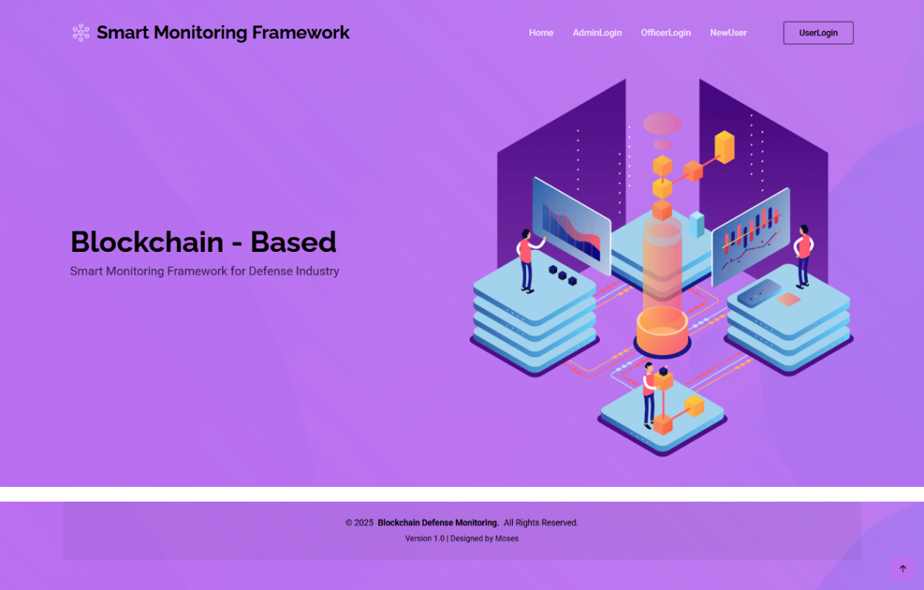
Admin Login:
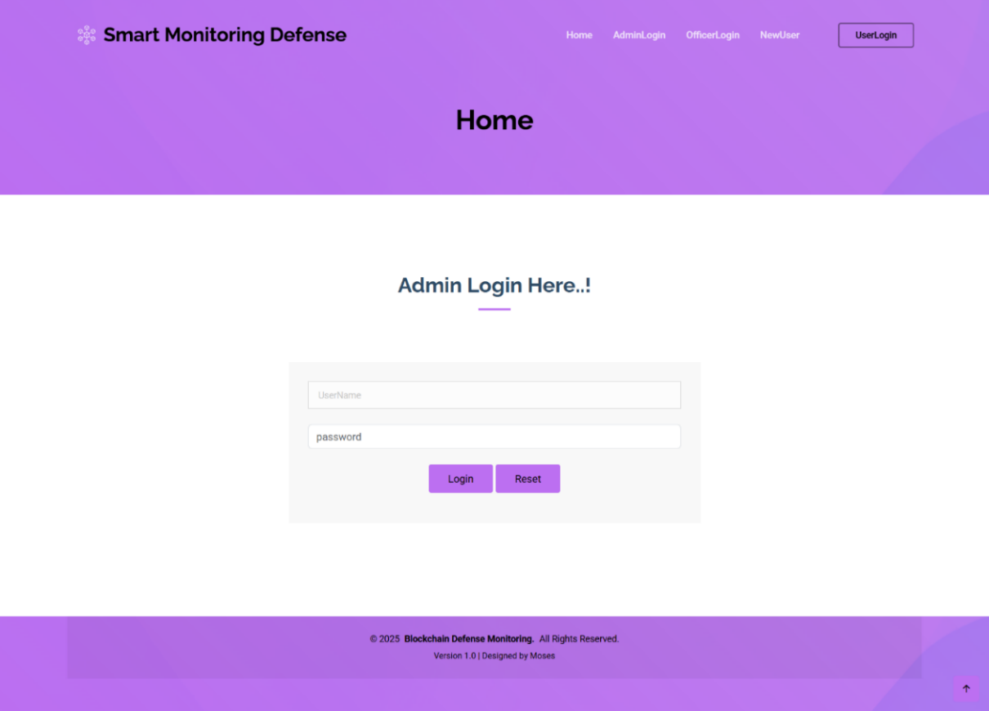
Officer Information:
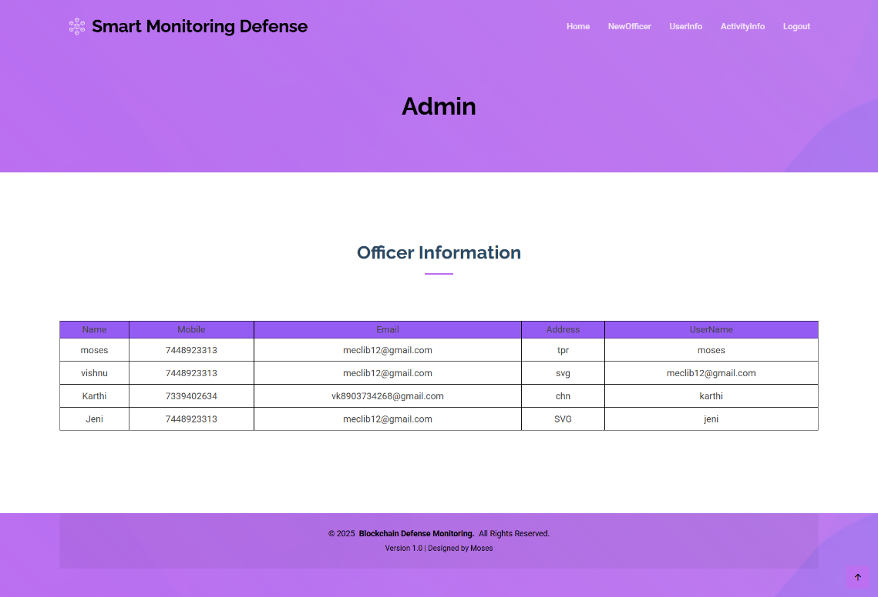
New Officer Registration:
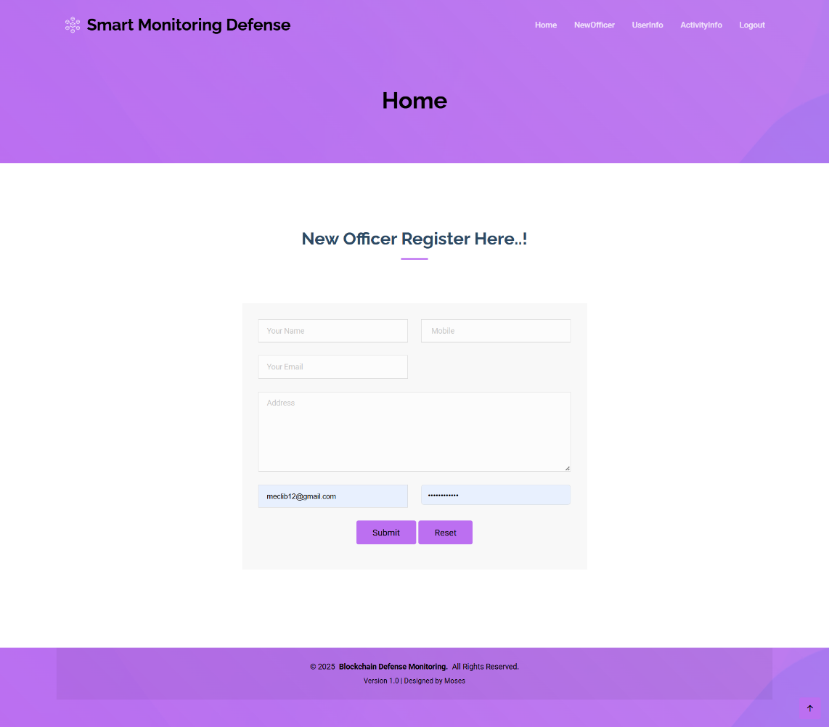
Record Saved:
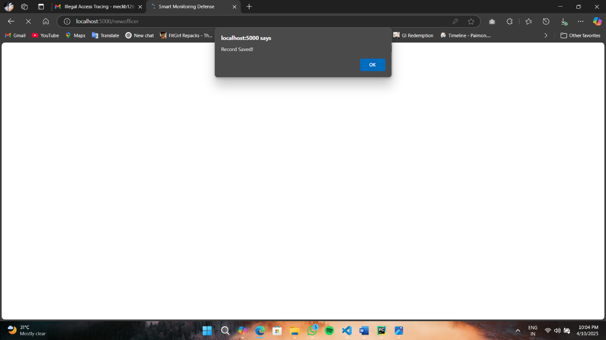
User Information:
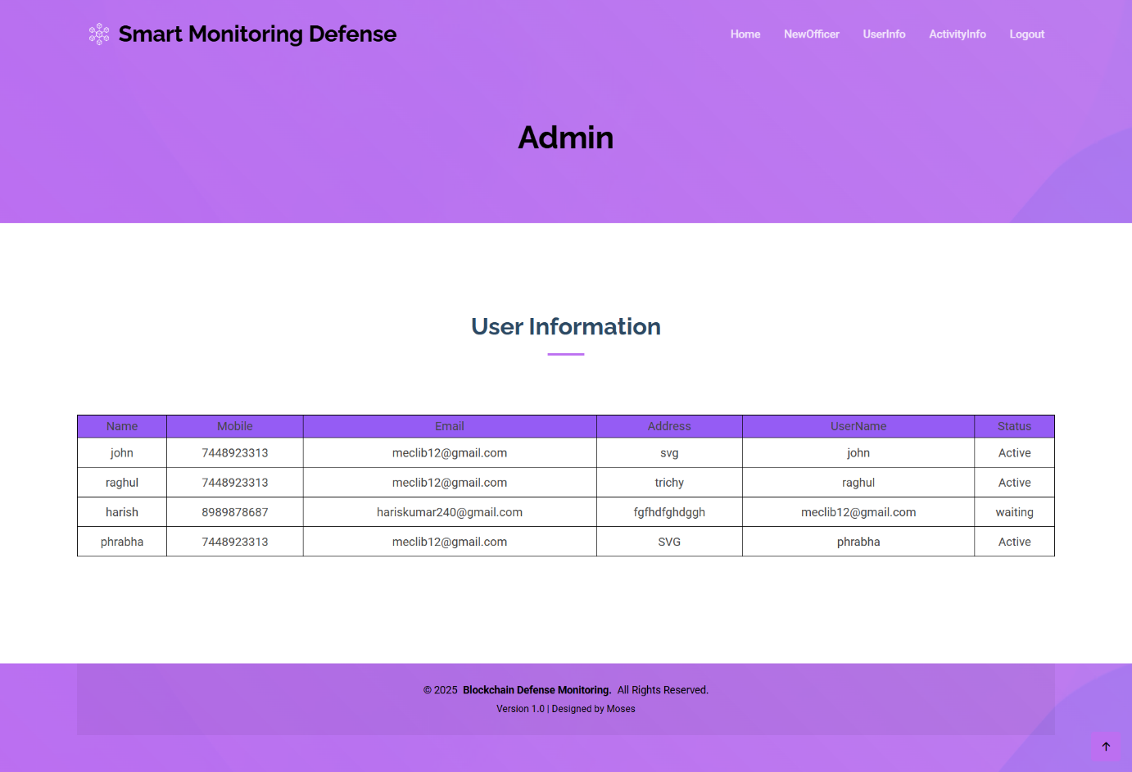
Activity Information:
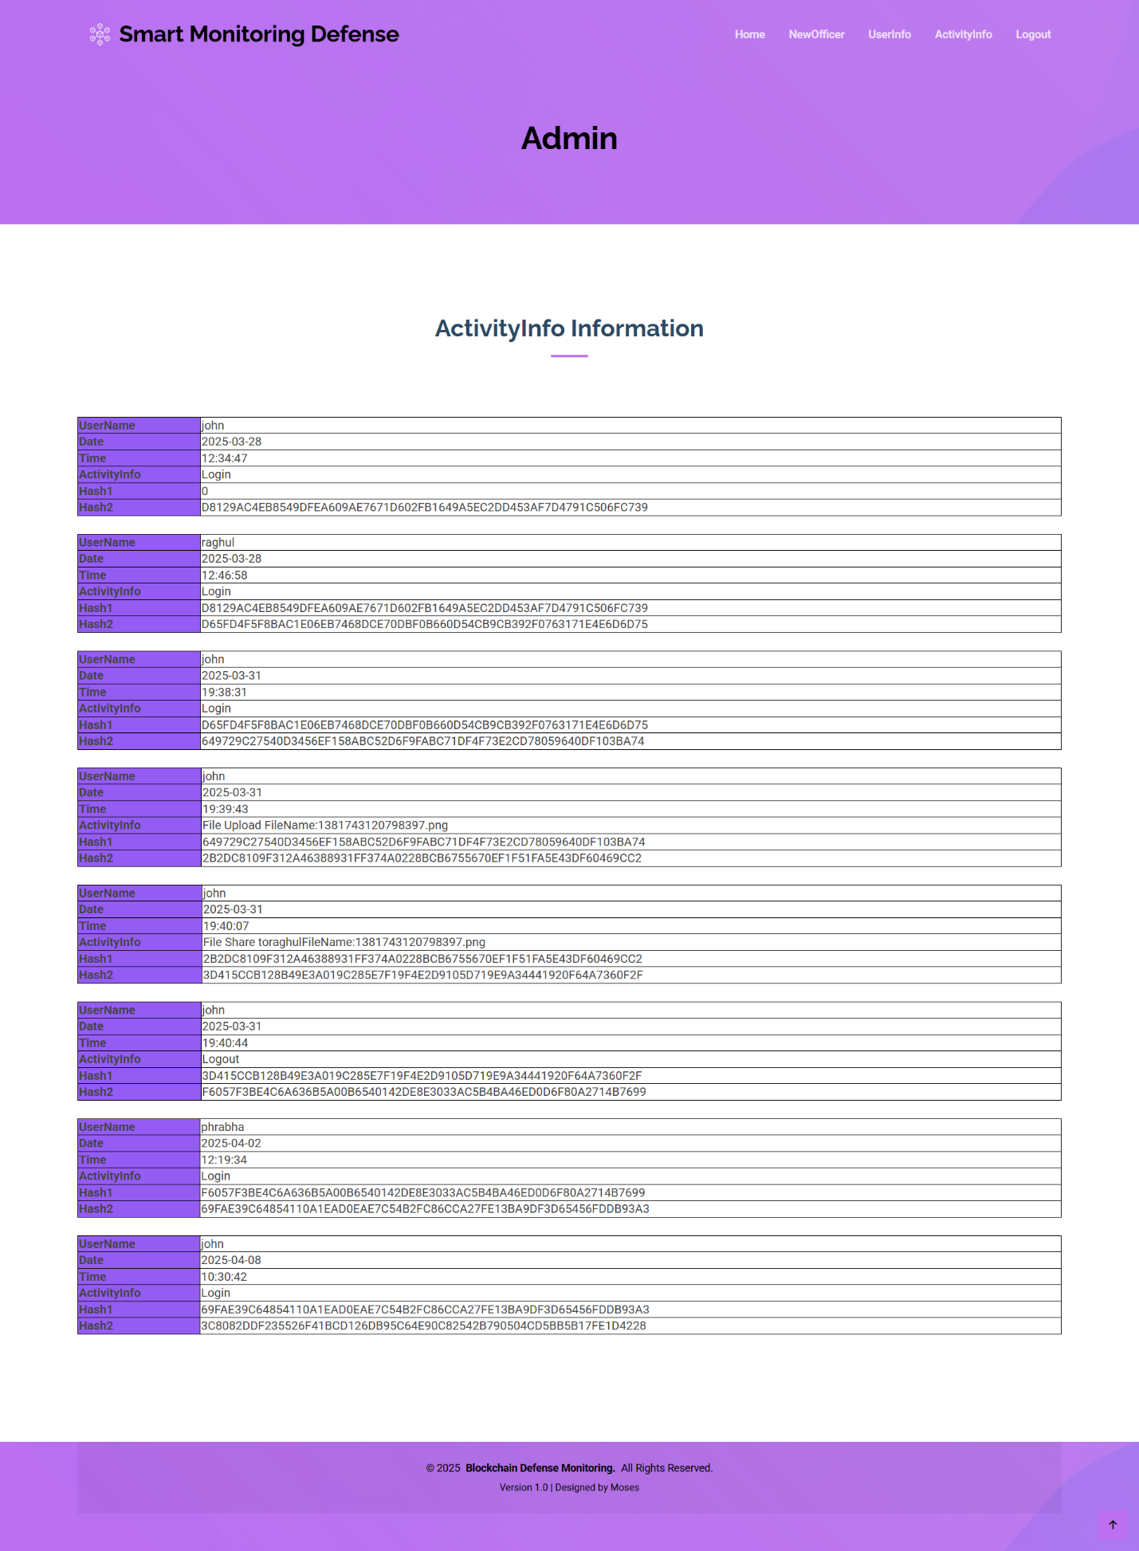

Officer Login:
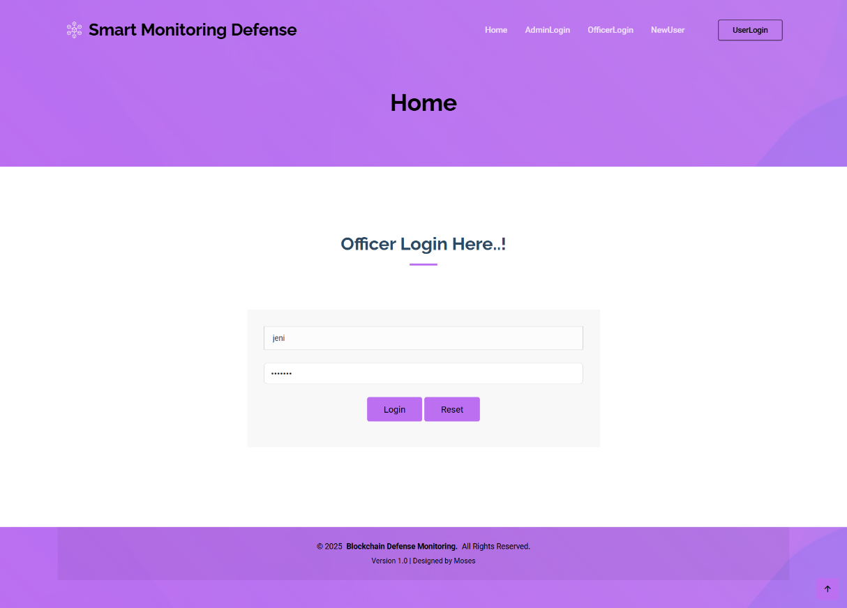
Officer HomePage:
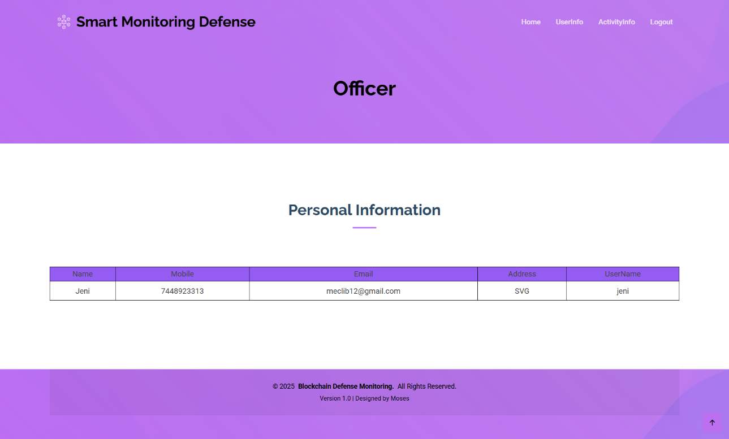

Officer’s User Information:
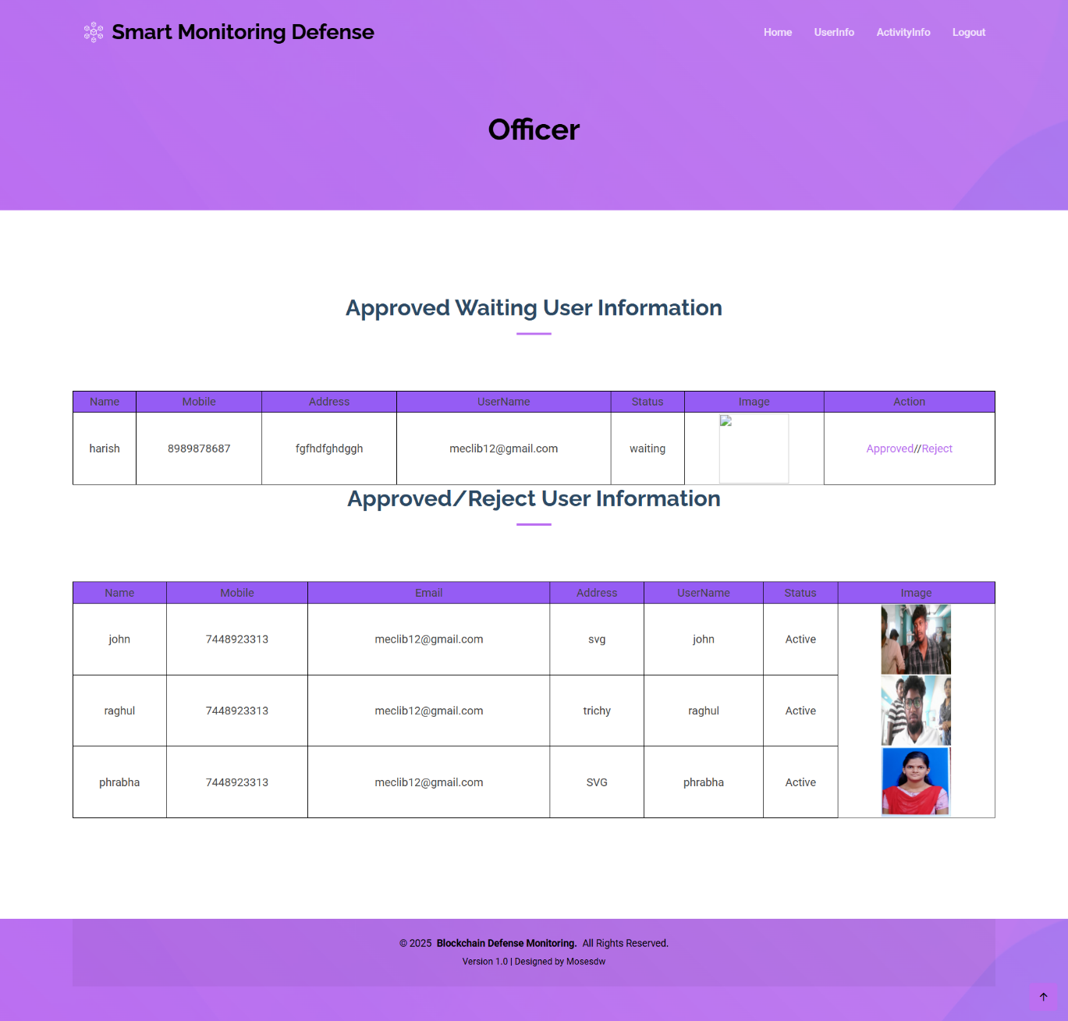

New User Registrations:
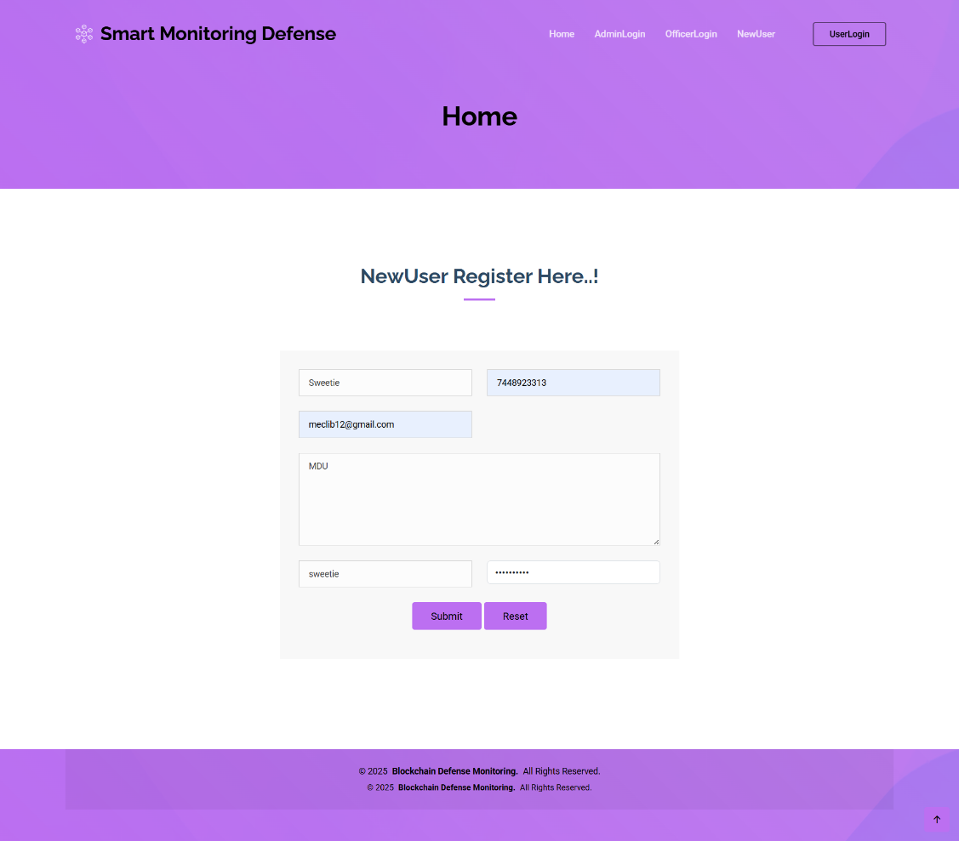
New User Registration (Live Recognitation):
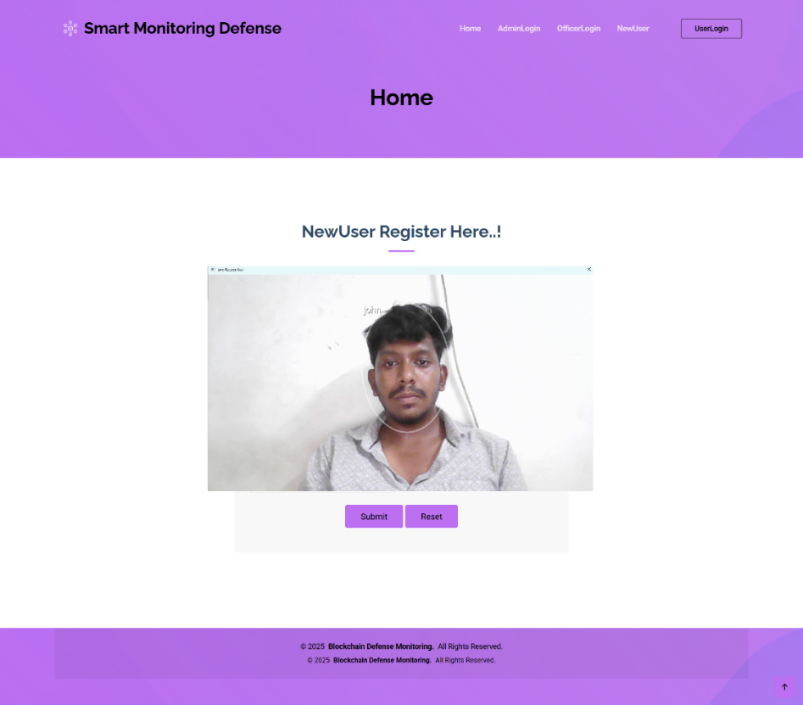
Officer Approval:
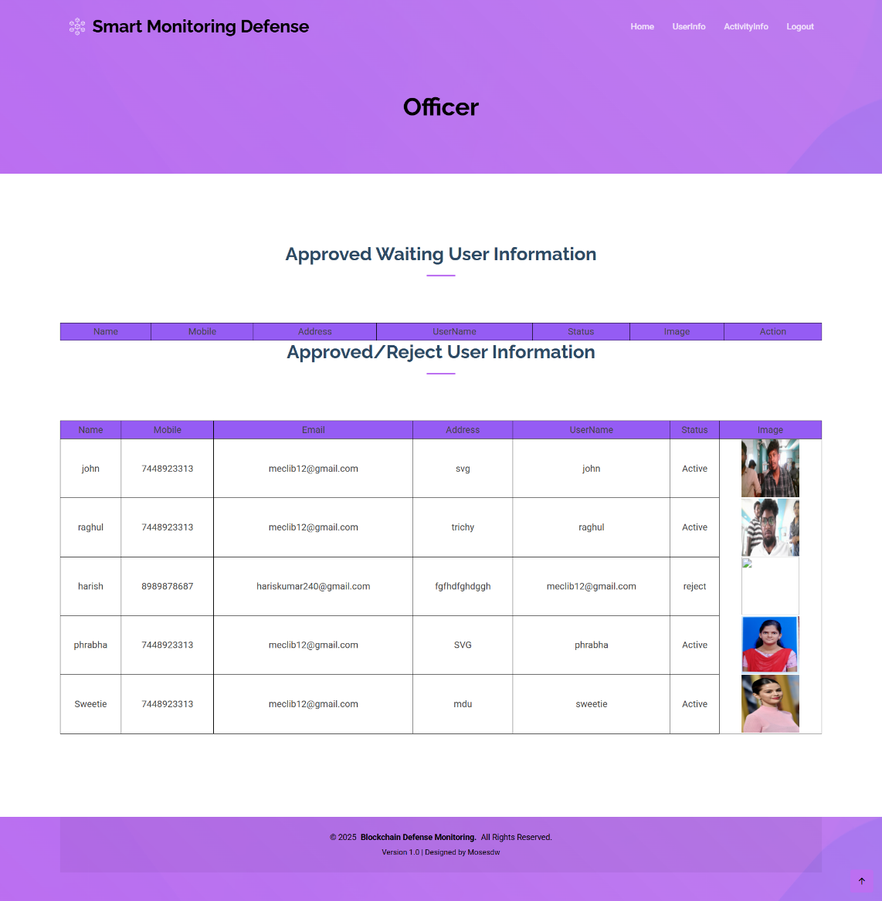
Login Key (Mail):
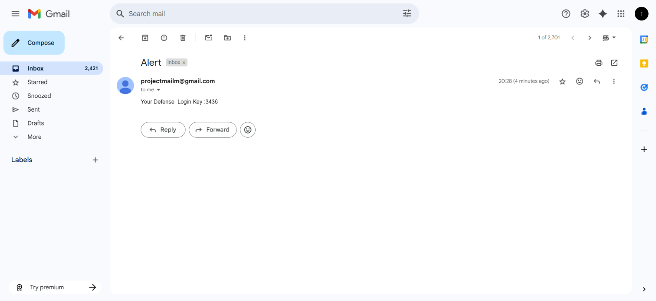
User Login:
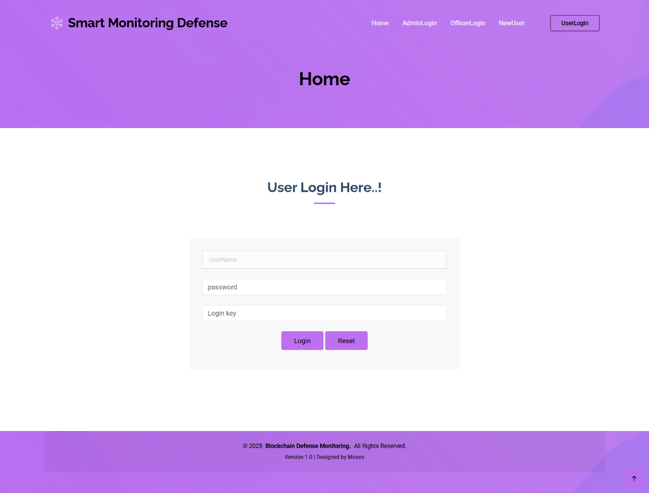
User Login (Live Recognitation):
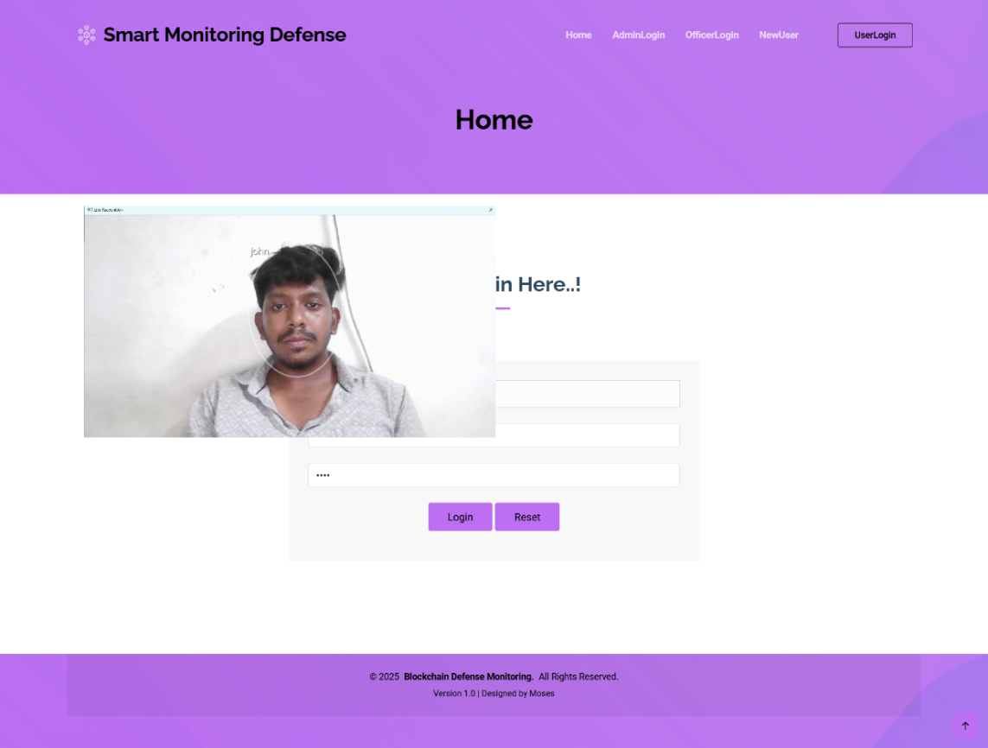
Illegal Access Tracing (Mail)
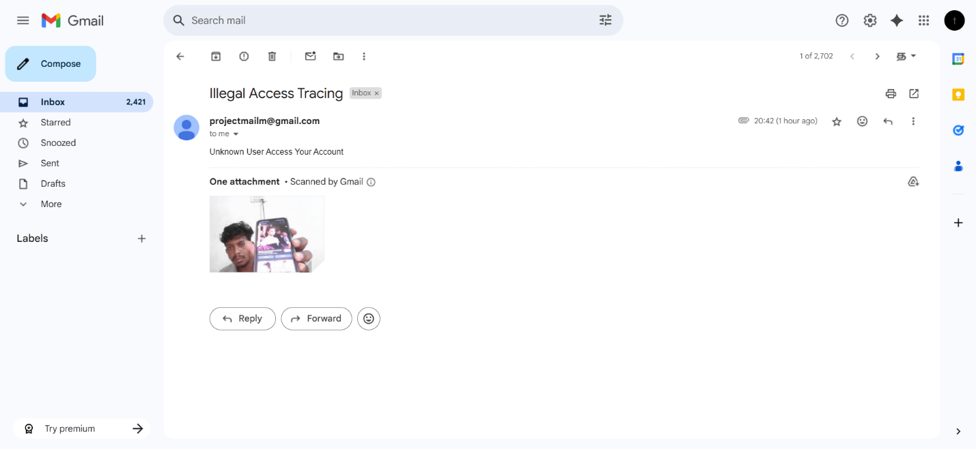

User Homepage:
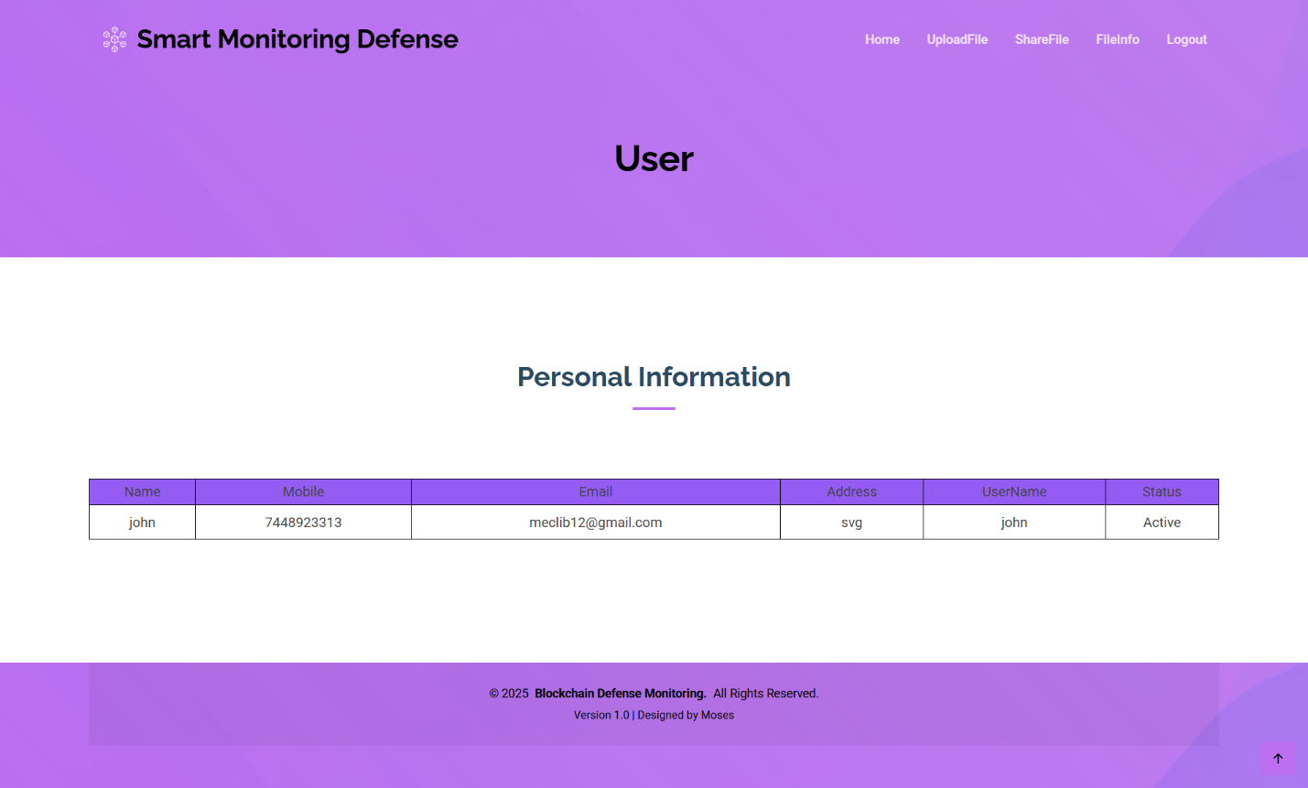

File Upload:
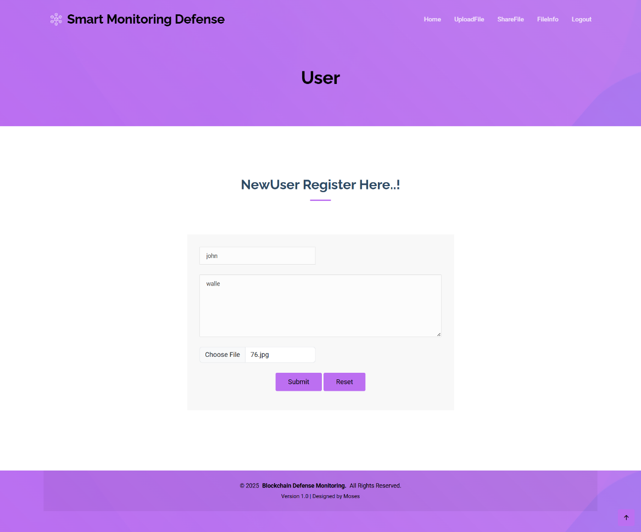
File Information:
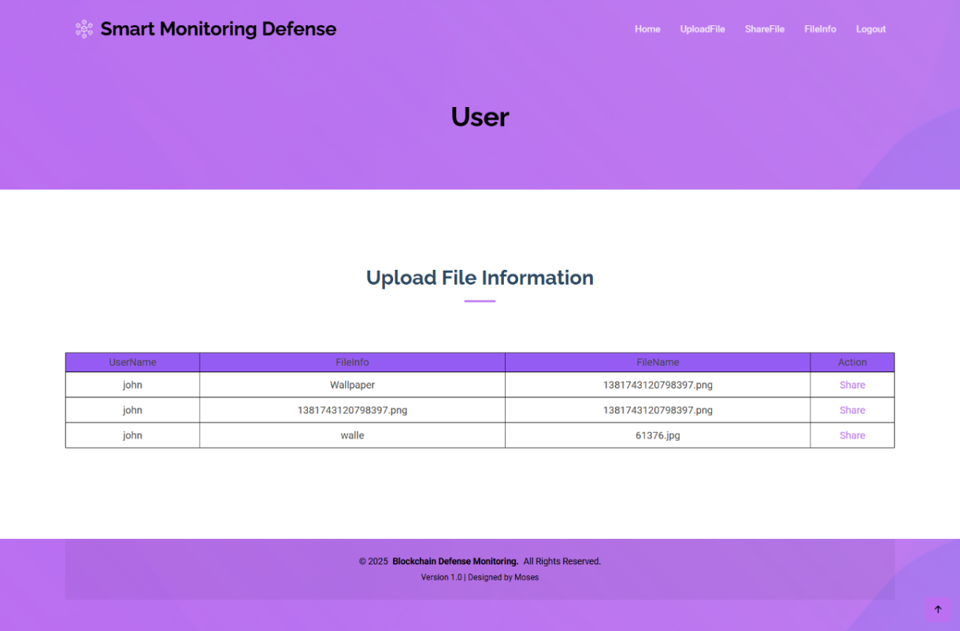
File Sharing:
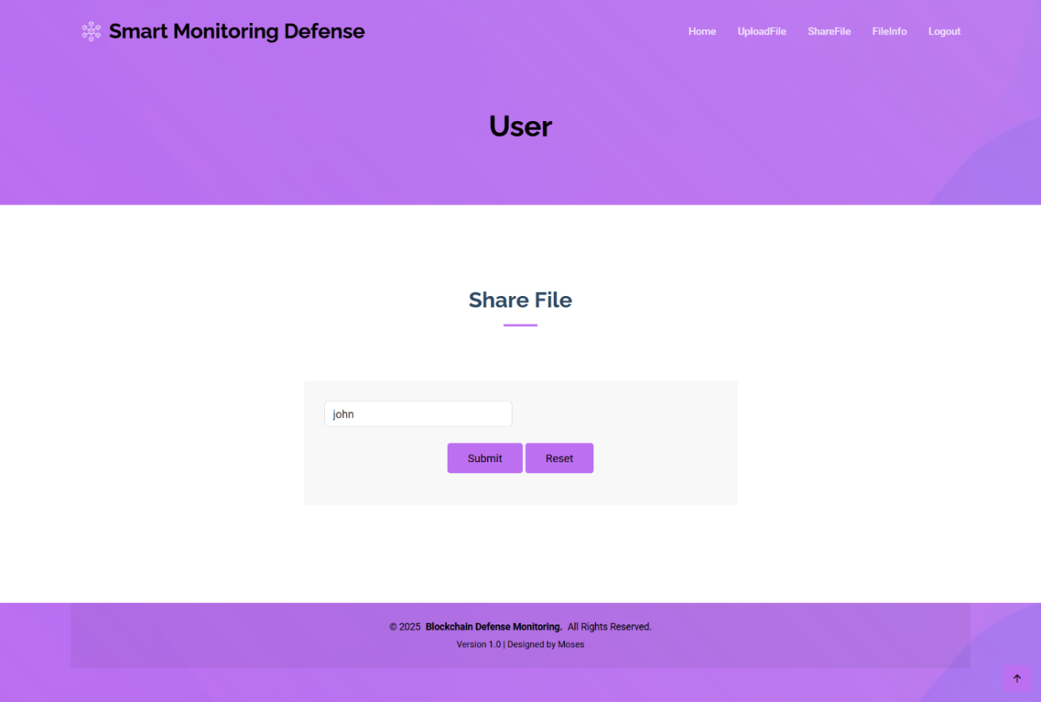
Shared File Information:
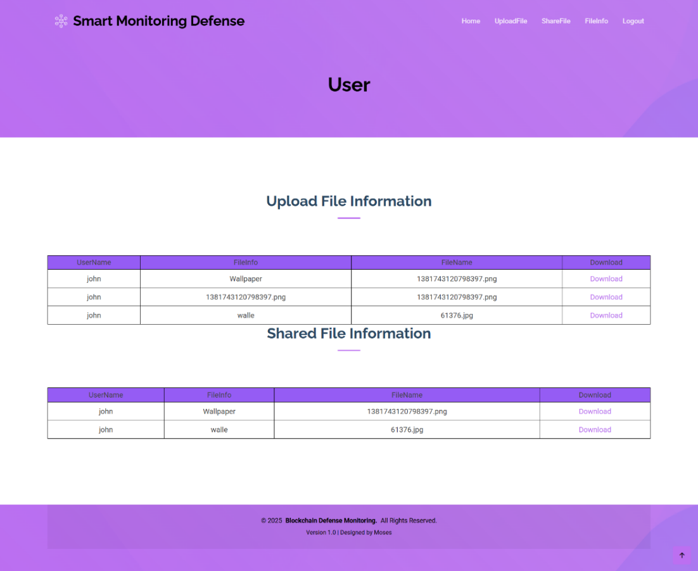

6.2 SOURCE CODE
App.py
from flask import (
Flask,
render_template,
request,
redirect,
url_for,
session,
send_file,
flash,
)
import mysql.connector
import base64, os, sys
app = Flask(__name__)
app.secret_key = "a"
@app.route("/")
def home():
return render_template("index.html")
@app.route("/AdminLogin")
def AdminLogin():
return render_template("AdminLogin.html")

@app.route("/OfficerLogin")
def OfficerLogin():
return render_template("OfficerLogin.html")
@app.route("/UserLogin")
def UserLogin():
return render_template("UserLogin.html")
@app.route("/NewOfficer")
def NewOfficer():
return render_template("NewOfficer.html")
@app.route("/NewUser")
def NewUser():
return render_template("NewUser.html")
@app.route("/adminlogin", methods=["GET", "POST"])
def adminlogin():
if request.method == "POST":
if request.form["uname"] == "admin" and request.form["password"] == "admin":
conn = mysql.connector.connect(
user="root", password="", host="localhost", database="1smartdefensedb"
)
cur = conn.cursor()
cur.execute("SELECT * FROM officertb ")
data = cur.fetchall()
return render_template("AdminHome.html", data=data)
else:
flash("Username or Password is wrong")
return render_template("AdminLogin.html")
@app.route("/AdminHome")
def AdminHome():
conn = mysql.connector.connect(
user="root", password="", host="localhost", database="1smartdefensedb"
)
cur = conn.cursor()
cur.execute("SELECT * FROM officertb ")
data = cur.fetchall(
return render_template("AdminHome.html", data=data)
@app.route("/AUserInfo")
def AUserInfo():
conn = mysql.connector.connect(
user="root", password="", host="localhost", database="1smartdefensedb"
)
cur = conn.cursor()
cur.execute("SELECT * FROM regtb ")
data = cur.fetchall()
return render_template("AUserInfo.html", data=data)
@app.route("/SFileInfo")
def SFileInfo():
conn = mysql.connector.connect(
user="root", password="", host="localhost", database="1smartdefensedb"
)
cur = conn.cursor()
cur.execute("SELECT * FROM filetb ")
data1 = cur.fetchall()
return render_template("SFileInfo.html", data=data1)
@app.route("/AActivityInfo")
def AActivityInfo():
conn = mysql.connector.connect(
user="root", password="", host="localhost", database="1smartdefensedb"
)
cur = conn.cursor()
cur.execute("SELECT * FROM activitytb ORDER BY id ")
data1 = cur.fetchall()
return render_template("AActivityInfo.html", data=data1)
@app.route("/newofficer", methods=["GET", "POST"])
def newofficer():
if request.method == "POST":
uname = request.form["uname"]
mobile = request.form["mobile"]
email = request.form["email"]
address = request.form["address"]
username = request.form["username"]
password = request.form["password"]
conn = mysql.connector.connect(
user="root", password="", host="localhost", database="1smartdefensedb"
)
cursor = conn.cursor()
cursor.execute("SELECT * from officertb where username='" + username + "' ")
data = cursor.fetchone()
if data is None:
conn = mysql.connector.connect(
user="root", password="", host="localhost", database="1smartdefensedb"
)
cursor = conn.cursor()
cursor.execute(
"INSERT INTO officertb VALUES ('','"
+ uname
+ "','"
+ mobile
+ "','"
+ email
+ "','"
+ address
+ "','"
+ username
+ "','"
+ password
+ "')"
)
conn.commit()
conn.close()
flash("Record Saved!")
return render_template("NewOfficer.html")
else:
flash("Already Register This Officer Name!")
return render_template("NewOwner.html")
@app.route("/officerlogin", methods=["GET", "POST"])
def officerlogin():
if request.method == "POST":
username = request.form["uname"]
password = request.form["password"]
session["oname"] = request.form["uname"]

conn = mysql.connector.connect(
user="root", password="", host="localhost", database="1smartdefensedb"
)
cursor = conn.cursor()
cursor.execute(
"SELECT * from officertb where username='"
+ username
+ "' and Password='"
+ password
+ "' "
)
data = cursor.fetchone()
if data is None:
flash("Username or Password is wrong")
return render_template("OfficerLogin.html")
else:
conn = mysql.connector.connect(
user="root", password="", host="localhost", database="1smartdefensedb"
)
cur = conn.cursor()
cur.execute(
"SELECT * FROM officertb where username='" + session["oname"] + "'"
)
data1 = cur.fetchall()
return render_template("OfficerHome.html", data=data1)
@app.route("/OfficerHome")
def OfficerHome():
conn = mysql.connector.connect(
user="root", password="", host="localhost", database="1smartdefensedb"
)
cur = conn.cursor()
cur.execute("SELECT * FROM officertb where username='" + session["oname"] + "'")
data1 = cur.fetchall()
return render_template("OfficerHome.html", data=data1)
@app.route("/OUserInfo")
def OUserInfo():
conn = mysql.connector.connect(
user="root", password="", host="localhost", database="1smartdefensedb"
)
cur = conn.cursor()
cur.execute("SELECT * FROM regtb where status='waiting'")
data = cur.fetchall()
conn = mysql.connector.connect(
user="root", password="", host="localhost", database="1smartdefensedb"
)
cur = conn.cursor()
cur.execute("SELECT * FROM regtb where status !='waiting'")
data1 = cur.fetchall()
return render_template("OUserInfo.html", data=data, data1=data1)
@app.route("/Approved")
def Approved():
id = request.args.get("lid")
email = request.args.get("email")
mob = request.args.get("mob")
import random
loginkey = random.randint(1111, 9999)
message = "Your Defense Login Key :" + str(loginkey)
sendmail(email, message)
sendmsg(mob, message)
conn = mysql.connector.connect(
user="root", password="", host="localhost", database="1smartdefensedb"
)
cursor = conn.cursor()
cursor.execute(
"Update regtb set Status='Active',LoginKey='"
+ str(loginkey)
+ "' where id='"
+ id
+ "' "
)
conn.commit()
conn.close()
conn = mysql.connector.connect(
user="root", password="", host="localhost", database="1smartdefensedb"
)
cur = conn.cursor()
cur.execute("SELECT * FROM regtb where status='waiting'")
data = cur.fetchall()
conn = mysql.connector.connect(
user="root", password="", host="localhost", database="1smartdefensedb"
)
cur = conn.cursor()
cur.execute("SELECT * FROM regtb where status !='waiting'")
data1 = cur.fetchall()
return render_template("OUserInfo.html", data=data, data1=data1)
@app.route("/Reject")
def Reject():
id = request.args.get("lid")
email = request.args.get("email")
message = "Your Request Rejected"
sendmail(email, message)
conn = mysql.connector.connect(
user="root", password="", host="localhost", database="1smartdefensedb"
)
cursor = conn.cursor()
cursor.execute("Update regtb set Status='reject' where id='" + id + "' ")
conn.commit()
conn.close()
conn = mysql.connector.connect(
user="root", password="", host="localhost", database="1smartdefensedb"
)
cur = conn.cursor()
cur.execute("SELECT * FROM regtb where status='waiting'")
data = cur.fetchall()
conn = mysql.connector.connect(
user="root", password="", host="localhost", database="1smartdefensedb"
)
cur = conn.cursor()
cur.execute("SELECT * FROM regtb where status !='waiting'")
data1 = cur.fetchall()
return render_template("OUserInfo.html", data=data, data1=data1)
@app.route("/OActivityInfo")
def OActivityInfo():
conn = mysql.connector.connect(
user="root", password="", host="localhost", database="1smartdefensedb"
)
cur = conn.cursor()
cur.execute("SELECT * FROM activitytb ORDER BY id ")
data1 = cur.fetchall()
return render_template("OActivityInfo.html", data=data1)
@app.route("/newuser", methods=["GET", "POST"])
def newuser():
if request.method == "POST":
uname = request.form["uname"]
mobile = request.form["mobile"]
email = request.form["email"]
address = request.form["address"]
username = request.form["username"]
password = request.form["password"]
outFileName = "static/user/" + username + ".jpg"
conn = mysql.connector.connect(
user="root", password="", host="localhost", database="1smartdefensedb"
)
cursor = conn.cursor()
cursor.execute("SELECT * from regtb where username='" + username + "' ")
data = cursor.fetchone()
if data is None:
conn = mysql.connector.connect(
user="root", password="", host="localhost", database="1smartdefensedb"
)
cursor = conn.cursor()
cursor.execute(
"INSERT INTO regtb VALUES ('','"
+ uname
+ "','"
+ mobile
+ "','"
+ email
+ "','"
+ address
+ "','"
+ username
+ "','"
+ password
+ "','waiting','','"
+ outFileName
+ "')"
)
conn.commit()
conn.close()
flash("Record Saved!")
import LiveRecognition as liv
liv.att()
del sys.modules["LiveRecognition"]
return render_template("NewUser.html")
else:
flash("Already Register This UserName!")
return render_template("NewUser.html")
import hmac
import hashlib
import binascii
def create_sha256_signature(key, message):
byte_key = binascii.unhexlify(key)
message = message.encode()
return hmac.new(byte_key, message, hashlib.sha256).hexdigest().upper()
def blockchainstor(username, activity):
import random
import datetime
import time
ts = time.time()
date = datetime.datetime.fromtimestamp(ts).strftime("%Y-%m-%d")
timeStamp = datetime.datetime.fromtimestamp(ts).strftime("%H:%M:%S")
conn = mysql.connector.connect(
user="root", password="", host="localhost", database="1smartdefensedb"
)
cursor = conn.cursor()
cursor.execute("SELECT * FROM activitytb ")
data2 = cursor.fetchone()
if data2:
conn1 = mysql.connector.connect(
user="root", password="", host="localhost", database="1smartdefensedb"
)
cursor1 = conn1.cursor()
cursor1.execute("select max(id) from activitytb")
da = cursor1.fetchone()
if da:
d = da[0]
print(d)
conn = mysql.connector.connect(
user="root", password="", host="localhost", database="1smartdefensedb"
)
cursor = conn.cursor()
cursor.execute("SELECT * FROM activitytb where id ='" + str(d) + "' ")
data1 = cursor.fetchone()
if data1:
hash1 = data1[6]
num1 = random.randrange(1111, 9999)
hash2 = create_sha256_signature(
"E49756B4C8FAB4E48222A3E7F3B97CC3", str(num1)
)
conn = mysql.connector.connect(
user="root", password="", host="localhost", database="1smartdefensedb"
)
cursor = conn.cursor()
cursor.execute(
"INSERT INTO activitytb VALUES ('','"
+ username
+ "','"
+ str(date)
+ "','"
+ str(timeStamp)
+ "','"
+ activity
+ "','"
+ hash1
+ "','"
+ hash2
+ "')"
)
conn.commit()
conn.close()
else:
hash1 = "0"
num1 = random.randrange(1111, 9999)
hash2 = create_sha256_signature("E49756B4C8FAB4E48222A3E7F3B97CC3", str(num1))
conn = mysql.connector.connect(
user="root", password="", host="localhost", database="1smartdefensedb"
)
cursor = conn.cursor()
cursor.execute(
"INSERT INTO activitytb VALUES ('','"
+ username
+ "','"
+ str(date)
+ "','"
+ str(timeStamp)
+ "','"
+ activity
+ "','"
+ hash1
+ "','"
+ hash2
+ "')"
)
conn.commit()
conn.close()

@app.route("/Download")
def Download():
fid = request.args.get("lid")
conn = mysql.connector.connect(
user="root", password="", host="localhost", database="1smartdefensedb"
)
cursor = conn.cursor()
cursor.execute("SELECT * FROM filetb where id='" + fid + "'")
data = cursor.fetchone()
if data:
fname = data[3]
else:
return "Incorrect username / password !"
filepath = "./static/upload/" + fname
return send_file(filepath, as_attachment=True)
@app.route("/userlogin", methods=["GET", "POST"])
def userlogin():
if request.method == "POST":
username = request.form["uname"]
password = request.form["password"]
loginkey = request.form["loginkey"]
session["uname"] = request.form["uname"]
conn = mysql.connector.connect(
user="root", password="", host="localhost", database="1smartdefensedb"
)
cursor = conn.cursor()
cursor.execute(
"SELECT * from regtb where username='"
+ username
+ "' and Password='"
+ password
+ "' "
)
data = cursor.fetchone()
if data is None:
flash("Username or Password is wrong")
return render_template("UserLogin.html")
else:
Status = data[7]
lkey = data[8]
session["lkey"] = data[8]
if Status == "waiting":
flash("Waiting For Server Approved!")
return render_template("UserLogin.html")
else:
if lkey == loginkey:
conn = mysql.connector.connect(
user="root",
password="",
host="localhost",
database="1smartdefensedb",
)
cursor = conn.cursor()
cursor.execute("truncate table temptb ")
conn.commit()
conn.close()
import LiveRecognition1
# del sys.modules["LiveRecognition1"]
return facelogin()
# return render_template('UserHome.html')
else:
flash("Login Key Incorrect")
return render_template("UserLogin.html")
def loginvales1():
uname = session["uname"]
conn = mysql.connector.connect(
user="root", password="", host="localhost", database="1smartdefensedb"
)
cursor = conn.cursor()
cursor.execute("SELECT * FROM regtb where username='" + uname + "'")
data = cursor.fetchone()
if data:
Email = data[3]
Phone = data[2]
else:
return "Incorrect username / password !"
return uname, Email, Phone
@app.route("/facelogin")
def facelogin():
uname = session["uname"]
conn = mysql.connector.connect(
user="root", password="", host="localhost", database="1smartdefensedb"
)
cursor = conn.cursor()
cursor.execute("SELECT * from temptb where username='" + uname + "' ")
data = cursor.fetchone()
if data is None:

flash("Face Wrong..!")
return render_template("UserLogin.html")
else:
blockchainstor(session["uname"], "Login")
conn = mysql.connector.connect(
user="root", password="", host="localhost", database="1smartdefensedb"
)
cur = conn.cursor()
cur.execute("SELECT * FROM regtb where username='" + session["uname"] + "'")
data1 = cur.fetchall()
flash("Login Successfully")
return render_template("UserHome.html", data=data1)
@app.route("/UserHome")
def UserHome():
conn = mysql.connector.connect(
user="root", password="", host="localhost", database="1smartdefensedb"
)
cur = conn.cursor()
cur.execute("SELECT * FROM UserHome where OwnerName='" + session["uname"] + "'")
data1 = cur.fetchall()
return render_template("UserHome.html", data=data1)
@app.route("/UploadFile")
def UploadFile():
oname = session["uname"]
return render_template("UploadFile.html", uname=oname)
@app.route("/owfileupload", methods=["GET", "POST"])
def owfileupload():
if request.method == "POST":
oname = session["uname"]
info = request.form["info"]
file = request.files["file"]
import random
fnew = random.randint(111, 999)
savename = str(fnew) + file.filename
file.save("static/upload/" + savename)
conn = mysql.connector.connect(
user="root", password="", host="localhost", database="1smartdefensedb"
)
cursor = conn.cursor()
cursor.execute(
"INSERT INTO filetb VALUES ('','"
+ oname
+ "','"
+ info
+ "','"
+ savename
+ "','"
+ oname
+ "')"
)
conn.commit()
conn.close()
flash("File Upload Successfully ")
blockchainstor(session["uname"], "File Upload FileName:" + savename)
return render_template("UploadFile.html", oname=oname)
@app.route("/ShareFile")
def ShareFile():
conn = mysql.connector.connect(
user="root", password="",j host="localhost", database="1smartdefensedb"
)
cur = conn.cursor()
cur.execute("SELECT * FROM filetb where UserName='" + session["uname"] + "'")
data1 = cur.fetchall()
return render_template("ShareFile.html", data=data1)
@app.route("/sharef")
def sharef():
lid = request.args.get("lid")
session["fid"] = lid
conn = mysql.connector.connect(
user="root", password="", host="localhost", database="1smartdefensedb"
)
cur = conn.cursor()
cur.execute("SELECT UserName FROM regtb ")
data1 = cur.fetchall()
return render_template("share.html", data=data1)
@app.route("/fshares", methods=["GET", "POST"])
def fshares():
if request.method == "POST":
oname = session["uname"]
suname = request.form["suname"]
conn = mysql.connector.connect(
user="root", password="", host="localhost", database="1smartdefensedb"
)
cursor = conn.cursor()
cursor.execute("SELECT * FROM filetb where id='" + session["fid"] + "'")
data = cursor.fetchone()
if data:
info = data[3]
ffile = data[3]
conn = mysql.connector.connect(
user="root", password="", host="localhost", database="1smartdefensedb"
)
cursor = conn.cursor()
cursor.execute(
"INSERT INTO filetb VALUES ('','"
+ oname
+ "','"
+ info
+ "','"
+ ffile
+ "','"
+ suname
+ "')"
)
conn.commit()
conn.close()
flash("File Share Successfully ")
blockchainstor(session["uname"], "File Share to" + suname + "FileName:" + ffile)
return ShareFile()
@app.route("/FileInfo")
def FileInfo():
uname = session["uname"]
conn = mysql.connector.connect(
user="root", password="", host="localhost", database="1smartdefensedb"
)
cur = conn.cursor()
cur.execute("SELECT * FROM filetb where UserName='" + uname + "'")
data = cur.fetchall()
conn = mysql.connector.connect(
user="root", password="", host="localhost", database="1smartdefensedb"
)
cur = conn.cursor()
cur.execute("SELECT * FROM filetb where shareName='" + uname + "'")
data1 = cur.fetchall()
return render_template("UFileInfo.html", data=data, data1=data1)
@app.route("/ULogout")
def ULogout():
blockchainstor(session["uname"], "Logout")
return render_template("index.html")
def sendmail(Mailid, message):
import smtplib
from email.mime.multipart import MIMEMultipart
from email.mime.text import MIMEText
from email.mime.base import MIMEBase
from email import encoders
fromaddr = "projectmailm@gmail.com"
toaddr = Mailid
# instance of MIMEMultipart
msg = MIMEMultipart()
# storing the senders email address
msg["From"] = fromaddr
# storing the receivers email address
msg["To"] = toaddr
# storing the subject
msg["Subject"] = "Alert"
# string to store the body of the mail
body = message
# attach the body with the msg instance
msg.attach(MIMEText(body, "plain"))
# creates SMTP session
s = smtplib.SMTP("smtp.gmail.com", 587)
# start TLS for security
s.starttls()
# Authentication
s.login(fromaddr, "qmgn xecl bkqv musr")
# Converts the Multipart msg into a string
text = msg.as_string()
# sending the mail
s.sendmail(fromaddr, toaddr, text)
# terminating the session
s.quit()
def sendmsg(targetno, message):
import requests
requests.post(
"http://sms.creativepoint.in/api/push.json?apikey=6555c521622c1&route=transsms&sender=FSSMSS&mobileno="
+ targetno
+ "&text=Dear customer, your login key is "
+ message
+ " Sent By SmartMonitor"
)
if __name__ == "__main__":
# app.run(host='0.0.0.0', debug=True, port=5000)
app.run(debug=True, use_reloader=True)

live recognitation.py
from __future__ import print_function
import sys, fsdk, math, ctypes, time
from fsdk import FSDK
license_key = "fVrFCzYC5wOtEVspKM/zfLWVcSIZA4RNqx74s+QngdvRiCC7z7MHlSf2w3+OUyAZkTFeD4kSpfVPcRVIqAKWUZzJG975b/P4HNNzpl11edXGIyGrTO/DImoZksDSRs6wktvgr8lnNCB5IukIPV5j/jBKlgL5aqiwSfyCR8UdC9s="
if not fsdk.windows:
print("The program is for Microsoft Windows.")
exit(1)
import win
trackerMemoryFile = "tracker70.dat"
FONT_SIZE = 30
print("Initializing FSDK... ", end="")
FSDK.ActivateLibrary(license_key)
FSDK.Initialize()
print("OK\nLicense info:", FSDK.GetLicenseInfo())
FSDK.InitializeCapturing()
print("Looking for video cameras... ", end="")
camList = FSDK.ListCameraNames()
if not camList:
print("Please attach a camera.")
print(camList[0]) # camList[0].devicePath
camera = camList[0] # choose the first camera (0)
print("using '%s'" % camera)
formatList = FSDK.ListVideoFormats(camera)
# print(*zip(range(len(formatList)), formatList), sep='\n')
print(*formatList[0:5], sep="\n")
if len(formatList) > 5:
print("...", len(formatList) - 5, "more formats (skipped)...")
vfmt = formatList[0] # choose the first format: vfmt.Width, vfmt.Height, vfmt.BPP
print("Selected camera format:", vfmt)
FSDK.SetVideoFormat(camera, vfmt)
print("Trying to open '%s'... " % camera, end="")
camera = FSDK.OpenVideoCamera(camera)
print("OK", camera.handle)
try:
fsdkTracker = FSDK.Tracker.FromFile(trackerMemoryFile)
except:
fsdkTracker = FSDK.Tracker() # creating a FSDK Tracker
fsdkTracker.SetParameters( # set realtime face detection parameters
RecognizeFaces=True,
DetectFacialFeatures=True,
HandleArbitraryRotations=True,
DetermineFaceRotationAngle=False,
InternalResizeWidth=256,
FaceDetectionThreshold=5,
)
need_to_exit = False
def WndProc(hWnd, message, wParam, lParam):
global capturedFace
if message == win.WM_CTLCOLOREDIT:
fsdkTracker.SetName(capturedFace, win.GetWindowText(inpBox))
if message == win.WM_DESTROY:
global need_to_exit
need_to_exit = True
else:
if message == win.WM_MOUSEMOVE:
updateActiveFace()
return 1
if message == win.WM_LBUTTONDOWN:
if activeFace and capturedFace != activeFace:
capturedFace = activeFace
win.SetWindowText(inpBox, fsdkTracker.GetName(capturedFace))
win.ShowWindow(inpBox, win.SW_SHOW)
win.SetFocus(inpBox)
else:
capturedFace = None
win.ShowWindow(inpBox, win.SW_HIDE)
return 1
return win.DefWindowProc(hWnd, message, win.WPARAM(wParam), win.LPARAM(lParam))
wcex = win.WNDCLASSEX(
cbSize=ctypes.sizeof(win.WNDCLASSEX),
style=0,
lpfnWndProc=win.WNDPROC(WndProc),
cbClsExtra=0,
cbWndExtra=0,
hInstance=0,
hIcon=0,
hCursor=win.LoadCursor(0, win.IDC_ARROW),
hbrBackground=0,
lpszMenuName=0,
lpszClassName=win.L("My Window Class"),
hIconSm=0,
)
win.RegisterClassEx(wcex)
hwnd = win.CreateWindowEx(
win.WS_EX_CLIENTEDGE,
win.L("My Window Class"),
win.L("Live Recognition"),
win.WS_SYSMENU | win.WS_CAPTION | win.WS_CLIPCHILDREN,
100,
100,
vfmt.Width,
vfmt.Height,
*[0] * 4
)
win.ShowWindow(hwnd, win.SW_SHOW)
# textBox = win.CreateWindow(win.L("STATIC"), win.L("Click face to name it"), win.SS_CENTER | win.WS_CHILD, 0, 0, 0, 0, hwnd, 0, 0, 0)
# myFont = win.CreateFont(30, 0, 0, 0, 0, 0, 0, 0, 0, 0, 0, 0, 0, win.L("Microsoft Sans Serif"))
# win.SendMessage(textBox, win.WM_SETFONT, myFont, True);
# win.SetWindowPos(textBox, 0, 0, vfmt.Height, vfmt.Width, 80, win.SWP_NOZORDER)
# win.ShowWindow(textBox, win.SW_SHOW)
inpBox = win.CreateWindow(
win.L("EDIT"), win.L(""), win.SS_CENTER | win.WS_CHILD, 0, 0, 0, 0, hwnd, 0, 0, 0
)
myFont = win.CreateFont(
30, 0, 0, 0, 0, 0, 0, 0, 0, 0, 0, 0, 0, win.L("Microsoft Sans Serif")
)
win.SendMessage(inpBox, win.WM_SETFONT, myFont, True)
win.SetWindowPos(inpBox, 0, 0, vfmt.Height - 80, vfmt.Width, 80, win.SWP_NOZORDER)
win.UpdateWindow(hwnd)
def dot_center(dots): # calc geometric center of dots
return sum(p.x for p in dots) / len(dots), sum(p.y for p in dots) / len(dots)
class LowPassFilter: # low pass filter to stabilize frame size
def __init__(self, a=0.35):
self.a, self.y = a, None
def __call__(self, x):
self.y = self.a * x + (1 - self.a) * (self.y or x)
return self.y
class FaceLocator:
def __init__(self, fid):
self.lpf = None
self.center = self.angle = self.frame = None
self.fid = fid
def isIntersect(self, state):
(x1, y1, x2, y2), (xx1, yy1, xx2, yy2) = self.frame, state.frame
return not (x1 >= xx2 or x2 < xx1 or y1 >= yy2 or y2 < yy1)
def isActive(self):
return self.lpf is not None
def is_inside(self, x, y):
x -= self.center[0]
y -= self.center[1]
a = self.angle * math.pi / 180
x, y = x * math.cos(a) + y * math.sin(a), x * math.sin(a) - y * math.cos(a)
return (x / self.frame[0]) ** 2 + (y / self.frame[1]) ** 2 <= 1
def draw_shape(self, surf):
container = surf.beginContainer()
surf.translateTransform(*self.center).rotateTransform(self.angle).ellipse(
facePen, *self.frame
) # draw frame
if activeFace == self.fid:
surf.ellipse(faceActivePen, *self.frame) # draw active frame
if capturedFace == self.fid:
surf.ellipse(faceCapturedPen, *self.frame) # draw captured frame
surf.endContainer(container)
def draw(self, surf, path, face_id=None):
if face_id is not None:
ff = fsdkTracker.GetFacialFeatures(0, face_id)
if self.lpf is None:
self.lpf = LowPassFilter()
xl, yl = dot_center([ff[k] for k in FSDK.FSDKP_LEFT_EYE_SET])
xr, yr = dot_center([ff[k] for k in FSDK.FSDKP_RIGHT_EYE_SET])
w = self.lpf((xr - xl) * 2.8)
h = w * 1.4
self.center = (xr + xl) / 2, (yr + yl) / 2 + w * 0.05
self.angle = math.atan2(yr - yl, xr - xl) * 180 / math.pi
self.frame = -w / 2, -h / 2, w / 2, h / 2
self.draw_shape(surf)
name = fsdkTracker.GetName(self.fid)
# print(name)
surf.drawString(
name,
font,
self.center[0] - w / 2 + 2,
self.center[1] - h / 2 + 2,
text_shadow,
)
surf.drawString(
name, font, self.center[0] - w / 2, self.center[1] - h / 2, text_color
)
else:
if self.lpf is not None:
self.lpf, self.countdown = None, 35
self.countdown -= 1
if self.countdown <= 8:
self.frame = [v * 0.95 for v in self.frame]
else:
self.draw_shape(surf)
name = "Unknown User!"
# print(name)
path.ellipse(*self.frame) # frame background
return self.lpf or self.countdown > 0
activeFace = capturedFace = None
def updateActiveFace():
global activeFace
p = win.ScreenToClient(hwnd, win.GetCursorPos())
for fid, tr in trackers.items():
if tr.is_inside(p.x, p.y):
activeFace = fid
break
else:
activeFace = None
gdiplus = win.GDIPlus() # initialize GDI+
graphics = win.Graphics(hwnd=hwnd)
backsurf = win.Bitmap.FromGraphics(vfmt.Width, vfmt.Height, graphics)
surfGr = win.Graphics(bmp=backsurf).setSmoothing(
True
) # graphics object for back surface with antialiasing
facePen, featurePen, brush = (
win.Pen(0x60FFFFFF, 5),
win.Pen(0xA060FF60, 1.8),
win.Brush(0x28FFFFFF),
)
faceActivePen, faceCapturedPen = win.Pen(0xFF00FF00, 2), win.Pen(0xFFFF0000, 3)
font = win.Font(win.FontFamily("Tahoma"), FONT_SIZE)
text_color, text_shadow = win.Brush(0xFFFFFFFF), win.Brush(0xFF808080)
trackers = {}
def att():
pass
def sendmsg(targetno, message):
import requests
requests.post(
"http://sms.creativepoint.in/api/push.json?apikey=6555c521622c1&route=transsms&sender=FSSMSS&mobileno="
+ targetno
+ "&text=Dear customer your Login Key is "
+ message
+ " Sent By BBSMDI"
)
while 1:
img = camera.GrabFrame()
surfGr.resetClip().drawImage(
win.Bitmap.FromHBITMAP(img.GetHBitmap())
) # fill backsurface with image
faces = frozenset(fsdkTracker.FeedFrame(0, img)) # recognize all faces in the image
for face_id in faces.difference(trackers):
trackers[face_id] = FaceLocator(face_id) # create new trackers
missed, gpath = [], win.GraphicsPath()
for face_id, tracker in trackers.items(): # iterate over current trackers
if face_id in faces:
tracker.draw(
surfGr, gpath, face_id
) # fsdkTracker.GetFacialFeatures(face_id)) # draw existing tracker
else:
missed.append(face_id)
for mt in missed: # find and remove trackers that are not active anymore
st = trackers[mt]
if any(st.isIntersect(trackers[tr]) for tr in faces) or not st.draw(
surfGr, gpath ):
del trackers[mt]
if capturedFace not in trackers:
capturedFace = None
win.ShowWindow(inpBox, win.SW_HIDE)
updateActiveFace()
# surfGr.clipPath(gpath, win.CombineModeExclude).fillRect(brush, 0, 0, vfmt.Width, vfmt.Height) # clip frames
graphics.drawImage(backsurf, 0, 0) # show backsurface
msg = win.MSG()
if win.PeekMessage(win.byref(msg), 0, 0, 0, win.PM_REMOVE):
win.TranslateMessage(win.byref(msg))
win.DispatchMessage(win.byref(msg))
if (
msg.message == win.WM_KEYDOWN
and msg.wParam == win.VK_ESCAPE
or need_to_exit
):
break
ss = fsdkTracker.GetName(face_id)
outFileName = "static/user/" + str(ss) + ".jpg"
# outFileName = 'static/out.jpg'
bmp = win.Bitmap.FromHBITMAP(img.GetHBitmap())
saimg = FSDK.Image(bmp.GetHBITMAP())
saimg.SaveToFile(outFileName, quality=85)
print("Please wait while saving Tracker memory... ", end="", flush=True)
fsdkTracker.SaveToFile(trackerMemoryFile)
win.ShowWindow(hwnd, win.SW_HIDE)
img.Free()
fsdkTracker.Free()
camera.Close()
FSDK.FinalizeCapturing()
FSDK.Finalize()

7. BIBILIOGRAPHY

BOOK REFERENCES
- Heinold, Brian. "A practical introduction to Python programming." (2021).
- Kneusel, Ronald T. Practical deep learning: A Python-based introduction. No Starch Press, 2021.
- Dhruv, Akshit J., Reema Patel, and Nishant Doshi. "Python: the most advanced programming language for computer science applications." Science and Technology Publications, Lda 2021: 292-299.
- Sundnes, Joakim. Introduction to scientific programming with Python. Springer Nature, 2020.
- Hill, Christian. Learning scientific programming with Python. Cambridge University Press, 2020.

WEBSITE REFERENCES
- https://medium.com/javarevisited/10-free-python-tutorials-and-courses-from-google-microsoft-and-coursera-for-beginners-96b9ad20b4e6
- https://www.bestcolleges.com/bootcamps/guides/learn-python-free/
- https://www.programiz.com/python-programming
- https://realpython.com/
- https://www.codecademy.com/learn/learn-python

