Name: Riaz Shajahan

Bio: Riaz is a 23-year-old male with a master’s degree in mechanical engineering, he has a decent job working on many interesting projects. However, he is unfulfilled in his job and in his free time he picked up the hobby of cyber security and has committed many cybercrimes whilst going unnoticed. He mostly likes to hack small websites with poor encryption and selling users’ data on the deep web.

|  |  |
| --- | --- |
| Age: 23 | Occupation: Mechanical Engineer |
| Goals:   * Changing careers; * Spreading fear; * Being famous. | Motivations:   * Unfulfillment; * Not being paid enough; * Revenge from big corporations   and capitalism. |
| Frustrations:   * Slow tech; * Having to use MS Excel; * Large amounts of debt. | Tech:   * AutoCAD; * MS Office; * Kali Linux; * Windows PC. |
| Favourites:   * Japanese food; * Music; * Video games. | Personality:  Introverted, struggles with meeting new people, intelligent, enjoys challenges, and motivated. |

Name: Ailsa Khan

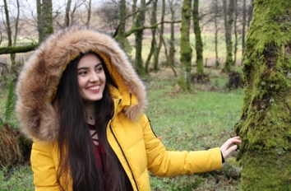 Bio: Ailsa is an 18-year-old female, she is a film & art student and has a general interest in Photography and Cinematics. She currently works in social media & marketing for a small company. However, she likes to broaden her horizons and have multiple streams of income.

|  |  |
| --- | --- |
| Age: 18 | Occupation: Student |
| Goals:   * Become an Oscar winning director; * Win photography awards; * Travel the world. | Motivations:   * Recognition; * Fear of failing; * Support from family. |
| Frustrations:   * Online university; * Expensive equipment; * RAW format. | Tech:   * Adobe lightroom; * Adobe photoshop; * MacBook Pro; * Sony A6000. |
| Favourites:   * KPOP music; * Korean language; * Anime. | Personality:  Passionate, extroverted, competitive, enjoys learning, and takes pride in what she does. |

Name: Kira McGrath

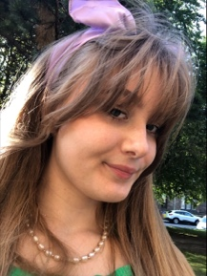

Bio: Kira is a 19-year-old female, she is a full-time student of Mathematics and Philosophy. She is interested in Cryptocurrencies and NFTs.

|  |  |
| --- | --- |
| Age: 19 | Occupation: Student |
| Goals:   * Become an actuary; * Having a good salary; * Travel to Iceland. | Motivations:   * Family; * Good academic performance; * Getting recognised for achievements. |
| Frustrations:   * Public transport; * Bad internet connection; * Social interaction. | Tech:   * Windows laptop; * Crypto wallet; * Digital watch. |
| Favourites:   * Metal music; * Korean cuisine; * Coffee. | Personality:  Introverted, pessimistic, enjoys travel, vivacious, scared of adulthood. |