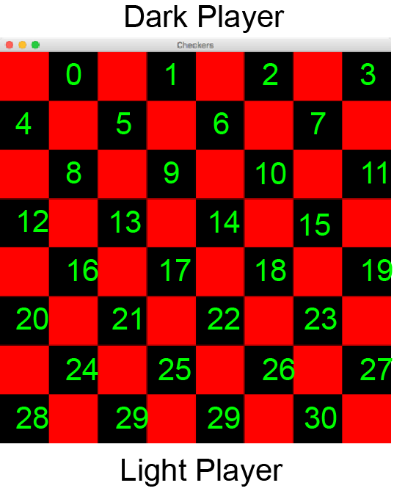

My Layout

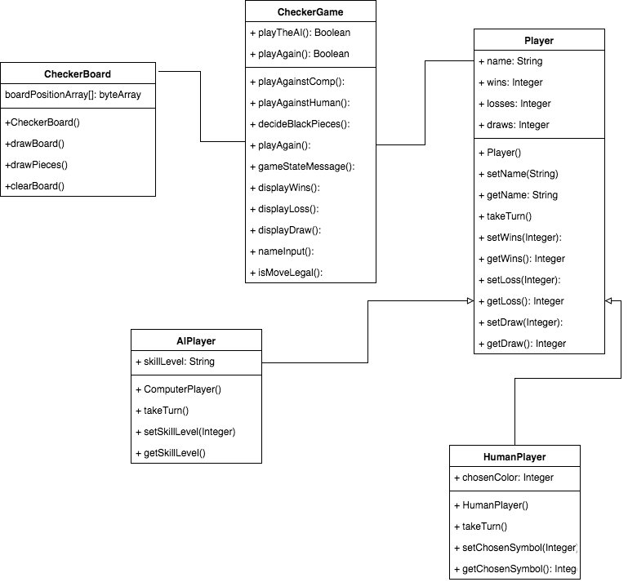

The board and it’s possible positions should be held in the boardPositionArray[].

•Collect and display the player names.

When the Game is started it should ask the user(s) to set the name by calling setName() and getName()

•Determine who moves first and gets assigned the black (dark) pieces.

The method in the CheckerGame class to decideBlackPieces() which should set and decide to chosenSymbol which will assign the pieces to the appropriate player

•Display a board with pieces the user can interact with if one or both players are human.

playAgainstComp() & playAgainstHuman() should redraw the board to allow needed interactions with players.

•Prevent illegal moves.

IsMoveLegal() should be called each time, takeTurn(which should take in currentPosition of the piece.) has been called to verify that the move is allowable and legal.

•Identify when there is a winner, loser, or if a draw has occurred. The goal of this challenge is to create a concept for a data model for the Checkers (Draughts) game.

setWin/setLoss/setDraw should determine if the games status and set the appropriate gameStatemessage() including the use of displayWin/loss/draw message in the case that the game has met that criteria.

A draw is considered when neither player can make any more moves, but neither has won.

A win is considered when one player has taken all of the other players pieces

A loss is when a player has lost all of his pieces to the other.