**Multi-Order Solar Extreme Ultraviolet Spectrograph**

**(MOSES)**

**FPGA Interface Board Design Document**

**Maintained by:**

**Justin Hogan**

Table of Contents

Connecting the JTAG Header to Xilinx Platform Cable USB-II Programmer 3

Connecting the JTAG Header to Xilinx Platform Cable USB-II Programmer

The FreeForm/PCI-104 board is connected to the Xilinx Platform Cable USB-II programmer using a flying-lead harness which adapts the 14-pin, 2-mm pitch header of the USB-II to the 7-pin, 2.54-mm (100-mil) pitch header on the FreeForm/PCI-104 board. The harness is manufactured by Xilinx and available as part number HW-USB-FLYLEADS-G. The cable connection between the two devices is shown in Table 1 below:

|  |  |  |  |
| --- | --- | --- | --- |
| **FreeForm/PCI-104 P2 Header** | | **HW-USB-FLYLEADS-G** | |
| **Pin Number** | **Signal Name** | **Pin Number** | **Signal Name** |
| 7 | 3.3V VREF | 1 | VREF |
| 6 | GND | 2 | GND |
| 5 | TCK | 4 | TCK |
| 1 | TRST | 5 | HALT |
| 4 | TDO | 6 | TDO |
| 3 | TDI | 7 | TDI |
| 2 | TMS | 9 | TMS |

Table 1: This table shows the pinouts of the JTAG connection between the FreeForm/PCI-104 FPGA board and a Platform Cable USB-II programmer.

Figure 1 shows the pinout numbering used for the HW-USB-FLYLEADS-G harness attached to the Platform USB-II device.

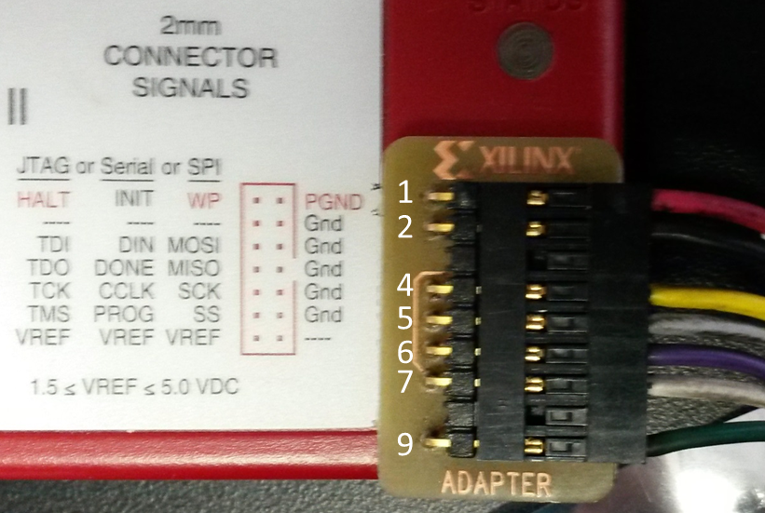

Figure : This figure shows the pin numbering convention used for determining the wiring between the Platform USB-II programmer and the seven pin JTAG header (P2) on the FreeForm/PCI-104 FPGA board.

Figure 2 shows the pin assignment for P2, the JTAG programming header located on the FreeForm/PCI-104 FPGA board.



Figure : This figure shows the pinout for the JTAG programming header on the FreeForm/PCI-104 FPGA board (P2).

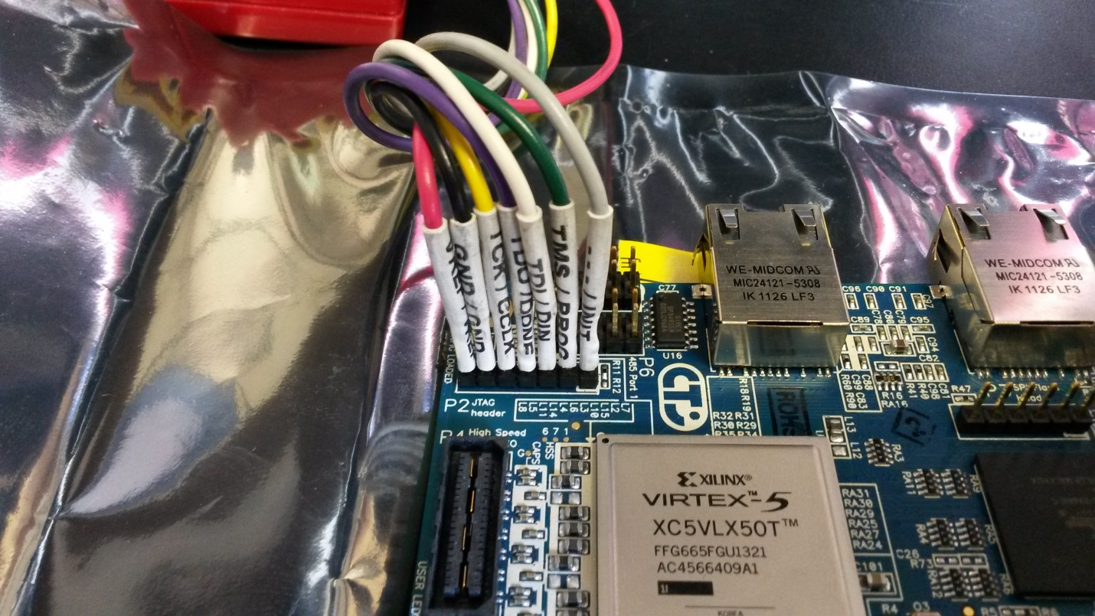

Figure : This figure shows the flying-lead harness attached to the FreeForm/PCI-104 FPGA board.

Finding the Tri-M VDX on the campus network

Run the Zenmap tool and execute the following command:

nmap -sn 153.90.122.0-255

search the results for (Tri-M Engineering / Nupak Dev.) computer and note the ip address

Setting up the JTAG Chain

