STI-EPI-FORECAST — Illustrated government handbook
This document supplements the comprehensive text handbook with embedded concept diagrams. Figures are generated for clarity in briefings; they are not live screenshots of the running app.
Project branding (logo):


Figure 1 — System architecture
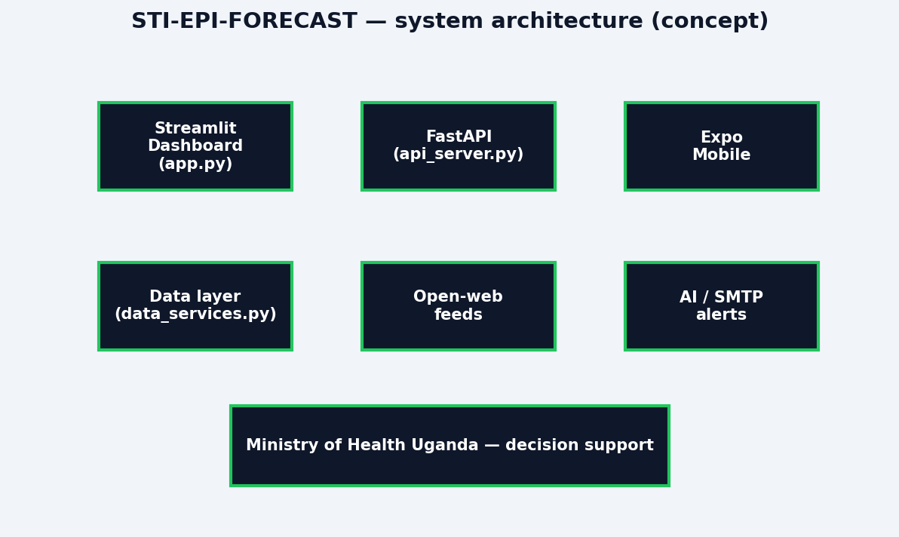
The Streamlit dashboard is the primary operator interface. FastAPI provides NLP alerts, forecasting, and OpenAI-compatible chat proxy endpoints. The Expo app mirrors key surveillance views.

Figure 2 — Open-web signal flow
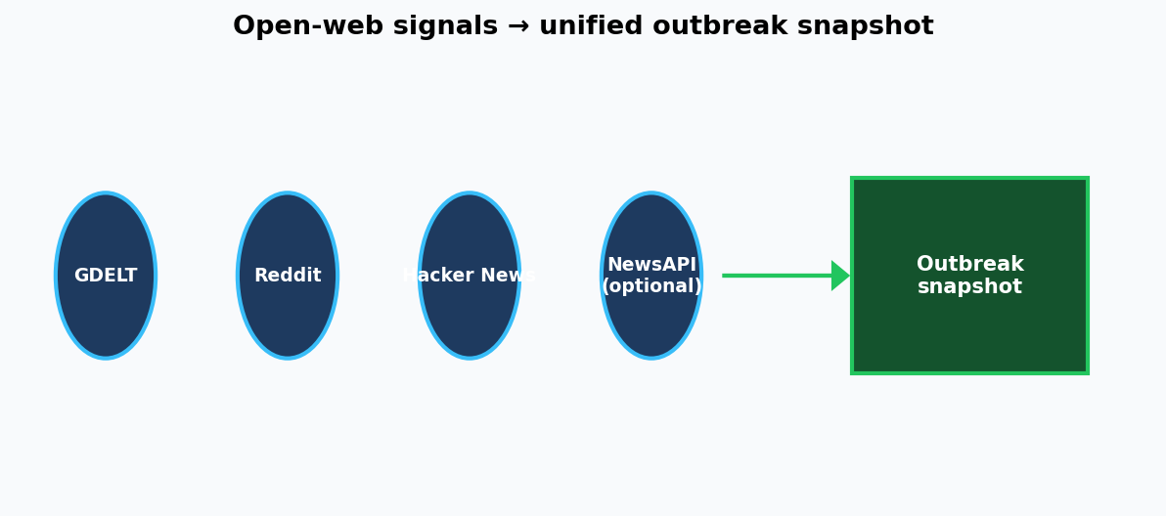
GDELT, Reddit public JSON, Hacker News Algolia, and optional NewsAPI contribute to a cached outbreak snapshot used across Dashboard, Global Surveillance, and Action Plan social views.

Figure 3 — Role workspace model
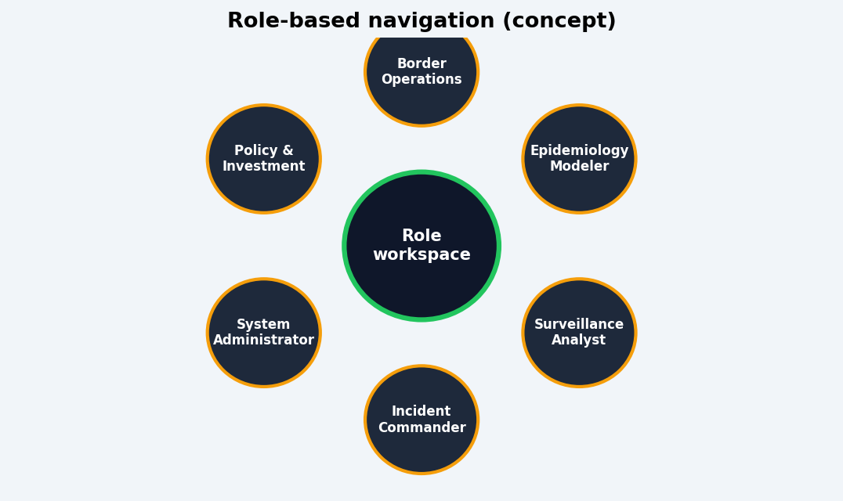
Six role profiles filter navigation so each user sees modules aligned with incident command, surveillance, modelling, border operations, policy, or platform administration.

Figure 4 — Admin email alert pipeline
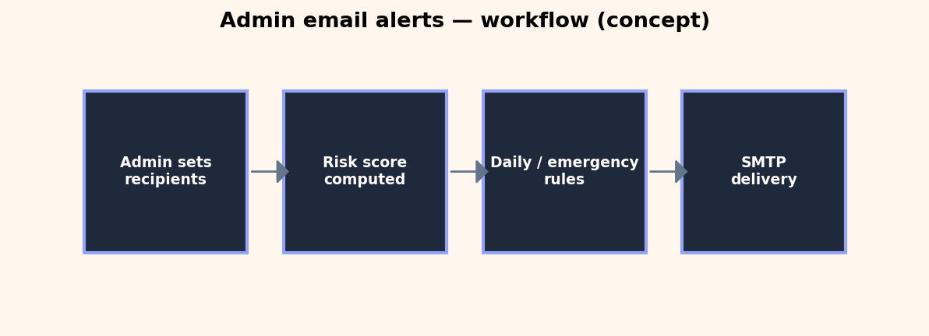
Administrators configure recipients and thresholds on the Admin page. The app evaluates risk periodically, sends scheduled daily summaries, and sends emergency alerts when the risk score exceeds the configured threshold, subject to cooldown. SMTP credentials are supplied via environment variables.

Figure 5 — Module map
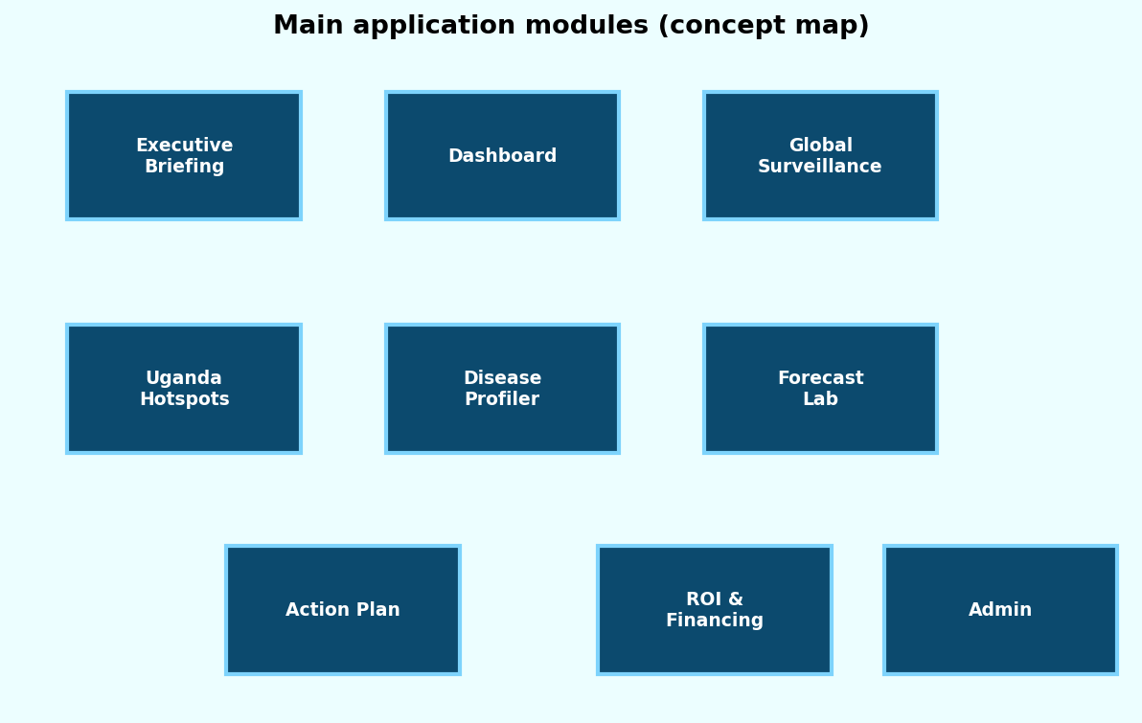
Core modules: Executive Briefing, Dashboard, Global Surveillance, Uganda Hotspots, Disease Profiler, Forecast Lab, Action Plan, ROI & Financing, and Administration.

How to capture real screenshots (optional)
For a fully photographic manual: run the Streamlit app locally, use Windows Snipping Tool or Win+Shift+S on each module, save PNG files, and insert them into this document using Word Insert → Pictures. Recommended captures: sidebar + Dashboard, Global Surveillance tabs, Action Plan tabs, Admin email panel, FastAPI /docs page, and Expo mobile home screen.

Deployment reminder
Streamlit Community Cloud: repository MosesLuzinda/STI-EPIFORECAST-DASHBOARD, branch main, main file app.py, with requirements.txt for dependencies. Configure secrets for AI keys, NewsAPI, and SMTP as needed.

