Implementation Architecture of a Custom ERP System Prepared for: Begal Farm Harvest (BFH) Date: August 2025 Prepared by: Analytics Business Centre
- Executive Summary This document outlines the software architecture and implementation structure of a tailored Enterprise Resource Planning (ERP) system designed for Begal Farm Harvest (BFH). The system consolidates operations into a unified platform, covering Finance, Inventory, Manufacturing, HR, Payroll, and Sales, ensuring:
- Full digitization of operational processes.
- Scalable and modular design for future growth.
- Real-time visibility into financials, inventory, and production.
- Farm-specific features such as poultry cycle management and feed cost tracking.
- Cloud-ready deployment for performance, availability, and data security.
- Technical Architecture 2.1 System Overview The ERP system follows a multi-layered architecture:
Layer | Technology Stack | Responsibilities
Frontend (Client Layer) | JavaScript, React, Bootstrap, REST API integration, Mobile Responsive Design | Provides dashboards, data entry forms, analytics, mobile access
Backend (Application Layer) | Python-based modular framework | Business logic, workflows, rules engine, API endpoints
Database Layer | MariaDB (SQL-based, ACID compliant) | Data persistence, transactions, reporting queries
Background Services | Redis | Task queues, notifications, reminders, job scheduling
Integration Layer | REST API, Webhooks | Connects with external apps (SMS, banking, payment systems, IoT sensors)
Security Layer | SSL/TLS, RBAC, OAuth2 | Authentication, access control, encryption
System Overview Diagram 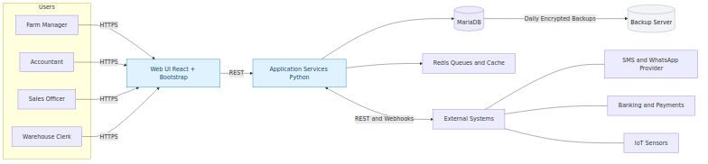
2.2 Backend (Application Layer) Technology Core: Python-based modular framework.
Architecture Style: Service-oriented modules (each app handles a domain such as Finance, HR, or Manufacturing).
Core Features:
- Business Logic Engine – Implements domain-specific rules (e.g., payroll formulas, cost of goods sold, depreciation).
- Workflow Manager – Automates approvals (purchase orders, leave requests, stock transfers).
- Background Workers – Uses Redis queues for sending emails, SMS alerts, automated reminders, and batch jobs.
- API Services – RESTful endpoints for web/mobile frontend, plus hooks for third-party systems (banking, messaging, IoT).
- Reporting Engine – Generates both tabular and graphical reports with drill-down capabilities.
2.3 Frontend (Client Layer) Technology Core: React + Bootstrap (responsive web), with optional mobile app wrapper.
Design Philosophy: Role-based, task-driven dashboards to minimize clutter.
Capabilities:
- Dashboards & KPIs – Visual charts for sales trends, feed costs, stock availability, payroll, and production efficiency.
- Forms & Transactions – User-friendly forms for creating invoices, recording expenses, stock entries, and payroll runs.
- Role-Based Views – Each user role (Farm Manager, Accountant, Sales Officer, Warehouse Clerk) only sees relevant menus, reports, and actions.
- Custom Reports Builder – End-users can filter, group, and export reports without developer intervention.
- Mobile-Responsive UI – Access via smartphones and tablets for field users.
2.4 Security Architecture Authentication: Enforced strong password policy; optional 2FA.
Authorization: Role-Based Access Control (RBAC) at document and field level.
Encryption:
- SSL/TLS for all web traffic.
- Encrypted backups using AES-256.
Audit Trail: Every record mutation logged with timestamp, user, and action for compliance.
Security Diagram 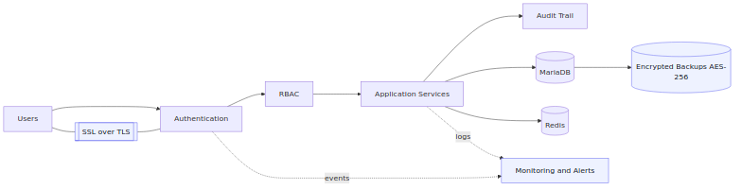
2.5 Deployment Architecture
Environment | Purpose | Hosting Option | Notes
Staging | Internal user acceptance testing | Cloud (DigitalOcean, or Private VM) | Mirrors production setup
Production | Live system for BFH staff | Cloud or On-Premise | Daily backups, high availability enabled
Deployment Diagram 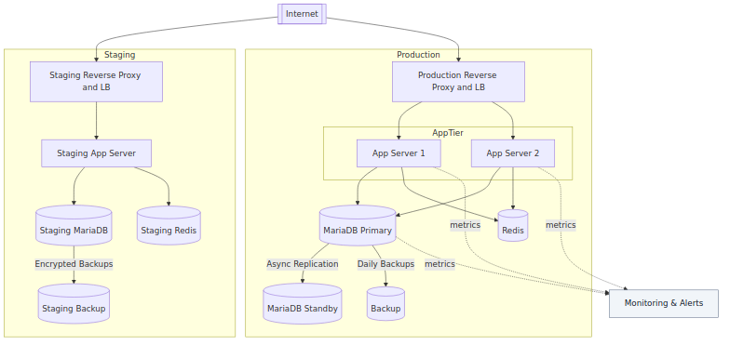
- Core Modules 3.1 Finance & Accounting Features: General Ledger, Chart of Accounts, Trial Balance, P&L, Balance Sheet, Bank Reconciliation.
Automation: Real-time posting from transactions (sales invoices, purchase bills, payroll).
Technical Note: SQL-driven reports, automated journal posting via backend service.
3.2 Inventory & Stock Features: Multi-warehouse management, stock transfers, item master, valuation methods (FIFO, Moving Average).
Batch & Serial Tracking: Supports poultry batch IDs, feed lot numbers.
Automation: Auto-reorder levels with system-generated Purchase Requests.
3.3 Manufacturing (Feed & Poultry Production) Feed Production:
- Define formulas (Bill of Materials).
- Generate Work Orders for production.
- Track actual vs. planned cost of feed.
Poultry Cycles:
- Track batches of birds.
- Record mortality and growth cycles.
- Calculate per-bird cost and profitability.
Technical Note: Backend BOM engine, costing algorithms, work order logic.
3.4 Sales & CRM Leads, Quotations, Sales Orders, Delivery Notes, Invoices.
Customer database with full transaction history.
Linked to Finance (AR) and Inventory (stock deduction).
3.5 HR & Payroll Employee master records.
Attendance, leave management, overtime tracking.
Payroll processor with salary structures and tax calculations.
Integration with Finance for automatic journal posting.
3.6 Reporting & Dashboards SQL-driven reports with configurable filters.
Graphical dashboards for management KPIs.
Export to Excel/PDF.
Process and Data Flow Diagram 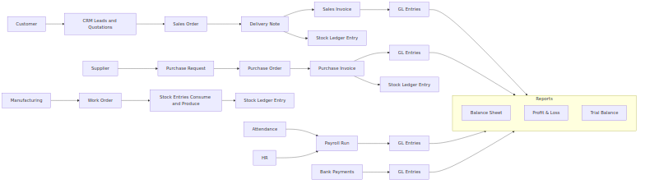
Data Model (High-Level) 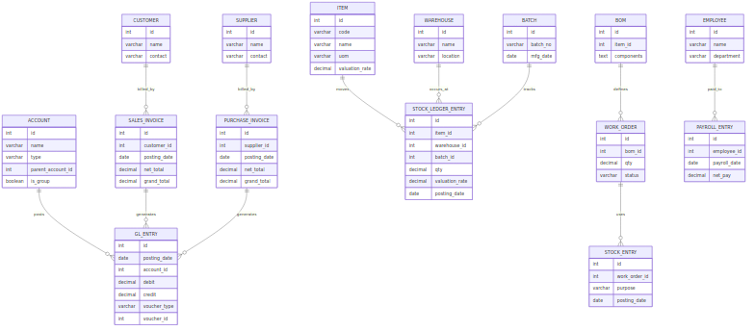
- Data Migration & Integration Legacy Data Import: Tools for Excel/CSV migration.
Transformations: Python scripts to map old accounts and normalize data.
External Integrations:
- Messaging (SMS/WhatsApp) for reminders.
- Testing & Quality Assurance Unit Testing: Automated validation of key backend functions (e.g., payroll calculation).
Integration Testing: Ensure cross-module consistency (e.g., Sales → Inventory → Finance).
User Acceptance Testing (UAT): In staging environment before rollout.
CI/CD Pipeline 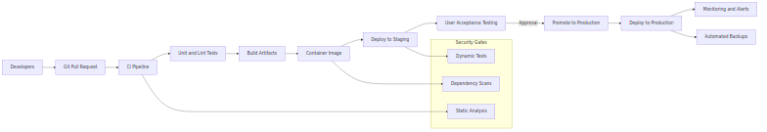
- Deployment & Maintenance Cloud/On-Premise Deployment depending on BFH’s preference.
Automated Daily Backups stored securely.
System Monitoring with alerts for downtime, errors, or unusual activity.
Ongoing Support with patches and module extensions as BFH grows.
- Implementation Timeline The following timeline assumes a 12–13 week delivery with overlapping workstreams to shorten elapsed time. Exact dates will be finalized during project kickoff.
Phase | Key Activities | Duration (elapsed) | Primary Owner | Outputs
Discovery & Planning | Process walkthroughs, scope finalization, success metrics, project plan | Week 1–2 | ABC + BFH | Signed scope, project plan, RACI
Environment & Security Setup | Staging & production environments, access control, backups, monitoring | Week 2–3 | ABC | Ready environments, backup & monitoring in place
Core Configuration | Finance, Inventory, HR/Payroll, Sales baseline setup; master data templates | Week 3–5 | ABC | Configured modules, data templates
Data Migration (Cycle 1) | Import CoA, Items, Customers, Suppliers, Opening Balances | Week 4–6 | ABC + BFH | Loaded masters & openings
Customizations & Reports | Forms, workflows, print formats, KPIs, role dashboards | Week 5–8 | ABC | Approved custom features & reports
Integrations | SMS/WhatsApp, payments/bank feeds, sensors (if in scope) | Week 6–8 | ABC | Working integrations
UAT (User Acceptance Testing) | Business scenario testing in Staging, defect fixes | Week 8–10 | BFH + ABC | UAT sign‑off
Training | Role-based training, quick reference guides | Week 9–10 | ABC | Trained users, training materials
Go‑Live | Production cutover, opening balances, final checks | Week 11 | ABC | Live system
Hypercare | On‑demand support, defect resolution, daily checks | Week 12–13 | ABC | Stabilized operations
- Costing (Budgetary Estimate) All figures are indicative in USD and will be refined after Discovery. Currency can be adjusted.
One‑Time Implementation
Item | Description | Amount (USD)
Discovery & Planning | Workshops, process mapping, delivery plan | 2,000
Environment & Security Setup | Staging/Prod setup, backups, monitoring | 1,500
Core Configuration | Finance, Inventory, HR/Payroll, Sales | 3,000
Data Migration (up to agreed volumes) | Masters, openings, one trial + one final load | 2,500
Customizations & Reports | Forms, workflows, 6 reports/prints included | 4,000
Integrations (basic) | SMS/WhatsApp, banking/payment gateway | 1,500
Training | 2 role-based sessions + materials | 1,500
Go‑Live & Hypercare (2 weeks) | Cutover support and stabilization | 1,500
Contingency (approx. 10%) | Risk reserve | 1,500
Total One‑Time |  | 19,000
Recurring (Monthly)
Item | Description | Amount (USD/Month)
Cloud Hosting & Backups | Compute, storage, encrypted backups | 200
Monitoring & Alerts | Availability and error alerts | 50
Support SLA (Business Hours) | Incident handling, minor changes | 300
Estimated Monthly Total |  | 550
Assumptions & Exclusions
- Data migration includes one trial and one final load; additional cycles billed T&M.
- Up to 6 reports/print formats included; extras estimated separately.
- Third‑party fees (SMS credits, payment gateway, bank APIs) are billed by providers.
- On‑site travel (if requested) billed at cost.
- Production scale sized for typical BFH usage; significant scale‑up may change hosting.
Commercial Terms (Sample)
- Payment Milestones: 40% on kickoff, 40% at UAT sign‑off, 20% at go‑live.
- Invoices due net 15 days. Prices exclude taxes.

