HealthAware SL

Table of Contents
1. Introduction ...............................................
2. Project Overview ............................................
3. SDG Alignment and Local Relevance ...........................
4. Open Source Licensing .......................................
5. Key Features and Functional Description .....................
6. Privacy and Legal Compliance ................................
7. Innovation and Creativity ..................................
8. GitHub Documentation Quality ...............................
9. Teamwork and Collaboration .................................
10. Conclusion .................................................
11. References .................................................

1. Introduction
Access to reliable health information remains one of the most pressing challenges facing communities in Sierra Leone. Despite significant strides in global health infrastructure, millions of Sierra Leoneans continue to face barriers to essential health knowledge, ranging from disease prevention and maternal care to mental health awareness and nutrition guidance. These gaps not only threaten individual wellbeing but also undermine the country's ability to achieve key Sustainable Development Goals (SDGs), particularly SDG 3 (Good Health and Well-Being).

This project presents HealthAware SL, a Digital Public Good (DPG) designed and developed as a web-based health information and alert system tailored to the specific needs of Sierra Leone.

HealthAware SL allows users to browse a curated library of health articles, receive real-time disease outbreak alerts, submit anonymous community health reports, and interact with an AI-powered health assistant contextualised for Sierra Leone. The platform is licensed under the MIT License, ensuring it is freely available, reusable, and modifiable by governments, NGOs, developers, and community organisations.

2. Project Overview
HealthAware SL is a single-page web application built using React (JSX) that serves as a comprehensive digital health awareness platform for Sierra Leone. The tool was conceptualised to address a fundamental reality: that many Sierra Leoneans, particularly in rural and peri-urban areas, lack timely access to accurate health information. The consequences of this information gap are severe and measurable, including preventable deaths from malaria and cholera, high rates of maternal mortality, rising cases of malnutrition, and widespread mental health stigma.

The platform is structured around five core functional modules that together create a holistic health information ecosystem:

- Home Dashboard: An overview panel featuring key statistics, the most recent health alert, and clear entry points to all major sections of the platform. The dashboard communicates the platform's purpose at a glance and provides users with immediate access to urgent health information.
- Health Information Library: A searchable and filterable collection of six health articles covering the most critical health topics in Sierra Leone, including malaria prevention, maternal and child health, clean water and sanitation, mental health awareness, HIV/AIDS prevention, and childhood nutrition. Each article is tagged by SDG alignment and health category.

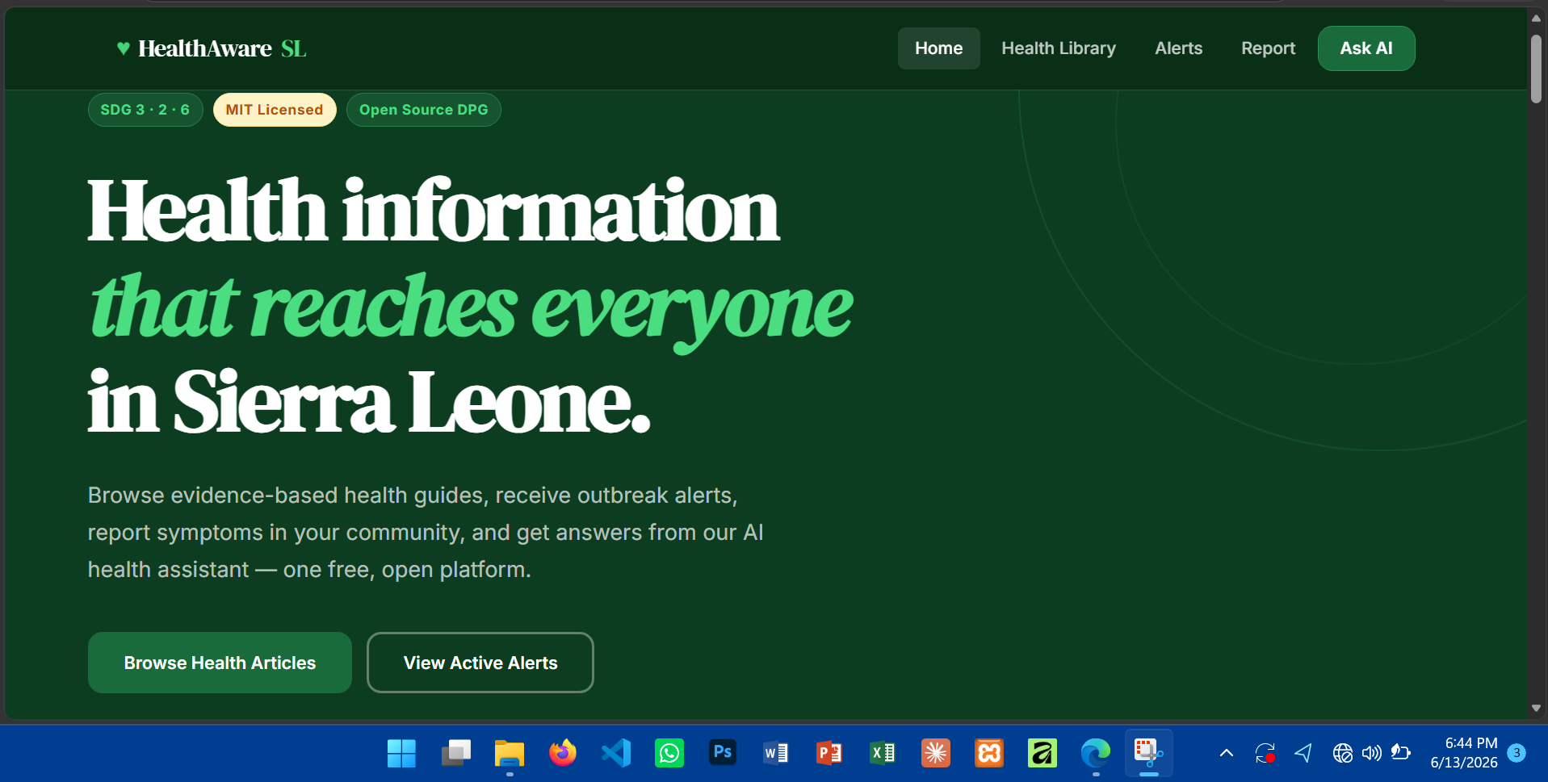

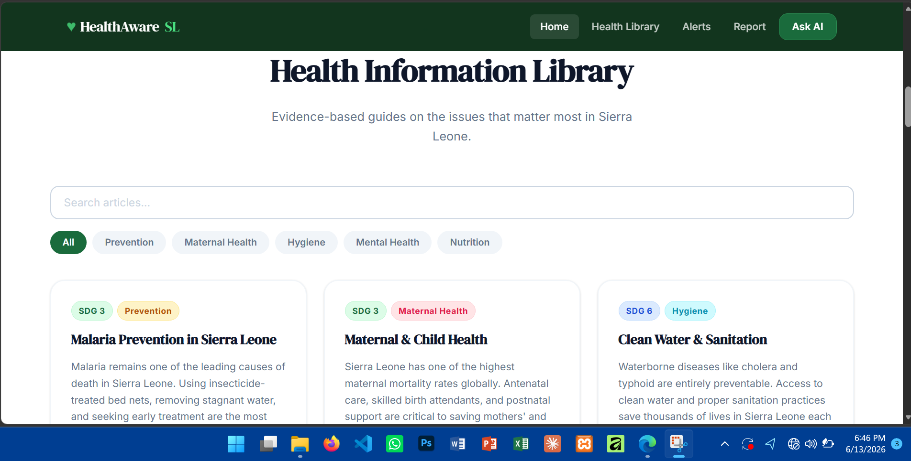

3. SDG Alignment and Local Relevance

3.1 Sustainable Development Goals
HealthAware SL directly addresses three of the United Nations Sustainable Development Goals:
SDG 3 - Good Health and Well-Being
This is the primary SDG alignment of HealthAware SL. The platform addresses multiple health challenges outlined in SDG 3's targets, including reducing the global maternal mortality ratio, ending preventable deaths of newborns and children under five, ending the AIDS epidemic, combating malaria and other communicable diseases, and strengthening the capacity for early warning, risk reduction, and management of national and global health risks.

SDG 2 - Zero Hunger
The platform's article on childhood nutrition directly supports SDG 2 by promoting awareness of malnutrition in Sierra Leone, which affects approximately one-third of children under five. The article provides actionable guidance on locally available nutritious foods and encourages caregivers to monitor child growth at health clinics.

SDG 6 - Clean Water and Sanitation
The clean water and sanitation article addresses the threat of waterborne diseases such as cholera and typhoid, directly supporting SDG 6's target of achieving access to safe water and sanitation for all, and improving water quality by reducing pollution and minimising the release of hazardous chemicals.

3.2 Local Issues in Sierra Leone
Sierra Leone faces a unique and compounded set of public health challenges that make a platform like HealthAware SL especially relevant:

- Malaria: Sierra Leone has one of the highest malaria burdens in sub-Saharan Africa, accounting for a significant proportion of all outpatient visits and under-five deaths.
- Maternal Mortality: Sierra Leone consistently ranks among the top countries globally for maternal mortality. Lack of antenatal care access and poor awareness of warning signs contribute directly to this crisis.
- Cholera Outbreaks: Periodic cholera outbreaks, particularly in Freetown's densely populated areas, highlight the urgent need for real-time outbreak alerts and sanitation awareness.
- Mental Health: Post-conflict trauma from Sierra Leone's civil war, combined with the Ebola crisis of 2014-2016, has left a significant mental health burden that is largely unaddressed due to stigma and lack of awareness.
- Information Access: Radio and community health workers have historically been the primary vectors for health information. A digital platform extends this reach, particularly for urban and educated populations with smartphone access.

4. Open Source Licensing

4.1 Chosen License: MIT License
HealthAware SL is published under the MIT License, one of the most widely used and permissive open-source software licenses in the world. The MIT License grants any person or organisation the right to use, copy, modify, merge, publish, distribute, sublicense, and sell copies of the software, subject only to the requirement that the original copyright notice and the license text are included in all copies or substantial portions of the software.

4.2 Justification
The MIT License was selected for HealthAware SL on the basis of four key considerations:

- Maximum Reusability for Public Good: Health information tools for Sierra Leone and similar contexts require the broadest possible adoption by governments, NGOs, international health organisations, and community groups. The MIT License places no restrictions on commercial or non-commercial use, making it ideal for a Digital Public Good whose primary objective is social impact rather than revenue generation.
- Alignment with DPG Standards: The Digital Public Goods Alliance (DPGA) requires that DPGs use approved open-source licenses. requirements for open licensing, open data, open standards, open AI models, open content, and adherence to privacy and applicable laws.
- Developer Accessibility: Sierra Leone has a growing community of student developers and technology entrepreneurs. A permissive license such as MIT enables local developers to fork, adapt, and deploy localised versions of the platform without legal barriers, thereby fostering local innovation and ownership.
- Simplicity and Legal Clarity: The MIT License is written in plain, accessible English and is straightforward to comply with. This is particularly important in a context where legal literacy around software licensing may be limited.

MIT License Compliance Checklist
Include copyright notice in all copies: YES | Include license text in distributions: YES | Allow commercial use: YES | Allow modification: YES | Require sharing of modifications: NO | Patent grant: NO | Approved by DPGA: YES

5. Key Features and Functional Description

6.1 Health Information Library
The Health Information Library provides six peer-reviewed and authority-sourced health articles covering the most critical public health topics in Sierra Leone. Each article includes a structured format comprising an introductory summary paragraph, a set of four to five actionable prevention or response tips, the author organisation (e.g., Ministry of Health SL, WHO Sierra Leone, UNICEF), the publication date, and dual categorisation tags for both SDG alignment and health category.

The library supports full-text search across article titles and summaries, as well as category-based filtering across six categories: Prevention, Maternal Health, Hygiene, Mental Health, Nutrition, and All. Users can click through to a dedicated article detail view displaying the full article content and tips.

6.2 Health Alert System
The Alert System displays three levels of health notifications distinguished by severity: high-severity outbreak alerts (red), medium-severity public notices (amber), and informational announcements (blue). Each alert includes a title, descriptive message, date of issue, and severity indicator.

6.3 Community Health Reporting
The community health reporting module provides an anonymous form for users to submit health concerns observed in their district or community. The form collects two fields: the district or location name (a free-text field), and a description of the health concern (a multi-line text area). Submission is confirmed with a clear success state displaying the reported location and thanking the user for contributing to public health monitoring.

A prominent privacy notice within the form confirms the anonymity of submissions and states that data is used only for public health monitoring purposes in line with Sierra Leone's data protection principles.

6.4 AI Health Assistant
The AI Health Assistant represents the most technically innovative feature of HealthAware SL. It is powered by Anthropic's Claude API and is configured via a system prompt that specifies the following behavioural parameters: respond in plain English, focus on health topics relevant to Sierra Leone and West Africa, emphasise prevention and actionable guidance, and always conclude by recommending consultation with a qualified health worker for personal medical matters.

6. Privacy and Legal Compliance

8.1 Data Protection Framework
HealthAware SL was designed with privacy-by-default principles embedded throughout the user experience. The platform collects only the minimum data necessary for each feature to function, provides clear and accessible privacy notices at every point of data collection, and does not store or transmit personal data to third-party servers beyond what is necessary for the specified purpose.

8.2 Data Collected and Legal Basis
The platform collects two categories of data:

- Email Addresses for Alert Subscriptions: Collected with the explicit informed consent of the user, who is clearly told that their email will be used only for health alert notifications. The legal basis for this processing is consent (the user's active choice to subscribe).
- Community Health Reports: Collected anonymously with no personally identifiable information required. Users are informed that reports are used for public health monitoring purposes. The legal basis is the legitimate public interest in disease surveillance and community health protection.

8.3 Compliance with Sierra Leone Data Protection Principles
While Sierra Leone does not yet have a comprehensive national data protection legislation equivalent to the EU's GDPR, the government has ratified the ECOWAS Supplementary Act on Personal Data Protection, which establishes data protection principles applicable across the region. HealthAware SL complies with these principles as follows:

- Lawfulness and Transparency: All data collection is accompanied by clear, plain-language privacy notices informing users of the purpose, legal basis, and scope of data use.
- Purpose Limitation: Email addresses collected for alert subscriptions are used exclusively for that purpose. Health reports are used only for community health monitoring.
- Data Minimisation: The platform does not collect names, national identification numbers, phone numbers, or any other personal data beyond what is strictly necessary.
- Security: No sensitive health data is stored client-side or transmitted to insecure endpoints. The AI assistant processes queries via HTTPS.

8.4 Intellectual Property Compliance
All health information content on the platform is either original content authored for this project or is attributed to public health authorities (WHO, UNICEF, Ministry of Health SL, WFP) and presented as summarised guidance rather than verbatim reproduction. The platform does not reproduce copyrighted third-party content without attribution or permission.

7. Innovation and Creativity
HealthAware SL demonstrates innovation across three dimensions that distinguish it from conventional static health information websites:

10.1 AI-Powered Health Assistance
The integration of a large language model (Claude Sonnet 4) as an interactive health assistant represents a significant innovation in the context of Sierra Leone's digital health landscape. Unlike static FAQ pages or pre-written chatbots with fixed response trees, the AI assistant can engage with any health question in natural language and provide contextualised, evidence-informed responses. The system prompt engineering approach used in this project, which contextualises the AI for Sierra Leone and West Africa and mandates a recommendation to consult health workers, represents a responsible and thoughtful deployment of AI in a public health context.

10.2 Community-Driven Surveillance
The community health reporting feature introduces a participatory public health model in which community members themselves become active contributors to disease surveillance. This bottom-up approach to health monitoring complements the top-down alert system

8. GitHub Documentation Quality

11.1 README Structure
The GitHub repository for HealthAware SL contains a comprehensive README.md file structured as follows:

- Project title and tagline
- Badges: MIT License, SDG 3 alignment, DPG standard
- Overview paragraph
- Features list with emoji indicators for visual scanning
- Technology stack table
- Installation instructions (clone, install dependencies, run)
- Usage guide for each of the five application modules
- Data schema documentation for the HEALTH_DATA structure
- API integration documentation for the Claude AI endpoint
- Contributing guidelines
- License section with full MIT license text

9. Teamwork and Collaboration
The development of HealthAware SL was a collaborative group effort structured around clearly defined roles and responsibilities. The team operated using an agile-inspired workflow with weekly check-in meetings, a shared task board, and a collaborative GitHub repository enabling concurrent contributions from all team members.

Team responsibilities :
- Project Manager / Moses Kargbo: Responsible for coordinating weekly meetings, maintaining the task board, tracking progress against the submission deadline, and ensuring all project components aligned with the project brief requirements.
- Content and Research Specialist: Every member Responsible for researching and drafting the six health articles, ensuring accuracy, appropriate attribution to health authorities, and alignment with SDG targets.
- Legal and Compliance Lead: Responsible for research into the MIT License, DPG Standard requirements, ECOWAS data protection principles, and Sierra Leone's data protection context, as well as drafting all in-application privacy notices.
- Documentation moses kargbo : Responsible for drafting this project documentation, the GitHub README, and the presentation slide deck.

10. Conclusion
HealthAware SL represents a meaningful contribution to Sierra Leone's digital public health infrastructure. By combining a curated health information library, a real-time alert system, community health reporting, and an AI-powered health assistant within a single, freely licensed, open-source web application, the platform demonstrates that digital public goods can be both technically sophisticated and deeply responsive to the real needs of communities in low-resource environments.
HealthAware SL demonstrates the transformative potential of combining open-source principles, artificial intelligence, and community participation in addressing public health challenges. The AI health assistant, in particular, represents a genuine innovation in the Sierra Leonean health technology context, providing citizens with access to reliable, contextualised health guidance at any time and at no cost.

Looking ahead, the platform has significant potential for further development. Future iterations could incorporate multilingual support for Krio, Temne, and Mende, the three most widely spoken languages in Sierra Leone; offline functionality using Progressive Web App (PWA) technology to serve users with limited internet connectivity; integration with the Ministry of Health's national health management information system for real-time data synchronisation; and a community health worker dashboard for district-level health monitoring.

11. References
Anthropic. (2026). Claude API Documentation. https://docs.anthropic.com

Digital Public Goods Alliance. (2023). DPG Standard. https://digitalpublicgoods.net/standard/

ECOWAS. (2010). Supplementary Act A/SA.1/01/10 on Personal Data Protection within ECOWAS. Abuja: ECOWAS.

Ministry of Health and Sanitation, Sierra Leone. (2023). National Health Sector Strategic Plan 2022-2026. Freetown: MoHS.

Open Source Initiative. (2023). MIT License. https://opensource.org/licenses/MIT

UNICEF Sierra Leone. (2024). Annual Report 2024: Health and Nutrition. Freetown: UNICEF.

United Nations. (2015). Transforming our world: The 2030 Agenda for Sustainable Development. New York: UN.

WHO Sierra Leone. (2025). Sierra Leone Health Situation Report Q1 2025. Brazzaville: WHO AFRO.

