
YVONNE MOSETI
BSCCS/2024/74596
COMPUTER SCIENCE

BIT4138 Advanced Cryptography

LECTURER MICHAEL NYORO
3RD YEAR SECOND SEMESTER
Practical Logbook

Table of Contents
Table of Contents 2
Week 1: Cryptography Development Environment Setup 3
Installation and Configuration of the Advanced Cryptography Toolchain 3
Week 2: Classical Cryptography — Cipher Design and Comparison 6
Implementation of Caesar Cipher and Vigenère Cipher with Comparative Analysis 6
Week 3: Stream Ciphers and Pseudorandom Sequence Analysis 11
Implementation of LFSR, RC4 Simulation, and Statistical Randomness Testing 11
Week 4: Stream Cipher Cryptanalysis and Berlekamp-Massey Attack 17
Applying the Berlekamp-Massey Algorithm to Recover LFSR Structure from Output Sequences 17
Week 5: Block Ciphers and Feistel Structure Simulation 23
Design and Implementation of a Feistel-Based Block Cipher with Avalanche Effect Analysis 23
Week 6: Symmetric Ciphers II – Substitution-Permutation Networks (SPN), S-Boxes and Non-Linearity 29
Design and Implementation of a Simple SPN with Non-Linearity Analysis 29
Figure 1: SPN Python implementation showing the SBOX lookup table, PBOX permutation table, and substitute() function used to perform nibble-level substitution on 16-bit plaintext blocks. 29
Figure 2: Terminal output showing step-by-step round results after running spn.py displaying the input block, binary and hexadecimal values after substitution and permutation in Round 1, and after substitution in Round 2. 30
Figure 3: Final RESULTS section of the terminal output showing the original plaintext alongside the computed ciphertext in both hexadecimal and binary format after two complete SPN rounds. 30
Figure 4: VS Code view of the SBOX array definition at the top of spn.py. 31
Figure 5: Terminal output of showing a structured table comparing Feistel Network and SPN structures across block operation, core components, decryption method, example ciphers, and diffusion approach. 31
Week 7: Block Cipher Cryptanalysis Differential Cryptanalysis, Linear Cryptanalysis and Algebraic Attacks 33
Cryptanalytic Techniques Against Block Ciphers 33

Week 1: Cryptography Development Environment Setup

Installation and Configuration of the Advanced Cryptography Toolchain
Practical Evidence
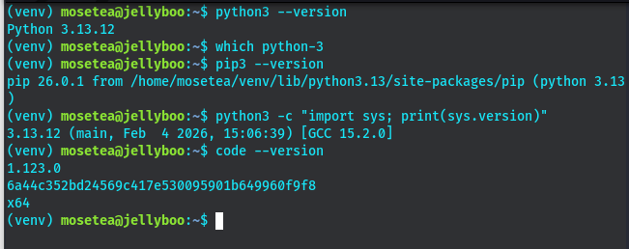
Figure 1: Python 3 installation confirmation showing version number and pip availability in the terminal
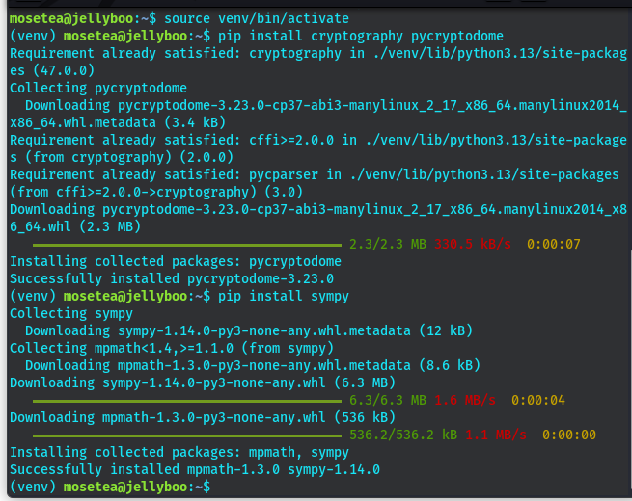
Figure 2: VS Code environment with the cryptography library successfully installed via pip, confirming zero errors.
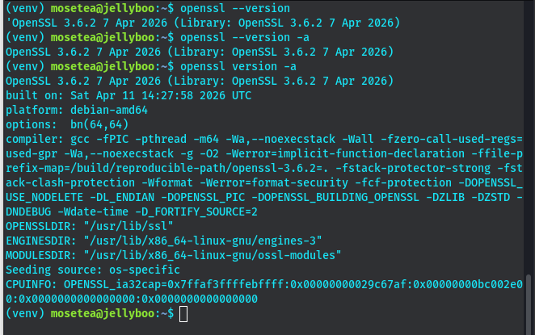
Figure 3: OpenSSL version command output confirming successful installation and readiness for certificate and key operations.
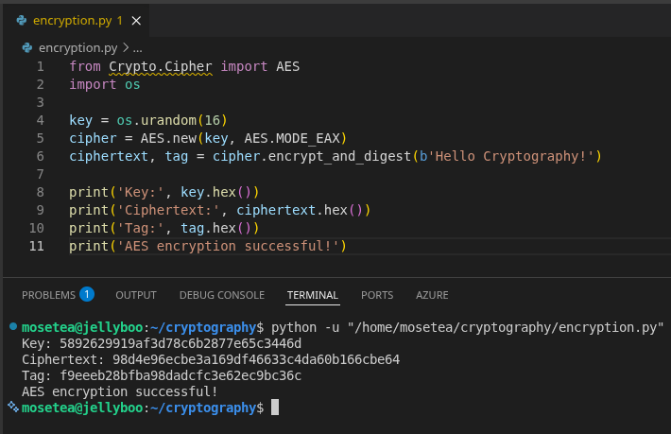
Figure 4: Execution of a basic Python AES encryption test script demonstrating that the cryptographic library is functional.
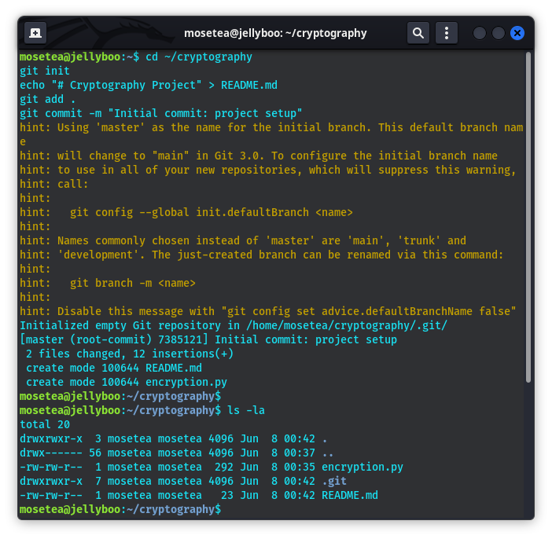
Figure 5: GitHub repository initialisation showing the first commit with a README file and project folder structure.

Week 1 Reflection
In week one I successfully configured the development environment. Python 3, VS code, PyCryptodome and OpenSSL installed and verified.
The AES encryption script confirmed full library functionality and I initialized a github repository with a README and structure thats ready for practical coursework.

Week 2: Classical Cryptography — Cipher Design and Comparison

Implementation of Caesar Cipher and Vigenère Cipher with Comparative Analysis

Practical Evidence
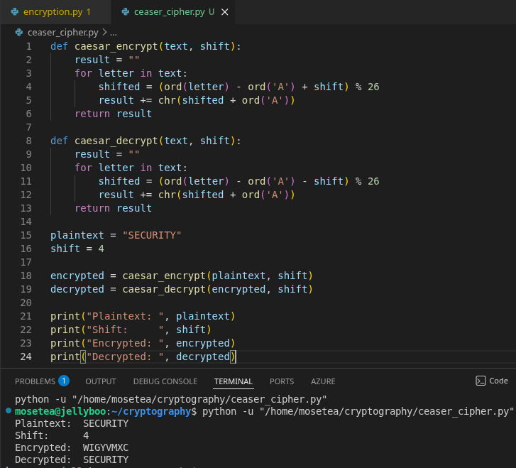
Figure 1: Caesar Cipher Python implementation showing encryption and decryption of 'SECURITY' with shift value 4.
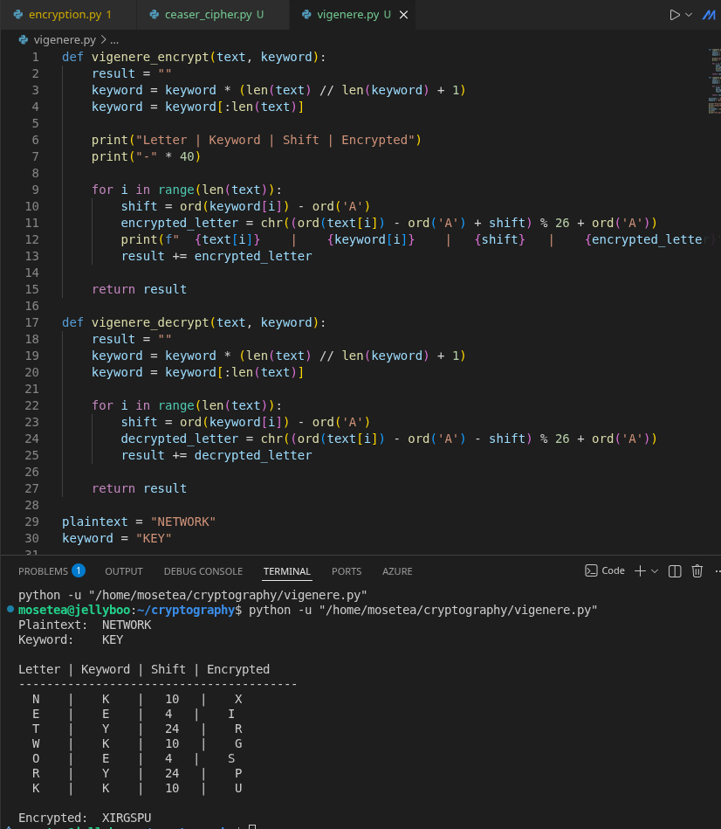
Figure 2: Vigenère Cipher Python program encrypting 'NETWORK' using keyword 'KEY', displaying intermediate keystream alignment.

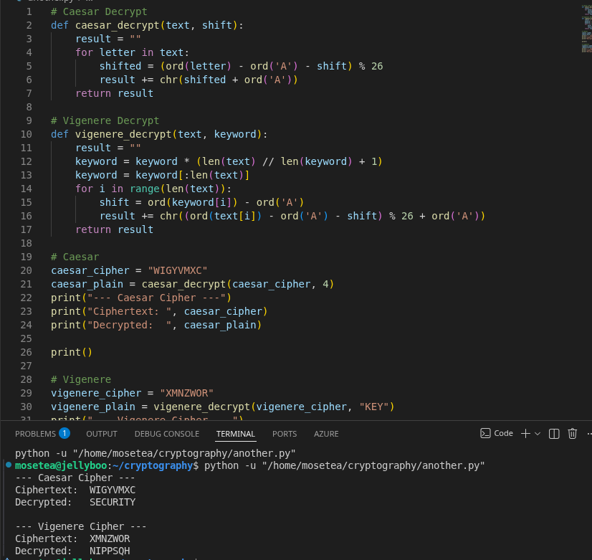
Figure 3: Successful decryption output for both ciphers confirming that the original plaintext is correctly recovered.

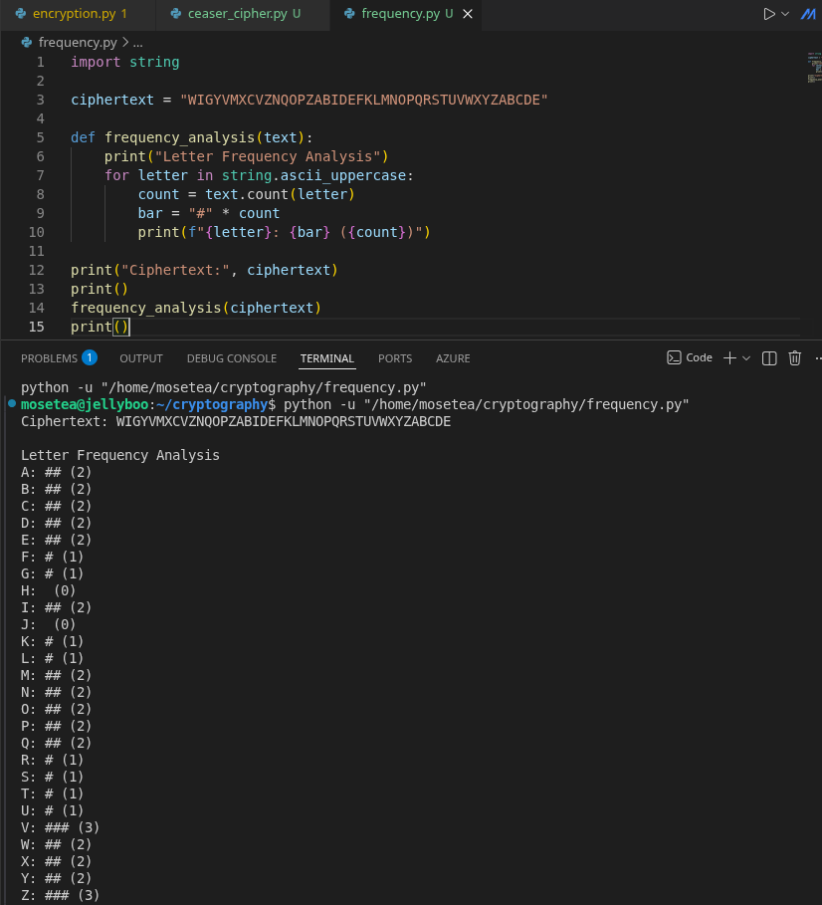
Figure 4: Frequency analysis output on a sample ciphertext demonstrating the statistical vulnerability of the Caesar Cipher.

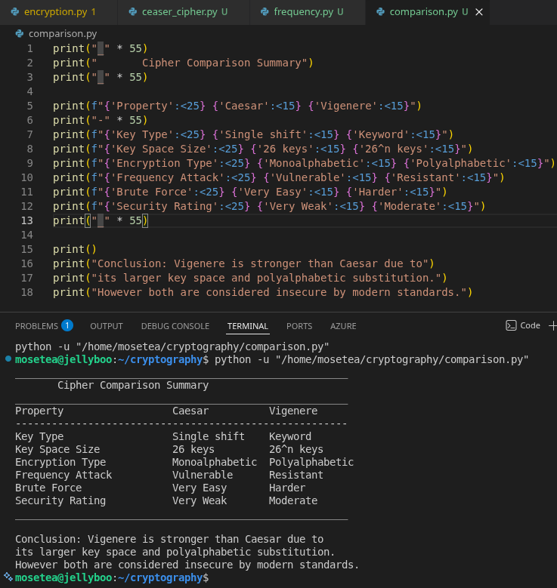
Figure 5: Cipher comparison summary table generated by the Python script showing key space size, attack resistance, and security rating.

Week 2 reflection
Caesar and Vigenère ciphers were implemented and tested in Python. Frequency analysis exposed the Caesar cipher's predictability due to its single shift key space. The Vigenère cipher showed improved resistance through polyalphabetic substitution, though it remains vulnerable when the keyword is short.

Week 3: Stream Ciphers and Pseudorandom Sequence Analysis

Implementation of LFSR, RC4 Simulation, and Statistical Randomness Testing
Practical Evidence
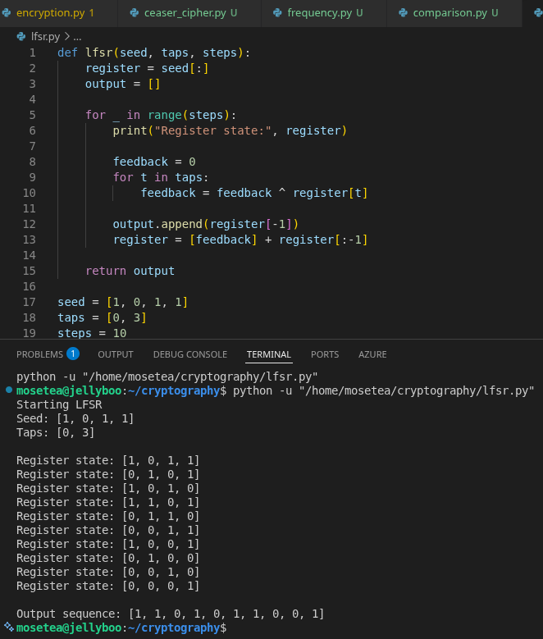
Figure 1: LFSR generator Python implementation showing register state transitions and the resulting binary output sequence.
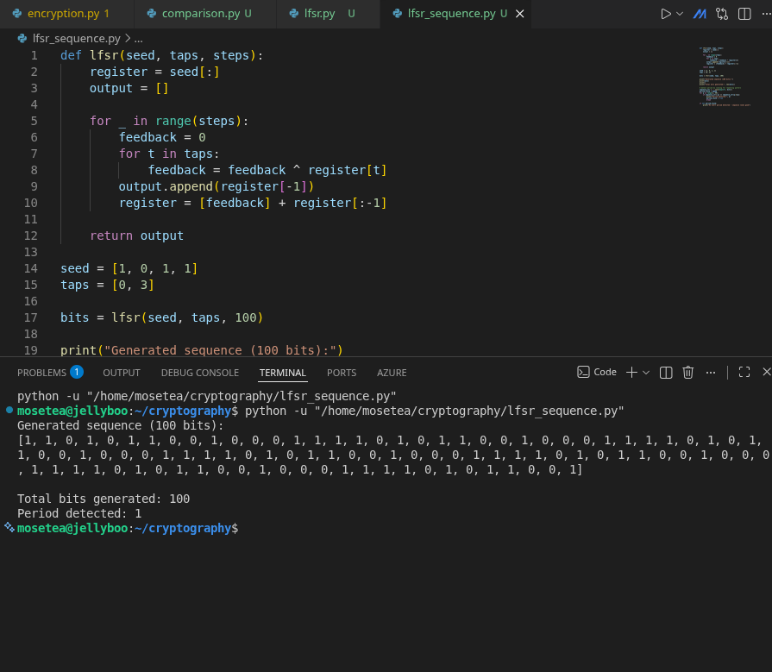
Figure 2: Pseudorandom binary sequence of 100+ bits generated by the LFSR, with period detection output displayed in the terminal.

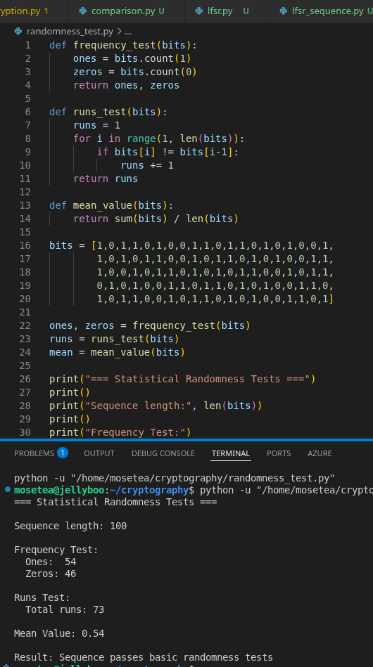
Figure 3: Statistical randomness test results showing frequency distribution, runs count, and mean value for the generated sequence.

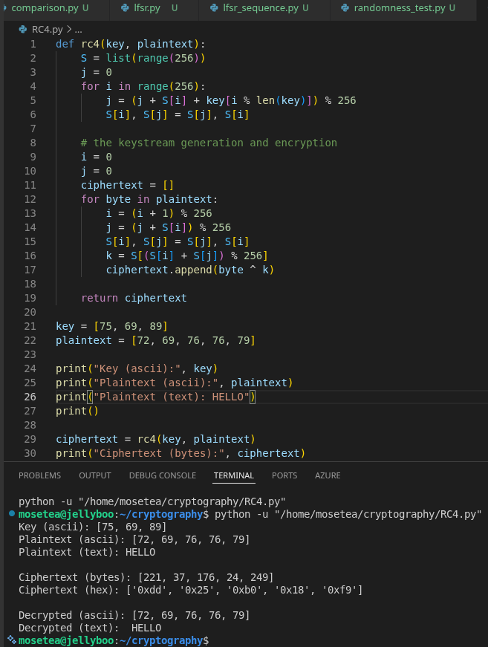
Figure 4: RC4 stream cipher simulation encrypting a plaintext message and producing XOR-derived ciphertext output.
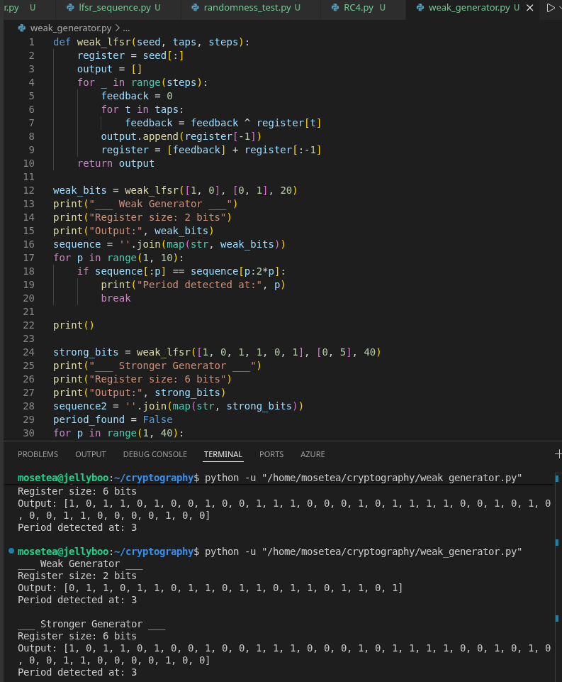
Figure 5: Weak generator analysis output showing how a short period and predictable repetition compromise stream cipher security.

Week 3 reflection
In week 3 I implemented an LFSR generator and RC4 stream cipher in python. Thetests confirmed acceptable frequency distribution and ran well for a well-configured generator. The weak generators with small registers produced short, repeating periods, showing how poor design makes stream ciphers easy to predict and attack.

Week 4: Stream Cipher Cryptanalysis and Berlekamp-Massey Attack

Applying the Berlekamp-Massey Algorithm to Recover LFSR Structure from Output Sequences
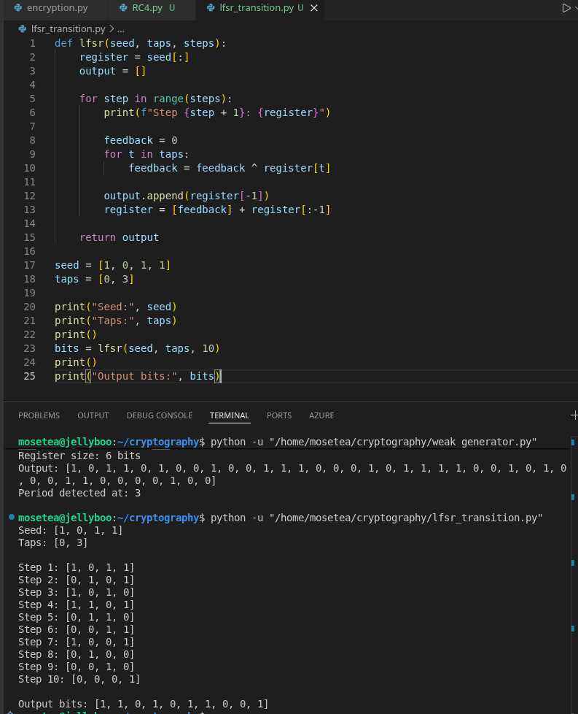
Figure 1: LFSR sequence generator with configurable tap positions and initial state, displaying step-by-step register transitions.
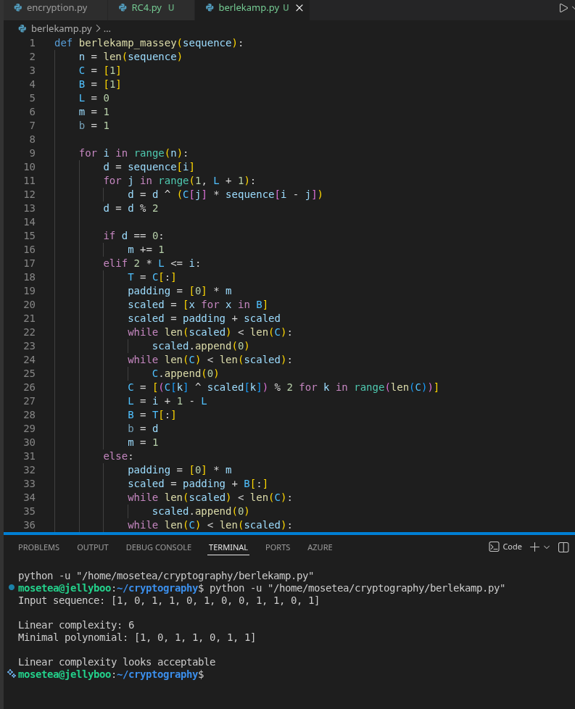
Figure 2: Berlekamp-Massey algorithm output showing the recovered minimal polynomial and linear complexity value for a test sequence.

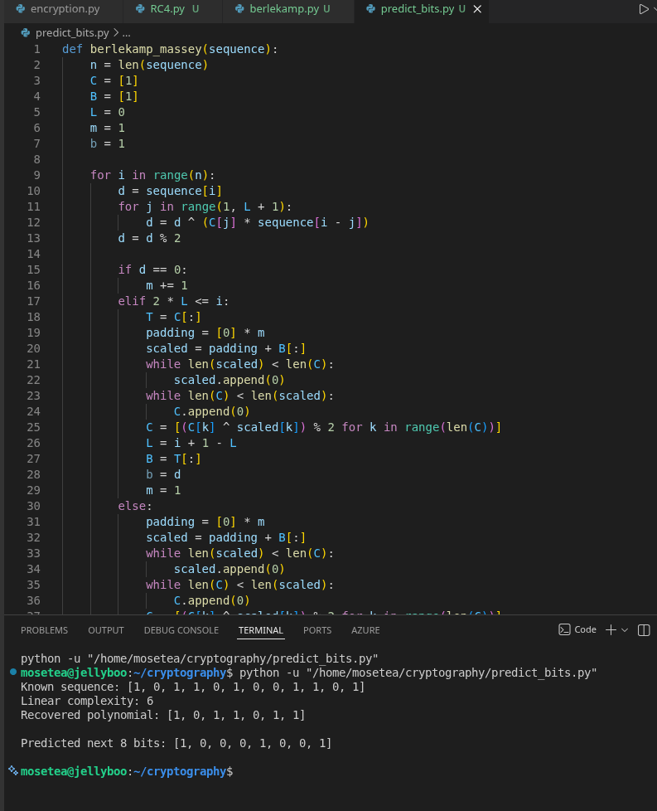
Figure 3: Demonstration of sequence predictability — future bits correctly predicted after applying the recovered recurrence relation.

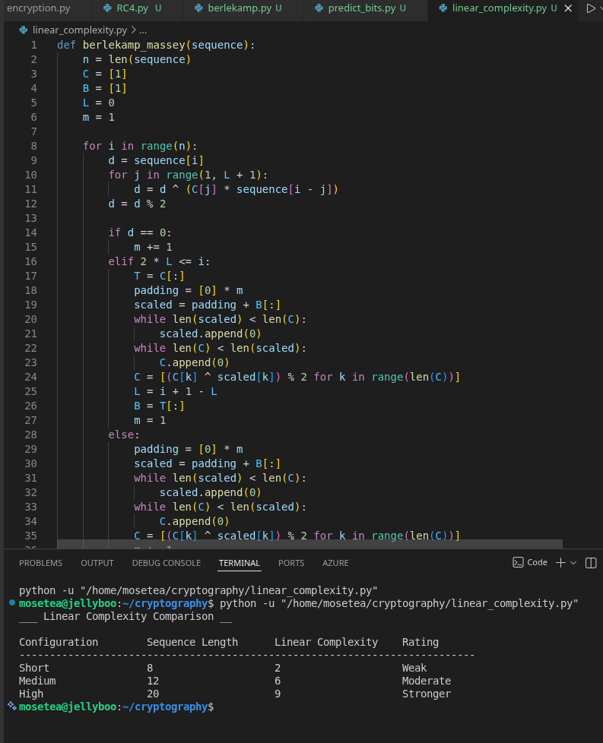
Figure 4: Linear complexity comparison chart for three generator configurations: short, medium, and high complexity sequences.

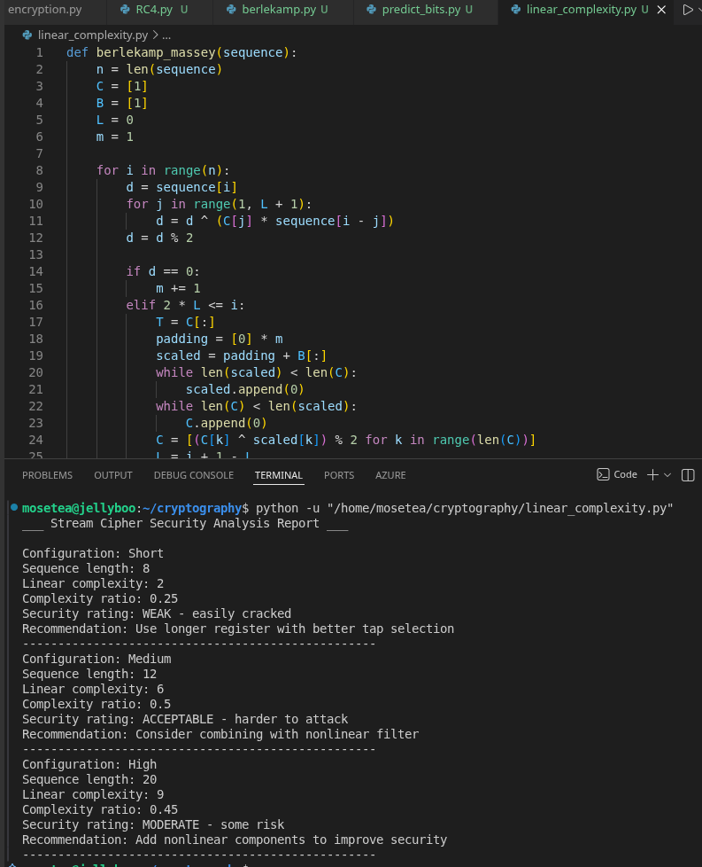
Figure 5: Security analysis report output summarising which configurations are cryptographically weak and recommended countermeasures.

Week 4 reflection
In week 4 i implemented the Berlekamp-Massey algorithm and applied it to LFSR output sequences. The algorithm successfully recovered the minimal polynomial from short sequences that were observed, showing how low linear complexity enables full sequence prediction. Strong stream ciphers must incorporate nonlinear components to resist this class of attack.

Week 5: Block Ciphers and Feistel Structure Simulation

Design and Implementation of a Feistel-Based Block Cipher with Avalanche Effect Analysis

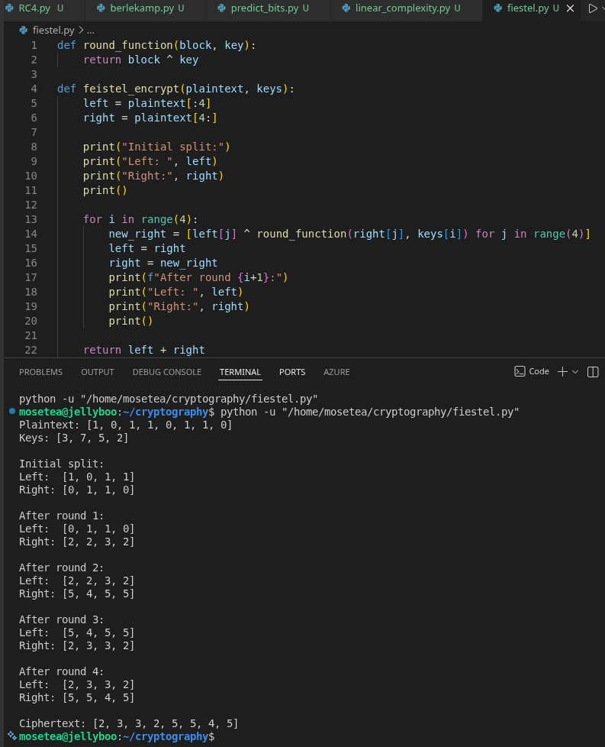
Figure 1: Feistel cipher Python implementation showing left/right block splitting, round function application, and final swap logic.

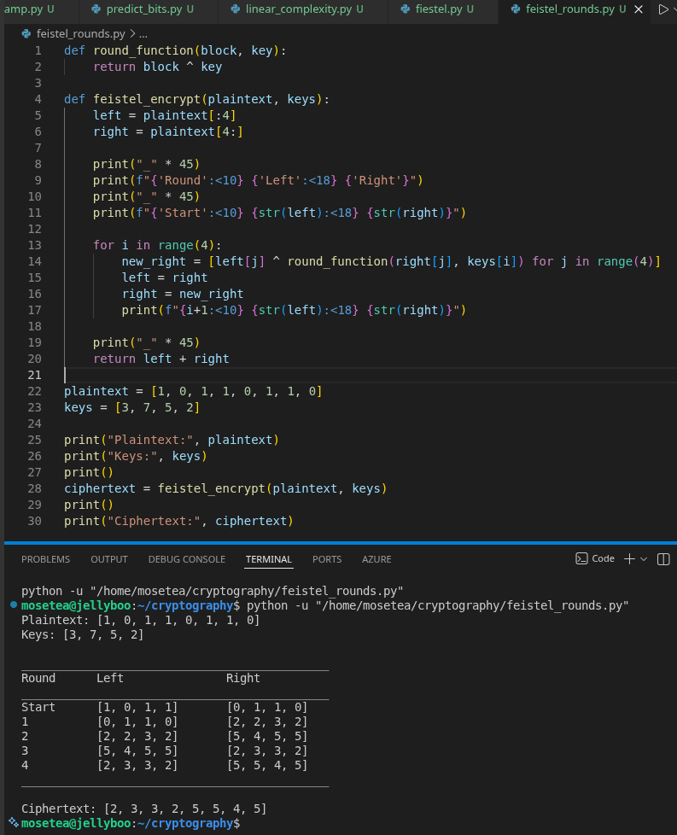
Figure 2: Step-by-step round output table displaying left and right halves at each of the four encryption rounds.

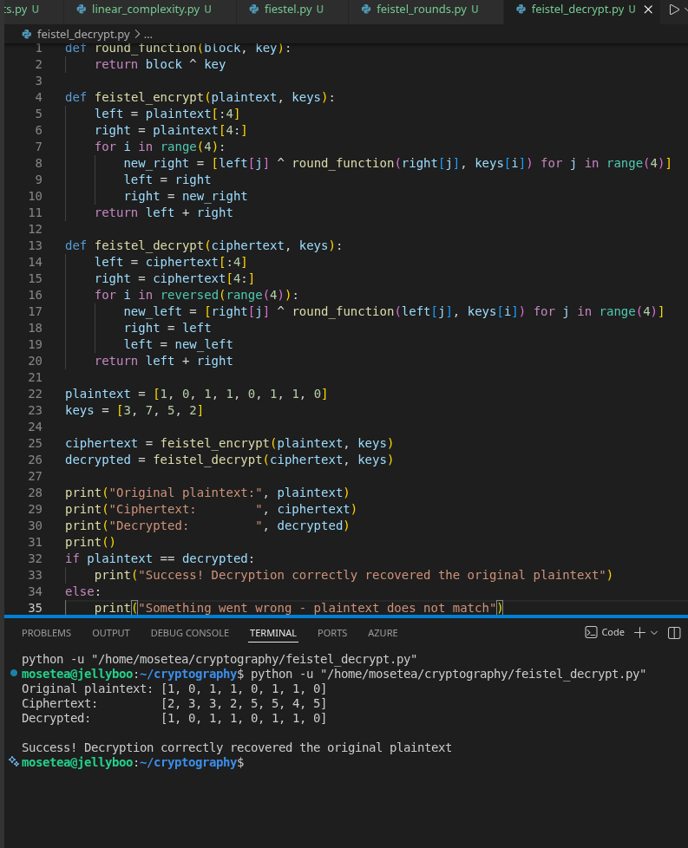
Figure 3: Successful decryption output confirming that the Feistel structure correctly recovers the original plaintext from ciphertext.

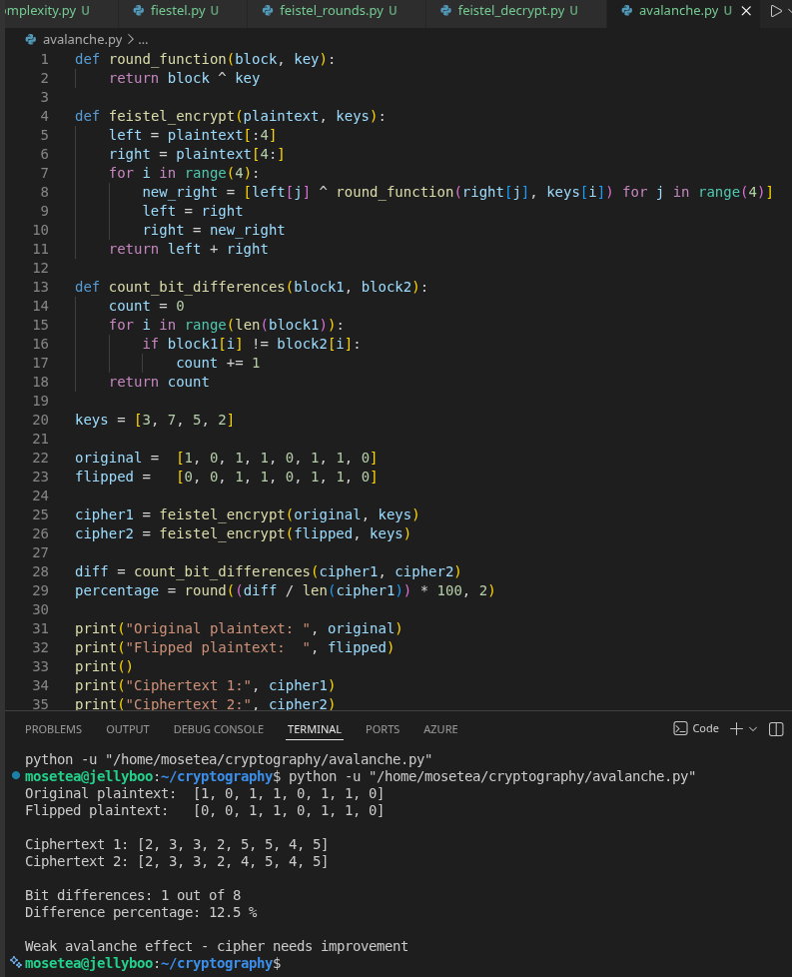
Figure 4: Avalanche effect experiment results — bit-difference count between two ciphertext outputs when one plaintext bit is flipped.

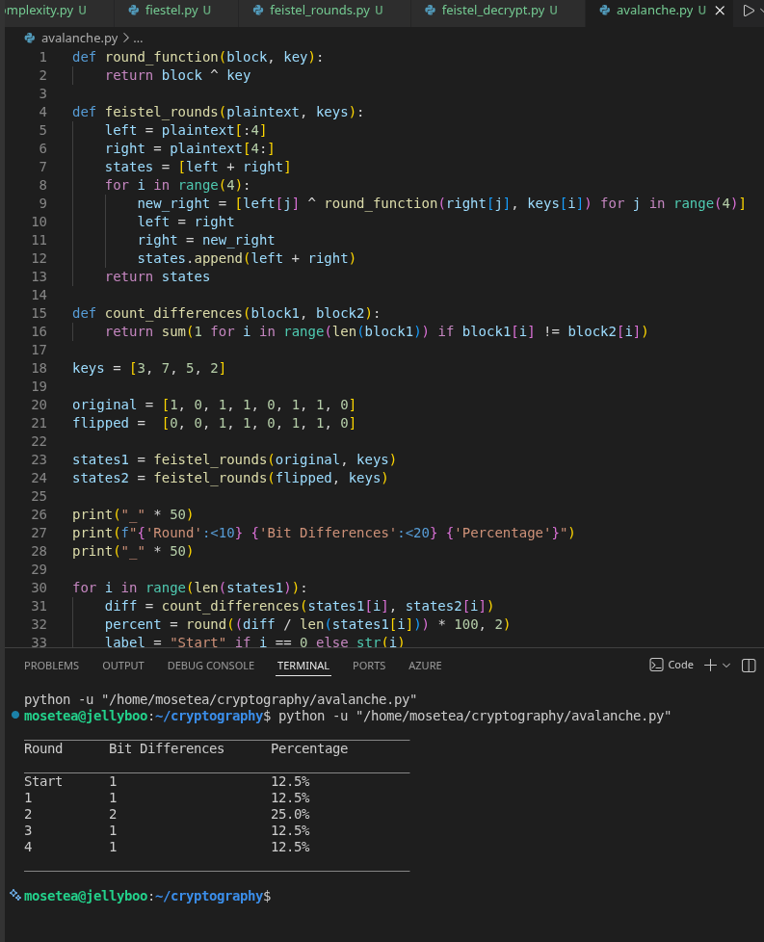
Figure 5: Graphical console output showing how bit differences accumulate across rounds, illustrating diffusion behaviour.

Week 5 reflection
In week 5 I implemented a four-round Feistel cipher and verified that encryption and decryption work as inverse operations using reversed round keys. I then tested the avalanche effect by flipping a single plaintext bit and observed the difference across rounds and this confirmed the Feistel structure provides meaningful diffusion across the block.

Week 6: Symmetric Ciphers II – Substitution-Permutation Networks (SPN), S-Boxes and Non-Linearity

Design and Implementation of a Simple SPN with Non-Linearity Analysis

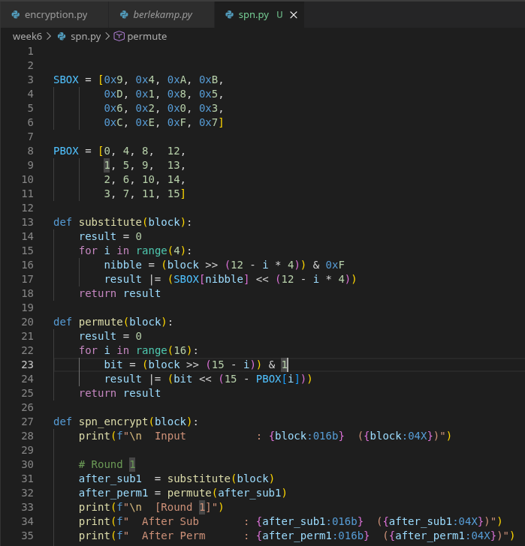
Figure 1: SPN Python implementation showing the SBOX lookup table, PBOX permutation table, and substitute() function used to perform nibble-level substitution on 16-bit plaintext blocks.

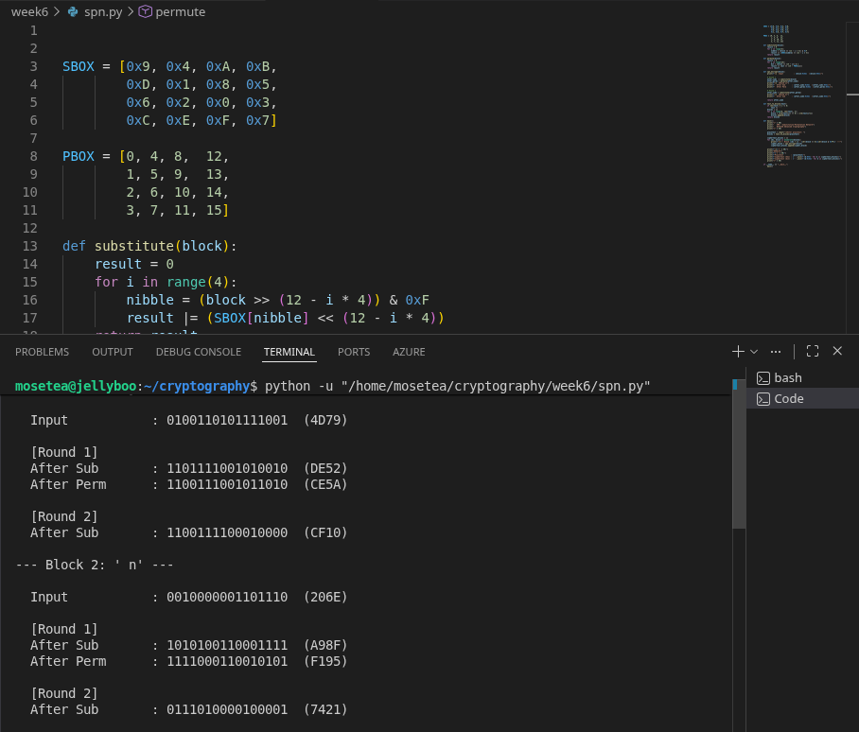
Figure 2: Terminal output showing step-by-step round results after running spn.py displaying the input block, binary and hexadecimal values after substitution and permutation in Round 1, and after substitution in Round 2.

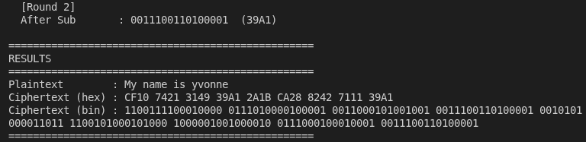
Figure 3: Final RESULTS section of the terminal output showing the original plaintext alongside the computed ciphertext in both hexadecimal and binary format after two complete SPN rounds.

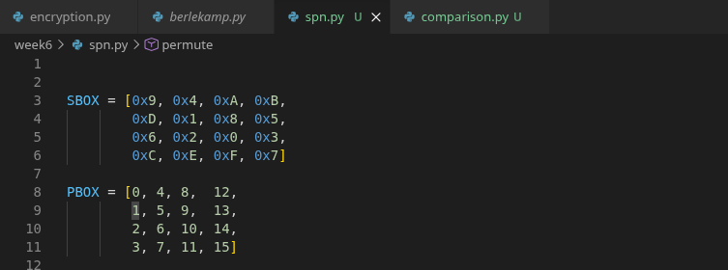
Figure 4: VS Code view of the SBOX array definition at the top of spn.py.

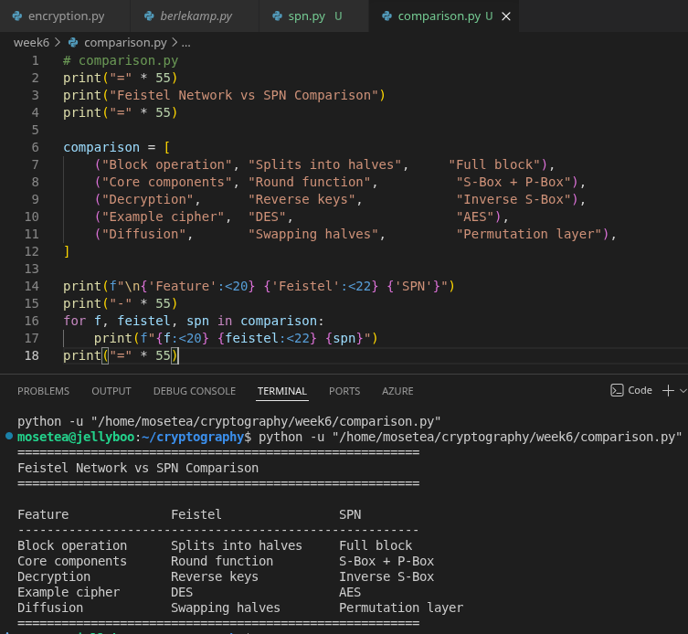
Figure 5: Terminal output of showing a structured table comparing Feistel Network and SPN structures across block operation, core components, decryption method, example ciphers, and diffusion approach.
Week 6 Reflection
In Week 6 I implemented a Substitution-Permutation Network in Python operating on 16-bit blocks. The S-Box performs nibble-level substitution across four 4-bit segments while the P-Box rearranges all 16 bit positions to achieve diffusion. Two rounds were applied with permutation omitted on the final round following standard SPN practice.
The practical demonstrated why non-linearity is critical — without it, a cipher's behavior can be modeled mathematically, making key recovery straightforward. I also compared SPNs with Feistel structures from Week 5, noting that SPNs operate on the full block simultaneously and require an inverse S-Box for decryption, unlike Feistel networks which use reversed round keys. AES adopts the SPN approach for its stronger diffusion and resistance to cryptanalysis.

Week 7: Block Cipher Cryptanalysis Differential Cryptanalysis, Linear Cryptanalysis and Algebraic Attacks

Cryptanalytic Techniques Against Block Ciphers
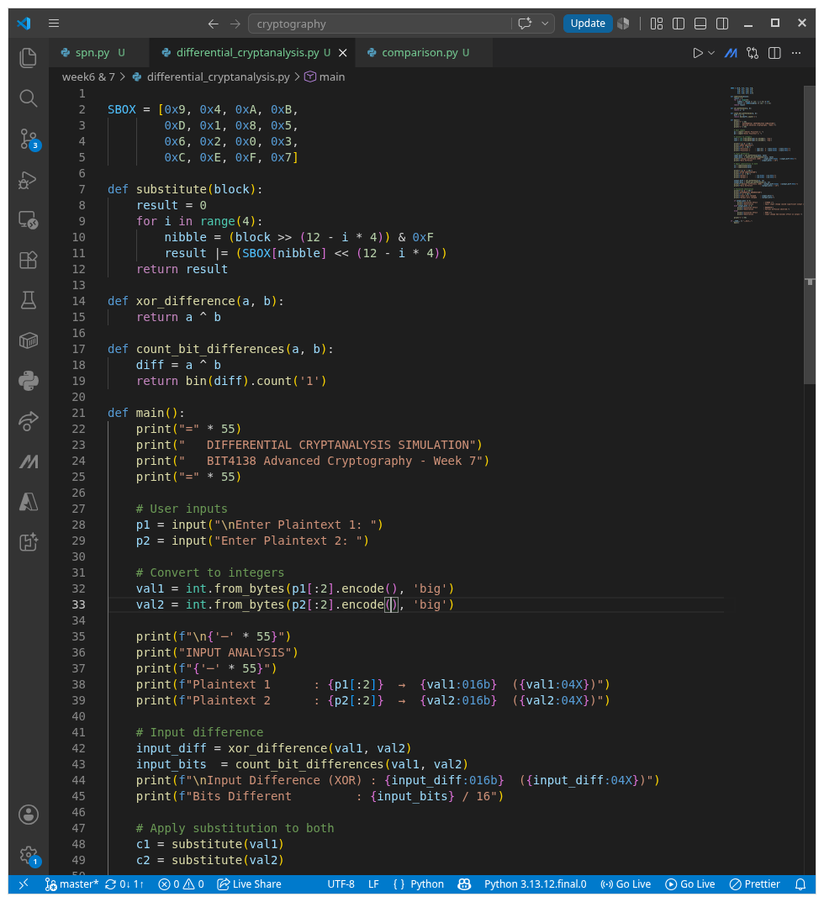
Figure 1: Differential_cryptanalysis.py showing the SBOX definition, substitute() function, XOR difference calculation, and bit difference counter.

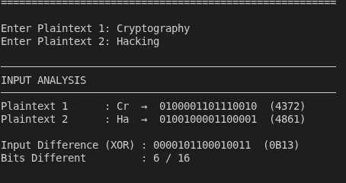
Figure 2: Terminal INPUT ANALYSIS section showing both plaintext inputs converted to binary and hexadecimal, with the XOR input difference and number of bits that differ between the two plaintexts.

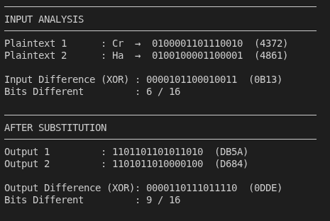
Figure 3: Terminal AFTER SUBSTITUTION section displaying the substituted output for both inputs in binary and hexadecimal, with the computed output XOR difference.
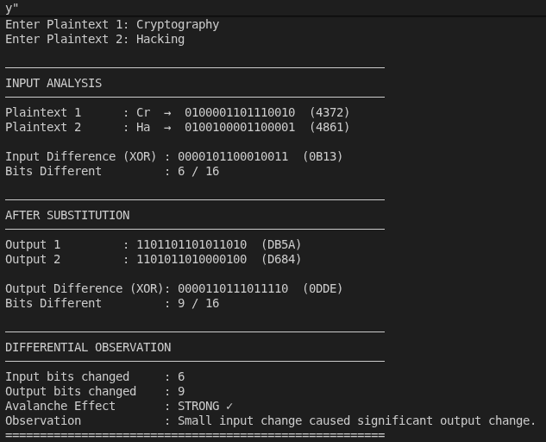
Figure 4: Terminal DIFFERENTIAL OBSERVATION section showing the comparison between input bits changed and output bits changed, with the avalanche effect strength rating and observation note.

Week 7 Reflection
In Week 7 I simulated differential cryptanalysis in Python by computing XOR differences between two similar plaintexts before and after S-Box substitution. This showed how a small input change propagates through the cipher — a strong S-Box causes even one bit change to affect many output bits, demonstrating the avalanche effect.
I also studied linear and algebraic attacks. Linear cryptanalysis exploits statistical patterns between plaintext, ciphertext, and key bits, while algebraic attacks model the cipher as equations and solve for the key. Both attacks succeed against weak S-Boxes with low non-linearity. AES resists all three techniques through its high non-linearity, strong diffusion via MixColumns, and multiple rounds, making no practical attack currently feasible against full AES.

