

YVONNE MOSETI
BSCCS/2024/74596
COMPUTER SCIENCE

BIT3208: Advanced Web Design and Development

LECTURER: MICHAEL NYORO

Project: ZuriMart
Tech stack: PHP, MySQL, Bootstrap 5, JavaScript (Fetch API), Chart.js, XAMPP on Kali Linux
GITHUB: https://github.com/Moseti-suddo/ZuriMart

Table of Contents

Table of Contents 2
Week 1: Local Environment Setup 3
Week 2: Wireframes and GUI Design 6
Week 3: JavaScript and PHP Basics 10
Week 4: User Authentication System 14
Week 5: Database Design and Integration 17
Week 6: CRUD Operations 20

Week 1: Local Environment Setup
Installation and Testing of Local Development Environment

Fig 1: Installation of XAMPP/WAMP/Laragon e.t.c
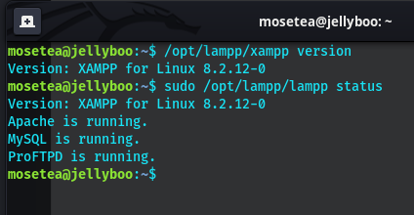

Fig 2: Apache and MySQL Running
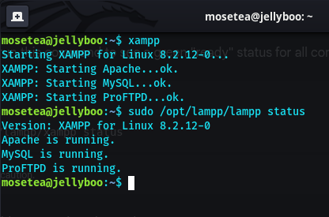

Fig 3: Localhost Test Page
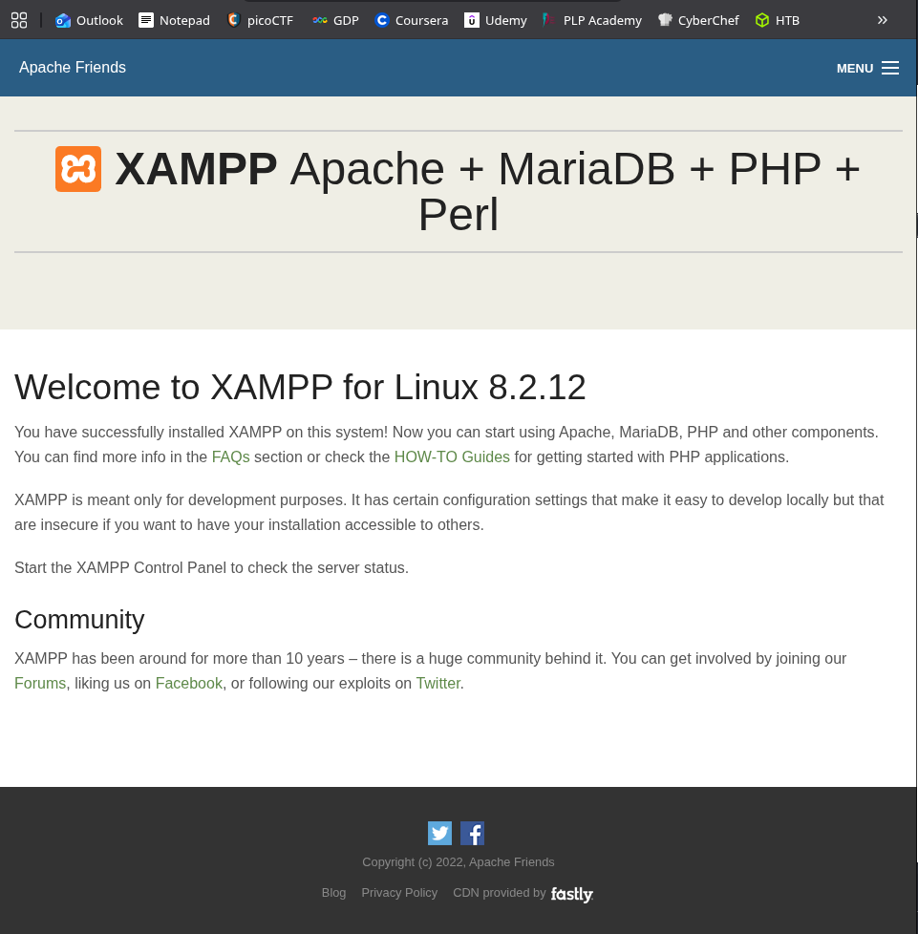
Fig 4: Hello World Test
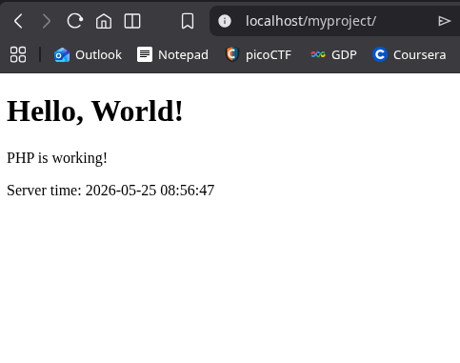
Fig 4: PHP page served by apache through XAMPP

Fig 5: Database Connection Test
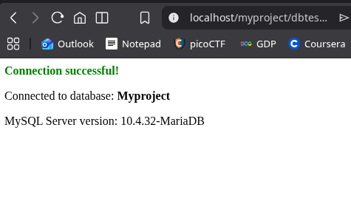

Fig 5: Successful connection to Myproject database

Reflection
From week one, local environment set up, I learnt how to install and get XAMPP working on Linux as my local development environment.
Technologies used include XAMPP, Apache, MySQL and PHP on Kali Linux.
The main challenge was a port conflict, The system had MariaDB pre-installed which occupied port 3306 on startup, preventing XAMPP’s MySQL from launching. I resolved this by disabling MariaDB.
The screenshots demonstrate successful Apache and MySQL startup, localhost running in the browser, and phpMyAdmin connecting to the database after troubleshooting.

Week 2: Wireframes and GUI Design
User Interface Planning and System Design
Required Evidence
Fig 1: Login page Wireframe
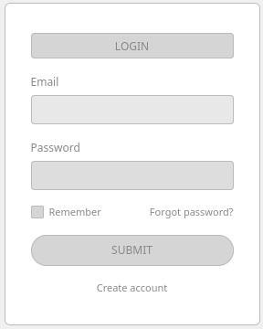

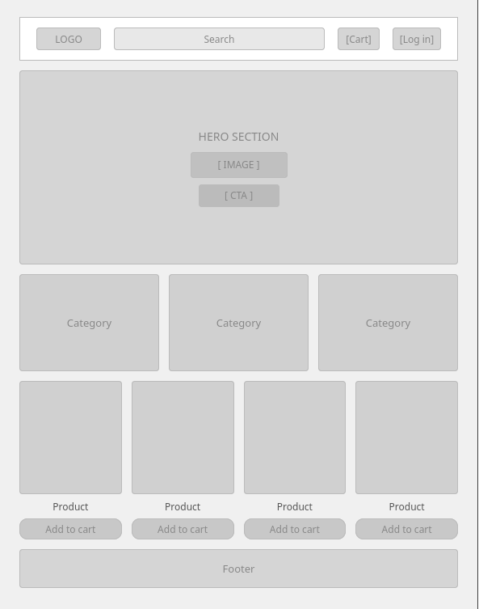
Fig 2: Dashboard Layout Design

Fig 3: Mobile View Mockup

Fig 4: Color Theme and Navigation Structure
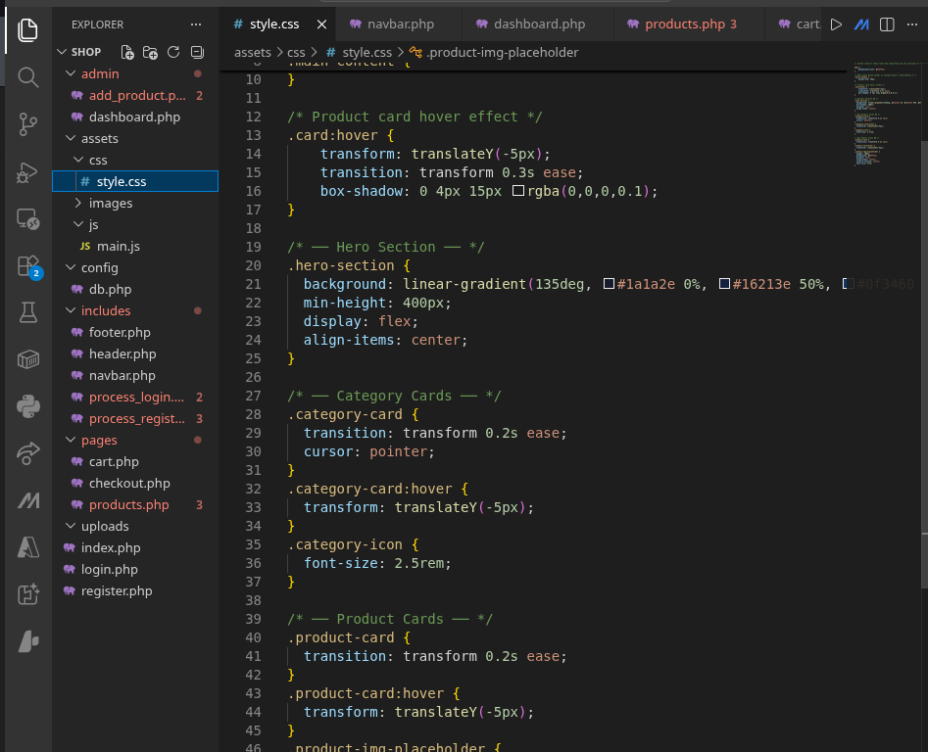

Fig 4: Color theme and navigation structure
GUI Prototype
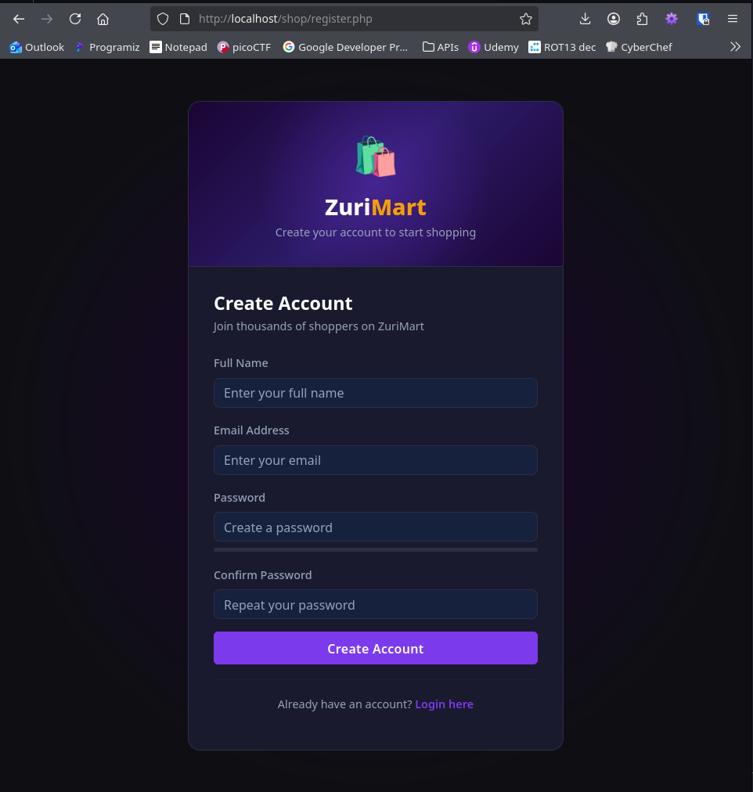
Fig 5: GUI prototype

Student Reflection
This week involved planning the ZuriMart e-commerce application before writing any code. I sketched hand-drawn wireframes for four pages — Login, Homepage, Product Page, and Admin Dashboard.
Each wireframe included labels showing how frontend elements connect to backend systems, for example how the product cards will be fetched dynamically from the database.
I also set up the professional project folder structure inside XAMPP separating assets, includes, admin, config, and pages folders. Bootstrap 5 was linked via CDN and a base template was built using PHP includes for the navbar, header, and footer.

Week 3: JavaScript and PHP Basics
Frontend Interaction and Backend Foundations
Required Evidence
Fig 1: JavaScript Form Validation
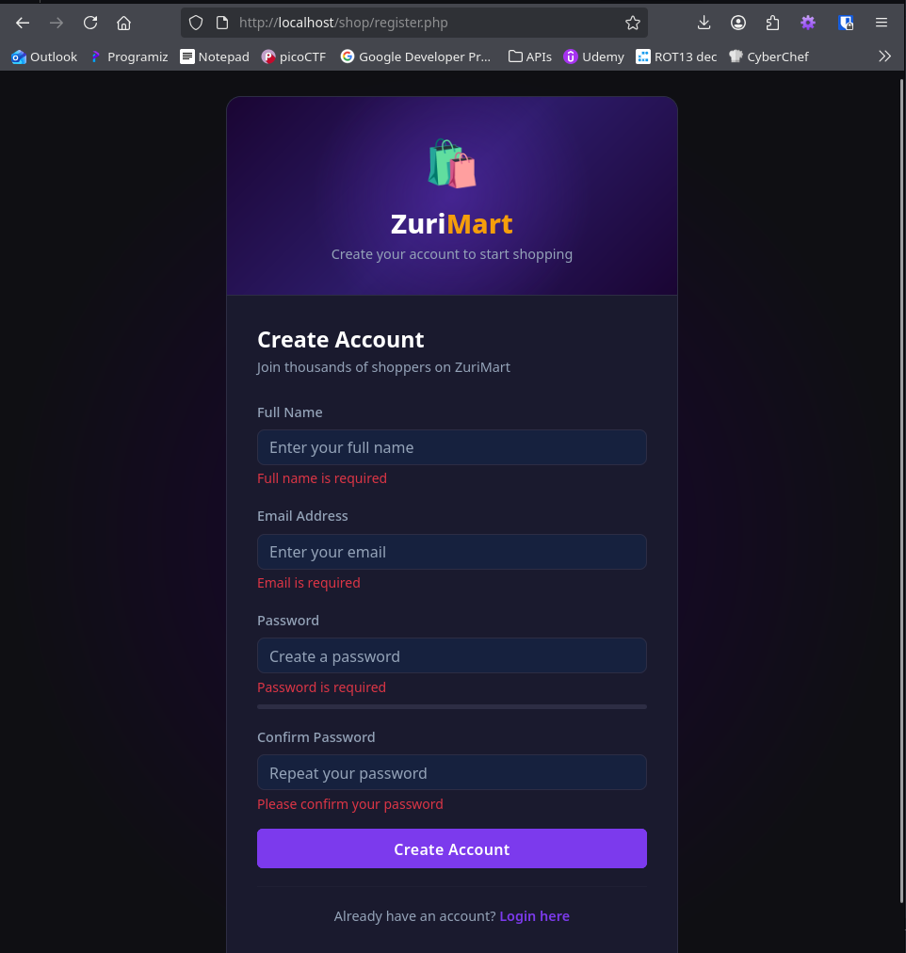
Fig 1: JavaScript form validation showing error messages on empty submit.

Password Strength Checker
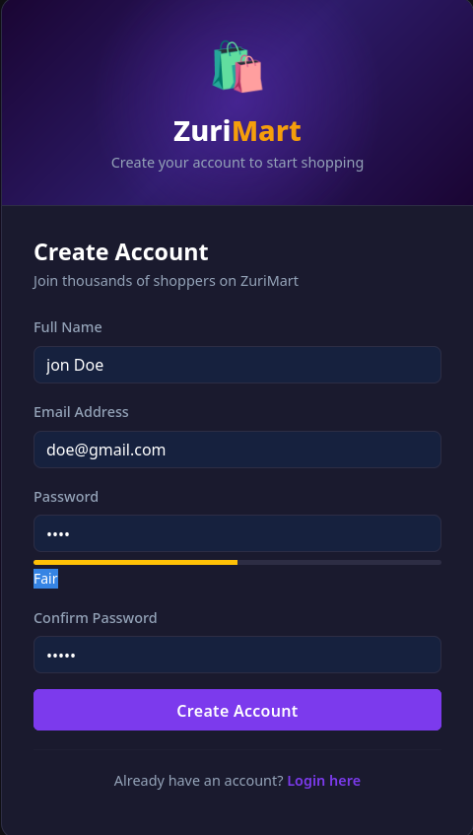
Fig 2: Password field with strength checker

PHP Syntax Practice
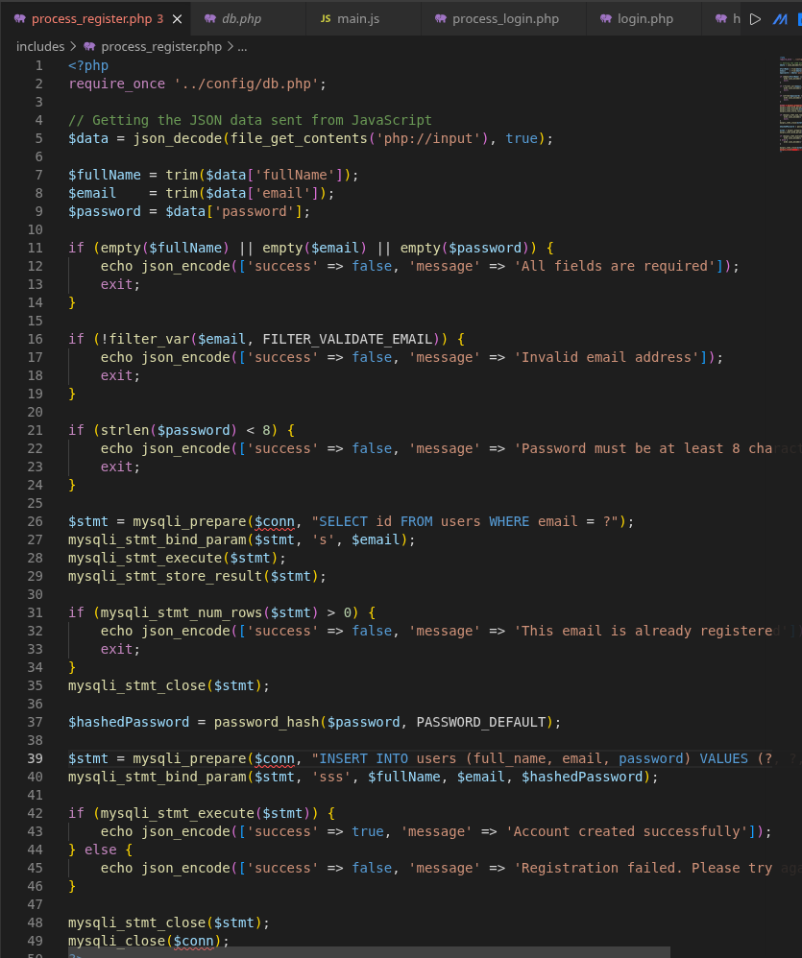

Fig 3: PHP syntax practice on process_register.php

Fig 4: Database Connection Script
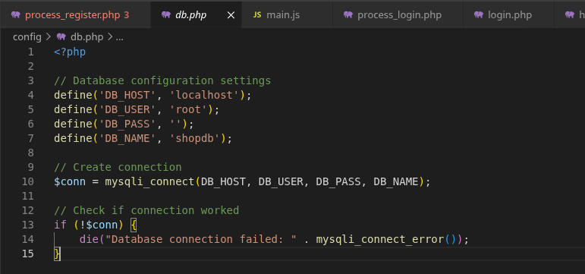
Fig 5: Dynamic User Input Handling
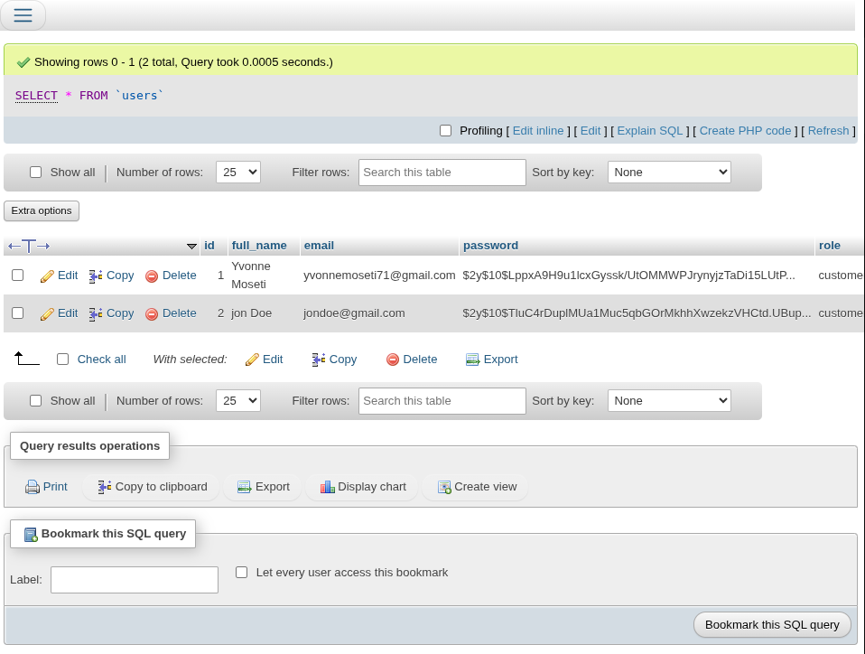
Fig 5: Table showing your registered test user with hashed passwords visible in the password column.

Student Reflection
This week I introduced JavaScript interactivity and PHP backend processing to ZuriMart. I built a registration form with real-time JavaScript validation covering name, email format, password strength, and password confirmation matching.
A colour-coded password strength bar updates as the user types. PHP processes the form server-side using prepared statements to prevent SQL injection and password_hash() to store credentials securely never plain text. The Fetch API submits data without page reloads, improving user experience.
Both client-side and server-side validation are implemented because JavaScript can be disabled by users, making server validation the true security layer.

Week 4: User Authentication System
Fig 1: User Registration Form
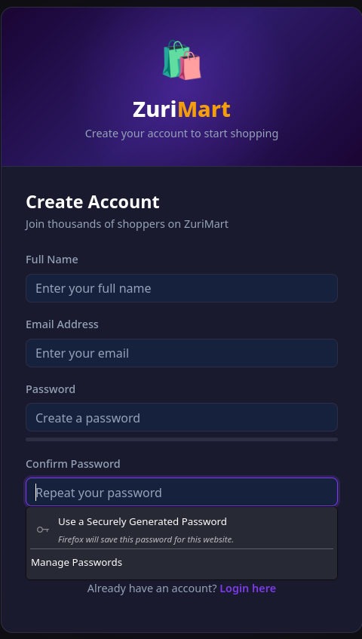

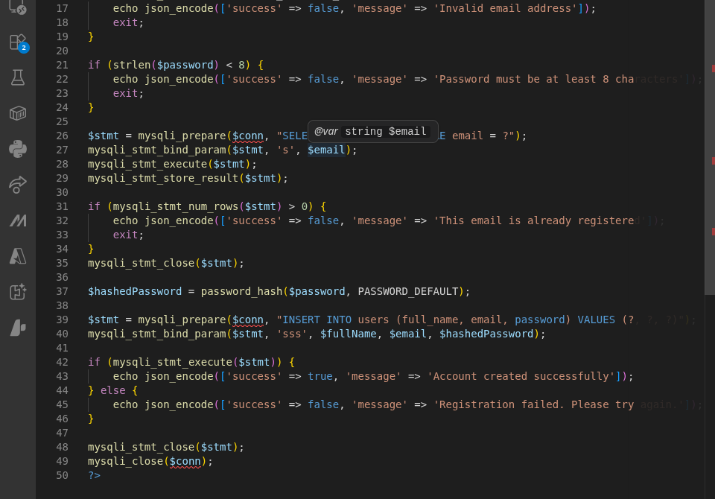
Fig 2: PHP Registration Script with Password Hashing

Fig 3: Login Form
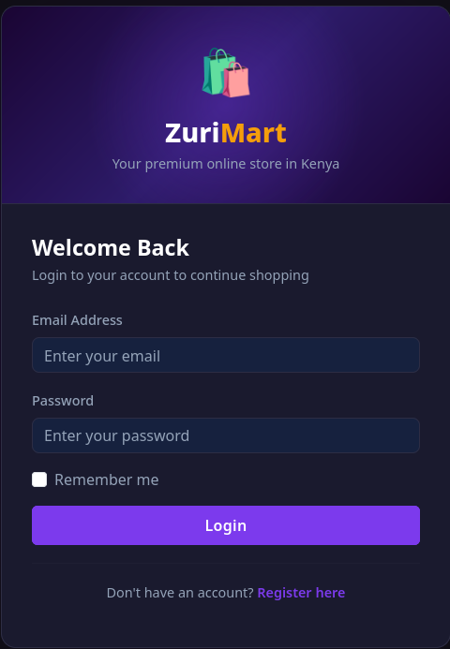

Fig 4: Session Management Code
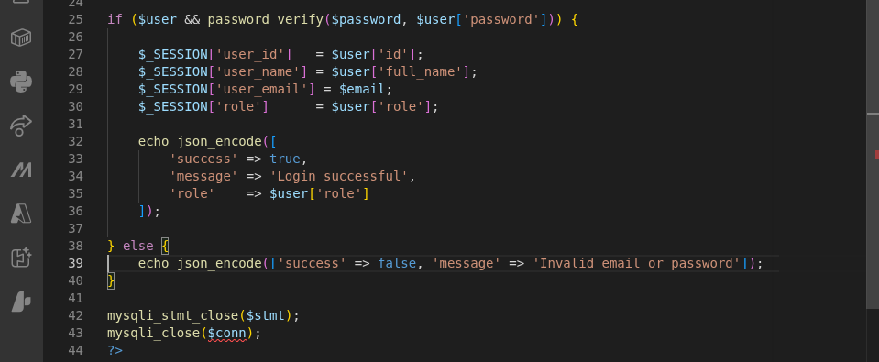

Fig 5: Successful Login and Dashboard Redirect
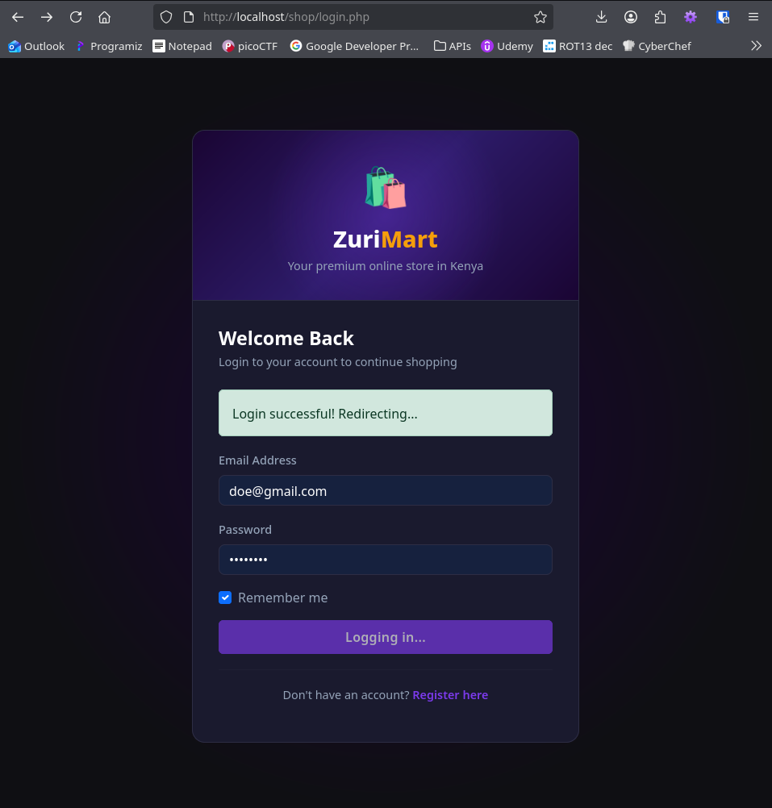

Student Reflection
I implemented user authentication for ZuriMart, both registration and login flows end-to-end. The registration form uses JavaScript validation to check for empty fields, valid email format, and matching passwords before submitting.
PHP processes the data server-side using prepared statements to prevent SQL injection, with password_hash() storing credentials securely as bcrypt hashes.
The login system uses password_verify() to compare input against the stored hash, and PHP sessions to persist the logged-in state across pages.
A role-based redirect was implemented — admin users are sent to the dashboard while regular users proceed to the homepage."

Week 5: Database Design and Integration
Entity Relationships and Data Management
Fig 1: Entity Relationship Diagram (ERD)
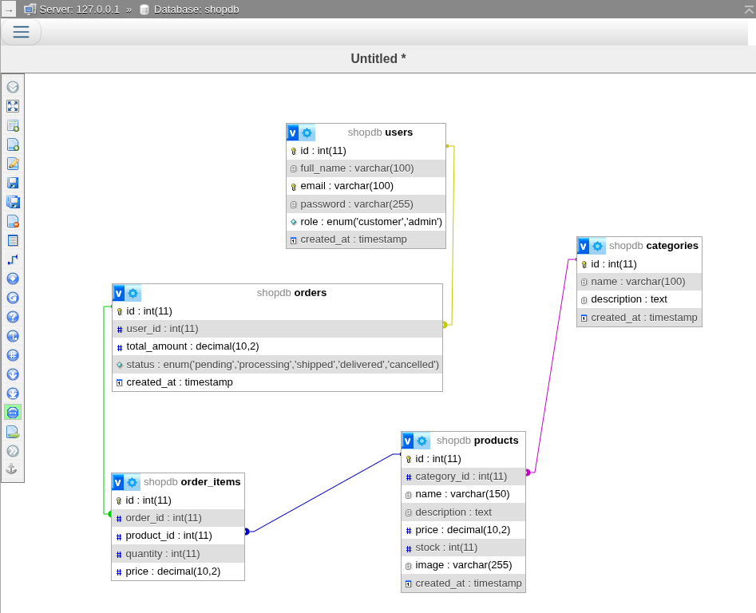

Fig 2: Database Tables in phpMyAdmin
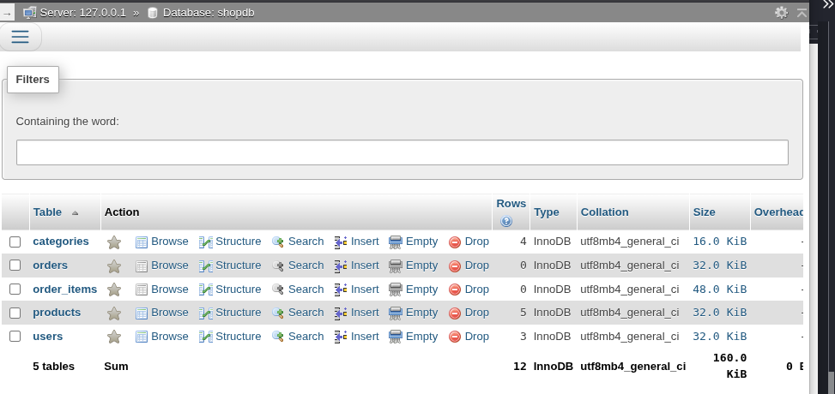

Fig 3: SQL CREATE TABLE Statements
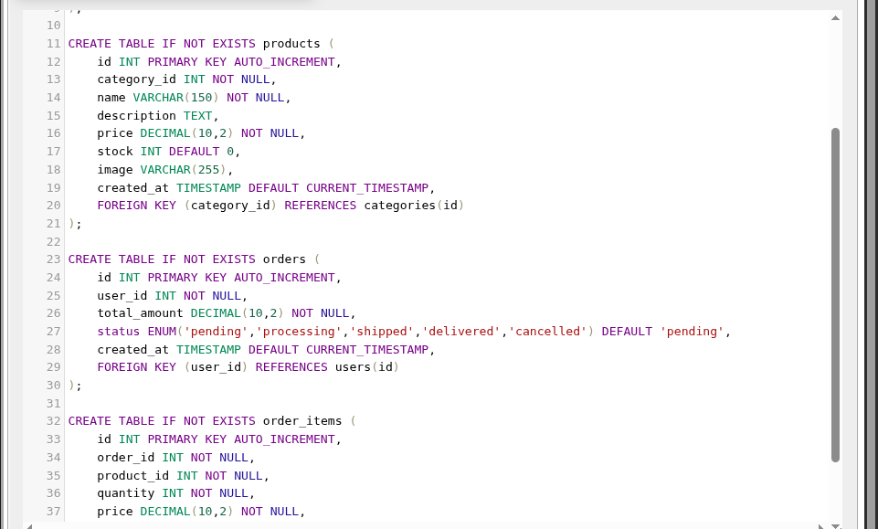

Fig 4: Data Insertion Script
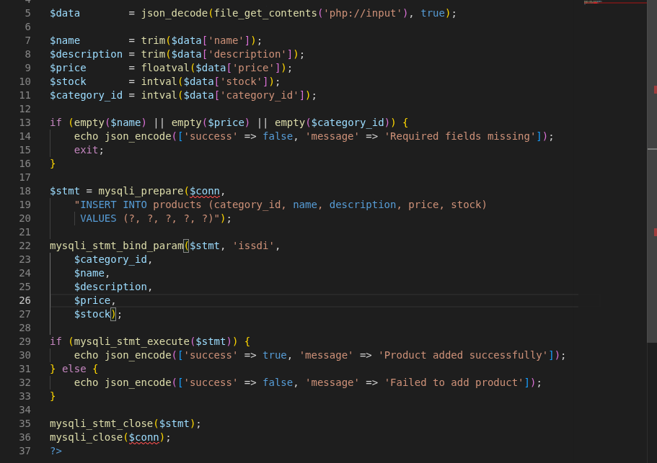

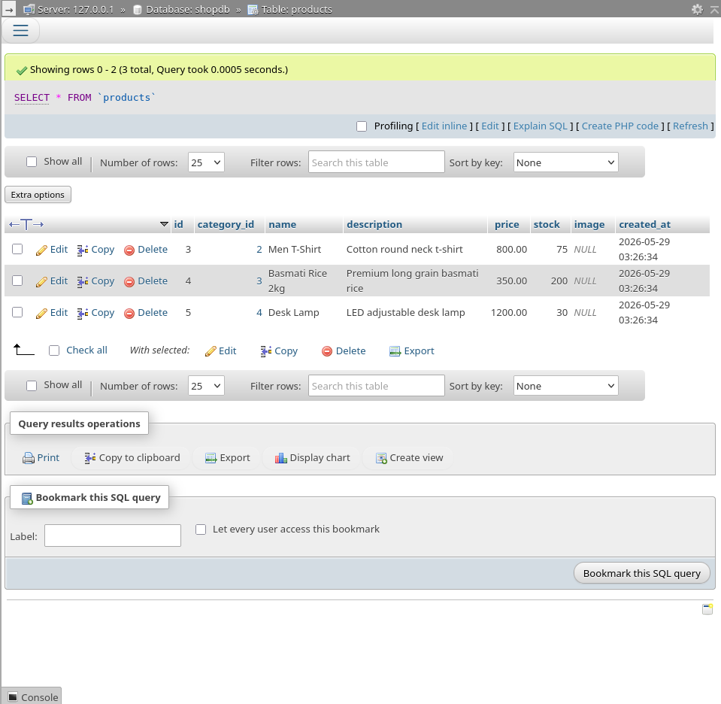
Fig 5: Query result showing product records retrieved from the products table in shopdb

Student Reflection
In week 5 I focused on database design and dynamic content rendering for ZuriMart. I created 5 relational tables in MySQL, users, categories, products, orders, and order_items with foreign keys enforcing data integrity between them.
I inserted sample data across all tables to enable realistic testing. The products page was connected to the database using PHP and mysqli prepared statements, replacing static HTML cards with a dynamic loop that renders real product data. A category filter system was implemented using GET parameters in the URL, allowing users to browse by category without a page reload of the full application."

Week 6: CRUD Operations
Create, Read, Update and Delete Functionality
Required Evidence
Fig 1: Create / Add Record Form
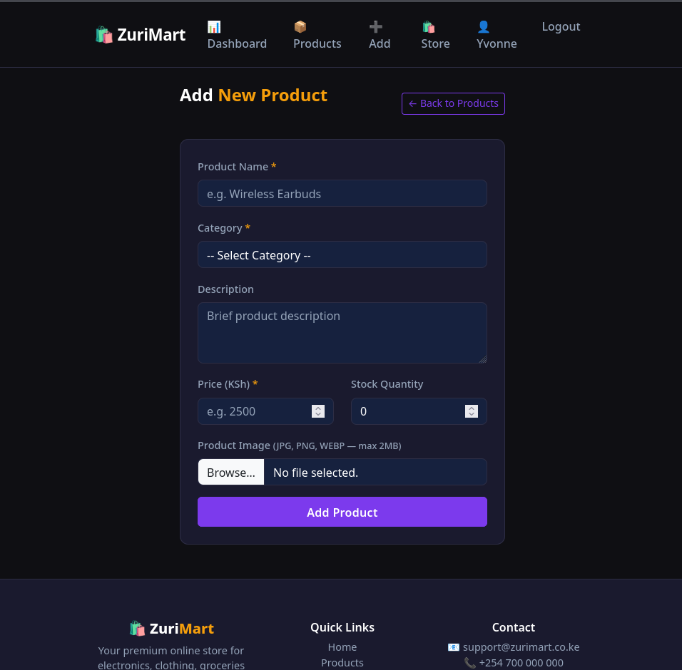

Fig 2: Database Record Listing (Read)
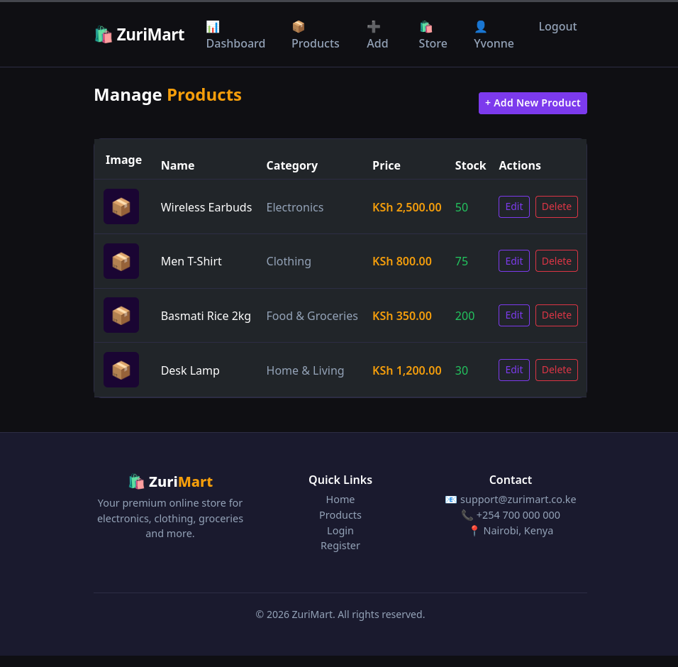

Fig 3: Edit / Update Form and Script
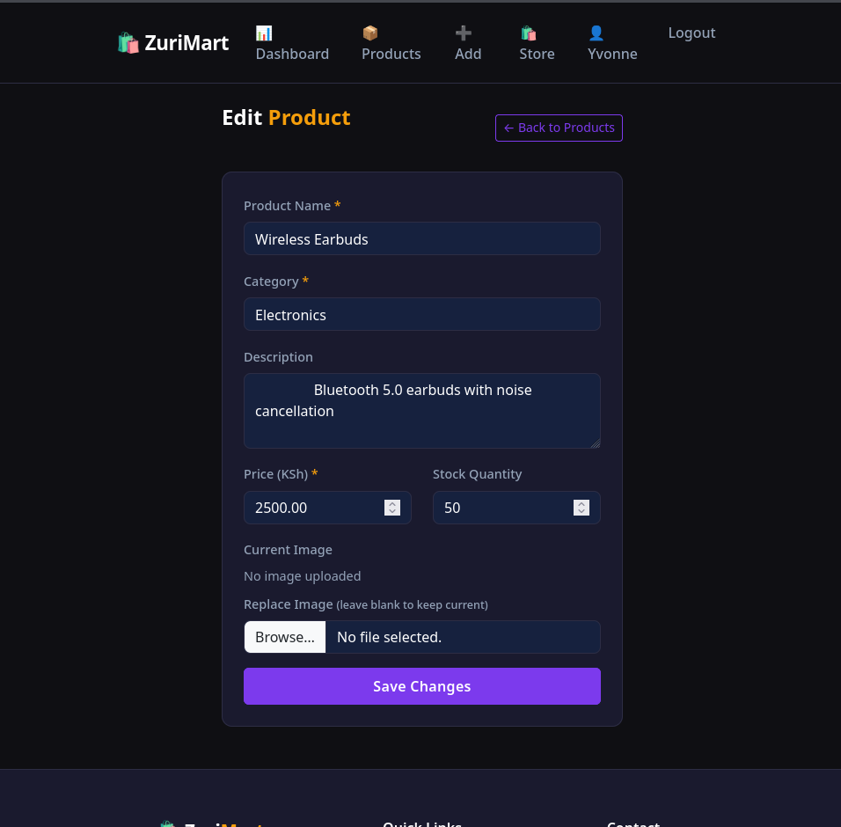
Fig 4: Delete Confirmation and Script
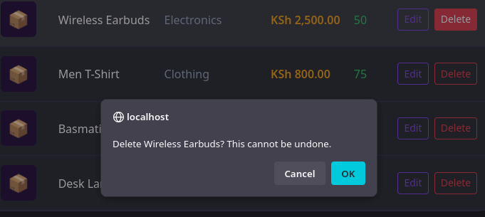
Fig 5: Database Changes Verified in phpMyAdmin
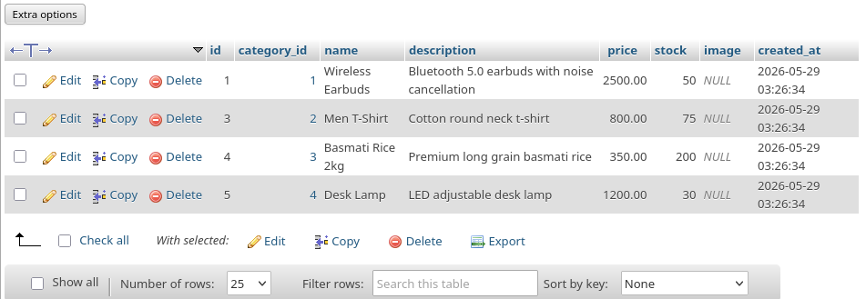
Before deletion
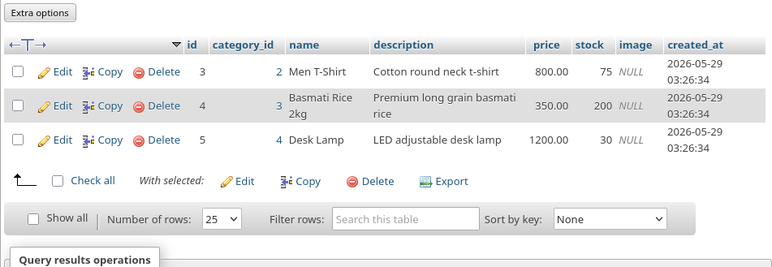
After deletion

Student Reflection
Week 6 implemented full CRUD functionality for ZuriMart's admin product management system. An add product form inserts new records into the products table using PHP prepared statements with category dropdown populated dynamically from the database. The products listing page reads all records using a JOIN query to display category names rather than IDs. An edit form pre-fills existing data and updates records using parameterised UPDATE queries. Deletion is handled via URL parameters with a JavaScript confirmation popup preventing accidental removal. All database changes were verified in phpMyAdmin before and after each operation, confirming data integrity throughout.

