מעבדה מס' 2

מגישים:

טל יהושע - 314774860

משה פרץ - 318263977

;

; hello4.asm - Conditional response.

;

.MODEL SMALL

.STACK 100h

.DATA

TimePrompt DB 'Is it 12 after noon (y/n)?',13,10,':$'

GoodAfternoonMessage DB 13,10

DB 'Good afternoon, world!',13,10,'$'

GoodMorningMessage DB 13,10

DB 'Good morning, world!',13,10,'$'

Error DB 13,10

DB 'Input Error',13,10,'$'

;

;

.CODE

ProgStart:

MOV AX,@DATA ; DS can be written to only through a register

MOV DS,AX ; Set DS to point to data segment

MOV AH,9 ; Set print option for int 21h

MOV DX,OFFSET TimePrompt ; Set DS:DX to point to TimePrompt

INT 21h ; Print TimePrompt

MOV AH,1 ; DOS get character function #

INT 21h ; Get a single character from keyboard

CMP AL,'y' ; AL has input. Compare with 'y'

JE IsAfternoon ; If AL = 'y' then go to IsAfternoon

CMP AL,'Y' ; Compare with 'Y'

JE IsAfternoon ; If AL = 'Y' then jump to IsAfternoon

CMP AL,'N' ; If AL = 'Y' then jump to IsMorning

JE IsMorning ;

CMP AL,'n' ; If AL = 'Y' then jump to IsMorning

JE IsMorning ;

MOV DX,OFFSET Error ; point to Error string

JMP DisplayGreeting ;

IsMorning:

MOV DX,OFFSET GoodMorningMessage ; Point display message to morning

JMP DisplayGreeting ; Avoid following code

IsAfternoon:

MOV DX,OFFSET GoodAfternoonMessage ; Point display message to afternoon

DisplayGreeting:

MOV AH,9 ; Set print option for int 21h

INT 21h ; Print chosen message

MOV AH,4Ch ; Set terminate option for int 21h

INT 21h ; Return to DOS (terminate program)

END ProgStart

פלטים:

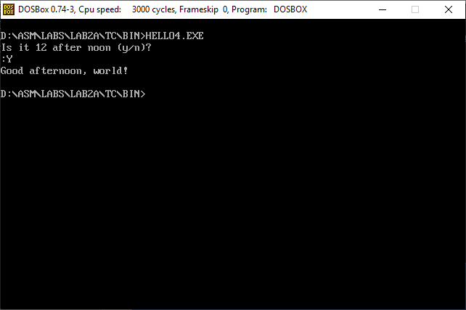

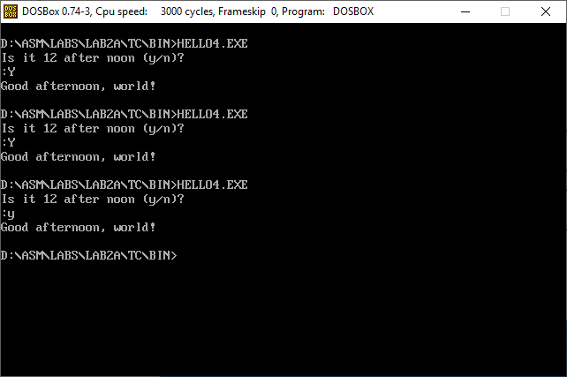

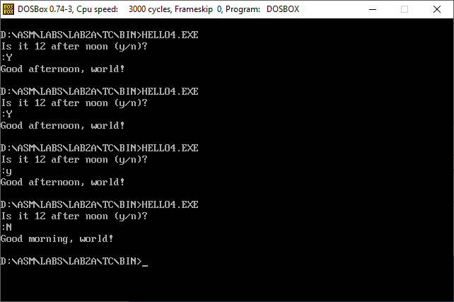

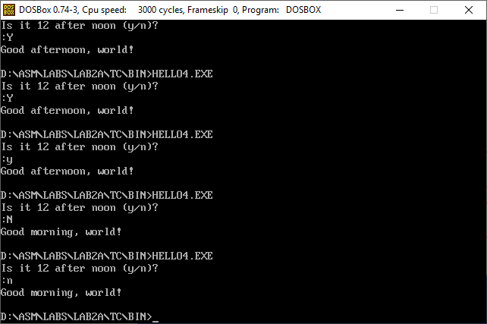

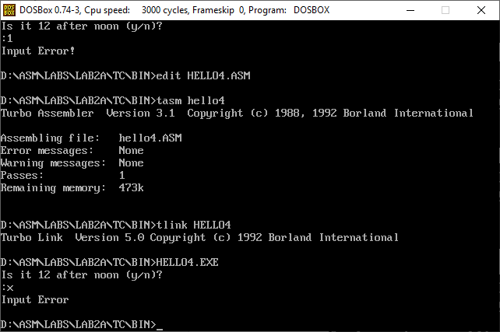

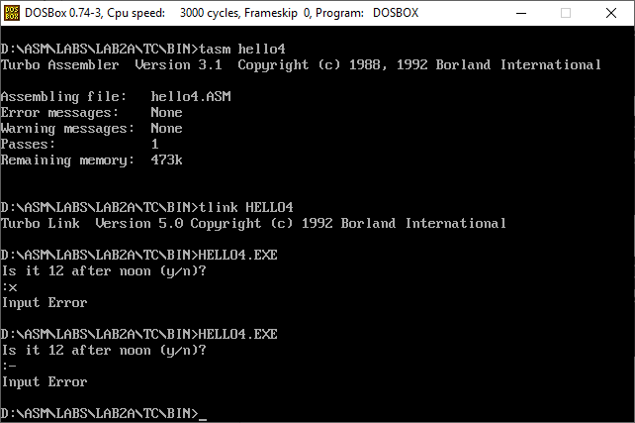

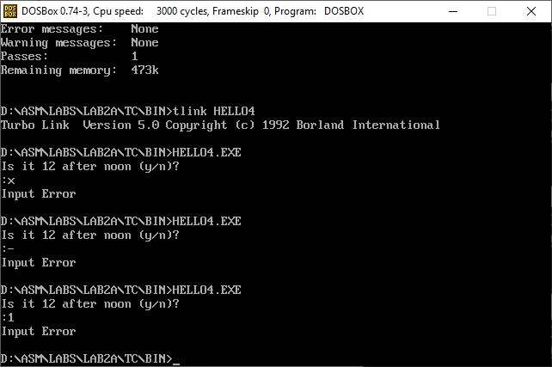

שאלה 2:

;q2.asm - GradeExplener

.MODEL SMALL

.STACK 100H

.DATA

EnterGrade DB 'Please enter your grade ',13,10,'$'

A DB 13,10

DB 'Very Good',13,10,'$'

B DB 13,10

DB 'Good',13,10,'$'

C DB 13,10

DB 'Not Good',13,10,'$'

F DB 13,10

DB 'Very Bad. You Failed',13,10,'$'

Error DB 13,10

DB 'Input Error!!!',13,10,'$'

.code

ProgStart:

MOV AX,@DATA

MOV DS,AX

MOV DX,OFFSET EnterGrade ; DX point to EnterGrade

MOV AH,9 ; set print for int 21h

INT 21H ; Print EnterGrade

MOV AH,1 ; Get character function

INT 21H ; Get a single character from keyboard

CMP AL,'A' ; If AL = 'A' then go to IsA

JE isA

CMP AL,'B' ; If AL = 'B' then go to IsB

JE isB

CMP AL,'C' ; If AL = 'C' then go to IsC

JE isC

CMP AL,'F' ; If AL = 'F' then go to IsF

JE isF

MOV DX,OFFSET Error ; Any other input point to Error string

JMP DisplayGrade

isA:

MOV DX,OFFSET A ; Point to A string

JMP DisplayGrade

isB:

MOV DX,OFFSET B ; Point to B string

JMP DisplayGrade

isC:

MOV DX,OFFSET C ; Point to C string

JMP DisplayGrade

isF:

MOV DX,OFFSET F ; Point to F string

JMP DisplayGrade

DisplayGrade:

MOV AH,9 ; Print command for 21h exe

INT 21H ; Execute the printing command

MOV AH,4CH ; End program

INT 21H

END ProgStart

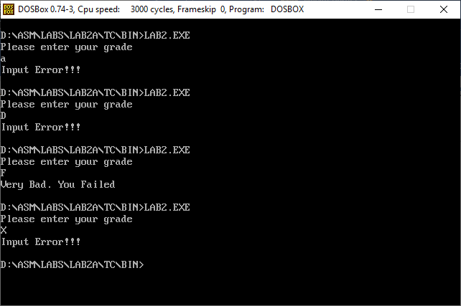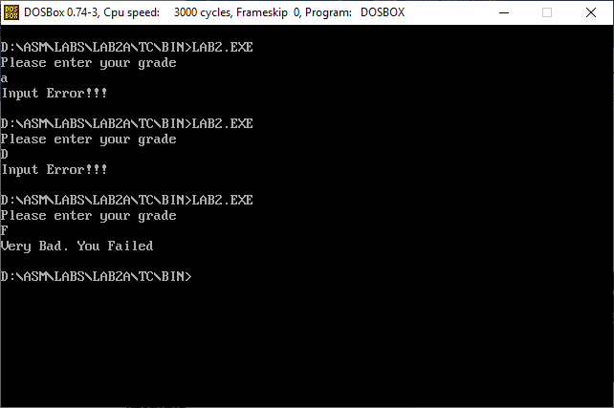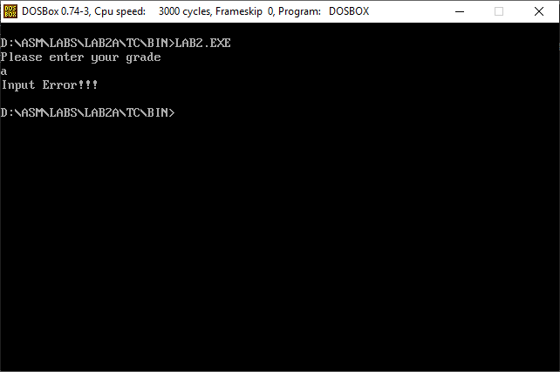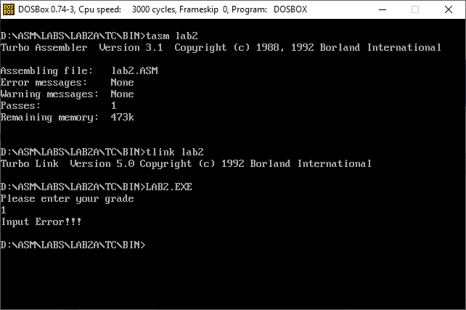פלטים:

