Data Technician
Workbook
Week 1 Excel

Name:
Course Date:
Table of contents
Day 1: Task 1 3
Day 2: Task 1 4
Day 2: Task 2 5
Day 3: Task 1 6
Day 3: Task 2 7
Dataset: 7
Step 1: Create a Pivot Table 7
Step 2: Use the SWITCH Function 7
Submission: 8
Day 3: Task 3 9
Course Notes 10
Additional Resources 11
Additional formation 12

Day 1: Task 1

Please research and complete the below boxes on common laws and regulations that must be followed when working with customers data, use the below bulleted list to support your answers.

- What is it
- Why is it important
- Provide a real-world example of how you can follow it
- How does it impact working with data
- What could happen if you breached it

Data Protection Act | The Data Protection Act is UK legislation that controls how personal information about individuals is collected, stored, used and shared. It works alongside the UK GDPR and requires organisations to handle personal data lawfully, fairly, transparently and securely.  Why is it important  It is important because it protects people’s privacy and give individual’s rights on how their personal information is used.  Provide a real-world example of how you can follow it  If I were analysing a customer dataset containing names, email addresses and purchasing information, I would only access the information necessary for my work. Where possible, I would remove or anonymise personally identifiable information before carrying out the analysis. I would also store the data securely to avoid any data breach  What could happen if you breached it  A data protection breach could expose people's personal information and potentially cause financial, reputational or other harm
GDPR | The General Data Protection Regulation (GDPR) is a data protection framework that sets rules for how organisations collect, process, store and share people's personal data. In the UK, the UK GDPR works alongside the Data Protection Act 2018.  Why is it important  It is important because it protects people's privacy and gives individuals greater control over how organisations use their personal information. It also makes organisations accountable for protecting the personal data they hold.  Provide a real-world example of how you can follow it  If I were analysing employee data to produce a report on staff performance or absence, I would only use the information necessary for the analysis. I would remove or anonymise identifying information where it was not required and ensure the dataset was stored securely with access restricted to authorised individuals.  When presenting my findings in Power BI or Excel, I would avoid displaying personally identifiable information unless there was a legitimate requirement for it.  What could happen if you breached it  A GDPR breach could result in personal information being accidentally or unlawfully accessed, disclosed, altered, lost or destroyed.
Freedom of Information Act | The Freedom of Information Act 2000 (FOIA) is a UK law that gives people the right to request recorded information held by public authorities. This includes organisations such as government departments, local councils, the NHS, police forces and state schools.  Why is it important  The Freedom of Information Act is important because it allows the public to understand how public authorities operate, spend public money and make decisions. This promotes transparency and helps hold public organisations accountable for their actions.  Provide a real-world example of how you can follow it  If I worked as a data analyst within a government department and received a request for statistics about how departmental money had been spent, I would follow the organisation's FOI procedures and identify the relevant data.  Before releasing information, I would ensure it was accurate and check whether it contained personal, confidential, commercially sensitive or otherwise exempt information. I would work with the appropriate FOI or information-governance team rather than releasing information independently  What could happen if you breached it  Failure to comply with the Freedom of Information Act can result in complaints and investigation by the Information Commissioner's Office (ICO). The ICO can require a public authority to take action to comply with the legislation.  There can also be serious reputational consequences for an organisation if it fails to handle requests appropriately.  It is also important not to deliberately destroy, alter or conceal information to prevent its disclosure after a valid FOI request has been made, as this can constitute a criminal offence.
Computer Misuse Act | The Computer Misuse Act 1990 is a UK law designed to protect computer systems and data from unauthorised access and misuse. It makes activities such as accessing computer systems without permission, accessing systems with the intention of committing further offences, and deliberately interfering with computer systems or data illegal.  Why is it important  The Act is important because organisations store large amounts of confidential, personal and commercially sensitive information electronically. It helps protect computer systems and data against hacking, unauthorised access, malware and deliberate disruption.  Provide a real-world example of how you can follow it  If I worked as a data analyst and had access to a company database containing customer information, I would only access the systems, databases and files that I was authorised to use for my role.  For example, even if I discovered that my login credentials allowed me to access a confidential HR database, I should not access it unless I had permission and a legitimate business reason to do so. I would report inappropriate access permissions to the relevant IT or security team.  What could happen if you breached it  Breaching the Computer Misuse Act can have serious consequences. Depending on the offence, an individual could face criminal prosecution, fines and imprisonment.  An employee could also face disciplinary action or dismissal for accessing or interfering with systems without authorisation.  For an organisation, computer misuse can result in data loss, system downtime, financial losses, security incidents and reputational damage.

Day 2: Task 1

Please research and complete the following tasks within the retail-sales_dataset.xlsx document, paste a print screen into the provided boxes below:

- Using the ‘filter’ function, filter ‘Age’ to ‘largest to smallest’. Sort results by Transaction ID to revert to original sorting order.
- Using the ‘SUM’ function, show me the commission total in cell ‘P10’
- Using the ‘AVERAGE’ function, show me the average commission in cell ‘P11’

Print screen 1 | 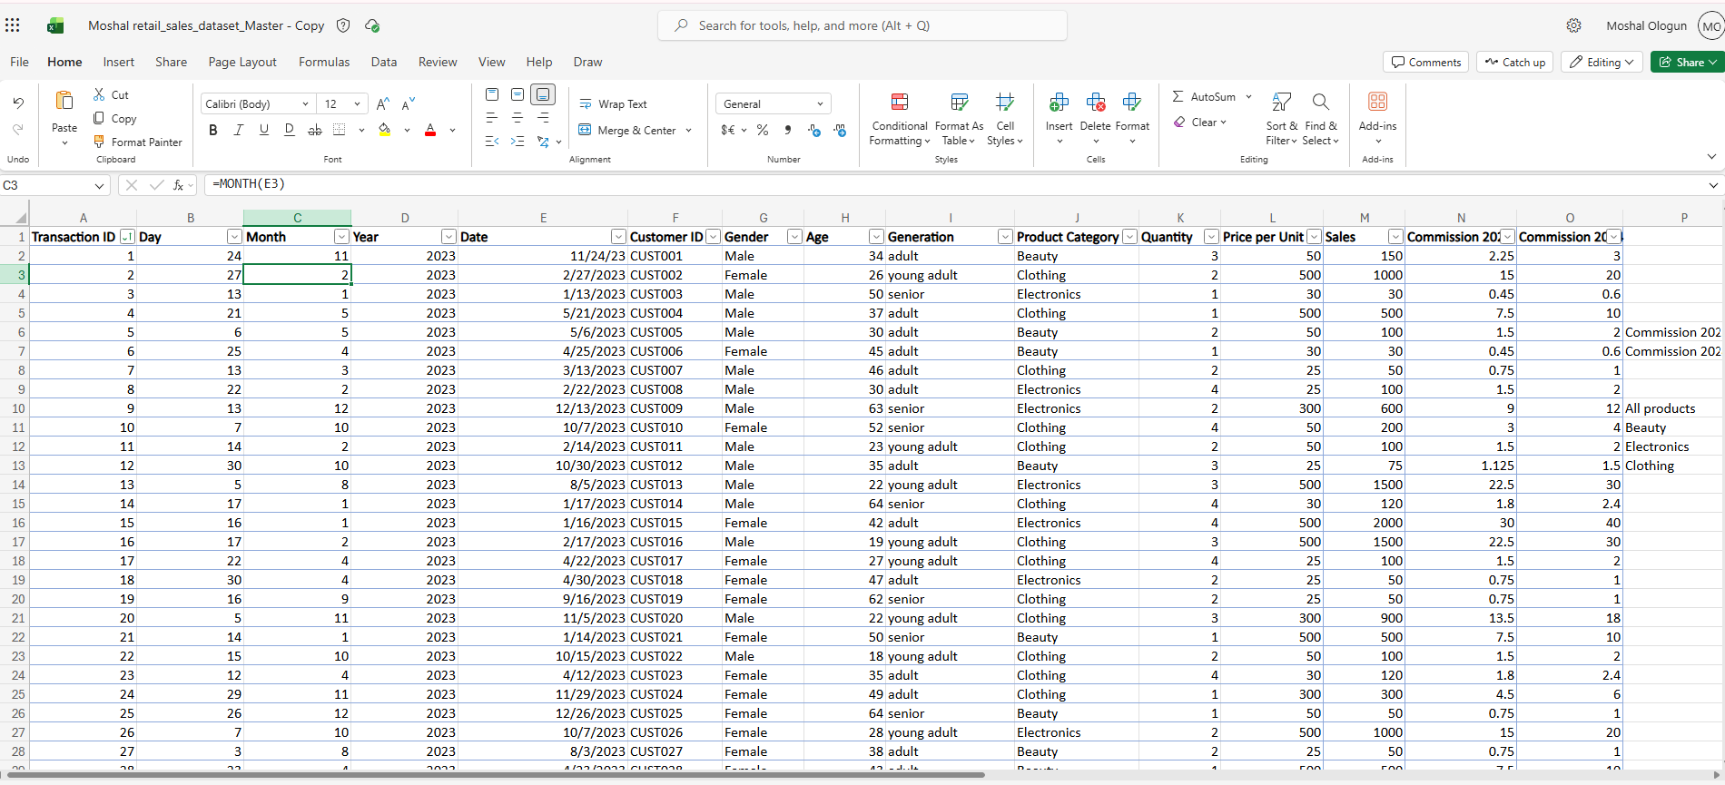
Print screen 2 | 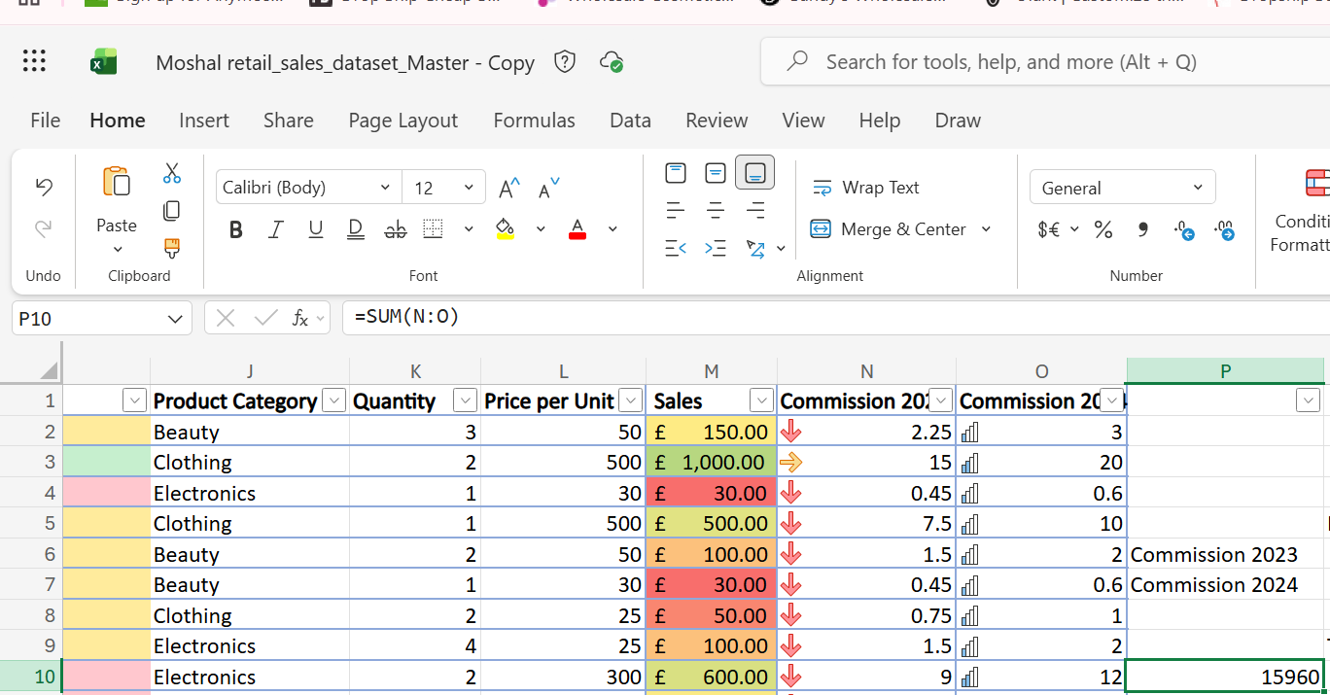
Print screen 3 | 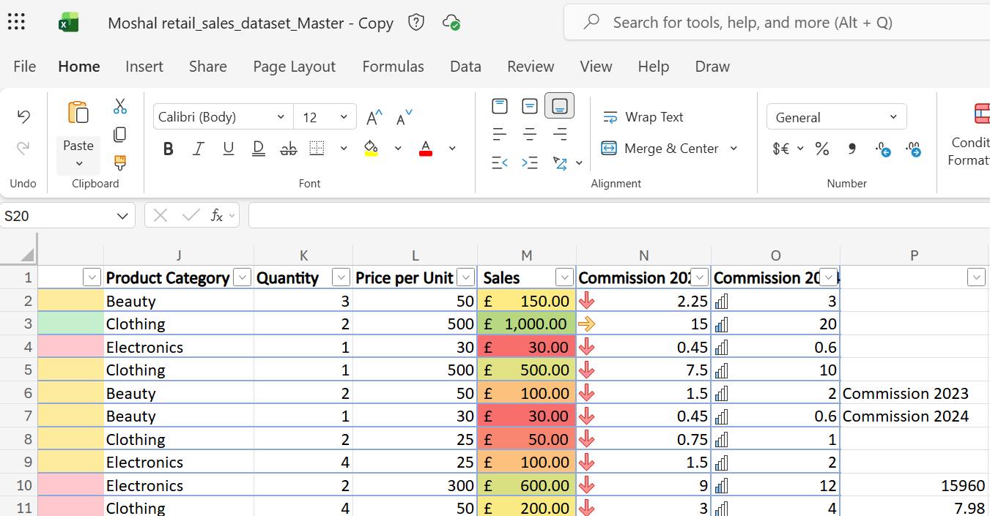

Day 2: Task 2

Using the skills developed today, have some fun with the data set you have imported. Paste your work below and enjoy!

Print screen 1 | 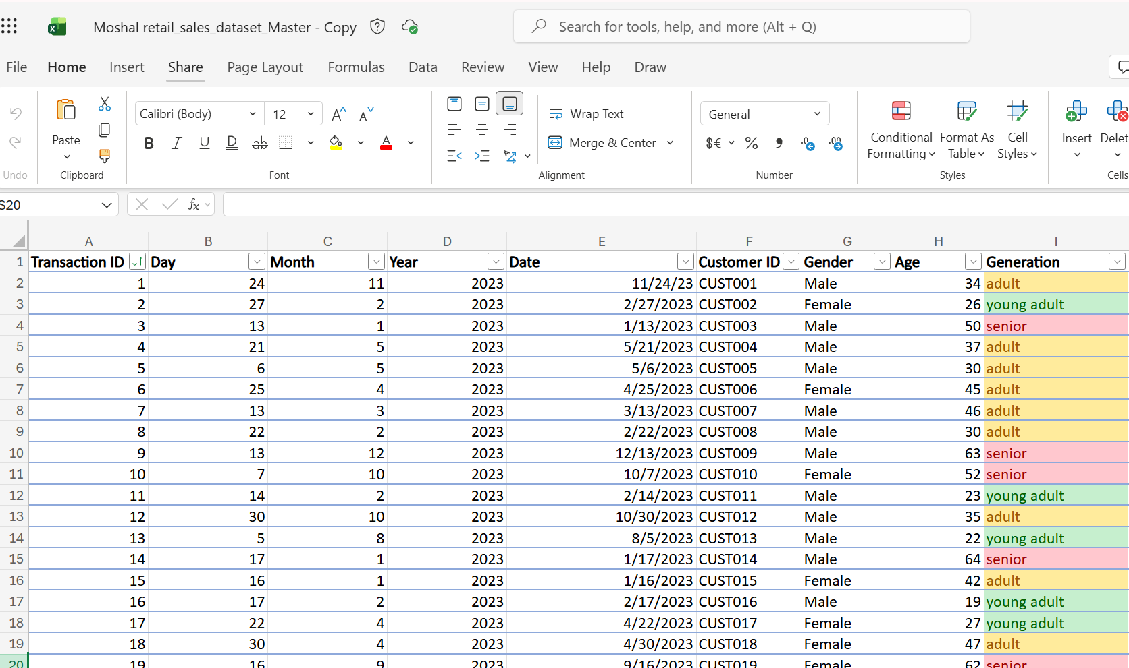
Print screen 2 | 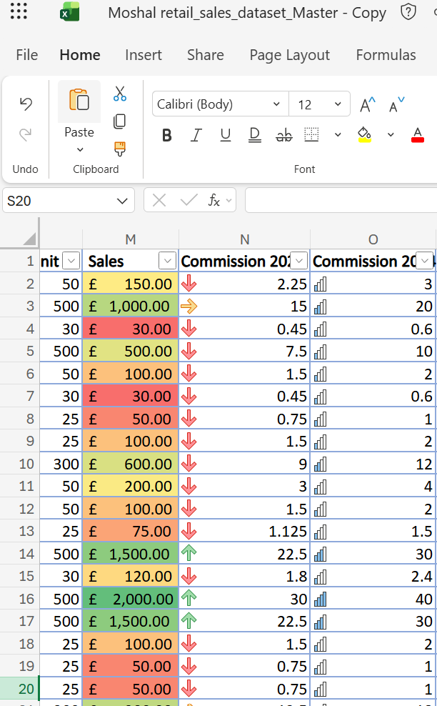
Print screen 3 | 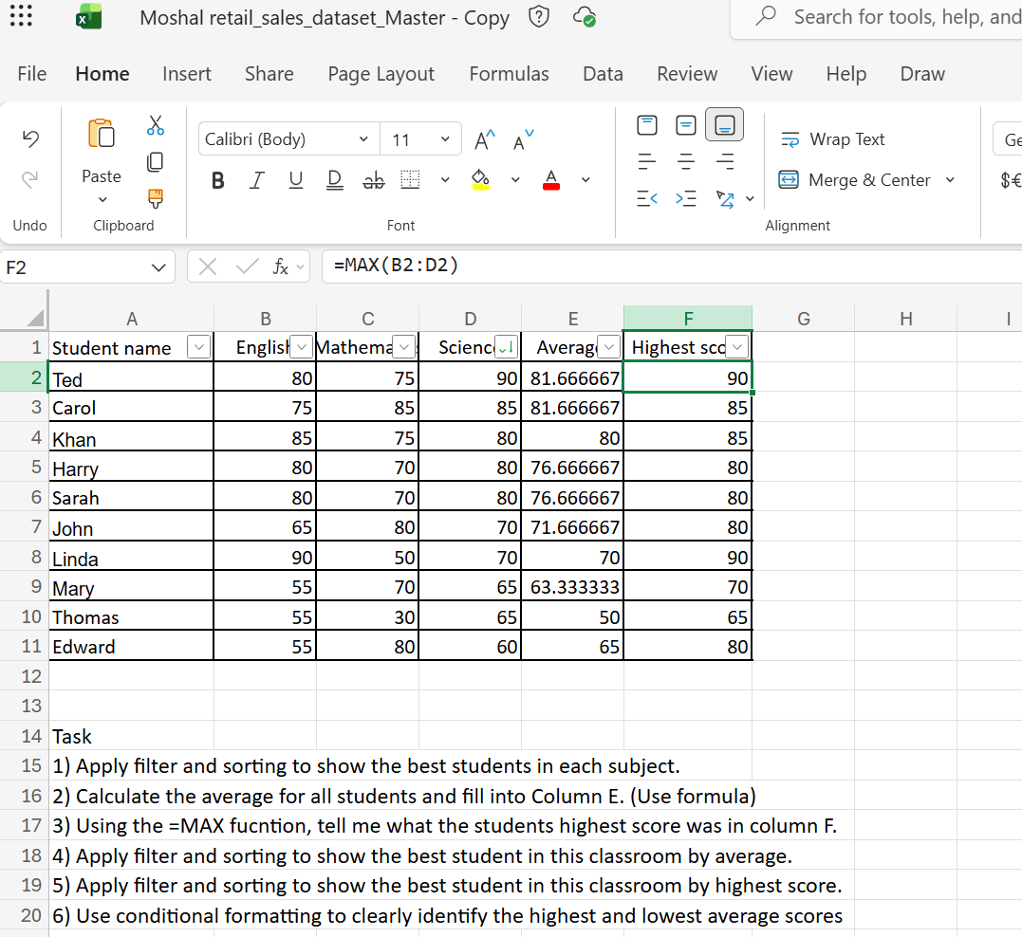
Print screen 4 | 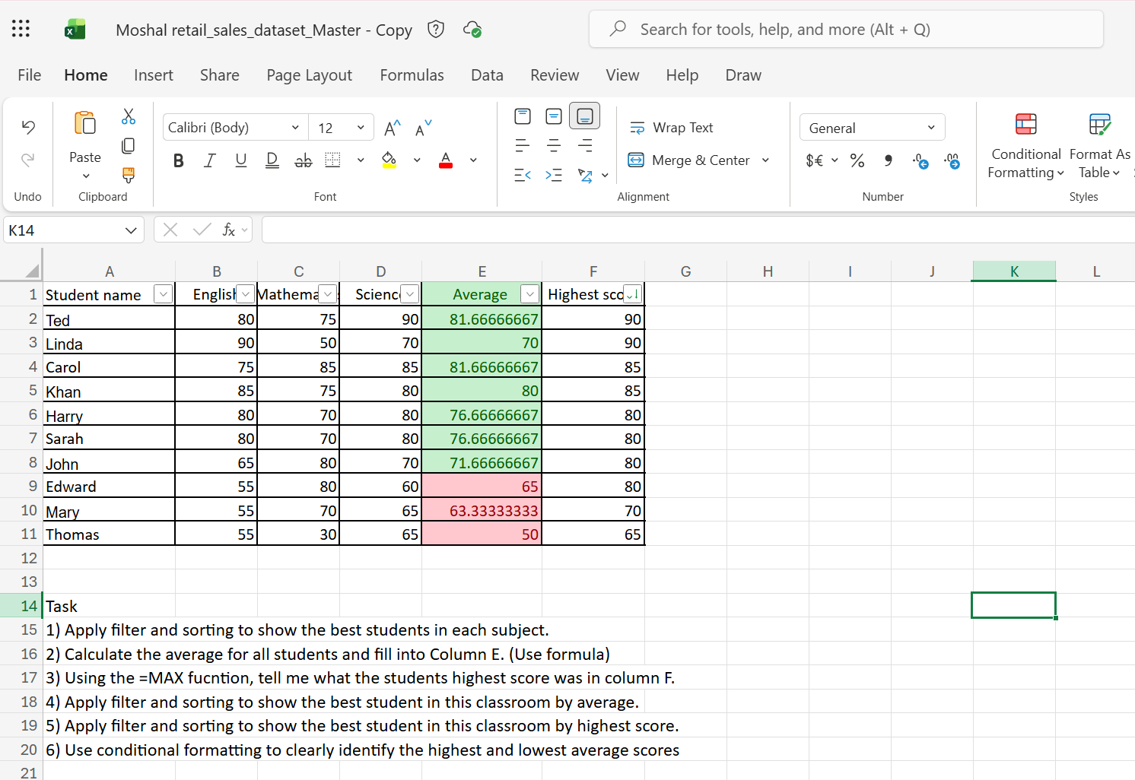

Day 3: Task 1

Please open and make an online copy of the dataset ‘Bike_Sales_Pivot_Lab.xlsx from here.

The lab instructions can be found here Bike Sales Pivot Tables.docx . Do not worry if you do not complete the lab, just working with data and playing with the pivot table will be good experience.

Please paste your final pivot table below and complete the reflection questions:

Print screen 1
In which Age Group does Germany have customers? | Germany - Adults (35-64)  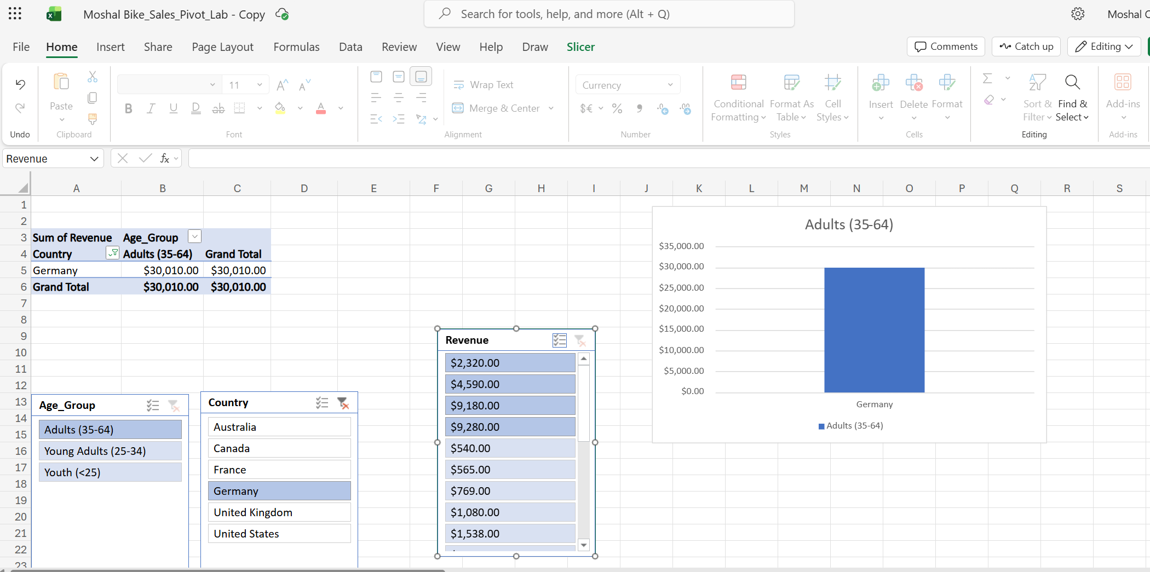
What country has sales in all markets? | Australia and United Kingdom  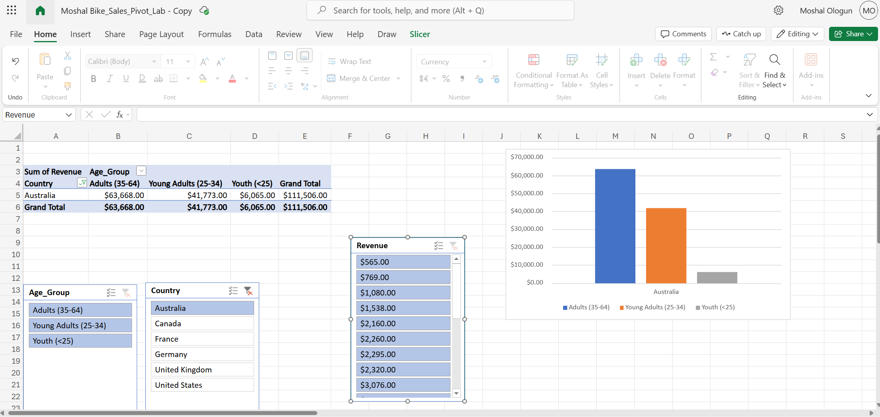  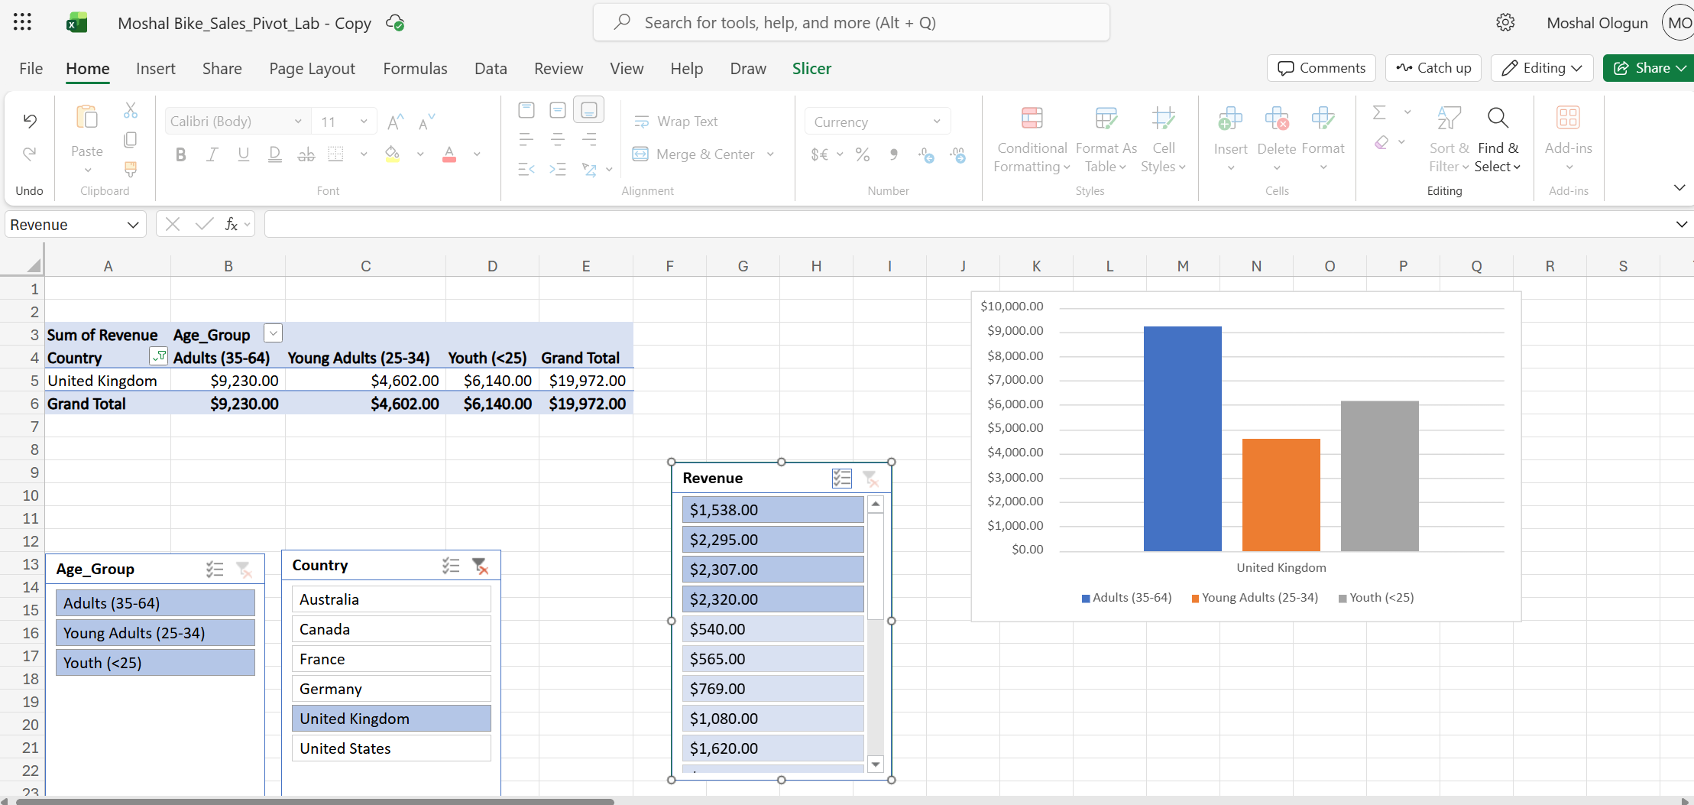
What is the most profitable country by age group, and gender? | United States  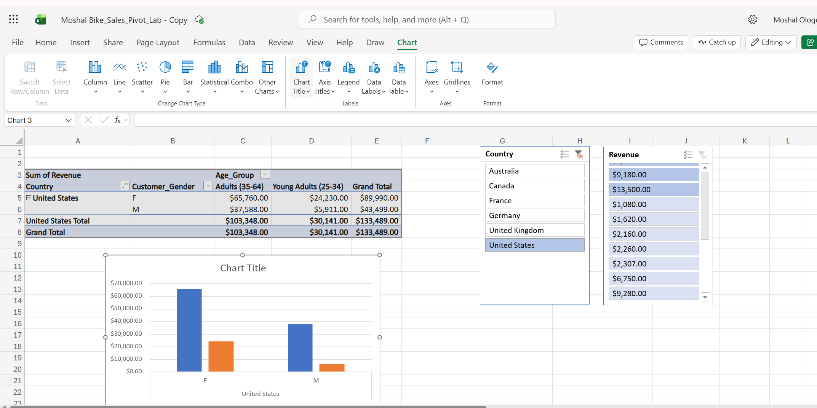
Any other findings? | Germany and Canada are the only two countries with customers within one age group

Day 3: Task 2
The dataset below tracks the sales performance of different products in various counties in England. Please paste the dataset into a blank Excel workbook. Your task is to:
- Create a Pivot Table to summarise the data by county and product.
- Use the SWITCH function to categorise products based on their sales volume.

Dataset:
County | Product | Sales Volume
Yorkshire | Laptops | 500
Yorkshire | Smartphones | 200
Cornwall | Laptops | 700
Cornwall | Printers | 400
Lancashire | Smartphones | 150
Lancashire | Laptops | 600
Essex | Printers | 800
Essex | Smartphones | 300
Durham | Laptops | 250
Durham | Printers | 300
Greater Manchester | Smartphones | 600
Greater Manchester | Laptops | 400

Step 1: Create a Pivot Table
- Select the dataset (columns A to C).
- Insert a Pivot Table to summarise the data by County in the rows and Products in the columns. Use Sales Volume as the value to be summarised.

Step 2: Use the SWITCH Function
In a new column next to your data, use the SWITCH function to categorise products based on Sales Volume as follows:
  - For sales greater than 600: "High"
  - For sales between 300 and 600: "Medium"
  - For sales less than 300: "Low"
SWITCH Function Example:
=SWITCH(TRUE, C2 > 600, "High", C2 >= 300, "Medium", "Low")

- Apply this formula to each row and check if the products are categorised correctly.

Submission:
- A completed Pivot Table summarising sales by county and product.
- A new column in the dataset categorising products by sales volume using the SWITCH function.
  - Please paste your completed work below

Print screen 1 | 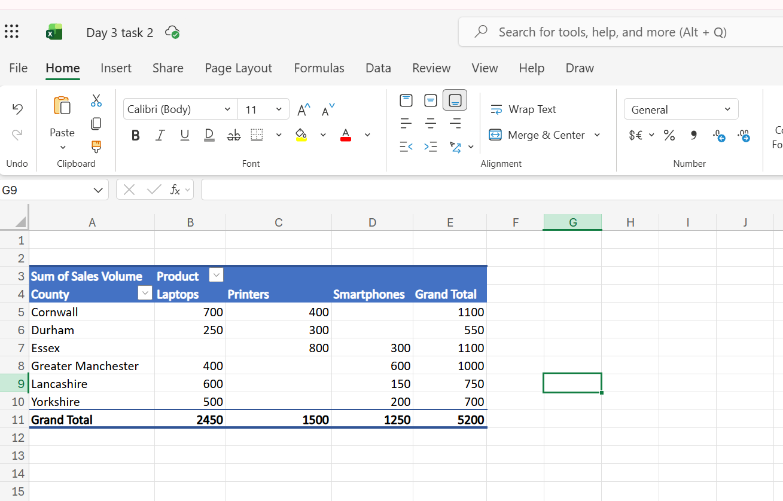  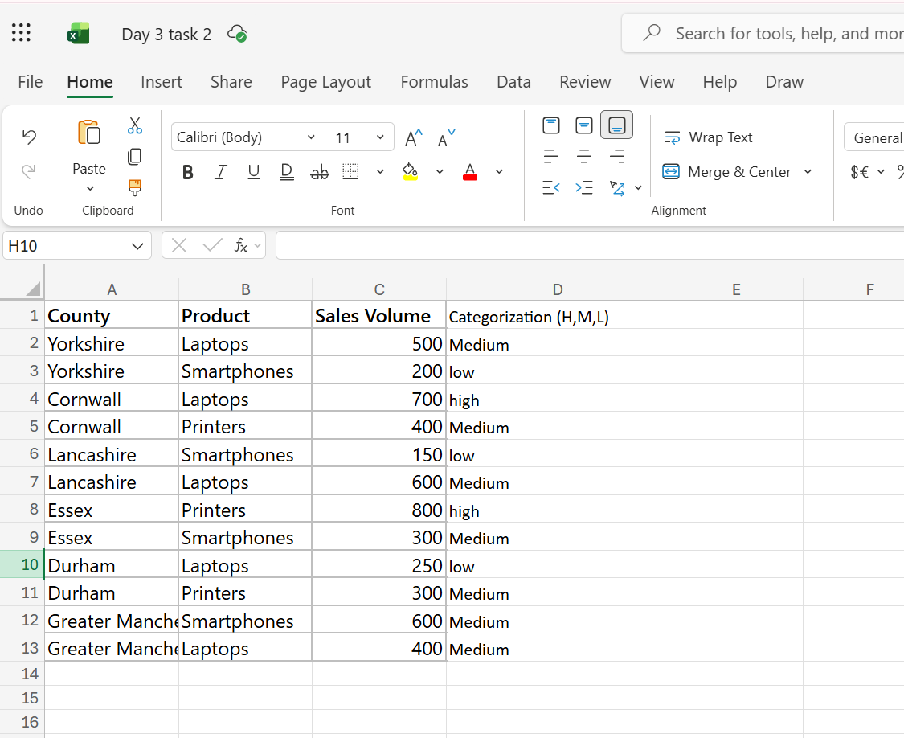  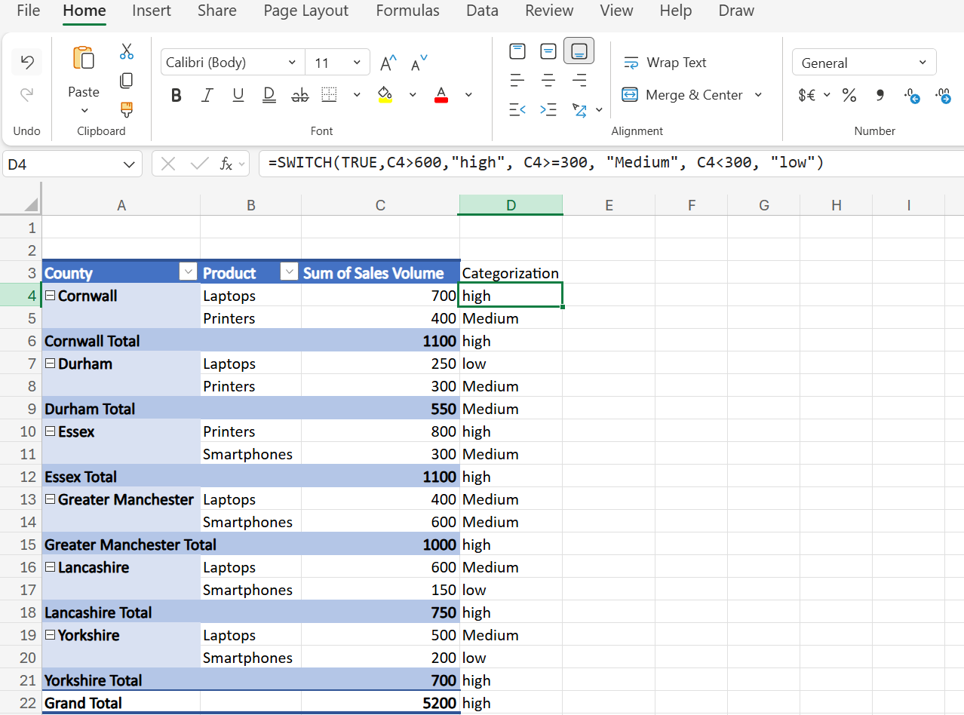

Day 3: Task 3

Please open and make an online copy of the dataset ‘Bike_Sales_Visualizations_Lab.xlsx from here.

The lab instructions can be found here Bike Sales Visualization Lab.docx. Do not worry if you do not complete the lab, just working with data and playing with the charts will be good experience.

Please paste your results below:

Print screen 1 | 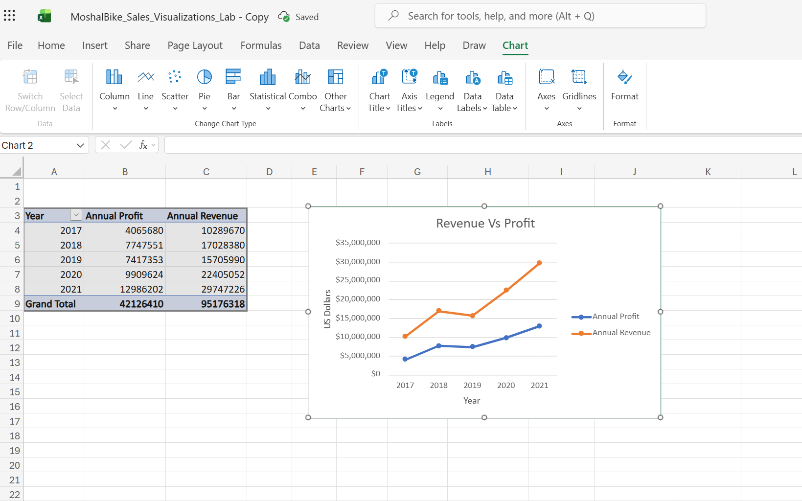  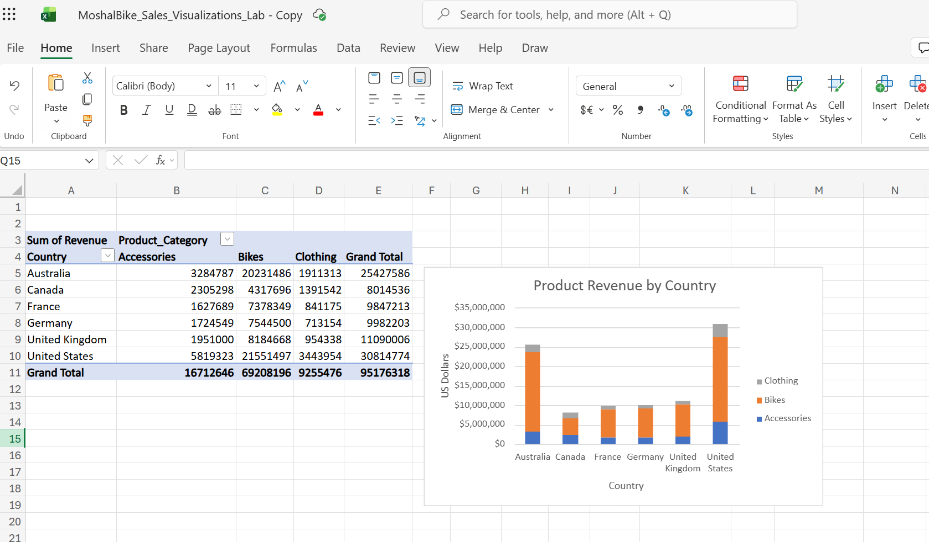  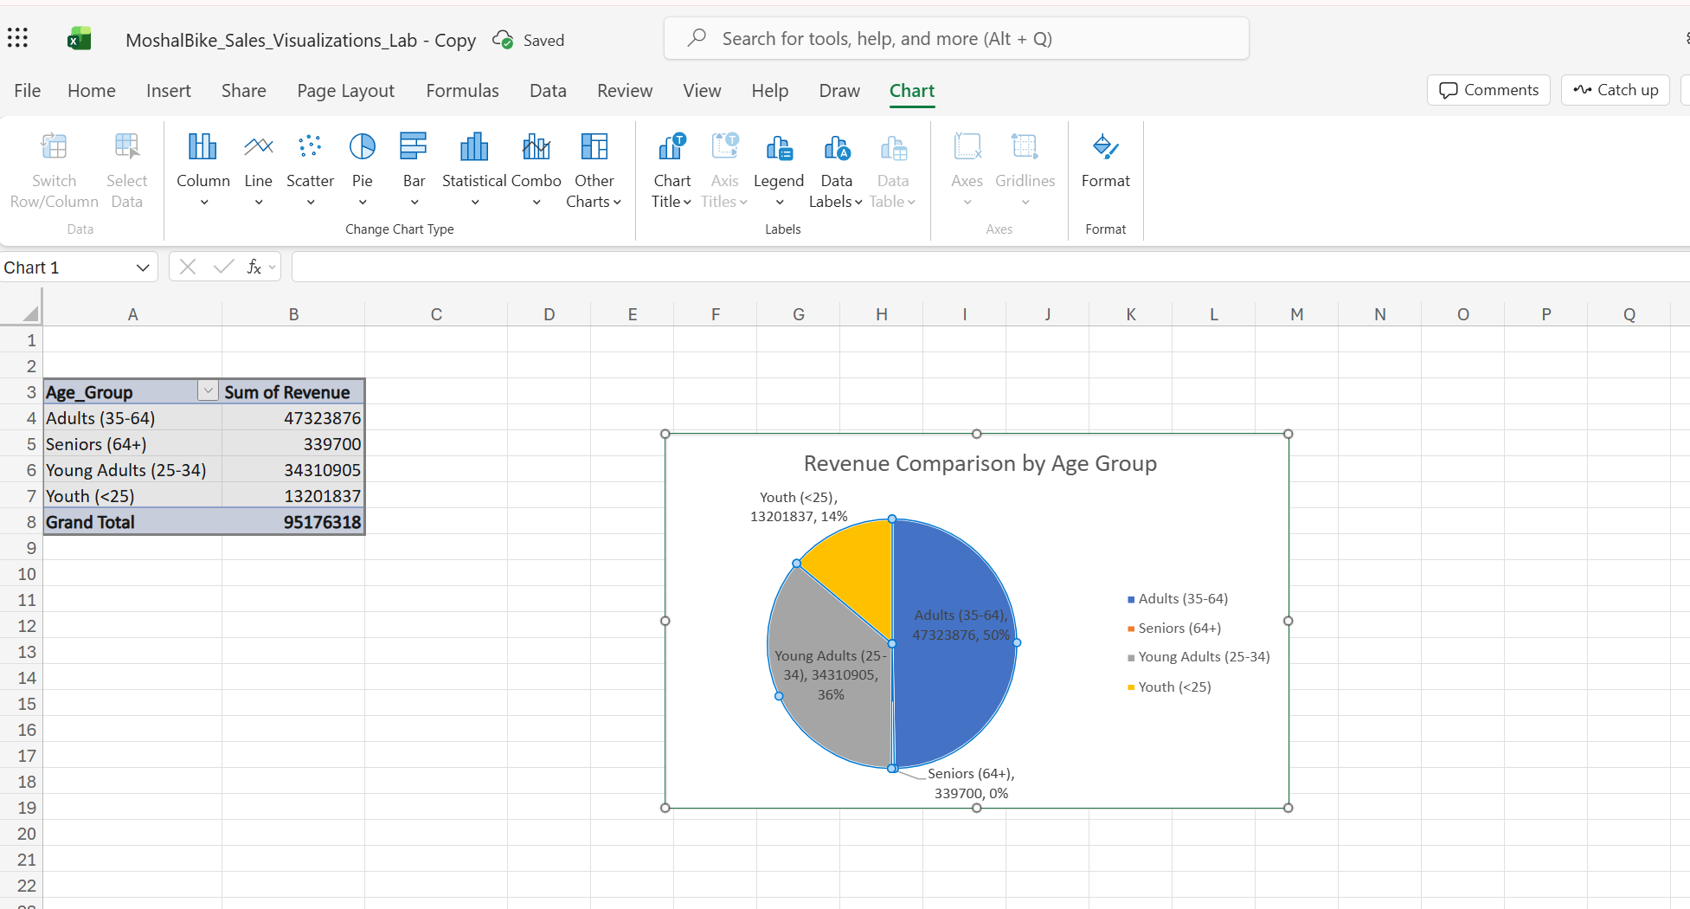

Course Notes

It is recommended to take notes from the course, use the space below to do so, or use the revision guide shared with the class:

Additional Resources
You can explore the additional resources to support your learning.

- DataCamp recommended courses.
  - Understanding GDPR - DataCamp Learn
  - Introduction to Excel - DataCamp Learn
  - Data Analysis in Excel - DataCamp Learn
  - Data Preparation in Excel - DataCamp Learn
  - Data Visualization in Excel - DataCamp Learn

- Introduction to Data Analytics Essentials
This data analytics essentials course teaches you the fundamental tools of a data analyst. You will learn to transform, organize, and visualize data with spreadsheet tools such as Excel.

- Excel Formulas and Functions Tutorial
Formulas can be used to perform simple math using +,-,*, or / to add, subtract, multiply or divide. Excel also comes built-in with over 300 functions that can be used to perform complex math, lookup values, work with text, and much more. This section will cover creating simple formulas, cell references, strings of text, and keyboard shortcuts.

- Excel Exercises Dashboard
Our bite-sized, interactive lessons make Excel skills easy to learn and remember.

- 100+ Excel Interview Questions & Answers To Make You Job Ready
This guide can also be used by interviewers who want to gauge the Excel skill of the candidates in the interview.

- ❎ How to use Excel - YouTube
In these step-by-step tutorials, learn how to use Microsoft Excel. Find out how to get started with MS Excel in under 10 minutes. Learn about Pivot Tables, formulas and functions, vlookup, shortcuts. Also, find out about the latest new features and the top tips and tricks.

- Use Excel skills (Filter, Sort, Conditional Formatting, Functions, VLOOKUP, Pivot Tables, Pivot Charts, and Slicers) to analyse global sales data and uncover key insights.
- Find exercises here Global Superstore Data Challenge.docx
- Open dataset global_superstore_2016.xlsx in Excel online and create an online copy.

- In this free Excel tutorial, learn how to create formulas and charts, use functions, format cells, and do more with your spreadsheets.
Free Excel Tutorial at GCFGlobal

Additional formation
We have included a range of additional links to further resources and information that you may find useful, these can be found within your revision guide.

END OF WORKBOOK

Please check through your work thoroughly before submitting and update the table of contents if required.

Please send your completed work booklet to your trainer by submitting in MS Teams Assignment page.

