Surrogate screening of trace metals in Bangladesh groundwater: a single iron measurement outperforms a fitted model on unseen districts

Abstract
Monitoring trace metals in groundwater requires laboratory instrumentation that is scarcest where contamination is most widespread. Whether parameters a field team can measure can stand in for that analysis has not been tested under validation accounting for spatial structure, left censoring and transfer. Using 271 wells of the BGS and DPHE National Hydrochemical Survey of Bangladesh, with external validation on 1,027 wells in fifteen unseen districts, we screened thirteen trace metals across five predictor tiers ordered by cost. Six metals proved unmodellable because the laboratory reported a detection limit rather than a measurement in up to 97 % of wells. Censoring also works in the opposite direction: an analysis that ignores the censoring flag classifies 65 wells as nitrate reducing where only 2 meet the criteria, and reports log-scale predictive skill that disappears when scoring is restricted to measured wells. Spatial blocking cut feasible target and tier combinations from 23 to 10; nickel, rated at R² = +0.288 under random folds, fell to -0.204. On unseen districts no model retained concentration skill, but exceedance ranking transferred, and the fitted model was not what carried it. A single dissolved iron measurement ranked wells better than the model built on iron, manganese and depth, 0.891 against 0.828 (1.8e-08), missing fewer contaminated wells at every laboratory burden, while on the development wells the ordering reversed (0.867 against 0.742). Split conformal intervals held 89.8 % to 91.7 % coverage locally but 72.7 % to 99.0 % on transfer. Surrogate screening orders wells usefully without quantifying them, and the fitted model earns nothing over the cheapest measurement it contains.
Keywords: groundwater; trace metals; left-censored data; spatial cross validation; conformal prediction; Bangladesh

1. Introduction
Groundwater supplies most drinking water across rural Bangladesh and West Bengal, and its trace metal content remains a persistent public health concern [1,2]. Arsenic is the best characterised of these metals. Concentrations exceeding the World Health Organization guideline of 10 µg L⁻¹ occur across large parts of Bangladesh and West Bengal, and the exposed population is counted in tens of millions [1–3]. Other trace metals including cadmium, nickel, lead, uranium and molybdenum are reported far less consistently. Regional assessments conducted across the Bengal Basin and comparable alluvial and deltaic settings reach divergent conclusions as to whether these metals approach drinking water standards. Cadmium has been reported well above permissible limits on the southeastern coast of Bangladesh [4] and identified as a principal contributor to health risk in another regional assessment [5], while other investigations in comparable settings report it at or below detection [6,7]. Comparable inconsistency attends lead, chromium and nickel [8–10]. The question of which trace metals constitute a genuine hazard in a given aquifer therefore remains, for metals other than arsenic, partly unsettled.
The geochemical mechanism that governs arsenic is well established. Arsenic is released into solution by reductive dissolution of iron oxyhydroxides, a process driven by microbial oxidation of sedimentary organic matter, so that dissolved arsenic rises together with dissolved iron and bicarbonate in reducing aquifers [11–14]. Arsenic concentration therefore depends strongly on redox condition, and classification frameworks built on dissolved oxygen, nitrate, manganese, iron and sulfate have become standard tools for describing that dependence [15,16]. Whether comparable geochemical controls render other trace metals similarly inferable has not been examined systematically.
Quantifying trace metals at regulatory concentrations requires inductively coupled plasma methods or atomic absorption spectrophotometry, with ion chromatography or titration for the major ions. A survey of sixteen recent assessments of groundwater quality across the Bengal Basin and comparable settings elsewhere in South Asia and in the Pearl River Delta finds this to be the universal practice [4–10,17–25]. Each determines its metals in the laboratory, generally alongside a complete major ion panel, and the field instrumentation appearing in these studies is confined to pH, electrical conductivity and total dissolved solids, which are reported as descriptive variables rather than used to infer anything further. Analysis is accordingly descriptive and index based, drawing on water quality indices, heavy metal pollution indices, principal component analysis and health risk quotients. None of the sixteen builds a predictive model from measured water parameters; where spatial prediction appears, it is interpolation of the measured concentrations themselves. Laboratory determination is accurate, but the expense constrains both how many wells a monitoring programme can cover and how often it can revisit them.
Arsenic constitutes a partial and instructive exception. Colorimetric field kits for arsenic cost approximately USD 0.17 per test at bulk procurement and perform creditably against laboratory determinations, correctly classifying 88 % of 799 wells in one evaluation, with errors concentrated in the 50 to 100 µg L⁻¹ range [26,27]. Blanket kit testing nonetheless represents a recurring rather than a one time expense, because new tubewells continue to be installed and must subsequently be tested [28]. Two implications follow. First, inexpensive field determination is demonstrably valuable, so the question is not whether low cost screening is worth pursuing. Second, the arsenic kit is analyte specific. No equivalent exists for cadmium, nickel, lead, uranium or molybdenum, and a separate consumable would be required for each. A surrogate approach is attractive precisely because a single set of field measurements might inform several metals simultaneously, provided that such inference is in fact possible. Establishing whether it is constitutes the aim of the present study.
Machine learning has become routine in groundwater arsenic research. Predictive models have been constructed at global [3], national [29–32] and district scales [33,34], and geomorphological descriptors such as abandoned river channels have been proposed to improve hotspot identification [35]. Most of these studies share a common structure. They predict a single metal, usually the probability that arsenic exceeds a guideline value, from geospatial covariates such as climate, soil properties, geology, elevation and well depth, and their output is a hazard map indicating where testing should be prioritised. The principal exception is instructive. Tan et al. [30] added laboratory hydrochemistry to 90 geo-environmental predictors for Bangladesh and found phosphorus and iron to be among the most important variables at every spatial scale, which is consistent with the reductive dissolution mechanism, but the added inputs are themselves laboratory determinations.
That objective differs from the one pursued here. A hazard map conveys nothing about the particular well in front of a field team on the basis of measurements obtainable at that well, because its predictors are not quantities a technician measures but layers attached to a location. Earlier geostatistical treatments share this limitation, and spatial interpolation has been shown to underestimate arsenic systematically at unsampled locations [36], an outcome consistent with the observation that arsenic varies over tens to hundreds of metres in response to the thickness of overlying fine grained sediments [37,38]. Prediction of trace metals from water chemistry itself has also been proposed, generally using major ions or electrical conductivity as inputs [39–42]. This body of work typically addresses one to three targets, evaluates on random partitions, and, significantly for any argument about cost, relies on inputs that are themselves laboratory determinations. A complete major ion panel does not constitute a low cost measurement.
A second limitation concerns uncertainty. Groundwater machine learning studies commonly report point predictions or class probabilities, an omission noted from within the field itself [43]. Where intervals are reported they are quantile, bootstrap or Bayesian constructions lacking a finite sample coverage guarantee [32,43,44], dispersion of ensemble votes [33], or confidence statements attached to population totals rather than to individual wells [31]. Conformal prediction offers a principled alternative, furnishing distribution free intervals with finite sample marginal coverage that wrap any underlying model [45–48]. We are not aware of its application to the prediction of trace metal concentrations in groundwater. The guarantee it provides is conditional on exchangeability, an assumption that spatial data violate. Recent theoretical work quantifies the coverage loss incurred when exchangeability fails [49], restores validity under covariate shift through likelihood ratio reweighting [50], and argues that spatial data are at best locally exchangeable [51,52]. How far a conformal guarantee survives transfer to an unseen district remains, to our knowledge, unmeasured in this setting.
Two further practices distort results in ways that are easily overlooked. The first concerns censoring. Trace metal datasets are left censored, since values falling below the analytical detection limit are reported only as being below that limit. Substitution of half the detection limit remains a common default, notwithstanding long standing evidence that it biases estimates and can manufacture structure absent from the data [53–55] and notwithstanding guidance discouraging the practice above modest censoring rates [56]. Established alternatives exist. Regression on order statistics accommodates multiple detection limits [57], censored regression dates to Tobin [58], and these approaches have been compared against uncensored ground truth [59]. In predictive groundwater work the more common response is to avoid the problem by converting concentrations into exceedance classes. Several of the arsenic models above binarise at a guideline value, in some cases explicitly because a large share of measurements fell below reporting limits or because analytical precision differed among data sources [3,32,33]. This is defensible for hazard mapping, but it discards the concentration information that screening an individual well requires, and it offers no route for metals whose measured values mostly lie below the detection limit. The second practice concerns validation. Random cross validation is optimistic when samples exhibit spatial dependence, and blocked designs constitute the standard correction [60,61]. The magnitude of the effect is not trivial, since random folds have been shown to conceal near zero predictive skill in ecological applications [62]. Models should additionally be assessed for whether a new sample falls within the feature space on which they were trained [63].
Table 1. Predictive studies of trace metals in groundwater, characterised by target, predictor class, validation design, the form in which uncertainty was reported, and the treatment given to values below the detection limit. Studies were identified through a targeted, non-exhaustive search. Each entry was checked against the source listed in the final column; n.r. means not reported in that source. The final row describes the present study.
Study | Region | Target | Predictors | Validation | Uncertainty | Below-DL treatment | Checked against
Podgorski and Berg (2020) [3] | Global | P(As > 10 µg/L) | Geospatial | Stratified random 80/20 holdout; deep-well (>100 m) test set | Class probability | Binarised; stated reason: unequal analytical precision | Full text
Podgorski et al. (2020) [29] | India (with BD, NP, PK data) | P(As > 10 µg/L) | Geospatial | n.r. | Class probability | Binarised | Abstract
Tan et al. (2020) [30] | Bangladesh | P(As > 5, 10, 50 µg/L) | Geospatial + laboratory hydrochemistry | Repeated random 10-fold CV | Class probability | Binarised | Abstract, excerpts
Nath et al. (2022) [33] | Murshidabad, West Bengal | P(As > 10 µg/L) | Geospatial | Stratified random 70/30; 10-fold CV; area of applicability checked | Class probability; SD of tree votes | Binarised; stated reason: analytical uncertainty | Preprint full text
Khatun et al. (2024) [34] | Chapainawabganj, Bangladesh | As class | n.r. | n.r. | Accuracy only | Classification target | Abstract
Shamsudduha et al. (2015) [38] | Bangladesh, national | As concentration | Hydrogeological, geospatial | n.r. | n.r. | Non-detects acknowledged; treatment n.r. | Abstract, introduction
Hossain et al. (2007) [36] | Bangladesh, BGS/DPHE | As concentration | Location (kriging) | Monte Carlo random subsampling | Point estimate | n.r. | Abstract
Ayotte et al. (2017) [31] | USA | P(As > 10 µg/L) | Geospatial | Train/test | CI on population total | Binarised | Abstract; Lombard et al.
Lombard et al. (2021) [32] | USA | P(As > 1, 5, 10 µg/L); class | Geospatial | Stratified random 70/30; 10-fold CV tuning | Bootstrap CI on probability | Binarised; stated reason: 45 % of wells below reporting limit | Full text
Ghadimi (2015) [39] | Arak, Iran | Pb, Zn, Cu | Laboratory major ions (HCO₃, SO₄) | Train/test | None | n.r. | Abstract
Ghadimi (2017) [40] | Arak, Iran | Pb, Zn, Cu | Laboratory major ions (HCO₃, SO₄) | Train/test | None | n.r. | Abstract
Khosravi et al. (2021) [41] | Campania Plain, Italy | As, Ba, Rb | EC, pH + laboratory major ions | Random 70/30 holdout | None | n.r. | Abstract
Bui et al. (2020) [42] | Italy | NO₃, Sr | Laboratory water quality variables | Holdout (173/73) | None | n.r. | Abstract
This study | Bengal Basin, BGS/DPHE | 13 trace metals screened, 7 modelled | Field measurable, tiered by cost | Random, spatially blocked and external | Conformal, with transfer tested | Four treatments compared | —

Counting across the thirteen prior studies summarised in Table 1 gives the following picture.
Table 2. Summary of practices across the thirteen reviewed studies, counted from Table 1.
Property | Studies | Share
Predict a single metal | 9 of 13 | 69 %
Use only geospatial or locational predictors | 7 of 13 | 54 %
Use any laboratory-measured predictor | 5 of 13 | 38 %
Use only field measurable predictors | 0 of 13 | 0 %
Report spatially blocked validation | 0 of 13 | 0 %
Test on an independent set beyond the training domain | 1 of 13ᵃ | 8 %
Report per-well intervals with evaluated coverage | 0 of 13 | 0 %
Binarise the target or predict a class | 7 of 13 | 54 %
Of six concentration models, state a below-DL treatment | 0 of 6ᵇ | 0 %

ᵃ Podgorski and Berg (2020) tested on wells deeper than 100 m, which were excluded from training. ᵇ Shamsudduha et al. (2015) acknowledge non-detects; the treatment was not identified in the source consulted.
Two qualifications are owed. First, each entry reflects the source consulted. Where only the abstract was accessible, absence of a design element means that it was not reported there, not that it was necessarily absent from the study. Second, for the seven studies that predict an exceedance class, the treatment of values below the detection limit is of limited consequence for their stated objective, and three of them make this choice explicitly. The omission matters for the six studies that model concentration directly. Of these, one acknowledges the presence of non-detects and none, in the sources consulted, states how they were treated.
The broader pattern is nonetheless consistent. Predictive work on trace metals in groundwater has concentrated on mapping a single analyte from geospatial covariates, has validated on random or simple holdout partitions, has reported class probabilities or intervals without a coverage guarantee, and has handled observations below the detection limit either by binarising the target or not at all. None of these choices is indefensible in isolation, and several are appropriate to the questions those studies set themselves. Taken together, however, they leave open precisely the questions posed here, namely whether field measurable parameters can substitute for laboratory analysis across several metals at once, how much of the reported skill survives honest spatial and external validation, and whether uncertainty can be quantified in a manner that remains valid outside the area in which it was calibrated.
The present study addresses the question these literatures leave open. Stated directly, that question is the following.
Which trace metals in groundwater can be predicted from parameters that are inexpensive to measure in the field, at what measurement cost, and what determines the limit of that predictability?
The question is approached through four subsidiary questions, each corresponding to a stage of the analysis reported below.
RQ1. Which of the trace metals present in the dataset carry sufficient measurable variation to permit modelling at all, and what distinguishes those that do from those that do not?
RQ2. For the metals that pass that screening, how much predictive skill do field measurable parameters provide, and how does that skill scale with the cost of acquiring the measurements?
RQ3. Can conformal prediction furnish calibrated uncertainty intervals at this sample size, and does their validity survive transfer to wells outside the area in which they were calibrated?
RQ4. To what extent does the prevailing practice of substituting half the detection limit distort the conclusions relative to censoring aware alternatives?
Underlying these questions is a testable hypothesis, namely that the binding constraint on surrogate screening is analytical rather than geochemical, that is, that detection limits rather than geochemical predictability determine which metals admit such screening. The hypothesis is falsifiable in that it predicts that metals with low censoring should prove modellable irrespective of their geochemical behaviour, and that heavily censored metals should prove unmodellable irrespective of how strongly they are controlled by the measured field parameters.
To this end the study employs 271 wells from the special study areas of the British Geological Survey and Department of Public Health Engineering national survey [1], the only component of that survey carrying field measured pH, redox potential, specific conductance, dissolved oxygen and dissolved organic carbon alongside a laboratory trace metal suite. Candidate predictors are organised into tiers reflecting what their acquisition actually costs, ranging from a multiparameter field meter alone through the successive addition of colorimetric test kits and titrimetric determinations, so that predictive performance may be read against expenditure.
This study proposes four contributions, each addressing one of the questions set out above. First, and in answer to RQ1, it reports a multi metal feasibility audit in which thirteen metals are screened against pre specified criteria, seven are carried into modelling and six are excluded because censoring leaves insufficient information for any method to exploit. Negative results are reported rather than omitted. Second, addressing RQ2, it reports predictive performance across cost tiers under random, spatially blocked and fully external validation side by side, rendering visible the proportion of apparent skill attributable to spatial autocorrelation rather than to chemistry. Third, addressing RQ3, it evaluates conformal prediction intervals on held out partitions rather than on the residuals used to calibrate them, and then examines how far their validity transfers to 1,027 independent wells situated in fifteen districts the models never encountered. Fourth, addressing RQ4, it quantifies the cost of standard practice by comparing substitution of half the detection limit against censoring aware alternatives evaluated on identical folds.
The principal finding is that surrogate screening is feasible for a minority of trace metals; that the detection limit sets a ceiling on which metals can be modelled at all, while below that ceiling feasibility is decided by whether the field measurable predictors carry information about the metal; and that what transfers to unseen districts is the ranking of wells by risk rather than their concentrations, while conformal intervals that are well calibrated within the study area lose their validity in an unpredictable manner upon transfer.

2. Materials and methods

2.1 Study area and data
The analysis uses the special study areas component of the National Hydrochemical Survey conducted jointly by the British Geological Survey and the Department of Public Health Engineering between 1998 and 1999, released in 2001 [1]. The survey is publicly available and its reuse requires acknowledgement of the funding and implementing partners.
Of the components released, only the special study areas carry field measured redox potential, dissolved oxygen and dissolved organic carbon alongside a laboratory trace metal suite, and this component is therefore used as the development set. It comprises 271 wells distributed across four districts, namely Nawabganj (125 wells), Lakshmipur (74), Faridpur (64) and Noakhali (8). Each record carries surveyed well coordinates rather than administrative centroids, together with well type, reported installation depth and the administrative hierarchy.
A second component, the national survey restricted to the sixteen districts of North Bengal, provides an independent test set. Nawabganj is the single district common to both components, and eleven development wells lie within 500 m of a national survey well, so Nawabganj is removed in its entirety from the external set. The remaining 1,027 wells occupy fifteen districts that the models never encounter during fitting, and the shortest distance between any development well and any external well is 1.64 km, which is asserted at run time rather than assumed.
These study areas were selected by the original survey because they are arsenic affected, so the exceedance rates reported here are not national prevalence figures. The design question is one of feasibility rather than of prevalence, and this selection does not compromise it. The data date from 1998 to 1999 and describe conditions at that time.
Maps are drawn over the national boundary, district lines, rivers and coastline supplied as reference files with the same survey, which the publisher describes as approximate and not intended for precise mapping. A companion file classifies every national survey site by surface geology after Alam et al. (1990), and is used in Section 2.8.
Samples were filtered and acidified in the field and the trace metals determined by inductively coupled plasma mass spectrometry, with the major ions by ion chromatography and titration, under the quality control described in the survey report. Every metal used here is therefore a laboratory determination, which matters for the cost tiers and is taken up in Section 2.4.
The data were collected in 1998 and 1999. This is the only component of the survey that carries field pH, redox potential, dissolved oxygen and dissolved organic carbon alongside a full trace metal suite, which is why it is used despite its age. The question asked here is whether one class of measurement can substitute for another, and that relation is a property of the analytical chemistry rather than of the year. Concentrations at individual wells will have changed; the feasibility question has not.
Figure 1 summarises the flow of data through the analysis, and Figure 2 shows the two sets of wells against those boundaries.
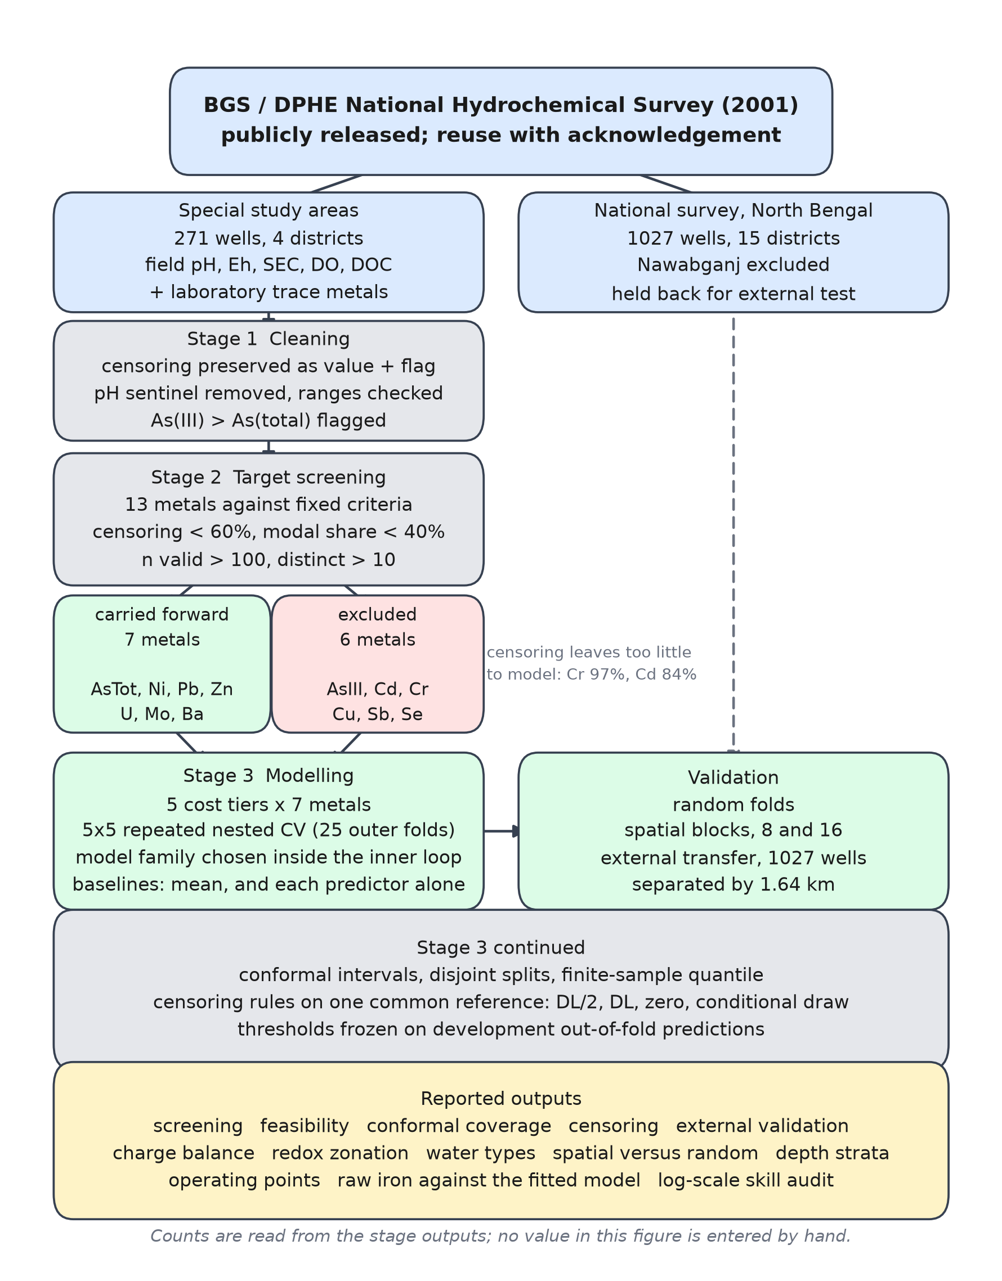
Figure 1. Data and analysis workflow from the published survey through cleaning and preprocessing to the reported tables.
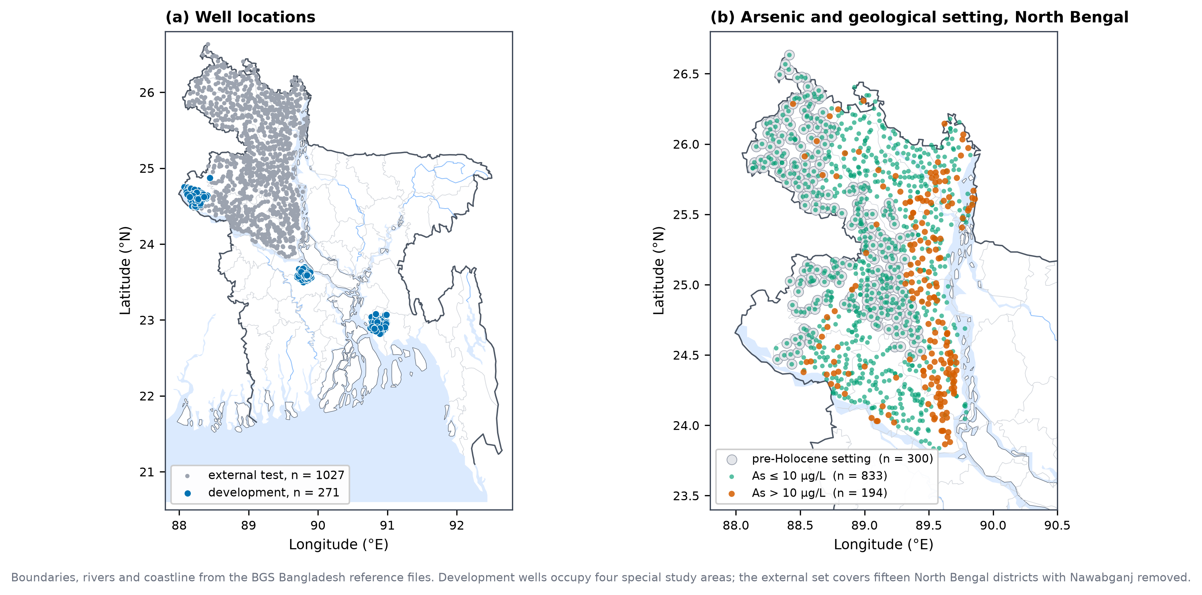
Figure 2. Study area showing development wells in four special study areas and external wells across North Bengal.

2.2 Data preparation
Every measured column is parsed into a numeric value together with a Boolean censoring flag. Where the survey reports a value as falling below the analytical detection limit, the numeric column retains that limit and the flag is set, so that no substitution rule is embedded at the point of reading. This matters because the comparison in Section 2.7 requires the original censoring structure to remain recoverable, which substitution would destroy irreversibly [53].
Three further checks are applied. Values of pH equal to zero are a missing value sentinel in this file rather than measurements and are converted to missing. Numeric columns with a defined plausible range, namely pH, redox potential, specific conductance, temperature, dissolved oxygen, well depth and the coordinates, are checked against that range and any value outside it is set to missing and recorded. Arsenic speciation is checked for internal consistency, since As(III) cannot exceed total arsenic; seven wells violate this and are flagged rather than deleted, so that the count is available as a data quality statement and the affected records can be excluded from speciation analysis alone.
Detection limits are recorded per determinand. Several columns carry more than one limit, reflecting analysis in separate batches: total arsenic has two (0.5 and 6.0 µg/L), As(III) has three, and lead, uranium and antimony have two each. This is retained in the metadata because pooling observations censored at different limits introduces an artificial step into the lower tail.
Major ions, minor anions and the stable isotopes are cleaned on identical terms but are held apart from both the predictor and the target sets, since they require laboratory analysis and their use as predictors would defeat the purpose of the study. They are used only for the hydrogeochemical characterisation described in Section 2.8.

2.3 Target screening
Thirteen trace metals are screened against criteria fixed before any model was fitted. A metal proceeds to modelling only if fewer than 60 % of its observations are censored, no single value accounts for more than 40 % of records, at least 100 valid measurements are present, and at least ten distinct values occur.
The modal share criterion is included because a censoring percentage alone can conceal a near constant column. Antimony, for instance, is 46 % censored yet 46 % of all records sit on the single value 0.02 µg/L, which is its detection limit, and As(III) places 43 % of records on 6.0 µg/L. Neither carries sufficient variation for any estimator to exploit, irrespective of the underlying geochemistry.
A qualification applies to the tiers throughout. Iron and manganese in this survey are inductively coupled plasma determinations on filtered and acidified samples, not colorimetric field kit readings, and pH and redox potential were measured with laboratory grade meters rather than under field conditions. The tiers therefore describe the information content of a set of determinands, not the performance of any particular instrument, and every result below is an upper bound on what a field team would achieve with kits of coarser resolution.
Seven metals satisfy all four criteria and are carried forward: total arsenic, nickel, lead, zinc, uranium, molybdenum and barium. Six are excluded: As(III), cadmium, chromium, copper, antimony and selenium. The outcome of this screening is reported as a result rather than as a preliminary step, since the pattern of exclusion is itself informative. Chromium is 97 % censored and cadmium 84 %, which places both beyond the reach of any method.

2.4 Predictor tiers
Predictors are grouped into nested tiers by what their acquisition costs in the field, so that performance can be read against expenditure rather than against an undifferentiated feature set. Tier E1 contains the four determinands obtainable from a multiparameter field meter alone, namely pH, redox potential, specific conductance and temperature. Tier E2 adds iron and manganese from colorimetric field kits. Tier E3 adds chloride and bicarbonate by titration. Tier E4 adds the reported well depth, which is obtained from the installation record at no cost. A fifth set, denoted REF, includes every determinand in the dataset that does not require inductively coupled plasma mass spectrometry, including the heavily censored nitrate and dissolved oxygen columns. REF is not field deployable and serves as a ceiling against which the deployable tiers are compared.
Complete cases number 254 for E1 and E2, 253 for E3, 243 for E4 and 229 for REF. Wells are not dropped on that account: median imputation is fitted inside each training fold, so every tier is scored on the full set of wells carrying a target value, which is why the feasibility matrix in Section 3.4 reports n = 271 throughout. Figure 3 sets out the tiers alongside the validation schemes.
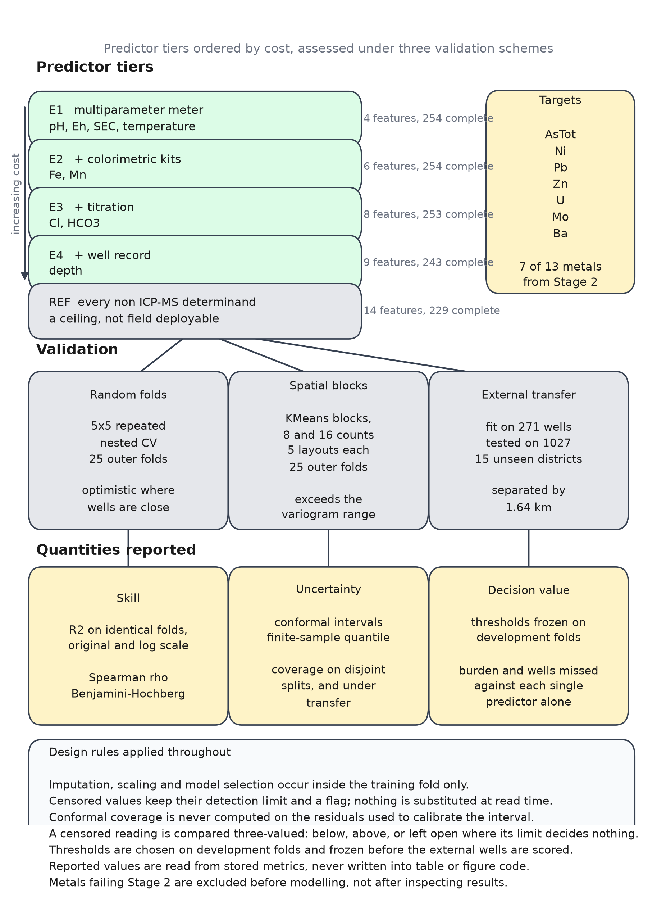
Figure 3. Analysis architecture, showing the predictor tiers, the three validation schemes and the quantities reported.
No imputation or scaling is performed at this stage. Both are pipeline steps fitted inside the training fold, for the reasons set out in Section 2.5.

2.5 Model fitting and validation

2.5.1 Estimation and nested cross validation
Each target is modelled on the log1p scale, which is applied because every target is strongly right skewed, and predictions are inverted before scoring so that all reported coefficients of determination refer to the original concentration scale. Negative predictions after inversion are truncated at zero.
Performance is estimated by five fold cross validation repeated five times, giving 25 outer folds. Within each outer training fold a three fold grid search selects both the model family and its hyperparameters from a single search space spanning ridge regression, elastic net, Huber regression, support vector regression with a radial basis kernel, and random forests. Placing family selection inside the inner loop means that the reported score already pays for that selection; choosing the best family first and scoring it afterwards would allow the test folds to inform the choice.
Median imputation and standardisation are pipeline steps fitted on the training fold only. A mean predictor is scored on the identical folds as a baseline, which is the comparison of interest: with 271 wells and skewed targets, a positive coefficient of determination is less informative than whether the model improves on predicting the mean.
Each target and tier combination is compared against its baseline by a one sided Wilcoxon signed rank test on the 25 paired fold scores. Because 35 comparisons are performed, p values are corrected by the Benjamini and Hochberg procedure at a false discovery rate of 0.05 [64]. A combination is declared feasible only where it both exceeds the baseline after correction and attains a positive coefficient of determination.

2.5.2 Spatial cross validation
Random folds are optimistic when samples are spatially dependent [60, 61, 62]. The development set contains such dependence at short range: 24 wells share exact coordinates, 28 have a neighbour within 50 m, and 117 of 271 have one within 1 km.
Block size is set from the data rather than by eye. The empirical variogram of each log transformed target is computed over lag bins at 0 to 1, 1 to 2, 2 to 5, 5 to 10, 10 to 20 and 20 to 40 km. Most targets approach pure nugget at the shortest lag, with total arsenic in particular showing semivariance at the sill from 0 to 1 km, consistent with the reported variability of arsenic over tens to hundreds of metres [37, 38]. Barium and nickel retain structure to roughly 10 to 20 km.
Spatial dependence is also summarised by a single statistic, since the variogram describes decay with separation but offers no reference distribution. Moran's I is computed on log transformed arsenic with inverse distance weights among wells within 10 km, and its significance assessed against 999 random permutations of the values across the same locations.
Wells are grouped into spatial blocks by k means clustering on coordinates projected to approximate kilometres, and folds are formed by grouped five fold partitioning over whole blocks. Two block counts, eight and sixteen, are evaluated so that the conclusion does not rest on a single choice, the former giving a median block diameter of 18.8 km and the latter 11.4 km. Blocking is repeated over five independent layouts at each count, giving 25 outer folds and matching the fold count of the random design. Repetition is necessary rather than cosmetic: a single five fold spatial pass cannot return a one sided Wilcoxon p value below 0.031 even when the model wins every fold, so a significance criterion applied to it would reject on power rather than on optimism.

2.5.3 External validation
Models are fitted on all 271 development wells and tested on the 1,027 external wells described in Section 2.1.
The external component does not carry pH, redox potential, specific conductance, temperature, chloride, bicarbonate or nitrate, so the tiers of Section 2.4 cannot be transferred intact. Two reduced predictor sets common to both components are used instead. The first, denoted T-cheap, contains iron, manganese and well depth, all of which remain inexpensive to obtain. The second, T-full, adds calcium, magnesium, sodium, sulfate, silicon and strontium, which require laboratory analysis and therefore serve only as an upper bound. Aluminium is excluded because it is reported in µg/L in the development component and mg/L in the external component, a discrepancy of three orders of magnitude that would be silently destructive. Units are compared across all shared columns before use and the run halts on any mismatch.
Because the transferable predictor set is smaller than that of Section 2.4, the same reduced set is also scored within the development data, so that the performance lost by discarding predictors can be separated from the performance lost in transfer.
Only total arsenic and barium can be validated externally, the remaining modelled metals being absent from the national component.

2.6 Conformal prediction
Prediction intervals are constructed by split conformal prediction [45, 46, 47, 48] at a nominal coverage of 90 %.
Coverage is evaluated under the protocol the method actually specifies, with three disjoint partitions. The model is fitted on half the wells, the nonconformity quantile is calibrated on a further quarter, and coverage is measured on the remaining quarter, which neither of the other partitions has touched. The procedure is repeated over 100 random partitions, and the mean and standard deviation of the test partition coverage are reported.
This separation is not a refinement but a requirement. Taking the quantile from a set of residuals and then counting how many of those same residuals fall within it is circular, because the quantile is by construction their (1 − α) percentile: the count returns approximately the nominal rate whatever the model does, and a zero skill predictor attains the same figure. Reported coverage is therefore informative only when measured out of sample.
The guarantee provided by split conformal prediction holds under exchangeability, which does not hold between the development and external components [49, 50, 51, 52]. Transfer is therefore examined directly: the quantile is calibrated on held out development wells and coverage is measured on the external wells, over 100 partitions, so that the extent to which the guarantee survives can be quantified rather than assumed.

2.7 Sensitivity to the treatment of censored values
Substituting half the detection limit for censored observations remains the prevailing default and has been criticised for decades [53, 54, 55, 56]. Its influence on the present conclusions is measured directly.
Four treatments are compared on identical folds: substitution of half the detection limit, substitution of the limit itself, substitution of zero, and a conditional draw from a fitted distribution [57]. Under the last, a lognormal distribution is fitted to the uncensored observations of each target and censored values are drawn from that distribution truncated above at the detection limit applying to each individual sample, which both preserves the shape of the lower tail and respects the multiple detection limits noted in Section 2.2.
The model family is searched inside each training fold exactly as in Section 2.5.1, so that the only quantity varying between runs is the censoring treatment. An earlier formulation holding the estimator fixed at ridge regression was discarded, because targets requiring a non-linear model then scored poorly regardless of the censoring rule and the spread between rules reflected an ill fitting model rather than the substitution choice.
Alongside the spread in performance, the median absolute shift in predicted concentration between the conventional substitution and regression on order statistics is reported, since a difference expressed in predicted micrograms per litre is harder to dismiss than a difference in a goodness of fit statistic.

2.8 Hydrogeochemical characterisation
Four analyses place the statistical results in a geochemical context and provide the data quality evidence expected of a hydrochemical study.
Charge balance error is computed from calcium, magnesium, sodium and potassium against chloride, bicarbonate, sulfate, nitrate and fluoride, all converted to milliequivalents per litre. Samples outside ±10 % are flagged rather than removed, and the rate is reported.
Redox condition is assigned by the framework of McMahon and Chapelle [15, 16], which uses dissolved oxygen, nitrate, manganese, iron and sulfate at threshold concentrations of 0.5, 0.5, 0.05, 0.1 and 0.5 mg/L respectively to identify a terminal electron accepting process.
Two departures from a bare cascade are necessary here, and both follow from the censoring that is the subject of this paper. First, each class is assigned only when its full criteria are met, so that a water carrying both nitrate above the threshold and dissolved iron above its own is called mixed rather than being awarded to whichever comparison was evaluated first. Second, every comparison is three valued. A censored reading stores its own detection limit, so the true value lies strictly below it: when that limit is at or below the threshold the comparison returns a definite negative, and when it lies above, the question is left open and the well is recorded as indeterminate. Reading a stored limit as though it were a measurement is not a hypothetical risk. Nitrate here is censored in 80 % of wells at limits of 0.3 and 0.5 mg/L, and an earlier version of this analysis, which omitted both departures, placed 65 wells in the nitrate reducing class of which only two met the full criteria and 40 qualified solely because a reported "< 0.5" was compared against a threshold of 0.5.
Saturation indices for calcite and siderite are computed from pH, temperature and the major ions, with activity coefficients from the Davies equation and carbonate speciation obtained from bicarbonate and pH through the second dissociation constant of carbonic acid. Siderite is included because its precipitation limits dissolved iron and therefore bears directly on the use of iron as a proxy.
Hydrochemical facies are assigned by dominance on a milliequivalent percentage basis, which is the quantitative content of a Piper diagram, and Gibbs ratios are computed to distinguish weathering from evaporation control.
The geological setting is characterised by joining the surface geology classification to the national survey records and summarising arsenic within each unit represented by at least thirty wells. This is descriptive rather than predictive: surface geology is not used as a model input, since it is a map attribute attached to a location rather than a quantity a field team measures.
Arsenic speciation is examined as an independent check on the redox assignment, using only wells where both As(III) and total arsenic are genuine measurements. Computed over all wells the ratio is an artefact, because in low arsenic wells both determinands sit at a common detection limit of 6.0 µg/L and the ratio is forced to unity.

2.9 Screening operating points
An area under the receiver operating characteristic curve describes ranking but does not tell a monitoring programme what to do. For total arsenic, therefore, three operating points are named: the threshold attaining at least 95 % sensitivity at the lowest laboratory burden, the threshold maximising Youden's index, and the threshold attaining at least 90 % specificity. Both the World Health Organization guideline of 10 µg/L and the Bangladesh national standard of 50 µg/L are evaluated.
Each threshold is chosen on out of fold predictions over the development wells and then frozen. Only after that are the external wells scored, so the reported sensitivity, specificity and laboratory burden are out of sample in the cut off as well as in the model. Choosing the threshold on the wells it is then measured against would make the reported sensitivity an in sample quantity, and an earlier version of this analysis did exactly that. Bootstrap percentile intervals over 2,000 resamples accompany each operating point, since with 64 positives a sensitivity near unity carries a wide interval.
Laboratory burden and wells missed are reported side by side rather than combined into a single score, because their relative weight is a policy judgement rather than a statistical one.

2.10 Software and reproducibility
The analysis is implemented in Python 3.12 using scikit learn, pandas, NumPy, SciPy and statsmodels. Random seeds are fixed throughout.
Each stage writes its outputs to disk, and every value appearing in a table or figure is read from those stored files rather than written into the reporting code, so that a re-run cannot leave a stale number behind. A verification suite of 55 assertions checks the properties the analysis depends on, among them that censoring counts survive cleaning unchanged, that detection limits rather than substituted values are retained, that no target passes screening in violation of its own stated criteria, that features remain unscaled and unimputed before cross validation, that conformal coverage derives from disjoint partitions, and that the external set is geographically separated from the development set.
The complete pipeline, including the raw data as released, is available at https://github.com/Mosharrof8097/ground-water-.

2.11 Statements
Data availability. All data are from the public release of the National Hydrochemical Survey of Bangladesh and are redistributed unchanged with the analysis code at https://github.com/Mosharrof8097/ground-water-, together with checksums and download provenance. Reuse is free, but any publication using them must cite the survey report and acknowledge the funder and partners: the survey was funded by DFID and carried out by the British Geological Survey with the Department of Public Health Engineering, Government of Bangladesh.
Funding. [NEW: funding statement, or "This research received no specific grant from any funding agency in the public, commercial or not for profit sectors."]
CRediT author statement. [NEW: per author, from the CRediT taxonomy.]
Declaration of competing interest. The authors declare no competing financial interests or personal relationships that could have appeared to influence the work reported in this paper.

3. Results

3.1 Data quality and hydrochemical setting
Charge balance error was computed for all 271 wells. The median absolute error is 1.54 %, 261 wells fall within ±5 % and 270 of 271 within ±10 %, so the major ion determinations are internally consistent and no sample was removed on this ground (Table 3).
Table 3. Charge balance error statistics for the analytical quality check.
statistic | value
n_evaluated | 271
median_abs_CBE_pct | 1.535
within_5pct | 261
within_10pct | 270
pct_within_10 | 99.6

Censoring varies sharply across the suite (Table 4). Among the predictors, pH, redox potential, specific conductance, temperature, chloride and bicarbonate are entirely uncensored, whereas nitrate is censored in 80 % of wells and dissolved oxygen in 74 %. Among the candidate targets the range runs from barium and zinc, with no censored observations, to chromium at 97 % and cadmium at 84 %. Several determinands carry more than one detection limit, total arsenic having two, at 0.5 and 6.0 µg/L.

Table 4. Descriptive statistics for all predictors, targets and geochemistry, with censoring and detection limits.
variable | role | unit | n valid | n censored | pct censored | detection limits | min | p25 | median | p75 | max | mean | sd
Cl | predictor | mg/L | 269 | 0 | 0 |  | 1 | 5 | 14.2 | 55.5 | 1550 | 78.08 | 210
Eh | predictor | mV | 269 | 0 | 0 |  | -105 | 42 | 82 | 119 | 341 | 85.48 | 71.14
HCO3 | predictor | mg/L | 271 | 0 | 0 |  | 125 | 377.5 | 474 | 577 | 1140 | 473.9 | 162.1
SEC | predictor | uS/cm | 271 | 0 | 0 |  | 96.8 | 591 | 742 | 949.5 | 4640 | 864.8 | 560.6
T | predictor | deg C | 271 | 0 | 0 |  | 24 | 25.9 | 26.5 | 27 | 31.1 | 26.48 | 0.9913
WELL_DEPTH | predictor | m | 261 | 0 | 0 |  | 3.6 | 14 | 28 | 38.7 | 375 | 47.05 | 65.51
pH | predictor | pH units | 256 | 0 | 0 |  | 5.9 | 6.84 | 7.01 | 7.143 | 8.39 | 6.992 | 0.2401
Fe | predictor | mg/L | 271 | 1 | 0.4 | 0.006 | 0.006 | 0.267 | 1.43 | 4.645 | 24.8 | 2.979 | 3.853
Mn | predictor | mg/L | 271 | 1 | 0.4 | 0.002 | 0.002 | 0.1985 | 0.543 | 0.9865 | 4.36 | 0.6734 | 0.6209
DOC | predictor | mg/L | 258 | 9 | 3.5 | 0.1; 1 | 0 | 1 | 1.7 | 3.075 | 14 | 2.461 | 2.384
SO4 | predictor | mg/L | 271 | 57 | 21 | 0.2 | 0.2 | 0.3 | 1.1 | 10.1 | 335 | 12.85 | 34.72
NH4-N | predictor | mg/L | 271 | 87 | 32.1 | 0.01; 0.02 | 0.01 | 0.02 | 0.38 | 1.535 | 17.8 | 1.339 | 2.535
diss O2 | predictor | mg/L | 268 | 201 | 75 | 0.1 | 0.1 | 0.1 | 0.1 | 0.1 | 6.8 | 0.2813 | 0.6419
NO3-N | predictor | mg/L | 271 | 217 | 80.1 | 0.01; 0.3; 0.5 | 0.01 | 0.3 | 0.3 | 0.5 | 68 | 1.189 | 5.093
Ba | target | ug/L | 271 | 0 | 0 |  | 5 | 55 | 114 | 169.5 | 657 | 121.9 | 89
Zn | target | ug/L | 260 | 1 | 0.4 | 1 | 1 | 4.85 | 8 | 20 | 301 | 16.58 | 24.62
Ni | target | ug/L | 271 | 3 | 1.1 | 0.4 | 0.4 | 1.75 | 2.4 | 3.3 | 18.8 | 2.846 | 1.797
Mo | target | ug/L | 271 | 20 | 7.4 | 0.1 | 0.1 | 0.4 | 1.1 | 2.2 | 20.5 | 2.027 | 2.888
Pb | target | ug/L | 271 | 34 | 12.5 | 0.01; 0.05 | 0.01 | 0.06 | 0.1 | 0.2 | 28.6 | 0.3515 | 1.914
U | target | ug/L | 271 | 62 | 22.9 | 0.007; 0.01 | 0.007 | 0.01 | 0.42 | 2.345 | 47.1 | 2.647 | 6.007
AsTot | target | ug/L | 271 | 92 | 33.9 | 0.5; 6 | 0.5 | 6 | 22 | 109 | 2400 | 125.3 | 298
Sb | target | ug/L | 271 | 126 | 46.5 | 0.02; 0.1 | 0.02 | 0.02 | 0.03 | 0.07 | 1.18 | 0.0576 | 0.0907
AsIII | target | ug/L | 270 | 140 | 51.9 | 0.5; 4; 6 | 0.5 | 6 | 6 | 53.75 | 2540 | 71.86 | 234.3
Cu | target | ug/L | 271 | 220 | 81.2 | 1 | 0.03 | 1 | 1 | 1 | 19.3 | 1.075 | 1.238
Cd | target | ug/L | 271 | 228 | 84.1 | 0.02; 0.06 | 0.02 | 0.02 | 0.02 | 0.02 | 0.19 | 0.0285 | 0.0218
Cr | target | ug/L | 271 | 263 | 97 | 0.5; 0.6 | 0.5 | 0.5 | 0.5 | 0.5 | 1.3 | 0.5251 | 0.102
Se | target | ug/L | 19 | 19 | 100 | 0.2 | 0.2 | 0.2 | 0.2 | 0.2 | 0.2 | 0.2 | 0
Ca | geochemistry | mg/L | 271 | 0 | 0 |  | 16.6 | 57.15 | 87.1 | 116 | 259 | 89.66 | 43.06
F | geochemistry | mg/L | 271 | 0 | 0 |  | 0.01 | 0.12 | 0.18 | 0.295 | 1.28 | 0.2262 | 0.1543
K | geochemistry | mg/L | 271 | 0 | 0 |  | 0.5 | 3.65 | 4.8 | 6.8 | 41.3 | 6.22 | 5.479
Mg | geochemistry | mg/L | 271 | 0 | 0 |  | 6.34 | 22.55 | 28.6 | 39.45 | 154 | 33.66 | 20.77
Na | geochemistry | mg/L | 271 | 0 | 0 |  | 5.1 | 16.2 | 27.1 | 61.75 | 1090 | 68.55 | 131.1
Si | geochemistry | mg/L | 271 | 0 | 0 |  | 6.15 | 13 | 15.3 | 18.8 | 41.9 | 16.34 | 5.472
Sr | geochemistry | mg/L | 271 | 0 | 0 |  | 0.0968 | 0.2715 | 0.353 | 0.448 | 1.4 | 0.3825 | 0.1828
I | geochemistry | ug/L | 271 | 2 | 0.7 | 0.8 | 0.5 | 6.4 | 19.3 | 56.05 | 1240 | 59.49 | 139.6
Br | geochemistry | mg/L | 270 | 13 | 4.8 | 0.001; 0.02 | 0.001 | 0.0243 | 0.0555 | 0.13 | 5.6 | 0.291 | 0.8078

The waters are dominated by the Ca-HCO₃ facies, which accounts for 182 of 271 wells (67.2 %), followed by Na+K-HCO₃ with 40 wells (14.8 %) and Mg-HCO₃ with 28 (10.3 %) (Table 5). Gibbs ratios of 0.261 for Na/(Na+Ca) and 0.048 for Cl/(Cl+HCO₃) place the samples firmly in the rock weathering field. Calcite is close to equilibrium, with a median saturation index of −0.02 and 44.3 % of wells oversaturated, while siderite is oversaturated in 67.5 % of wells with a median index of +0.37.
Table 5. Hydrochemical water types by Piper classification, with well counts and median arsenic.
water type | n wells | pct wells | median As ugL
Ca-HCO3 | 182 | 67.2 | 12
Na+K-HCO3 | 40 | 14.8 | 39.5
Mg-HCO3 | 28 | 10.3 | 85
Na+K-Cl | 13 | 4.8 | 22
Mg-Cl | 5 | 1.8 | 6
undetermined | 2 | 0.7 | 47.3
Ca-Cl | 1 | 0.4 | 6

3.2 Which metals constitute a hazard (RQ1, first part)
Only three of the thirteen metals exceed their drinking water guideline in any well (Table 6). Total arsenic exceeds the WHO guideline of 10 µg/L in 156 of 271 wells, and its maximum of 2,400 µg/L is 240 times that guideline. Uranium exceeds 30 µg/L in four wells and lead exceeds 10 µg/L in one. The remaining ten metals never approach their guidelines: the highest cadmium observation reaches 6 % of its limit, chromium 3 % and copper 1 %.

Table 6. Guideline exceedance summary for the thirteen trace metals against WHO and Bangladesh standards.
metal | unit | n valid | pct censored | median | max | who guideline | who value type | n above who | pct above who | bangladesh standard | n above bd | max as pct of who | modelled | role
Mn | mg/L | 271 | 0.4 | 0.543 | 4.36 | 0.08 | health-based value (WHO 2021, provisional) | 245 | 90.4 | 0.1 | 228 | 5450 | False | predictor
AsTot | ug/L | 271 | 33.9 | 22 | 2400 | 10 | guideline | 156 | 57.6 | 50 | 108 | 2.4e+04 | True | target
U | ug/L | 271 | 22.9 | 0.42 | 47.1 | 30 | guideline | 4 | 1.5 |  |  | 157 | True | target
Pb | ug/L | 271 | 12.5 | 0.1 | 28.6 | 10 | guideline | 1 | 0.4 | 50 | 0 | 286 | True | target
Cd | ug/L | 271 | 84.1 | 0.02 | 0.19 | 3 | guideline | 0 | 0 | 5 | 0 | 6.3 | False | target
Ni | ug/L | 271 | 1.1 | 2.4 | 18.8 | 70 | guideline | 0 | 0 | 100 | 0 | 26.9 | True | target
Cu | ug/L | 271 | 81.2 | 1 | 19.3 | 2000 | guideline | 0 | 0 | 1000 | 0 | 1 | False | target
Cr | ug/L | 271 | 97 | 0.5 | 1.3 | 50 | guideline | 0 | 0 | 50 | 0 | 2.6 | False | target
Zn | ug/L | 260 | 0.4 | 8 | 301 | 3000 | acceptability threshold | 0 | 0 | 5000 | 0 | 10 | True | target
Mo | ug/L | 271 | 7.4 | 1.1 | 20.5 | 70 | health-based value | 0 | 0 |  |  | 29.3 | True | target
Sb | ug/L | 271 | 46.5 | 0.03 | 1.18 | 20 | guideline | 0 | 0 |  |  | 5.9 | False | target
Se | ug/L | 19 | 7 | 0.2 | 0.2 | 40 | guideline | 0 | 0 | 10 | 0 | 0.5 | False | target
Ba | ug/L | 271 | 0 | 114 | 657 | 1300 | guideline | 0 | 0 |  |  | 50.5 | True | target
AsIII | ug/L | 270 | 51.7 | 6 | 2540 |  | guideline |  |  |  |  |  | False | target
Fe | mg/L | 271 | 0.4 | 1.43 | 24.8 |  | acceptability threshold |  |  | 1 | 152 |  | False | predictor

This is the first result the modelling has to respect. A surrogate model for a metal that never approaches its guideline answers a question of limited practical interest, however well it performs.

3.3 Which metals can be modelled at all (RQ1)
Of the thirteen metals screened against the criteria fixed in Section 2.3, seven proceed and six are excluded (Table 7). The exclusions are governed by censoring rather than by chemistry. Chromium is excluded at 97 % censored with only six distinct values, cadmium at 84 %, and copper at 81 %. Antimony and As(III) fail the modal share criterion rather than the censoring threshold: both are nominally below 60 % censored, yet 46 % of antimony records and 43 % of As(III) records sit on a single value, which is in each case the detection limit. Selenium is excluded on sample size, with 19 valid measurements and a single distinct value.
Table 7. Screening of the thirteen candidate targets, with the reason each excluded metal was dropped.
target | n valid | pct censored | n distinct | modal value | pct at modal value | median | max | who limit ug L | n exceeding who | modellable | exclusion reason
Ba | 271 | 0 | 171 | 10 | 2.2 | 114 | 657 | 1300 | 0 | True
Zn | 260 | 0.4 | 74 | 3 | 8.8 | 8 | 301 | 3000 | 0 | True
Ni | 271 | 1.1 | 61 | 2.1 | 6.3 | 2.4 | 18.8 | 70 | 0 | True
Mo | 271 | 7.4 | 61 | 0.1 | 9.2 | 1.1 | 20.5 | 70 | 0 | True
Pb | 271 | 12.5 | 61 | 0.05 | 9.2 | 0.1 | 28.6 | 10 | 1 | True
U | 271 | 22.9 | 163 | 0.01 | 25.1 | 0.42 | 47.1 | 30 | 4 | True
AsTot | 271 | 33.9 | 149 | 6 | 28.4 | 22 | 2400 | 10 | 156 | True
Sb | 271 | 46.5 | 25 | 0.02 | 45.8 | 0.03 | 1.18 | 20 | 0 | False | 46% of rows share the single value 0.02 (> 40%)
AsIII | 270 | 51.9 | 109 | 6 | 42.6 | 6 | 2540 |  |  | False | 43% of rows share the single value 6.0 (> 40%)
Cu | 271 | 81.2 | 23 | 1 | 84.5 | 1 | 19.3 | 2000 | 0 | False | 81% censored (> 60%); 85% of rows share the single value 1.0 (> 40%)
Cd | 271 | 84.1 | 12 | 0.02 | 78.2 | 0.02 | 0.19 | 3 | 0 | False | 84% censored (> 60%); 78% of rows share the single value 0.02 (> 40%)
Cr | 271 | 97 | 6 | 0.5 | 87.1 | 0.5 | 1.3 | 50 | 0 | False | 97% censored (> 60%); only 6 distinct values (< 10); 87% of rows share the single value 0.5 (> 40%)
Se | 19 | 100 | 1 | 0.2 | 100 | 0.2 | 0.2 | 40 | 0 | False | only 19 measurements (< 100); 100% censored (> 60%); only 1 distinct values (< 10); 100% of rows share the single value 0.2 (> 40%)

The pattern bears on the first half of the hypothesis set out in Section 1. Cadmium is among the metals most frequently reported as a hazard in the regional literature [4, 5], yet in these wells it cannot be modelled, not because its geochemistry is intractable but because 84 % of its observations are a detection limit rather than a measurement. Censoring sets a ceiling. It does not follow that metals below that ceiling are modellable, and Section 3.5 shows that several are not.

3.4 Predictive skill and its cost (RQ2)
Under random cross validation, 23 of the 35 target and tier combinations exceed the mean baseline after correction (Figure 4, Table 8). Best performance by metal is barium at R² = 0.597, uranium at 0.374, molybdenum at 0.361, nickel at 0.288 and total arsenic at 0.104, each at the REF tier except arsenic, which peaks at E4. Lead and zinc do not beat the baseline at any tier.
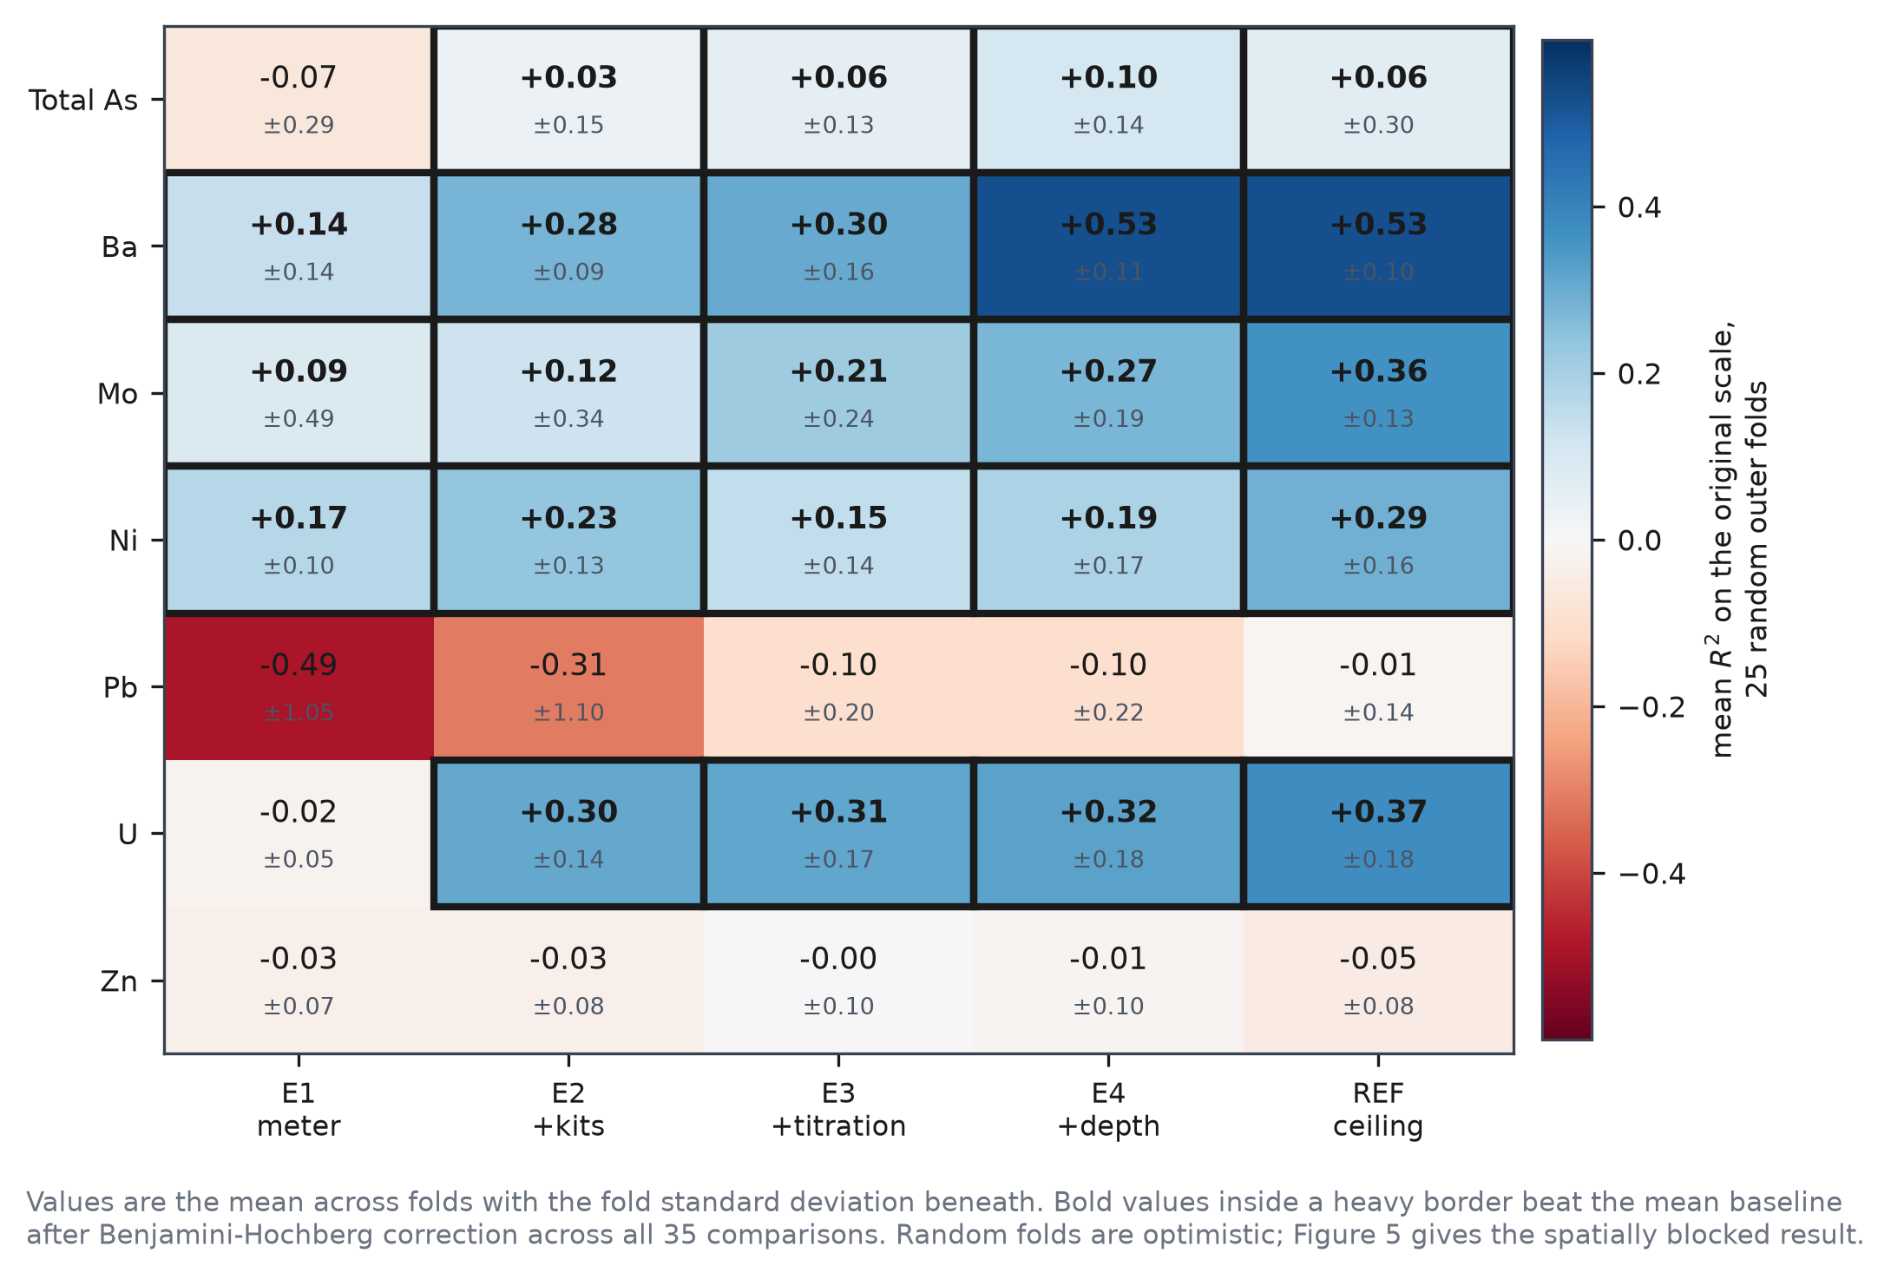
Figure 4. Predictive skill by metal and cost tier, mean R² over twenty five random outer folds.

Table 8. Feasibility matrix of every target and tier under random cross validation, with the dominant model family.
target | tier | n | n features | r2 mean | r2 std | r2 baseline mean | delta r2 | rmse mean | spearman pooled | wilcoxon p | folds won vs baseline | dominant model | fdr significant | feasible
AsTot | E1_meter | 271 | 4 | -0.07025 | 0.2946 | -0.1211 | 0.0509 | 281.3 | 0.4776 | 0.2454 | 15 | RandomForestRegressor | False | False
AsTot | E2_meter_kit | 271 | 6 | 0.03497 | 0.1486 | -0.1211 | 0.1561 | 274 | 0.6735 | 0.004411 | 17 | SVR | True | True
AsTot | E3_meter_kit_titration | 271 | 8 | 0.05764 | 0.1343 | -0.1211 | 0.1788 | 270.7 | 0.6898 | 0.0002148 | 21 | RandomForestRegressor | True | True
AsTot | E4_plus_well_record | 271 | 9 | 0.104 | 0.1407 | -0.1211 | 0.2251 | 264 | 0.7167 | 1.49e-07 | 24 | SVR | True | True
AsTot | REF_full_cheap | 271 | 14 | 0.06296 | 0.2961 | -0.1211 | 0.1841 | 267.2 | 0.7636 | 0.0008127 | 22 | RandomForestRegressor | True | True
Ba | E1_meter | 271 | 4 | 0.1404 | 0.1442 | -0.03484 | 0.1752 | 80.04 | 0.5107 | 3.183e-05 | 23 | RandomForestRegressor | True | True
Ba | E2_meter_kit | 271 | 6 | 0.2798 | 0.08983 | -0.03484 | 0.3146 | 73.27 | 0.5971 | 2.98e-08 | 25 | RandomForestRegressor | True | True
Ba | E3_meter_kit_titration | 271 | 8 | 0.3011 | 0.1645 | -0.03484 | 0.336 | 72.31 | 0.627 | 1.49e-07 | 23 | RandomForestRegressor | True | True
Ba | E4_plus_well_record | 271 | 9 | 0.5255 | 0.1103 | -0.03484 | 0.5603 | 59.64 | 0.7808 | 2.98e-08 | 25 | RandomForestRegressor | True | True
Ba | REF_full_cheap | 271 | 14 | 0.5261 | 0.102 | -0.03484 | 0.5609 | 59.76 | 0.7937 | 2.98e-08 | 25 | RandomForestRegressor | True | True
Mo | E1_meter | 271 | 4 | 0.08817 | 0.4862 | -0.0713 | 0.1595 | 2.527 | 0.5827 | 2.694e-05 | 24 | RandomForestRegressor | True | True
Mo | E2_meter_kit | 271 | 6 | 0.1249 | 0.3433 | -0.0713 | 0.1962 | 2.518 | 0.6428 | 2.271e-05 | 24 | RandomForestRegressor | True | True
Mo | E3_meter_kit_titration | 271 | 8 | 0.2138 | 0.2365 | -0.0713 | 0.2851 | 2.4 | 0.6577 | 2.98e-08 | 25 | RandomForestRegressor | True | True
Mo | E4_plus_well_record | 271 | 9 | 0.274 | 0.1896 | -0.0713 | 0.3453 | 2.328 | 0.7134 | 2.98e-08 | 25 | RandomForestRegressor | True | True
Mo | REF_full_cheap | 271 | 14 | 0.3611 | 0.1282 | -0.0713 | 0.4324 | 2.187 | 0.7672 | 2.98e-08 | 25 | RandomForestRegressor | True | True
Ni | E1_meter | 271 | 4 | 0.1693 | 0.09539 | -0.02193 | 0.1913 | 1.576 | 0.4998 | 2.98e-08 | 25 | RandomForestRegressor | True | True
Ni | E2_meter_kit | 271 | 6 | 0.234 | 0.1278 | -0.02193 | 0.2559 | 1.516 | 0.5874 | 5.96e-08 | 24 | RandomForestRegressor | True | True
Ni | E3_meter_kit_titration | 271 | 8 | 0.1466 | 0.1369 | -0.02193 | 0.1685 | 1.593 | 0.5599 | 7.451e-07 | 24 | Ridge | True | True
Ni | E4_plus_well_record | 271 | 9 | 0.1916 | 0.1704 | -0.02193 | 0.2135 | 1.549 | 0.5856 | 5.662e-07 | 24 | RandomForestRegressor | True | True
Ni | REF_full_cheap | 271 | 14 | 0.2877 | 0.1641 | -0.02193 | 0.3096 | 1.467 | 0.6509 | 2.98e-08 | 25 | SVR | True | True
Pb | E1_meter | 271 | 4 | -0.4893 | 1.05 | -1.164 | 0.6752 | 1.315 | 0.135 | 0.007986 | 14 | RandomForestRegressor | True | False
Pb | E2_meter_kit | 271 | 6 | -0.3118 | 1.097 | -1.164 | 0.8527 | 1.306 | 0.1285 | 0.0401 | 13 | ElasticNet | False | False
Pb | E3_meter_kit_titration | 271 | 8 | -0.1004 | 0.2025 | -1.164 | 1.064 | 1.296 | 0.1134 | 0.006777 | 14 | ElasticNet | True | False
Pb | E4_plus_well_record | 271 | 9 | -0.09884 | 0.2218 | -1.164 | 1.066 | 1.296 | 0.1291 | 0.006777 | 15 | ElasticNet | True | False
Pb | REF_full_cheap | 271 | 14 | -0.0118 | 0.1437 | -1.164 | 1.153 | 1.287 | 0.2307 | 0.00171 | 16 | SVR | True | False
U | E1_meter | 271 | 4 | -0.01898 | 0.05074 | -0.04262 | 0.02364 | 5.773 | 0.3039 | 0.2054 | 13 | RandomForestRegressor | False | False
U | E2_meter_kit | 271 | 6 | 0.3048 | 0.1444 | -0.04262 | 0.3474 | 4.71 | 0.8353 | 5.96e-08 | 24 | RandomForestRegressor | True | True
U | E3_meter_kit_titration | 271 | 8 | 0.3117 | 0.1722 | -0.04262 | 0.3543 | 4.711 | 0.8428 | 2.98e-08 | 25 | RandomForestRegressor | True | True
U | E4_plus_well_record | 271 | 9 | 0.3233 | 0.1816 | -0.04262 | 0.366 | 4.678 | 0.8402 | 2.98e-08 | 25 | RandomForestRegressor | True | True
U | REF_full_cheap | 271 | 14 | 0.3736 | 0.1777 | -0.04262 | 0.4163 | 4.43 | 0.8743 | 1.49e-07 | 23 | RandomForestRegressor | True | True
Zn | E1_meter | 260 | 4 | -0.0321 | 0.06661 | -0.02039 | -0.01171 | 22.47 | 0.2516 | 0.8564 | 8 | HuberRegressor | False | False
Zn | E2_meter_kit | 260 | 6 | -0.02854 | 0.08391 | -0.02039 | -0.008156 | 22.48 | 0.2447 | 0.7288 | 9 | HuberRegressor | False | False
Zn | E3_meter_kit_titration | 260 | 8 | -0.004467 | 0.1036 | -0.02039 | 0.01592 | 22.27 | 0.2544 | 0.5837 | 10 | HuberRegressor | False | False
Zn | E4_plus_well_record | 260 | 9 | -0.0146 | 0.09864 | -0.02039 | 0.005788 | 22.36 | 0.255 | 0.7791 | 8 | ElasticNet | False | False
Zn | REF_full_cheap | 260 | 14 | -0.05014 | 0.08496 | -0.02039 | -0.02976 | 22.67 | 0.2593 | 0.9178 | 7 | RandomForestRegressor | False | False

Cost matters, and it matters differently by metal. For arsenic and uranium the meter alone is insufficient and the addition of iron and manganese field kits is what makes the model work: arsenic moves from R² = −0.070 at E1 to +0.035 at E2, and uranium from −0.019 to +0.305. For molybdenum and barium the meter alone already yields a positive result, at 0.088 and 0.268 respectively.
Coefficients of determination and rank correlations diverge sharply for arsenic, which attains R² = 0.104 but a pooled Spearman ρ of 0.717. The model orders wells considerably better than it estimates their concentrations.

3.5 How much skill survives honest validation (RQ2)
Arsenic is spatially structured at the regional scale. Moran's I on log transformed arsenic in the development wells is +0.259 against an expected value of −0.004 under no autocorrelation, with p = 0.001 over 999 permutations and a mean of 43.3 neighbours within the 10 km radius. The variogram of Section 2.5.2 and this statistic describe the same field from two directions: clustering is real at the regional scale, yet semivariance is already at the sill in the shortest lag bin, so neighbouring wells differ sharply. Both findings argue for blocked validation.
Spatial blocking changes the picture substantially (Figure 5a, Table 9). The number of feasible combinations falls from 23 under random folds to 15 under sixteen blocks and to 10 under eight blocks, the larger blocks being the more demanding test.
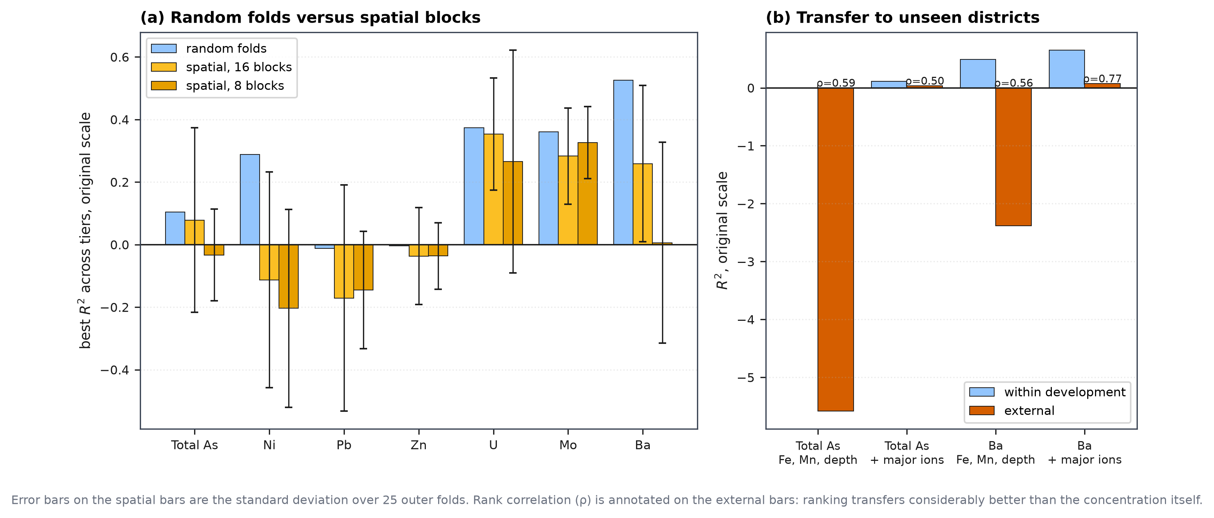
Figure 5. How much skill survives honest validation: random folds against spatial blocks, and transfer to unseen districts.
Table 9. Random against spatially blocked cross validation for every target, tier and block count.
target | tier | n blocks | random r2 | spatial r2 | spatial r2 std | spatial r2 log | optimism gap | wilcoxon p | n folds | random feasible | spatial feasible
AsTot | E1_meter | 8 | -0.0702 | -0.0332 | 0.1467 | -0.1748 | -0.0371 | 0.04121 | 25 | False | False
AsTot | E1_meter | 16 | -0.0702 | 0.078 | 0.2203 | 0.0303 | -0.1483 | 0.0003 | 25 | False | True
AsTot | E2_meter_kit | 8 | 0.035 | -0.2296 | 1.068 | 0.1178 | 0.2646 | 0.0034 | 25 | True | False
AsTot | E2_meter_kit | 16 | 0.035 | -0.1608 | 0.7674 | 0.1929 | 0.1958 | 0.00641 | 25 | True | False
AsTot | E3_meter_kit_titration | 8 | 0.0576 | -0.1057 | 0.6013 | 0.1371 | 0.1633 | 0.01227 | 25 | True | False
AsTot | E3_meter_kit_titration | 16 | 0.0576 | 0.0384 | 0.3172 | 0.2513 | 0.0192 | 0.00011 | 25 | True | True
AsTot | E4_plus_well_record | 8 | 0.104 | -0.0652 | 0.4637 | 0.1617 | 0.1692 | 0.00858 | 25 | True | False
AsTot | E4_plus_well_record | 16 | 0.104 | 0.0783 | 0.2952 | 0.2693 | 0.0257 | 4e-05 | 25 | True | True
AsTot | REF_full_cheap | 8 | 0.063 | -0.038 | 0.6508 | 0.2265 | 0.1009 | 0.00049 | 25 | True | False
AsTot | REF_full_cheap | 16 | 0.063 | 0.0056 | 0.7948 | 0.3426 | 0.0573 | 0.00078 | 25 | True | True
Ni | E1_meter | 8 | 0.1693 | -0.3192 | 0.4259 | -0.3268 | 0.4885 | 0.1377 | 25 | True | False
Ni | E1_meter | 16 | 0.1693 | -0.3302 | 0.769 | -0.2791 | 0.4995 | 0.2814 | 25 | True | False
Ni | E2_meter_kit | 8 | 0.234 | -0.2615 | 0.3497 | -0.235 | 0.4955 | 0.06408 | 25 | True | False
Ni | E2_meter_kit | 16 | 0.234 | -0.2225 | 0.4448 | -0.1445 | 0.4565 | 0.00641 | 25 | True | False
Ni | E3_meter_kit_titration | 8 | 0.1466 | -0.3684 | 0.3843 | -0.3235 | 0.515 | 0.3784 | 25 | True | False
Ni | E3_meter_kit_titration | 16 | 0.1466 | -0.2759 | 0.4134 | -0.1765 | 0.4225 | 0.0871 | 25 | True | False
Ni | E4_plus_well_record | 8 | 0.1916 | -0.28 | 0.3318 | -0.2405 | 0.4716 | 0.04364 | 25 | True | False
Ni | E4_plus_well_record | 16 | 0.1916 | -0.2202 | 0.3618 | -0.1239 | 0.4118 | 0.00123 | 25 | True | False
Ni | REF_full_cheap | 8 | 0.2877 | -0.2039 | 0.3167 | -0.1698 | 0.4916 | 0.00102 | 25 | True | False
Ni | REF_full_cheap | 16 | 0.2877 | -0.1127 | 0.3449 | -0.0276 | 0.4004 | 1e-05 | 25 | True | False
Pb | E1_meter | 8 | -0.4893 | -1.628 | 3.461 | -1.03 | 1.138 | 0.8165 | 25 | False | False
Pb | E1_meter | 16 | -0.4893 | -0.4374 | 0.7878 | -0.4545 | -0.0519 | 0.1379 | 25 | False | False
Pb | E2_meter_kit | 8 | -0.3118 | -0.1449 | 0.1875 | -0.2098 | -0.1669 | 0.06077 | 25 | False | False
Pb | E2_meter_kit | 16 | -0.3118 | -0.6454 | 1.444 | -0.4637 | 0.3336 | 0.3482 | 25 | False | False
Pb | E3_meter_kit_titration | 8 | -0.1004 | -0.1752 | 0.2753 | -0.2435 | 0.0748 | 0.1154 | 25 | False | False
Pb | E3_meter_kit_titration | 16 | -0.1004 | -0.1998 | 0.3561 | -0.2599 | 0.0993 | 0.06091 | 25 | False | False
Pb | E4_plus_well_record | 8 | -0.0988 | -0.1568 | 0.2563 | -0.2131 | 0.058 | 0.06077 | 25 | False | False
Pb | E4_plus_well_record | 16 | -0.0988 | -0.1708 | 0.3611 | -0.2175 | 0.072 | 0.06091 | 25 | False | False
Pb | REF_full_cheap | 8 | -0.0118 | -0.157 | 0.2272 | -0.2255 | 0.1452 | 0.02709 | 25 | False | False
Pb | REF_full_cheap | 16 | -0.0118 | -0.1751 | 0.2608 | -0.2445 | 0.1633 | 0.03073 | 25 | False | False
Zn | E1_meter | 8 | -0.0321 | -0.0773 | 0.1277 | -0.1177 | 0.0452 | 0.6519 | 25 | False | False
Zn | E1_meter | 16 | -0.0321 | -0.0826 | 0.1422 | -0.0743 | 0.0505 | 0.5 | 25 | False | False
Zn | E2_meter_kit | 8 | -0.0285 | -0.0955 | 0.0932 | -0.1524 | 0.067 | 0.7623 | 25 | False | False
Zn | E2_meter_kit | 16 | -0.0285 | -0.0912 | 0.1527 | -0.0792 | 0.0626 | 0.6444 | 25 | False | False
Zn | E3_meter_kit_titration | 8 | -0.0045 | -0.0363 | 0.1062 | -0.078 | 0.0318 | 0.1102 | 25 | False | False
Zn | E3_meter_kit_titration | 16 | -0.0045 | -0.0368 | 0.1548 | -0.0222 | 0.0323 | 0.1763 | 25 | False | False
Zn | E4_plus_well_record | 8 | -0.0146 | -0.061 | 0.1133 | -0.1069 | 0.0464 | 0.1764 | 25 | False | False
Zn | E4_plus_well_record | 16 | -0.0146 | -0.0451 | 0.1528 | -0.0263 | 0.0305 | 0.2131 | 25 | False | False
Zn | REF_full_cheap | 8 | -0.0501 | -1.681 | 3.101 | -0.3126 | 1.631 | 0.8501 | 25 | False | False
Zn | REF_full_cheap | 16 | -0.0501 | -3.14 | 8.34 | -0.2732 | 3.09 | 0.9817 | 25 | False | False
U | E1_meter | 8 | -0.019 | -0.1676 | 0.4775 | -0.2585 | 0.1486 | 0.02709 | 25 | False | False
U | E1_meter | 16 | -0.019 | -0.0597 | 0.0836 | -0.1081 | 0.0407 | 0.8679 | 25 | False | False
U | E2_meter_kit | 8 | 0.3048 | 0.1269 | 0.5099 | 0.4342 | 0.1779 | 1e-05 | 25 | True | True
U | E2_meter_kit | 16 | 0.3048 | 0.1936 | 0.1653 | 0.4165 | 0.1112 | 1e-05 | 25 | True | True
U | E3_meter_kit_titration | 8 | 0.3117 | 0.1998 | 0.231 | 0.4627 | 0.1119 | 1e-05 | 25 | True | True
U | E3_meter_kit_titration | 16 | 0.3117 | 0.2284 | 0.0934 | 0.4573 | 0.0833 | 1e-05 | 25 | True | True
U | E4_plus_well_record | 8 | 0.3233 | 0.2219 | 0.2928 | 0.4644 | 0.1015 | 1e-05 | 25 | True | True
U | E4_plus_well_record | 16 | 0.3233 | 0.2507 | 0.1101 | 0.4656 | 0.0727 | 1e-05 | 25 | True | True
U | REF_full_cheap | 8 | 0.3736 | 0.2656 | 0.356 | 0.5592 | 0.1081 | 1e-05 | 25 | True | True
U | REF_full_cheap | 16 | 0.3736 | 0.3538 | 0.1794 | 0.5932 | 0.0199 | 1e-05 | 25 | True | True
Mo | E1_meter | 8 | 0.0882 | 0.1229 | 0.1772 | 0.2044 | -0.0348 | 6e-05 | 25 | True | True
Mo | E1_meter | 16 | 0.0882 | 0.0887 | 0.24 | 0.1824 | -0.0005 | 1e-05 | 25 | True | True
Mo | E2_meter_kit | 8 | 0.1249 | 0.1291 | 0.1418 | 0.1934 | -0.0041 | 1e-05 | 25 | True | True
Mo | E2_meter_kit | 16 | 0.1249 | 0.1355 | 0.1488 | 0.2513 | -0.0106 | 1e-05 | 25 | True | True
Mo | E3_meter_kit_titration | 8 | 0.2138 | 0.1805 | 0.1013 | 0.2649 | 0.0332 | 1e-05 | 25 | True | True
Mo | E3_meter_kit_titration | 16 | 0.2138 | 0.1825 | 0.1249 | 0.2724 | 0.0313 | 1e-05 | 25 | True | True
Mo | E4_plus_well_record | 8 | 0.274 | 0.232 | 0.1313 | 0.2969 | 0.042 | 1e-05 | 25 | True | True
Mo | E4_plus_well_record | 16 | 0.274 | 0.2243 | 0.1607 | 0.3284 | 0.0497 | 1e-05 | 25 | True | True
Mo | REF_full_cheap | 8 | 0.3611 | 0.3258 | 0.1151 | 0.3704 | 0.0353 | 1e-05 | 25 | True | True
Mo | REF_full_cheap | 16 | 0.3611 | 0.2831 | 0.1536 | 0.3923 | 0.078 | 1e-05 | 25 | True | True
Ba | E1_meter | 8 | 0.1404 | -0.6066 | 0.755 | -1.403 | 0.747 | 0.04886 | 25 | True | False
Ba | E1_meter | 16 | 0.1404 | -0.2913 | 0.5707 | -0.7008 | 0.4317 | 0.1697 | 25 | True | False
Ba | E2_meter_kit | 8 | 0.2798 | -0.3547 | 0.6882 | -1.184 | 0.6345 | 0.03456 | 25 | True | False
Ba | E2_meter_kit | 16 | 0.2798 | -0.237 | 0.7493 | -0.6142 | 0.5168 | 0.1006 | 25 | True | False
Ba | E3_meter_kit_titration | 8 | 0.3011 | -0.529 | 0.8956 | -1.19 | 0.8301 | 0.09128 | 25 | True | False
Ba | E3_meter_kit_titration | 16 | 0.3011 | -0.2083 | 0.5114 | -0.6085 | 0.5094 | 0.1006 | 25 | True | False
Ba | E4_plus_well_record | 8 | 0.5255 | -0.0488 | 0.322 | -0.1536 | 0.5742 | 1e-05 | 25 | True | False
Ba | E4_plus_well_record | 16 | 0.5255 | 0.2374 | 0.2331 | 0.2401 | 0.2881 | 1e-05 | 25 | True | True
Ba | REF_full_cheap | 8 | 0.5261 | 0.0061 | 0.3215 | -0.0388 | 0.52 | 1e-05 | 25 | True | True
Ba | REF_full_cheap | 16 | 0.5261 | 0.259 | 0.2497 | 0.2891 | 0.2671 | 1e-05 | 25 | True | True

The optimism attributable to spatial autocorrelation differs greatly by metal. The median gap between random and spatial R² is +0.784 for barium and +0.492 for nickel under eight blocks, against +0.033 for molybdenum. Nickel collapses from R² = 0.288 under random folds to −0.204 under eight blocks and −0.113 under sixteen, and is feasible at no tier under either blocking scheme. Reported under random validation alone, nickel would have been presented as screenable.
Four metals remain feasible under at least one spatial scheme, namely total arsenic, barium, molybdenum and uranium. Only molybdenum and uranium survive the more demanding eight block design.
External transfer degrades performance further (Figure 5b, Table 10). For barium the coefficient of determination falls from 0.650 within the development data to 0.074 on the external wells using the same reduced predictor set, and for arsenic from 0.111 to 0.035. Rank correlation is more robust, at ρ = 0.774 for barium and 0.502 for arsenic.
Table 10. External validation on unseen North Bengal districts, with conformal coverage under transfer.
target | tier | n dev | n ext | internal cv r2 | external r2 | external spearman | external auc who | conformal transfer coverage | conformal transfer coverage sd
AsTot | T_cheap | 271 | 1027 | -0.001 | -5.58 | 0.5877 | 0.8282 | 0.9556 | 0.0489
AsTot | T_full | 271 | 1027 | 0.1109 | 0.0355 | 0.5023 | 0.8382 | 0.9896 | 0.0023
Ba | T_cheap | 271 | 1026 | 0.4917 | -2.385 | 0.5611 |  | 0.7265 | 0.1045
Ba | T_full | 271 | 1026 | 0.6501 | 0.0743 | 0.774 |  | 0.9069 | 0.0326

The practical consequence is better expressed by classification. On the 1,027 external wells the arsenic model attains an area under the curve of 0.828 using iron, manganese and well depth alone, and 0.838 with the laboratory major ions added (Figure 11a). The expensive predictors add 0.010 of discrimination.

3.6 Calibrated uncertainty and its limits (RQ3)
Within the study area the conformal intervals behave as intended. Across the 23 feasible combinations, held out coverage ranges from 89.8 % to 91.7 % against a nominal 90 %, with standard deviations between 4.6 and 6.2 percentage points (Figure 6a, Table 11). Coverage sits at or slightly above nominal in 22 of the 23 combinations, which is expected at this sample size.
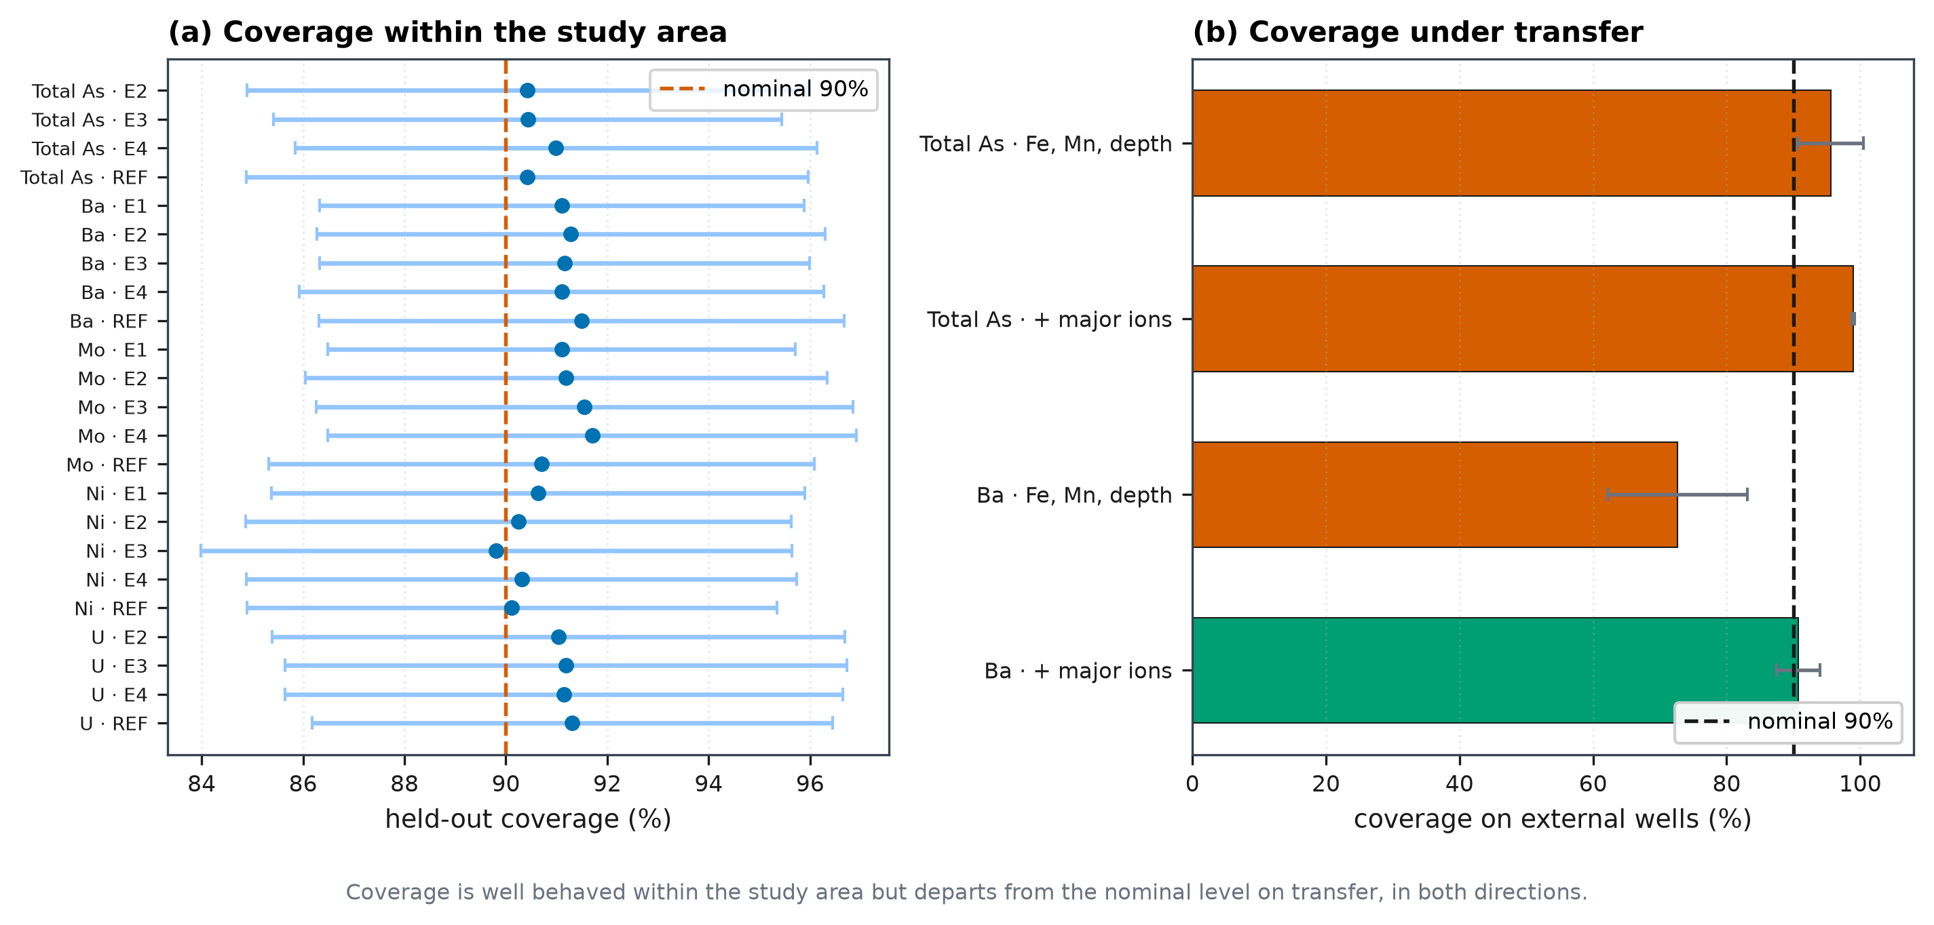
Figure 6. Conformal interval coverage within the study area and under transfer to external wells.
Table 11. Held-out split conformal coverage and interval width for each feasible target and tier.
target | tier | nominal coverage | held out coverage mean | held out coverage std | mean interval width | median q hat
AsTot | E2_meter_kit | 0.9 | 0.9042 | 0.0552 | 314.7 | 221.2
AsTot | E3_meter_kit_titration | 0.9 | 0.9043 | 0.0501 | 310.9 | 211
AsTot | E4_plus_well_record | 0.9 | 0.9099 | 0.0514 | 318.5 | 214.8
AsTot | REF_full_cheap | 0.9 | 0.9042 | 0.0554 | 298.7 | 210.5
Ni | E1_meter | 0.9 | 0.9064 | 0.0526 | 4.913 | 2.645
Ni | E2_meter_kit | 0.9 | 0.9025 | 0.0538 | 4.598 | 2.413
Ni | E3_meter_kit_titration | 0.9 | 0.8981 | 0.0583 | 4.577 | 2.422
Ni | E4_plus_well_record | 0.9 | 0.9031 | 0.0543 | 4.357 | 2.28
Ni | REF_full_cheap | 0.9 | 0.9012 | 0.0522 | 4.132 | 2.084
U | E2_meter_kit | 0.9 | 0.9104 | 0.0565 | 7.939 | 6.447
U | E3_meter_kit_titration | 0.9 | 0.9119 | 0.0554 | 7.853 | 6.146
U | E4_plus_well_record | 0.9 | 0.9115 | 0.055 | 7.726 | 6.022
U | REF_full_cheap | 0.9 | 0.9131 | 0.0513 | 7.19 | 5.649
Mo | E1_meter | 0.9 | 0.911 | 0.0461 | 5.348 | 3.826
Mo | E2_meter_kit | 0.9 | 0.9119 | 0.0515 | 5.349 | 3.748
Mo | E3_meter_kit_titration | 0.9 | 0.9155 | 0.0529 | 5.221 | 3.712
Mo | E4_plus_well_record | 0.9 | 0.917 | 0.0521 | 5.146 | 3.575
Mo | REF_full_cheap | 0.9 | 0.907 | 0.0538 | 4.403 | 2.865
Ba | E1_meter | 0.9 | 0.911 | 0.0478 | 219.2 | 125.8
Ba | E2_meter_kit | 0.9 | 0.9128 | 0.0501 | 212.2 | 123.1
Ba | E3_meter_kit_titration | 0.9 | 0.9116 | 0.0483 | 207.4 | 119.7
Ba | E4_plus_well_record | 0.9 | 0.911 | 0.0517 | 179.7 | 99.49
Ba | REF_full_cheap | 0.9 | 0.9149 | 0.0518 | 183.3 | 103

Transfer is a different matter (Figure 6b). Calibrating the quantile on held out development wells and applying it to the external wells gives coverage of 90.7 % for barium under the T-full predictors, which is close to nominal, but 72.7 % for the same metal under T-cheap, and 99.0 % for arsenic under T-full. The departures run in both directions. Under coverage of 72.7 % against a nominal 90 % would mislead a user into unwarranted confidence, while coverage of 99.0 % indicates intervals so wide as to be uninformative.
This is the clearest limitation we identify. Conformal prediction supplies valid intervals where the exchangeability assumption holds, and gives no warning when it does not.

3.7 The cost of the conventional censoring rule (RQ4)
Across the four treatments compared on identical folds, the spread in R² is negligible for most metals but substantial for arsenic (Table 12, Figure 8). Barium, with no censored observations, shows a spread of 0.000; zinc 0.003; uranium 0.007 despite 23 % censoring; molybdenum 0.009; lead 0.005; nickel 0.014. Arsenic, at 34 % censored, shows a spread of 0.125 on the original scale and 0.288 on the log scale, which is larger than its entire performance signal: no rule gives it positive skill on the measured wells, the coefficient of determination running from +0.000 under the detection limit to −0.125 under zero substitution.

Table 12. Comparison of four censoring treatments on identical folds, with the resulting spread in R².
target | pct censored | largest detection limit | dl as fraction of median | pct mass at or below dl | n scored against | n censored | consistency substitute half | consistency substitute dl | consistency substitute zero | consistency stochastic imputation | r2 substitute half | r2 substitute dl | r2 substitute zero | r2 stochastic imputation | r2 spread | r2log substitute half | r2log substitute dl | r2log substitute zero | r2log stochastic imputation | r2 log spread | pred shift pct of median
AsTot | 33.9 | 6 | 0.2727 | 37.3 | 179 | 92 | 46.7 | 27.2 | 59.8 | 42.4 | -0.0308 | 0.0001 | -0.1246 | -0.0468 | 0.1247 | 0.1501 | 0.2164 | -0.0719 | 0.1521 | 0.2883 | 8.4
Ni | 1.1 | 0.4 | 0.1667 | 1.1 | 268 | 3 | 0 | 0 | 0 | 0 | 0.1832 | 0.1814 | 0.1695 | 0.1809 | 0.0137 | 0.272 | 0.2696 | 0.2537 | 0.2692 | 0.0183 | 0.3
Pb | 12.5 | 0.05 | 0.5 | 24.7 | 237 | 34 | 0 | 0 | 2.9 | 0 | -0.0893 | -0.0943 | -0.09 | -0.0927 | 0.0049 | -0.0956 | -0.1015 | -0.0948 | -0.1012 | 0.0067 | 1.4
Zn | 0.4 | 1 | 0.125 | 1.5 | 259 | 1 | 0 | 0 | 0 | 0 | -0.0197 | -0.0164 | -0.0198 | -0.0164 | 0.0034 | 0.0571 | 0.0586 | 0.0572 | 0.0586 | 0.0015 | 0.1
U | 22.9 | 0.01 | 0.0238 | 26.9 | 209 | 62 | 6.5 | 6.5 | 9.7 | 6.5 | 0.2684 | 0.275 | 0.2686 | 0.2684 | 0.0067 | 0.4808 | 0.4839 | 0.4809 | 0.4806 | 0.0033 | 0.2
Mo | 7.4 | 0.1 | 0.0909 | 9.2 | 251 | 20 | 10 | 5 | 25 | 5 | 0.257 | 0.2482 | 0.2483 | 0.2558 | 0.0088 | 0.4251 | 0.4255 | 0.4151 | 0.4295 | 0.0143 | 1.3
Ba | 0 |  |  | 0 | 271 | 0 |  |  |  |  | 0.5255 | 0.5255 | 0.5255 | 0.5255 | 0 | 0.6254 | 0.6254 | 0.6254 | 0.6254 | 0 | 0

Censoring rate alone does not predict this. Uranium is censored in 23 % of wells yet the choice of rule is immaterial, because its detection limits of 0.007 and 0.01 µg/L lie far below its median of 0.42. Arsenic carries a limit of 6.0 µg/L against a median of 22.0, which is 27 % of the median, and there the rule changes the answer. Figure 8 contrasts the two framings: the relationship with censoring rate is weak, while the relationship with the detection limit expressed as a fraction of the median is clear.
Predictions move as well as scores. Substituting half the detection limit rather than drawing each censored value from a fitted distribution shifts the median predicted arsenic concentration by 8.4 % of the median observed value.

3.8 What the models use, and whether it is the expected mechanism
Permutation importance identifies iron as the single most informative predictor for arsenic, accounting for 37 % of positive importance, with pH contributing 31 % (Figure 7, Table 13). Redox indicators together account for 45.9 %. For uranium the pattern is stronger still, iron alone accounting for 79 % and redox indicators for 83.2 %.
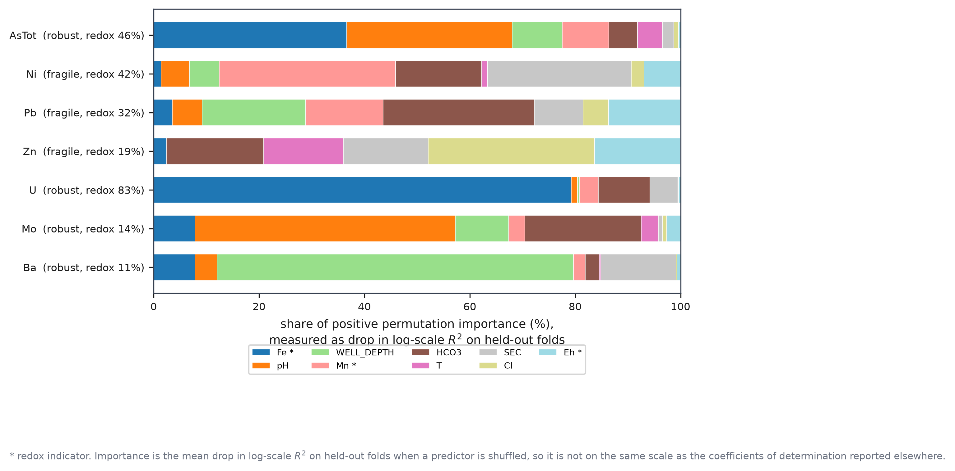
Figure 7. Permutation importance showing what each model actually uses, with redox indicators marked.
Table 13. Permutation feature importance for every modelled metal, with redox indicators flagged.
target | feature | mean r2 drop | sd | share | redox proxy | spatially robust target
AsTot | Fe | 0.3928 | 0.1121 | 0.3665 | True | True
AsTot | pH | 0.3365 | 0.1263 | 0.314 | False | True
AsTot | WELL_DEPTH | 0.1016 | 0.04504 | 0.0948 | False | True
AsTot | Mn | 0.09487 | 0.06339 | 0.0885 | True | True
AsTot | HCO3 | 0.05827 | 0.05081 | 0.0544 | False | True
AsTot | T | 0.05039 | 0.02452 | 0.047 | False | True
AsTot | SEC | 0.02347 | 0.03518 | 0.0219 | False | True
AsTot | Cl | 0.00984 | 0.0209 | 0.0092 | False | True
AsTot | Eh | 0.00394 | 0.03224 | 0.0037 | True | True
Ni | Mn | 0.1343 | 0.067 | 0.3347 | True | False
Ni | SEC | 0.1093 | 0.101 | 0.2725 | False | False
Ni | HCO3 | 0.06559 | 0.05437 | 0.1635 | False | False
Ni | Eh | 0.02791 | 0.03059 | 0.0696 | True | False
Ni | WELL_DEPTH | 0.02281 | 0.03775 | 0.0569 | False | False
Ni | pH | 0.02146 | 0.02039 | 0.0535 | False | False
Ni | Cl | 0.00969 | 0.02856 | 0.0242 | False | False
Ni | Fe | 0.00566 | 0.01198 | 0.0141 | True | False
Ni | T | 0.00452 | 0.0141 | 0.0113 | False | False
Pb | HCO3 | 0.03872 | 0.07385 | 0.287 | False | False
Pb | WELL_DEPTH | 0.02653 | 0.06662 | 0.1966 | False | False
Pb | Mn | 0.01979 | 0.03145 | 0.1467 | True | False
Pb | Eh | 0.01846 | 0.03319 | 0.1368 | True | False
Pb | SEC | 0.0125 | 0.02383 | 0.0926 | False | False
Pb | pH | 0.00764 | 0.01433 | 0.0566 | False | False
Pb | Cl | 0.0065 | 0.02097 | 0.0482 | False | False
Pb | Fe | 0.00478 | 0.03543 | 0.0354 | True | False
Pb | T | -0.00548 | 0.00873 | 0 | False | False
Zn | Cl | 0.07616 | 0.1036 | 0.3159 | False | False
Zn | HCO3 | 0.04449 | 0.06564 | 0.1845 | False | False
Zn | Eh | 0.03928 | 0.01704 | 0.1629 | True | False
Zn | SEC | 0.03892 | 0.05833 | 0.1614 | False | False
Zn | T | 0.03635 | 0.03996 | 0.1508 | False | False
Zn | Fe | 0.00588 | 0.00913 | 0.0244 | True | False
Zn | WELL_DEPTH | -0.00137 | 0.03081 | 0 | False | False
Zn | Mn | -0.00234 | 0.01465 | 0 | True | False
Zn | pH | -0.0246 | 0.03423 | 0 | False | False
U | Fe | 0.9825 | 0.1148 | 0.7925 | True | True
U | HCO3 | 0.121 | 0.04894 | 0.0976 | False | True
U | SEC | 0.06594 | 0.04361 | 0.0532 | False | True
U | Mn | 0.04471 | 0.02796 | 0.0361 | True | True
U | pH | 0.01505 | 0.00804 | 0.0121 | False | True
U | Eh | 0.00476 | 0.01148 | 0.0038 | True | True
U | WELL_DEPTH | 0.00435 | 0.01706 | 0.0035 | False | True
U | Cl | 0.00148 | 0.00962 | 0.0012 | False | True
U | T | -0.00215 | 0.00414 | 0 | False | True
Mo | pH | 0.466 | 0.09831 | 0.4942 | False | True
Mo | HCO3 | 0.2081 | 0.08596 | 0.2207 | False | True
Mo | WELL_DEPTH | 0.09546 | 0.06776 | 0.1012 | False | True
Mo | Fe | 0.07389 | 0.03121 | 0.0784 | True | True
Mo | T | 0.03077 | 0.03836 | 0.0326 | False | True
Mo | Mn | 0.02882 | 0.01418 | 0.0306 | True | True
Mo | Eh | 0.02495 | 0.02875 | 0.0265 | True | True
Mo | SEC | 0.00798 | 0.01495 | 0.0085 | False | True
Mo | Cl | 0.00689 | 0.01779 | 0.0073 | False | True
Ba | WELL_DEPTH | 0.8118 | 0.129 | 0.6762 | False | True
Ba | SEC | 0.171 | 0.05314 | 0.1424 | False | True
Ba | Fe | 0.09428 | 0.0275 | 0.0785 | True | True
Ba | pH | 0.05036 | 0.01995 | 0.0419 | False | True
Ba | HCO3 | 0.03197 | 0.02474 | 0.0266 | False | True
Ba | Mn | 0.02697 | 0.01349 | 0.0225 | True | True
Ba | Eh | 0.00815 | 0.00683 | 0.0068 | True | True
Ba | T | 0.00381 | 0.00599 | 0.0032 | False | True
Ba | Cl | 0.00226 | 0.00418 | 0.0019 | False | True

The two metals whose models rely on redox indicators, total arsenic and uranium, are the two that both exceed their guidelines and survive spatial validation. Lead also exceeds, in a single well, but is infeasible at every tier. Molybdenum and barium, which survive spatial validation without approaching their guidelines, depend on different predictors: molybdenum on pH, at 49 %, with redox indicators contributing only 13.5 %, and barium on well depth, at 50 %.
The redox zonation provides an independent account of the arsenic result (Figure 8, Table 14). Of the 271 wells, 95 are Fe(III) reducing, 68 sulfate reducing or methanogenic, 65 nitrate reducing, 34 oxic, 7 Mn(IV) reducing and 2 suboxic. Median arsenic rises along this sequence, from 6.00 µg/L in oxic wells, through 22.00 in Fe(III) reducing wells, to 85.50 in sulfate reducing and methanogenic wells. Exceedance of the WHO guideline follows: 38 % of oxic wells against 69 % of sulfate reducing wells. Taking the reducing zones together, median arsenic is 36.0 µg/L across 170 wells against 10.7 µg/L in the remaining 101, and the difference is significant (Mann-Whitney, p = 0.0029).
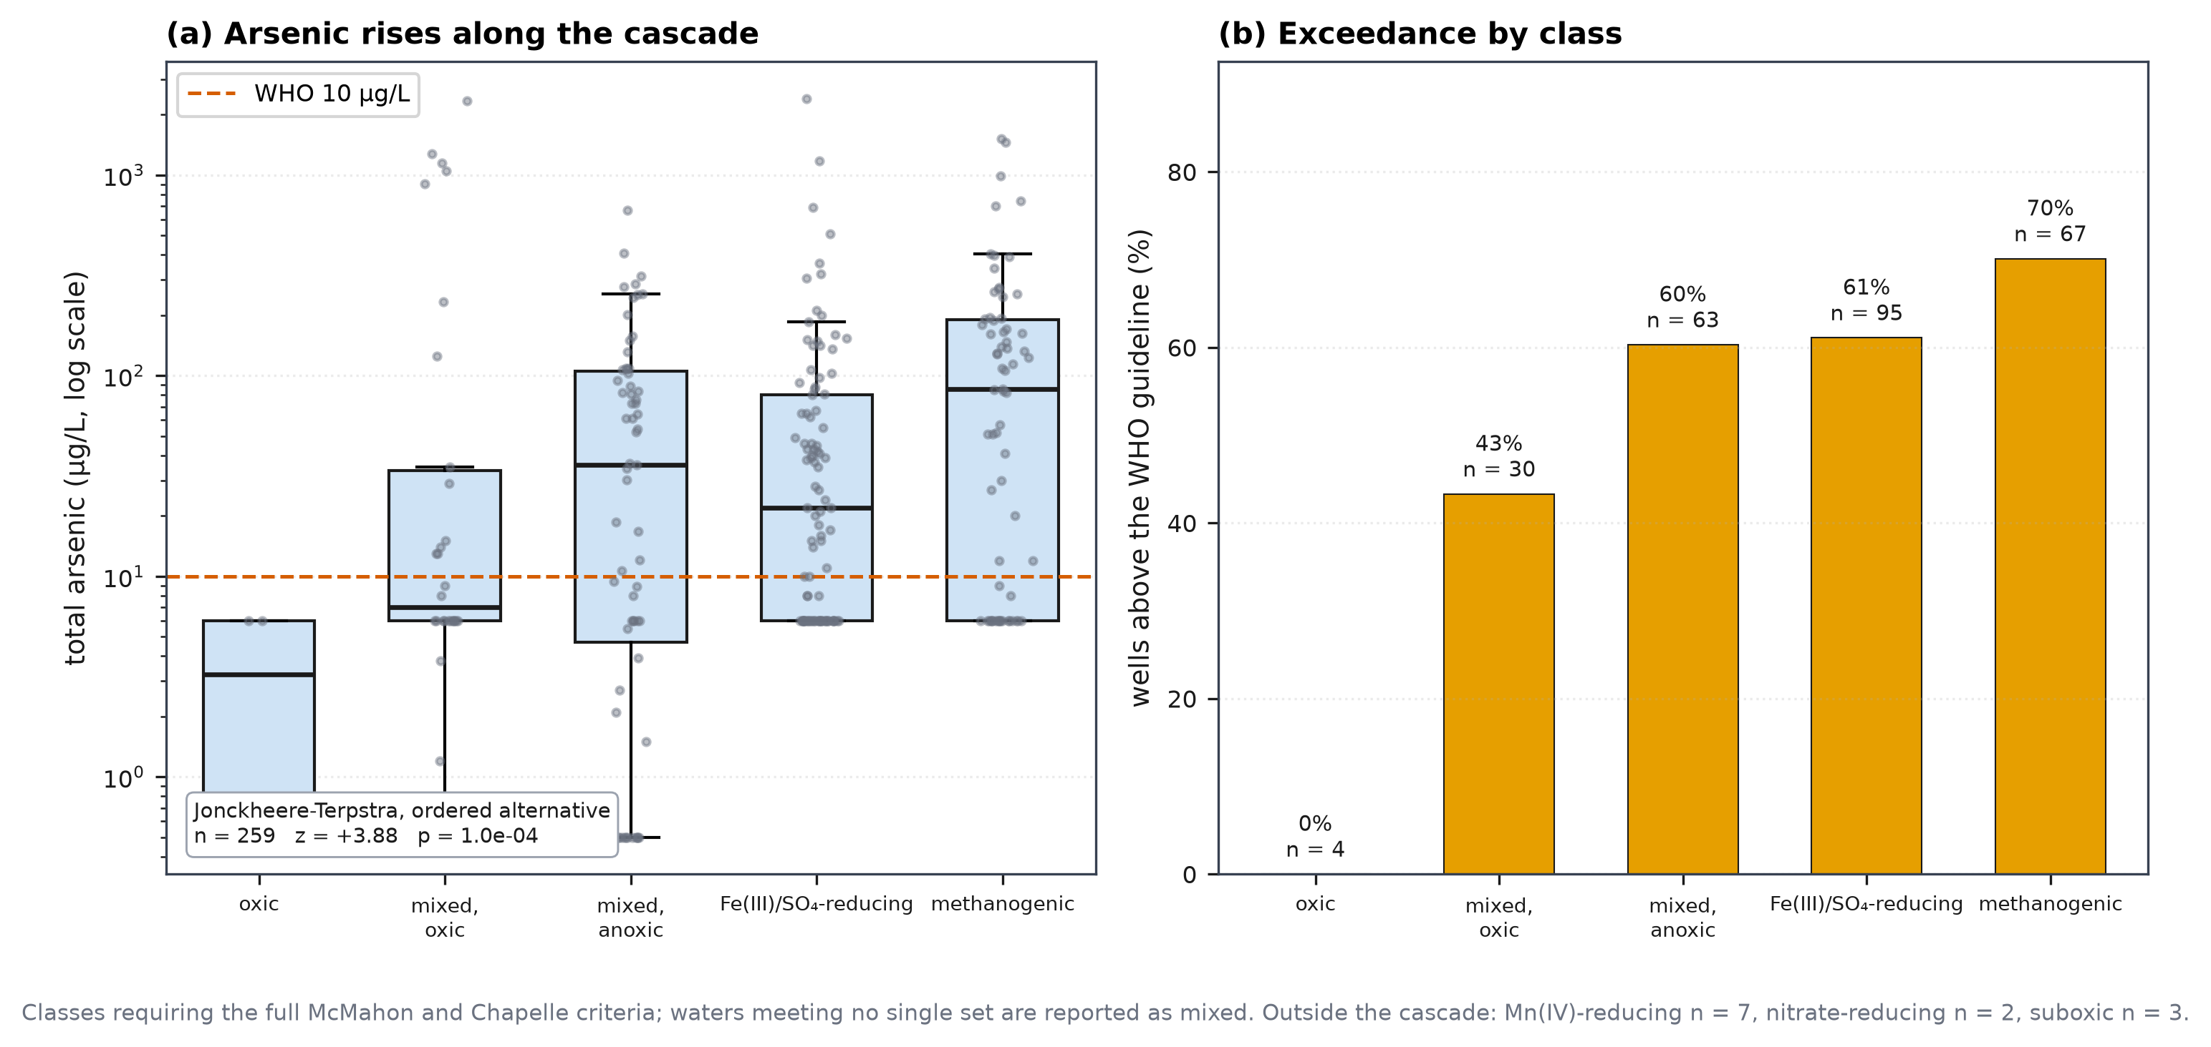
Figure 8. Arsenic concentration and guideline exceedance follow redox condition across the zonation.
Table 14. Redox zonation after McMahon and Chapelle, with arsenic, iron and manganese by zone.
redox zone | n wells | pct wells | median As ugL | n As above WHO | pct As above WHO | median Fe mgL | median Mn mgL | median Eh mV
Fe(III)- / sulfate-reducing | 95 | 35.1 | 22 | 58 | 61.1 | 1.43 | 0.7 | 85
methanogenic | 67 | 24.7 | 86 | 47 | 70.1 | 4.53 | 0.383 | 71
mixed (anoxic) | 63 | 23.2 | 36 | 38 | 60.3 | 1.4 | 0.759 | 74.5
mixed (oxic) | 30 | 11.1 | 7 | 13 | 43.3 | 0.282 | 0.629 | 122
Mn(IV)-reducing | 7 | 2.6 | 6 | 0 | 0 | 0.042 | 0.454 | 52
oxic | 4 | 1.5 | 3.25 | 0 | 0 | 0.049 | 0.005 | 264
suboxic | 3 | 1.1 | 6 | 0 | 0 | 0.022 | 0.035 | 106
nitrate-reducing | 2 | 0.7 | 3.65 | 0 | 0 | 0.044 | 0.015 | 191

Arsenic is therefore elevated where iron oxyhydroxides are being reductively dissolved [11, 12, 13, 14], and the model's reliance on iron reflects that process rather than an incidental correlation.
Arsenic speciation does not corroborate the zonation. Restricted to the 122 wells where both As(III) and total arsenic are genuine measurements, the As(III) fraction does not rise along the reducing sequence (p = 1.000). Computed over all wells the ratio appears highest in oxic water, but that is an artefact: where arsenic is low both determinands sit at a common detection limit of 6.0 µg/L and the ratio is forced to unity. We report this as a non-confirmation. Arsenic redox kinetics are slow and speciation is unstable between sampling and analysis, so disequilibrium is not unexpected.

3.9 Geological setting
Arsenic separates cleanly by surface geology across the 3,465 national survey wells carrying a classification (Figure 9, Table 15). Median arsenic is 114.00 µg/L in the Chandina Alluvium, where 68.9 % of wells exceed the WHO guideline, 44.85 µg/L in Deltaic Silt (65.9 %) and 42.30 µg/L in Deltaic Sand (68.4 %).
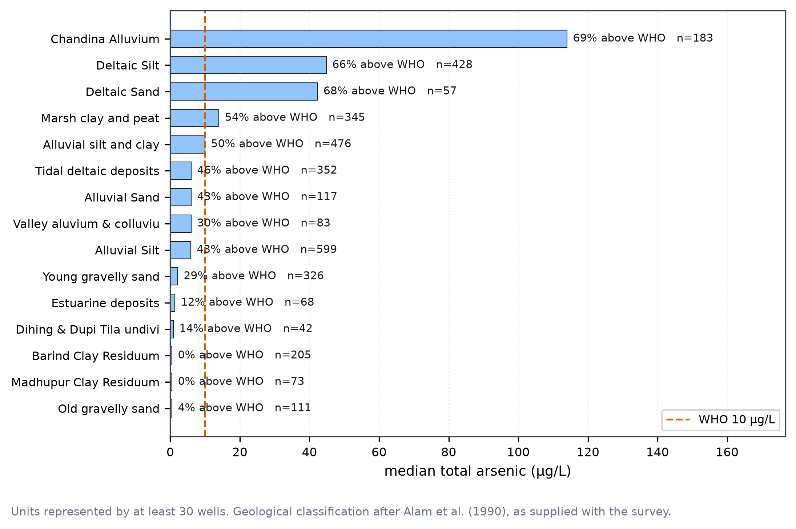
Figure 9. Arsenic by surface geology in the national survey, which includes the external test wells.
Table 15. Arsenic by surface geology unit in the national survey, with exceedance percentages.
GEOL UNIT | n | median | above | pct above
Chandina Alluvium | 183 | 114 | 126 | 68.9
Deltaic Silt | 428 | 44.85 | 282 | 65.9
Deltaic Sand | 57 | 42.3 | 39 | 68.4
Marsh clay and peat | 345 | 14 | 185 | 53.6
Alluvial silt and clay | 476 | 10 | 237 | 49.8
Tidal deltaic deposits | 352 | 6 | 163 | 46.3
Alluvial Sand | 117 | 6 | 50 | 42.7
Valley aluvium & colluviu | 83 | 6 | 25 | 30.1
Alluvial Silt | 599 | 5.9 | 258 | 43.1
Young gravelly sand | 326 | 2.15 | 94 | 28.8
Estuarine deposits | 68 | 1.35 | 8 | 11.8
Dihing & Dupi Tila undivi | 42 | 0.9 | 6 | 14.3
Barind Clay Residuum | 205 | 0.5 | 0 | 0
Madhupur Clay Residuum | 73 | 0.5 | 0 | 0
Old gravelly sand | 111 | 0.5 | 4 | 3.6

At the other extreme, the two Pleistocene terrace units contain no exceeding well at all: Barind Clay Residuum across 205 wells and Madhupur Clay Residuum across 73, both with a median of 0.50 µg/L, which is the detection limit. Old gravelly sand follows at 3.6 % across 111 wells.
The contrast between Holocene deltaic and alluvial deposits on the one hand and the uplifted Pleistocene terraces on the other is the established regional pattern [11, 14, 37], and the data reproduce it without any modelling. It also bears on the external validation of Section 3.5: the external set spans both settings, so transfer is being tested across a genuine geological contrast rather than within a single depositional environment.

3.10 Depth
Arsenic declines significantly with depth (Spearman ρ = −0.305, FDR significant; Table 16). Median arsenic falls from 65.00 µg/L in wells shallower than 20 m, through 15.00 µg/L at 20 to 30 m and 8.90 µg/L at 30 to 50 m, to 6.00 µg/L below 50 m, and exceedance falls correspondingly from 75.9 % to 30.8 %. Comparing wells shallower and deeper than 30 m gives medians of 45.00 and 6.00 µg/L (Mann-Whitney, p = 1.7 × 10⁻⁵).
Table 16. Arsenic and iron by depth stratum, showing where the two decouple.
stratum | n wells | median As ugL | mean As ugL | n above WHO | pct above WHO | median Fe mgL
shallow <20 m | 87 | 65 | 118 | 66 | 75.9 | 1.01
intermediate 20-30 m | 60 | 15 | 259.9 | 33 | 55 | 0.748
deep 30-50 m | 75 | 8.9 | 72.41 | 35 | 46.7 | 1.02
very deep >=50 m | 39 | 6 | 35.61 | 12 | 30.8 | 4.53

Uranium, molybdenum and zinc also decline with depth, at ρ = −0.340, −0.419 and −0.231 respectively, all FDR significant. Barium rises, at ρ = +0.398. Nickel and lead show no significant relationship.
One detail bears on the use of iron as a proxy. The deepest stratum carries the highest median iron of the four, at 4.53 mg/L, while carrying the lowest median arsenic. Iron and arsenic decouple at depth, so an iron based rule will over-flag deep wells.

3.11 Does more data help? (RQ2, limits)
Learning curves were computed for the four metals surviving spatial validation (Figure 10, Table 17). Three flatten before the full sample is reached. For arsenic the final increment in training size changes R² by −0.006, for uranium by +0.004 and for barium by −0.012, against gains of +0.155, +0.154 and +0.261 over the whole range. Molybdenum is still improving, gaining +0.057 in the final step.
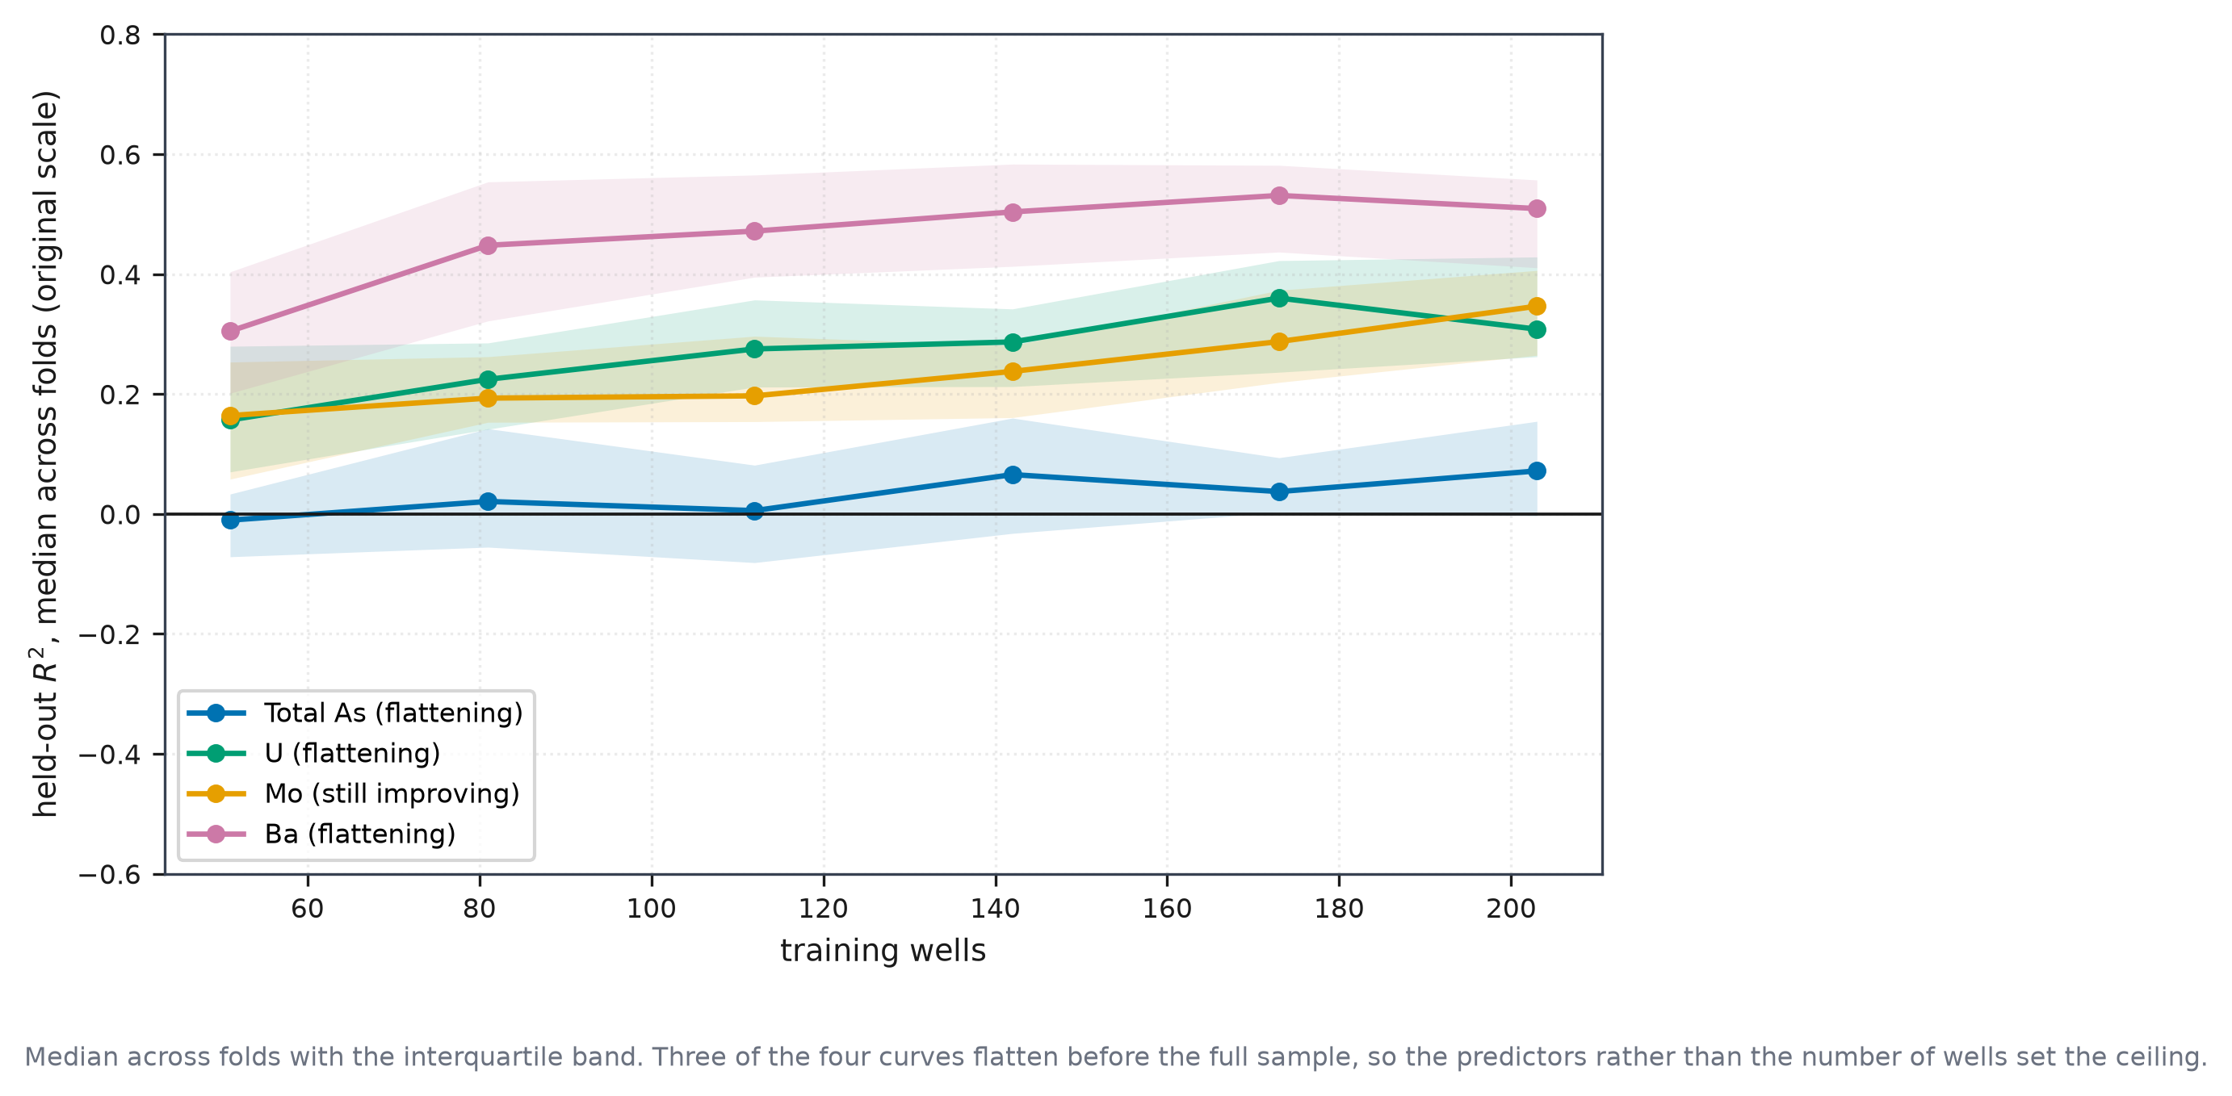
Figure 10. Learning curves for the four spatially robust metals, held-out R² against training set size.
Table 17. Learning curve results, held-out R² against training set size for four metals.
target | fraction of pool | n train | n test | r2 mean | r2 sd | r2 median | r2 q1 | r2 q3 | r2 log mean | r2 log median
AsTot | 0.25 | 51 | 68 | -0.08185 | 0.6296 | -0.0103 | -0.0714 | 0.03319 | 0.3228 | 0.3228
AsTot | 0.4 | 81 | 68 | 0.03344 | 0.1489 | 0.02088 | -0.05534 | 0.1422 | 0.3712 | 0.3666
AsTot | 0.55 | 112 | 68 | -5.023 | 27.46 | 0.005621 | -0.08115 | 0.08137 | 0.37 | 0.3981
AsTot | 0.7 | 142 | 68 | 0.07435 | 0.1129 | 0.06567 | -0.0324 | 0.1599 | 0.4716 | 0.4758
AsTot | 0.85 | 173 | 68 | 0.07893 | 0.1214 | 0.03731 | 0.002858 | 0.09383 | 0.4987 | 0.5042
AsTot | 1 | 203 | 68 | 0.0733 | 0.1167 | 0.0718 | -0.003272 | 0.1545 | 0.492 | 0.4984
U | 0.25 | 51 | 68 | 0.1795 | 0.129 | 0.1568 | 0.07011 | 0.2797 | 0.4137 | 0.4251
U | 0.4 | 81 | 68 | 0.0929 | 0.8173 | 0.2246 | 0.1413 | 0.2852 | 0.4714 | 0.4717
U | 0.55 | 112 | 68 | 0.2922 | 0.1209 | 0.2752 | 0.2117 | 0.357 | 0.5646 | 0.5769
U | 0.7 | 142 | 68 | 0.2749 | 0.1174 | 0.2869 | 0.2124 | 0.3419 | 0.5266 | 0.5463
U | 0.85 | 173 | 68 | 0.3299 | 0.1352 | 0.36 | 0.2364 | 0.4225 | 0.5962 | 0.606
U | 1 | 203 | 68 | 0.3336 | 0.1087 | 0.3081 | 0.2622 | 0.4286 | 0.5906 | 0.5997
Mo | 0.25 | 51 | 68 | -12.44 | 78.49 | 0.1641 | 0.05807 | 0.2533 | 0.2322 | 0.2722
Mo | 0.4 | 81 | 68 | 0.1966 | 0.1228 | 0.1932 | 0.1529 | 0.2623 | 0.3463 | 0.3534
Mo | 0.55 | 112 | 68 | 0.1999 | 0.2013 | 0.197 | 0.154 | 0.2964 | 0.3505 | 0.3638
Mo | 0.7 | 142 | 68 | 0.2334 | 0.1068 | 0.2378 | 0.1607 | 0.281 | 0.4233 | 0.4276
Mo | 0.85 | 173 | 68 | 0.2984 | 0.1113 | 0.2875 | 0.2194 | 0.3731 | 0.4598 | 0.4672
Mo | 1 | 203 | 68 | 0.3558 | 0.1171 | 0.3465 | 0.2646 | 0.4061 | 0.5046 | 0.5322
Ba | 0.25 | 51 | 68 | -0.1584 | 2.604 | 0.3049 | 0.2013 | 0.4038 | 0.3968 | 0.4393
Ba | 0.4 | 81 | 68 | 0.4333 | 0.1464 | 0.4481 | 0.3219 | 0.5538 | 0.5319 | 0.5372
Ba | 0.55 | 112 | 68 | 0.4707 | 0.1074 | 0.4717 | 0.3949 | 0.5653 | 0.5506 | 0.5671
Ba | 0.7 | 142 | 68 | 0.481 | 0.1553 | 0.5038 | 0.4129 | 0.5835 | 0.5976 | 0.6142
Ba | 0.85 | 173 | 68 | 0.5067 | 0.1099 | 0.5312 | 0.4368 | 0.5814 | 0.5925 | 0.5852
Ba | 1 | 203 | 68 | 0.4942 | 0.1138 | 0.5093 | 0.4106 | 0.557 | 0.6133 | 0.6443

For three of the four metals, therefore, the ceiling is set by the predictors rather than by the number of wells, and collecting further wells of the same kind would not materially improve them.

3.12 What a screening programme could expect (RQ2, applied)
Operating points were evaluated on the 1,027 external wells using iron, manganese and well depth (Table 18, Figure 11b).

Table 18. Operating points for arsenic screening on external wells under both regulatory standards.
standard | tier | operating point | auc | threshold ugL | sensitivity | specificity | ppv | npv | pct referred to lab | contaminated missed | n contaminated | tp | fp | fn | tn | threshold chosen on | dev sensitivity | sensitivity ci95 | auc ci95
WHO_10 | T_cheap | dev_target_sensitivity_95 | 0.8282 | 8.144 | 0.9794 | 0.4454 | 0.2914 | 0.9893 | 63.5 | 4 | 194 | 190 | 462 | 4 | 371 | development out-of-fold | 0.9551 | [0.957, 0.9952] | [0.8004, 0.8548]
WHO_10 | T_cheap | balanced_youden | 0.8282 | 19.35 | 0.8969 | 0.6831 | 0.3973 | 0.966 | 42.6 | 20 | 194 | 174 | 264 | 20 | 569 | development out-of-fold | 0.7756 | [0.8533, 0.9382] | [0.8004, 0.8548]
WHO_10 | T_cheap | dev_target_specificity_90 | 0.8282 | 32.68 | 0.8041 | 0.7455 | 0.4239 | 0.9423 | 35.8 | 38 | 194 | 156 | 212 | 38 | 621 | development out-of-fold | 0.6603 | [0.7448, 0.8603] | [0.8004, 0.8548]
WHO_10 | T_full | dev_target_sensitivity_95 | 0.8382 | 8.005 | 0.9948 | 0.1825 | 0.2208 | 0.9935 | 85.1 | 1 | 194 | 193 | 681 | 1 | 152 | development out-of-fold | 0.9679 | [0.9835, 1.0] | [0.8097, 0.8668]
WHO_10 | T_full | balanced_youden | 0.8382 | 15.9 | 0.8608 | 0.6819 | 0.3866 | 0.9546 | 42.1 | 27 | 194 | 167 | 265 | 27 | 568 | development out-of-fold | 0.8718 | [0.8118, 0.9055] | [0.8097, 0.8668]
WHO_10 | T_full | dev_target_specificity_90 | 0.8382 | 33.78 | 0.5103 | 0.8968 | 0.5351 | 0.8872 | 18 | 95 | 194 | 99 | 86 | 95 | 747 | development out-of-fold | 0.6346 | [0.4364, 0.5846] | [0.8097, 0.8668]
Bangladesh_50 | T_cheap | dev_target_sensitivity_95 | 0.8008 | 9.484 | 1 | 0.4444 | 0.1068 | 1 | 58.3 | 0 | 64 | 64 | 535 | 0 | 428 | development out-of-fold | 0.9537 | [1.0, 1.0] | [0.7575, 0.8387]
Bangladesh_50 | T_cheap | balanced_youden | 0.8008 | 19.73 | 0.9219 | 0.6085 | 0.1353 | 0.9915 | 42.5 | 5 | 64 | 59 | 377 | 5 | 586 | development out-of-fold | 0.8704 | [0.8485, 0.9831] | [0.7575, 0.8387]
Bangladesh_50 | T_cheap | dev_target_specificity_90 | 0.8008 | 73.2 | 0.5938 | 0.758 | 0.1402 | 0.9656 | 26.4 | 26 | 64 | 38 | 233 | 26 | 730 | development out-of-fold | 0.4259 | [0.4697, 0.7121] | [0.7575, 0.8387]
Bangladesh_50 | T_full | dev_target_sensitivity_95 | 0.8299 | 13.06 | 0.9531 | 0.4704 | 0.1068 | 0.9934 | 55.6 | 3 | 64 | 61 | 510 | 3 | 453 | development out-of-fold | 0.9537 | [0.8909, 1.0] | [0.7876, 0.8667]
Bangladesh_50 | T_full | balanced_youden | 0.8299 | 38.44 | 0.4844 | 0.8733 | 0.2026 | 0.9622 | 14.9 | 33 | 64 | 31 | 122 | 33 | 841 | development out-of-fold | 0.75 | [0.3582, 0.6032] | [0.7876, 0.8667]
Bangladesh_50 | T_full | dev_target_specificity_90 | 0.8299 | 59.15 | 0.2031 | 0.9626 | 0.2653 | 0.9479 | 4.8 | 51 | 64 | 13 | 36 | 51 | 927 | development out-of-fold | 0.5648 | [0.1071, 0.3077] | [0.7876, 0.8667]

Each threshold is chosen on out of fold predictions over the development wells and frozen before the external wells are scored, so the figures below are out of sample in the cut off as well as in the model.
Against the Bangladesh standard of 50 µg/L, where 64 of the external wells exceed, the rule targeting 95 % sensitivity on the development wells attains 100 % on the external wells, missing none of the 64 while referring 58.3 % for laboratory confirmation. The balanced rule attains 92.2 %, misses five and refers 42.5 %. Against the WHO guideline of 10 µg/L, where 194 wells exceed, the corresponding rule attains 97.9 % and misses four at a burden of 63.5 %.
A programme willing to send roughly half its samples to a laboratory could therefore identify almost every well exceeding the national standard using three inexpensive measurements. The same models cannot state how contaminated those wells are: the mean conformal interval for arsenic spans 299 to 318 µg/L against a guideline of 10 µg/L.

3.13 Does the fitted model earn its place? (RQ2, applied)
The tiers are built from predictors, and a tier can only be judged against the alternative of using one of those predictors on its own. Three single predictor rules were therefore scored under the same frozen threshold protocol (Figure 11a, Table 19).
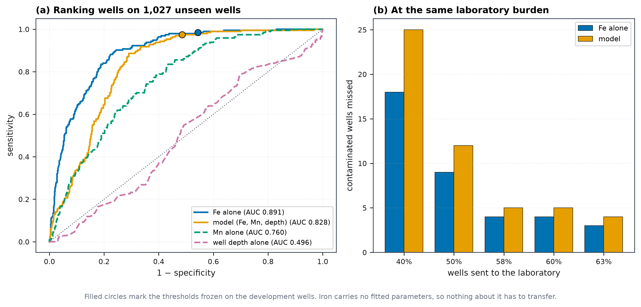
Figure 11. Arsenic screening performance on external wells and operating points against the Bangladesh standard.

Table 19. Raw iron against the fitted model on the external wells, with the development comparison and kit degradation.
standard | n external | n contaminated | dev auc model oof | dev auc iron | ext auc model | ext auc iron | iron advantage | delong p | ext auc iron holocene | ext auc model holocene | iron auc district median | iron auc district range | iron auc kit cv25 | iron auc strip
WHO_10 | 1026 | 194 | 0.867 | 0.7418 | 0.8284 | 0.8915 | 0.0631 | 1.752e-08 | 0.8764 | 0.8088 | 0.9105 | 0.2617 | 0.8914 | 0.8833
Bangladesh_50 | 1026 | 64 | 0.8489 | 0.7344 | 0.8009 | 0.8572 | 0.0562 | 0.008332 | 0.8176 | 0.7674 | 0.8115 | 0.2363 | 0.8553 | 0.8504

Well depth alone is worthless on the external wells, at an area under the curve of 0.496. Manganese alone reaches 0.760. Dissolved iron alone reaches 0.891, which exceeds the 0.828 of the model built on iron, manganese and depth together. The difference of +0.063 has a bootstrap interval of 0.042 to 0.094 and a paired DeLong test gives 1.8e-08 on identical wells.
Three checks were applied before accepting this. Restricting to the Holocene aquifers, where the pre-Holocene terraces no longer supply easy negatives, the advantage widens rather than narrows, 0.876 against 0.809 (3.1e-07). Comparing the two rules at equal laboratory burden rather than at their own thresholds, iron misses fewer contaminated wells at every burden examined, from 40 % to 63 % of wells referred (Figure 11b). And the iron here is an inductively coupled plasma determination rather than a kit reading, so the rule was re-scored under multiplicative imprecision of 25 % and after reading onto a typical colorimetric strip ladder; the area under the curve held at 0.891 and 0.883, and at the frozen threshold of 0.165 mg/L sensitivity remained 0.985 with 3 of 194 wells missed.
On the development wells the ordering reverses. There the model reaches 0.867 against 0.742 for iron, an advantage of +0.125. The model is not a weak one; it is fitted, and what it fits does not survive transfer, whereas a raw concentration carries no coefficients.
Neither rule is stable across regions. Across the 7 external districts with at least ten exceedances, the area under the curve for iron alone runs from 0.731 to 0.993 with a median of 0.910, against 0.742 in the development set (Figure 10). The spread is larger than the gap between the two rules.
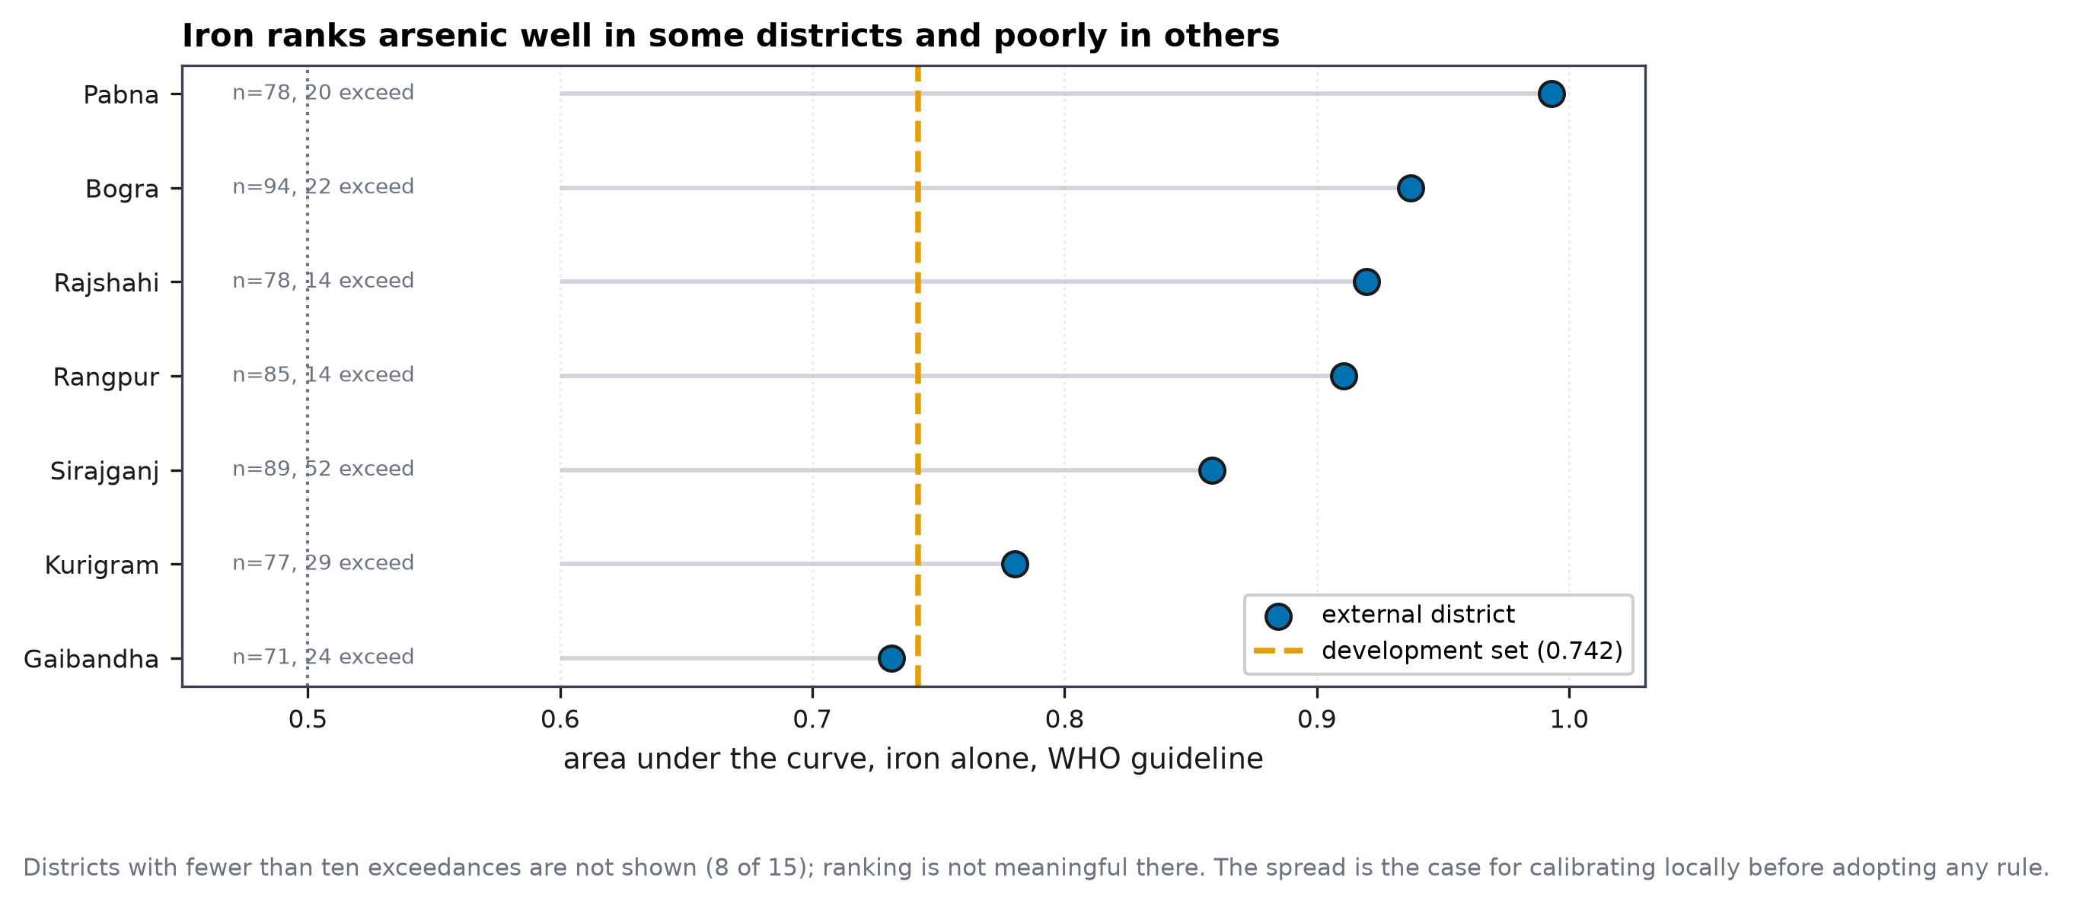
Figure 12. Iron ranks arsenic differently in each external district, against its value in the development set.

4. Discussion

4.1 What sets the limit on surrogate screening
The hypothesis advanced in Section 1 was that the binding constraint on surrogate screening is analytical rather than geochemical. The results support half of it, and refute the other half. Six of thirteen metals were excluded before any model was fitted, and in five of the six the reason was that the laboratory had reported a detection limit rather than a measurement: chromium in 97 % of wells, cadmium in 84 %, copper in 81 %, while antimony and As(III) placed 46 % and 42 % of records on a single value. Selenium was excluded on different grounds, having been measured in only 19 wells. No estimator can recover structure that was never recorded.
The practical consequence is uncomfortable for the regional literature. Cadmium is among the metals most often reported as a hazard in assessments across the Bengal Basin [4, 5], yet here it is unmodellable, and its highest observation reaches 6 % of the WHO guideline. Where a determinand is censored at a limit comparable to the concentrations of interest, both the reported occurrence and any model built on it rest on the detection limit as much as on the water.
What does not follow is the converse, and our own data refute it. If detection limits were the whole story, metals with little censoring would be modellable whatever their geochemistry. Nickel is censored in 1.1 % of wells, zinc in 0.4 % and lead in 12.5 %, and all three are infeasible at every tier under every spatial scheme. Below the censoring ceiling the limit is set by something else: whether the field measurable predictors carry information about that metal at all. The defensible claim is therefore two sided. Censoring imposes a ceiling, and for the heavily censored metals that ceiling is the whole explanation; for the rest, feasibility is decided by predictor information, and nothing about a low censoring rate promises it.
So far censoring has appeared in one role, as something that hides a signal. Chromium, cadmium and copper carry so little measured variation that no model can be built, and that ceiling is the whole of their story. The same mechanism has a second role that is easier to miss and more damaging, because it runs the other way: censoring can manufacture a signal that is not there. An analysis that ignores the censoring flag would classify 65 wells as nitrate reducing, and would report positive log-scale skill for arsenic under spatial blocking. Neither survives when the flag is respected.
Both cases turn on reading a stored detection limit as though it were a measurement. Nitrate is censored in 80 % of these wells at limits of 0.3 and 0.5 mg/L, so a well reported as "< 0.5" carries the value 0.5 and passes a test for nitrate at or above 0.5 mg/L. Of the 65 wells that test places in the nitrate reducing class, only 2 meet the full criteria; the rest are anoxic waters carrying iron and manganese in milligrams per litre. Arsenic shows the same thing in a different metric. On the log scale the lower tail carries disproportionate weight, so the split between the two detection limits of 0.5 and 6.0 µg/L is itself learnable. The coefficient of determination is +0.227 under the most demanding blocking, but restricted to the wells that carry a genuine measurement it falls to +0.022 (p = 0.42). Table S1 reports both cases side by side.
This is Helsel's objection [53] made concrete. Substitution does not merely lose information, it fabricates structure, and the fabricated structure is strong enough to pass a cross validated model search and a spatially blocked design. The practical consequence for this paper is that arsenic retains no concentration skill under spatial blocking on either scale. What it retains is the ranking of wells by exceedance, which the next section takes up.
One class of result is unaffected. Classification against the WHO guideline of 10 µg/L does not depend on how censored values are filled, because a well reported below 6.0 or below 0.5 µg/L is below 10 µg/L whatever number is substituted, so its negative label is correct by construction. The areas under the curve reported here are therefore not exposed to the mechanism described above.
A diagnostic that predicts which determinands will be sensitive to the substitution rule would be useful, and we cannot offer one. Across the seven modelled targets, the rank correlation between the spread in R² and the detection limit as a fraction of the median is ρ = +0.14, and against the censoring rate ρ = +0.49; neither is distinguishable from chance with seven points, and arsenic is the only target whose spread is material. What the cases have in common is better read as two conditions than as a correlation. A substitution rule can only matter where the model has skill to lose and where the limit sits high enough to move an appreciable share of the target. Uranium fails the second condition, its limits lying two orders of magnitude below its median; lead fails the first, its models carrying no skill at any tier although its limit sits at half its median. Only arsenic meets both.

4.2 How much skill is real
Random cross validation gave 23 feasible target and tier combinations. Spatial blocking reduced this to 15 under sixteen blocks and 10 under eight, and the combinations lost were not evenly distributed. Nickel fell from R² = 0.288 under random folds to −0.204 under eight blocks and −0.113 under sixteen, and became infeasible at every tier. Reported under random validation alone, which is the prevailing practice in this literature (Table 1), nickel would have been presented as screenable.
Four metals survive spatial blocking: arsenic, barium, molybdenum and uranium. The two that survive the more demanding eight block design are molybdenum and uranium.
External transfer imposes a further cost, and separates three things that are easily conflated. The coefficient of determination falls heavily, for barium from 0.650 within the development data to 0.074 on unseen districts under the same reduced predictor set. Rank correlation holds up far better, reaching ρ = 0.774 for barium and 0.502 for arsenic on that set. Classification holds up best of all: against the WHO guideline the arsenic model attains an area under the curve of 0.838 on 1,027 wells in districts it never saw, and 0.828 when reduced to iron, manganese and well depth alone.
What transfers, therefore, is the ordering of wells by risk, not the estimate of how contaminated each is. For a screening programme that ordering is the operative quantity, and the distinction is worth stating plainly, because for the arsenic model built on iron, manganese and depth a coefficient of determination of −5.58 and an area under the curve of 0.828 describe the same predictions.

4.3 Calibrated uncertainty, and where it fails
Within the study area the conformal intervals behaved as the theory promises, with held out coverage at or above the nominal 90 %. To our knowledge conformal prediction has not previously been applied to trace metal concentrations in groundwater, and on this evidence it suits the problem: it wraps any estimator and requires no distributional assumption.
Transfer is where it fails, and it fails in a way that offers no warning. Barium under the reduced laboratory predictors retained 90.7 % coverage, close to nominal; the same metal under iron, manganese and depth fell to 72.7 %; and arsenic rose to 99.0 %. One of these would mislead a user into unwarranted confidence and another into intervals too wide to act on, and nothing in the calibration distinguishes them in advance.
This is consistent with the theoretical position that exchangeability is what the guarantee rests on, and that spatial data satisfy it only locally [49, 50, 51, 52]. The contribution here is to measure the size of the failure on real wells rather than to restate the caveat. A conformal interval calibrated in one district should not be presented as valid in another.
Even where coverage is correct, width may make the interval useless. The mean conformal interval for arsenic ranges from 299 to 318 µg/L across tiers, against a guideline of 10 µg/L. A statistically valid interval twenty two times the regulatory threshold at its narrowest supports no decision at all, and reporting coverage without width would misrepresent what the model offers.

4.4 The mechanism is the expected one
Iron is the single most informative predictor for arsenic, at 37 % of positive permutation importance, and redox indicators together account for 45.9 %. For uranium the dependence is stronger, iron alone reaching 79 %.
The redox zonation gives the same answer from different variables. Median arsenic rises from 6.00 µg/L in oxic wells to 22.00 in Fe(III) reducing wells and 85.50 in sulfate reducing and methanogenic wells, and exceedance from 38 % to 69 %. Arsenic is elevated where iron oxyhydroxides are being reductively dissolved, which is the established release mechanism in this basin [11, 12, 13, 14, 17]. The surface geology reproduces the same division without any modelling: no well in the Barind or Madhupur Clay Residuum exceeds the guideline, against 68.9 % in the Chandina Alluvium.
The major ion composition is unexceptional for the region. The dominance of the Ca-HCO₃ facies, Gibbs ratios lying in the rock weathering field and near equilibrium with calcite match what hydrogeochemical surveys report across the Bengal Basin and the adjacent alluvial tracts [18, 19, 22, 24, 25]. These wells are therefore chemically typical of the wider setting, even though the districts were selected for arsenic.
The models are therefore using the process rather than an incidental correlation, which is the difference between a screening rule that may generalise and one that will not.
Two caveats attach. Arsenic speciation does not corroborate the zonation, the As(III) fraction failing to rise along the reducing sequence. Slow arsenic redox kinetics and the instability of speciation between sampling and analysis make disequilibrium unsurprising, but we report the non-confirmation rather than omit it. Second, iron and arsenic decouple with depth: the deepest stratum carries the highest median iron at 4.53 mg/L and the lowest median arsenic, so an iron based rule will over-flag deep wells. This is a predictable and correctable failure mode rather than a hidden one.

4.5 What this is worth in practice
A field kit for arsenic already exists, costs about USD 0.17 per test and classified 88 % of wells correctly in evaluation [26, 27]. Any honest appraisal must begin there: for arsenic alone, that kit is cheaper and more accurate than the models reported here, and we do not propose replacing it.
The second thing an honest appraisal must concede is that the fitted model does not earn its place. On the external wells a single measurement of dissolved iron ranks them better than the model built on iron, manganese and well depth together, 0.891 against 0.828, a difference of +0.063 with a bootstrap interval of 0.042 to 0.094 and 1.8e-08 on a paired DeLong test. The gap is not an artefact of easy negatives: within the Holocene aquifers alone, where the decision actually falls, it widens to 0.876 against 0.809. Nor is it an artefact of where each threshold happened to sit, since iron misses fewer contaminated wells than the model at every laboratory burden we examined. Depth on its own is worth nothing, at an area under the curve of 0.496.
What makes this interpretable rather than merely awkward is the development set. There the ordering reverses: the model beats iron by +0.125, 0.867 against 0.742. The model is not weak. It is fitted, and what it fits does not survive the journey to another district, whereas a raw concentration carries no coefficients and so has nothing to lose. This is the same lesson as Section 4.2, arriving by a different route.
Iron indicating arsenic is not a new idea and we do not claim it. Red staining on a tubewell platform marks iron reduction and with it arsenic release, while black staining marks manganese reduction, and the idea is already deployed: the iArsenic application predicts well risk from depth, location and platform colour with a reported accuracy of 84 % [67, 68]. The sediment colour a driller reports serves the same purpose [71].
The gap this paper fills is one of setting rather than of mechanism. The validation that established platform colour was carried out at Matlab, where 99 % of the 233 red-platform wells among 272 exceeded the WHO guideline [65]. Where almost every well is contaminated, a rule that flags almost every well is correct almost always and screens nothing; the authors say as much, calling for re-examination where arsenic varies more between wells. In the alluvial aquifers of eastern India, where it does, platform colour identified contaminated wells with about 83 % accuracy, and performance rose with prevalence [66]. Our external districts carry a prevalence of 18.9 %, 194 of 1,027 wells, which is the mixed regime in which the heuristic has not been tested quantitatively.
What this paper adds is therefore a measured and kit-checkable form of that heuristic, carried through the validation the earlier work did not have: a threshold frozen on one set of districts, applied unchanged to 1,027 wells in fifteen others at a prevalence where the rule can fail, and compared against a fitted alternative on identical wells.
The mechanism also explains the pattern that defeated the regression. Arsenic is released when Fe(III) coatings are converted to Fe(II) phases such as siderite or vivianite, and that conversion need not put iron into solution [69]. Concentrations of the two therefore decouple while their ordering need not, which is why a correlation search finds little and a ranking finds a great deal. It is also consistent with iron ranking poorly in our own development set, 125 of whose 271 wells lie in Nawabganj: a study of ten municipal wells there, repeatedly sampled, reported no relationship between arsenic and iron [70]. Ten wells cannot establish a district-wide pattern, and we offer it as consistent with our result rather than as an explanation of it.
Two qualifications bound the recommendation. The iron used here is an inductively coupled plasma determination, not a kit reading, so the rule was re-scored under kit-grade imprecision and after reading onto a typical strip ladder; the area under the curve held at 0.891 and 0.883, and the frozen threshold of 0.165 mg/L falls between two rungs of that ladder rather than on one. More seriously, no rule is stable across regions. Iron's area under the curve runs from 0.731 to 0.993 across the 7 external districts with enough exceedances to rank, against 0.742 in the development set. A programme entering a district it has not measured should calibrate against a small laboratory sub-sample before adopting any threshold, ours included.
The case for a surrogate approach rests on two things the kit cannot do. It is analyte specific, so a programme concerned with more than arsenic needs a separate consumable for each determinand, and no equivalent exists for uranium, molybdenum or barium. And a single set of field measurements can, in principle, inform several metals at once.
On the evidence here that principle delivers less than one might hope. Of the thirteen metals screened, only three exceed any guideline in any well, and of those only arsenic and uranium both exceed and remain modellable after spatial validation. Lead exceeds in one well and is infeasible at every tier. The metals that model best, barium and molybdenum, never approach their guidelines. The intersection of "hazardous here" and "screenable" contains two metals, and for one of them a cheaper instrument already exists.
One hazard sits outside that accounting and should be named. Manganese enters this study as a predictor rather than as a target, so it is absent from the thirteen and from the exceedance table, yet the World Health Organization lowered its health based value to 80 µg/L in 2021 and the median well here carries 543 µg/L. On that basis most of these wells exceed it. The point cuts against the premise of surrogate screening rather than for it: manganese is measured directly in the E2 tier, so for manganese there is nothing to substitute. A programme equipping field teams with iron and manganese kits would be measuring a hazard, not predicting one, and would obtain the arsenic ranking as a by product.
Uranium is the most promising candidate and the least evidenced. It survives spatial blocking at every tier from E2 upward and at both block counts, depends overwhelmingly on iron, and has no field kit. But it exceeds the WHO guideline in four wells out of 271, and a coefficient of determination between 0.25 and 0.35 on a target with four positives says nothing about whether exceedances can be detected. It could not be validated externally either, because the national survey does not report it. Uranium is therefore a hypothesis for a future study with a sufficient number of exceedances, not a screening result.
The direction of the dependence is at least consistent with the known chemistry. Uranium is mobile as uranyl carbonate complexes in less reducing water and is removed as conditions become iron reducing, so uranium should fall as iron rises, and bicarbonate appearing as the second predictor fits that account. Permutation importance gives magnitude but not sign, so this remains an interpretation rather than a demonstration.
Where the approach is used, the operating point matters more than the summary statistic. Against the Bangladesh standard, a rule using iron, manganese and well depth identifies all 64 contaminated wells while referring 58.3 % of wells for laboratory confirmation, and the balanced rule refers 40 % while missing five. Whether that trade is acceptable is a policy judgement, and the figures are reported side by side rather than combined so that it can be made explicitly. Adding the laboratory major ions raises the area under the curve from 0.828 to 0.838 against the WHO guideline and from 0.801 to 0.830 against the Bangladesh standard, gains too small to justify their cost.

4.6 Limitations
The development set comprises 271 wells in four districts, selected by the original survey because they are arsenic affected. Exceedance rates here are therefore not prevalence estimates for Bangladesh. The data were collected in 1998 and 1999 and describe conditions at that time.
External validation applies to a reduced predictor set. The national survey carries neither pH nor redox potential, so the tiers that make arsenic and uranium work could not be transferred intact, and the external result tests a weaker model than the one the development data support. The within development score for that same reduced set is reported alongside, which separates the cost of losing predictors from the cost of transfer, but it does not remove the limitation.
Uranium, molybdenum and the remaining metals could not be validated externally at all, since the national component does not report them. The strongest statement available for uranium is that it survives spatial blocking within the study area.
Learning curves flatten for arsenic, uranium and barium, indicating that the predictors rather than the number of wells set the ceiling for those metals. Molybdenum was still improving at the full sample. More wells of the same kind would not materially improve three of the four.
Several methodological choices bound what the numbers can bear, and are stated here rather than left for a reader to find. Targets are modelled on a log1p scale and inverted with the exponential before scoring, without a smearing correction, so the back transformed prediction estimates a conditional median and the coefficients of determination on the original scale are pulled down by a small number of high wells. The conformal score is the absolute residual on the original scale, which produces intervals of constant width by construction; conformalised quantile regression or a score on the log scale would give multiplicative intervals and is the natural next step. Conformal calibration uses random partitions, so the optimism this paper demonstrates for random folds applies to the coverage estimates too, and 24 wells sharing exact coordinates are not accounted for in those splits. Covariate shift weighted conformal and the area of applicability are discussed but not applied, and applying them would test the claim that transfer fails without warning. The comparison of censoring rules scores each rule against its own reconstructed target, so part of the spread reported for arsenic is variance in the target rather than distortion of the model, and no censoring aware learner such as a Tobit or accelerated failure time model was fitted. Significance is assessed with Wilcoxon tests over repeated cross validation folds that share wells, which makes those p values anti conservative. Permutation importance is computed on the log scale while the feasibility table reports the original scale, so the two sets of numbers are not directly comparable, and no single predictor baseline was computed, which leaves open how much of the classification performance well depth alone would deliver. The model family search covers regularised linear models, support vector and random forest regression but no gradient boosting. All results use a single random seed, and stability across seeds is unquantified.
Two features of the setting also flatter the external results. The redox potential is a mixed potential on a platinum electrode rather than a measure of a single couple, and the data show it: the median in the most reducing class is positive, and its permutation importance for arsenic is indistinguishable from zero. And the external districts include the Barind and Madhupur terraces, where arsenic is almost uniformly at the detection limit; these are easy negatives, and the pooled area under the curve is higher than it would be within the Holocene aquifers where the decision actually matters.
Finally, the study assesses whether field measurable parameters can substitute for laboratory analysis. It does not establish that a programme adopting such a rule would improve health outcomes, which would require a different design and a prospective comparison. Exposure based risk assessments in the region show what that different question involves, combining measured concentrations with intake assumptions to estimate hazard to a population rather than testing whether a cheaper measurement can stand in for a dearer one [20, 21].

5. Conclusions
Thirteen trace metals were screened against parameters a field team can measure, in 271 wells carrying field pH, redox potential, conductance and dissolved oxygen alongside a laboratory metal suite, with validation extended to 1,027 wells in fifteen districts the models never saw.
1. Censoring both hides and manufactures structure. Six of thirteen metals carried too little measured variation for any method, which is the familiar ceiling. The second direction is easier to miss: an analysis that reads a stored detection limit as a measurement classifies 65 wells as nitrate reducing where only 2 meet the criteria, and credits arsenic with log-scale skill (+0.227) that falls to +0.022 once only measured wells are scored. Substitution does not merely lose information; it fabricates structure strong enough to pass a cross validated search and a spatially blocked design.
2. Below that ceiling, predictor information decides. Nickel, zinc and lead are almost uncensored and still fail at every tier, so a low censoring rate promises nothing.
3. Honest validation removes most of the apparent skill. Feasible combinations fell from 23 under random folds to 10 under the most demanding spatial design. Nickel, which random validation would have reported as screenable at R² = +0.288, reaches -0.204 once folds are blocked. Arsenic is feasible under sixteen blocks but not under eight, and that fragility should be read as instability rather than as skill.
4. Ranking transfers; concentration does not. No model retained concentration skill on unseen districts on either the original or the log scale. Exceedance ranking transferred, and classification against the WHO guideline is unaffected by the substitution rule, since a well reported below 6.0 µg/L is below 10 µg/L whatever value is filled in.
5. The fitted model earns nothing over the cheapest measurement it contains. On unseen districts a single dissolved iron reading ranked wells better than the model built on iron, manganese and depth, 0.891 against 0.828 (1.8e-08, interval 0.042 to 0.094), held its advantage within the Holocene aquifers (0.876 against 0.809), and missed fewer contaminated wells at every laboratory burden. On the development wells the ordering reversed, 0.867 against 0.742. The model is not weak; it is fitted, and a raw concentration has no coefficients to lose in transit.
6. Calibrated uncertainty is local. Coverage held between 89.8 % and 91.7 % within the study area but ranged from 72.7 % to 99.0 % on transfer, with no advance indication of direction. Width is a separate constraint: the arsenic interval spans 299 to 318 µg/L against a 10 µg/L guideline.
7. The models use the expected process. Arsenic rises along the reducing cascade (259 wells, Jonckheere-Terpstra z = +3.88, p = 1.0e-04), and no well in the pre-Holocene units exceeds the guideline.
8. The practical scope is narrower than the premise suggests. Only arsenic and uranium both exceed a guideline here and survive spatial validation, and arsenic is already served by a cheaper field kit. Uranium remains a hypothesis, exceeding in four wells. Manganese, used here as a predictor rather than screened as a target, exceeds the WHO health based value in most of these wells and is the hazard a field kit could address directly.
For monitoring programmes the implication is specific. Field measurable parameters can order wells by risk well enough to halve a laboratory workload while missing very few contaminated wells, but they cannot say how contaminated a well is, and no rule is stable across regions: iron's area under the curve runs from 0.731 to 0.993 across the external districts. A programme entering a district it has not measured should calibrate against a small laboratory sub-sample before adopting any threshold.
Two recommendations follow for data collection rather than for modelling. Surveys should record pH and redox potential, without which surrogate screening for the redox sensitive metals is not possible. And detection limits should be chosen and reported with the intended analysis in mind, since a limit set close to ambient concentrations forecloses modelling, distorts occurrence estimates, and as shown here can create apparent structure where none exists.

References
[1] BGS and DPHE (2001) Arsenic contamination of groundwater in Bangladesh. Kinniburgh DG, Smedley PL (eds). British Geological Survey Technical Report WC/00/19, Keyworth.
[2] Fendorf S, Michael HA, van Geen A (2010) Spatial and temporal variations of groundwater arsenic in South and Southeast Asia. Science 328(5982):1123-1127. https://doi.org/10.1126/science.1172974
[3] Podgorski J, Berg M (2020) Global threat of arsenic in groundwater. Science 368(6493):845-850. https://doi.org/10.1126/science.aba1510
[4] Deeba F, Rahman SH, Kabir MZ, Dina NT, Das SC, Sultana S, Ahmed FT (2021) Heavy metals distribution and contamination in groundwater of the south eastern coastal area of Bangladesh. Journal of Water and Environment Technology 19(5):267-282. https://doi.org/10.2965/jwet.20-169
[5] Brindha K, Paul R, Walter J, Tan ML, Singh MK (2020) Trace metals contamination in groundwater and implications on human health: comprehensive assessment using hydrogeochemical and geostatistical methods. Environmental Geochemistry and Health 42(11):3819-3839. https://doi.org/10.1007/s10653-020-00637-9
[6] Uddin MG, Diganta MTM, Sajib AM, Hasan MA, Moniruzzaman M, Rahman A, Olbert AI, Moniruzzaman M (2023) Assessment of hydrogeochemistry in groundwater using water quality index model and indices approaches. Heliyon 9(9):e19668. https://doi.org/10.1016/j.heliyon.2023.e19668
[7] Islam MS, Ahmed MK, Al Bakky A, Ismail Z, Ibrahim KA, Idris AM (2025) Assessing chemical properties and heavy metals in groundwater resources in a developing country: a baseline study. Scientific Reports 15(1). https://doi.org/10.1038/s41598-025-15128-z
[8] Ullah Z, Rashid A, Ghani J, Nawab J, Zeng XC, Shah M, Alrefaei AF, Kamel M, Aleya L, Abdel-Daim MM, Iqbal J (2022) Groundwater contamination through potentially harmful metals and its implications in groundwater management. Frontiers in Environmental Science 10:1021596. https://doi.org/10.3389/fenvs.2022.1021596
[9] Nag SK, Das S (2017) Assessment of groundwater quality from Bankura I and II Blocks, Bankura District, West Bengal, India. Applied Water Science 7(6):2787-2802. https://doi.org/10.1007/s13201-017-0530-8
[10] Upadhyaya D, Survaiya MD, Basha S, Mandal SK, Thorat RB, Haldar S, Goel S, Dave H, Baxi K, Trivedi RH, Mody KH (2013) Occurrence and distribution of selected heavy metals and boron in groundwater of the Gulf of Khambhat region, Gujarat, India. Environmental Science and Pollution Research 21(5):3880-3890. https://doi.org/10.1007/s11356-013-2376-4
[11] Nickson R, McArthur J, Burgess W, Ahmed KM, Ravenscroft P, Rahman M (1998) Arsenic poisoning of Bangladesh groundwater. Nature 395(6700):338. https://doi.org/10.1038/26387
[12] Nickson RT, McArthur JM, Ravenscroft P, Burgess WG, Ahmed KM (2000) Mechanism of arsenic release to groundwater, Bangladesh and West Bengal. Applied Geochemistry 15(4):403-413. https://doi.org/10.1016/S0883-2927(99)00086-4
[13] Islam FS, Gault AG, Boothman C, Polya DA, Charnock JM, Chatterjee D, Lloyd JR (2004) Role of metal-reducing bacteria in arsenic release from Bengal delta sediments. Nature 430(6995):68-71. https://doi.org/10.1038/nature02638
[14] Smedley PL, Kinniburgh DG (2002) A review of the source, behaviour and distribution of arsenic in natural waters. Applied Geochemistry 17(5):517-568. https://doi.org/10.1016/S0883-2927(02)00018-5
[15] McMahon PB, Chapelle FH (2008) Redox processes and water quality of selected principal aquifer systems. Ground Water 46(2):259-271. https://doi.org/10.1111/j.1745-6584.2007.00385.x
[16] Jurgens BC, McMahon PB, Chapelle FH, Eberts SM (2009) An Excel workbook for identifying redox processes in ground water. U.S. Geological Survey Open-File Report 2009-1004. https://pubs.usgs.gov/of/2009/1004/
[17] Barman S, Mandal D, Ghosh P, Das A, Majumder M, Chatterjee D, Chatterjee D, Saha I, Basu A (2023) Identification of microbiogeochemical factors responsible for arsenic release and mobilization, and isolation of heavy metal hyper-tolerant bacterium from irrigation well water: a case study in rural Bengal. Environment, Development and Sustainability 26(2):4887-4918. https://doi.org/10.1007/s10668-023-02914-w
[18] Batabyal AK, Chakraborty S (2015) Hydrogeochemistry and water quality index in the assessment of groundwater quality for drinking uses. Water Environment Research 87(7):607-617. https://doi.org/10.2175/106143015X14212658613956
[19] Soren DDL, Barman J, Roy KC, Naskar S, Biswas B (2023) Evaluation of groundwater quality of South Bengal, India. Journal of Earth System Science 132(3). https://doi.org/10.1007/s12040-023-02152-8
[20] Hossain M, Patra PK, Ghosh B, Khatun A, Nayek S (2021) Sensitive assessment of groundwater-associated, multi-exposure health hazards in a fluoride-enriched region of West Bengal, India. Environmental Geochemistry and Health 43(11):4515-4532. https://doi.org/10.1007/s10653-021-00942-x
[21] Das SK, Ghosh J, Pramanik AK, Majumder D, Hossain M, Chatterjee A (2023) Non-cancer risk evaluation using a multidimensional strategy owing to groundwater fluoride and iron in a semi-arid region near the Indo-Bangladesh international frontier. Environmental Geochemistry and Health. https://doi.org/10.1007/s10653-023-01824-0
[22] Roy B, Pramanik M, Manna AK (2022) Hydrogeochemistry and quality evaluation of groundwater and its impact on human health in North Tripura, India. Environmental Monitoring and Assessment 195(1). https://doi.org/10.1007/s10661-022-10642-3
[23] Lu Y, Tang C, Chen J, Yao H (2015) Assessment of major ions and heavy metals in groundwater: a case study from Guangzhou and Zhuhai of the Pearl River Delta, China. Frontiers of Earth Science 10(2):340-351. https://doi.org/10.1007/s11707-015-0513-8
[24] Islam MS, Mostafa MG (2022) Evaluation of hydrogeochemical processes in groundwater using geochemical and geostatistical approaches in the Upper Bengal Basin. Geofluids 2022:9591717. https://doi.org/10.1155/2022/9591717
[25] Pan T, Gupta S, Chowdhury AN, Gayen A, Sarkar A, Nayek S, Sukul PK (2026) Hydrochemical characterisation and critical evaluation of groundwater quality in Dakshin Dinajpur, West Bengal: insights into fluoride and iron contamination. Water Practice & Technology 21(3):1106-1127. https://doi.org/10.2166/wpt.2026.225
[26] van Geen A, Cheng Z, Seddique AA, Hoque MA, Gelman A, Graziano JH, Ahsan H, Parvez F, Ahmed KM (2005) Reliability of a commercial kit to test groundwater for arsenic in Bangladesh. Environmental Science & Technology 39(1):299-303.
[27] George CM, Zheng Y, Graziano JH, Rasul SB, Hossain Z, Mey JL, van Geen A (2012) Evaluation of an arsenic test kit for rapid well screening in Bangladesh. Environmental Science & Technology 46(20).
[28] van Geen A, Ahmed EB, Pitcher L, et al. (2014) Comparison of two blanket surveys of arsenic in tubewells conducted 12 years apart in a 25 km² area of Bangladesh. Science of the Total Environment 488-489.
[29] Podgorski J, Wu R, Chakravorty B, Polya DA (2020) Groundwater arsenic distribution in India by machine learning geospatial modeling. International Journal of Environmental Research and Public Health 17(19):7119. https://doi.org/10.3390/ijerph17197119
[30] Tan Z, Yang Q, Zheng Y (2020) Machine learning models of groundwater arsenic spatial distribution in Bangladesh: influence of Holocene sediment depositional history. Environmental Science & Technology 54(15):9454-9463. https://doi.org/10.1021/acs.est.0c03617
[31] Ayotte JD, Medalie L, Qi SL, Backer LC, Nolan BT (2017) Estimating the high-arsenic domestic-well population in the conterminous United States. Environmental Science & Technology 51(21):12443-12454. https://doi.org/10.1021/acs.est.7b02881
[32] Lombard MA, Bryan MS, Jones DK, Bulka C, Bradley PM, Backer LC, Focazio MJ, Silverman DT, Toccalino P, Argos M, Gribble MO, Ayotte JD (2021) Machine learning models of arsenic in private wells throughout the conterminous United States as a tool for exposure assessment in human health studies. Environmental Science & Technology 55(8):5012-5023. https://doi.org/10.1021/acs.est.0c05239
[33] Nath B, Das A, Majumder S, Roychowdhury T, Ni-Meister W, Rahman MM (2022) Geospatial machine learning prediction of arsenic distribution in the groundwater of Murshidabad District, West Bengal, India: analyzing spatiotemporal patterns to understand human health risk. ACS ES&T Water 2(12):2409-2421. https://doi.org/10.1021/acsestwater.2c00263
[34] Khatun MF, Reza AHMS, Sattar GS, Khan AS, Khan MIA (2024) Prediction of arsenic concentration in groundwater of Chapainawabganj, Bangladesh: machine learning-based approach to spatial modeling. Environmental Science and Pollution Research 31(33):46023-46037. https://doi.org/10.1007/s11356-024-34148-2
[35] Donselaar ME, Khanam S, Ghosh AK, Corroto C, Ghosh D (2024) Machine-learning approach for identifying arsenic-contamination hot spots: the search for the needle in the haystack. ACS ES&T Water (Viewpoint). https://doi.org/10.1021/acsestwater.4c00422
[36] Hossain F, Hill J, Bagtzoglou AC (2007) Geostatistically based management of arsenic contaminated ground water in shallow wells of Bangladesh. Water Resources Management 21(7):1245-1261. https://doi.org/10.1007/s11269-006-9079-2
[37] Weinman B, Goodbred SL, Zheng Y, Aziz Z, Steckler M, van Geen A, Singhvi AK, Nagar YC (2008) Contributions of floodplain stratigraphy and evolution to the spatial patterns of groundwater arsenic in Araihazar, Bangladesh. Geological Society of America Bulletin 120(11-12):1567-1580.
[38] Shamsudduha M, Taylor RG, Chandler RE (2015) A generalized regression model of arsenic variations in the shallow groundwater of Bangladesh. Water Resources Research 51(1):685-703. https://doi.org/10.1002/2013WR014572
[39] Ghadimi F (2015) Prediction of heavy metals contamination in the groundwater of Arak region using artificial neural network and multiple linear regression. Quarterly Journal of Tethys 3(3):203-215.
[40] Ghadimi F (2017) Machine learning algorithm for prediction of heavy metal contamination in the groundwater in the Arak urban area. Quarterly Journal of Tethys 5(2):115-127.
[41] Khosravi K, Barzegar R, Golkarian A, Busico G, Cuoco E, Mastrocicco M, Colombani N, Tedesco D, Ntona MM, Kazakis N (2021) Predictive modeling of selected trace elements in groundwater using hybrid algorithms of iterative classifier optimizer. Journal of Contaminant Hydrology 242:103849. https://doi.org/10.1016/j.jconhyd.2021.103849
[42] Bui DT, Khosravi K, Karimi M, Busico G, Khozani ZS, Nguyen H, Mastrocicco M, Tedesco D, Cuoco E, Kazakis N (2020) Enhancing nitrate and strontium concentration prediction in groundwater by using new data mining algorithm. Science of the Total Environment 715:136836. https://doi.org/10.1016/j.scitotenv.2020.136836
[43] Rahmati O, Choubin B, Fathabadi A, et al. (2019) Predicting uncertainty of machine learning models for modelling nitrate pollution of groundwater using quantile regression and UNEEC methods. Science of the Total Environment 688.
[44] Karimanzira D (2024) Probabilistic uncertainty consideration in regionalization and prediction of groundwater nitrate concentration. Knowledge 4(4):462-480. https://doi.org/10.3390/knowledge4040025
[45] Vovk V, Gammerman A, Shafer G (2005) Algorithmic Learning in a Random World. Springer, New York. https://doi.org/10.1007/b106715
[46] Lei J, G'Sell M, Rinaldo A, Tibshirani RJ, Wasserman L (2018) Distribution-free predictive inference for regression. Journal of the American Statistical Association 113(523):1094-1111. https://doi.org/10.1080/01621459.2017.1307116
[47] Romano Y, Patterson E, Candès E (2019) Conformalized quantile regression. Advances in Neural Information Processing Systems 32. https://arxiv.org/abs/1905.03222
[48] Angelopoulos AN, Bates S (2023) Conformal prediction: a gentle introduction. Foundations and Trends in Machine Learning 16(4):494-591. https://doi.org/10.1561/2200000101
[49] Barber RF, Candès EJ, Ramdas A, Tibshirani RJ (2023) Conformal prediction beyond exchangeability. The Annals of Statistics 51(2):816-845. https://doi.org/10.1214/23-AOS2276
[50] Tibshirani RJ, Barber RF, Candès E, Ramdas A (2019) Conformal prediction under covariate shift. Advances in Neural Information Processing Systems 32. https://arxiv.org/abs/1904.06019
[51] Mao H, Martin R, Reich BJ (2024) Valid model-free spatial prediction. Journal of the American Statistical Association 119(546):904-914. https://doi.org/10.1080/01621459.2022.2147531
[52] Jiang H, Xie Y (2024) Spatial conformal inference through localized quantile regression. arXiv preprint arXiv:2412.01098.
[53] Helsel DR (2006) Fabricating data: how substituting values for nondetects can ruin results, and what can be done about it. Chemosphere 65(11):2434-2439. https://doi.org/10.1016/j.chemosphere.2006.04.051
[54] Helsel DR (2012) Statistics for Censored Environmental Data Using Minitab and R, 2nd edn. Wiley, Hoboken. https://doi.org/10.1002/9781118162729
[55] Shoari N, Dubé JS (2018) Toward improved analysis of concentration data: embracing nondetects. Environmental Toxicology and Chemistry 37(3):643-656. https://doi.org/10.1002/etc.4046
[56] Baccarelli A, Pfeiffer R, Consonni D, Pesatori AC, Bonzini M, Patterson DG, Bertazzi PA, Landi MT (2005) Handling of dioxin measurement data in the presence of non-detectable values: overview of available methods and their application in the Seveso chloracne study. Chemosphere 60(7). https://doi.org/10.1016/j.chemosphere.2005.01.055
[57] Lee L, Helsel D (2005) Statistical analysis of water-quality data containing multiple detection limits: S-language software for regression on order statistics. Computers & Geosciences 31(10):1241-1248. https://doi.org/10.1016/j.cageo.2005.03.012
[58] Tobin J (1958) Estimation of relationships for limited dependent variables. Econometrica 26(1):24-36. https://doi.org/10.2307/1907382
[59] Antweiler RC, Taylor HE (2008) Evaluation of statistical treatments of left-censored environmental data using coincident uncensored data sets: I. Summary statistics. Environmental Science & Technology 42(10):3732-3738. https://doi.org/10.1021/es071301c
[60] Roberts DR, Bahn V, Ciuti S, Boyce MS, Elith J, Guillera-Arroita G, Hauenstein S, Lahoz-Monfort JJ, Schröder B, Thuiller W, Warton DI, Wintle BA, Hartig F, Dormann CF (2017) Cross-validation strategies for data with temporal, spatial, hierarchical, or phylogenetic structure. Ecography 40(8):913-929. https://doi.org/10.1111/ecog.02881
[61] Valavi R, Elith J, Lahoz-Monfort JJ, Guillera-Arroita G (2019) blockCV: an R package for generating spatially or environmentally separated folds for k-fold cross-validation of species distribution models. Methods in Ecology and Evolution 10(2):225-232. https://doi.org/10.1111/2041-210X.13107
[62] Ploton P, Mortier F, Réjou-Méchain M, Barbier N, Picard N, Rossi V, Dormann C, Cornu G, Viennois G, Bayol N, Lyapustin A, Gourlet-Fleury S, Pélissier R (2020) Spatial validation reveals poor predictive performance of large-scale ecological mapping models. Nature Communications 11:4540. https://doi.org/10.1038/s41467-020-18321-y
[63] Meyer H, Pebesma E (2021) Predicting into unknown space? Estimating the area of applicability of spatial prediction models. Methods in Ecology and Evolution 12(9):1620-1633. https://doi.org/10.1111/2041-210X.13650
[64] Benjamini Y, Hochberg Y (1995) Controlling the false discovery rate: a practical and powerful approach to multiple testing. Journal of the Royal Statistical Society Series B 57(1):289-300. https://doi.org/10.1111/j.2517-6161.1995.tb02031.x
[65] Annaduzzaman M, Bhattacharya P, Biswas A, Hossain M, Ahmed KM, van Halem D (2018) Arsenic and manganese in shallow tubewells: validation of platform color as a screening tool in Bangladesh. Groundwater for Sustainable Development 6:181-188. https://doi.org/10.1016/j.gsd.2017.11.008
[66] Chatterjee R, Mal U, et al. Tube well platform colour as a proxy for identification of arsenic contaminated wells: case study from alluvial aquifers of eastern India. International Journal of Environmental Analytical Chemistry. [NEW: year, volume, pages and DOI from the journal page]
[67] University of Portsmouth (2025) iArsenic: mobile and web tool for arsenic risk assessment in tubewell water (bilingual: Bengali and English), v1 [web application]. University of Portsmouth, Portsmouth. https://researchportal.port.ac.uk/en/publications/iarsenic-mobile-and-web-tool-for-arsenic-risk-assessment-in-tubew/
[68] Hoque MA, Butler AP (2016) Can water quality of tubewells be assessed without chemical testing? Geophysical Research Abstracts 18:EGU2016-15455.
[69] Horneman A, van Geen A, Kent DV, Mathe PE, Zheng Y, Dhar RK, O'Connell S, Hoque MA, Aziz Z, Shamsudduha M, Seddique AA, Ahmed KM (2004) Decoupling of As and Fe release to Bangladesh groundwater under reducing conditions. Part I: evidence from sediment profiles. Geochimica et Cosmochimica Acta 68(17):3459-3473. https://doi.org/10.1016/j.gca.2004.01.026
[70] Ohno K, Furukawa A, Hayashi K, Kamei T, Magara Y (2005) Arsenic contamination of groundwater in Nawabganj, Bangladesh, focusing on the relationship with other metals and ions. Water Science and Technology 52(8):87-94. [NEW: DOI from the IWA Publishing page]
[71] Hossain M, et al. (2014) Sediment colour tool for targeting arsenic safe aquifers for the installation of shallow drinking water tubewells. Science of the Total Environment. [NEW: full author list, year, volume, pages and DOI from PubMed 24984232]

