Drunk@Home

MS3: Inter-Team code review and changes

The D@H website’s functionality circulates mostly around one main feature: **Search By Ingredients**

And therefore the obvious choice for our internal code-review, revision and implementation-improvements was this feature.

The Initial Code version:

Dov Tuchman wrote the initial 2 .cgi files in PERL – *resultsByIng.cgi* and *recipeByIng.cgi* for Search By Ingredients, the code implemented a basic set of SQL queries running against our DB checking for a compatible Cocktail to the user’s input

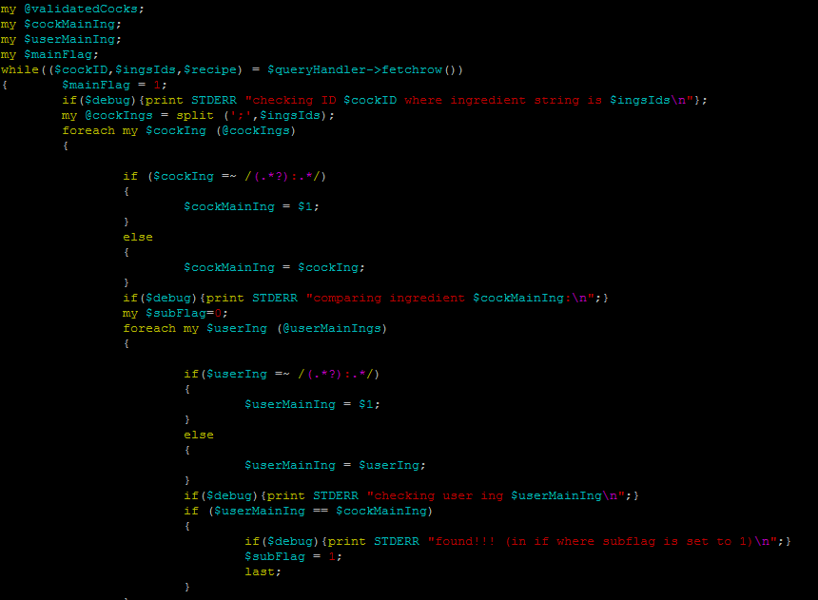

*A snippet of the Original Code (resultsByIng.cgi) – parsing the user’s input and checking it against existing ingredients in the DB (already pulled using $queryHandler->fetchrow ())*

While the main functionality of the code was fine, Dov handed the *resultsByIng.cgi* file to Moshe Shpilman – a more experienced PERL programmer that both fixed-up the code to a higher standard and also added a new feature to the code:

**Using an Ingredient’s Alt ID:** A Cocktail’s ingredient can have more then one name, for example “Bacardi” is simply a type of Rum (and so is for example Captain Morgan), and therefore Dov’s code did not catch cocktails that had these Alt ID’s within them, but rather only the exact combination that the user entered.

The other half (*recipeByIng.cgi*) of Dov’s code was handed to Igor Osetinsky for revision and audit, after Moshe finished his work on *resultsByIng.cgi*  Igor changed/added to the *recipeByIng.cgi* file:

**Search by Ingredient - recipe page:** While Dov’s code served the purpose of the Search By Ingredients feature, it lacked a proper design of a relevant single-recipe-page, meaning that with Moshe’s changes the recipe page **appeared as if the user did not select these ingredients!**

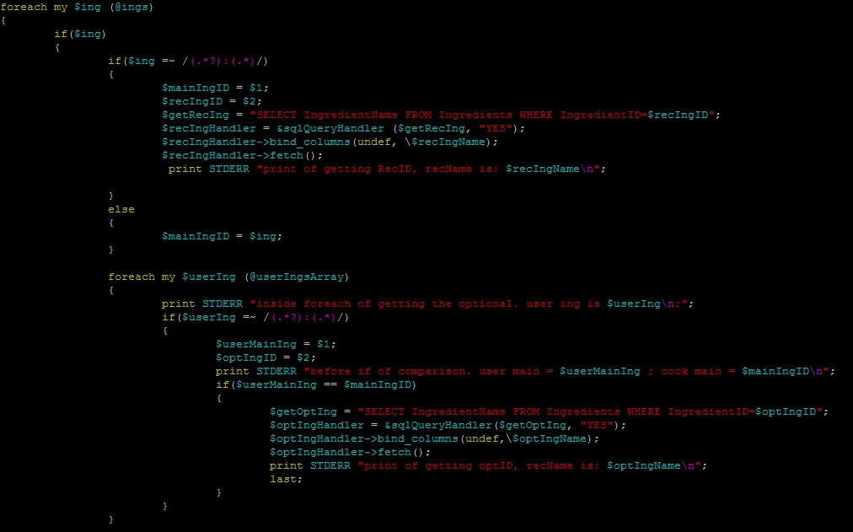

*A snippet of Igor’s addition to the recipeByIng.cgi code, adding the “optional” Ingredient field/text*

In Summary: Dov “poured the basics”, Moshe’s code “set the foundations” for these mandatory changes, and Igor’s code audit “sealed the deal”.

You can see the product of this work like so:

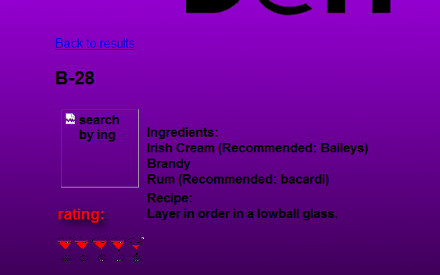

You would only get B-28’s cocktail page if you manually input *Irish Cream,Brandy,Rum* into the Search By Ingredients page,

But now, after each has revised the other’s code you can also get this:

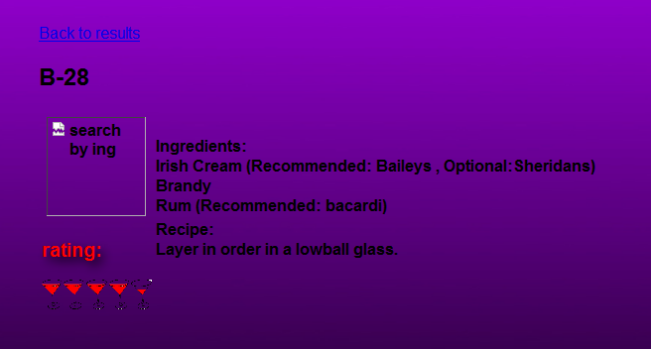

And by searching for *Brandy, Bacardi,and Sheridans*!!! (notice the **Optional** tag)

The Experiment was a Blasting Success!!!