Class, object, inheritance, association

data types (byte, short, int, long, foat, double, boolean, char, String)

Variables:

1) Local variable: defined within a block/method. It should be initialized before it is used. It is not initialized by default.

2) Instance Variables: which belongs to the object/instance of the class. Every object will have it's own copy.

3) Class Variable/static : which belongs to the class. Shared among the objects.

Instance variables and class variables are initialized by default.

static:

This can be used with a variable/ method/ class/block

1) when variable is static=> It belongs to the class. Only one copy shared among the objects

2) static method: It belongs to class. In a static method/block you cannot access instance members but in instance methods, u can access static members.

3) static block:

Constructor:

Whenever u call a new operator, it will the constructor of the class.

If you don't define a constructor in the class, compiler will add a default constructor.

1) It should not have a return type. If u put a return type in front of a constructor, it behaves like a method

2) Name of the constructor should be same as classname

3) First line by default is the call to the parent constructor

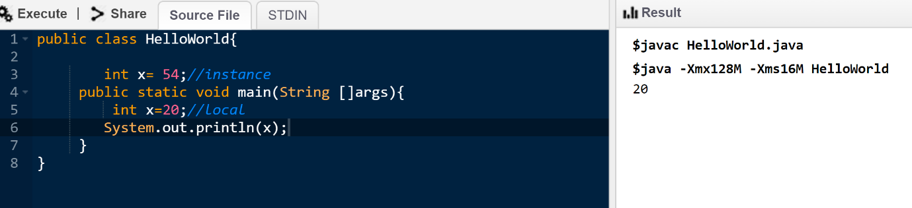

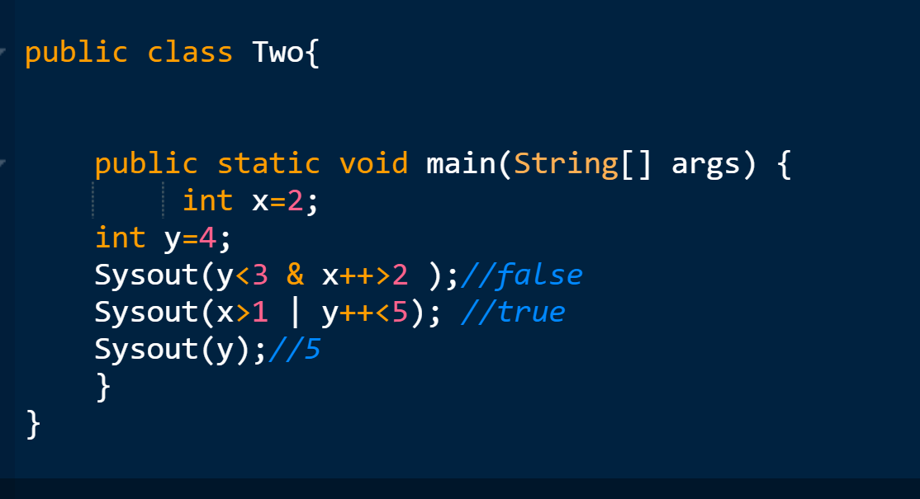

&: and gate only if both are true: answer true: It will always evaluate both the conditions even if first is false.

&&: and gate only if both are true: answer true. It will only evaluate the second expression if first is true

**Control statement**

If block

If-else

If-elseif-else

Switch statement

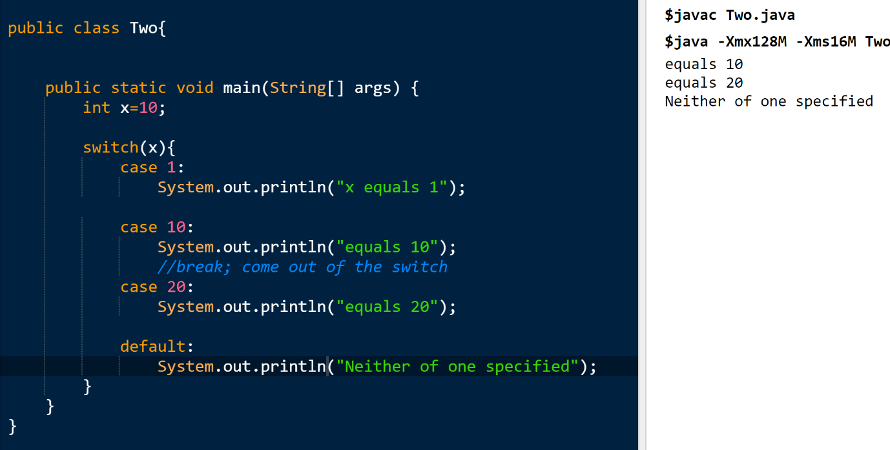

Java works:

Source code -> compiler (javac/ eclipse compiler…) -> class file (bytecode: platform independent) -> intermediary code which can only be understood by ur jvm.

Class file -> (jvm/jre : specific to the machine)-> run this using interpreter (converts to machine language ->) (line by line)