Goals for Lect. 15

1. Cont'd from pumps (Chap. 11) Specific speed
2. Introduction to external flow over bodies and its application
3. Boundary layer (BL) for external flows and comparison with internal flows
4. Displacement thickness in BL, and time permitting start of discussion about BL equations

Chapter 7 – Flow over Immersed Bodies

<https://www.youtube.com/watch?v=dUhiDctsyfs>

This type of flow is important for:

1. Airplanes
2. Cars, trains
3. Ships
4. Buildings (CN Tower)

A “shear and no-slip" zone exists near the surfaces; and away from a surface, flow can be considered inviscid (can use Euler Equations, see chapter 3)

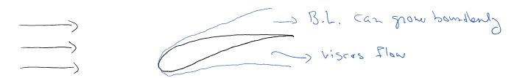

A “patching” technique is used to relate the viscous B.L. to inviscid outer flow

Patch: relate pressure in inviscid region to viscos stress in B.L.

Patching is not always possible, so to understand the flow experiment or CFD should be used on theoretical treatment is not available e.g. 1 < Re < 1000

Compassion between External & Internal B.L

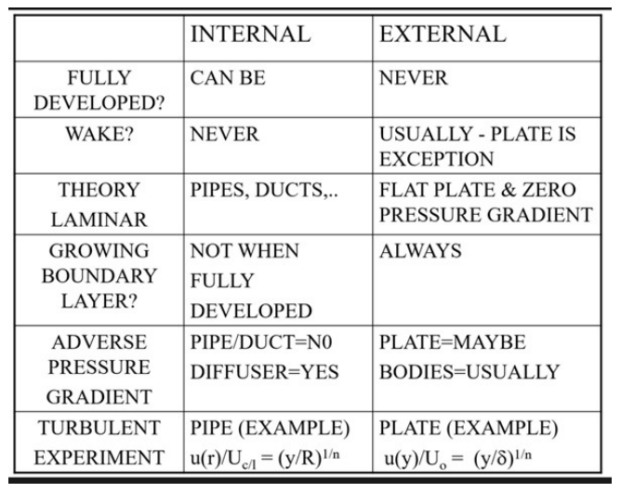

|  |  |  |
| --- | --- | --- |
|  | INTERNAL | EXTERNAL |
| FULLY DEVELOPED? | CAN BE | NEVER |
| WAKE? | NEVER | USUALLY – PLATE IS EXCEPTION |
| THEORY LAMINAR | PIPES,DUCTS,… | FLAT PLATE & ZERO PRESSURE GRADIENT |
| GROWING BOUNDARY LAYER? | NOT WHEN FULLY DEVELOPED | ALWAYS |
| ADVERSE PRESSURE GRADIENT | PIPE/DUCT=NO  DIFFUSER=YES | PLATE=MAYBE  BODIES=USUALLY |
| TURBULENT EXPERIMENT | PIPE (EXAMPLE)  u(r)/Uc/l = (y/R)1/n | PLATE(EXAMPLE)  U(y)/Uo = (y/δ)1/n |

Special case of low Re < 1000

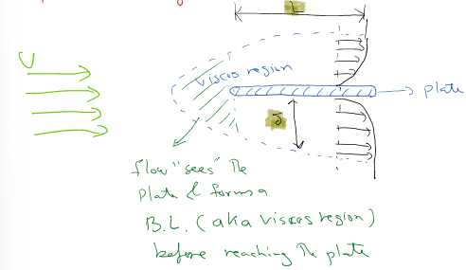

Flow “sees” the plate & forms a B.L. (aka – viscous region) before reaching the plate

Usually, this flow is seen for and only way to study details of flow is by experiment or CFD, “patching” possible.

Higher Re number flows: In such cases there is possible to find .

If flow is laminar, one can show:

, x – local on the plate – calculate Re at local x,

B.L. begins at the plate unlike the case for



For other bodies above Eq. Will not work ! expermient or CFD

If flow is turbulent: (x for plate)

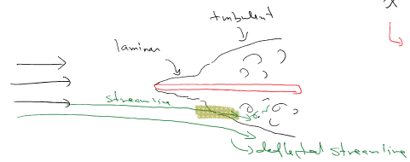

Note a B.L. border is not a streamline (see highlighted region in Fig)

Q1. Is growing faster in lam or turbant flow?

Q2. Is larger in lam or turbulant flow?

Sec 7.2

In chap. 3, we showed that drag (D) on a plate (bx X) is

(1)

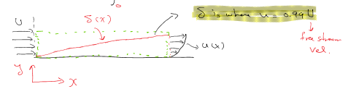

Von karman wrote Eq(1) in the form of momentum thickness ()

(2) (Measure of drag)

Where

Is a measure of drag (momentum deficit)

It can be shown (w-wall) (3)

Up to now all relationships apply to both lam & turbulent flow. But assuming a parabolic form for u(x), Van Karman showed for a laminar flow:

Knowing

Considering Eq (3), we get , within 10% of earlier equation for ￼

Q. Why is there a 10% difference?

It can be shown that:

[Cf – skin friction coefficient, for plate] , which is accurate within 10%

NOTE: Read about “Displacement Thickness from your textbook. Displacement Thickness is the displacement of the streamline in the free flow by the B.L. to hold the conservation of the mass valid.

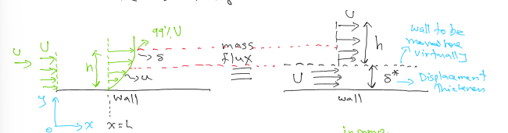

Specific (Sec 11.4)

If we eliminate D between , and consider the BEP, it can be shown that:

(9),

where n – rps, H*- head at BEP, Q* - flow rate at BEP

Industrial version of N’s, => (Q – gpm (gel/min)

Giving,

The value of Ns is in that indicates what type of pump design (axial centirfugal, mixed) is the must efficient machine for a given H & Q, see fig 11.11

One can also find the minute required NPSH, by using

NPSH specific speed: (11)

IF Nss > 1800, pump may cavitate (emperically found)

Consider a pump geometrically similar to the 9-in-diameter pump of Fig. P11.34 to deliver 1200 gal/min of kerosene at 1500 rpm. Determine the appropriate (a) impeller diameter; (b) shut-off head; (c) maximum efficiency; and (d) BEP horsepower. The pump rotational speed for water is 1760 RPM

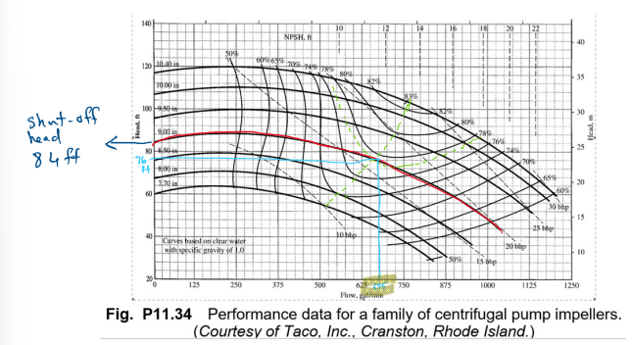

NOTE: We’re “cheating” a bit by using similarity going from water to kerosine!

Eq(5) water

449 – conversation of gpm to ft 3/9

1760 – RPM of pump read off chart

60 – to conv to RPS

12 – conv. Ft

Reversive (see the note):

Shuff_off Eq(4)

Usingg Eq(8)

(0.77 - read that off the chart)

Using Eq 5 for Cp:

P11.65 An 11.5-in diameter centrifugal pump, running at 1750 rev/min, delivers 850 gal/min and a head of 105 ft at best efficiency (82%). (a)Can this pump operate efficiently when delivering water at 20°C through 200 m of 10-cm-diameter smooth pipe? Neglect minor losses. (b)If your answer to (a) is negative, can the speed n be changed to operate efficiently? (c)If your answer to (b) is also negative, can the impeller diameter be changed to operate efficiently and still run at 1750 rev/min?

(a)Can this pump operate efficiently when delivering water at 20°C through 200 m of 10-cm-diameter smooth pipe? Neglect minor losses.

For water at ,

Convert to SI units:

Compute Red and f:

(a) Now compute the friction head loss at 850 gal.min and see if it matches the pump head:

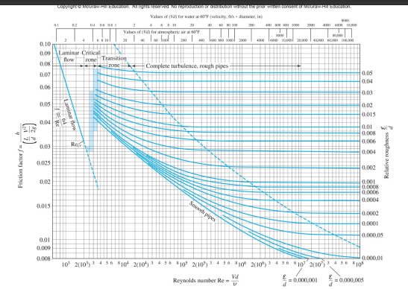

(b) If your answer to (a) is negative, can the speed be changed to operate efficiently?

At BEP, (*gH/n2D2*) is constant, therefore pump head is proportional to *n2*. But the pipe friction loss is also approximately proportional to *n2.* Thus, for any speed *n*, the pipe head will always be about twice as large as the pump head and not operate efficiently

(c)If your answer to (b) is also negative, can the impeller diameter be changed to operate efficiently and still run at 1750 rev/min?

This time the answer is Yes. First note the BEP dimensionless parameters, = 1750/60=29.2 rps:

Now combine these with that fact that *hf* is approximately propotional to *n2*. In SI units,

(c)If your answer to (b) is also negative, can the impeller diameter be changed to operate efficiently and still run at 1750 rev/min?

inches Ans(c.)

This is approximately correct. Check: the pump head is 22.4 m(74 ft) and flow rate is 497 gal/min. For this flow rate, the pipe head loss is 22.3 m (73 ft).

NOTE: Part (c) is almost independent of *n*. For example, if *n* =20 rev/s, the best efficiency converges to an impeller diameter of 0,24 m (9.45 in), with *Q323 gal/min* and

**Fig. Chap 11:**

**Basic Principles and History of Industrial Pumps**

<https://www.youtube.com/watch?v=eWachJNuxSU>

**Breast Pump: Ameda:History of the Breast Pump**

<https://www.youtube.com/watch?v=2U0s5D8maNk&ab_channel=MyAmeda>

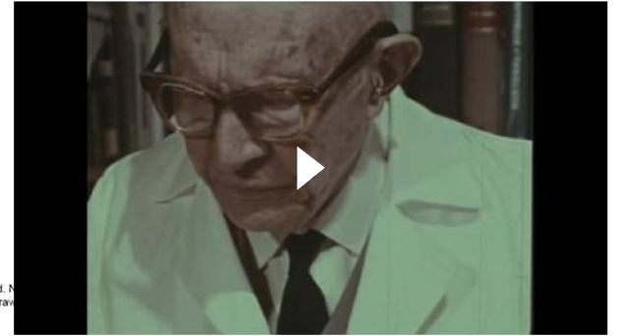

Piping system characteristic curve to intersect pump char. curve at or near BEP to have an efficient pumping system.

Fig 11.10

Given curve by CQ

Figure 11.8

Euler’s turbomachine equation

