Females Trainers

### Libraries

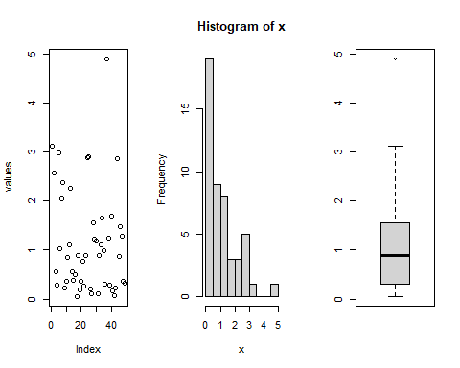

## Fitting of the distribution ' norm ' by maximum likelihood   
## Parameters :   
## estimate Std. Error  
## mean 1.134354 0.1496269  
## sd 1.047389 0.1058018  
## Loglikelihood: -71.79669 AIC: 147.5934 BIC: 151.377   
## Correlation matrix:  
## mean sd  
## mean 1 0  
## sd 0 1

## mean   
## 1.134354

## sd   
## 1.047389

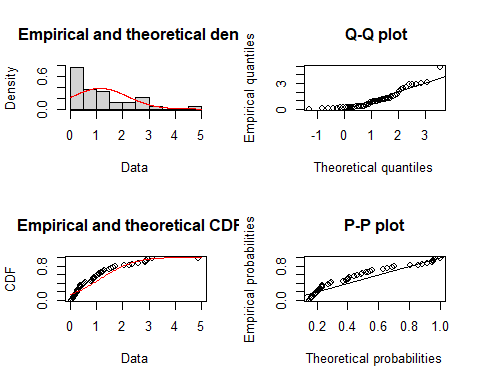

## Fitting of the distribution ' exp ' by maximum likelihood   
## Parameters :   
## estimate Std. Error  
## rate 0.8815592 0.1259369  
## Loglikelihood: -55.17709 AIC: 112.3542 BIC: 114.246

## rate   
## 0.8815592

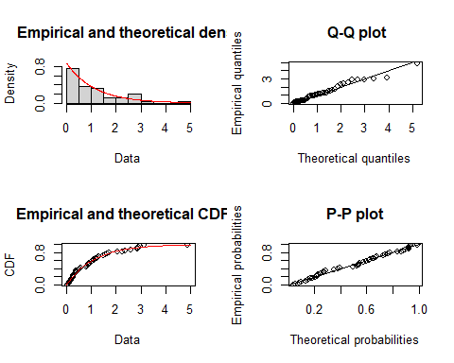

** The graphs can be combined into one graph in the following manner: **

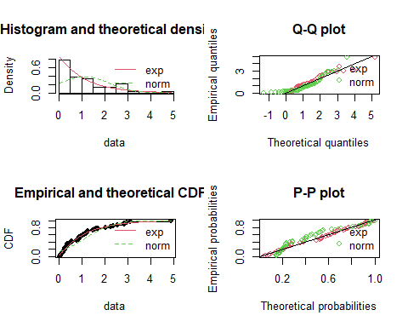

normgof<- gofstat(normFit)%>%print()

## Goodness-of-fit statistics  
## 1-mle-norm  
## Kolmogorov-Smirnov statistic 0.1577313  
## Cramer-von Mises statistic 0.3838611  
## Anderson-Darling statistic 2.2898892  
##   
## Goodness-of-fit criteria  
## 1-mle-norm  
## Akaike's Information Criterion 147.5934  
## Bayesian Information Criterion 151.3770

normgof$kstest%>%print()

## 1-mle-norm   
## "not rejected"

For norm Fit - H0 is denied.

expgof<- gofstat(expFit)%>%print()

## Goodness-of-fit statistics  
## 1-mle-exp  
## Kolmogorov-Smirnov statistic 0.08059141  
## Cramer-von Mises statistic 0.04580558  
## Anderson-Darling statistic 0.34756679  
##   
## Goodness-of-fit criteria  
## 1-mle-exp  
## Akaike's Information Criterion 112.3542  
## Bayesian Information Criterion 114.2460

expgof$kstest%>%print()

## 1-mle-exp   
## "not rejected"

For exp Fit - H0 is not denied.