**Introduction:**

**Tic-tac-toe** (also known as **noughts and crosses** or **Xs and Os**) is a [paper-and-pencil game](https://en.wikipedia.org/wiki/Paper-and-pencil_game) for two players, *X* and *O*, who take turns marking the spaces in a 3×3 grid. The player who succeeds in placing three of their marks in a horizontal, vertical, or diagonal row wins the game.

The following example game is won by the first player, X:

[Game of Tic-tac-toe, won by X](https://en.wikipedia.org/wiki/File:Tic-tac-toe-game-1.svg)

The program will allow a human user to play against the computer.

While explaining the rules, each small 3-by-3 tic-tac-toe board will be referred to as a local board, and the larger 3-by-3 board will be referred to as the global board.

The game starts with X playing wherever he wants in any of the 9 empty spots. This move 'sends' the next player to its relative location. For example, if X played in the middle of his local board, then O needs to play next in the local board in the middle of the global board. This game rule is easier to understand from the second image, where X played in the top-right corner of the central local board, forcing O (red) to play in the top-right local board. O can then play in any one of the nine available spots in the top-right local board, each move sending X to a different local board.

Note that if a player is sent to an already completed local board (either won by either player or tied), then that player may play wherever it wants (as long as the move is legal).

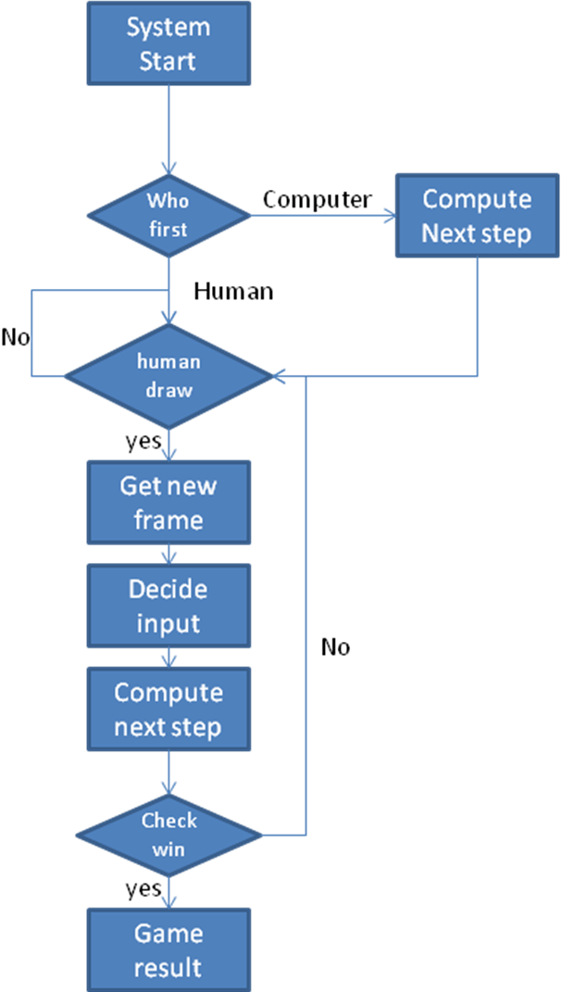

Limitation:

1.Sometime computer doesn’t show it’s input .

2.Sometimes computer show two input at a single turn.