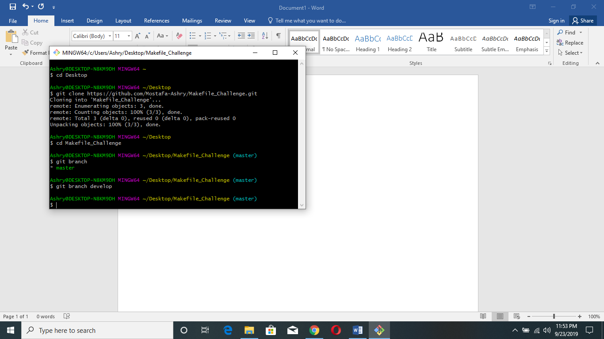

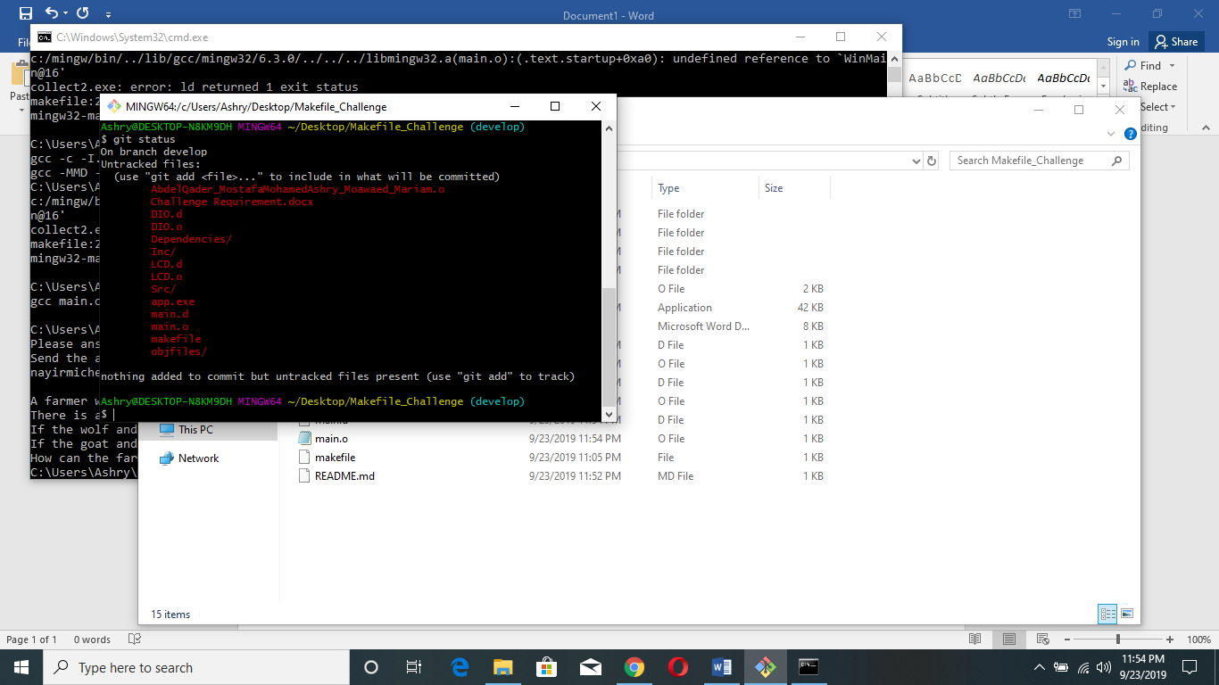

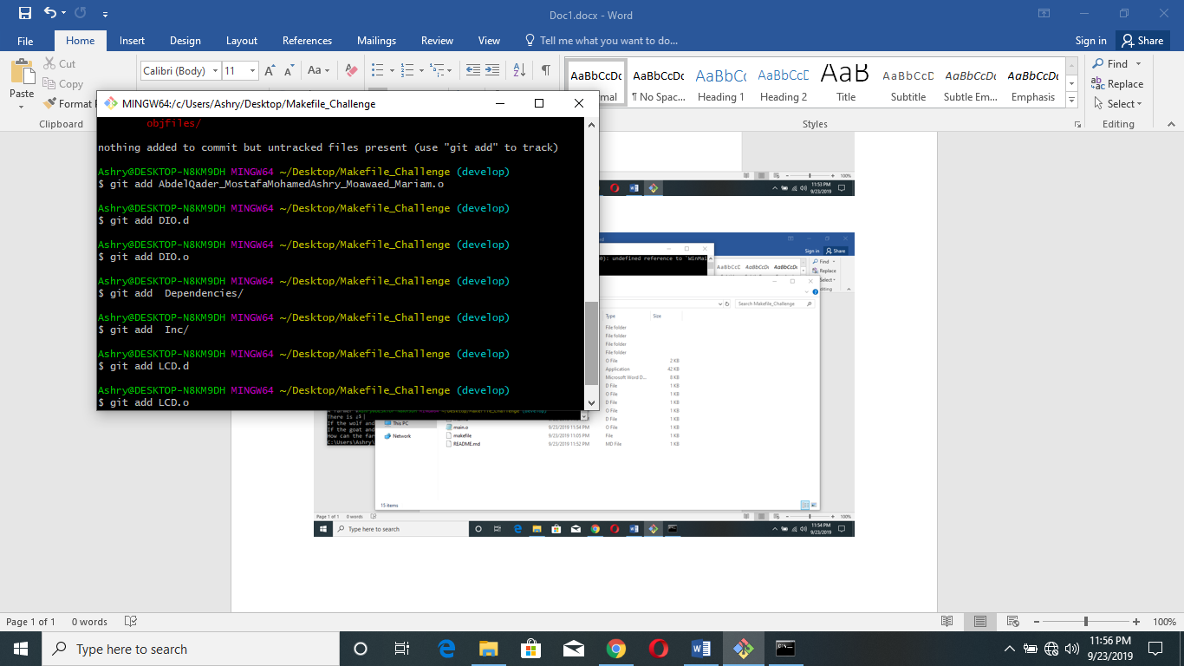

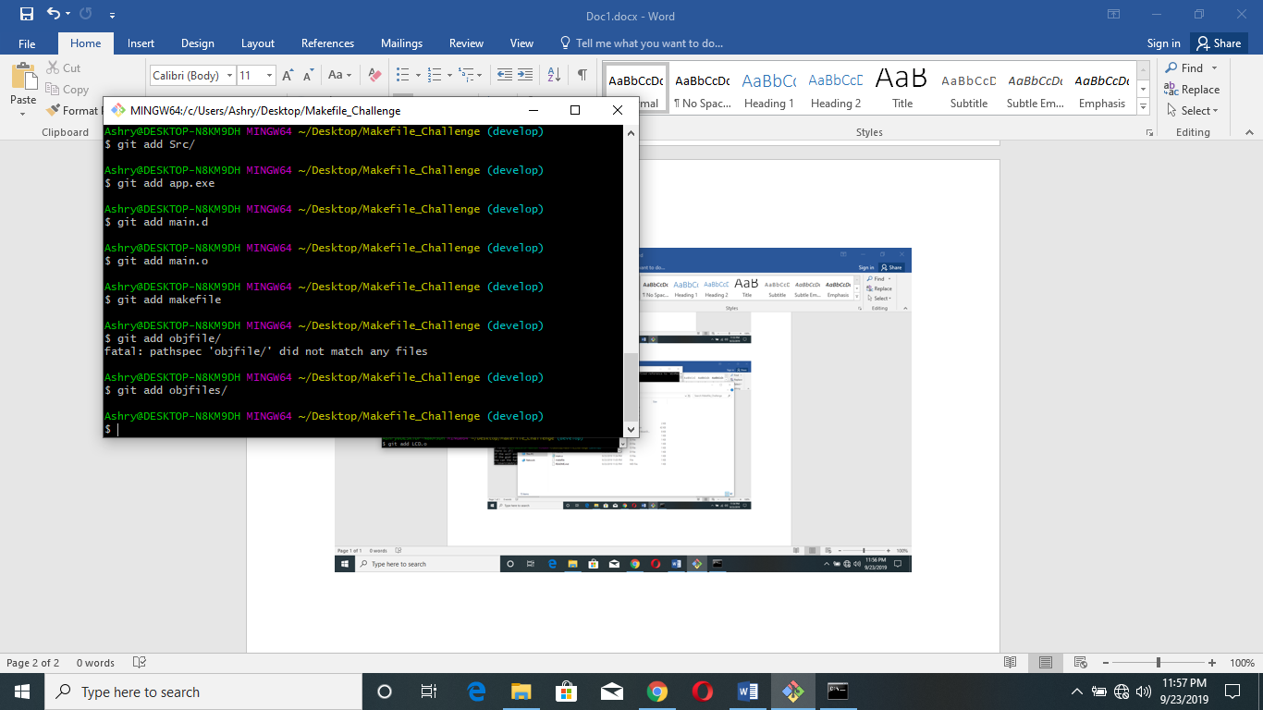

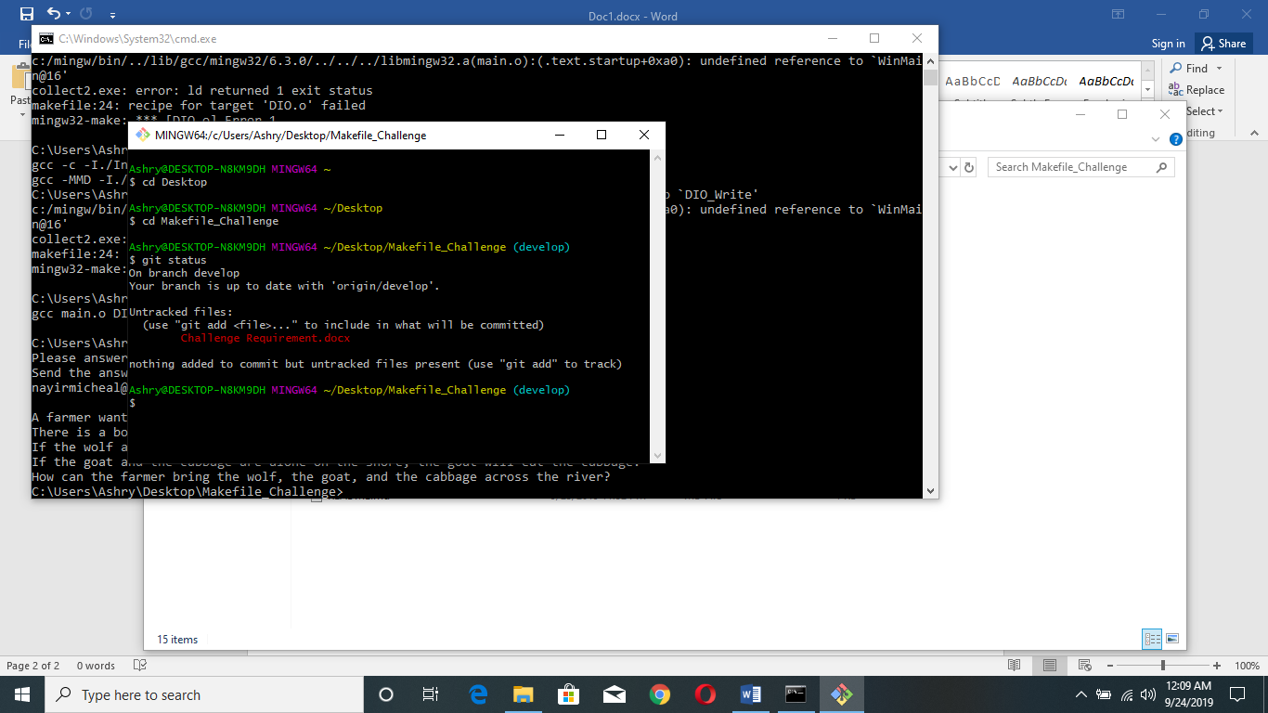

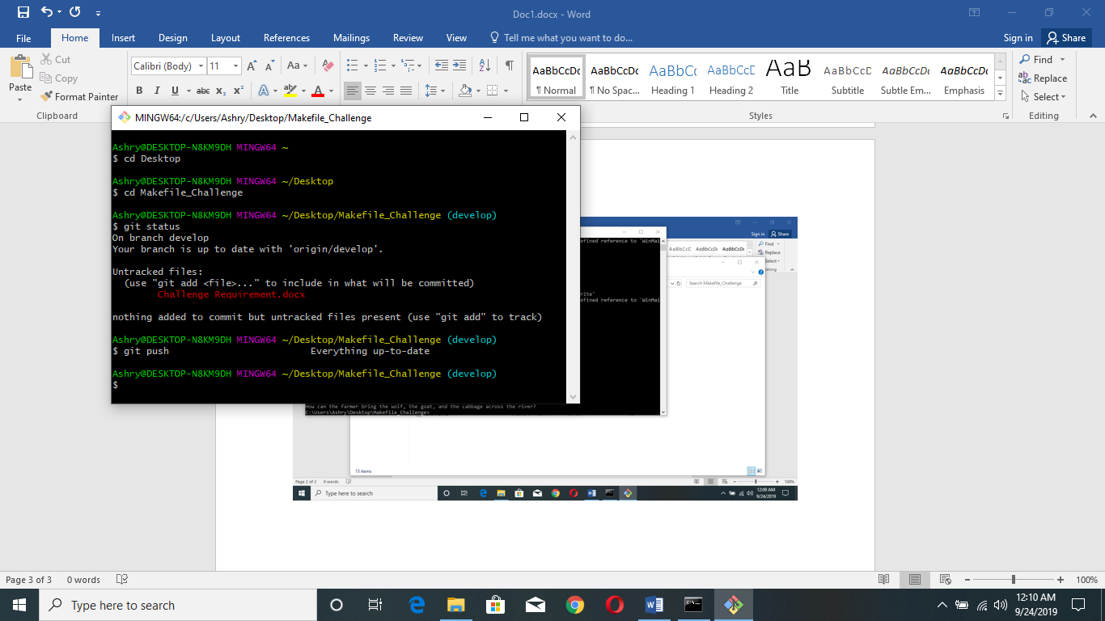

The Answer Of The Quiz

the farmer has to take the goat first and leaving the wolf and cabbage behind. afterwords the farmer returns by himself and after takes the wolf alone and move across and takes the goat back again to the other side. so we got 2 sides one with the farmer and the cabbage and the goat. on the other side the wolf alone. so now farmer takes cabbage first and move it across and then gets back alone taking the goat to the other side.