**[2024-2025] DSP Project Listing**

1. **EOG Right and Left**

**Description:**

Amyotrophic lateral sclerosis (ALS) patients communicate with the world using eye movement, since their voluntary muscles are paralyzed. Many efforts are exerted to support this way of communication by tracking or detecting eye movement. Electro-oculogram (EOG) is an electro-physiological signal generated by eye movement and can be measured using electrodes placed around the eyes. The electrodes will be placed on the forehead. The two channels are arranged vertically and horizontally. Each eye movement displays a positive or negative peak in the corresponding EOG signal. Human-machine interface (HMI) can be developed based on eye movement recognition. These interfaces can help paralyzed people to interact with smart phones or laptops and also can help them to move wheelchair or play games without any help from others. In this project, we are interested to distinguish between left and right movements using horizontal EOG signals.

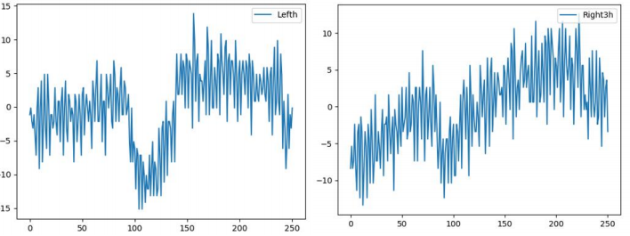

**Input:**

  EOG Signal

**Output:**

  One label either “Right” or “Left”

**Steps:**

1. Preprocessing:

mean removal + Bandpass Filter (Butterworth 0.5 to 20) + normalization

Resampling to reduce computations

1. Feature Extraction: Wavelet (Daubechies family ( db 1-4 ) mother wavelets )
2. Classification: KNN

**Dataset:**

EOG dataset (sampling rate 176 HZ)

1. **EOG UP and Down**

**Description:**

Amyotrophic lateral sclerosis (ALS) patients communicate with the world using eye movement, since their voluntary muscles are paralyzed. Many efforts are exerted to support this way of communication by tracking or detecting eye movement. Electro-oculogram (EOG) is an electro-physiological signal generated by eye movement and can be measured using electrodes placed around the eyes. The electrodes will be placed on the forehead. The two channels are arranged vertically and horizontally. Each eye movement displays a positive or negative peak in the corresponding EOG signal. Human-machine interface (HMI) can be developed based on eye movement recognition. These interfaces can help paralyzed people to interact with smart phones or laptops and also can help them to move wheelchair or play games without any help from others. In this project, we are interested to distinguish between up and down movements using vertical EOG signals.

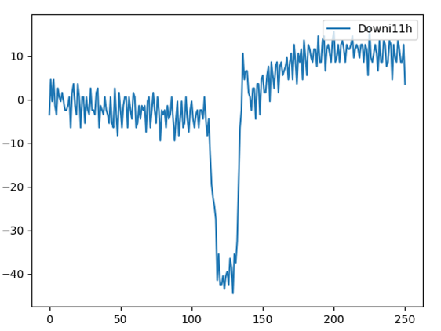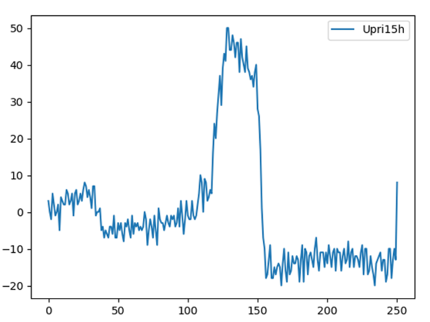

**Input:**

         EOG Signal

**Output:**

         One label either “Up” or “Down”

**Steps:**

1. Preprocessing:

mean removal + Bandpass Filter (Butterworth 0.5 to 20) + normalization

Resampling to reduce computations

1. Feature Extraction: Wavelet (Daubechies family ( db 1-4 ) mother wavelets )
2. Classification: KNN

**Dataset:**

EOG dataset (sampling rate 176 HZ)

1. **ECG based Biometrics**

**Description:**

Biometrics is needed where security is essential. The electrocardiogram (ECG) has been used as a significant diagnostic tool for decades. It is a recording of the electrical activity of the heart over time, reflecting the underlying cardio-physiology of the subject. Visual inspection of each heart beat within an ECG trace reveals three prominent excursions from baseline. These excursions are termed waves – and are labeled P, QRS and T waves, which occur in this temporal order. The physiological and geometrical differences of the heart among individuals reveal certain uniqueness in their ECG signals. This allows for suggesting ECG as a new biometric trait. The lure of utilizing ECG as a biometric trait comes from the fact that ECG as a biological signal is a life indicator. Thus, it can be used as a tool for aliveness detection. Moreover, it is difficult to be spoofed or falsified. In this project, we need to distinguish between three individuals using their ECG signals.

**Input:**

         ECG Signal

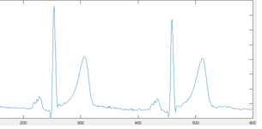

**Output:**

         Individual label

**Steps:**

1. Preprocessing:

mean removal + Bandpass Filter (Butterworth 1 to 40 HZ) + normalization

resampling to reduce computation

segment the ECG signal into segments. Each one contains round 4 heartbeats.

1. Feature Extraction: autocorrelation (AC) ( choose significant coefficients ) then apply discrete cosine transform ( DCT) ( choose non zero coefficients)
2. Classification: KNN

**Dataset:**

PTB dataset (sampling rate 1000 HZ)

1. **ECG (Normal & PVC)**

**Description:**

The ECG heart beat classification is considered from the main tools for the heart diseases diagnosis. Hence, the automation of this process is a critical issue since the 24-hour monitoring process of the ECG signals is very difficult and exhaustive. ECG is a recording of the electrical activity of the heart over time, reflecting the underlying cardio-physiology of the subject. Visual inspection of each heart beat within an ECG trace reveals three prominent excursions from baseline. These excursions are termed waves – and are labeled P, QRS and T waves, which occur in this temporal order. Cardiac arrhythmias (diseases) which are the result of any abnormal activity in the heart can be indicated by any change occurs in the main ECG waves (P, QRS and T waves). One of these diseases is the PVC, which in turn has a specific signal shape as in the following figure:

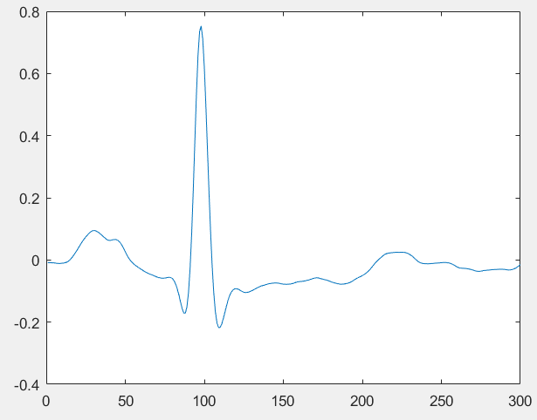 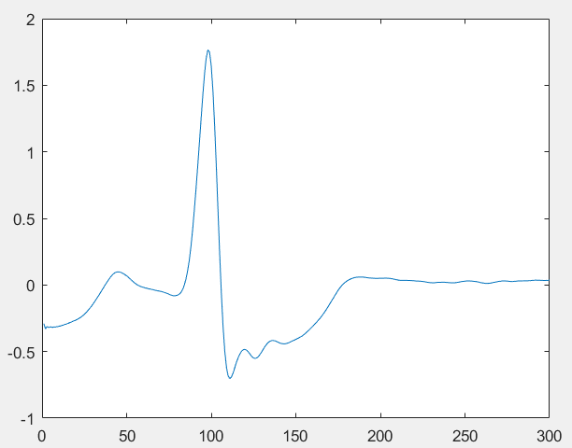  
 Normal Beat PVC Beat

**Input:**

         ECG Signal

**Output:**

         Label whether the person has no disease (Normal), or has PVC disease.

**Steps:**

1. Preprocessing: Band Pass Filter(Butterworth 0.5 to 40) + normalization
2. Feature Extraction: Wavelet (Daubechies mother wavelets)
3. Classification: KNN

**Dataset:**

MIT_BIH database (sampling rate 360 HZ)

1. **ECG (Normal & LBBB)**

**Description:**

The ECG heart beat classification is considered from the main tools for the heart diseases diagnosis. Hence, the automation of this process is a critical issue since the 24-hour monitoring process of the ECG signals is very difficult and exhaustive. ECG is a recording of the electrical activity of the heart over time, reflecting the underlying cardio-physiology of the subject. Visual inspection of each heart beat within an ECG trace reveals three prominent excursions from baseline. These excursions are termed waves – and are labeled P, QRS and T waves, which occur in this temporal order. Cardiac arrhythmias (diseases) which are the result of any abnormal activity in the heart can be indicated by any change occurs in the main ECG waves (P, QRS and T waves). One of these diseases is the LBBB, which in turn has a specific signal shape as in the following figure:

 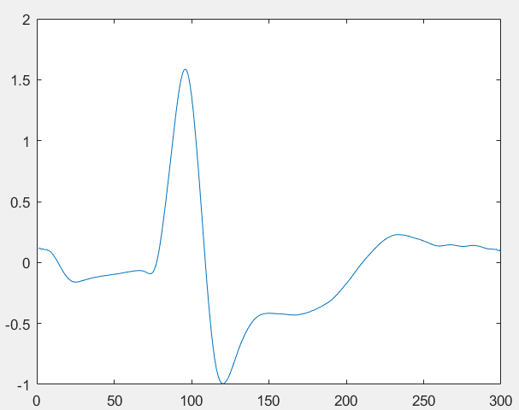

Normal Beat LBBB Beat

**Input:**

         ECG Signal

**Output:**

         Label whether the person has no disease (Normal), or has PVC disease.

**Steps:**

1. Preprocessing: mean removal + Bandpass filter(Butterworth 0.5 to 40 HZ) + normalization
2. Feature Extraction: Wavelet (Daubechies mother wavelets)
3. Classification: KNN

**Dataset:**

MIT-BIH database (sampling rate 360 HZ)

1. **ECG (Normal & RBBB)**

**Description:**

The ECG heart beat classification is considered from the main tools for the heart diseases diagnosis. Hence, the automation of this process is a critical issue since the 24-hour monitoring process of the ECG signals is very difficult and exhaustive. ECG is a recording of the electrical activity of the heart over time, reflecting the underlying cardio-physiology of the subject. Visual inspection of each heart beat within an ECG trace reveals three prominent excursions from baseline. These excursions are termed waves – and are labeled P, QRS and T waves, which occur in this temporal order. Cardiac arrhythmias (diseases) which are the result of any abnormal activity in the heart can be indicated by any change occurs in the main ECG waves (P, QRS and T waves). One of these diseases is the RBBB, which in turn has a specific signal shape as in the following figure:

 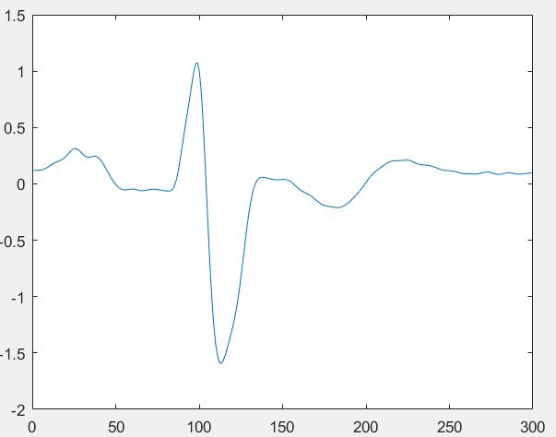

Normal Beat RBBB Beat

**Input:**

         ECG Signal

**Output:**

         Label whether the person has no disease (Normal), or has PVC disease.

**Steps:**

1. Preprocessing: mean removal + Bandpass Filter(Butterworth 0.5 to 40) + normalization
2. Feature Extraction: Wavelet
3. Classification: KNN

**Dataset:**

MIT_BIH database (sampling rate 360)