- Install Packages called ncompress,ksh.
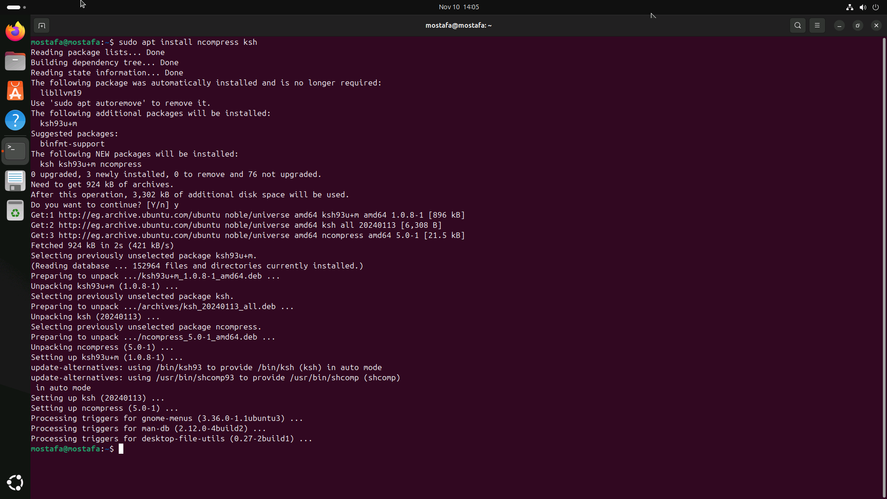

2. Compress a file by gzip, bzip2 commands and
decompress it again.
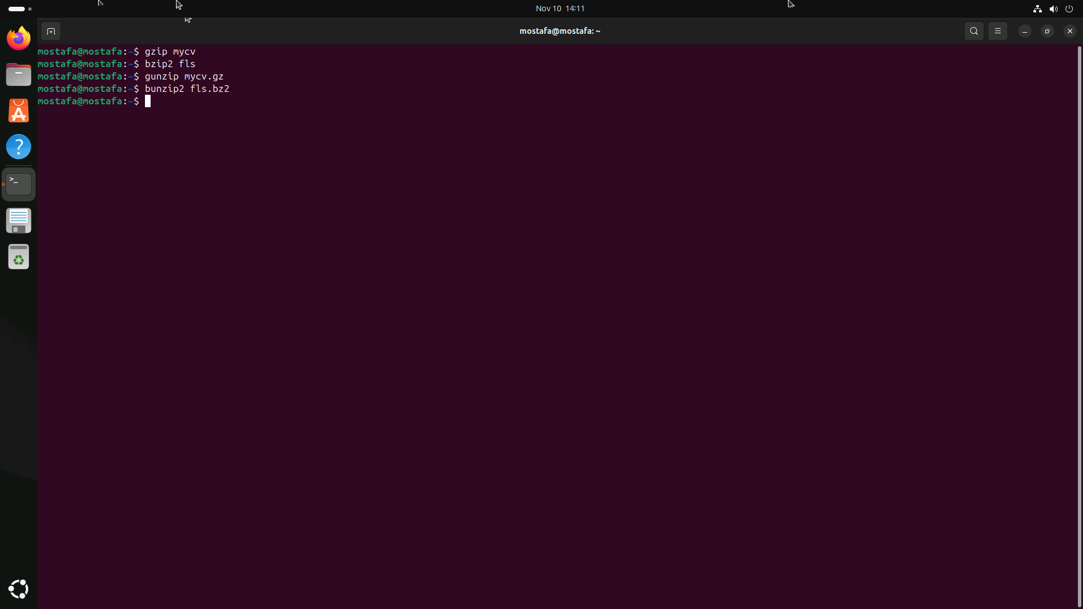

3. List the directories that have 777 Permissions in the
system.
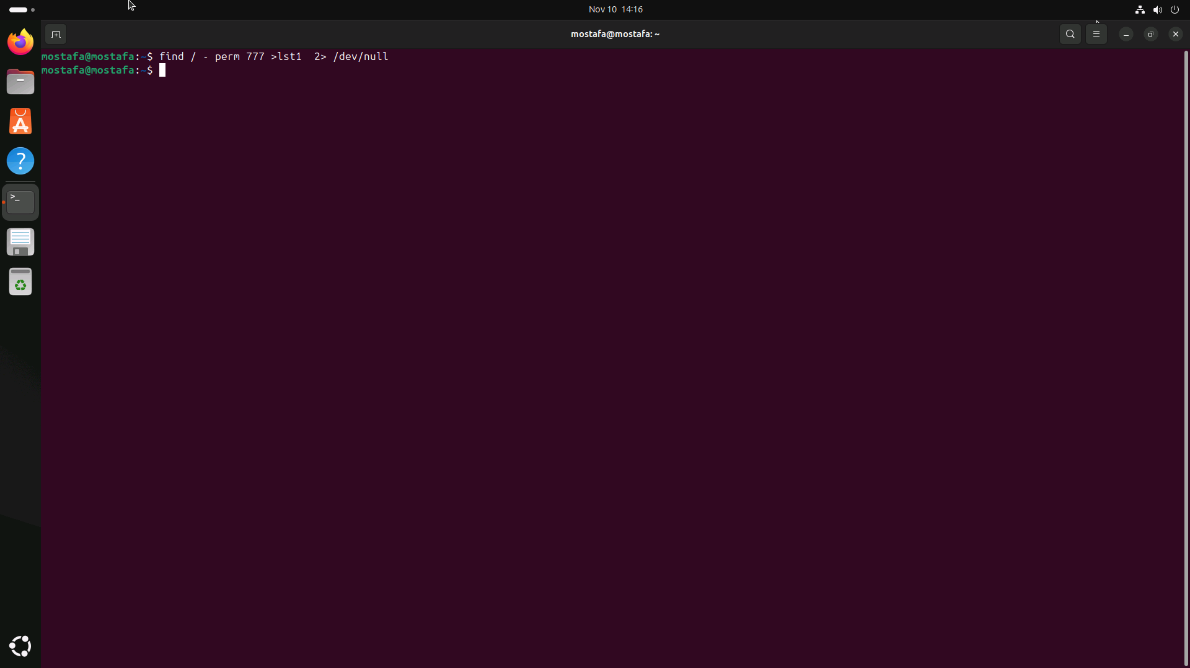

4. Remove package ncompress and ksh.
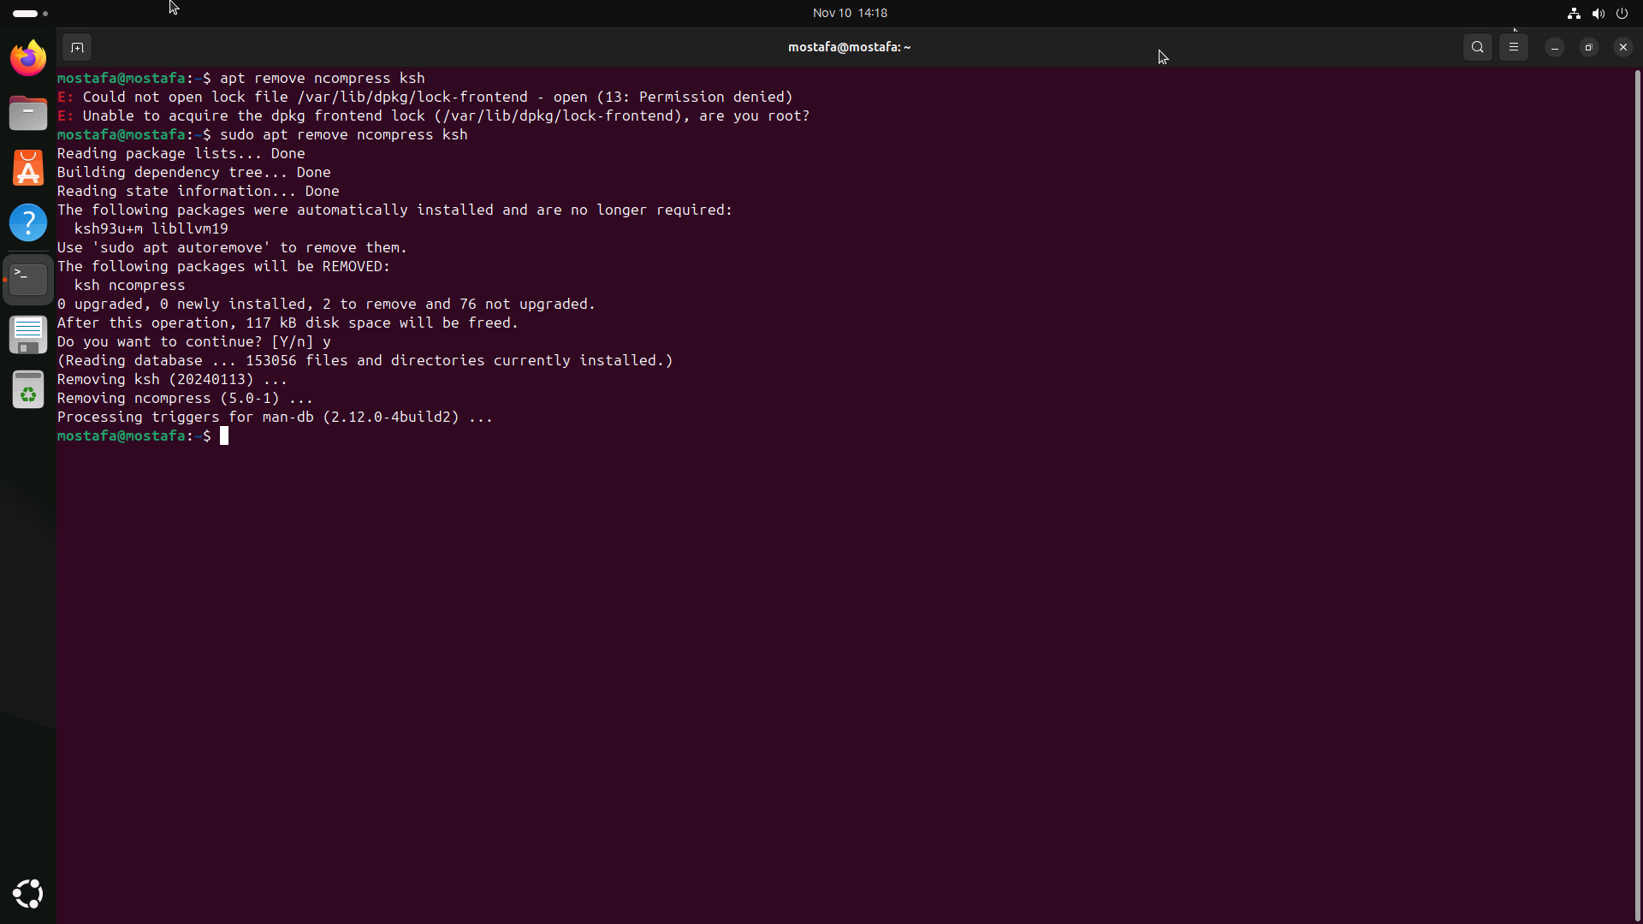

5. Install Vlc , Vscode ,Atom ,Krita, Google Chrome ,Libre
office, zoom and teams.

Compress a file by compress, gzip, zip commands and decompress it again. State the differences between compress and gzip commands.

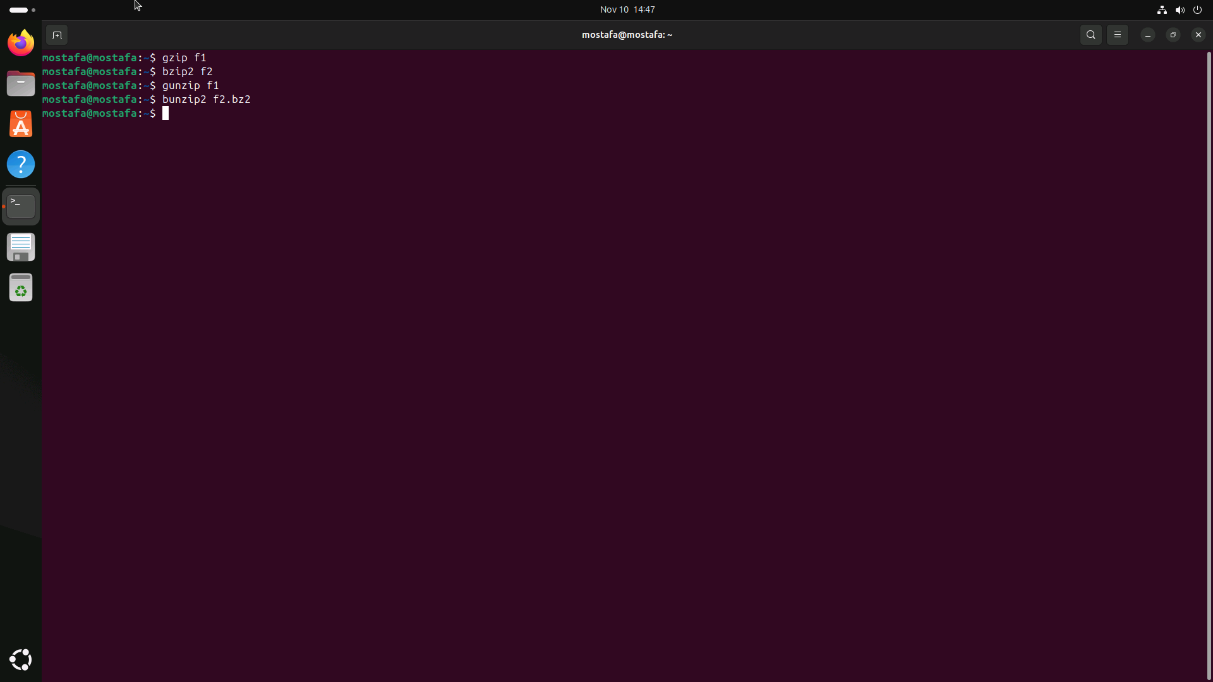

What is the command used to view the content of a compressed file.
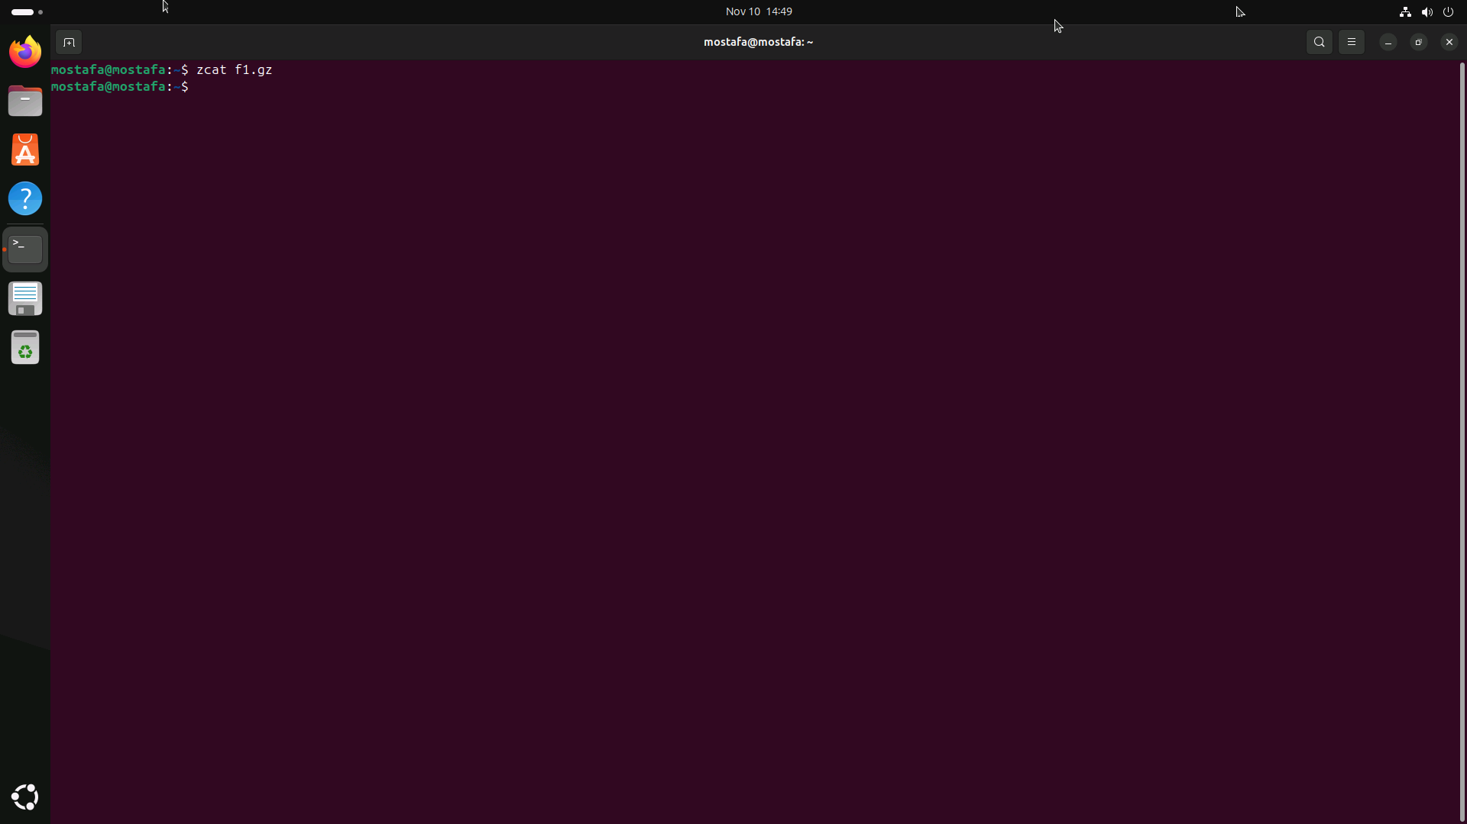

Backup /etc directory using tar utility.

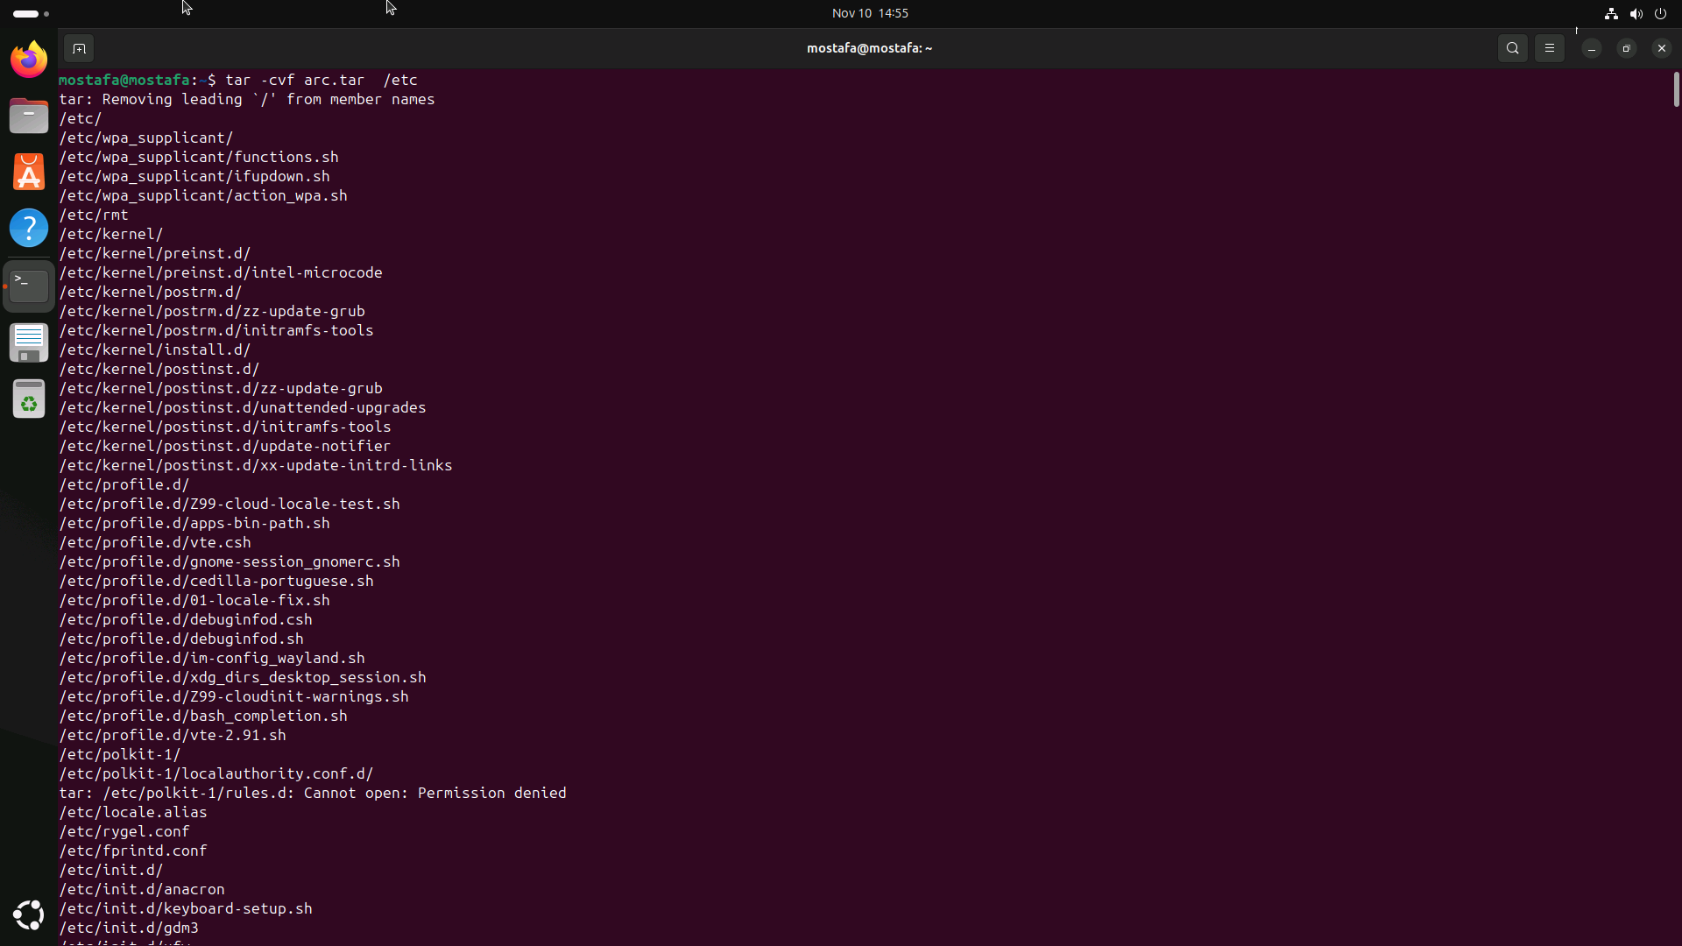

Starting from your home directory, find all files that were modified in the last two day.
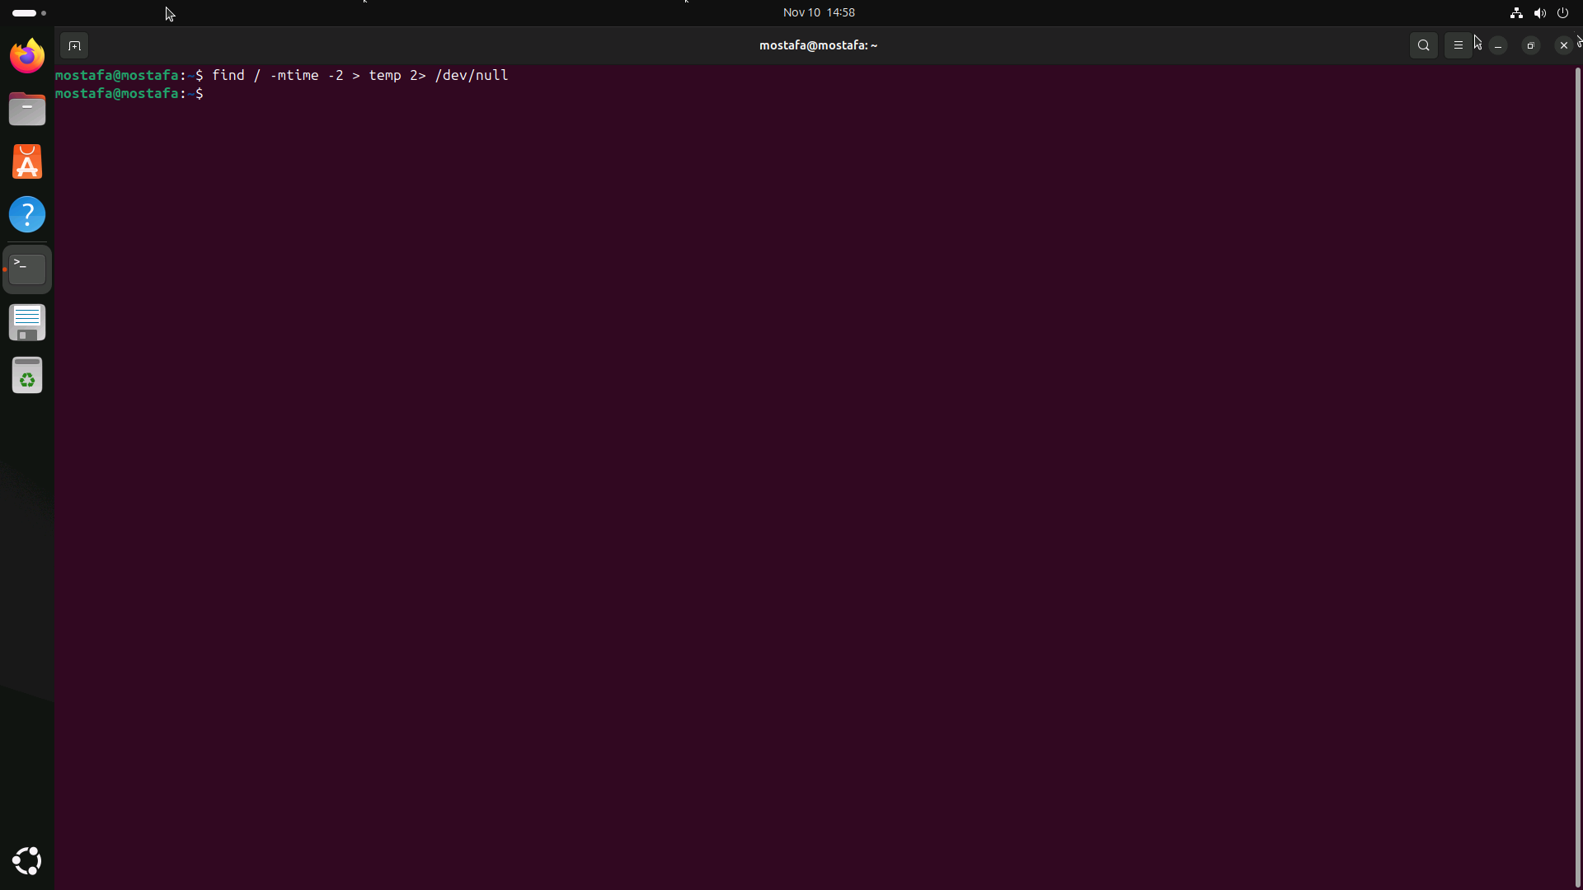

5. Starting from /etc, find files owned by root user.
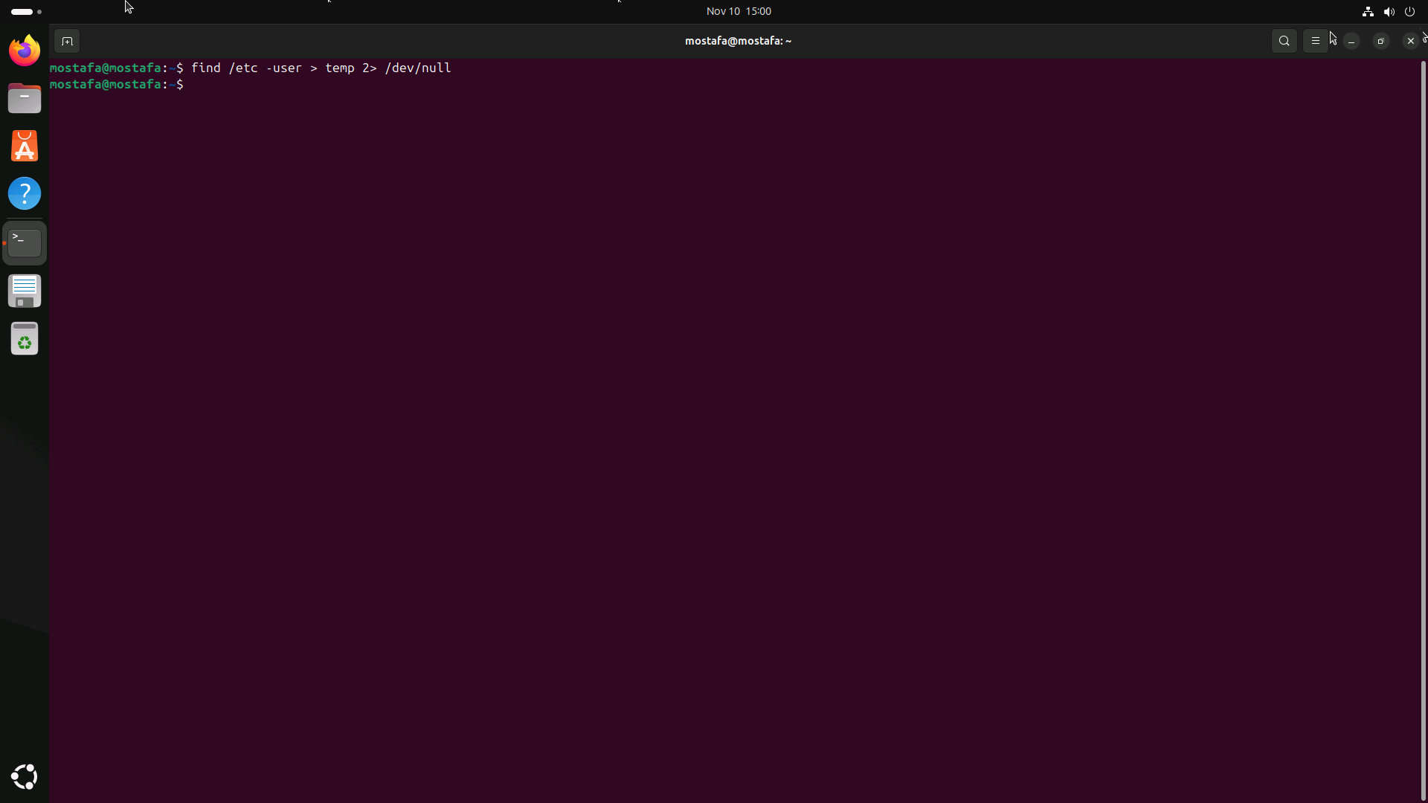

6. Find all directories in your home directory.
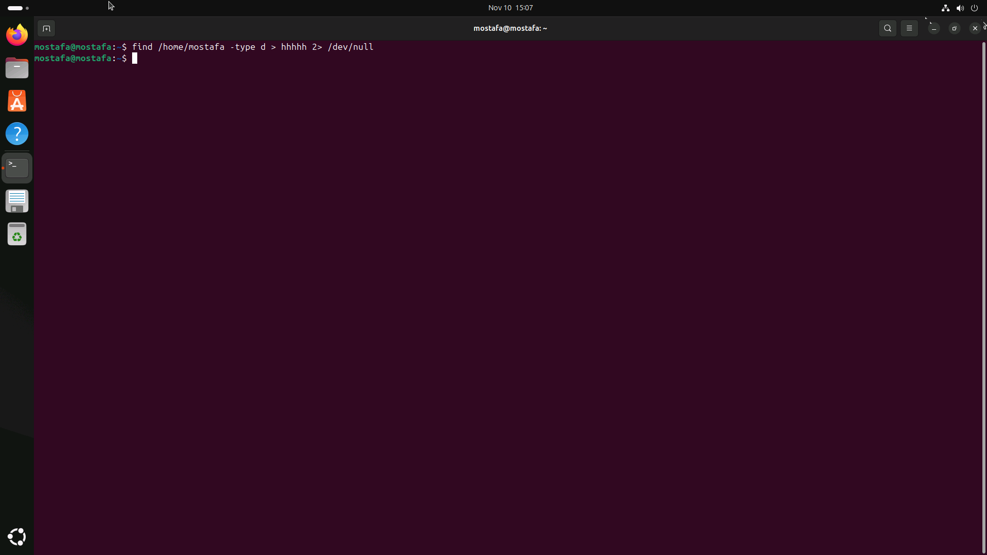

7. Write a command to search for all files on the system that, its name is “.profile”.

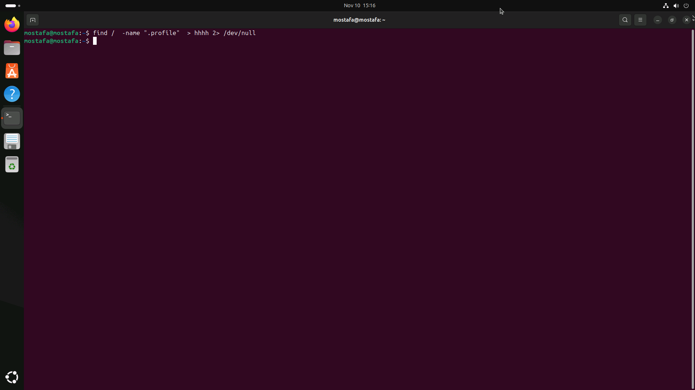

8. Identify the file types of the following: /etc/passwd, /dev/pts/0, /etc, /dev/sda
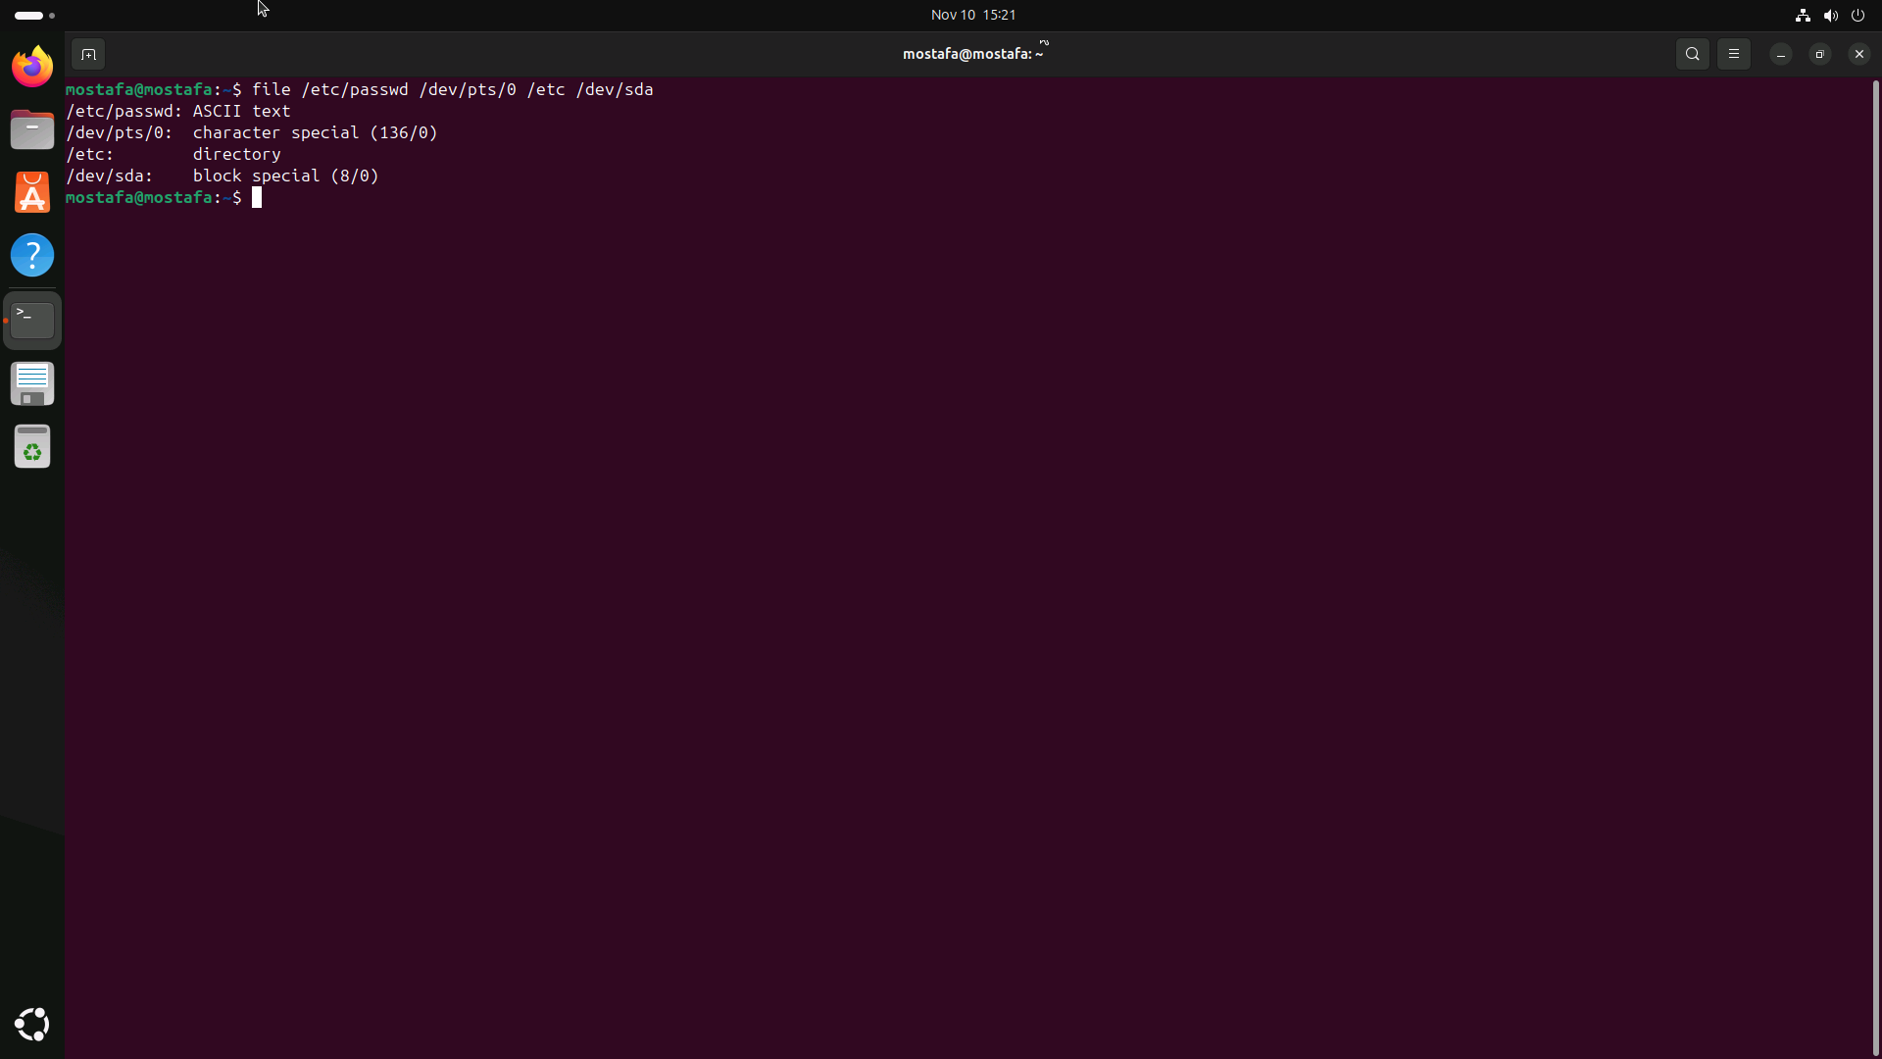

List the inode numbers of /, /etc, /etc/hosts.

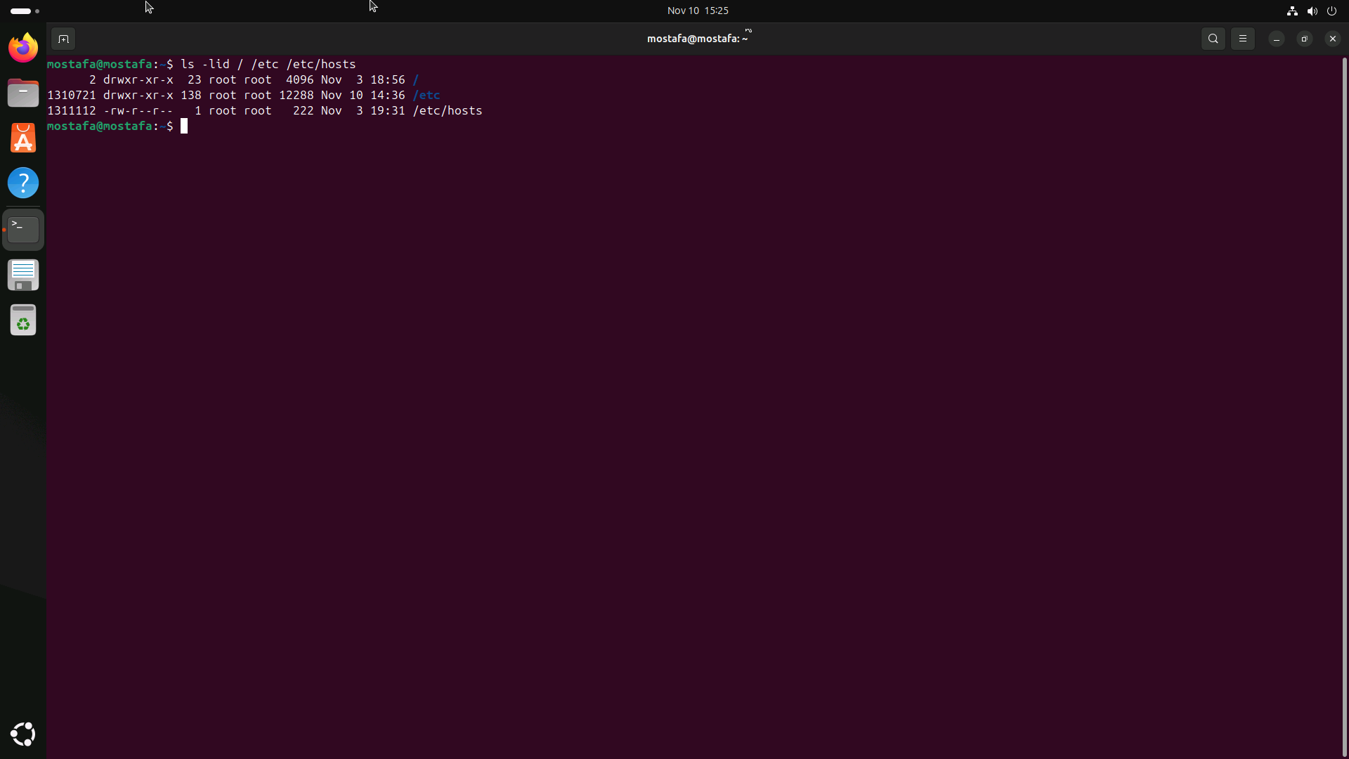

10. Copy /etc/passwd to your home directory, use the commands diff and cmp, and Edit in the file you copied, and then use these commands again, and check the output.
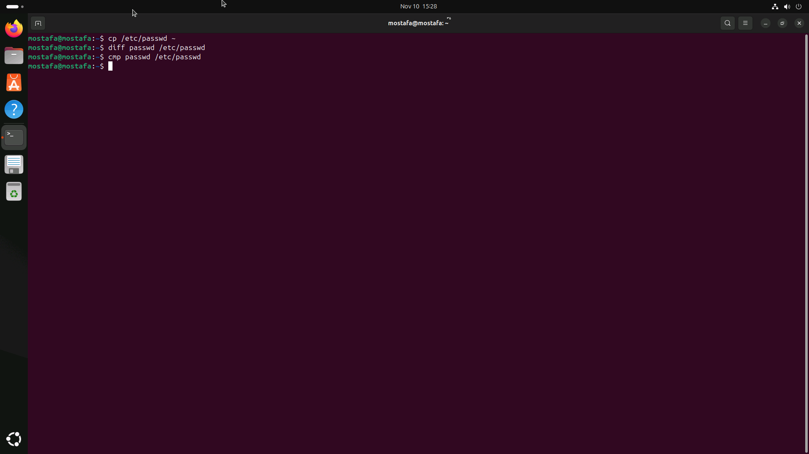
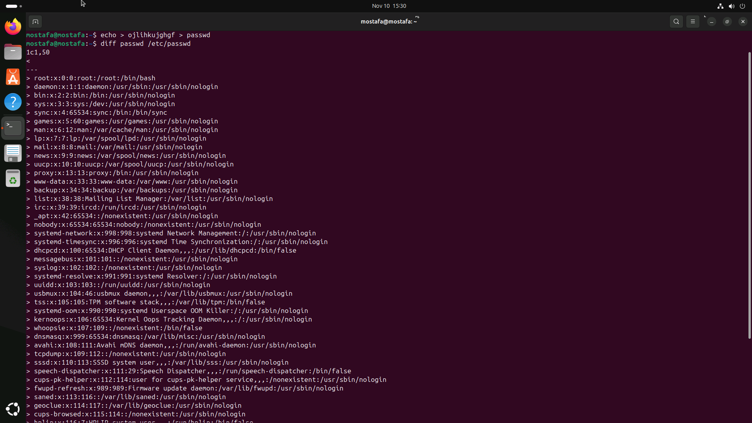

11. Create a symbolic link of /etc/passwd in /boot.
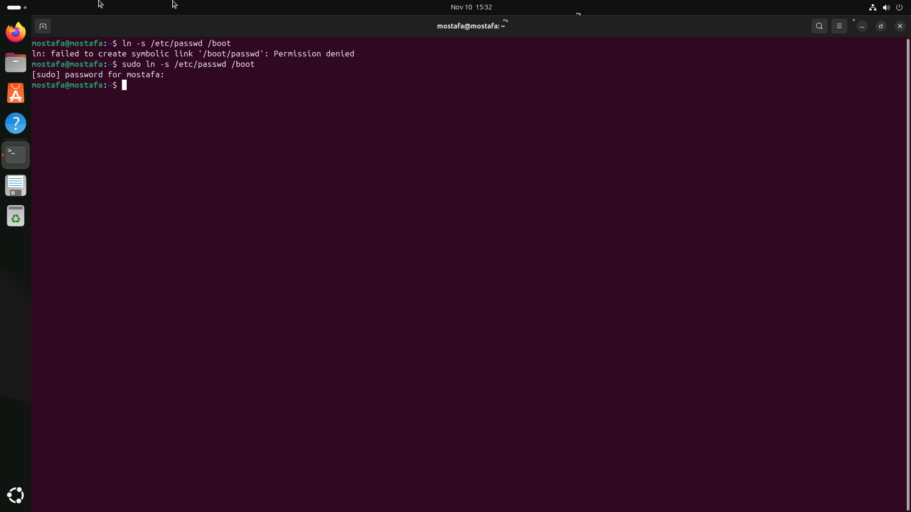

12. Create a hard link of /etc/passwd in /boot. Could you? Why?
