**Pressure Controller Project**

* **Case study: Pressure controller system**
  + **Pressure controller system should check if the pressure inside a cabin exceeds 20 bar.**
  + **If the pressure inside a cabin exceeds 20 bar pressure controller system should inform the crew with an alarm for a duration of 60 seconds.**
* **Assumptions:**
  + **System setup and shutdown procedure are not modelled.**
  + **System maintenance is not modelled.**
  + **Ultrasonic sensor never fails.**
  + **DC motors never fail.**
  + **System never faces power cut.**
* **Method: for Collision avoidance software development cycle Waterfall Model was found to be the most suitable.**
* **Requirement diagram:**

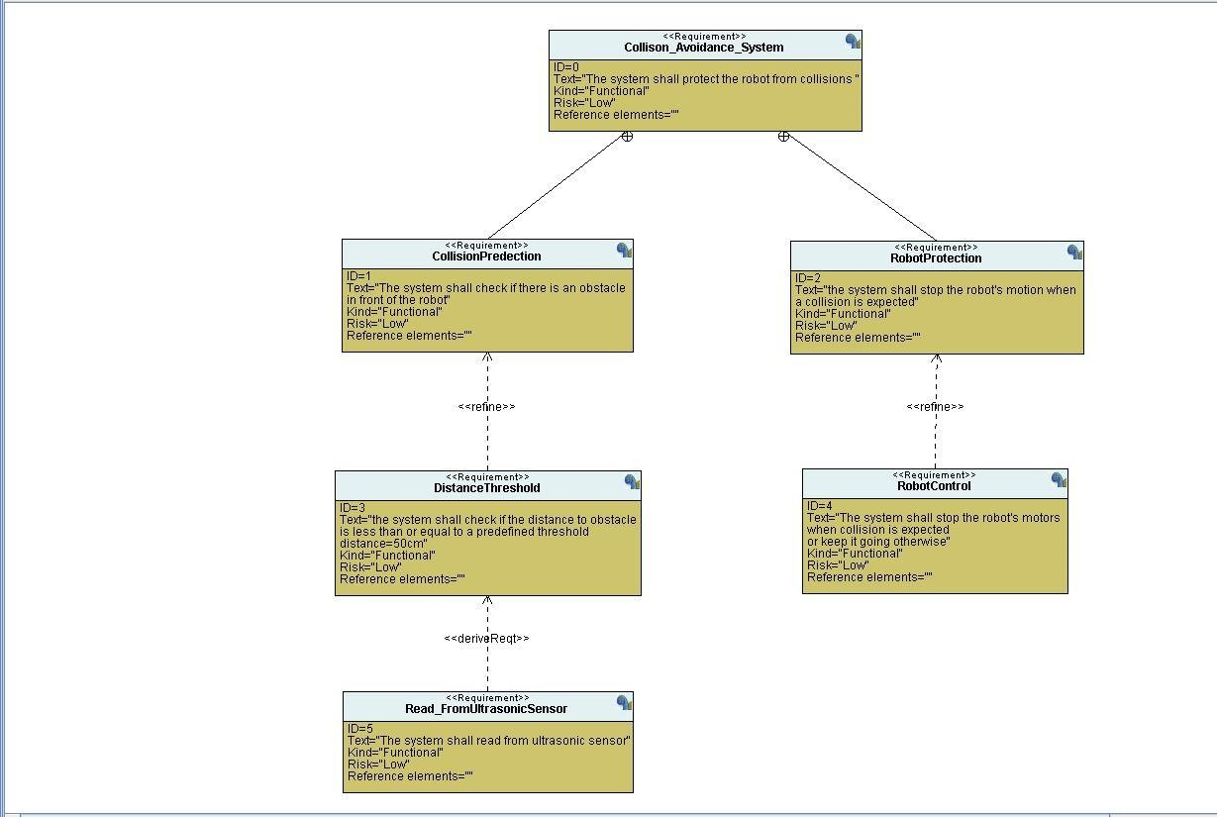

* **Space exploration/Partitioning: the project is quiet simple it doesn’t require more than one ECU and STM32 was found suitable for this project.**
* **System analysis:**
  + **Use Case diagram:**

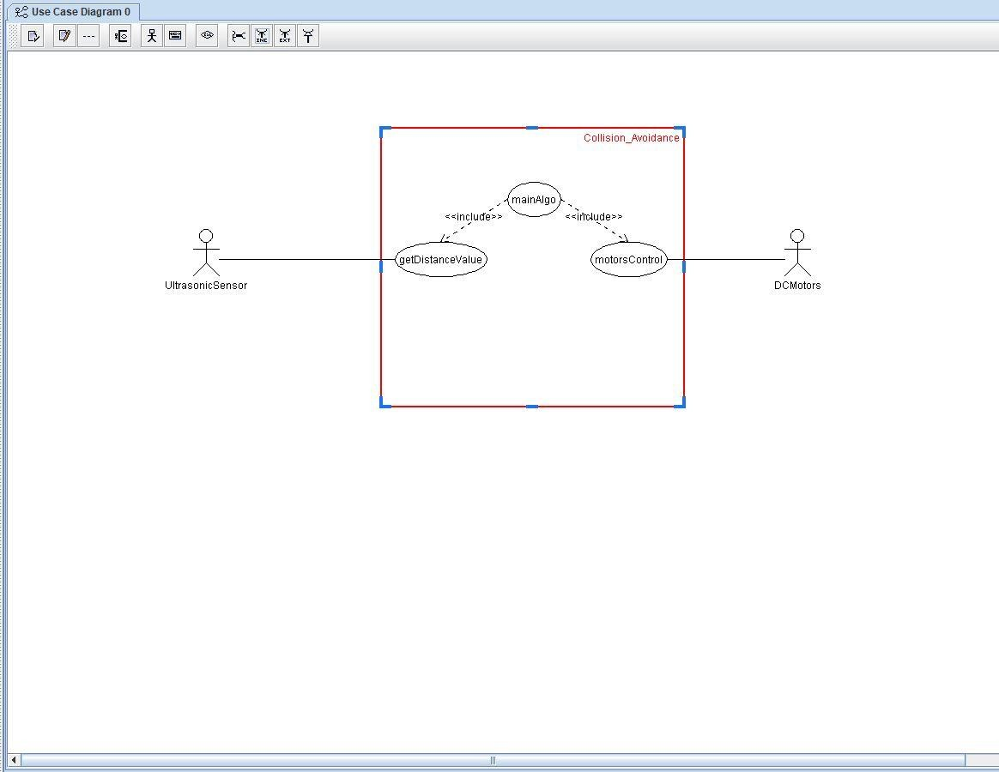

* + **Activity diagram:**

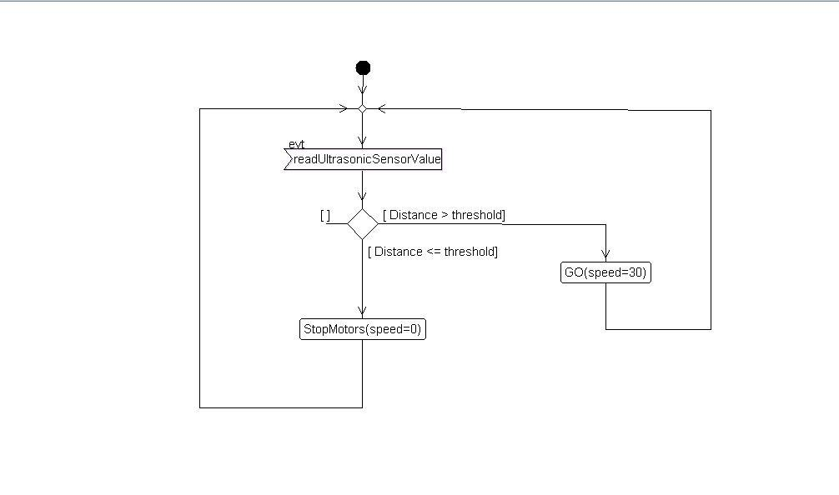

* + **Sequence diagram:**

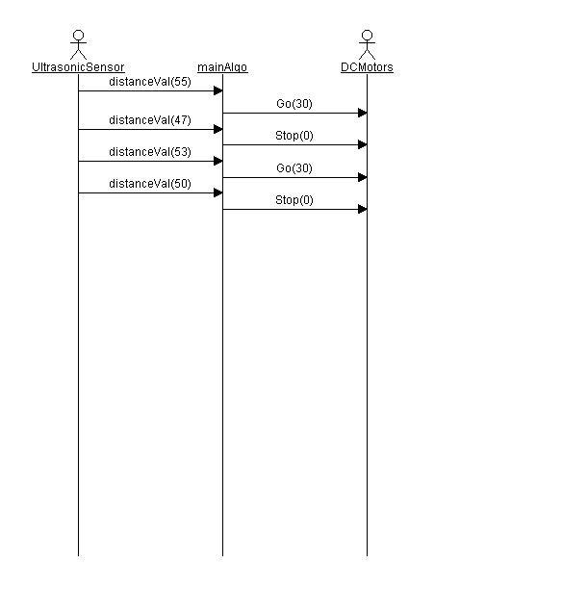

* 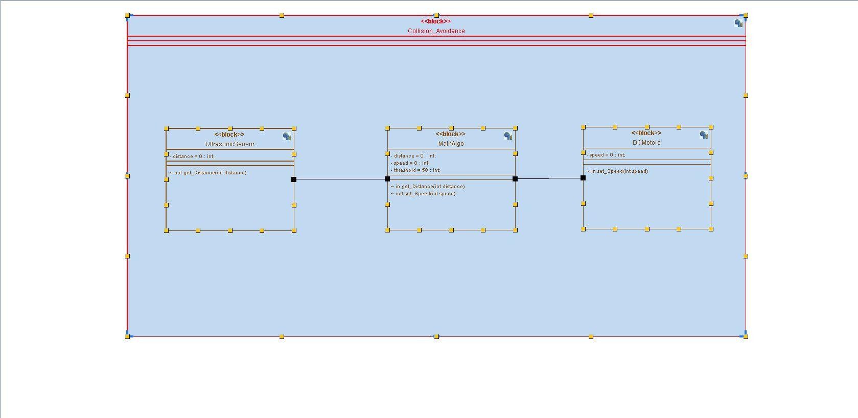**Block diagram:**
* **System Design:**
  + **State Machine UltrasonicSensor:**

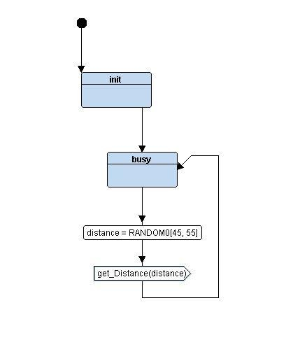

* + **State Machine DCMotors:**

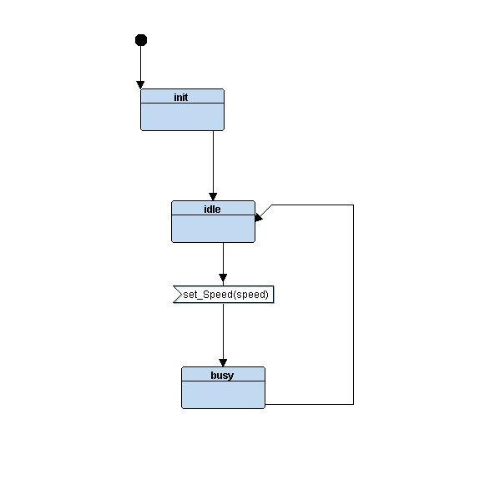

* + **State Machine MainAlgo:**

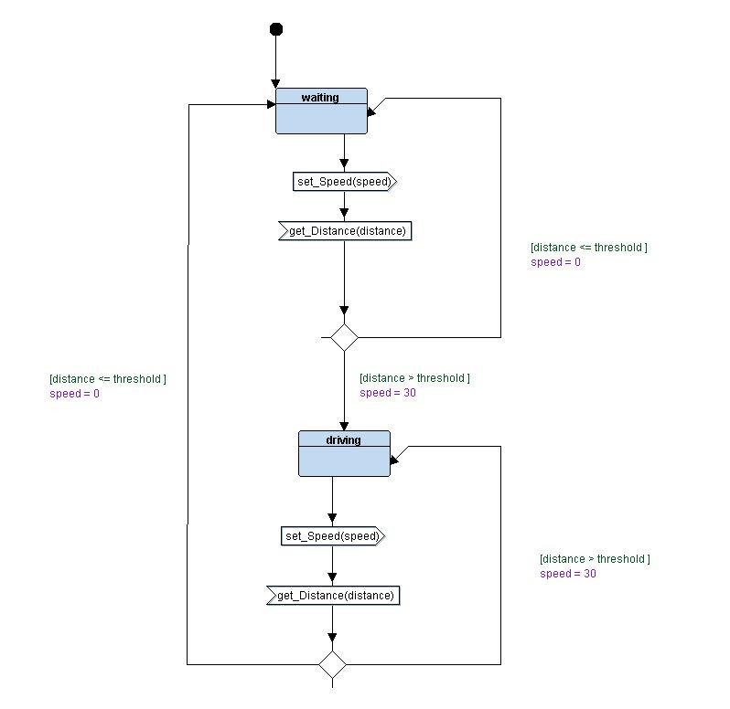

* **Simulation:**

