Computer Engineering Department

Electronics

21ELEC02C

Project Report

***Submitted to***

Dr. Hany Bastawrous & Eng. Kareem Abozeid

**ELEC. Dep., BUE**

***Students:***

*Mohamed Ahmed Abdel Galeil* ***ID:****214618*

*Mostafa Mohamed Ahmed* ***ID:*** *212577*

**COMP. Dep. DY1**

PC-based oscilloscope using Arduino

Contents

1. Project description: 2

2. Circuit Design: 2

3. Components Table: 3

4. Testing Setup: 3

5. Testing Result: 4

# Project description:

The concept behind the PC-based Oscilloscope is that it allows us to simulate a real oscilloscope using 2 things: An Arduino, and a laptop. By connecting the Arduino and the processing circuit to a laptop, the waves of the input signal can be displayed on the screen throughout the PC scope application. The maximum input voltage for the circuit is 5 V DC. It cannot accept more than 5 volts due to safety measures, as per the original author of the circuit.

# Circuit Design:

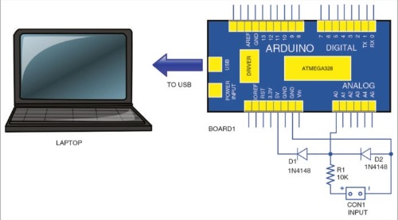

Figure 2.1: Circuit Design

# Components Table:

|  |  |
| --- | --- |
| Components | Price list |
| Arduino UNO | 230 L.E |
| Breadboard | 30 L.E |
| Ten Male-Male Jumper Wires | 7 L.E |
| Two 1N4148 Diodes | 0.7 L.E |
| 10kΩ Resistance | 1 L.E |
| Two Red & Black Probes | 16 L.E |

Figure 3.1: Components Table with Prices

# Testing Setup:

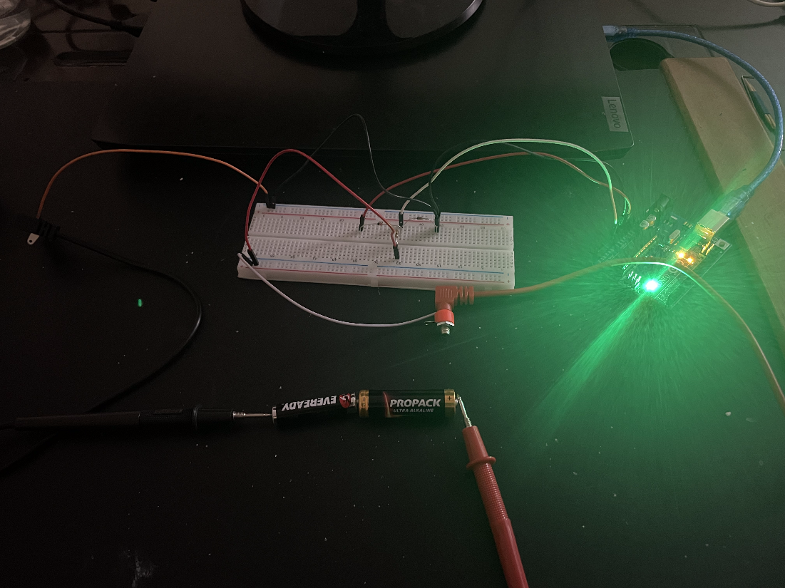

Figure 4.1: Testing Setup

Shown above is the circuit board, Arduino, and the laptop in its connected form. The probes are used so we can input our voltage, in this case 3 V DC connected in series.

# Testing Result:

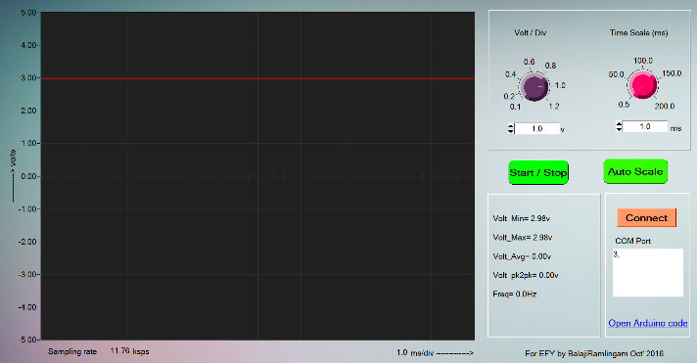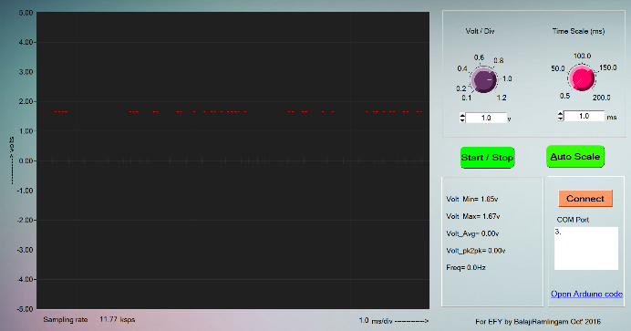

Figure 5.1: Testing Results with different Batteries

Shown above is the output application (PC Scope). By connecting different voltage sources, the oscilloscope displays the value and wave form of the input signal.