|  |  |
| --- | --- |
| Student_id | Student_name |
| 20236094 | Mostafa Raafat Kamal |
| 20236103 | Moneer Magdy Shaaban |
| 20236120 | Yamen Mohamed Fouad |
|  |  |



**Project Title**

**Software Requirements Specification**

Supervised by

Dr Manar El Kady

Mostafa

Table of Contents

Project Idea 3

Problem Definition 3

Objectives 4

Stakeholders 5

User Stories 7

Functional Requirements 8

Non Functional Requirements 9

Usecase Diagram 10

Scrum Implementation 13

Sprint Planning 14

Agile Methodolgy 15

Github repo 18

References 19

# Project Idea

A concise overview of the project’s purpose and scope, highlighting what it aims to accomplish.

The project aims to develop an application that facilitates the buying, renting, and viewing of objects online, The goal of the project is to achieve a proportionate combination of ease of use, smoothness and speed of operations with the aim of enhancing the overall online experience in shopping whatever it's shopping or renting or just viewing the product details and reviews.

# Problem Definition

Detailed explanation of the specific real-world problem the project addresses, explaining its impact. Include any relevant background or context to clarify why this problem matters

The project addresses a major real-world problem related to the process of purchasing, renting, viewing, and reviewing products and items. The roots of this problem go back to the challenges that consumers face in today's huge market, as online shopping has become an important solution. but the massive inflation in online shopping has led to several problem Such as, the Difficulty of communicating with sellers or lessors without a trusted platform, the lack of accurate and honest reviews and details about products; There is a huge amount of data available online, but it is often fragmented, incomplete or misleading to the consumer and the large number of online fraud operations is due to the lack of security and the large number of unreliable sources due to the wide market. Which negatively affects the online market due to the gradual decrease in trust between customers and the online market.so, That's why this problem is really important because it affects a broad spectrum of consumers, from those making everyday purchases to people seeking specialized items for specific needs

# Objectives

A list of clear, measurable goals that the project aims to accomplish. Describe how achieving these objectives will address the problem

1- Displaying products in an organized manner that contains precise details on each product, its pictures, and previous reviews to facilitate consumers' browsing and finding their needs.

2- Establishing a strong security system to choose sellers and lessors who can be trusted to avoid fraudulent transactions to build trust with the consume

3- Improving and facilitating renting process between the seller and the consumer by setting clear and fixed conditions for the process of renting, which helps facilitate the matter for both parties.

Achieving these goals will collectively address the core issues consumers face when making purchasing or renting decisions in the marketplace.

# Stakeholders

Identification of all stakeholders, including clients, end-users and other parties who will interact with or benefit from the project. Include a summary of their needs and expectations

End-users(consumers) :

Consumers are those who will use the site's services to buy, rent, or view and browse products

needs:

1- Clear, detailed descriptions of products, including specifications, pricing, and availability (whether for sale or rent).

2- Honest and verified user reviews to help them make their decisions and decide if the product matches their requirements and is worth its price.

3- Seamless experience and a smooth, easy-to-use interface to simplify all operations.

4- A reliable security system to protect all the personal data.

Expectations:

1- Fast and simple operations to Make it easier for them to use the services.

2- High-quality, reliable products that match the descriptions, ratings and reviews.

3- A platform that helps them find their needs with the less effort and time.

4- Their ability and freedom to place their ratings and reviews on products after purchase, regardless of whether the review is negative or positive

Sellers and Rental Service Providers:

Needs:

1- Features that help them to show and highlight their products and list it in a hooking way.

2- Reach a wider audience of potential customers interested in buying or renting their products, by placing them in suggestions or placing them in the category they belong to.

3- A platform where rental prices, durations, and terms are clearly stated and easy for users to understand.

4- A reliable and secure payment gateway to process transactions without fraud or delays.

Expectations:

1- Simple, intuitive tools for managing product listings, pricing, and promotions.

2- Low transaction fees and clear terms for using the platform.

3- Tools to manage booking, availability, and rental periods.

# User Stories

1)as a service provider, I want add products in my profile, so I can let customers view my products.

2)as a service provider, I want to add description of the products by strings, so I can inform the customer with the details.

3)as a service provider, I want to add the balance of the product, so customers can see each balance of the products.

4)as a service provider, I want to register a profile using email and password, so customers can reach any products offered by me.

5)as a service provider, I want to login to my account using email and password, so I can access my profile.

6) as a customer, I want to register account, so I can store my credentials.

7) as a customer, I want to login to my account using email and password, so I can access my profile.

8)as a service provider, I want to edit my profile, so I can edit wrong credentials.

9) as customer, I want to edit my profile, so I can edit wrong credentials.

10)as a customer, I want to view service provider products, so I can decide what to rent.

11) as a customer , I want to view the categories of the available products, so it’ll be easier for me to reach what I’m searching for.

12)as a customer , I want to view available offers, so I can decide what to choose form the offers.

13)as a customer, I want to view product details by clicking on it, so I can view it in details.

14) as a customer, I want to add coins to my e-wallet, so I can begin renting products.

15)as a customer, I want to rent products by clicking rent, so I can be able to rent some

Products.

16) as a service provider, I want to edit password and email, so I can change them later on.

17)as a customer, I want to edit password and email, so I can change them later on.

18) as a service provider, I want to make sales and offers, so that service providers can get customers easily.

19) as an admin, I want to know available customer and renters, so I can track the progress of the software.

21) as a user , I want to choose either to be a service provider or customer in the account, so I can access the functions I want to use.

22) As a service provider, I want to increment by balance with every buy/rent function, so I can use my E-coins.

# Functional Requirements

1. Requirement 1 : Allow service provider to add products (user story 1)
2. Requirement 2 : Allow service provider to description to the product using strings(user story 2)
3. Requirement 3 : Allow service provider to add the balance of the product (user story 3)
4. Requirement 4 : Allow service provider to register to a profile using email and a password(user story 4)
5. Requirement 5 : Allow service provider to login to the profile using email and password (user story 5)
6. Requirement 6 : Allow customer to register a profile using email and password (user story 6)
7. Requirement 7: Allow customer to login to a profile using email and password(user story 7)
8. Requirement 8: Allow service provider to edit the profile credentials (user story 8)
9. Requirement 9: Allow customer to edit the profile credentials(user story 9)
10. Requirement 10: Allow customer to view products(user story 10)
11. Requirement 11: Allow customer to view categories of products(user story 11)
12. Requirement 12 : Allow customer to view available offers(user story 12)
13. Requirement 13 : Allow customer to view products details(user story 13)
14. Requirement 14 : Allow customer to add coins to the e-wallet(user story 14)
15. Requirement 15 : Allow customer to rent the products(user story 15)
16. Requirement 16 : Allow service provider to edit the profile email and password(user story 16)
17. Requirement 17 : Allow customers to edit the profile email and password(user story 17)
18. Requirement 18 : Allow service provider to make sales and offers(user story 18)
19. Requirement 19 : Allow Admin to view current available renter and customers(user story 19)
20. Requirement 20 : Allow customer to buy products (user story 20)
21. Requirement 21: Allow user to choose either to be service provider or customer(user story 21)
22. Requirement 22: Allow service provider to increase his balance by every buy/rent

# Non Functional Requirements

**Performance Requirements**

*As a customer/renter, I want to run this software on simple performance requirements.*

**Safety Requirements**

*As a renter/customer, I want to store my data in a secure building, as it has sensitive credentials.*

**Security Requirements**

*As a renter/customer, I want to encrypt my data , so if its accessible it can’t be understandable.*

**Software Quality Attributes**

*As a customer/renter, I want to a good stable software with a low response time minimum 2 seconds, so it I’ll be easy to move from one function to another without any crashes.*

*As a customer/renter, I want a simple user friendly UI, so that the software would be easy to use.*

# Usecase Diagram

|  |  |
| --- | --- |
| Element | Detail |
| Name | Provider login |
| Description | Allow the provider user to access his account to begin publish products |
| Actors | Service provider |
| Organizational benefits | Makes the business clean and organized as every provider has his account to login into |
| Frequent of use | Every Provider will use it alot |
| Triggers | Login as Service provider |
| Preconditions | Logged in as Service Provider  Registered and has a service provider account |
| Postconditions | No Postconditions |
| Main Course | 1. Choose to be Service Provider 2. Login |
| Alternate course | No alternate Course |
| Exception Course | Exception << “Invalid email or password”   1. Display Error 2. Login Service Provider |

|  |  |
| --- | --- |
| Element | Detail |
| Name | Customer login |
| Description | Allow the Customer user to access his account to begin publish products |
| Actors | Customer provider |
| Organizational benefits | Makes the business clean and organized as every customer has his account to login into |
| Frequent of use | Every customer will use it alot |
| Triggers | Login as Customer |
| Preconditions | Logged in as customer  Registered and has a customer account |
| Postconditions | No Postconditions |
| Main Course | 1. Choose to be Customer  2. Login |
| Alternate course | No alternate Course |
| Exception Course | Exception << “Invalid email or password”   1. Display Error 2. Login Customer |

|  |  |
| --- | --- |
| Element | Detail |
| Name | Buy productors |
| Description | Allows customers to buy products from service providers |
| Actors | Customer |
| Organizational benefits | Main project goal is received. The customer and the service provider both agreed and transaction completed. |
| Frequent of use | Often |
| Triggers | Buy |
| Preconditions | Logged in as Customers  Registered and has an account  Logged in as Customer |
| Postconditions | No Postconditions |
| Main Course | 1. Choose to be a customer 2. Login as customer 3. View products 4. View product details 5. buy |
| Alternate course | 1. Choose to be a customer 2. Login as Customers 3. View Categories View product details 4. Buy   Second alternate   1. Choose to be a customer 2. Login as Customer 3. View Offers/ Sales 4. View Products Details 5. Buy |
| Exception Course | Exception << “Not enough funds”   1. Display Error   Exception << “Products is out of stock”   1. Display Error |

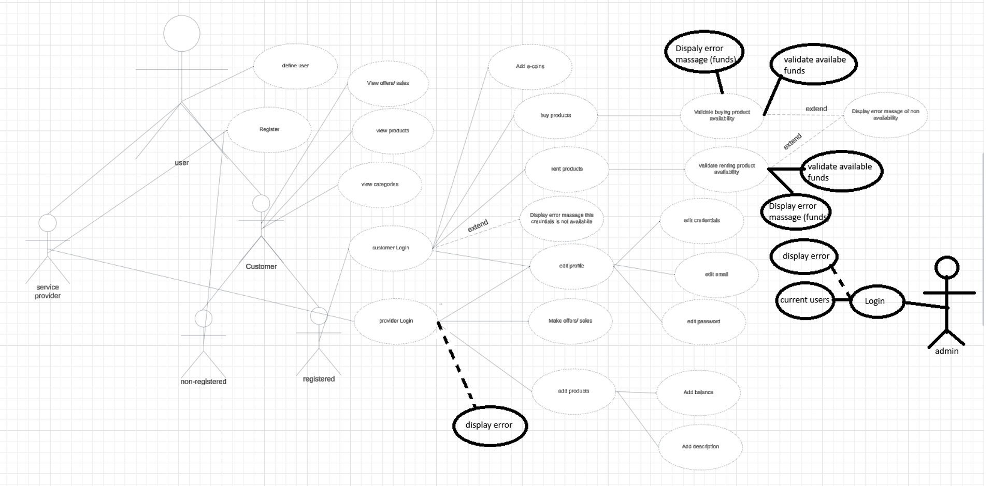The diagram was edit through paint. As lucidcharts the used online site used to make use case diagrams, requires Subscriptions for more shapes

https://lucid.app/lucidchart/c5d175fd-c731-4443-94ca-f1c3e91d1096/edit?viewport_loc=-9388%2C-10920%2C30960%2C15256%2C0_0&invitationId=inv_24121f1f-a6ae-44ae-930a-f99d2d5f878a

# Scrum Implementation

1. Scrum is an agile project management framework that helps teams structure and manage their work through a set of values, principles, and practices. Related tasks and requirements will be divided through a group of epics and sprints.
2. Team roles: Moneer as the Scrum master, Yamen as the product owner and Mostafa as the Developer.

# Sprint Planning

Task prioritization and sprint duration

* Tasks are broken to epics and sprint to deliver small, working and efficient product. Sprints duration often rely between 2 weeks to 4 weeks.
* A large user complex user story is broke to smaller user stories that act like and include the large one. These small user stories is called epic.

Task effort estimation

* Story Points and Agile estimation.

Defining Sprint goals

* You should track all requirements and ensure that tasks added to this sprint let you reach out the main purpose of this sprint(Sprint goal).

Progress tracking

* The Product owner would make sure every sprint and epic is progressed in the right time. And in another hand, Scrum master would remove any obstacles that may face the team.

Sprint review

* At the end of each sprints a meeting is set so that any one in the team can outline and explain any obstacle they faced, how they solved it and how they would handle if it appears in the next sprints.

Standups meetings summary

* Include a table summarizing each standup meeting during the sprint for tracking purposes.
* **Example:**

|  |  |
| --- | --- |
| 11/11/2024 | Added problem definition |
| 14/11/2024 | Finished user stories and constructed the usecase diagram |

# Agile Methodolgy

Definition

Agile is a project management methodology that emphasizes flexibility, collaboration, and customer feedback. It promotes iterative development, where teams deliver small, working increments of a product, often in short cycles called sprints or iterations. This allows for continuous improvement and adaptation as the project evolves.

Application in project management

* User stories and features will be broken into sprints and epics in iterations. Each sprint has its own duration and po

Screenshots (maximum 6)

* provide screenshots illustrating tasks progress and epics in jira

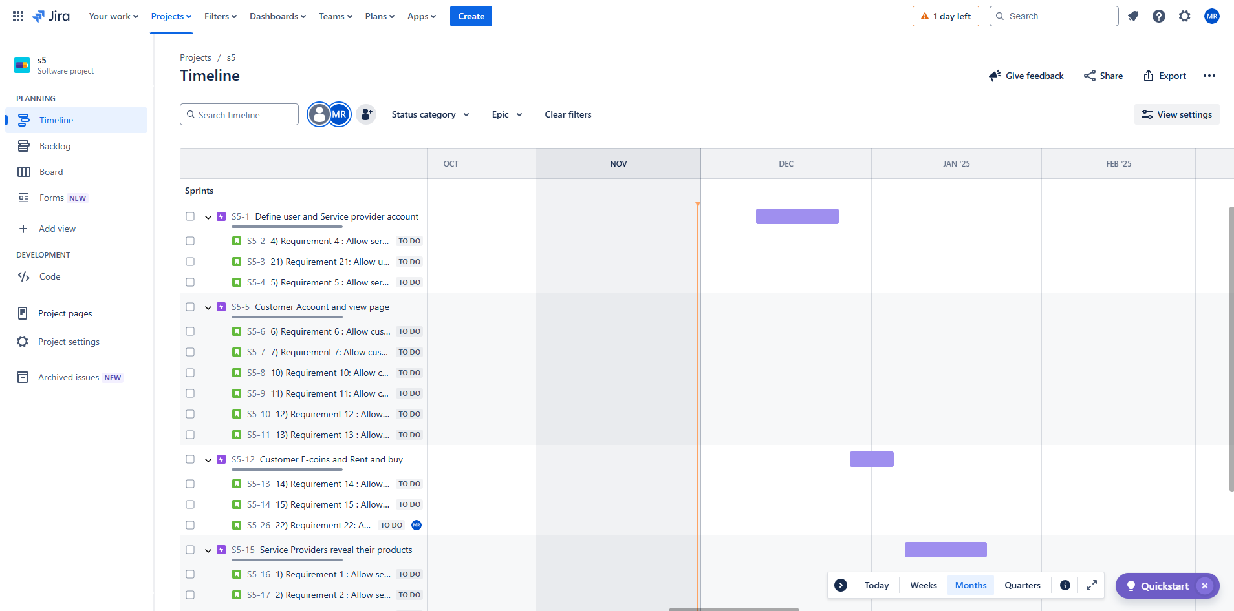

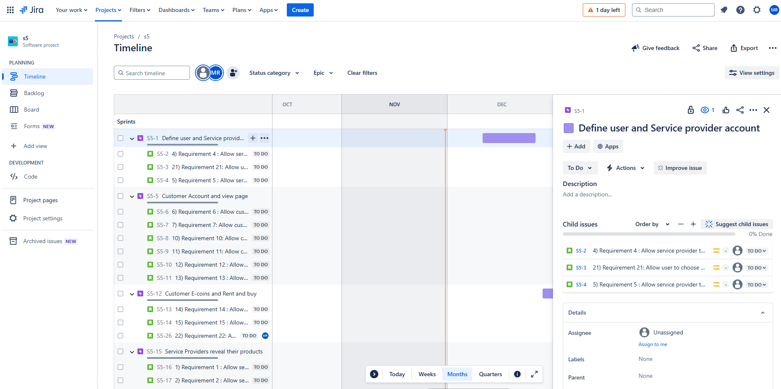

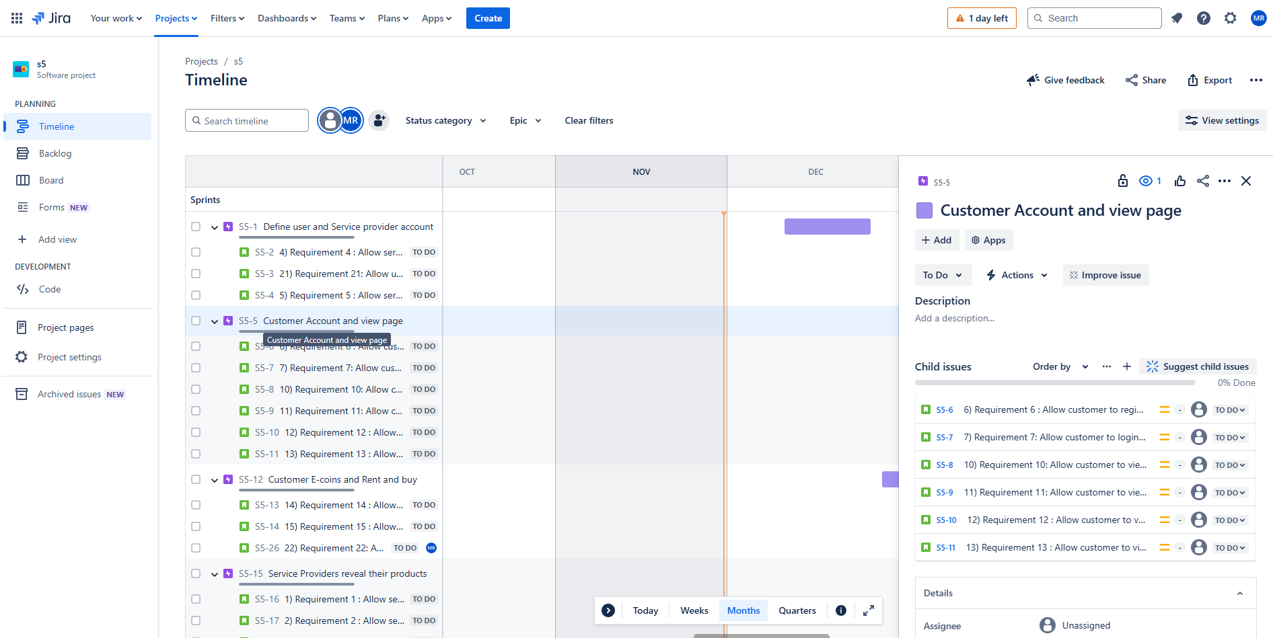

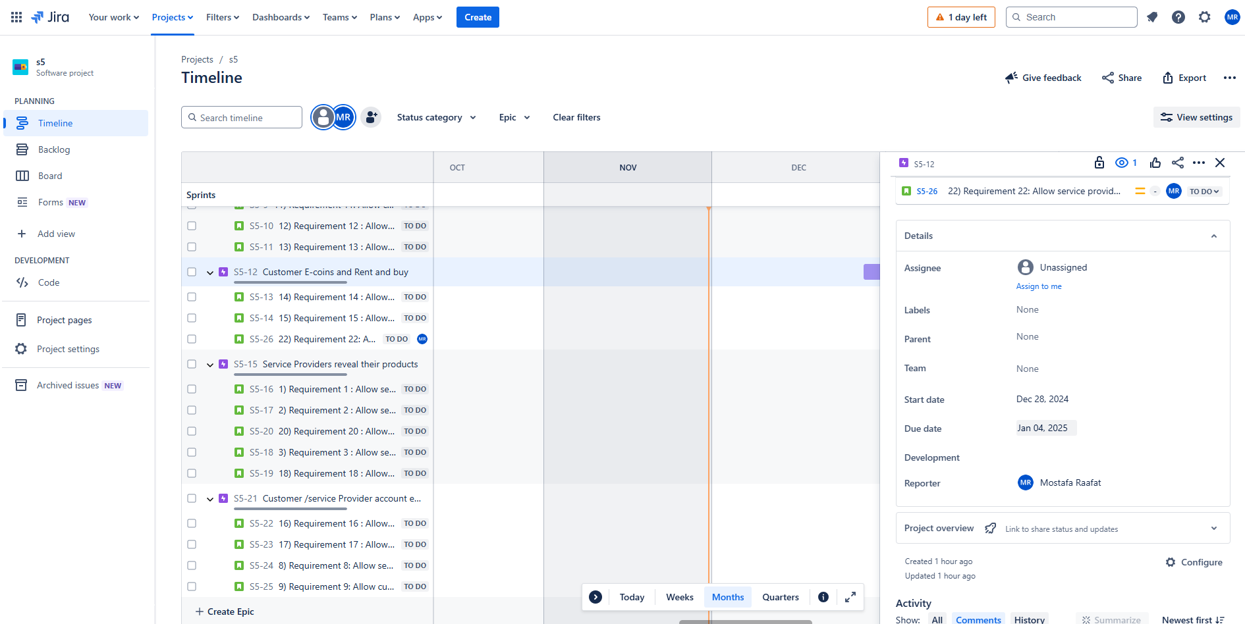

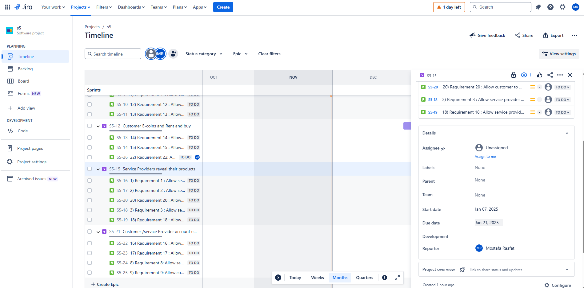

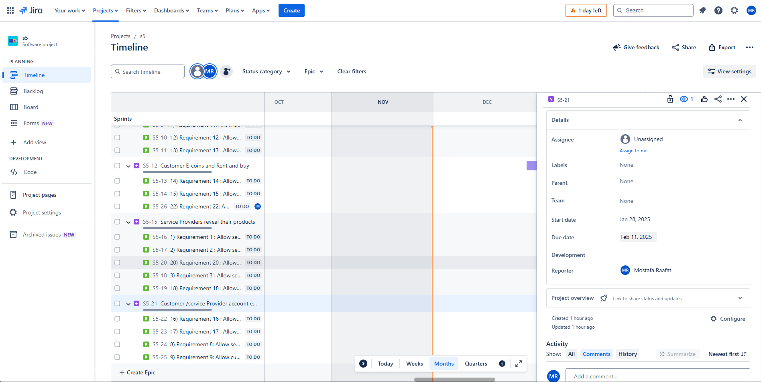

# Github repo

Provide a link of your repo that includes team mates names, groups, and IDs.

<https://github.com/Mostafa-Raafat1/Buying-Renting-system>

# References

<https://www.atlassian.com/software/jira>

<https://www.geeksforgeeks.org/>

<https://www.lucidchart.com/pages/>