Name: Mostafa Shaaban Mohamed Mahmoud Shanab
Track: Web & UI

CMD vs ENTRYPOINT: Both define what runs when a container starts. ENTRYPOINT is the fixed command (you can't override it easily), CMD is the default argument (easily overridden). Think: ENTRYPOINT = the program, CMD = its default flags.

Problem1:
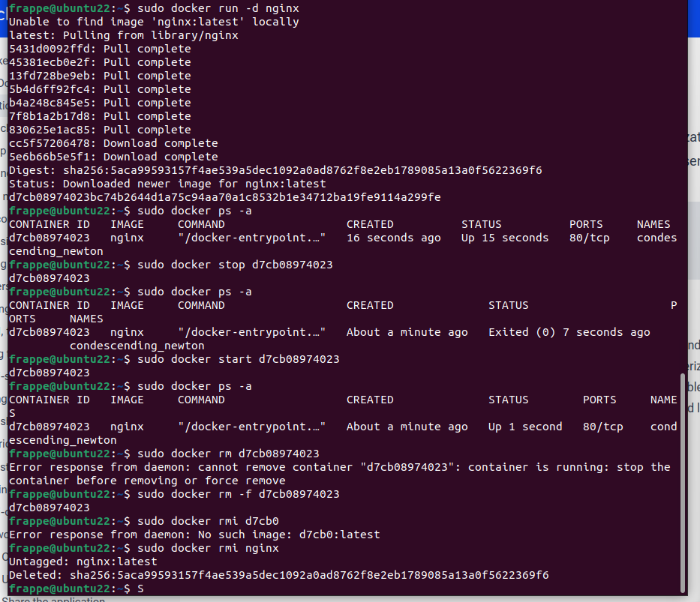

Problem2:
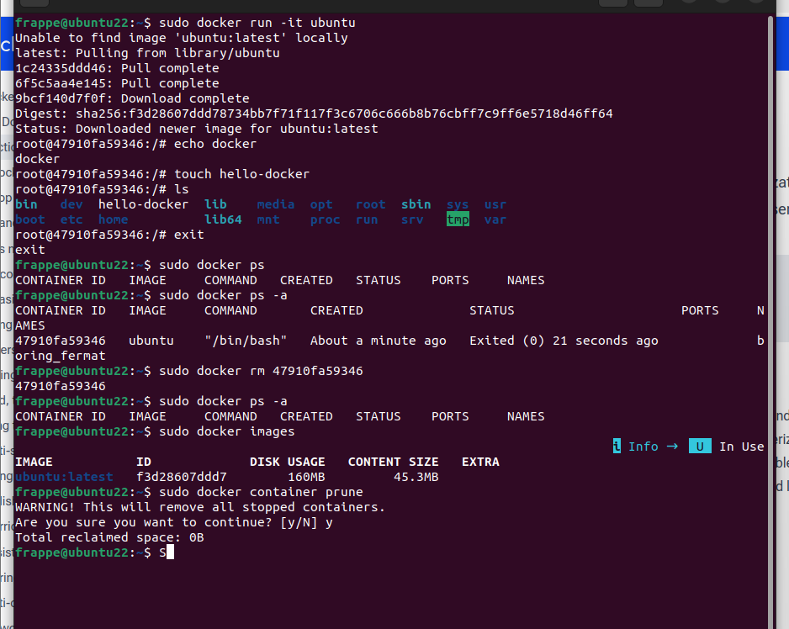
The file hello-docker is GONE forever. This is the key lesson: containers don't save data by default. When you delete a container, everything inside it is deleted too.

Problem3:
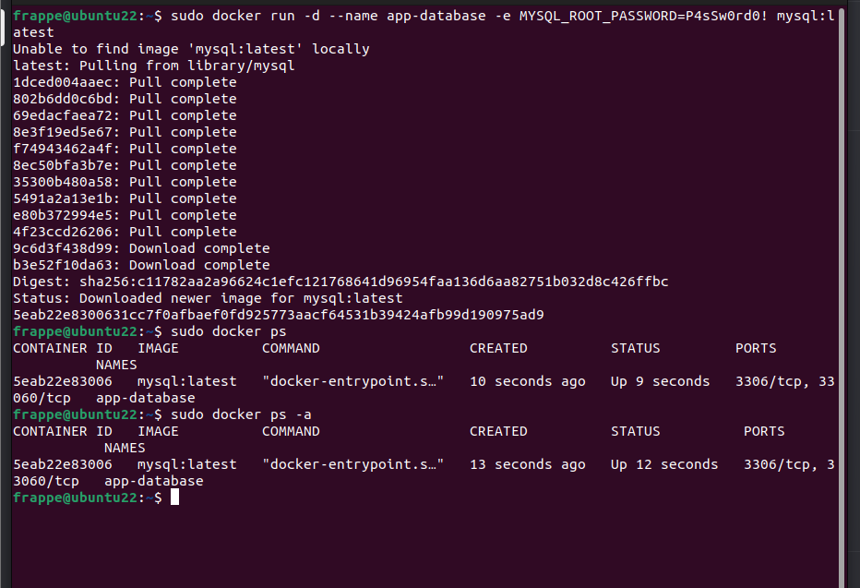
Problem4:
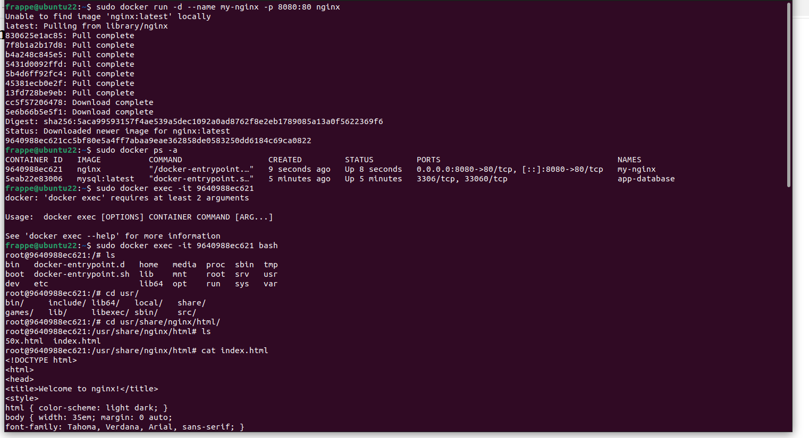
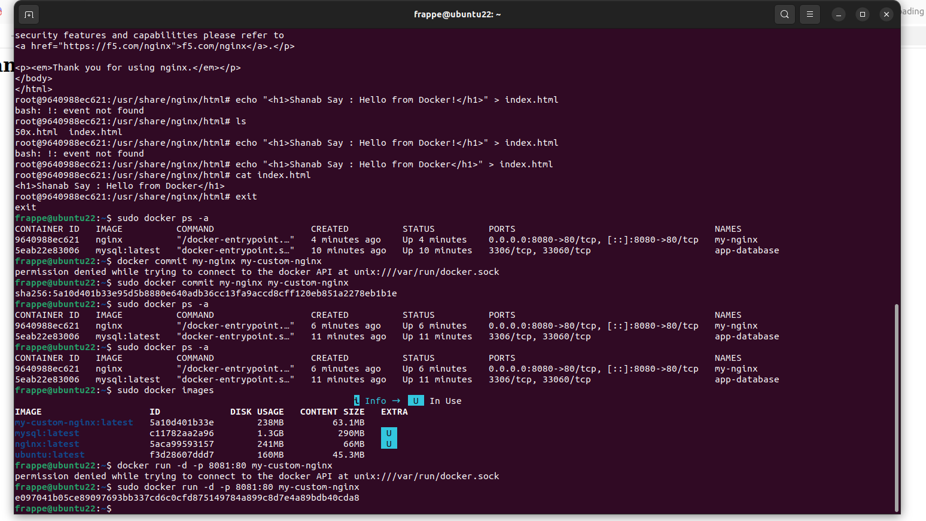
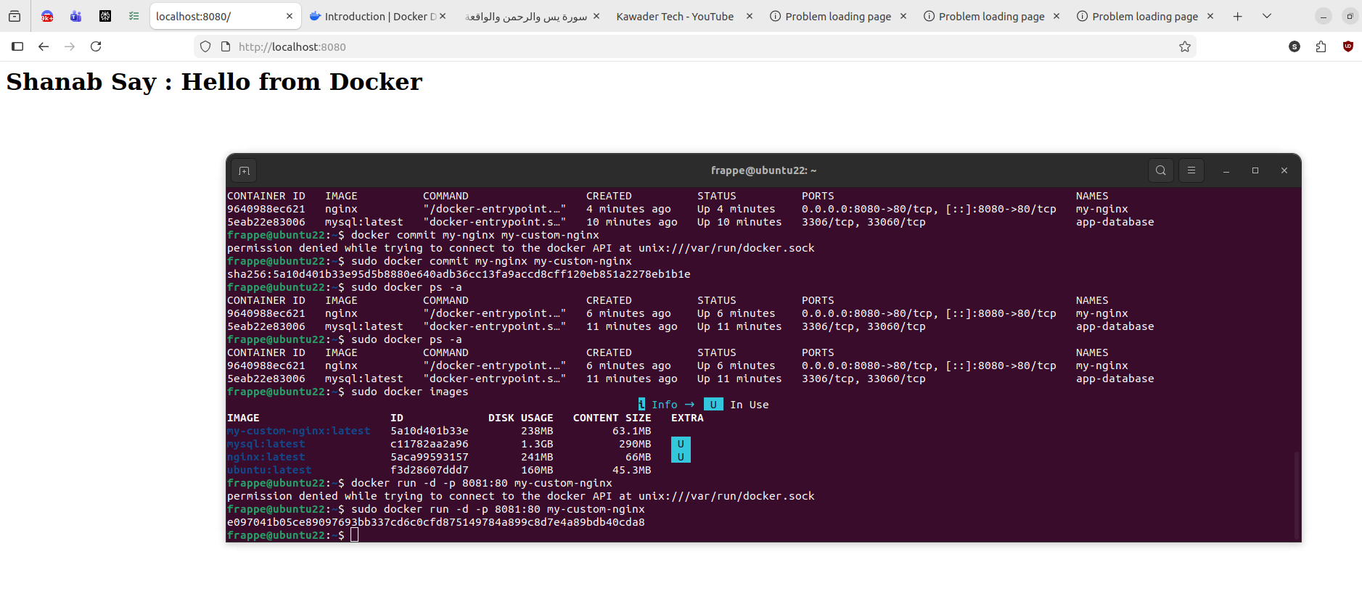
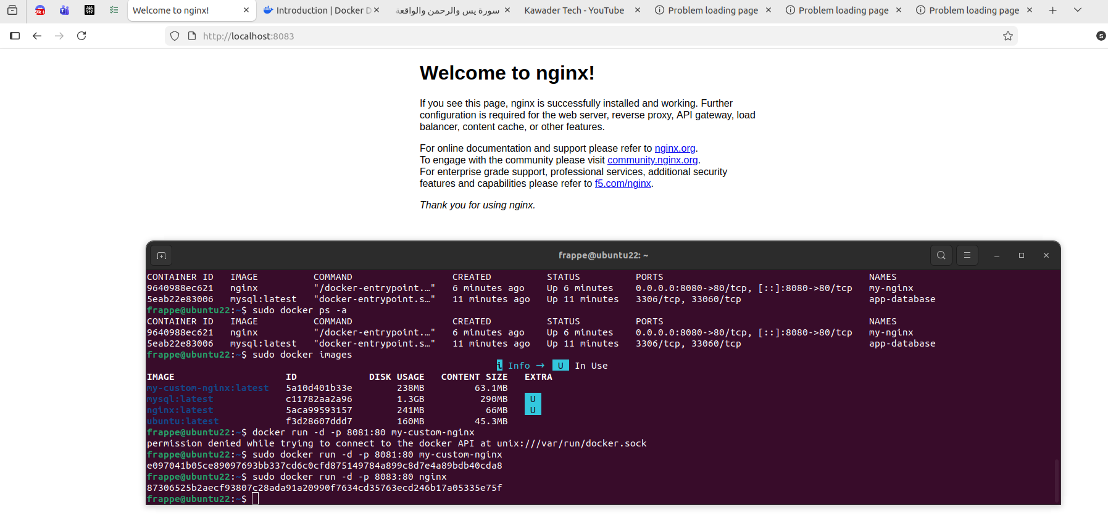
Problem5:
