Smart Classroom
for
Graduation Project, CS Department
Version 1.0 approved
Mostafa Usama Ahmed - Mohamed Nabil Hassan – Mohamed Ramadan Farouk – Sondos Osama Mohamed – Manar Mohamed Sayed– Nourhan Mahmoud Hassan
Assiut University
1/12/2022
Table of Contents
Table of Contents ii
Revision History ii
1. Introduction 1
1.1 Purpose 1
1.2 Document Conventions 1
1.3 Intended Audience and Reading Suggestions 1
1.4 Product Scope 1
2. Overall Description 2
2.1 Product Perspective 2
2.2 Product Functions 2
2.3 User Classes and Characteristics 2
2.4 Operating Environment 3
2.5 Design and Implementation Constraints 3
2.6 User Documentation 3
2.7 Assumptions and Dependencies 3
3. External Interface Requirements 3
3.1 User Interfaces 3
3.2 Hardware Interfaces 4
3.3 Software Interfaces 4
3.4 Communications Interfaces 4
4. System Features 4
4.1 Feature 1: Control lighting 4
4.2 Feature 2: Control ventilation 5
4.3 Feature 3 5
5. Other Nonfunctional Requirements 5
5.1 Performance Requirements 5
5.2 Safety Requirements 6
5.3 Security Requirements 6
5.4 Software Quality Attributes 6
5.5 Business Rules 6
References 6
6. Other Requirements 6
Appendix A: Glossary 6
Appendix B: Analysis Models 7
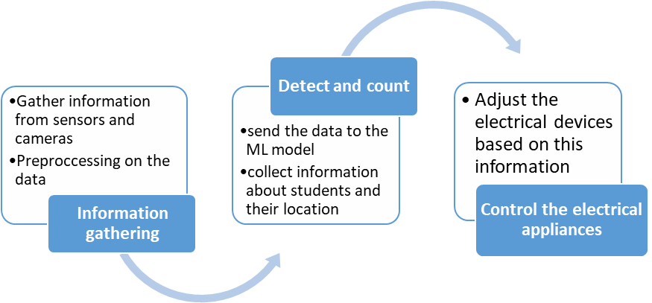 7
Appendix C: To Be Determined List 7

Revision History
Name | Date | Reason For Changes | Version

Introduction
The following sections provides an overview the software requirements specifications for the smart classroom.

Purpose
The purpose of this SRS is to determine both functional and non-functional requirements of the system in the classroom which will control the lighting and ventilation. Also, the document provides an overall description with UML analysis models.

Document Conventions
The document is prepared using Microsoft Word 2013 and has used the font type 'Times New Roman'.
The fixed font size that has been used to type this document is 14pt with 1.5 line spacing. It has used the bold property to set the headings of the document.

Intended Audience and Reading Suggestions
Intended reader groups for this software requirement specification are the Faculty Administration, the lecturer, the project team, and the supervisor.
Through this document, the workload needed for development, validation and verification will ease. To be specific, this document is going to describe functionality, external interfaces, performance, attributes, and the design constraints of the system which is going to be developed.

Product Scope
This project aims to prevent wasting electricity in the classroom by implementing a tiny machine learning system that will detect and count the number of students entering and exiting the classroom. Also, the system will reduce the consumed energy, cost, and human resources by automating the process of lighting and ventilation.

Overall Description

Product Perspective
The smart classroom system is a new self-contained product which will be produced by
the project team in order to overcome the problem of wasting energy, this classroom system manages the electrical devices in the classroom by collecting data from sensors and cameras, then processing this data, taking action, and finally sending orders to the lighting system, air conditioning, and more, the final outcome of this project will increase the efficiency of the current systems and will reduce energy wasted.
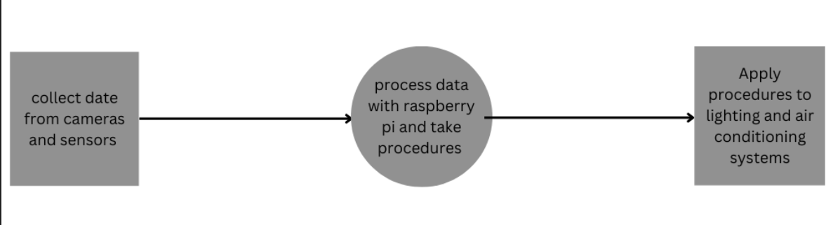

Product Functions
The system will help make the classroom more energy efficient with some functions such as:

- Calculate the total number of people in the classroom.
- Count the number of people in a specific section of the classroom.
- Control the lighting in a specific space based on the number of people in that space and turn it off when not in use.
- Control air conditioners in a specific place based on the temperature and the number of people present in that place and shut them down when not in use.

User Classes and Characteristics
<Identify the various user classes that you anticipate will use this product. User classes may be differentiated based on frequency of use, subset of product functions used, technical expertise, security or privilege levels, educational level, or experience. Describe the pertinent characteristics of each user class. Certain requirements may pertain only to certain user classes. Distinguish the most important user classes for this product from those who are less important to satisfy.>

Operating Environment
Hardware:

- Heat sensors
- Camera
- Raspberry Pi microprocessor
Software:

- Microsoft SQL Server Management Studio Express 2010.
- Raspbian Operating system.

Design and Implementation Constraints
- All electrical connections must be in place and all appliances working efficiently.
- The system will be suitable for regular classrooms and not for huge halls or open spaces

User Documentation
There will be a simple user manual written in an understandable way to operate the system, and there will be a hard copy that will be delivered with the system.

Assumptions and Dependencies
Assuming that there is a machine vision model for counting people in the classroom, this algorithm can be used in the system after modification, or this model will be generated from scratch.

External Interface Requirements

User Interfaces
<Describe the logical characteristics of each interface between the software product and the users. This may include sample screen images, any GUI standards or product family style guides that are to be followed, screen layout constraints, standard buttons, and functions (e.g., help) that will appear on every screen, keyboard shortcuts, error message display standards, and so on. Define the software components for which a user interface is needed. Details of the user interface design should be documented in a separate user interface specification.>

Hardware Interfaces
- A camera will be used to take photos of the students in the classroom to determine their position, the camera should be placed in an appropriate location to take pictures of the classroom with a good angle.
- Various sensors will also be used to determine the temperature of the classroom, these sensors will be placed all around the classroom to accurately calculate the temperature.
- The GPIO pins in the raspberry PI will be used to connect the electrical devices with the microprocessor and control them based on collected information from the camera and the sensors.

Software Interfaces
The Python programming language version 3.10 will be used to develop the software,
Google Colab platform will be used for developing the system, OpenCV or Tensorflow libraries will be used for detecting students in the classroom, Proteus software will be used to simulate how the system will work.

Communications Interfaces
<Describe the requirements associated with any communications functions required by this product, including e-mail, web browser, network server communications protocols, electronic forms, and so on. Define any pertinent message formatting. Identify any communication standards that will be used, such as FTP or HTTP. Specify any communication security or encryption issues, data transfer rates, and synchronization mechanisms.>

System Features

Feature 1: Control lighting

Description and Priority:
Control the lighting in the classroom (High Priority).

Stimulus
A student sits on a place with no lights on.

Response Sequence
The lights are turned on on this position.

Functional Requirements

Feature 2: Control ventilation

Description and Priority
Control the ventilation in the classroom (High Priority).

Stimulus
The temperature in the classroom is high.

Response Sequence
The fans/air conditioning are turned on.

Functional Requirements

Feature 3
- Description and Priority

Counting the number of students (High Priority).

Stimulus
A student enters or leaves the classroom.

Response Sequence
The number of the students will change.

Functional Requirements

Other Nonfunctional Requirements

Performance Requirements
- The accuracy of the detection model should not be less than 95%.
- The response of the system should not exceed 3 seconds,
- The system would not slow down under high workloads.

Safety Requirements
- In case of failure, the system will switch to safe mood and the user will be able to control the electrical devices manually

Security Requirements
- Only developers can make modifications to the RPI

Software Quality Attributes
- Availability: the system will be working during all working hours of the university.
- Maintainability: maintain sessions would not take more than 2 hours
- Environmental: RPI will be protected by a cooling system to prevent any damage caused by the weather

Business Rules

References
[1] IEEE Guide for Software Requirements Specifications," in IEEE Std 8301984, vol., no.,
pp.126, Feb. 10, 1984, Doi: 10.1109/IEEESTD.1984.119205,
URL: http://ieeexplore.ieee.org/stamp/stamp.jsp?tp=&arnumber=278253&isnumber=6883

Other Requirements
Appendix A: Glossary
RPI | raspberry PI
ML | Machine Learning
GPIO | General purpose input output
UML | Unified Modeling Language

Appendix B: Analysis Models

Appendix C: To Be Determined List

