**Assignment 3**

**Omar Tawfik 221000307**

**Mostafa El Sheikh 221000362**

**Mariam Alaa 221000919**

**Nada Zaki 221000829**

Flow Chart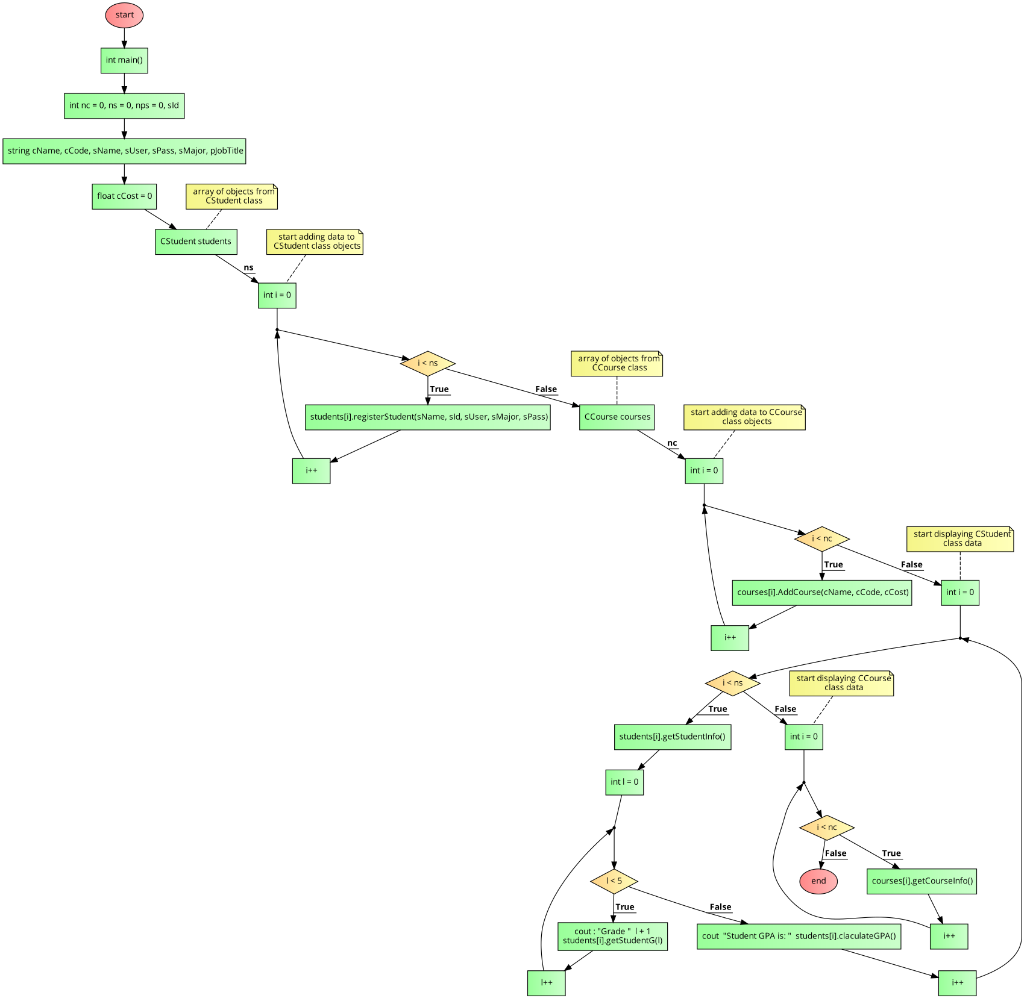

INPUT

OUTPUT

INPUT

OUTPUT

