System Architecture
Enterprise SDN Controller — Full Stack Design

1. Architecture Overview
The platform is structured as a layered, enterprise-grade SDN controller composed of seven distinct planes. Each plane has a clearly defined responsibility, ensuring that failures in one layer cannot cascade into others. The design mirrors patterns found in VMware NSX and Cisco ACI, extended with a full security and compliance envelope suitable for production enterprise deployment.

1.1 Full Architecture Diagram
The diagram below illustrates the complete system stack, from the NacTrack operator UI at the top through all control, security, data, and southbound planes down to the physical fabric layer. The dashed line on the right shows the telemetry return path.

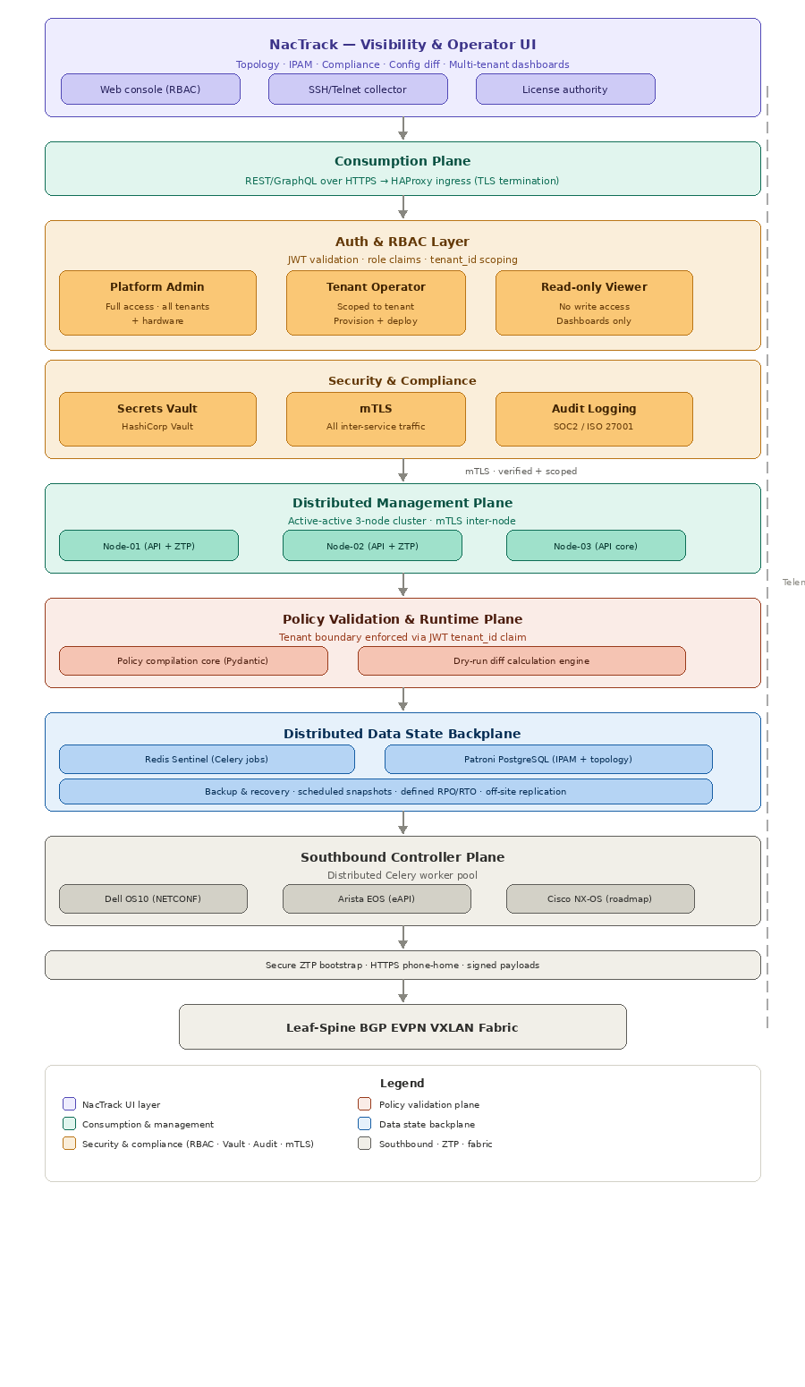

2. NacTrack — Visibility & Operator UI
NacTrack by Yuften Services serves as the primary operator-facing interface and network visibility layer. It is deployed on-premises, air-gap capable, and integrates natively with the SDN controller's telemetry pipeline.

Component | Role
Web console | Operator dashboards, topology visualization, IPAM, compliance auditing, config diff
SSH/Telnet collector | Receives gNMI, sFlow, and NETCONF telemetry streams from the physical fabric
License authority | Ed25519 signed offline license validation — compatible with air-gapped deployments

NacTrack provides 40+ granular RBAC permissions and native multi-tenancy, eliminating the need to build a custom observability UI from scratch.

3. Consumption Plane
All operator and integration requests enter the system through the consumption plane. Traffic is encrypted in transit (TLS) and load-balanced across the management plane cluster.

Component | Role
HAProxy ingress | TLS termination, distributed round-robin VIP tracking across the 3-node cluster
REST / GraphQL API | Primary interface for Morpheus provisioning webhooks and NacTrack configuration intents

4. Auth & RBAC Layer
Every inbound request is validated and scoped before it reaches the management plane. Authentication is handled via JWT tokens carrying role claims and a tenant_id. Three roles are defined:

Role | Permissions
Platform admin | Full access — tenant management, fabric blueprints, ZTP onboarding, global telemetry
Tenant operator | Scoped to their tenant — VLAN/VRF provisioning, IPAM, dry-run diffs, config deployment
Read-only viewer | Topology and telemetry dashboards within their tenant — no write access

Tenant scoping is enforced structurally: the tenant_id JWT claim is validated against every database query in the policy plane, not just at the API boundary.

5. Security & Compliance Layer
Three cross-cutting security components are embedded between the consumption and management planes.

5.1 Secrets Management
All credentials — NETCONF/SSH keys, eAPI tokens, PostgreSQL passwords — are stored in HashiCorp Vault. Workers retrieve short-lived dynamic secrets at task execution time. No credentials are stored in config files or environment variables.

5.2 Mutual TLS (mTLS)
All inter-service communication is secured with mTLS. This includes traffic between the 3 management nodes, between the API and PostgreSQL, and between Celery workers and Redis Sentinel.

5.3 Audit Logging
Every configuration change pushed to a switch is logged with the originating user identity, JWT claims, timestamp, and the exact XML or CLI payload delivered. Logs are immutable and retained for compliance with SOC2 and ISO 27001 requirements.

6. Distributed Management Plane
The management plane runs as a 3-node active-active cluster. All nodes serve API requests simultaneously. ZTP engine responsibilities are distributed across Node-01 and Node-02.

Node | Role
Node-01 | API server + ZTP engine (primary)
Node-02 | API server + ZTP engine (secondary)
Node-03 | API core only — fallback and scaling capacity

If any single node fails, HAProxy automatically removes it from rotation. The remaining two nodes continue serving all traffic without operator intervention.

7. Policy Validation & Runtime Plane
Configuration intents are validated through a four-stage pipeline before any change is committed to hardware.

Stage | Description
Syntax validation | Pydantic schema enforcement — CIDR structures, field types, required attributes
Tenant boundary isolation | Confirms IP subnets do not overlap within the tenant VRF scope
Topology pattern analysis | Validates interface maps and VLAN distributions to prevent loops and duplicate IDs
Dry-run diff engine | If dry_run=true, returns exact XML/CLI payloads without committing — safe change preview

8. Distributed Data State Backplane
Persistent state is managed across two clustered systems, both running under Patroni for automatic failover.

Component | Role
Redis Sentinel cluster | Inter-process coordination, Celery task queue, distributed locks
Patroni PostgreSQL cluster | Multi-tenant IPAM, topology state, switch lifecycle, VRF definitions
Backup & recovery | Scheduled snapshots with defined RPO/RTO — off-site replication for disaster recovery

Recommended: RPO ≤ 1 hour, RTO ≤ 30 minutes before production sign-off.

9. Southbound Controller Plane
Configuration changes are dispatched asynchronously to network hardware via vendor-specific driver plugins running in a distributed Celery worker pool.

Driver | Protocol
Dell SmartFabric OS10 | NETCONF — structured YANG XML transactions
Arista EOS | eAPI — JSON-RPC over HTTPS
Cisco NX-OS | Deferred — roadmap placeholder, not implemented in current scope

10. Secure ZTP Bootstrap
When a new bare-metal switch is powered on for the first time, the Zero Touch Provisioning flow automatically discovers, identifies, and onboards the device into the controller.

Step | Description
1. DHCP boot | Switch receives IP and DHCP Option 67 pointing to the bootstrap script URL
2. HTTPS download | Switch downloads the bootstrap script over HTTPS — plain HTTP is explicitly disallowed
3. Identity collection | Script reads serial number, MAC address, model, and OS version via dmidecode
4. Signed phone-home | Switch posts signed identity payload to the controller discovery endpoint
5. Operator assignment | Operator selects the discovered node, applies a fabric blueprint, and deploys

11. Physical Fabric
The physical layer consists of a leaf-spine BGP EVPN VXLAN fabric providing non-blocking, scalable multi-tenant network infrastructure.

Protocol | Purpose
BGP EVPN | Control plane for VXLAN overlay — distributes MAC/IP reachability across the fabric
VXLAN | Data plane encapsulation — carries tenant traffic across the underlay
BGP underlay | P2P routing between spine and leaf switches — provides transport for VXLAN tunnels

12. Known Production Considerations
The following items are acknowledged as areas requiring further hardening before a full production rollout:

- Vault unsealing strategy — auto-unseal via cloud KMS or HSM must be configured to avoid manual intervention after restarts.
- mTLS certificate rotation — automated certificate lifecycle management (e.g., cert-manager) is required to prevent expiry-related outages.
- Cisco NX-OS driver — currently a roadmap placeholder; the driver interface is defined in the abstract base class.
- ZTP network isolation — the management network used for ZTP bootstrap should be physically or logically isolated from production tenant traffic.
- InfluxDB cluster — the telemetry time-series storage for NacTrack requires its own HA configuration and retention policy definition.

These items do not block the core SDN controller functionality but should be addressed before enterprise security sign-off.

