Image Processing and Pattern Recognition

Project Proposal

Cairo University Faculty of Engineering

Computer Engineering Department

Image Processing and Pattern Recognition

Team Members

1- Hossam Saeed

2- Mostafa Wael Kamal

3- Yousef Aatef Tawfik

4- Yousef Gamal Reda

# Project Idea

**Smart Card Game:** The main idea of the project is to build a program that helps you win a card game, all you have to do is to send two images one for the cards in the ground and another one for the cards in your hand and the program will indicate the most promising move to take.

# Informative Block Diagram

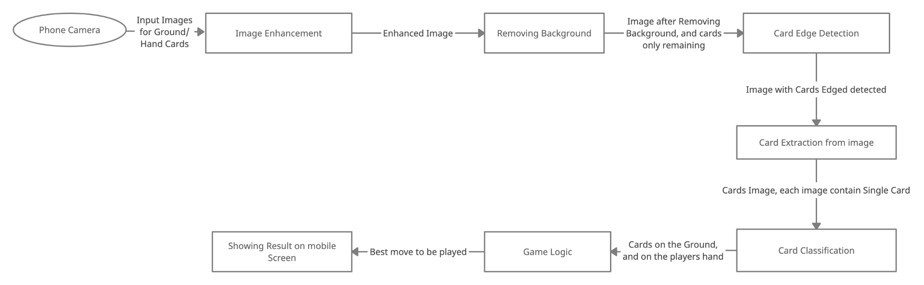

# Application Platform

Mobile Application for Android and IOS using Flutter

The Backend will be hosted an deployed on cloud using Python Flask

# Nonprimitive Functions

SVC module from sklearn.svm module for classification pipeline with tuning the parameters of the model.

# Papers references

1- Hands on Machine Learning with Scikit-learn, keras, and tensorflow textbook, Chapter 5 Support Vector Machines.

2- Single-image Background Removal with Entropy Filtering Paper.

3- G. Kumar and P. K. Bhatia, "A Detailed Review of Feature Extraction in Image Processing Systems," 2014 Fourth International Conference on Advanced Computing & Communication Technologies, 2014, pp. 5-12, doi: 10.1109/ACCT.2014.74.