

Cairo University

Faculty of Engineering

Computer Engineering Department

First Year

**Coach-ina**

Project Report for the Image Processing  
 and Pattern Recognition Course

**Team 18**

**By:**

Hossam Mohamed

Mostafa Wael

Yousef Atef Tawfik

Yousef Gamal

**Jan 2022**

Project Proposal

# Project Idea

**Smart Card Game:** The main idea of the project is to build a program that helps you win a card game, all you have to do is to send two images one for the cards in the ground and another one for the cards in your hand and the program will indicate the most promising move to take.

# Informative Block Diagram

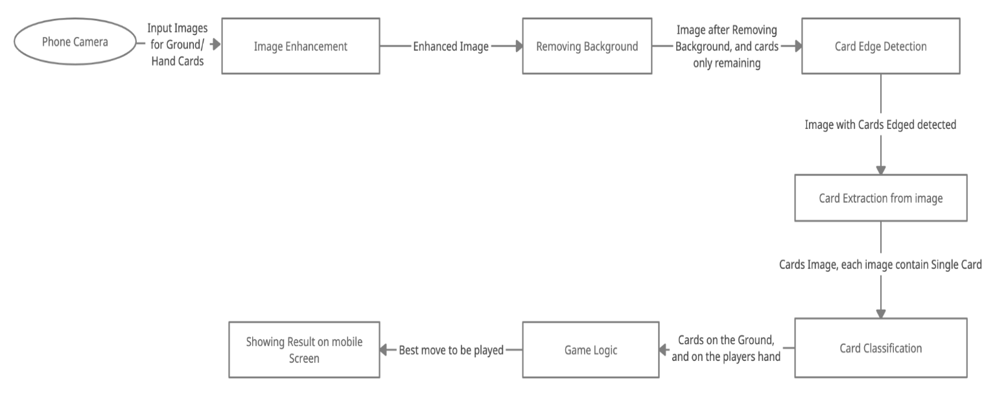

# Application Platform

Mobile Application for Android and IOS using Flutter

The Backend will be hosted an deployed on cloud using Python Flask

# Nonprimitive Functions

SVC module from sklearn.svm module for classification pipeline with tuning the parameters of the model.

# Papers references

1- Hands on Machine Learning with Scikit-learn, keras, and tensorflow textbook, Chapter 5 Support Vector Machines.

2- Single-image Background Removal with Entropy Filtering Paper.

3- G. Kumar and P. K. Bhatia, "A Detailed Review of Feature Extraction in Image Processing Systems," 2014 Fourth International Conference on Advanced Computing & Communication Technologies, 2014, pp. 5-12, doi: 10.1109/ACCT.2014.74.

# **Used Algorithms**

Our application has 2 main pipelines, one for hand cards and the other one is for ground cards. User chooses trough the application which type of cards it is that they will take a picture of.

**Diagram:**

//To be added by Hossam

**Card Detection Pipeline: (Only on Non-overlapping Cards)**

If it is a ground cards image, Our original block diagram pipeline is chosen:

1- Image Enhancement: Convert to grayscale and then Gaussian Filter

2- Segmentation: Otsu’s Thresholding

3- Contour Detection.

4- Contour Approximation and Filtering: Approximates Contours to a low number of points, then filters 4-point contours by angles and area. Then, sorts 4-point to get the right orientation of each card

5- Inverse Prespective Transformation: to get an image of each card

6- Cropping to get top left corner: used to separate rank and suit,then a contour detection is applied and the largest area contour is selected for each of the rank and suit and this output is delivered to the model.

**Symbol Detection Pipeline:**

If it is a hand cards image, Symbol Detection Pipeline is chosen:

1- Image Enhancement: Masking on Red channel, Convert to grayscale and then Gaussian Filter

2- Segmentation: Otsu’s Thresholding

3- Contour Detection.

4- Contour Filtering:

- Filter out too large or too small contours relative to image area  
- Filter out contours with too high or low aspect ratio  
- Filter out contours with too low number of points relative to image   
 perimeter  
- For contours inside of others, only one of the outside or inside contours is   
 selected based on area ratio.

5- For each passing contour: Cropping original image to contour bounding box, same thresholding is applied, checking for number of connected componenents in cropped image via dfs and number of black pixels in these components. These computations are used to filter out some Noise and textures.

**Learning Model:**

//To do

**Matching Classified Symbols:**

//To do by Hossam

**Game Logic:**

//To do by Hossam

**Experiment Results & Analysis:**

//To do

**Application:**

1 -Mobile Application using Flutter, for the Game, when the user enters the game, it choose the Game mode between two modes: King, and Hand Ground Matcher, then it will be navigated to the Game Page, it upload hand image in case of king, and hand, and ground images on case of hand ground matcher, and it get the best thing to play.

2- Backend: Implemented using Flask API, gets the images, and game type, and returns the best move.

3- Docker: Containerized using Docker.

4- Google Cloud Platform VM instance for deploying the model.

**Work Division:**

Hossam Mohamed: Game Logic, Symbol Detection Pipeline, Matching Classified Symbols

Mostafa Wael: KNN Model, SVC Model, Card Detection Pipeline

Yousef Atef Tawfik: Game Logic, Card Detection Pipeline, KNN Model, SVC Model

Yousef Gamal: Application, Random Forest Model, Symbol Detection Pipeline

**Accuracy & Performance:**

//To do

**Conclusion & References:**

//To do