**Class Diagram**

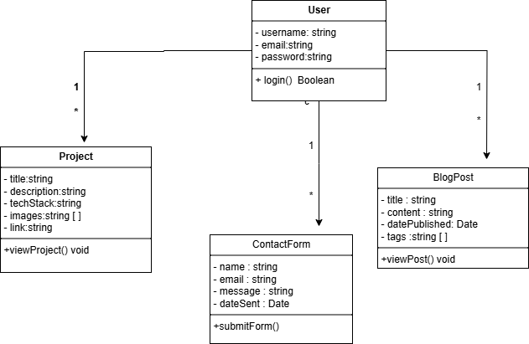

**Sequence Diagram**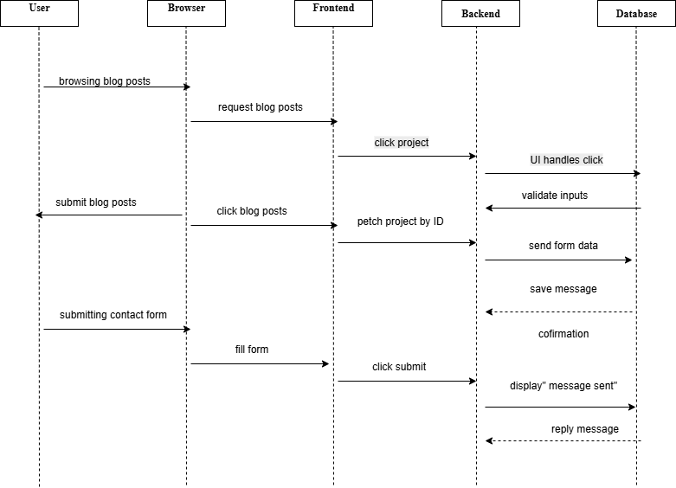

**SDLC Phases for Portfolio Website**

**1. Planning**

* **Goal:** Define the purpose of the portfolio website.
* **Actions:**
  + Identify the main features: homepage, projects, blog, contact form.
  + Determine the target audience (employers, clients, etc.).
  + Choose the tech stack (HTML, CSS, JavaScript, maybe a backend like Node.js or PHP).

**2. Design**

* **Goal:** Create the layout and architecture.
* **Actions:**
  + Draw **wireframes** and **UI mockups** (using tools like Figma or draw.io).
  + Design diagrams like the **Class Diagram** and **Sequence Diagram**.
  + Plan the site structure: navigation menu, pages, sections.

**3. Development**

* **Goal:** Build the actual website.
* **Actions:**
  + Code the frontend using HTML, CSS, and JavaScript.
  + Implement components: blog posts, contact form, project showcase.
  + Add animations or interactivity as needed.

**4. Testing**

* **Goal:** Make sure everything works well.
* **Actions:**
  + Test all features: links, form submissions, blog loading.
  + Use different browsers and screen sizes to check responsiveness.
  + Fix bugs and improve performance.

**5. Maintenance**

* **Goal:** Keep the website updated.
* **Actions:**
  + Regularly update project content and blog posts.
  + Fix any future bugs or broken links.
  + Add new features based on feedback or personal growth.

Mostafa El Sayed

25/7/2025