**DB Tables description:**

* book: a list of all books available in the store. \
* book_author: stores the authors for each book, which is a many-to-many relationship. \
* author: a list of all authors.
* book_language: a list of possible languages of books. \
* publisher: a list of publishers for books. \
* customer: a list of the customers of the Gravity Bookstore. \
* customer_address: a list of addresses for customers, as a customer can have more than one address, and an address has more than one customer. \
* address: a list of addresses in the system. \
* country: a list of countries that addresses are in. \
* cust_order: a list of orders placed by customers. \

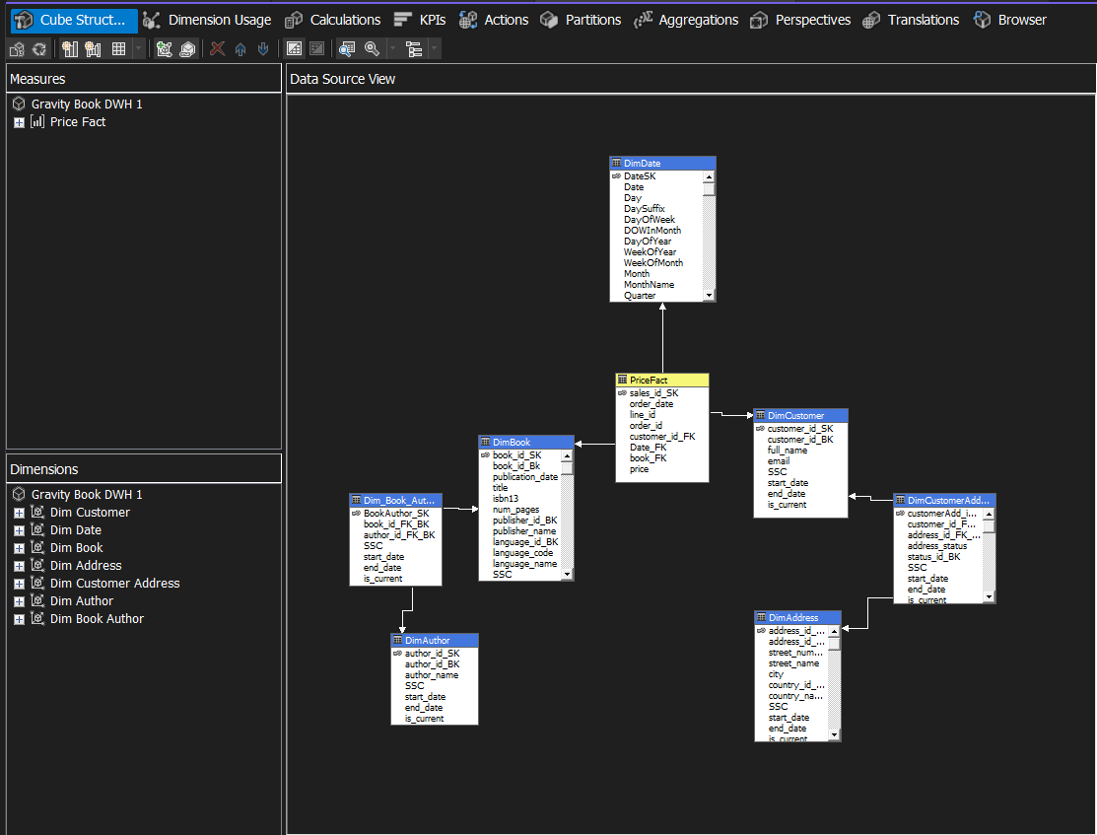

the FactOrder table is in the center, and all the other tables (DimCustomer, DimBook, DimShippingMethod, and DimDate) connect directly to it. These dimension tables are flat and store all the descriptive details in one place instead of being broken into smaller pieces. For example, DimBook contains everything about a book, like its title, author, language, and publisher, all in one table.

I used a snwoflask schema because I have a bridge tables. I try to make 3 sub dimension This structure makes it much faster and easier to query data since you don’t need to deal with a bunch of joins. For example, if I wanted to find the total sales by customer.

The snowflake schema also makes things easier to understand and use. Analysts or anyone writing reports won’t have a hard time figuring out where the data is stored. Everything is laid out clearly, with the fact table storing the numbers and the dimensions holding all the details.