Building Occupant Monitoring Box Manual

Version 2.0

1. System Functionality

The overall system functionality is described in Figure 1. The Base Station controls all the synchronization through the entire system. The Tags collects foot impact timing information. The Anchors collects the vibration signal as well as the synchronization signal from the Base Station.

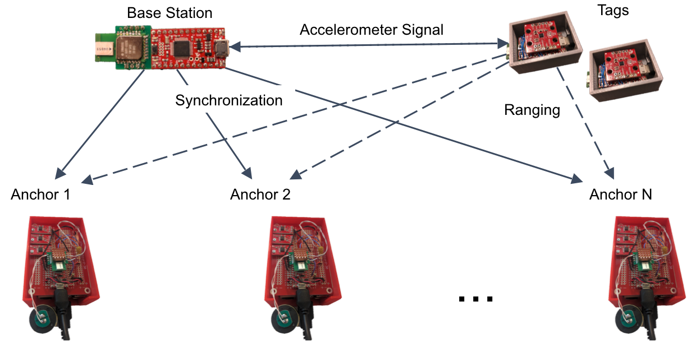

Figure 1. System Overview

1. System Installation

The system has both raspberry pi and arduino zero part

* 1. Arduino Zero installation

To flush the code, first of all, you need to install the Arduino Zero from board manager, and remove the Arduino Due board, they are not compatible sometimes.

Then follow the guidance here: <https://learn.sparkfun.com/tutorials/samd21-minidev-breakout-hookup-guide/setting-up-arduino>

Make sure select **SparkFun SAMD21 Mini Breakout** as the board when flush.

* 1. Raspberry Pi installation

First of all, download SD card installation file:

<https://www.raspberrypi.org/downloads/noobs/>

Unzip the file and put the files into the SD card formatted as FAT32

Find **wired mouse, keyboard, HDMI cable, ethernet cable, and a screen** before you start.

Refer to

<https://www.raspberrypi.org/learning/noobs-install/elcapitan/>

<https://github.com/dandanpan/multi-people-tracking>

for the rest of the installation.

When ask for ”Enter interface name”, enter **wlan0** to setup the wireless network settings

Furthermore, setup the **static IP address** for the node for easy access:

<https://www.raspberrypi.org/learning/networking-lessons/rpi-static-ip-address/>

**Enable SSH** on the Pi by following this:

<https://pihw.wordpress.com/guides/direct-network-connection/>

1. System Setup
   1. Mac

The Mac is connected to the Base Station, run readcom_base.py under the designated folder.

* 1. Base Station

Change the Tag and Anchor number in Footstep.h file in the library, then flash the Base Station before run readcom_base.py.

Put the updated library into the /Arduino folder.

* 1. Anchor

Place the anchors on the floor and power them.

* 1. Tag

Place the tag on people’s leg and power with battery through USB

1. Data Access
   1. Base Station

Connect Base Station to Mac, and run **python readcom_base.py**

* 1. Anchor
     1. SSH

SSH into the anchor node:

**ssh pi@<ip address>**

**ssh pi@192.168.0.2 -o UserKnownHostsFile=null**

Sometimes use:

**ssh-keygen -R 192.168.0.2**

Find the folder location:

**cd Footstep/config/scripts/pyanchor-read/**

Checkout collected files:

**find . -name "*.txt" -type f**

Copy from pi to local machine:   
 **scp -r pi@192.168.0.2:/home/pi/Footstep/config/scripts/pyanchor-read ./**

Delete collected files after copy out:

**find . -name "2017-*.txt" -type f -delete**

* + 1. Through Ethernet

To access the data through Ethernet port, the ethernet setting on the Mac needs to be set to 192.168.0.1 to allow correct LAN connection, as shown in Figure 2.

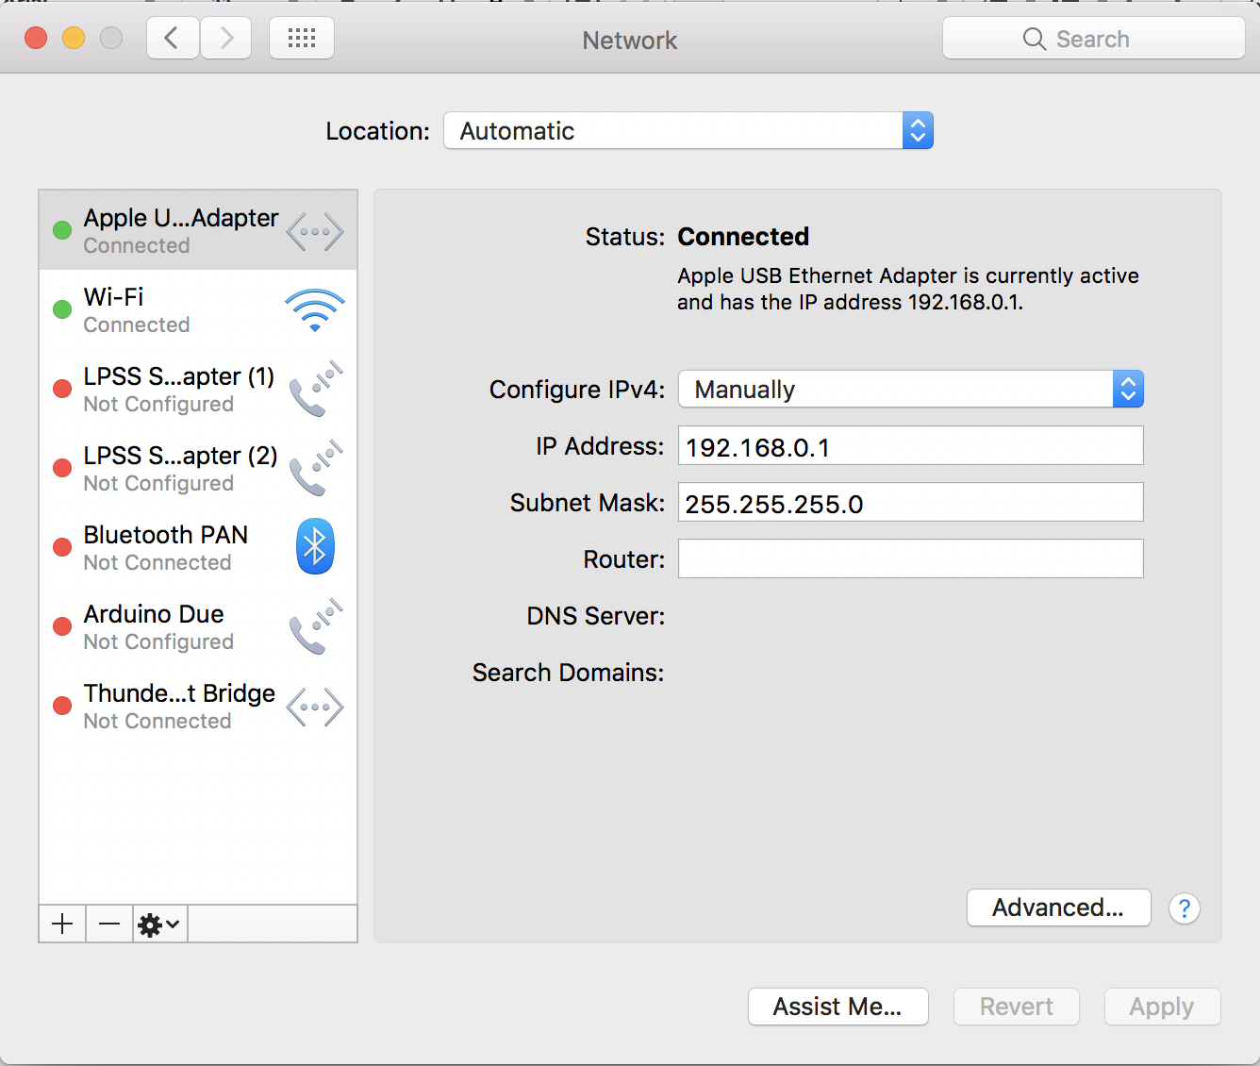

Figure 2. Ethernet settings

* + 1. Through WiFi

Connect to CMU-Secure. Find anchor IP address at: <https://console.firebase.google.com/project/footstep-wsn-cmusv/database>

If ssh through WiFi, replace the IP address with the one’s in the firebase

1. Data Pre-Processing
   1. Data Organization

Copy all the txt files from each node into the corresponding folder.

The folder is organized as

Anchor: **/Dataset/Anchor*N*/copyFromPi/Footstep/**

Base: **/Dataset/Base/copyFromMac/**

* 1. Signal Alignment

Run **dataExtraction.m** under corresponding folder. Define number of Tag and Anchor in the file.