Q1 && Q 2
- 1- How many Namespaces exist on the system?
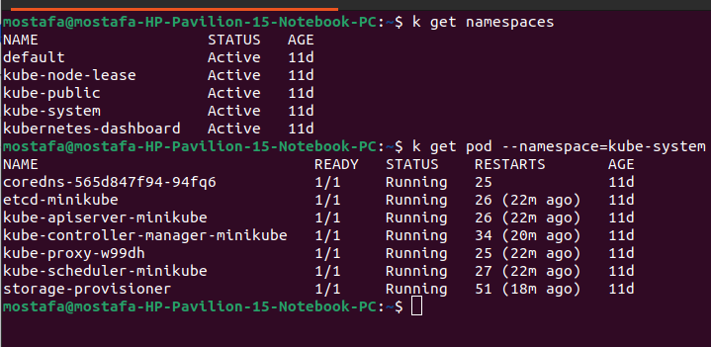
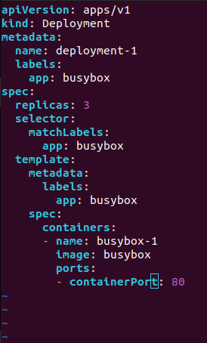
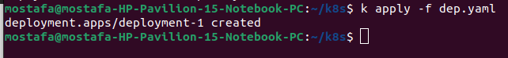
- 2-How many pods exist in the kube-system namespace?
Q 3

Q 4 :

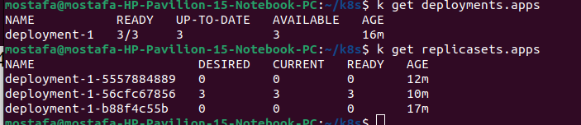

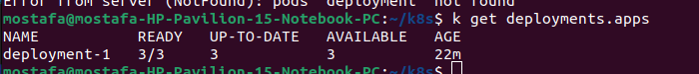
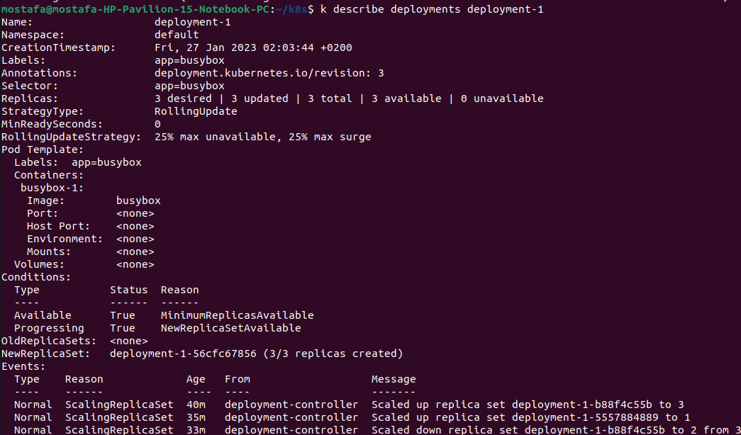
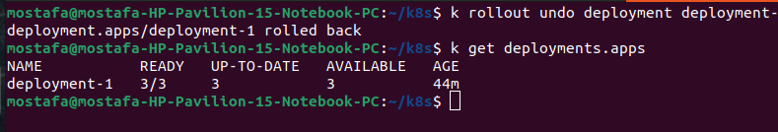
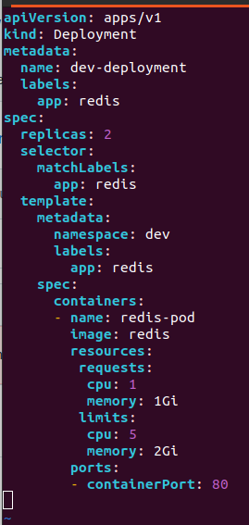
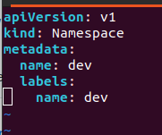
Q 5 : 5- How many pods are ready with the deployment-1?
Q 6 :
q: 7
Q 8 && Q 9 :
10 :

