



Software Requirements
Draft
Student Name: Mostafa Ammar Abdelazim
Student ID: 900203676
Section: 3
Course: MOIS 4999 - Graduation Project
Delivered to: Dr. Dina Rateb | Dr. Aida Zakaria | Dr. Kamal Boutros
Date: Fall 2026

Table of Contents
1. Solution Objective 3
2. Solution Overview 4
3. Abbreviations and Definitions 6
4. User Profiles 8
5. Solution Scope 12
5.1 In Scope 12
5.2 Out of Scope 14
5.3 Release Phasing 15
5.4 Assumptions 15
5.5 Dependencies 16
5.6 Constraints 16
6. Functional Requirements 16
6.1 Authentication and Access Control 17
6.2 Inventory and Batch Control 18
6.3 Warehouse Audit 20
6.4 Expiry Monitoring and Surplus Release 21
6.5 Disposal and Write-Off 23
6.6 Demand Forecasting and Purchase Planning 24
6.7 Business Rules and System Administration 26
6.8 Sales and Inventory Analytics 28
6.9 Buyer Registration and Verification 30
6.10 Catalogue and Ordering 32
6.11 Payment and Fulfilment 33
6.12 Odoo Integration (Full Release) 34
7. Non-Functional Requirements 34
7.1 Functionality 35
7.2 Usability 35
7.3 Reliability 36
7.4 Performance 36
7.5 Supportability 37
7.6 Security 37
8. Use Case Diagram 38
9. Use Cases 40
9.1 Use Case Summary 40
9.2 Textual Use Case Specifications 44
10. Activity Diagrams 80
10.1 Demand Forecasting and Purchase Planning 81
10.2 Warehouse Audit 81
10.3 Near-Expiry Products 82
10.4 E-Commerce Purchase 83
11. Data Models 84
11.1 Data Flow Diagram 84
11.2 Entity Relationship Diagram 85
12. Conclusion 90

1. Solution Objective
The proposed solution gives Kubbar International a way to act on its inventory before the loss becomes irreversible. The Root Cause Analysis established that the company imports against supplier minimum order quantities and long lead times, sells through a single field channel into a finite customer base, and recognizes surplus only at expiry. The company therefore pays three times for the same inventory error: once in lost profit, once in holding cost, and once in regulated disposal. The proposed solution intercepts stock between unsold and expired.
It does so through two web applications that share one database. The Inventory Management System (IMS) is the internal application. It holds every batch with its lot number, expiry date, location, and market registration, audits that record against the physical warehouse, forecasts demand from sales history before the company commits to a purchase, and raises an alert once a batch enters its six-month action window. The B2B E-Commerce Platform is the external application. It offers released near-expiry batches at 65% to 70% of their original price to verified trade buyers that the field sales team does not currently reach.
The proposed solution is designed to achieve the following outcomes:
- One batch-level record of stock, showing how old each quantity is rather than only how much is held.
- A demand forecast and purchase plan built inside the system from actual sales by product, region, and customer, replacing the spreadsheet that currently sits outside Odoo.
- Warehouse audits that reconcile the system record with the physical count, so that alerts and listings rest on accurate data.
- An automatic near-expiry alert six months before expiry, with a named owner and a defined route: existing customers first, the clearance channel second, disposal last.
- Executive control over which batches are released and at what price, so that recovered value does not displace full-price sales.
- A second route to market for surplus stock, open to distributors, veterinary clinics, pharmacies, farms, feed mills, and other suppliers, each verified before purchase.
- Management analytics that link inventory to sales and report value at risk, recovered value, and forecast accuracy in EGP.
Surplus stock does not need better visibility of the same buyers. It needs different buyers, and it needs to reach them while it still has value. Every requirement in this document traces back to that objective.

2. Solution Overview
The proposed solution is two cloud-hosted web applications built on one shared database. The DFD As-Is showed that Kubbar's transactional record is complete but that nothing reads the expiry data in a way that could act on it, and that no entity exists to receive surplus stock. The IMS introduces the first missing element: the process that reads expiry data. The E-Commerce Platform introduces the second: the buyer. Because both applications read and write the same records, a batch offered online is the same batch the warehouse holds, so stock that has already been sold or has already expired cannot be offered.
The IMS is internal and is accessed only by Kubbar staff. The E-Commerce Platform is public-facing, but only verified trade buyers can see prices or place orders. The pilot runs in Egypt, so all prices are in EGP and only products registered for sale in Egypt can be listed. The data model holds a market for every buyer and every registration, so the same rules extend to Kubbar's other eight markets without redesign.
In the full release, both applications connect to Kubbar's Odoo ERP through its API. The IMS reads products, customers, sales orders, and stock movements from Odoo and writes platform sales back to it, so that Odoo remains the system of record for accounting. The prototype does not connect to Odoo. It runs on sales, stock, and product data imported from Odoo exports in Excel or CSV format, the same data used to build the data warehouse.
The IMS is organized into seven modules:
Module 1: Inventory and Batch Control. The QA Officer records the lot number, manufacture date, expiry date, and approved quantity of every inspected batch. The Inventory Controller books approved batches into a warehouse location. The Warehouse Officer transfers stock between locations and dispatches orders, with the system allocating the earliest-expiring batch first.
Module 2: Warehouse Audit. The Inventory Controller schedules full or cycle counts. The Warehouse Officer records the physical count on a blind count sheet. The system calculates the variance. The Inventory Controller reconciles it, and the General Manager approves any adjustment above the configured value threshold.
Module 3: Expiry Monitoring and Surplus Release. The system scans every batch daily and raises an alert once a batch is six months or less from expiry. The Sales Representative first checks whether existing customers can absorb it. Batches they cannot absorb are flagged as surplus. Management (the COO) approves release and sets a clearance price within 65% to 70% of the original price. The system confirms market registration and publishes the listing to the E-Commerce Platform.
Module 4: Disposal and Write-Off. Batches that expire unsold, or that fail inspection, are submitted for write-off by the Inventory Controller and approved by the General Manager and the QA Officer. The system records the write-off value and disposal cost, so that the loss feeds back to procurement instead of ending as a finance entry.
Module 5: Demand Forecasting and Purchase Planning. The Procurement Officer imports sales and stock data and generates a monthly demand forecast by product and region. The system converts the forecast into a recommended order quantity, rounds it up to the supplier minimum order quantity, and shows the surplus that rounding creates before the order is placed. The General Manager approves the purchase plan.
Module 6: Sales and Inventory Analytics. The system links inventory to sales by product, region, and customer, and reports value at risk, stock ageing, sell-through, days of cover, forecast accuracy, and recovered value. Every report can be exported.
Module 7: System Administration. The System Administrator manages user accounts and roles for both applications, configures business rules such as the near-expiry window and the clearance price band, maintains reference data, and reviews the audit trail.
The E-Commerce Platform is organized into three modules:
Module 8: Buyer Registration and Verification. A trade buyer registers a company account and uploads the owner's national ID, commercial register, tax card, and the licence that authorizes the company to trade veterinary products. The Regulatory Affairs Officer verifies the documents and sets which product categories the buyer may purchase.
Module 9: Catalogue and Ordering. A verified buyer browses released listings that show batch number, expiry date, remaining shelf life, storage condition, quantity, and clearance price, then places an order. The system reserves the listed quantity at checkout so that no batch can be sold twice.
Module 10: Payment and Fulfilment. The buyer pays by bank transfer or on invoice. The Finance Officer confirms the payment or the invoice terms, the Warehouse Officer dispatches the order, and the buyer tracks it to delivery.
At the data level, the shared database holds batch records (lot number, manufacture and expiry dates, quantity, location, release status), product registrations by market, sales history by product, region, and customer, forecasts and purchase plans, audit counts and adjustments, listings, buyers and their verification documents, platform orders and payments, write-offs and disposals, and a complete audit trail of who did what and when.

3. Abbreviations and Definitions
As shown in Exhibit #1, the document uses a small set of abbreviations and three operational terms that carry a precise meaning in this specification. The three terms (near-expiry, surplus, and clearance price) are defined here because each one triggers a different system behavior.
Term | Definition
API | Application Programming Interface, used in the full release to connect both applications to Odoo
B2B | Business-to-Business
Batch | A quantity of one product sharing one lot number, manufacture date, and expiry date
Clearance Price | The price at which a released batch is listed on the E-Commerce Platform, set between 65% and 70% of the product's original sale price
COO | Chief Operating Officer, who approves batch release and clearance price on behalf of Management
DFD | Data Flow Diagram
EDA | Egyptian Drug Authority, which registers veterinary vaccines and medicaments in Egypt
EGP | Egyptian Pound, the currency of the pilot
ERD | Entity Relationship Diagram
ERP | Enterprise Resource Planning (Odoo, in Kubbar's case)
FEFO | First-Expired-First-Out, the rule that allocates the batch with the earliest expiry date first
FR | Functional Requirement
GOVS | General Organization for Veterinary Services, which registers feed additives and nutritional products in Egypt with the Ministry of Agriculture
IMS | Inventory Management System, the internal application of the proposed solution
KPI | Key Performance Indicator
MAPE | Mean Absolute Percentage Error, the measure of forecast accuracy
MOQ | Minimum Order Quantity set by the supplier
Near-Expiry | A batch with six months (180 days) or less of remaining shelf life
NFR | Non-Functional Requirement
PDPL | Egyptian Personal Data Protection Law No. 151 of 2020
QA | Quality Assurance
RBAC | Role-Based Access Control
SDLC | Systems Development Life Cycle
SRS | Software Requirements Specification
Surplus | A near-expiry batch that the Sales Representative confirms existing customers cannot absorb before expiry
UAT | User Acceptance Testing
UC | Use Case
Value at Risk | The cost value, in EGP, of near-expiry stock not yet sold or released
Exhibit #1: Abbreviations and Definitions

4. User Profiles
The proposed solution serves the same roles that perform Kubbar's processes in the DFD As-Is, plus two roles that the current operation does not have. Nine internal roles come directly from the DFD. Each keeps the responsibility it holds today, so the system formalizes existing work rather than redistributing it. The System Administrator is added because two applications with role-based access need an owner. The E-Commerce Buyer is added because, as the DFD showed, no entity in the current operation can receive surplus stock.
Two DFD external entities are not system users. Overseas Partners and Government Authorities exchange documents with Kubbar outside the system, and their outputs (lot and expiry data, import permits, product registrations) enter the IMS through the QA Officer and the Regulatory Affairs Officer. Existing Customers continue to buy through the field sales team, because the platform is directed at buyers the field team does not reach rather than at accounts it already holds.
User Role | Application | Responsibilities | Key Competencies
Sales Representative | IMS | Reviews near-expiry batches for their products and regions. Offers them to existing customers first. Flags batches the customer base cannot absorb as surplus. Reviews sales analytics by product, region, and customer. | Customer knowledge, product knowledge, sales analysis
Warehouse Officer | IMS | Transfers stock between locations. Picks and dispatches platform orders against FEFO allocation. Records physical counts during warehouse audits. | Stock handling, cold-chain handling, counting accuracy
Inventory Controller | IMS | Books inspected batches into stock. Schedules warehouse audits and reconciles count variances. Reviews near-expiry stock. Requests write-off of expired or rejected batches. | Inventory control, reconciliation, data accuracy
QA Officer | IMS | Records lot number, manufacture date, expiry date, and inspection outcome for every received batch. Co-approves write-off and disposal of expired and rejected stock. | Quality inspection, batch traceability, regulated disposal
Procurement Officer | IMS | Imports sales and stock data. Generates the demand forecast. Builds the purchase plan against supplier MOQs and submits it for approval. Reviews forecast accuracy. | Demand planning, supplier terms, data analysis
Regulatory Affairs Officer | IMS | Maintains product registration status and expiry by market. Verifies buyer documents and sets the product categories each buyer may purchase. | EDA and GOVS registration, licence verification
Finance Officer | IMS | Confirms bank transfer payments. Approves invoice payment terms and credit limits for buyers. Issues platform invoices. Exports financial reports. | Receivables, credit control, invoicing
General Manager | IMS | Approves the purchase plan. Approves stock adjustments above threshold. Co-approves write-off and disposal. Reviews analytics for the Egyptian operation. | Operational oversight, approval authority
Management (CEO, Group CFO, COO) | IMS | The COO approves batch release, sets the clearance price within the 65% to 70% band, and withdraws or reprices listings. Management reviews KPIs, recovered value, and the audit trail. | Commercial authority, pricing control, performance review
System Administrator | IMS and Platform | Creates, edits, and deactivates internal user accounts and roles. Configures business rules. Maintains reference data. Reviews the audit trail. | Access control, configuration, system support
E-Commerce Buyer | Platform | Registers a company account and uploads verification documents. Browses clearance listings, places orders, submits payment, and tracks delivery. | Trade purchasing, licensed to trade veterinary products
Exhibit #2: User Profiles
As shown in Exhibit #2, approval authority stays where the DFD and the Top Management Feasibility assessment place it. The General Manager approves the purchase plan and disposal, as in processes 6.0 and 15.0 of the DFD. The COO controls which batches are released and at what price, as the proposal assigns. The sales team enters the clearance channel through the batch-flagging role, as the Operational Feasibility assessment requires, so the channel is entered through the team rather than around it.

5. Solution Scope
The scope covers the full life of a batch, from the forecast that decides whether to buy it to the sale or disposal that ends it. It is deliberately limited to that life. The proposed solution does not replace Odoo, does not handle accounting, and does not change how the field sales team serves existing accounts. Its job is the part of the cycle that no current system performs.

5.1 In Scope
In-scope functions are grouped by module and traced to the roles in Section 4.
Inventory and Batch Control (Module 1)
- Batch inspection records with lot number, manufacture date, expiry date, storage condition, approved quantity, and rejected quantity (QA Officer).
- Stock receipt of approved batches into a warehouse and bin location (Inventory Controller).
- Stock transfer between locations and dispatch of platform orders with FEFO allocation (Warehouse Officer).
- Search of stock and batch records by product, category, lot, warehouse, expiry range, and release status (all internal roles).
Warehouse Audit (Module 2)
- Scheduling of full counts and cycle counts by warehouse, category, or batch (Inventory Controller).
- Blind physical count entry, with the system quantity hidden from the counter (Warehouse Officer).
- Variance calculation, reconciliation with a reason code, and adjustment posting, with General Manager approval above the configured threshold.
Expiry Monitoring and Surplus Release (Module 3)
- A daily expiry scan with alerts at six months, and at the minimum sellable shelf life (default 30 days).
- Review of near-expiry stock, an offer to existing customers, and surplus flagging (Sales Representative).
- Batch release approval and clearance price setting within 65% to 70% of the original price (COO).
- Market registration checks before any listing is published, and registration maintenance (Regulatory Affairs Officer).
Disposal and Write-Off (Module 4)
- Write-off requests for expired, damaged, or rejected batches, with dual approval by the General Manager and the QA Officer.
- Recording of disposal method, disposal cost, write-off value, and the disposal certificate reference.
Demand Forecasting and Purchase Planning (Module 5)
- Import of sales history, stock, and product data from Odoo exports in the prototype.
- A monthly demand forecast by product and region using seasonal exponential smoothing, with a moving-average fallback for products with short history.
- Recommended order quantity net of stock on hand, open purchase orders, and stock that expires within the coverage period, rounded up to the supplier MOQ, with the resulting MOQ surplus shown in units and EGP.
- Purchase plan submission and General Manager approval.
Sales and Inventory Analytics (Module 6)
- KPI dashboards and reports covering value at risk, stock ageing, days to expiry, days of cover, sell-through by product, region, and customer, forecast accuracy, recovered value, write-off cost, audit accuracy, and buyer activity.
- Export of reports in PDF and Excel format.
System Administration (Module 7)
- User accounts and roles, business rule configuration, reference data maintenance, and the audit trail.
Buyer Registration and Verification (Module 8)
- Company registration with the owner's national ID, commercial register, tax card, and the licence that authorizes trading in veterinary products.
- Document verification and category eligibility set by the Regulatory Affairs Officer.
Catalogue and Ordering (Module 9)
- A catalogue of released listings filtered by the buyer's market and licensed categories.
- Cart, checkout, and stock reservation at the moment of checkout.
Payment and Fulfilment (Module 10)
- Payment by bank transfer (with upload of the transfer receipt) or on invoice for buyers approved for credit.
- Payment confirmation, invoice issue, dispatch, and order tracking.

5.2 Out of Scope
Explicit exclusions protect the 12-week schedule and keep the system from drifting into functions that Odoo already performs.
- ERP and Financial Functions. General ledger, accounts payable, payroll, and tax filing remain in Odoo. The proposed solution issues platform invoices and records payments, then hands them to Odoo in the full release.
- Field Sales and CRM. Quotations, customer visits, and orders from existing accounts remain in the Odoo CRM and Sales modules.
- Card and Online Payments. No payment gateway, card payment, or wallet is in scope. Payment is by bank transfer or on invoice only.
- Consumer Sales. The platform does not sell to individuals or end consumers.
- Logistics. Carrier booking, route planning, and fleet management are excluded. The Warehouse Officer records dispatch and delivery.
- Machine Learning. Forecasting uses established statistical methods. Machine learning models and automated purchase order creation are excluded.
- Markets Other Than Egypt. The data model supports nine markets, but only Egypt is activated in the pilot. Each further market requires its own legal review, as the Legal Feasibility assessment states.
- Non-Expiring Products. Capital equipment does not expire, so it is excluded from expiry monitoring and clearance listings. It remains visible in stock ageing reports.
- Hardware. Barcode scanners, RFID, and temperature sensors are excluded from the current phase.

5.3 Release Phasing
The proposed solution is delivered in two releases. The prototype proves the logic on real Kubbar data without touching live systems. The full release connects it to Odoo.
Capability | Prototype | Full Release
IMS Modules 1 to 7 | Yes | Yes
E-Commerce Platform Modules 8 to 10 | Yes | Yes
Data source | Excel and CSV import from Odoo exports | Scheduled API synchronization with Odoo
Sales written back to Odoo | No | Yes
Markets active | Egypt | Egypt, then the other eight markets in sequence
Notifications | In-app and email | In-app and email
Exhibit #3: Release Phasing

5.4 Assumptions
- Kubbar can export at least 24 months of sales history by product, region, customer, quantity, and price. The data warehouse draft already holds 2024 to 2026 sales for Egypt.
- Lot number and expiry date are available for every batch in stock at go-live, either from Odoo or from the QA inspection records.
- Each product has a recorded original sale price, which is the base for the clearance price band.
- Product registration status for Egypt can be confirmed by the Regulatory Affairs Officer before go-live.
- The COO, or a delegate the COO names, is available to approve releases within two working days of a surplus flag.
- Trade buyers in Egypt can provide the owner's national ID, commercial register, tax card, and trading licence in digital form.

5.5 Dependencies
- Requirements must be formally approved before design begins, consistent with the Waterfall sequence.
- The IMS must be built and populated before the E-Commerce Platform, because the platform has nothing accurate to display until batch, expiry, and registration data exist. The Technical Feasibility assessment identified this build order.
- The business rules in Section 6.7 (near-expiry window, price band, variance threshold, minimum sellable shelf life) must be signed off by Management before UAT.
- The DFD and ERD must be extended to include the platform entities listed in Section 11.
- The full release depends on API access to Kubbar's Odoo instance.

5.6 Constraints
- Only products registered in the buyer's market and within the minimum sellable shelf life may be listed or sold.
- Buyer personal data must be collected with consent and stored securely under the PDPL.
- The clearance price cannot fall outside 65% to 70% of the original price without a change to the business rule by the System Administrator, approved by Management.
- Cold-chain products can only be sold to buyers whose verification confirms cold storage.
- The system must be usable by staff without technical training beyond a short orientation.
- The project follows a 12-week Waterfall lifecycle from 8 September to 2 December 2026.

6. Functional Requirements
The functional requirements below are organized by module and trace to the forty-four use cases in Section 9. Each requirement states what the system shall do, not how it is built. The requirements that carry the most weight are the ones the Root Cause Analysis points to directly: batch-level expiry data (FR-07 to FR-12), the six-month alert and release route (FR-24 to FR-34), and the forecast that exposes MOQ surplus before purchase (FR-41 to FR-49).

6.1 Authentication and Access Control
ID | Requirement | Use Case
FR-01 | The system shall allow internal users to log in to the IMS with a registered email address and password. | UC-01
FR-02 | The system shall allow verified buyers to log in to the E-Commerce Platform with a registered email address and password, separately from internal accounts. | UC-32
FR-03 | The system shall restrict every screen, action, and record to the roles assigned to it, as defined in Exhibit #2. | All
FR-04 | The system shall lock an account after five consecutive failed login attempts and notify the System Administrator (IMS) or allow self-service unlock by email (Platform). | UC-01, UC-32
FR-05 | The system shall end a session on log out and clear all session data. | UC-02
FR-06 | The system shall display a role-specific dashboard with open alerts and pending approvals after login. | UC-03

6.2 Inventory and Batch Control
ID | Requirement | Use Case
FR-07 | The system shall allow the QA Officer to record, for each received batch, the product, lot number, manufacture date, expiry date, storage condition, quantity received, quantity approved, quantity rejected, and rejection reason. | UC-04
FR-08 | The system shall reject an inspection record whose expiry date is earlier than the manufacture date or earlier than the inspection date. | UC-04
FR-09 | The system shall calculate remaining shelf life at receipt and warn the QA Officer when it is below the configured minimum receiving shelf life (default 12 months). | UC-04
FR-10 | The system shall allow the Inventory Controller to book an approved batch into a warehouse and bin location, and shall update stock on hand only after booking. | UC-05
FR-11 | The system shall prevent cold-chain products from being booked into a location without cold storage. | UC-05, UC-07
FR-12 | The system shall hold stock at batch level, so that two batches of the same product are never merged into one total. | UC-05
FR-13 | The system shall allow the Warehouse Officer to transfer a batch quantity between locations, recording source, destination, quantity, user, and time. | UC-07
FR-14 | The system shall allocate stock to a dispatch by FEFO, selecting the batch with the earliest expiry date that is still within the minimum sellable shelf life. | UC-08, UC-09
FR-15 | The system shall deduct the dispatched quantity from the allocated batch on dispatch confirmation and prevent dispatch of more than the quantity on hand. | UC-08
FR-16 | The system shall allow internal users to search stock and batch records by product, category, lot number, warehouse, expiry date range, days to expiry, and release status. | UC-06
FR-17 | The system shall record every stock movement (receipt, transfer, dispatch, adjustment, write-off) with batch, quantity, type, user, and timestamp. | UC-05, UC-07, UC-08, UC-12, UC-22

6.3 Warehouse Audit
ID | Requirement | Use Case
FR-18 | The system shall allow the Inventory Controller to schedule a full count or a cycle count by warehouse, category, or batch, and assign it to a Warehouse Officer. | UC-10
FR-19 | The system shall freeze stock movements for the batches under count from the start of the count until it is submitted. | UC-10, UC-11
FR-20 | The system shall present a blind count sheet that shows product, lot, and location but hides the system quantity. | UC-11
FR-21 | The system shall calculate the variance per batch in units and in EGP at cost once the count is submitted, and flag variances above the configured tolerance. | UC-11, UC-12
FR-22 | The system shall require the Inventory Controller to assign a reason code (counting error, damage, loss, expiry not recorded, mis-location) to every flagged variance, with an optional recount. | UC-12
FR-23 | The system shall post adjustments below the approval threshold directly and route adjustments above it to the General Manager, updating stock only after approval. | UC-12, UC-13

6.4 Expiry Monitoring and Surplus Release
ID | Requirement | Use Case
FR-24 | The system shall scan every batch with stock on hand once a day and calculate days to expiry. | UC-14
FR-25 | The system shall mark a batch as Near-Expiry when it has 180 days or less to expiry and notify the Inventory Controller and the Sales Representative responsible for its product and region. | UC-14
FR-26 | The system shall escalate to the General Manager any Near-Expiry batch that has had no action (offered, flagged, or released) for 14 days. | UC-14
FR-27 | The system shall allow the Sales Representative to record that a Near-Expiry batch has been offered to an existing customer, with the customer, quantity, and outcome. | UC-15
FR-28 | The system shall show, for each Near-Expiry batch, the average monthly sales of that product over the last 12 months and the projected quantity left unsold at expiry. | UC-15
FR-29 | The system shall allow the Sales Representative to flag all or part of a Near-Expiry batch as Surplus with a reason, and route it to Management for release. | UC-16
FR-30 | The system shall allow the COO to approve or reject the release of a surplus batch, the released quantity, and a clearance price. | UC-17
FR-31 | The system shall propose a clearance price of 70% of the original sale price and reject any clearance price below 65% or above 70% of it. | UC-17, UC-40
FR-32 | The system shall check, before publishing a listing, that the product is registered and its registration valid in the listing market, and block the listing if not. | UC-18, UC-19
FR-33 | The system shall publish an approved release as a listing on the E-Commerce Platform showing product, category, lot number, expiry date, remaining shelf life, storage condition, available quantity, unit, and clearance price. | UC-18
FR-34 | The system shall withdraw a listing automatically when remaining shelf life reaches the minimum sellable shelf life (default 30 days) or when the registration lapses. | UC-14, UC-18
FR-35 | The system shall allow the Regulatory Affairs Officer to record and update, per product and market, the registering authority (EDA or GOVS), registration number, status, and registration expiry date. | UC-20

6.5 Disposal and Write-Off
ID | Requirement | Use Case
FR-36 | The system shall allow the Inventory Controller to request write-off of an expired, damaged, or rejected batch, with quantity and reason. | UC-21
FR-37 | The system shall prevent any further sale, allocation, or listing of a batch that has passed its expiry date. | UC-14, UC-21
FR-38 | The system shall require approval by both the General Manager and the QA Officer before a write-off is posted. | UC-22
FR-39 | The system shall record disposal method, disposal date, disposal cost in EGP, write-off value at cost, and disposal certificate reference. | UC-22
FR-40 | The system shall link every write-off to the purchase plan period that bought the batch, so that the loss is visible in forecast accuracy reporting. | UC-22, UC-27

6.6 Demand Forecasting and Purchase Planning
ID | Requirement | Use Case
FR-41 | The system shall allow the Procurement Officer to import sales history, stock on hand, open purchase orders, and product data from Excel or CSV files exported from Odoo. | UC-23
FR-42 | The system shall validate imported files, reject rows with missing product, date, or quantity, and standardize region names to the reference list (for example, "Cairo & Giza" and "Cairo&Giza" to one region). | UC-23
FR-43 | The system shall generate a monthly demand forecast by product and region for a planning horizon of up to 12 months, using seasonal exponential smoothing where 24 months of history exist and a 6-month moving average otherwise. | UC-24
FR-44 | The system shall display each forecast with its prior-period accuracy (MAPE) and the actual sales it is compared against. | UC-24
FR-45 | The system shall calculate a recommended order quantity as forecast demand over the supplier lead time and coverage period, plus safety stock, minus usable stock on hand, minus open purchase orders. | UC-25
FR-46 | The system shall exclude from usable stock any quantity projected to reach Near-Expiry before it can be sold at the forecast rate. | UC-25
FR-47 | The system shall round the recommended quantity up to the supplier MOQ and show the MOQ surplus in units, in EGP, and as the projected quantity left at expiry. | UC-25
FR-48 | The system shall allow the Procurement Officer to override a recommended quantity with a mandatory reason and submit the purchase plan for approval. | UC-25
FR-49 | The system shall allow the General Manager to approve, return, or reject a purchase plan line by line with comments, and lock approved plans. | UC-26

6.7 Business Rules and System Administration
The business rules below are configurable by the System Administrator, and any change requires Management approval. Their default values follow the decisions recorded in the proposal and in this specification.
Rule | Default Value
Near-expiry window | 180 days (6 months)
Clearance price band | 65% to 70% of original sale price
Minimum sellable shelf life | 30 days
Minimum receiving shelf life warning | 12 months
Unactioned near-expiry escalation | 14 days
Count variance tolerance | 2% of batch quantity
Adjustment approval threshold | 10,000 EGP at cost
Platform order reservation hold | 48 hours for bank transfer orders
Active market | Egypt
Exhibit #4: Business Rules and Default Values
ID | Requirement | Use Case
FR-50 | The system shall allow the System Administrator to create, edit, and deactivate internal user accounts and assign one or more roles. | UC-41
FR-51 | The system shall allow the System Administrator to suspend or reactivate buyer accounts. | UC-41
FR-52 | The system shall allow the System Administrator to configure the business rules in Exhibit #4 and record the approving manager for each change. | UC-42
FR-53 | The system shall allow the System Administrator to maintain reference data: warehouses and locations, product categories, regions, markets, suppliers, reason codes, and buyer types. | UC-43
FR-54 | The system shall keep a tamper-proof audit trail of logins, approvals, price changes, adjustments, write-offs, verification decisions, and configuration changes, searchable by user, action, record, and date. | UC-44

6.8 Sales and Inventory Analytics
ID | Requirement | Use Case
FR-55 | The system shall display value at risk in EGP, by category, product, and warehouse. | UC-27
FR-56 | The system shall display stock ageing by remaining shelf life in four bands (more than 12 months, 6 to 12 months, 30 days to 6 months, under 30 days) with quantity and EGP value. | UC-27
FR-57 | The system shall display sales by product, region, customer, and month, including sell-through rate and each region's share of a product's sales. | UC-27
FR-58 | The system shall display days of cover and inventory turnover per product. | UC-27
FR-59 | The system shall display forecast versus actual sales and MAPE by product and region. | UC-27
FR-60 | The system shall display recovered value: quantity and value released, sold through the platform, recovery rate against original value, and average days from listing to sale. | UC-27
FR-61 | The system shall display write-off value, disposal cost, and the number of batches expired per month. | UC-27
FR-62 | The system shall display audit accuracy (share of counted batches within tolerance) and adjustment value per audit. | UC-27
FR-63 | The system shall display platform activity: verified buyers, new buyers per month, orders, average order value, and sales by buyer type. | UC-27
FR-64 | The system shall allow authorized users to filter analytics by date range, category, product, region, and warehouse. | UC-27
FR-65 | The system shall allow authorized users to export any report or dashboard in PDF or Excel format, stamped with filters, user, and time. | UC-28

6.9 Buyer Registration and Verification
ID | Requirement | Use Case
FR-66 | The system shall allow a buyer to register a company account with company name, buyer type (distributor, veterinary clinic, pharmacy, farm, feed mill, supplier), market, address, contact person, email, and phone. | UC-29
FR-67 | The system shall require upload of the owner's national ID, commercial register, tax card, and license to trade veterinary products, and shall accept cold storage proof as an optional document. | UC-29, UC-30
FR-68 | The system shall accept PDF, JPG, and PNG files up to 10 MB each and store them encrypted. | UC-30
FR-69 | The system shall record the buyer's consent to data processing and terms of service at registration. | UC-29
FR-70 | The system shall flag any registration whose commercial register number matches an existing Kubbar customer and route it to that customer's Sales Representative. | UC-29, UC-31
FR-71 | The system shall allow the Regulatory Affairs Officer to approve, reject, or request resubmission of each document, and approve the account only when all mandatory documents are approved. | UC-31
FR-72 | The system shall allow the Regulatory Affairs Officer to set the product categories a buyer may purchase, and whether the buyer may purchase cold-chain products. | UC-31
FR-73 | The system shall notify the buyer by email of each verification decision and the reason for any rejection. | UC-31
FR-74 | The system shall alert the Regulatory Affairs Officer 30 days before any buyer licence expires, and suspend ordering when it does. | UC-31

6.10 Catalogue and Ordering
ID | Requirement | Use Case
FR-75 | The system shall show prices and allow ordering only to verified buyers, and shall show each buyer only listings in their market and licensed categories. | UC-33
FR-76 | The system shall allow buyers to search and filter listings by category, product, expiry date, remaining shelf life, and price. | UC-33
FR-77 | The system shall allow a buyer to add listings to a cart, with quantities limited to the available listed quantity. | UC-34
FR-78 | The system shall reserve the ordered quantity against the listed batch at checkout and release it if the order is cancelled or unpaid within the reservation hold. | UC-34, UC-35
FR-79 | The system shall require the buyer to confirm cold-chain receiving capability before ordering cold-chain products. | UC-34
FR-80 | The system shall allow the COO to withdraw a listing or change its price within the price band, without affecting confirmed orders. | UC-40

6.11 Payment and Fulfilment
ID | Requirement | Use Case
FR-81 | The system shall offer bank transfer to all verified buyers and payment on invoice only to buyers the Finance Officer has approved for credit. | UC-36, UC-39
FR-82 | The system shall display Kubbar's bank details and order reference for bank transfer and allow the buyer to upload the transfer receipt. | UC-36
FR-83 | The system shall allow the Finance Officer to confirm or reject a bank transfer and to set a buyer's payment terms (15, 30, or 45 days) and credit limit in EGP. | UC-38, UC-39
FR-84 | The system shall block an on-invoice order that would take the buyer above their credit limit or that is placed while the buyer has an overdue invoice. | UC-36, UC-39
FR-85 | The system shall release a confirmed order to the warehouse for dispatch and generate an invoice in EGP. | UC-38
FR-86 | The system shall update order status (Placed, Awaiting Payment, Confirmed, Dispatched, Delivered, Cancelled) and notify the buyer at each change. | UC-37

6.12 Odoo Integration (Full Release)
The requirements below apply to the full release only. The prototype meets the same data needs through FR-41.
ID | Requirement | Use Case
FR-87 | The system shall read products, customers, sales orders, purchase orders, and stock movements from Odoo through its API at least once a day. | UC-23
FR-88 | The system shall write confirmed platform sales and invoices back to Odoo so that Odoo remains the accounting record. | UC-38
FR-89 | The system shall log every synchronization with record counts and errors, and alert the System Administrator when a run fails. | UC-44

7. Non-Functional Requirements
The non-functional requirements are set for Kubbar's scale and risk profile, and each one carries a measurable target. They are organized under the FURPS framework, with Security as an additional category. The Risk Assessment found that the highest risks cluster around data integrity rather than technology, so the reliability and security requirements carry the most weight here.

7.1 Functionality
ID | Requirement
NFR-01 | Both applications shall read and write one shared database, so that stock on hand, reservations, and listings never disagree.
NFR-02 | The IMS and the E-Commerce Platform shall be separate web applications with separate login, so that a buyer account can never reach an internal screen.
NFR-03 | All monetary values in the pilot shall be stored and displayed in EGP with two decimal places.

7.2 Usability
ID | Requirement
NFR-04 | The E-Commerce Platform shall be available in Arabic and English, with right-to-left layout for Arabic. The IMS shall be available in English, with Arabic customer and region names displayed as recorded.
NFR-05 | Fields drawn from fixed lists (warehouse, category, region, reason code, buyer type, status) shall be dropdowns, not free text.
NFR-06 | Every alert shall link directly to the batch or record that raised it.
NFR-07 | A new internal user shall be able to complete their core tasks after a 2-hour orientation. A new buyer shall be able to register without assistance in under 15 minutes.
NFR-08 | The E-Commerce Platform shall be fully usable on a mobile phone screen of 360 pixels width.

7.3 Reliability
ID | Requirement
NFR-09 | The system shall reject any transaction that would produce a negative batch quantity, and no batch shall ever be reserved, sold, or dispatched twice.
NFR-10 | Reservation at checkout shall be atomic: when two buyers order the last units of a listing at the same time, exactly one order succeeds.
NFR-11 | The daily expiry scan shall complete before 07:00 Cairo time, and a failed scan shall be retried and reported to the System Administrator.
NFR-12 | No transaction record shall be deleted. Corrections shall be made by reversing entries that keep the original.
NFR-13 | Imported data shall pass validation before it is written, and a failed import shall leave existing data unchanged.

7.4 Performance
ID | Requirement
NFR-14 | Screens shall load within 3 seconds, and saves shall complete within 2 seconds, with up to 25 concurrent internal users and 200 concurrent buyer sessions.
NFR-15 | Analytics dashboards shall load within 5 seconds for 36 months of sales history.
NFR-16 | A demand forecast for all active products and regions shall complete within 5 minutes.
NFR-17 | A released listing shall appear in the catalogue within 1 minute of approval.

7.5 Supportability
ID | Requirement
NFR-18 | The IMS shall be available 99% of the time during Kubbar Egypt working hours (Sunday to Thursday, 08:00 to 18:00 Cairo time). The E-Commerce Platform shall be available 99.5% of the time, 24 hours a day.
NFR-19 | The database shall be backed up daily and kept for 30 days, with recovery within 4 hours and no more than 24 hours of data lost.
NFR-20 | Business rules, reference data, and user roles shall be changed through administration screens, without code changes.
NFR-21 | The data model shall support activating a new market by adding reference data, registrations, and buyers, without changes to the schema.

7.6 Security
ID | Requirement
NFR-22 | All traffic shall use HTTPS (TLS 1.2 or higher). Passwords shall be stored hashed and salted.
NFR-23 | Passwords shall be at least 10 characters, mixing letters and numbers. Internal users shall use two-factor authentication.
NFR-24 | Internal sessions shall time out after 15 minutes of inactivity, and buyer sessions after 30 minutes.
NFR-25 | Buyer identity and company documents shall be encrypted at rest, visible only to the Regulatory Affairs Officer and the System Administrator, and every view shall be logged.
NFR-26 | Buyer data processing shall comply with the PDPL: consent recorded at registration, a stated purpose, and deletion of documents for rejected applications after 90 days.
NFR-27 | Approvals, price changes, verification decisions, adjustments, and write-offs shall be logged with user, time, old value, and new value, and the log shall not be editable by any role.

8. Use Case Diagram
Exhibit #5 presents the use case diagram for the proposed solution. It shows forty-three of the forty-four use cases across two system boundaries. The IMS boundary holds eight zones, arranged as horizontal bands: Shared Access, Demand Forecasting and Purchase Planning, Sales and Inventory Analytics, Expiry Monitoring and Surplus Release, Inventory and Batch Control, Warehouse Audit, Disposal and Write-Off, and System Administration. The E-Commerce Platform boundary holds three: Buyer Registration and Verification, Catalogue and Ordering, and Payment and Fulfilment. The eleven roles from Exhibit #2 sit outside the boundaries. Two further actors complete the diagram. The System Scheduler runs the daily expiry scan, and Internal User stands for any of the ten internal roles, which keeps UC-01, UC-03, and UC-06 from carrying ten association lines each.
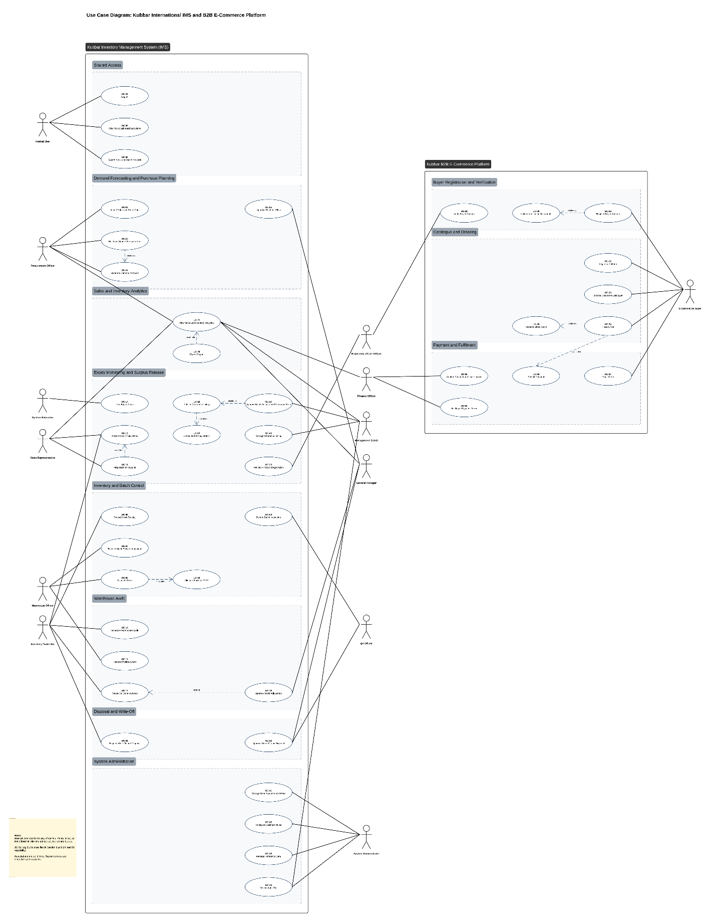
Exhibit #5: Use Case Diagram - IMS and B2B E-Commerce Platform
The diagram uses two relationship types only: «include» and «extend». UC-01 (Log In), UC-03, and UC-06 are associated with Internal User, and UC-32 (Log In to Platform) with the E-Commerce Buyer. UC-08 (Dispatch Order) includes UC-09 (Allocate Stock by FEFO). UC-13 (Approve Stock Adjustment) extends UC-12 (Reconcile Count Variance) when a variance exceeds the approval threshold. UC-16 (Flag Batch as Surplus) extends UC-15 (Review Near-Expiry Stock) when existing customers cannot absorb a batch. UC-17 (Approve Batch Release and Clearance Price) includes UC-18 (Publish Clearance Listing), which in turn includes UC-19 (Check Market Registration). UC-25 (Build and Submit Purchase Plan) includes UC-24 (Generate Demand Forecast). UC-28 (Export Report) extends UC-27 (View Sales and Inventory Analytics). UC-29 (Register Buyer Account) includes UC-30 (Upload Verification Documents). UC-34 (Place Order) includes UC-35 (Reserve Listed Stock) and UC-36 (Submit Payment). UC-02 (Log Out) is specified in Section 9 but omitted from the diagram to keep it readable.
As shown in Exhibit #5, the path from surplus to recovery now exists as a chain of connected use cases. In the DFD As-Is, the only outward flow for unsold stock ended in disposal. In the diagram, a batch flagged by the Sales Representative (UC-16) is released by the COO (UC-17), published to the platform (UC-18), and ordered by a verified buyer (UC-34). Disposal (UC-21 and UC-22) is still present, but it becomes the last route rather than the only one.

9. Use Cases
The forty-four use cases below define how every user interacts with the proposed solution. Every role in Exhibit #2 owns at least one use case, and every functional requirement in Section 6 traces to at least one use case. Each specification follows the same structure, with no more than two pre-conditions, and main flows that name the screens, fields, and dropdowns the user works with.

9.1 Use Case Summary
ID | Use Case | Primary Actor | Application
UC-01 | Log In | All internal users | IMS
UC-02 | Log Out | All users | IMS and Platform
UC-03 | View Role Dashboard and Alerts | All internal users | IMS
UC-04 | Record Batch Inspection | QA Officer | IMS
UC-05 | Record Stock Receipt | Inventory Controller | IMS
UC-06 | Search Stock and Batch Records | All internal users | IMS
UC-07 | Transfer Stock Between Locations | Warehouse Officer | IMS
UC-08 | Dispatch Order | Warehouse Officer | IMS
UC-09 | Allocate Stock by FEFO | System | IMS
UC-10 | Schedule Warehouse Audit | Inventory Controller | IMS
UC-11 | Record Physical Count | Warehouse Officer | IMS
UC-12 | Reconcile Count Variance | Inventory Controller | IMS
UC-13 | Approve Stock Adjustment | General Manager | IMS
UC-14 | Run Expiry Scan | System Scheduler | IMS
UC-15 | Review Near-Expiry Stock | Sales Representative, Inventory Controller | IMS
UC-16 | Flag Batch as Surplus | Sales Representative | IMS
UC-17 | Approve Batch Release and Clearance Price | Management (COO) | IMS
UC-18 | Publish Clearance Listing | System | IMS and Platform
UC-19 | Check Market Registration | System | IMS
UC-20 | Maintain Product Registration | Regulatory Affairs Officer | IMS
UC-21 | Request Write-Off and Disposal | Inventory Controller | IMS
UC-22 | Approve Write-Off and Disposal | General Manager, QA Officer | IMS
UC-23 | Import Sales and Stock Data | Procurement Officer | IMS
UC-24 | Generate Demand Forecast | Procurement Officer | IMS
UC-25 | Build and Submit Purchase Plan | Procurement Officer | IMS
UC-26 | Approve Purchase Plan | General Manager | IMS
UC-27 | View Sales and Inventory Analytics | Sales Representative, Procurement Officer, Finance Officer, General Manager, Management | IMS
UC-28 | Export Report | Same as UC-27 | IMS
UC-29 | Register Buyer Account | E-Commerce Buyer | Platform
UC-30 | Upload Verification Documents | E-Commerce Buyer | Platform
UC-31 | Verify Buyer Account | Regulatory Affairs Officer | IMS
UC-32 | Log In to Platform | E-Commerce Buyer | Platform
UC-33 | Browse Clearance Catalogue | E-Commerce Buyer | Platform
UC-34 | Place Order | E-Commerce Buyer | Platform
UC-35 | Reserve Listed Stock | System | Platform
UC-36 | Submit Payment | E-Commerce Buyer | Platform
UC-37 | Track Order | E-Commerce Buyer | Platform
UC-38 | Confirm Payment and Issue Invoice | Finance Officer | IMS
UC-39 | Set Buyer Payment Terms | Finance Officer | IMS
UC-40 | Manage Clearance Listing | Management (COO) | IMS
UC-41 | Manage User Accounts and Roles | System Administrator | IMS
UC-42 | Configure Business Rules | System Administrator | IMS
UC-43 | Manage Reference Data | System Administrator | IMS
UC-44 | Review Audit Trail | System Administrator, Management | IMS
Exhibit #6: Use Case Summary

9.2 Textual Use Case Specifications

UC-01 Log In
Field | Detail
Primary Actor | All internal users
Trigger | A user opens the IMS to perform their assigned work.
Pre-Conditions | The user holds an active IMS account.
Post-Conditions | The user is authenticated and their role dashboard (UC-03) loads.
Relationships | Associated with all internal actors.
Related FRs | FR-01, FR-03, FR-04
Main Flow
- The user opens the IMS login screen.
- The user enters their Email Address and Password and selects Log In.
- The system validates the credentials and sends a one-time code to the user's registered device.
- The user enters the code.
- The system confirms authentication and loads the role dashboard.
Alternative Flows
- A1. Invalid credentials: the system shows an error and counts the attempt. After five failed attempts the account is locked and the System Administrator is notified.
- A2. Account deactivated: the system denies access and shows a deactivated-account message.
- A3. Incorrect or expired code: the system rejects it and offers to resend.

UC-02 Log Out
Field | Detail
Primary Actor | All users
Trigger | An authenticated user ends their session.
Pre-Conditions | The user is logged in.
Post-Conditions | The session is closed and the login screen is shown.
Relationships | Omitted from the diagram for readability.
Related FRs | FR-05
Main Flow
- The user selects Log Out from the navigation bar.
- The system ends the session and clears session data.
- The system returns the user to the login screen.
Alternative Flows
- A1. Unsaved changes exist: the system asks the user to confirm before logging out.
- A2. Inactivity timeout: the system ends the session automatically (15 minutes internal, 30 minutes buyer).

UC-03 View Role Dashboard and Alerts
Field | Detail
Primary Actor | All internal users
Trigger | The user logs in or selects Dashboard.
Pre-Conditions | The user is logged in.
Post-Conditions | The user sees the alerts and pending tasks for their role.
Relationships | None.
Related FRs | FR-06
Main Flow
- The system loads the dashboard for the user's role.
- The system shows summary cards: near-expiry batches and value at risk, pending approvals, open audits, and open orders, filtered to what the role acts on.
- The system lists open alerts, newest first, each linked to its record.
- The user selects an alert or card and the system opens the record.
Alternative Flows
- A1. No open alerts: the system shows an empty state for each panel.

UC-04 Record Batch Inspection
Field | Detail
Primary Actor | QA Officer
Trigger | A received shipment has been verified by the warehouse and is ready for batch inspection.
Pre-Conditions | The QA Officer is logged in. The shipment's purchase order exists in the system.
Post-Conditions | Each batch is recorded with lot and expiry data, and approved quantities are ready for receipt (UC-05).
Relationships | None.
Related FRs | FR-07, FR-08, FR-09
Main Flow
- The QA Officer opens Batch Inspection and selects the Purchase Order from the dropdown.
- The system lists the products on the order.
- For each batch, the officer enters Lot Number, Manufacture Date, Expiry Date, Quantity Received, Quantity Approved, and Quantity Rejected, and selects Storage Condition (Ambient, Refrigerated 2-8°C, Frozen).
- For any rejected quantity, the officer selects a Rejection Reason (Damaged, Short-Dated, Temperature Breach, Documentation, Other).
- The officer selects Save Inspection.
- The system validates the dates and calculates remaining shelf life.
- The system saves the record and notifies the Inventory Controller that approved batches are ready for receipt.
Alternative Flows
- A1. Expiry date earlier than the manufacture or inspection date: the system rejects the entry and highlights the field.
- A2. Remaining shelf life below 12 months: the system warns the officer and requires confirmation, and the batch is marked for early monitoring.
- A3. Approved plus rejected quantity does not equal received quantity: the system blocks saving.

UC-05 Record Stock Receipt
Field | Detail
Primary Actor | Inventory Controller
Trigger | The QA Officer has approved one or more batches.
Pre-Conditions | The Inventory Controller is logged in. The batch has an approved inspection record.
Post-Conditions | The batch is on hand in a warehouse location and visible for allocation and monitoring.
Relationships | None.
Related FRs | FR-10, FR-11, FR-12, FR-17
Main Flow
- The Inventory Controller opens Stock Receipt and selects the inspected batch.
- The system shows the product, lot, expiry date, storage condition, and approved quantity.
- The controller selects Warehouse and Bin Location from the dropdowns.
- The controller selects Confirm Receipt.
- The system checks that the location's storage type matches the batch's storage condition.
- The system adds the batch to stock on hand, records the movement, and calculates days to expiry.
Alternative Flows
- A1. Cold-chain batch assigned to a non-refrigerated location: the system blocks the receipt and lists valid locations.
- A2. Location at capacity: the system warns the controller and asks for another location.

UC-06 Search Stock and Batch Records
Field | Detail
Primary Actor | All internal users
Trigger | A user needs to find stock or a batch.
Pre-Conditions | The user is logged in.
Post-Conditions | Matching batches are displayed with quantity, location, expiry, and status.
Relationships | None.
Related FRs | FR-16
Main Flow
- The user opens Stock Search.
- The user sets filters: Product, Category, Lot Number, Warehouse, Expiry Date range, Days to Expiry band, and Release Status (In Stock, Near-Expiry, Surplus, Released, Reserved, Expired).
- The user selects Search.
- The system lists matching batches with quantity on hand, quantity reserved, location, expiry date, and days to expiry.
- The user selects a batch to view its movement history.
Alternative Flows
- A1. No match: the system shows a no-results message.

UC-07 Transfer Stock Between Locations
Field | Detail
Primary Actor | Warehouse Officer
Trigger | Stock must move between bins or warehouses.
Pre-Conditions | The Warehouse Officer is logged in. The batch has unreserved stock on hand.
Post-Conditions | The batch quantity is recorded in its new location.
Relationships | None.
Related FRs | FR-11, FR-13, FR-17
Main Flow
- The officer opens Stock Transfer and selects the batch.
- The officer enters Quantity and selects Destination Warehouse and Bin.
- The system checks storage compatibility and available quantity.
- The officer selects Confirm Transfer.
- The system moves the quantity and records the movement.
Alternative Flows
- A1. Quantity exceeds unreserved stock: the system blocks the transfer and shows the available quantity.
- A2. Batch is frozen for an audit count: the system blocks the transfer until the count is submitted.

UC-08 Dispatch Order
Field | Detail
Primary Actor | Warehouse Officer
Trigger | A platform order has been confirmed by Finance (UC-38).
Pre-Conditions | The Warehouse Officer is logged in. The order status is Confirmed.
Post-Conditions | Stock is deducted, the order is Dispatched, and the buyer is notified.
Relationships | «include» UC-09 (Allocate Stock by FEFO) at step 2.
Related FRs | FR-14, FR-15, FR-17
Main Flow
- The officer opens the Dispatch Queue and selects the order.
- The system confirms the batch allocation (UC-09) and prints a pick list with lot and location.
- The officer picks the stock and confirms the lot numbers picked.
- For cold-chain items, the officer confirms the cold-chain packaging check.
- The officer enters Delivery Method and Delivery Date and selects Confirm Dispatch.
- The system deducts the quantity, sets the order to Dispatched, and notifies the buyer.
Alternative Flows
- A1. Picked lot does not match the allocated lot: the system blocks confirmation.
- A2. Stock found damaged at picking: the officer records the shortage, and the system holds the order and alerts the Inventory Controller.

UC-09 Allocate Stock by FEFO
Field | Detail
Primary Actor | System
Trigger | A dispatch is started (UC-08).
Pre-Conditions | The order has a product and quantity.
Post-Conditions | The order is linked to specific batches.
Relationships | Included by UC-08.
Related FRs | FR-14
Main Flow
- For a platform order, the system uses the batch named in the listing.
- For any other dispatch, the system lists the product's batches with unreserved stock, sorted by expiry date, earliest first.
- The system excludes batches below the minimum sellable shelf life or frozen for audit.
- The system allocates from the earliest batch, moving to the next until the quantity is covered.
Alternative Flows
- A1. Not enough eligible stock: the system allocates what is available and flags the shortfall.

UC-10 Schedule Warehouse Audit
Field | Detail
Primary Actor | Inventory Controller
Trigger | A periodic count is due, or the controller suspects a discrepancy.
Pre-Conditions | The Inventory Controller is logged in.
Post-Conditions | A count is scheduled, assigned, and its batches are frozen from the start date.
Relationships | None.
Related FRs | FR-18, FR-19
Main Flow
- The controller opens Warehouse Audit and selects New Count.
- The controller selects Count Type (Full Count, Cycle Count), Warehouse, and Scope (All, Category, or selected Batches).
- The controller selects the Count Date and assigns a Warehouse Officer from the dropdown.
- The controller selects Schedule.
- The system generates the count sheet and notifies the assigned officer.
- On the count date, the system freezes movements for the batches in scope.
Alternative Flows
- A1. Batches in scope have open dispatches: the system lists them and asks the controller to reschedule or exclude them.
- A2. Another count already covers the same batches: the system blocks the duplicate.

UC-11 Record Physical Count
Field | Detail
Primary Actor | Warehouse Officer
Trigger | A count assigned to the officer is due.
Pre-Conditions | The Warehouse Officer is logged in. A count is scheduled and assigned to them.
Post-Conditions | The count is submitted and variances are calculated.
Relationships | None.
Related FRs | FR-19, FR-20, FR-21
Main Flow
- The officer opens My Counts and selects the scheduled count.
- The system displays the blind count sheet: product, lot number, expiry date, and location, without the system quantity.
- The officer counts each batch and enters Counted Quantity.
- The officer records any batch found that is not on the sheet, with product, lot, expiry, and quantity.
- The officer selects Submit Count.
- The system calculates the variance per batch in units and EGP and flags those above tolerance.
- The system notifies the Inventory Controller.
Alternative Flows
- A1. A line is left blank: the system blocks submission until every line has a count or is marked Not Found.
- A2. Expiry date on the physical stock differs from the record: the officer records the observed date for reconciliation.

UC-12 Reconcile Count Variance
Field | Detail
Primary Actor | Inventory Controller
Trigger | A count has been submitted with one or more flagged variances.
Pre-Conditions | The Inventory Controller is logged in. The count is Submitted.
Post-Conditions | Each variance is explained, adjustments are posted or routed for approval, and the count is closed.
Relationships | «extend» UC-13 (Approve Stock Adjustment) when an adjustment exceeds the approval threshold.
Related FRs | FR-21, FR-22, FR-23, FR-17
Main Flow
- The controller opens the submitted count.
- The system lists each batch with system quantity, counted quantity, and variance in units and EGP.
- For each flagged variance, the controller selects a Reason Code (Counting Error, Damage, Loss, Expiry Not Recorded, Mis-location).
- The controller selects Post Adjustments.
- The system posts adjustments below 10,000 EGP, updates stock, and releases the movement freeze.
- The system closes the count and records its accuracy rate.
Alternative Flows
- A1. Controller requests a recount: the system reissues the lines to the Warehouse Officer as a blind recount.
- A2. Adjustment at or above 10,000 EGP: the system routes it to the General Manager (UC-13) and keeps the batch frozen until a decision.

UC-13 Approve Stock Adjustment
Field | Detail
Primary Actor | General Manager
Trigger | An adjustment above the approval threshold is awaiting approval.
Pre-Conditions | The General Manager is logged in.
Post-Conditions | The adjustment is posted or rejected, and the batch is released from freeze.
Relationships | Extends UC-12.
Related FRs | FR-23
Main Flow
- The General Manager opens Pending Approvals and selects the adjustment.
- The system shows the batch, system and counted quantities, value in EGP, reason code, and recount history.
- The General Manager selects Approve and enters a comment.
- The system posts the adjustment, updates stock, and notifies the Inventory Controller.
Alternative Flows
- A1. The General Manager selects Reject with a mandatory comment: the system returns the line to the controller for recount.

UC-14 Run Expiry Scan
Field | Detail
Primary Actor | System Scheduler
Trigger | The daily schedule runs at 06:00 Cairo time.
Pre-Conditions | Batch records exist with expiry dates.
Post-Conditions | Every batch has a current days-to-expiry value and status, and alerts are sent.
Relationships | None.
Related FRs | FR-24, FR-25, FR-26, FR-34, FR-37
Main Flow
- The scheduler starts the expiry scan.
- The system calculates days to expiry for every batch with stock on hand.
- Batches at 180 days or less that are In Stock are set to Near-Expiry, and the system notifies the Inventory Controller and the responsible Sales Representative.
- Released listings at or below 30 days of shelf life are withdrawn from the platform.
- Batches past their expiry date are set to Expired and blocked from sale, and the Inventory Controller is notified to request write-off.
- Near-Expiry batches with no action for 14 days are escalated to the General Manager.
- The system records the scan result and updates value at risk.
Alternative Flows
- A1. Scan fails: the system retries once after 30 minutes and alerts the System Administrator if the retry fails.
- A2. Batch is reserved for a confirmed order: the system leaves the reservation in place and alerts the Warehouse Officer to dispatch first.

UC-15 Review Near-Expiry Stock
Field | Detail
Primary Actor | Sales Representative, Inventory Controller
Trigger | A Near-Expiry alert is raised, or the user opens the near-expiry list.
Pre-Conditions | The user is logged in. At least one batch is Near-Expiry.
Post-Conditions | Each reviewed batch has a recorded action: offered to a customer, flagged as surplus, or kept under watch.
Relationships | «extend» UC-16 (Flag Batch as Surplus) when existing customers cannot absorb the batch.
Related FRs | FR-27, FR-28
Main Flow
- The user opens Near-Expiry Stock.
- The system lists Near-Expiry batches for the user's products and regions, with quantity, expiry date, days to expiry, cost value, average monthly sales over the last 12 months, and projected quantity unsold at expiry.
- The user selects a batch and reviews which customers and regions bought the product in the last 12 months.
- The Sales Representative offers the batch to an existing customer and records Customer, Quantity Offered, and Outcome (Accepted, Declined, Pending).
- The system records the action and reduces the projected unsold quantity by any accepted quantity.
Alternative Flows
- A1. Projected unsold quantity is zero: the user marks the batch Keep Under Watch.
- A2. Existing customers decline or cannot absorb the remaining quantity: the Sales Representative flags it as surplus (UC-16).

UC-16 Flag Batch as Surplus
Field | Detail
Primary Actor | Sales Representative
Trigger | Existing customers cannot absorb a Near-Expiry batch before expiry.
Pre-Conditions | The Sales Representative is logged in. The batch is Near-Expiry.
Post-Conditions | The quantity is Surplus and awaits release by Management.
Relationships | Extends UC-15.
Related FRs | FR-29
Main Flow
- From the batch review, the Sales Representative selects Flag as Surplus.
- The representative enters Surplus Quantity and selects a Reason (No Customer Demand, Customer Declined, Seasonal Demand Passed, Other) with a comment.
- The representative selects Submit.
- The system sets the quantity to Surplus, records the flag, and notifies the COO.
Alternative Flows
- A1. Surplus quantity exceeds unreserved stock: the system blocks submission.
- A2. Product is capital equipment: the system blocks the flag because non-expiring products are not listed.

UC-17 Approve Batch Release and Clearance Price
Field | Detail
Primary Actor | Management (COO)
Trigger | A surplus flag is awaiting release.
Pre-Conditions | The COO is logged in. The batch has a Surplus quantity.
Post-Conditions | The batch is Released with a clearance price and published, or the flag is rejected.
Relationships | «include» UC-18 (Publish Clearance Listing) at step 6.
Related FRs | FR-30, FR-31
Main Flow
- The COO opens Release Requests and selects the batch.
- The system shows the product, lot, expiry date, days to expiry, surplus quantity, original sale price, cost, the Sales Representative's reason, and customer offers already made.
- The system proposes a clearance price of 70% of the original sale price.
- The COO confirms or edits Release Quantity and Clearance Price.
- The COO selects Approve Release.
- The system validates the price against the band and publishes the listing (UC-18).
- The system notifies the Sales Representative.
Alternative Flows
- A1. Price below 65% or above 70% of the original: the system rejects it and shows the allowed range in EGP.
- A2. The COO selects Reject with a comment: the batch returns to Near-Expiry and the Sales Representative is notified.

UC-18 Publish Clearance Listing
Field | Detail
Primary Actor | System
Trigger | The COO approves a release (UC-17).
Pre-Conditions | The release is approved with a valid price.
Post-Conditions | The listing is visible to eligible buyers in the catalogue.
Relationships | Included by UC-17. «include» UC-19 (Check Market Registration) at step 1.
Related FRs | FR-32, FR-33, FR-34
Main Flow
- The system checks the product's registration for the listing market (UC-19).
- The system checks that remaining shelf life is above 30 days.
- The system creates the listing with product, category, lot number, expiry date, remaining shelf life, storage condition, available quantity, unit, and clearance price.
- The system sets the batch to Released and publishes the listing within 1 minute.
Alternative Flows
- A1. Registration missing or lapsed: the system blocks the listing and alerts the Regulatory Affairs Officer and the COO.
- A2. Shelf life at or below 30 days: the system blocks the listing and returns the batch for write-off review.

UC-19 Check Market Registration
Field | Detail
Primary Actor | System
Trigger | A listing is about to be published (UC-18).
Pre-Conditions | The product and market are known.
Post-Conditions | The listing is cleared or blocked.
Relationships | Included by UC-18.
Related FRs | FR-32
Main Flow
- The system retrieves the product's registration record for the market.
- The system checks that Status is Active and that the registration expiry date is later than the batch expiry date.
- The system returns Cleared.
Alternative Flows
- A1. No record, status not Active, or registration expiring first: the system returns Blocked with the reason.

UC-20 Maintain Product Registration
Field | Detail
Primary Actor | Regulatory Affairs Officer
Trigger | A product is registered, renewed, suspended, or newly imported.
Pre-Conditions | The Regulatory Affairs Officer is logged in. The product exists.
Post-Conditions | The product's registration for the market is current.
Relationships | None.
Related FRs | FR-35
Main Flow
- The officer opens Product Registrations and selects the product.
- The officer selects Market and Authority (EDA, GOVS) and enters Registration Number, Status (Active, Pending, Suspended, Expired), and Registration Expiry Date.
- The officer attaches the registration certificate and selects Save.
- The system saves the record and re-checks any open listings for that product.
Alternative Flows
- A1. Status set to Suspended or Expired: the system withdraws open listings for the product in that market and notifies the COO.
- A2. Registration expires within 60 days: the system alerts the officer.

UC-21 Request Write-Off and Disposal
Field | Detail
Primary Actor | Inventory Controller
Trigger | A batch has expired, is damaged, or was rejected at inspection.
Pre-Conditions | The Inventory Controller is logged in. The batch has stock on hand.
Post-Conditions | A write-off request awaits dual approval.
Relationships | None.
Related FRs | FR-36, FR-37
Main Flow
- The controller opens Write-Off and selects the batch.
- The system shows quantity on hand, cost value, expiry date, and the batch history, including any surplus flag and release.
- The controller enters Quantity and selects Reason (Expired, Damaged, Rejected at Inspection, Temperature Breach).
- The controller selects Proposed Disposal Method (Licensed Destruction, Return to Supplier, Incineration).
- The controller selects Submit.
- The system blocks the quantity from any sale and routes the request to the General Manager and the QA Officer.
Alternative Flows
- A1. Batch is Near-Expiry but not yet expired and not yet flagged: the system warns the controller that the release route has not been tried and asks for confirmation.

UC-22 Approve Write-Off and Disposal
Field | Detail
Primary Actor | General Manager, QA Officer
Trigger | A write-off request is awaiting approval.
Pre-Conditions | The approver is logged in. The request is Pending.
Post-Conditions | The write-off is posted and disposal is recorded, or the request is rejected.
Relationships | None.
Related FRs | FR-38, FR-39, FR-40, FR-17
Main Flow
- Each approver opens Pending Approvals and selects the request.
- The system shows the batch, quantity, value, reason, and disposal method.
- The QA Officer confirms the disposal method meets regulatory requirements and selects Approve.
- The General Manager selects Approve.
- Once both approvals exist, the system posts the write-off and removes the quantity from stock.
- After disposal, the QA Officer enters Disposal Date, Disposal Cost in EGP, and Certificate Reference.
- The system records the loss against the purchase plan period that bought the batch.
Alternative Flows
- A1. Either approver selects Reject with a comment: the request returns to the Inventory Controller and the quantity remains blocked.

UC-23 Import Sales and Stock Data
Field | Detail
Primary Actor | Procurement Officer
Trigger | A forecasting cycle begins, or new sales data is available.
Pre-Conditions | The Procurement Officer is logged in. An Odoo export file is available (prototype).
Post-Conditions | Sales history, stock, open purchase orders, and products are current in the IMS.
Relationships | None.
Related FRs | FR-41, FR-42, FR-87
Main Flow
- The officer opens Data Import and selects Data Type (Sales History, Stock on Hand, Open Purchase Orders, Products).
- The officer uploads the Excel or CSV file exported from Odoo.
- The system maps the columns (order number, area, customer, category, product, quantity, price, total, month, year for sales) and shows a preview.
- The system validates every row and standardizes region names to the reference list.
- The system shows a summary of rows accepted, corrected, and rejected.
- The officer selects Confirm Import.
- The system writes the accepted rows and logs the import.
Alternative Flows
- A1. Required column missing: the system rejects the file and names the column.
- A2. Region name not recognized: the system lists it and asks the officer to map it to a reference region before import.
- A3. Full release: the import runs automatically from the Odoo API each night, and this use case is used only for corrections.

UC-24 Generate Demand Forecast
Field | Detail
Primary Actor | Procurement Officer
Trigger | A purchase planning cycle begins.
Pre-Conditions | The Procurement Officer is logged in. Sales history has been imported.
Post-Conditions | A monthly forecast by product and region is saved for the planning horizon.
Relationships | Included by UC-25.
Related FRs | FR-43, FR-44
Main Flow
- The officer opens Demand Forecast and selects Planning Horizon (3, 6, or 12 months), Category, and Products.
- The officer selects Generate.
- The system selects the method for each product: seasonal exponential smoothing where 24 months of history exist, a 6-month moving average otherwise.
- The system produces a monthly forecast by product and region.
- The system shows each forecast next to the last 12 months of actual sales and the prior forecast's accuracy (MAPE).
- The officer reviews the forecast and selects Save.
Alternative Flows
- A1. Fewer than 6 months of history: the system marks the product Insufficient History and asks the officer to enter a manual estimate with a reason.
- A2. MAPE above 30% for a product: the system flags the forecast as low confidence.

UC-25 Build and Submit Purchase Plan
Field | Detail
Primary Actor | Procurement Officer
Trigger | A forecast is saved and a purchasing decision is due.
Pre-Conditions | The Procurement Officer is logged in. Supplier MOQ and lead time are recorded for each product.
Post-Conditions | A purchase plan with recommended and final quantities is submitted to the General Manager.
Relationships | «include» UC-24 (Generate Demand Forecast) at step 2.
Related FRs | FR-45, FR-46, FR-47, FR-48
Main Flow
- The officer opens Purchase Plan and selects New Plan.
- The system loads the latest saved forecast (UC-24).
- For each product, the system calculates the recommended order quantity: forecast demand over lead time and coverage period, plus safety stock, minus usable stock on hand, minus open purchase orders.
- The system excludes stock projected to reach Near-Expiry before it can be sold.
- The system rounds each quantity up to the supplier MOQ and shows the MOQ surplus in units, in EGP, and as the projected quantity left at expiry.
- The officer reviews each line and accepts or overrides the quantity.
- The officer selects Submit for Approval.
- The system locks the plan for editing and notifies the General Manager.
Alternative Flows
- A1. Override without a reason: the system blocks submission.
- A2. Projected quantity left at expiry is above zero: the system marks the line At Risk of Surplus so the General Manager sees it before approving.

UC-26 Approve Purchase Plan
Field | Detail
Primary Actor | General Manager
Trigger | A purchase plan is submitted.
Pre-Conditions | The General Manager is logged in. The plan is Submitted.
Post-Conditions | The plan is Approved and locked, or returned with comments.
Relationships | None.
Related FRs | FR-49
Main Flow
- The General Manager opens Pending Approvals and selects the plan.
- The system shows each line with forecast, stock, recommended quantity, final quantity, overrides and reasons, MOQ surplus, and total value in EGP.
- The General Manager approves the plan or individual lines with comments.
- The system locks approved lines and notifies the Procurement Officer to raise purchase orders in Odoo.
Alternative Flows
- A1. Return for Revision: the system unlocks the returned lines for the Procurement Officer with the comments.
- A2. Reject: the plan is closed with the reason recorded.

UC-27 View Sales and Inventory Analytics
Field | Detail
Primary Actor | Sales Representative, Procurement Officer, Finance Officer, General Manager, Management
Trigger | The user needs performance information to make a decision.
Pre-Conditions | The user is logged in.
Post-Conditions | The selected dashboard is displayed with the user's filters.
Relationships | «extend» UC-28 (Export Report).
Related FRs | FR-55 to FR-64, FR-40
Main Flow
- The user opens Analytics.
- The user selects a Dashboard: Inventory Health, Sales Performance, Forecast Accuracy, Recovery and Write-Off, Audit Accuracy, or Platform Activity.
- The user sets filters: Date Range, Category, Product, Region, and Warehouse.
- The system calculates and displays the KPIs for the dashboard:
  - Inventory Health: value at risk, stock ageing bands, days to expiry, days of cover, inventory turnover.
  - Sales Performance: sales by product, region, customer, and month, sell-through rate, regional share.
  - Forecast Accuracy: forecast versus actual and MAPE by product and region, MOQ surplus bought.
  - Recovery and Write-Off: quantity and value released, sold, recovery rate, days from listing to sale, write-off value, disposal cost.
  - Audit Accuracy: share of batches within tolerance, adjustment value per audit.
  - Platform Activity: verified buyers, new buyers, orders, average order value, sales by buyer type.
- The user selects any figure to drill into the records behind it.
Alternative Flows
- A1. No data for the filters: the system shows an empty state and keeps the filters.
- A2. The Sales Representative sees only their own products and regions.

UC-28 Export Report
Field | Detail
Primary Actor | Same actors as UC-27
Trigger | The user needs a report for offline review or a management meeting.
Pre-Conditions | The user is logged in. A dashboard is open.
Post-Conditions | The report is downloaded in the selected format.
Relationships | Extends UC-27.
Related FRs | FR-65
Main Flow
- From the open dashboard, the user selects Export.
- The user selects Format (PDF, Excel).
- The system generates the file with the filters, user, and timestamp in its header.
- The user downloads the file.
Alternative Flows
- A1. Export fails: the system shows an error and offers Retry.

UC-29 Register Buyer Account
Field | Detail
Primary Actor | E-Commerce Buyer
Trigger | A trade buyer wants to buy clearance stock from Kubbar.
Pre-Conditions | The buyer has the company and owner documents in digital form.
Post-Conditions | The account is Pending Verification and the Regulatory Affairs Officer is notified.
Relationships | «include» UC-30 (Upload Verification Documents) at step 4.
Related FRs | FR-66, FR-67, FR-69, FR-70
Main Flow
- The buyer opens the E-Commerce Platform and selects Register.
- The buyer enters Company Name, Commercial Register Number, Tax Card Number, Address, Contact Person, Email, and Phone, and selects Buyer Type (Distributor, Veterinary Clinic, Pharmacy, Farm, Feed Mill, Supplier) and Market (Egypt).
- The buyer enters the owner's Full Name and National ID Number.
- The buyer uploads the verification documents (UC-30).
- The buyer accepts the Terms of Service and the data processing consent and selects Submit.
- The system verifies the email address by a confirmation link.
- The system sets the account to Pending Verification and notifies the Regulatory Affairs Officer.
Alternative Flows
- A1. Email or commercial register number already registered: the system blocks the registration.
- A2. Commercial register number matches an existing Kubbar customer: the system flags the registration and notifies the customer's Sales Representative.
- A3. Consent not given: the system blocks submission.

UC-30 Upload Verification Documents
Field | Detail
Primary Actor | E-Commerce Buyer
Trigger | The buyer reaches the documents step of registration, or verification requests a resubmission.
Pre-Conditions | A registration is in progress or Pending Verification.
Post-Conditions | All mandatory documents are stored, encrypted, and linked to the account.
Relationships | Included by UC-29.
Related FRs | FR-67, FR-68
Main Flow
- The system lists the documents: Owner National ID (front and back), Commercial Register, Tax Card, and Veterinary Trading Licence (mandatory), and Cold Storage Proof (optional).
- The buyer uploads each file and enters the licence expiry date.
- The system checks each file's type (PDF, JPG, PNG) and size (10 MB or less).
- The system stores the files encrypted and shows each as Uploaded.
Alternative Flows
- A1. Wrong type or size: the system rejects the file and states the accepted formats.
- A2. Licence already expired: the system rejects the document.

UC-31 Verify Buyer Account
Field | Detail
Primary Actor | Regulatory Affairs Officer
Trigger | A buyer account is Pending Verification.
Pre-Conditions | The Regulatory Affairs Officer is logged in. All mandatory documents are uploaded.
Post-Conditions | The account is Verified with licensed categories, Rejected, or returned for resubmission.
Relationships | None.
Related FRs | FR-70 to FR-74
Main Flow
- The officer opens Buyer Verification and selects the application.
- The system shows the company details and each document, and any match to an existing customer.
- The officer checks that the owner's name and national ID match across documents and that the licence is valid for the buyer type.
- The officer marks each document Approved.
- The officer selects the Licensed Categories the buyer may purchase and sets Cold-Chain Eligible (Yes, No).
- The officer selects Verify Account.
- The system activates the account, records the decision, and emails the buyer.
Alternative Flows
- A1. Document unclear or inconsistent: the officer selects Request Resubmission with a reason, and the buyer is asked to upload it again (UC-30).
- A2. Buyer not authorized to trade veterinary products: the officer selects Reject with a reason, and the documents are deleted after 90 days.
- A3. Registration flagged as an existing customer: the officer coordinates with the Sales Representative before deciding.

UC-32 Log In to Platform
Field | Detail
Primary Actor | E-Commerce Buyer
Trigger | A registered buyer opens the platform.
Pre-Conditions | The buyer has a registered account.
Post-Conditions | The buyer is authenticated and sees the catalogue with prices if Verified.
Relationships | Associated with the E-Commerce Buyer.
Related FRs | FR-02, FR-04
Main Flow
- The buyer selects Log In and enters Email and Password.
- The system validates the credentials.
- The system loads the catalogue and the buyer's account status.
Alternative Flows
- A1. Account Pending Verification: the system shows the status and hides prices and ordering.
- A2. Forgotten password: the buyer selects Reset Password and the system emails a reset link valid for 30 minutes.
- A3. Five failed attempts: the system locks the account and emails an unlock link.

UC-33 Browse Clearance Catalogue
Field | Detail
Primary Actor | E-Commerce Buyer
Trigger | The buyer wants to find stock to buy.
Pre-Conditions | The buyer is logged in and Verified.
Post-Conditions | The buyer sees eligible listings and can add them to the cart.
Relationships | None.
Related FRs | FR-75, FR-76
Main Flow
- The buyer opens the Catalogue.
- The system lists active listings in the buyer's market and licensed categories.
- The buyer filters by Category, Product, Remaining Shelf Life, Expiry Date, and Price, and sorts the results.
- The buyer opens a listing.
- The system shows product, lot number, expiry date, remaining shelf life, storage condition, available quantity, unit, original price, and clearance price.
Alternative Flows
- A1. No eligible listings: the system shows an empty state and offers an email alert for new listings in the buyer's categories.
- A2. Cold-chain listing and buyer not cold-chain eligible: the system shows the listing as Not Available to Your Account.

UC-34 Place Order
Field | Detail
Primary Actor | E-Commerce Buyer
Trigger | The buyer decides to buy one or more listings.
Pre-Conditions | The buyer is logged in and Verified. The cart holds at least one listing.
Post-Conditions | The order is Placed, its stock is reserved, and payment is submitted.
Relationships | «include» UC-35 (Reserve Listed Stock) at step 4. «include» UC-36 (Submit Payment) at step 6.
Related FRs | FR-77, FR-78, FR-79
Main Flow
- The buyer enters Quantity on a listing and selects Add to Cart.
- The buyer opens the Cart, reviews lines and totals in EGP, and selects Checkout.
- The buyer confirms the Delivery Address and, for cold-chain items, confirms cold-chain receiving capability.
- The system reserves the quantities (UC-35).
- The system creates the order with an order reference and status Placed.
- The buyer selects a payment method and submits payment (UC-36).
- The system emails the order confirmation.
Alternative Flows
- A1. Quantity exceeds available listed quantity: the system limits the line to the available quantity and tells the buyer.
- A2. A listing is withdrawn or sold out before checkout: the system removes the line and recalculates the total.
- A3. Cold-chain confirmation not given: the system blocks checkout for those lines.

UC-35 Reserve Listed Stock
Field | Detail
Primary Actor | System
Trigger | The buyer checks out (UC-34).
Pre-Conditions | The listing is active with available quantity.
Post-Conditions | The ordered quantity is reserved against the listed batch.
Relationships | Included by UC-34.
Related FRs | FR-78
Main Flow
- The system locks the listing record.
- The system confirms that available quantity covers the ordered quantity.
- The system reserves the quantity against the batch, reduces available listed quantity, and releases the lock.
- The system sets the reservation hold to 48 hours for bank transfer orders.
Alternative Flows
- A1. Another order reserved the stock first: the system reserves what remains and returns the shortfall to UC-34.
- A2. Hold expires without payment: the system cancels the order, releases the quantity, and notifies the buyer.

UC-36 Submit Payment
Field | Detail
Primary Actor | E-Commerce Buyer
Trigger | An order is Placed (UC-34).
Pre-Conditions | The buyer is logged in. The order is Placed.
Post-Conditions | The order is Awaiting Payment Confirmation (bank transfer) or Awaiting Credit Approval (on invoice).
Relationships | Included by UC-34.
Related FRs | FR-81, FR-82, FR-84
Main Flow
- The system shows the payment methods available to the buyer: Bank Transfer, and Pay on Invoice where the buyer has approved terms.
- The buyer selects Bank Transfer.
- The system shows Kubbar's bank details, the amount in EGP, and the order reference.
- The buyer makes the transfer, uploads the transfer receipt, and selects Submit.
- The system sets the order to Awaiting Payment Confirmation and notifies the Finance Officer.
Alternative Flows
- A1. The buyer selects Pay on Invoice: the system checks the credit limit and overdue invoices, sets the order to Awaiting Credit Approval, and notifies the Finance Officer.
- A2. Order would exceed the credit limit, or the buyer has an overdue invoice: the system hides Pay on Invoice and offers Bank Transfer only.
- A3. No receipt uploaded within 48 hours: the reservation lapses (UC-35, A2).

UC-37 Track Order
Field | Detail
Primary Actor | E-Commerce Buyer
Trigger | The buyer wants to check an order.
Pre-Conditions | The buyer is logged in and has at least one order.
Post-Conditions | The buyer sees the current status and documents of the order.
Relationships | None.
Related FRs | FR-86
Main Flow
- The buyer opens My Orders.
- The system lists orders with reference, date, total, and status (Placed, Awaiting Payment, Confirmed, Dispatched, Delivered, Cancelled).
- The buyer selects an order.
- The system shows the lines, lots, status history, dispatch date, and the invoice for download.
- On receipt, the buyer selects Confirm Delivery.
Alternative Flows
- A1. Order still Placed or Awaiting Payment: the buyer may select Cancel Order, and the system releases the reservation.
- A2. The buyer reports a delivery problem: the system records it and notifies the Warehouse Officer.

UC-38 Confirm Payment and Issue Invoice
Field | Detail
Primary Actor | Finance Officer
Trigger | An order is Awaiting Payment Confirmation or Awaiting Credit Approval.
Pre-Conditions | The Finance Officer is logged in.
Post-Conditions | The order is Confirmed and invoiced and is released for dispatch, or it is rejected.
Relationships | None.
Related FRs | FR-83, FR-85, FR-88
Main Flow
- The officer opens Payment Queue and selects the order.
- The system shows the order, the buyer, and the uploaded receipt or the credit position.
- The officer checks the bank statement for the matching amount and reference.
- The officer selects Confirm Payment.
- The system sets the order to Confirmed, generates the invoice in EGP, and releases the order to the Dispatch Queue (UC-08).
- The system notifies the buyer and, in the full release, posts the sale and invoice to Odoo.
Alternative Flows
- A1. Amount not received or incorrect: the officer selects Reject Payment with a reason, and the buyer is asked to resubmit within the hold.
- A2. On-invoice order: the officer confirms the credit position and selects Approve Credit Order, and the invoice is issued with its due date.

UC-39 Set Buyer Payment Terms
Field | Detail
Primary Actor | Finance Officer
Trigger | A buyer requests payment on invoice, or Finance reviews a buyer's credit.
Pre-Conditions | The Finance Officer is logged in. The buyer is Verified.
Post-Conditions | The buyer's payment terms and credit limit are set or revoked.
Relationships | None.
Related FRs | FR-81, FR-83, FR-84
Main Flow
- The officer opens Buyer Credit and selects the buyer.
- The system shows the buyer's order history, payment record, and any overdue amount.
- The officer selects Payment Terms (Bank Transfer Only, 15, 30, or 45 days) and enters a Credit Limit in EGP.
- The officer selects Save.
- The system applies the terms to future orders and logs the change.
Alternative Flows
- A1. Buyer has an overdue invoice: the system warns the officer before credit is granted.

UC-40 Manage Clearance Listing
Field | Detail
Primary Actor | Management (COO)
Trigger | A listing is not selling, or market conditions change.
Pre-Conditions | The COO is logged in. The listing is active.
Post-Conditions | The listing is repriced within the band, its quantity is changed, or it is withdrawn.
Relationships | None.
Related FRs | FR-31, FR-80
Main Flow
- The COO opens Active Listings.
- The system lists each listing with days listed, quantity sold, quantity remaining, days to expiry, and clearance price.
- The COO selects a listing and chooses Reprice, Change Quantity, or Withdraw.
- The system validates the change (price within 65% to 70% of the original, quantity not below reserved).
- The system updates the listing and logs the change, leaving confirmed orders unchanged.
Alternative Flows
- A1. Withdraw: the batch returns to Near-Expiry and the Inventory Controller is notified.

UC-41 Manage User Accounts and Roles
Field | Detail
Primary Actor | System Administrator
Trigger | A user joins, changes role, or leaves, or a buyer account must be suspended.
Pre-Conditions | The System Administrator is logged in.
Post-Conditions | The account is created, updated, deactivated, suspended, or reactivated.
Relationships | None.
Related FRs | FR-50, FR-51
Main Flow
- The administrator opens User Management and selects Account Type (Internal, Buyer).
- For an internal user, the administrator selects Action (Create, Edit, Change Role, Deactivate, Unlock).
- To create, the administrator enters Full Name, Email, and Department, and selects one or more Roles from the dropdown.
- The administrator selects Save.
- The system validates the entry, sends an activation email to new users, and logs the action.
Alternative Flows
- A1. Email already in use: the system blocks the entry.
- A2. Buyer account: the administrator can only Suspend or Reactivate, with a reason, and the Regulatory Affairs Officer is notified.

UC-42 Configure Business Rules
Field | Detail
Primary Actor | System Administrator
Trigger | Management approves a change to a business rule.
Pre-Conditions | The System Administrator is logged in. The change is approved by Management.
Post-Conditions | The new value applies from the next transaction or scan.
Relationships | None.
Related FRs | FR-52
Main Flow
- The administrator opens Business Rules.
- The system lists each rule from Exhibit #4 with its current value.
- The administrator selects a rule, enters the New Value, and selects the Approving Manager.
- The administrator selects Save.
- The system validates the value, applies it, and logs the old value, new value, and approver.
Alternative Flows
- A1. Value outside allowed limits (for example, a price band floor above its ceiling): the system rejects it.

UC-43 Manage Reference Data
Field | Detail
Primary Actor | System Administrator
Trigger | A reference list needs a new, changed, or retired entry.
Pre-Conditions | The System Administrator is logged in.
Post-Conditions | The list is updated and the change appears in every dropdown that uses it.
Relationships | None.
Related FRs | FR-53
Main Flow
- The administrator opens Reference Data and selects the List (Warehouses and Locations, Categories, Regions, Markets, Suppliers, Reason Codes, Buyer Types).
- The administrator selects Add, Edit, or Deactivate.
- The administrator enters the values and selects Save.
- The system checks for duplicates, saves the change, and refreshes the dropdowns.
Alternative Flows
- A1. Entry is still used by active records: the system warns the administrator, and a deactivated entry is hidden from new records but kept on old ones.

UC-44 Review Audit Trail
Field | Detail
Primary Actor | System Administrator, Management
Trigger | A user needs to check who did what, for control or compliance.
Pre-Conditions | The user is logged in with audit access.
Post-Conditions | Matching audit entries are displayed.
Relationships | None.
Related FRs | FR-54, FR-89
Main Flow
- The user opens Audit Trail.
- The user filters by User, Action Type (Login, Approval, Price Change, Adjustment, Write-Off, Verification, Configuration, Data Sync), Record Reference, and Date Range.
- The system lists matching entries with user, action, record, old value, new value, and timestamp.
- The user may export the result (PDF, Excel).
Alternative Flows
- A1. No entries match: the system shows a no-results message.
- A2. User without audit access: the system denies access.

10. Activity Diagrams
The four activity diagrams below follow a batch through its full life: whether it should be bought, whether the record of it is true, what happens when it stops selling, and how a new buyer takes it. Each diagram uses swim lanes for the roles in Exhibit #2, plus a System lane for automated steps, so that every hand-off between people and the proposed system is visible.

10.1 Demand Forecasting and Purchase Planning
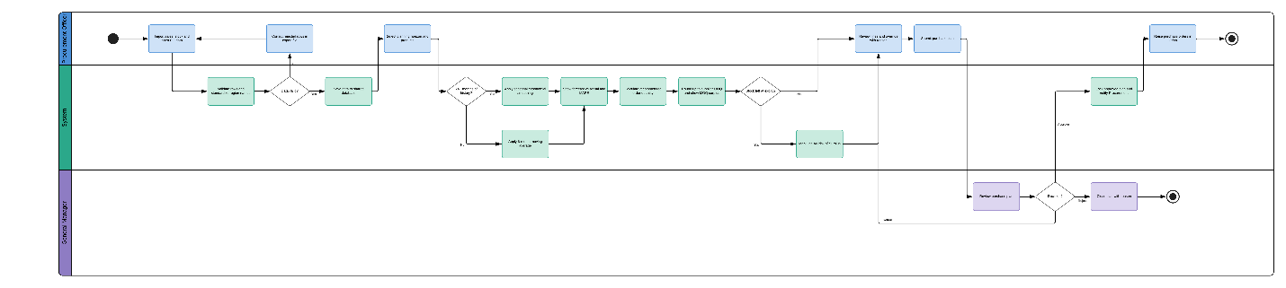
Exhibit #7: Activity Diagram, Demand Forecasting and Purchase Planning
As shown in Exhibit #7, the forecast moves inside the system rather than sitting in a spreadsheet outside it. The Procurement Officer imports sales, stock, and open purchase orders. The system validates the rows and standardizes region names, so a file with errors returns to the officer rather than entering the forecast. The system then chooses the method by history: seasonal exponential smoothing where 24 months exist, a 6-month moving average where they do not. Every forecast is shown against actual sales and its MAPE, so accuracy is measured rather than assumed.
The critical step is the MOQ check. The system rounds each recommended quantity up to the supplier minimum, shows the surplus this creates, and marks any line that would leave stock at expiry as At Risk of Surplus. This is the point at which the DFD As-Is had no control: the error that used to arrive as physical goods is now visible as a number before the General Manager approves it. The General Manager can approve, return, or reject the plan. Only an approved plan becomes a purchase order in Odoo. The diagram supports FR-41 to FR-49 and UC-23 to UC-26.

10.2 Warehouse Audit
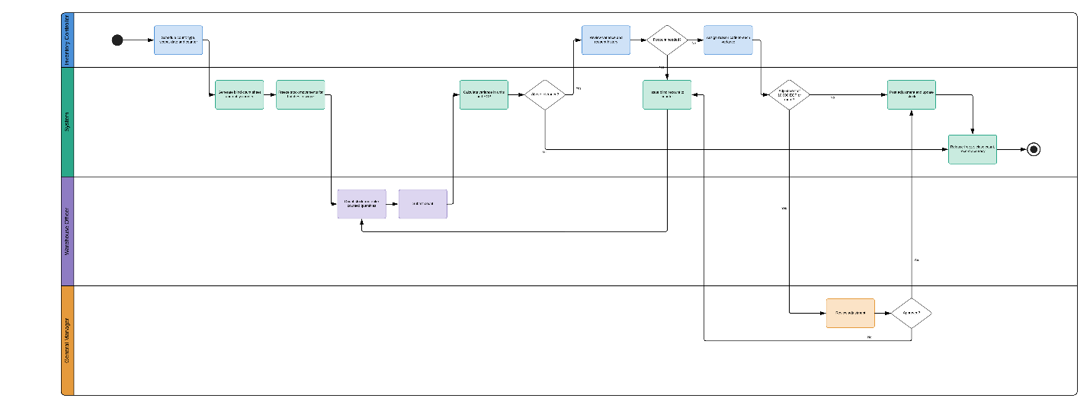
Exhibit #8: Activity Diagram, Warehouse Audit
As shown in Exhibit #8, the audit protects the data on which every other process depends. The Risk Assessment identified inventory and expiry tracking failure as the highest-rated risk, and the Technical Feasibility assessment located the principal risk in data quality rather than technology. The audit is the control for both. The Inventory Controller schedules a count, and the system freezes movements on the batches in scope and issues a blind count sheet. The Warehouse Officer counts without seeing the system quantity, so the count cannot simply confirm the record.
Variances within tolerance close the count directly. Variances above tolerance return to the Inventory Controller, who either requests a blind recount or assigns a reason code. Adjustments under 10,000 EGP post immediately. Adjustments at or above that value go to the General Manager, and a rejected adjustment triggers a recount rather than a forced correction. The count closes only once every variance is explained, and the accuracy rate feeds the Audit Accuracy dashboard. The diagram supports FR-18 to FR-23 and UC-10 to UC-13.

10.3 Near-Expiry Products
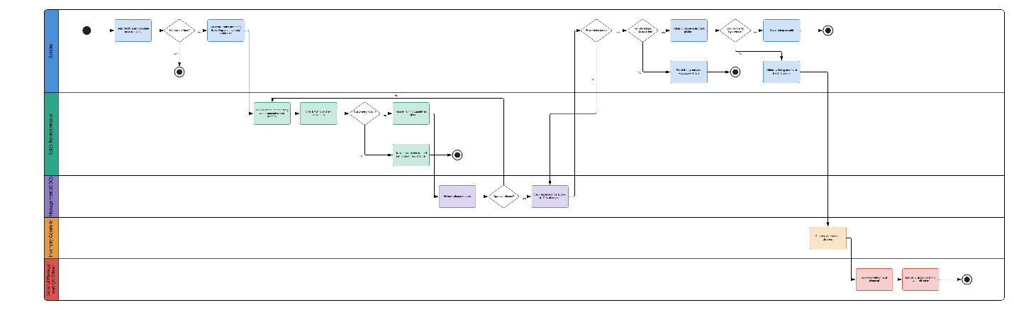
Exhibit #9: Activity Diagram, Near-Expiry Products
As shown in Exhibit #9, this is the process the company does not have today. The DFD As-Is ended unsold stock at process 15.0, write-off and disposal. In the proposed system, the daily scan flags every batch at 180 days, six months before that point, and gives it a defined route with a named owner at each step.
The route follows a deliberate order. The Sales Representative first offers the batch to existing customers, because a full-price sale through the field channel is worth more than a clearance sale. Only the quantity those customers cannot absorb is flagged as surplus. The COO then decides whether to release it and sets a price between 65% and 70% of the original, and the system rejects any price outside that band. Before publishing, the system confirms that the product is registered in the market and has more than 30 days of shelf life left, which is the condition the Legal Feasibility assessment set for selling online.
Disposal remains in the diagram, but as the last branch rather than the only one. A listing that does not sell before 30 days remain is withdrawn, the batch is blocked at expiry, and the Inventory Controller requests write-off for dual approval. The loss is then recorded against the purchase plan that bought it, so the forecasting process in Exhibit #7 receives the corrective signal that the Problem Statement found missing. The diagram supports FR-24 to FR-40 and UC-14 to UC-22.

10.4 E-Commerce Purchase
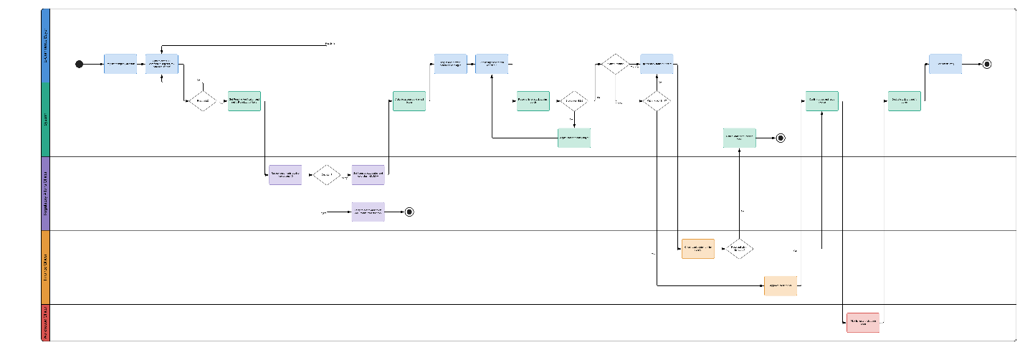
Exhibit #10: Activity Diagram, E-Commerce Purchase
As shown in Exhibit #10, a buyer cannot reach the catalogue without first passing verification. The buyer registers and uploads the owner's national ID, commercial register, tax card, and veterinary trading license. The Regulatory Affairs Officer then approves, rejects, or asks for resubmission, and sets the categories the buyer may purchase and whether it may take cold-chain products. This keeps veterinary medicines and vaccines with buyers authorized to hold them, as EDA and GOVS registration requires.
Ordering is built to prevent the most common failure of a secondary channel, which is selling stock that is no longer there. The system reserves the listed batch at checkout, and if the quantity has gone, it adjusts the cart before payment. Payment then splits by method. Bank transfer orders hold their reservation for 48 hours while the Finance Officer checks the statement, and lapse if payment does not arrive. Invoice orders pass a credit-limit check before the Finance Officer approves them. Only a confirmed order reaches the Warehouse Officer, who picks by lot, and stock is deducted when the order is dispatched. The diagram supports FR-66 to FR-86 and UC-29 to UC-39.
Taken together, Exhibits #7 to #10 show that the proposed solution places its controls where the Root Cause Analysis placed the causes. The forecast controls what is bought, the audit controls whether the record is true, the near-expiry route controls what happens to stock that stops selling, and verification controls who can buy it.

11. Data Models

11.1 Data Flow Diagram
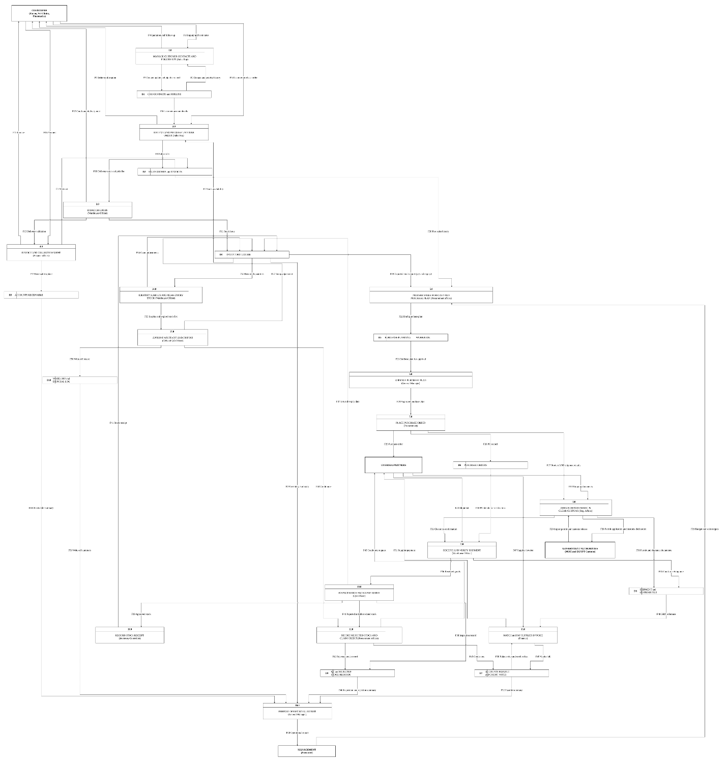
Exhibit #11: Data Flow Diagram (As-Is), Kubbar International
As shown in Exhibit #11, Kubbar's current operation runs sixteen processes, ten data stores, and four external entities, and every transaction except the purchase plan is recorded in Odoo. The diagram established two absences, and the proposed system is designed around them. First, nothing reads the expiry data the company already holds in a way that could act on it, because process 14.0 identifies surplus only so that process 15.0 can dispose of it. Second, no external entity exists that could receive surplus stock, because the only customer entity is the portfolio whose demand has already been met.
The proposed system changes the diagram at four points. Process 5.0, the spreadsheet forecast, moves inside the system as UC-23 to UC-26, so the purchase plan is built from the same sales data store it currently reads only by export. Process 14.0 becomes the daily expiry scan (UC-14), which runs six months before expiry rather than at it. A new branch is added between 14.0 and 15.0: offer to existing customers, flag as surplus, release by the COO, and publish (UC-15 to UC-18). A new external entity, the E-Commerce Buyer, receives that output through UC-29 to UC-37. Process 15.0 remains, but it now receives only what the new branch could not sell. A To-Be DFD drawn from Section 9 would show these four changes as new processes and flows on the existing diagram.

11.2 Entity Relationship Diagram
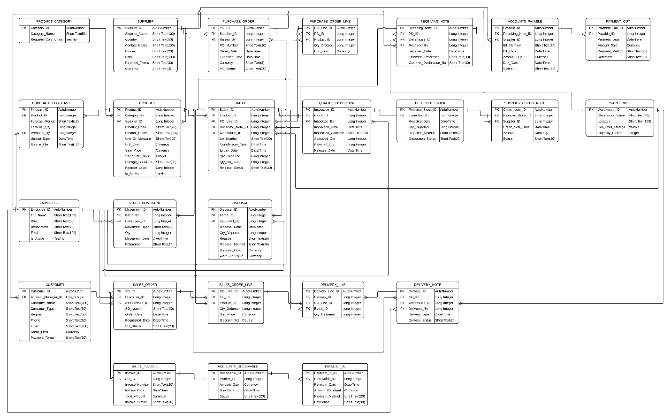
Exhibit #12: Entity Relationship Diagram, Kubbar International
As shown in Exhibit #12, the current ERD models Kubbar's existing transactions in twenty-five entities: procurement (SUPPLIER, PURCHASE_FORECAST, PURCHASE_ORDER, PURCHASE_ORDER_LINE), receiving and quality (RECEIVING_NOTE, QUALITY_INSPECTION, REJECTED_STOCK, SUPPLIER_CREDIT_NOTE), stock (PRODUCT_CATEGORY, PRODUCT, BATCH, WAREHOUSE, STOCK_MOVEMENT, DISPOSAL), sales (CUSTOMER, SALES_ORDER, SALES_ORDER_LINE, DELIVERY_NOTE, DELIVERY_LINE, SALES_INVOICE), finance (ACCOUNTS_PAYABLE, PAYMENT_OUT, ACCOUNTS_RECEIVABLE, PAYMENT_IN), and EMPLOYEE. Its strongest feature for the proposed system is that BATCH already carries Lot_Number, Expiry_Date, Qty_On_Hand, and Release_Status, and that DELIVERY_LINE references the batch shipped. Expiry is therefore modeled at the right level. What the model lacks is everything after a batch stops selling, and the two new user groups the proposed system introduces.
Exhibit #13 lists the entities the ERD must add to support the requirements in Section 6. Existing entities also need a small number of new attributes: PRODUCT needs MOQ and Lead_Time_Days; BATCH needs Location_ID and Market_ID; CUSTOMER needs Commercial_Register_No so that a buyer registration can be matched to an existing account (FR-70); PURCHASE_FORECAST needs Region_ID, Method, and MAPE; and SALES_INVOICE needs an optional Platform_Order_ID so that platform sales are invoiced through the same entity.
Entity | Purpose | Key Attributes | Related FRs
MARKET | The nine markets, with Egypt active | Market_ID, Market_Name, Currency, Is_Active | FR-32, NFR-21
REGION | Sales regions within a market | Region_ID, Market_ID, Region_Name | FR-42, FR-57
PRODUCT_REGISTRATION | Registration of a product in a market | Registration_ID, Product_ID, Market_ID, Authority, Registration_No, Status, Expiry_Date | FR-32, FR-35
BIN_LOCATION | Storage locations inside a warehouse | Location_ID, Warehouse_ID, Code, Storage_Type, Capacity | FR-10, FR-11
STOCK_COUNT | A scheduled warehouse audit | Count_ID, Warehouse_ID, Count_Type, Scheduled_Date, Assigned_To, Status, Accuracy_Rate | FR-18, FR-19
STOCK_COUNT_LINE | One counted batch | Count_Line_ID, Count_ID, Batch_ID, System_Qty, Counted_Qty, Variance_Value, Reason_Code, Approved_By | FR-20 to FR-23
EXPIRY_ALERT | Near-expiry and expiry alerts | Alert_ID, Batch_ID, Alert_Type, Raised_Date, Days_To_Expiry, Status | FR-24 to FR-26
CUSTOMER_OFFER | Offers of near-expiry stock to existing customers | Offer_ID, Batch_ID, Customer_ID, Qty_Offered, Outcome, Offered_By | FR-27
SURPLUS_RELEASE | Surplus flag and COO decision | Release_ID, Batch_ID, Flagged_By, Flag_Reason, Surplus_Qty, Approved_By, Release_Qty, Clearance_Price, Decision | FR-29 to FR-31
LISTING | A released batch on the platform | Listing_ID, Release_ID, Market_ID, Listed_Qty, Available_Qty, Clearance_Price, Status | FR-33, FR-34, FR-80
PURCHASE_PLAN | A submitted purchase plan | Plan_ID, Prepared_By, Status, Approved_By, Approval_Date | FR-48, FR-49
PURCHASE_PLAN_LINE | One product in the plan | Plan_Line_ID, Plan_ID, Product_ID, Forecast_Qty, Recommended_Qty, MOQ_Surplus_Qty, Final_Qty, Override_Reason, At_Risk_Flag | FR-45 to FR-48
BUYER | A verified trade buyer | Buyer_ID, Company_Name, Buyer_Type, Market_ID, Commercial_Register_No, Owner_National_ID (encrypted), Status, Cold_Chain_Eligible, Payment_Terms, Credit_Limit, Consent_Date | FR-66 to FR-74, FR-83
BUYER_DOCUMENT | Uploaded verification documents | Document_ID, Buyer_ID, Document_Type, File_Ref, Expiry_Date, Review_Status, Reviewed_By | FR-67, FR-68, FR-71
BUYER_CATEGORY | Categories a buyer may purchase | Buyer_ID, Category_ID | FR-72, FR-75
PLATFORM_ORDER | An order placed on the platform | Order_ID, Buyer_ID, Order_Date, Status, Payment_Method, Total_Amount, Reservation_Expiry | FR-77 to FR-86
PLATFORM_ORDER_LINE | One listing in an order | Order_Line_ID, Order_ID, Listing_ID, Batch_ID, Qty, Unit_Price | FR-77, FR-78
PAYMENT_PROOF | Uploaded bank transfer receipt | Proof_ID, Order_ID, File_Ref, Amount, Status, Confirmed_By | FR-82, FR-83
BUSINESS_RULE | Configurable rules and their history | Rule_ID, Rule_Name, Value, Changed_By, Approved_By, Changed_Date | FR-52
AUDIT_LOG | Tamper-proof record of actions | Log_ID, User_ID, Action, Record_Ref, Old_Value, New_Value, Timestamp | FR-54, NFR-27
Exhibit #13: Entities Required by the Proposed System
As shown in Exhibit #13, most of the new entities sit on the path from BATCH to BUYER. EXPIRY_ALERT, CUSTOMER_OFFER, SURPLUS_RELEASE, LISTING, and PLATFORM_ORDER_LINE form a chain that records every decision a batch passes through between its first alert and its sale, which is exactly the record the DFD As-Is showed to be missing. The data model therefore captures not only what was lost but where in that chain the loss occurred.

12. Conclusion
This specification defines a solution to a problem that Kubbar's existing systems record accurately but cannot act on. The company already knows, batch by batch, what it holds and when that stock expires. What it lacks is a process that reads that date while the stock still has value, and a buyer who can take what the existing customers do not need. The proposed solution supplies both.
The IMS turns the record into action at three points. It builds the purchase plan from actual sales and shows the MOQ surplus before the order is placed, so the error is seen as a number rather than received as goods. It audits the warehouse against the record, so that alerts and listings rest on data that has been checked. And it flags every batch six months before expiry and routes it through a fixed order: existing customers first, then release by the COO at 65% to 70% of the original price, and disposal only for what remains. The E-Commerce Platform then adds the outlet the DFD As-Is lacked. It is open only to verified trade buyers, limited to registered products with remaining shelf life, and protected against selling the same batch twice.
The specification is deliberately bounded. It covers forty-four use cases for eleven user roles, eighty-nine functional requirements, and twenty-seven non-functional requirements, and it stops short of accounting, field sales, card payments, and machine learning. Authority stays where the organization already places it: the General Manager approves purchasing and disposal, the COO controls release and price, and the sales team enters the new channel through the flagging role rather than being bypassed by it.
The company currently pays three times for the same inventory error. The proposed solution does not remove the forecast error, because no forecast is exact. It changes what happens next: surplus is seen before purchase, intercepted before expiry, and sold rather than destroyed. The requirements in this document are therefore complete enough to proceed to the design phase of the Waterfall lifecycle.

