
Faculty of Informatics and Computer Science
Software Engineering

Automated Detection and Classification of Diabetic Retinopathy Stages.

By: Mostafa ElDahshan
Supervised By
Dr. Amr Ghoneim

August 2020
Abstract
Diabetes is a dangerous disease threatening humanity, let alone having that disease in a part of the eye, which is until now incurable even through what medicine and science reached. The only solution is early detection to reduce its effects to a limit. Since it affects all parts of body parts and organs hence there are ways to detect its presence before it critically damages the body. Eyes retina is also affected by diabetes, causing blood vessels in the retina to rupture and due to some complication eventually causing permanent blindness. Luckily, we can take images of retina using retinopathy. These images can be utilized to detect Diabetic Retinopathy. These images are the solution to classify the disease at its early stages to prevent any upcoming damages the person might suffer from later.
The problem was firstly to detect whether the retinal image input to the model was affected with diabetic retinopathy or not. The binary classification method was through a CNN model Xception which excelled in the binary classification method alongside with bottleneck feature extraction. The model achieved 97% accuracy in detecting the input retinal image.
The second objective was to classify the severity of the diabetic retinopathy from the input image. Such classification was done by using deep learning state-of-the-art method. The convolutional neural networks (CNN) combined with some Machine Learning (ML) methods such as the Logistic Regression model. The CNN models used to solve the problem was Resnet50 and EfficientNetB5 with accuracy achieved 79% and 85% respectively.
The previously mentioned models were built and experimented through fine-tuning of the layers and specific hyperparameters to achieve the best accuracy and least loss/misclassification. However, in this experiment a supervised machine learning model was used to classify using t-SNE. The Logistic Regression Model achieved 93% accuracy.

Attestation &Turnitin Report
I understand the nature of plagiarism, and I am aware of the University’s policy on this.
I certify that this report reports original work by me during my University project except for the following (adjust according to the circumstances):
- The technology review in Section 2.5 was largely taken from [17].

Signature: Mostafa ElDahshan Date:

Acknowledgements
First and foremost, this project was made by the help and guidance of Dr.Amr Ghoneim. Dr. Amr Ghoneim is not only a Professor that helps his students through their graduation projects but provides vastly knowledge that was so insightful, eye-opening ideas and methods to help his students achieve their goals, he’s also professional in the medical image processing and provided a lot of guidance and substantial help through building this project. I’d like to wholeheartedly thank Professor Abeer Hamdy (Software Engineering Department Coordinator) for supporting me when I needed guidance, helping me in searching for the projects idea phase and give me the best advice whenever I needed it. I’d like to thank my parents for providing me with their medical information and support. I’d like to thank my elder brother Ahmed who is a medical student, my best friends and every person helped and supported me throughout my college years.
Table of Contents
The table of contents below is automatically generated from the paragraphs of style Heading N and Unnumbered N. To update this after revisions, right-click in the table and choose Update Field for the entire table.
Abstract ii
Attestation &Turnitin Report iii
Acknowledgements iv
Table of Contents v
List of Figures vii
List of Tables viii
1 Introduction 1
1.1 Overview 1
1.2 Problem Statement 1
1.3 Scope and Objectives 1
1.4 Report Organization (Structure) 1
1.5 Work Methodology 2
2 Related Work (State-of-The-Art) 3
2.1 Background 3
2.2 Literature Survey 3
2.3 Analysis of the Related Work 5
3 Proposed solution 8
3.1 Solution Methodology 8
3.1.1 Main idea: 8
3.1.2 Detailed explanation: 8
3.1.2.1 The state-of-the-art method (CNN): 8
3.1.2.2 Machine Learning: 13
3.2 Functional/ Non-functional Requirements 14
3.2.1 Functional requirements: 14
3.2.2 Non-Functional requirements: 14
3.3 Design / Simulation set up 14
4 Implementation 16
4.1 Project Explanation 16
4.2 Dataset: 16
4.3 Pre-processing: 16
4.4 Experimentations: 17
4.4.1 Xception model with Bottleneck features: 17
4.4.2 Resnet50 model: 19
4.4.3 EfficientNetB5 model: 20
4.4.4 Logistic Regression with t-SNE model: 21
5 Testing and evaluation 23
5.1 Testing 23
5.2 Evaluation 23
6 Result and Discussion 25
6.1 Results: 25
6.1.1 Xception Results: 25
6.1.2 Resnet-50 Results: 26
6.1.3 EfficientNetB5 Results: 27
6.1.4 Logistic Regression Results: 28
6.2 Discussions: 29
7 Conclusions and Future Work 30
7.1 Summary 30
7.2 Future Work 30
References 31
Appendix 1 – Dataset 34
Appendix 2 – Installation guide 35

List of Figures
Figure 1 - Uni-Modal 6
Figure 2 - Multi-Modal 6
Figure 3 - Hybrid model with SVM Classifier 6
Figure 4 - CNN explained 9
Figure 5 - Basic Components of CNN 9
Figure 6 - ReLU function 10
Figure 7 - Average Pooling 12
Figure 8 - Max Pooling 12
Figure 9 - Linear and Logistic Regression Graphs 14
Figure 10 - - a) Original Image, b) Greyscale Image, c) First layer of Gaussian filter and d) Second layer of Gasussian filter 17
Figure 11 - Xception modified Model 18
Figure 12 - ResNet-50 architecture 19
Figure 13 - Comparison of EfficientNetB0 and ResNet-50 20
Figure 14 - Comparison of EfficientNet to other models 20
Figure 15 - Xception Confusion Matrix 24
Figure 16 - Resnet-50 Confusion Matrix 25
Figure 17 - EfficientNetB5 Confusion Matrix 26
Figure 18 - LR Confusion Matrix before fine-tuning 27
Figure 19 - LR Confusion Matrix after fine-tuning 28

List of Equations
Equation 1 - Quadratic Weighted Kappa 5
Equation 2 - Softmax Equation 10
Equation 3 - Sigmoid Equation 11
Equation 4 - Difference between Sigmoid and Tanh 11
Equation 5 - Accuracy Equation 22
Equation 6 - Precision Equation 22
Equation 7 - Recall Equation 23

List of Tables
Table 1 - Results Comparison 4
Table 2 - Xception Results 24
Table 3 - ResNet-50 Results 25
Table 4 - EfficientNetB5 Results 26
Table 5 - LR Before Fine-tuning Table 6 - LR After fine-tuning 27
Table 7 - Results Comparison 29

Introduction

Overview
Nowadays, diabetic retinopathy is one the main causes and reasons for blindness among people, adult being or adolescent. Moreover, this disease can be manually detected by expert ophthalmologists to identify which stage the disease has reached and how to cure patients accordingly. This process could consume a lot of time as well as the efficiency is not quite satisfying considering the ophthalmologists are not experts. Using a fast and accurate designed project that is trained and accurately classifying the stages of the disease is more efficient and time saving to have more patients diagnosed easily and sufficiently, therefore, saving their eyesight.

Problem Statement
The problem being that Diabetic Retinopathy is major cause of blindness. To have its stages detected and identified, expert ophthalmologists spend time and a lot of effort in the process of identifying the current patient stage so therefore giving the correct medication to the patient accordingly. The project to be made is a fast and accurate while remaining light weighted approach in identifying the stages of the Diabetic Retinopathy that can be reliable to ophthalmologists while diagnosing the patient severity.

Scope and Objectives
The proposed project aims to save time for the ophthalmologists in detecting the stages of the Diabetic Retinopathy of the patient as well as improving the accuracy as the experimented project is trained on a large dataset of images including the healthy patient, mild, moderate, severe and proliferative stages. The project will be used in hospitals, clinics and other medical facilities to help ophthalmologists detect the stage easily and accurately to have a better chance in curing the patient faster. The proposed project is to be lightweight in size and be sufficient.

Report Organization (Structure)
Chapter 1: is the Introduction to the project that hold the overview, explains the problem and the scope and objectives to be achieved.
Chapter 2: is about the related work and how it is analysed through research of some published articles and scientific journals that faced this problem, how they proposed a solution to solve it and what they achieved.
Chapter 3: is about the solution methodology that is to be used in this experiment as well as functional and non-functional requirements of the project.
Chapter 4: is about the implementation of the pre-processing methods, models used and optimization of hyperparameters to achieve the best results.
Chapter 5: Testing functions and standards and evaluation through defining the metrics.
Chapter 6: Results of the experiments analysing them.
Chapter 7: Summary of the study and future work explained that is needed to be done to improve the models.

Work Methodology
The work methodology will be as follows; firstly, the searching for possible ideas part will be done through examining current problems and issues that can be solved through a system or project. Secondly, by researching main project idea and gaining information about every element regarding the project. The research process includes searching for papers, articles, conferences and dissertations that experimented all aspects of the project. Thirdly, searching for all publicly available datasets. The dataset for each project is a core and vital elements that has a lot of co-dependent elements. Once the dataset is acquired from a trusted source, the next step is to explore other projects that worked on the same dataset and tried experimenting different techniques upon such dataset. Fourthly, exploring different techniques experiments done on this dataset. Once the information gathered, the fifth step is to find a new technique for implementing the chosen idea and project experiment. The chosen technique is needed to help in serving the main issue that the idea deals with. Sixth step is to implement the project idea and monitor the results from experimenting. Seventh step is to do a comparative study that will compare each experiment that has been done throughout the implementation phase hence, gaining the most efficient and effective technique possible to achieve the goal. The eightieth step includes finalizing the project with composed results and documenting it properly so it can be published to be another experiment that helps improving the current solutions and widen the space of knowledge among people who faces the same problem and seeking help of the academic experiments. The eightieth step includes writing the thesis of project and experiments.

Related Work (State-of-The-Art)

Background
Diabetic Retinopathy is one of the leading causes to blindness worldwide. It was proven that 51% of patients at the interval of 45-60 years old in Egypt have this disease [22].The disease can be caused by having a high blood glucose levels for a very long time therefore weakens the retinal blood vessels causing microaneurysms, haemorrhages or even exudates. This disease can be controlled by acknowledging its stages/severity. The severity/grades of the disease are as follows; Mild, Moderate, Severe and Proliferative. Ophthalmologists usually diagnose the retina being examined by searching for abnormalities such as microaneurysms (MAs), hard exudates, soft exudates, intraretinal microvascular abnormalities (IRMAs) and venous looping or beading. Each stage/grade of the disease is diagnosed based on the abnormalities found the retina’s image. The severity can be acknowledged manually by expert ophthalmologists to cure it. However, the faster and more accurate solution is to use a software that detects the severity automatically through a trained model on a huge dataset which contains all the disease stages as well as the healthy ones. [18]

Literature Survey
Diabetic Retinopathy has been known for a long time as well as the deep/machine learning techniques and approaches that solves the issue of detecting its severity and having high accuracy. The papers will be discussed are some of the approaches and techniques that machine learning developers and computer scientists used to solve this problem of identifying the stages of disease. Each paper will be discussed in detail in the next section of analysis to demonstrate what differs them.
[10] 2018 published an article taking the CNN approach in their research to help in the process of classifying the Diabetic Retinopathy stages. The approach was a comparative study about the pre-processing needed to improve the accuracy that the model reaches. However, the main goal was not reach maximum accuracy but to compare between the effects of different pre-processing techniques and how those techniques have impact in the training phase of the model. The results were satisfying as the Contrast Limited Adaptive Histogram Equalization (CLAHE) method had a huge impact on helping the model in refining feature extraction phase.

In 2019 [6] a paper was published by the IEEE journal that approached the Diabetic Retinopathy classification issue with a basic CNN model. The preprocessing of the given retinal images was cropping and dimention reduction to 224x224. The approach taken in this paper regarding the model is to maintain the model complexity to an extent where the model should learn the features of each input retinal image to give the best performance.
A different approach was taken by [2] in order to simplify the classification process by using a proposed multi-model fusion module. This module helps in the improvement of feature extraction so that serves the purpose of easier classification and a better software being used in the clinics. Moreover, the authors used pre-trained models with defined weights to help imporving the process of training.
Alternativly, [8] research article provided another way to help solve the problem of classifying the stages of Diabetic Retinopathy by using pre-processing then features extracted from a search network in NASNet search space. The accuracy is improved according to this technique of deep feature extraction. However, the processed data will be presented in t-distributed stochastic neighbor embedding(t-SNE) to give better discriminative representation then fed to a at ⱱ-Support Vector Machine(ⱱ-SVM) to reach maximum accuracy.
Table 1 - Results Comparison
Research Study | Approach | Accuracy achieved
(Fayemiwo , Akinboro , & Adepegba, 2018) | Pre-processing using CLAHE Comparison | 85.20%
(Dekhil, et al., 2019) | Basic CNN built model | 77%
(Bodapat, et al., 2020) | Blended Multi-modal Deep ConvNet features | 81.7%
(Dondeti, Bodapati, Shareef, & Naralasetti, 2020) | Deep Conv. Featues in Non-linear Embedding Space | 77.90%

Analysis of the Related Work
[10] experminet is divided into two parts, the first part regarding the classification with and without the CLAHE pre-processing to the given dataset which is Kaggle Asia Pacific Tele Ophthalmology Society (APTOS 2019) that contains 3662 images of healthy people’s retinas and patients suffering from DR with different grades. The experiment achieved accuracy of multiclass classification of 85.20% with CLAHE pre-processing and 71.79% without CLAHE pre-processing. However, the binary class classification as for DR or Non-DR achieved 94.47% and 93.43% testing accuracy for both with and without CLAHE pre-processing respectively. The major difference here between the results was due to the less complexity and minimal feature extraction of the model to input data fed to it. The case of multiclass classification requires the model to extract more features to be able to recognize each image according to their features. The challenge in this case to the model is the confusion between adjacent classes and their features. Hence, the massive difference in the results regarding the CLAHE pre-processing. On the contrary, the binary class classification has shown more features variances, so it is easier for the model to identify them and predict accordingly. This paper proves that pre-processing is significantly vital when classifying multiclass and specifically vague features to be detected.
[6] built and used basic CNN architecture for the classification process. The pre-processing was quite simple as it was two steps of cropping then down sampling the image to 224x224 dimentions. The convolutional neural network is composed of 5 layers. The evaluation of the experiment was tough due to the misleading accuracy result from the imbalancment of the dataset. This problem is solved by two ways; balancing the dataset through augmentation, the other is calculate the quadratic weighted kappa. The equation is as follows:
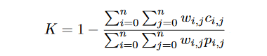
Equation 1 - Quadratic Weighted Kappa
Where K is weighted kappa statistics and n is number of classes. The quadratic weighted kappa score is 78%.
[2] took another approach in feature extraction as it is proposed in the experiment that 2 models have been used to represent the feature efficiently. A uni-modal and multi-modal. Using the VGG16 first two fully connected layers to produce feature vector and then feeding them to the Neural Architecture Search Network (NASNet), Xception or InceptionResNetV2 to search and represent feature effectivly. A diagram is presented to elaborate the general idea behind the difference of uni-modal and multi-modal feature extraction are as follows;

The uni-modal:
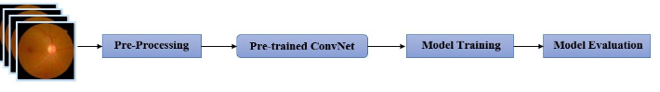
Figure 1 - Uni-Modal
The Multi-modal:
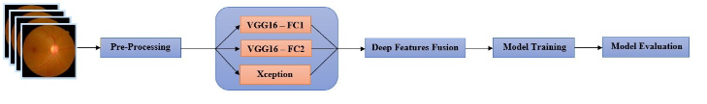
Figure 2 - Multi-Modal
The study proves that the blended features in addition to the CNN reached best accuracy which achieved 80.96% in comparison to every CNN architecture without the multi-modal feature extraction.
[8] proposed another solution for deep feature extraction using transfer learning based on t-SNE. The technique t-SNE uses conditional probabilty instead of Equlidian probabilty. Therefore, the representation of global and local data are in lower dimensional. However, t-SNE is used reducing the dimentionality by transformation method and to avoid overfitting. The pre-processing needed is minimal. An illustration figure is presented to elaborate the model:
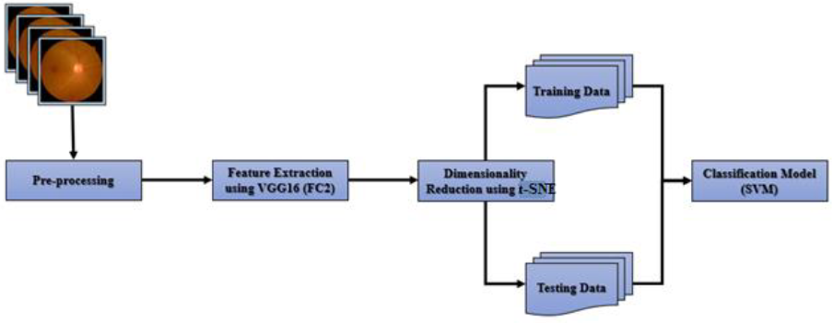
Figure 3 - Hybrid model with SVM Classifier

Contribution:
The proposed approach of this project:
1) Using specific layers and global average pooling layers to extract features.
2) Solve the imbalancement problem in the dataset to improve accuracy.
3) Comparative study among multiple CNN models and machine learning models to achieve best efficiency.

Proposed solution

Solution Methodology

Main idea:
As stated in the previous sections the approaches of classifying the Diabetic Retinopathy was through deep neural networks specifically Convolutional Neural Networks proved to be one of the most powerful tools in serving to solve the problem. The proposed automated project used in detection and classification the Diabetic Retinopathy (DR) severity will be using the state-of-the-art method (CNN) architectures such as Xception, Resnet50 and EfficientNetB5 also with the Logistic Regression model for classifying the input images. The Xception model had a different approach in feeding the data to the model. Bottleneck Feature Extraction was used to extract the features from the given retinal images. Each model has different layers and architecture to extract the features and classify the given classes. The dataset will be used is publicly available at Kaggle for classification of DR Asia Pacific Tele Ophthalmology Society (APTOS 2019). The project used 3662 images from the Kaggle dataset divided into imbalanced portions for each severity. The dataset needed to be balanced for each severity class through augmentation. The training has 80% of the portion of images and 20% was assigned to the validation.

Detailed explanation:

The state-of-the-art method (CNN):
Convolutional neural network is a basic artificial neural network in addition to multiple hidden layers and convolutional filters running through the input data to extract every single possible feature exists in such given data. [1]. Any convolutional neural network is composed multiple layers such as convolutional layers, pooling layers, normalization layers and fully connected layers. Convolutional layers are the layers that apply the filter specificied to the input image or to any feature map given to the CNN. Moreover, the convolutional layers apply activation functions on every value of the feature map or image given to the layer. The significant parameters are number of kernels and kernel sizes. The pooling layers serves in reducing the dimentionality and extracting max average of the region given through an approach called sliding window approach. A batch normalization layer normalizes the inputs through batches of data to speed up training of convolutional neural networks and reduce the sensitivity to network initialization. “Batch Normalization achieves the same accuracy with 14 times fewer training steps and beats the original model by a significant margin.” [16]. The fully connected layers are layers that have all inputs from one layer connected to all activation units from the next layer. “Each node in a fully-connected layer is directly connected to every node in both the previous and in the next layer”[1]. Fully connected layers have simply two main tasks; first one is feature extraction, the second is to classify the given inputs to classes.
The difference between simple neural network and deep learning neural network;

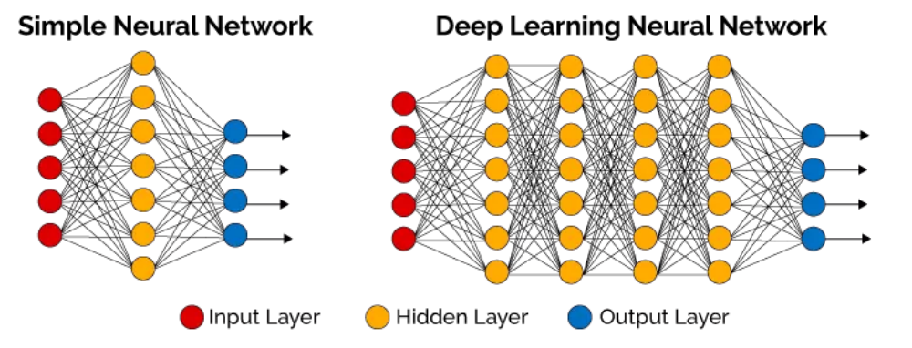
Figure 4 - CNN explained
The basic components of the convolutional neural network are as follows;
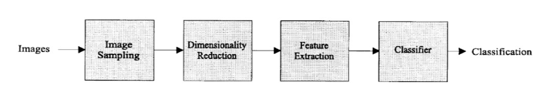
Figure 5 - Basic Components of CNN
This figure was presented to elaborate the basic CNN in [15].
The main four operations in the ConvNets are simply: Convolution, Non-linearity, Pooling or sub-sampling and finally classification. The image is read as a matrix of pixel values, divided into three main channels; red, greed and blue. The main task of convoluting is through is the image is feature extraction and it is done by generating a filter of 3x3 or 5x5 that convolves around the matrix of pixel of the given image. The mentioned beforehand filter slides over the given image to extract every feature that exists in this 3x3 or 5x5 filter in the image. The dot product is calculated for each slide of the filter/kernel producing the feature map. The kernel matrix could conclude different results also known as feature maps from sliding over the same image. The size of the feature map is handled by three main specific parameters; Depth, Stride and Zero-padding. Firstly, the depth is defined as the number of kernels or filters used to function for the convolution operation. Secondly, the stride is defined as the number of pixels sliding over the input image matrix given to the kernel. Thirdly, zero-padding is bordering the current given image matrix with zeros to enhance and control the feature maps produced. Non-linearity is the second main operation in the ConvNet and is aimed to substitute every negative value of the given feature map extracted to zero. Non-linearity activation functions are divided into four main activation functions; ReLU, Softmax, Sigmoid and TanH. As proved by [11] the “ReLU” activation function helps in the vanishing gradient descent problem in the training phase of the model to enhance the process and achieve better results, furthermore, the mentioned activation function helps in speeding up the learning convergence. The “ReLU” activation function could be visually represented as:
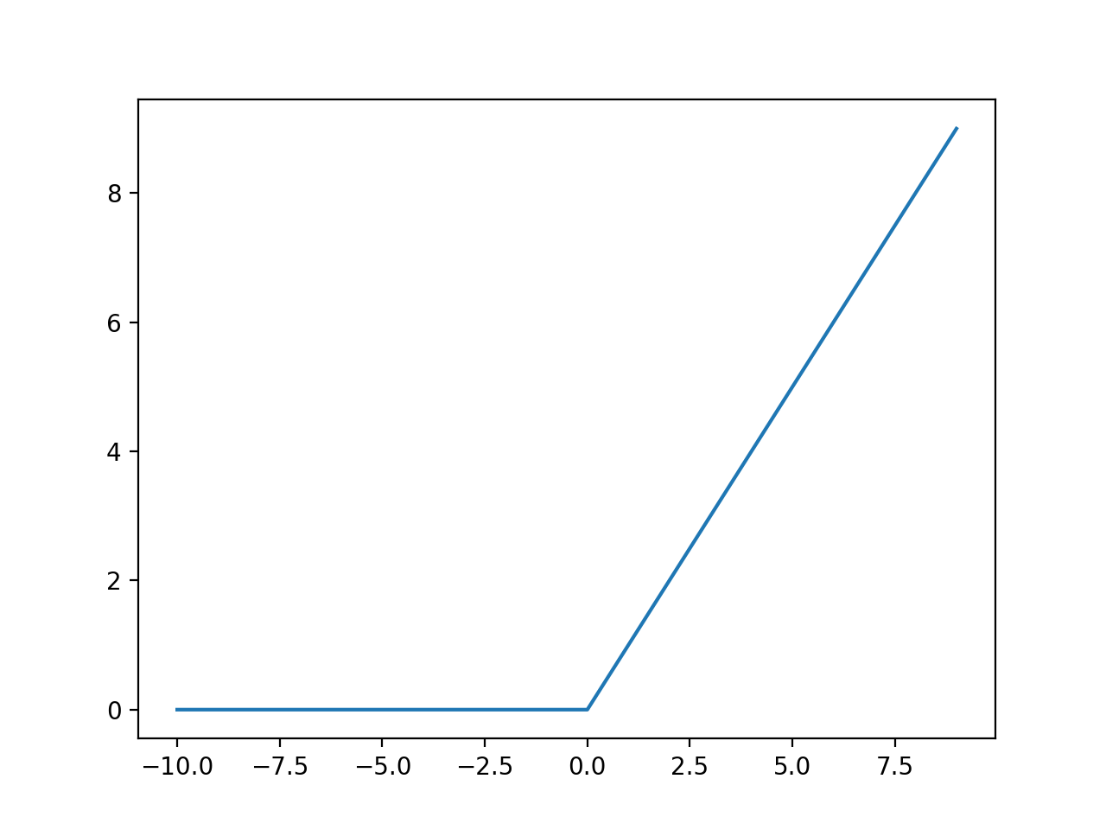
Figure 6 - ReLU function
Alternatively, the “Softmax” activation function can be described as a function that maps the non-normalized output of the network to a probabilistic predicted output class. The Softmax function is usually used to classify the output of the multiclass network. According to [26] the Softmax activation function mostly used in the output layer of the deep neural networks and can be mathematically represented as:
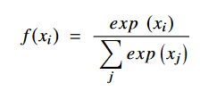
Equation 2 - Softmax Equation
Unlike the Softmax, the sigmoid function is used mostly in the binary classification problem as it outputs either zero or one as an output for the classified data. Also mentioned in [26] that Sigmoid function is mostly used in feedforward neural networks and lacks smoothness as an output. Sigmoid function can be mathematically represented as:
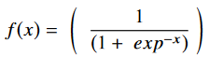
Equation 3 - Sigmoid Equation
Finally, the TanH function or also known as Hyperbolic Tangent Function is another activation function that can be smoother in the output and also zero-centered which has a range that lies between -1 and 1 as stated in [26]. According to [17] and [25] also proved that TanH function surpasses the Sigmoid function in case of training a multi-layer neural network. A visual representation between the Sigmoid and Tanh functions can be shown as:
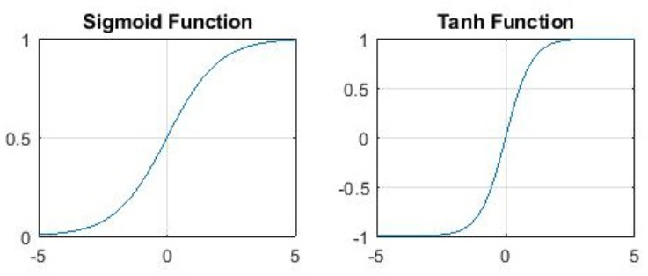
Equation 4 - Difference between Sigmoid and Tanh
Pooling or sub-sampling plays a vital role in reducing the dimensionality of given input data by merging the output units at one layer to a single neuron in the next layer. There are multiple pooling layers that sub-samples the given data such as local, average and max pooling layers. According to [30] the local combines small groups of data, global pooling functions on all the units if the convolution layer and the max pooling layer functions on the groups/clusters found at the previous convolutional layer. [27]

Average pooling can be visually represented as:
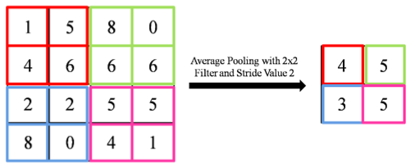
Figure 7 - Average Pooling
While Max pooling can be visually represented as:
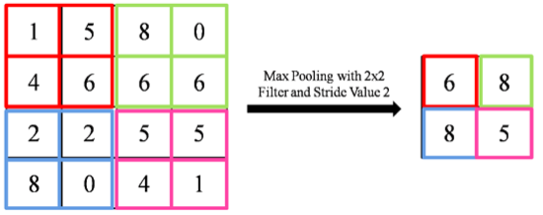
Figure 8 - Max Pooling
Hyperparameters are plays a vital role in optimizing the convolutional neural network efficiency. Hyperparameters are defined to be the optimizing value for which models use to manipulate the learning phase. Hyperparameters are considered to be Batch size, Epochs, learning rate, loss function, number of hidden layers and activation functions. Activation functions are mentioned previously and explained briefly so it will be skipped. Batch size and Epochs are similar in definition but has different function as the number of Epochs is the number of iterations of the whole given dataset passed to the model. On the other size, batch size is the division of the given data to small batches for each iteration also known as Epoch to reduce the memory consumption, speed up the learning process and improve feature extraction. The learning rate is defined to be the step size which has a main task of updating the weights to the model throughout the training phase to improve and enhance the training process. Loss functions also known as cost functions have a main duty in optimizing the parameter values in the neural network to real values. A lot of Loss functions for machine and deep learning exists for different purposes but there are two most commonly used Loss functions such as Binary Cross Entropy and Categorical Cross Entropy. Binary Cross entropy for example is used for identifying whether the given data is assigned to one of the two classes that the model being trained on. According to [13] the binary cross entropy is not a predicting function though; it is used to indicate the error or misclassification from the given input by a probability distribution function. Usually, the Sigmoid activation function is used afterwards to calculate the probability of both classes given the data. Similarly, the Categorical Cross Entropy functions the same but on a multiclass input level. The Softmax activation function is afterwards used to predict the output through their calculated probabilities.

Machine Learning:
Machine learning is a branch of Artificial intelligence which the models are learning through built models th at does not need prior programming to conclude a certain outcome. However, machine learning built models varies in their equations and algorithms to achieve a certain outcome. A lot of machine learning model have been built such as Linear Regression, Logistic Regression, Decision Tree, SVM, Naïve Bayes, kNN and Random Forest. Yet, the chosen model to be used in this experiment is the Logistic Regression model due to its efficiency and lack of missclassfication when applied to multiclass classification problems. Logistic Regression is a supervised machine learning algorithm that classifies data input by dividing it and forming a hyperplane. The output predicted data by the model is calculated through a probability, the probability is calculated through sigmoid function which lies between 0 and 1. As reported in [9] Logistic Regression model is a machine learning model based on the algorithm of creating a hyperplane that seprates the input data into two sets of data using the logistic function to describe the distance as a probabilty of classification. The Logistic Regression model is a binary model that classifies between 2 classes which are labeled 0 and 1. However, the Logistic Regression model is used to classify between several classes by dividing the given n classes to mulitple binary classes to distinguish between their features and draw the hyperplane line. The accuracy is calculated through the probabilty of identifying each given class features. [9] also proved that Logistic Regression achieved the highest accuracy of 82.88% in comparison to other machine learning algorithm models such as kNN, Decision Tree and Polynomial. As proved in [23], the maximum liklihood method and Logistic Regression model achieved a score 75.61% of accuracy and a Kappa score 0.68. As stated in [14] the Logistic Regression model uses maximum likelihood method in estimation of the prediction. On the contrary, the linear regression used the least square fit to calculate and classify the given features.
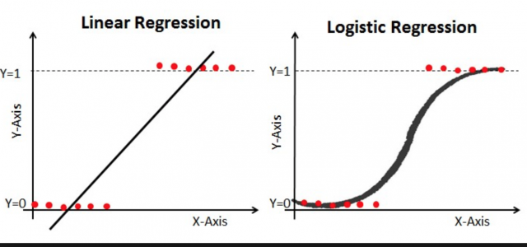
Figure 9 - Linear and Logistic Regression Graphs

Functional/ Non-functional Requirements

Functional requirements:
- The project should detect whether the input image is healthy or shows signs of Diabetic Retinopathy.
- The project should classify the input images and identify the Diabetic Retinopathy stages.
- The project should pre-process each input image.
- The project should be accurate and fast.

Non-Functional requirements:
- The project should handle any input image size.
- The project should have minimal time for predicting each input image.
- The project should use minimal hardware requirements to load and be fully functional.

Design / Simulation set up
The simulated setup for this project is composed of two components:
    - Used Software:
Anaconda 3.0 using Spyder 3.3.6 with Python 3.7.7.
    - Libraries:
Tensorflow-GPU, sklearn, keras, tqdm, seaborn, matplotlib, PIL, pandas.
    - Used Hardware:
Nvidia Geforce GTX 1050-TI– 4GB GDDR4, Intel Core-i7 7th Gen, 16GB RAM DDR4
Further explanation in Appendix 2 Installation Guide.

Implementation

Project Explanation
The project is divided into two main parts; the first part is to detect whether the given retinal image is healthy or affected with Diabetic Retinopathy. The first part uses the Xception model along with Bottleneck feature extraction. The second part is the classification part between each grade of the disease. The second part handles the classification of the 5 classes through 3 different models that are Resnet50, EfficientNetB5 and Logistic Regression.

Dataset:
The dataset being used in this experiment is publicly free on Kaggle website known as APTOS 2019 Blindness Detection. The dataset contains 3662 retinal images of patients suffering from Diabetic Retinopathy classified into 5 classes according to the disease’s grades. The dataset imbalance problem will be solved by using data augmentation generator through the ImageDataGenerator class imported from keras library to manipulate the data.
Further information of the dataset is in Appendix 1 Dataset.

Pre-processing:
Every image needs to be pre-processed before being fed to the model as pre-processing is vital part in highlighting the images’ features to mitigate the process of feature extraction and classification when input data are being fed to the model. Pre-processing such as Contrast Limited Adaptive Histogram Equalization (CLAHE) played a crucial role in improving the testing accuracy in [10] from 71.79% to 85.20% whilst using the same CNN architecture and dataset on the same machine. The pre-processing technique done to the given retinal images from the dataset was BenGarahm’s Method. [3] stated in their research that using BenGraham’s method for image pre-processing reached to be the winner of the competition of Kaggle. The method was layering 2 Gaussian filters with specific attribute values to clarify the features of the retinal images. The method was proven to achieve the best accuracy possible throughout all competitors that joined the competition. According to [7] the Guassian filter helps in noise suppression and edge detection, the exessive using of the Guassian filter does egde vanishing therefore, blurring the image to some degree. However, in this experiment, we will be using the addWeighted function and passing the image and then passing the alpha variable which represents weight of the first array elements which will be 4 and -4 for the beta variable which represents weight of the second array elements. The first layer of the Gaussian filter we will be converting the image from RGB to greyscale and for the second layer the greyscale will be converted to RGB again to enhance the centre colour of the retinal image. BenGraham used the same exact technique of layering the Gaussian filter except that when using the GaussianBlur method, the sigmaX variable was set to 10. The sigmaX variable represents the standard deviation in the X direction on the axis by a Gaussian kernel. The kernel size variable (ksize) was set to 0 on the width and height size. By applying the mention above specified values, the features will be in the finest form of illumination to be fed to the model.
A visual representation is to elaborate the effectiveness of the pre-processing.
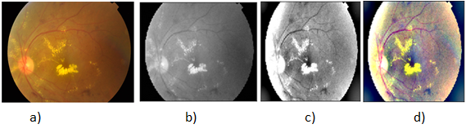
Figure 10 - - a) Original Image, b) Greyscale Image, c) First layer of Gaussian filter and d) Second layer of Gasussian filter

Experimentations:

Xception model with Bottleneck features:
As stated in [5] the Xception model is based on the Inception modules but has slight difference in the modules that are replaced with depthwise separable convolutions. The mentioned previously model contains 36 convolutional layers forming the layers that based on feature extraction of the model. On the other hand, the pretrained Xception model used for image classification contains 171 layers which will be used in this experiment. Moreover, the features of the given retinal images will be extracted firstly through Bottleneck feature extraction method. Bottleneck feature extraction method as reported in [20] are features extracted from the first top layer of the model to the Global Average Pooling layer. [20] stated also that transfer learning in their work replaced the softmax layer to new randomized weight softmax, hence, bottleneck features are used to train the proposed model. On the other hand, in this experiment the bottleneck features technique will be a concatination between specific layers of the pre-trained model and Global Average Pooling layers for each selected layer of the model as an experiment to enhance the feature extraction by using the same technique. Since the data is gathered and pre-processed, the next step is to use the mentioned previously technique to extract the significant features and save them as a ‘.npy’ file then pass them to the model. The concatinated layers to extract the bottlenck features are 16, 26, 36 and 126 alongside with Global Average Pooling layer to each selected layer as an output of the model. The dataset was input to the model by a class object ImageDataGenerator that has train/validation split of 20%. Furthermore, Tensorflow works on eager execution which is defined to be execution of the operations instantly once the python code is run. However, eager execution is disabled through a function termed ‘diable_eager_execution’ to reduce the memory usage and maintain optimized memory allocation. The dataset being fed to the model is divided into two main folder which are train and test folder. The train contains the majority of the images which will be later on divided on the train/validation split of 20%, the test part is randomly selected 20 images of the dataset divided into healthy retinal images and retinal images affected with Diabetic Retinopathy. The test folder is made to verifiy the model efficiency by predicting them after training. All retinal images input to the model rescaled to (1/255). The model is sequential and in this experiment, 2 dense layers of 128 neurons added with activation function “ReLU” alongside with kernel regularizer of ‘l2’ with 1e-5, bias regularizer with 1e-05 and ‘l1’ for activity regularizer with 1e-06 for the first dense layer. The second dense layer is combined with kernel regularizer of 1e-06, bias regularizer with 0.01 and ‘l1’ for activity regularizer with 1e-07. A dropout layer of 50% is added also to minimize the overfitting. A final dense layer to output the classified image/array of images with 2 units and an activation function “sigmoid”. The hyperparameter optimization is done by specific values assigned to achieve the best accuracy. The hyperparameters values are:
- Batch size: 16
- Image height and width: 299
- Epochs: 100
- Learning rate: 1e-05
- Loss function: Binary Cross entropy
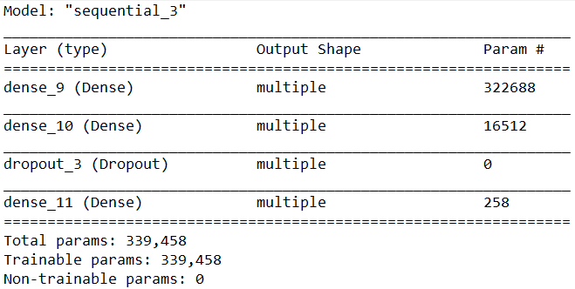
Figure 11 - Xception modified Model

Resnet50 model:
Resnet50 model is simply composed of 48 convolutional layers in addition to one Max Pooling layer and one Average Pooling layer. As stated in [12] the comparison between the resnet layers and typical convolutional neural networks led to an outstanding performance regarding the resnet architecture by an error rate of 6.97% which was the second least error rate before the resnet 110 architecture. According to [24] The resnet architecture helps also in the vanishing gradient decend problem unlike the basic CNN architecture. The resnet50 architecture can be visually elaborated through the following figure:
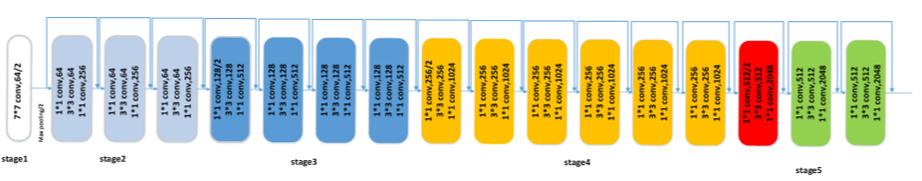
Figure 12 - ResNet-50 architecture

The dataset is passed to the model through the ImageDataGenerator class object from the keras library to perform augmentation on the given retinal images, which is composed of horizontal and vertical flip, rotation to 180 degree and finally rescaling. The resnet50 model built in this experiment is a pre-trained model with weights from ‘imagenet’ dataset to improve the accuracy achieved in addition to Global Average Pooling layer, Dropout layer to handle the overfitting set to 50%, Dense layer that has 1024 units and finally another Dropout layer that is also set to 50%. The model has all its layers initially restricted from training, the first top layers are the only layers that will be trained. Nevertheless, fine-tuning of the model is done subsequently and all the trainable layers are to be available to be trained afterwards. The next part is training all the layers including the added layers in this experiment. The hyperparameters set in this experiment are as follows:
- Batch size: 16
- Image height and width: 225
- Epochs: 10
- Learning rate: 1e-4
- Loss function: Categorical Cross Entropy

EfficientNetB5 model:
According to [28] it is proven that the efficientnet models outperforms the majority of the pre-trained model in accuracy metrics due their build structure. The research paper states that every version of the efficientnet from b0 to b7 excessivly surpasses in comparison to other pre-trained models such that efficientnet b0 is 4.9x smaller and 1.5% more accurate than the ResNet-50. The following figure will visually illustrates the mentioned above statisitcs:
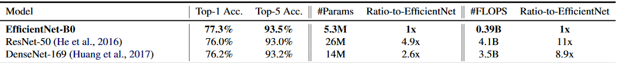
Figure 13 - Comparison of EfficientNetB0 and ResNet-50
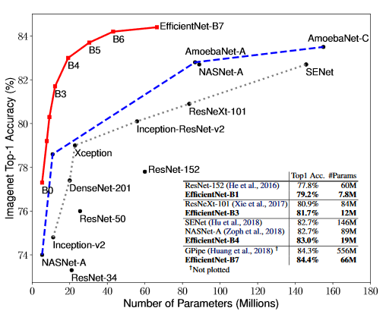
Figure 14 - Comparison of EfficientNet to other models
However, in this experiment, the pre-trained EfficientNetB5 will be used to classify the given retinal image. In addition to the pre-trained model layers, other layers will be combined to the original layers such as Global Average Pooling, Dropout set to 50% to handle the overfitting, Dense layer of 1024 units with activation function “ReLU”, another Dropout of 50% and finally the output Dense layer of 5 units and “softmax” activation function. The experimental EfficientNetB5 model will have all the layers restricted from being trainable and only the first top layers are allowed to be trained. The model will be fine-tuned and all the trainable layers will be available to be trained to improve accuracy. The hyperparameters of this experiment is:
- Batch size: 8
- Image height and width: 225
- Epochs: 10
- Learning rate: 1e-4
- Loss function: Categorical Cross Entropy

Logistic Regression with t-SNE model:
The Logistic Regression model as mentioned beforehand is based on the maximum likelihood method in classifying the different input data and classes fed to it by dividing the problem into multiple binary class classification problems and find the best probability given by each class through the logistic regression equation. Moreover, a method for visualization the multi-dimensional data for human observation is used termed t-SNE. The t-SNE method is short for T-distributed Stochastic Neighbour, it is a non-linear algorithm for dimensionality reduction of high dimensional data. According to [21] adding another method for dimensionality reduction overturn some noise and speeds up the computation pairwise distances from the given samples. Thus, another method for reducing the dimensionality of the given data is PCA. As stated in [29] The probabilistic model is implemented through the ‘score’ and ‘score_samples’ method. PCA is short for Principle Component Analysis which has a main task of removing the mean and scaling unit through standardizing the features given to it. Principle Component Analysis can be defined by “z = (x - u) / s”, where x denotes the number of samples passed, u denotes the mean of the training samples and s denotes the standard deviation of the training samples. Both u and s variables can be defined as zero or one with functions “with_mean=False” and “with_std=False” respectively. In this experiment the data is reshaped then transformed through the StandardScalar fitting function. Afterwards, the data are to be reduced in dimensionality by the PCA fitting function to represent the given features. Alternatively, to solve the imbalance problem of the dataset, class object SMOTE from the library ‘imblearn’ is called. According to [4] the SMOTE method functions by generating synthetic observations through the given minority existing observations. Subsequentially, the Logistic Regression is built with a “muilti_class = ‘ovr’” attribute to elaborate to the model to perform a binary classification method to each given label from the dataset to enhance and improve the accuracy.

Testing and evaluation

Testing
Testing this experimental project efficiency was through saving each model and model weights in files through function such as “model.save” and “model.save_weights”. The saved model and saved weights permit passing the model and its weights to the predict function. The “model.predict” function is used afterwards to predict a randomly given input array that has never been seen or used while training the model on such extracted features. The predict function verifies that the training phase and resulted accuracies and losses are correct and not randomly calculated to prove the models’ efficiency. This experiment also uses the “classification_report” function to verify the results.

Evaluation
The evaluation of this experiment is done by F1-Metrics and Confusion Matrix. F1-Metrics is considered to be proof of each class identification and how the model trained to recognize this class through its extracted features from the feature maps. The verification of the model is done through basic values such as, TP which stands for True Positive, TN which stands for True Negative, FP which stands for False Positive and finally FN which stands for False Negative. Accuracy is a vital evaluation metric as its assets the identification of the model to the positive and negative given data and can be calculated as follows:
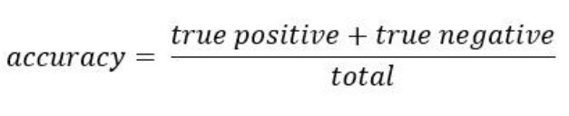
Equation 5 - Accuracy Equation
Precision is another important metric that verifies the model identification of the positive given data and can be calculated as follows:
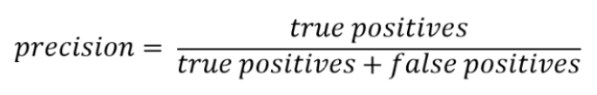
Equation 6 - Precision Equation

Recall is another equally important metric for evaluating the sensitivity of model towards positive given data and can be calculated as follows:
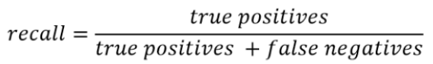
Equation 7 - Recall Equation

Result and Discussion

Results:

Xception Results:
The Xception model was trained to identify whether the given retinal image is healthy or show signs of Diabetic Retinopathy. Moreover, the achieved results were quite fascinating. The following table elaborates the detailed results.
Table 2 - Xception Results
Xception Results of Evaluation
Precision | 100%
Recall | 100%
F-Score | 100%
Accuracy | 97%

This model has been tested on 20 randomly selected retinal images to assure the training process worked correctly. The following Confusion matrix is to elaborate:
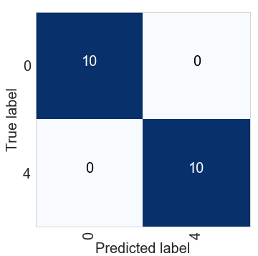
Figure 15 - Xception Confusion Matrix

Resnet-50 Results:
The Resnet-50 model was trained to classify between the 5 stages of the Diabetic Retinopathy through the given dataset and the results it achieved can be defined as the following:
Table 3 - ResNet-50 Results
Resnet-50 Results of Evaluation
Precision | 54%
Recall | 67%
F-Score | 55%
Accuracy | 79%

The model has been also tested on randomly selected set of images that varies in Diabetic Retinopathy grade to determine the efficiency and the Confusion matrix is as follows:
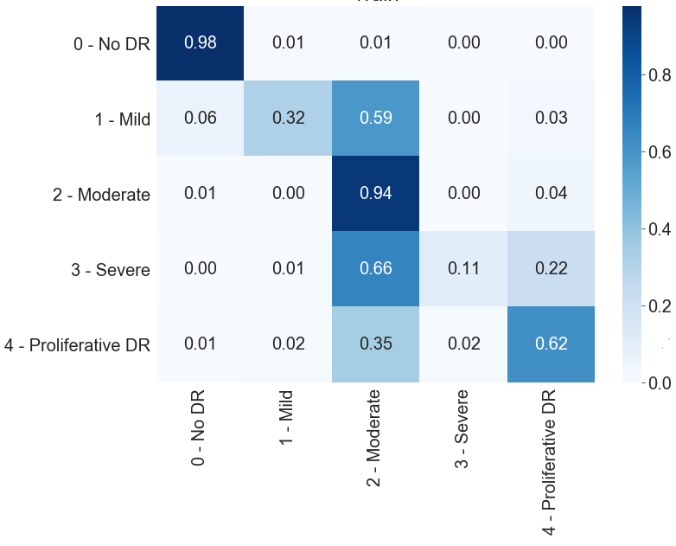
Figure 16 - Resnet-50 Confusion Matrix
The Severe grade can be easily misclassified as shown in the above Confusion matrix due to its insufficient number of images in the dataset even after the data augmentation done.

EfficientNetB5 Results:
The EfficientNetB5 was another model trained to classify the diseases’ five grades of severity through the same dataset and the results achieved can be elaborated as follows:
Table 4 - EfficientNetB5 Results
EfficientNetB5 Results of Evaluation
Precision | 70%
Recall | 75%
F-Score | 72%
Accuracy | 85%

To elaborate more on how each class is recognized by the model, the model has been given a randomly selected images that has never been seen by the model and the Confusion Matrix is as follows:
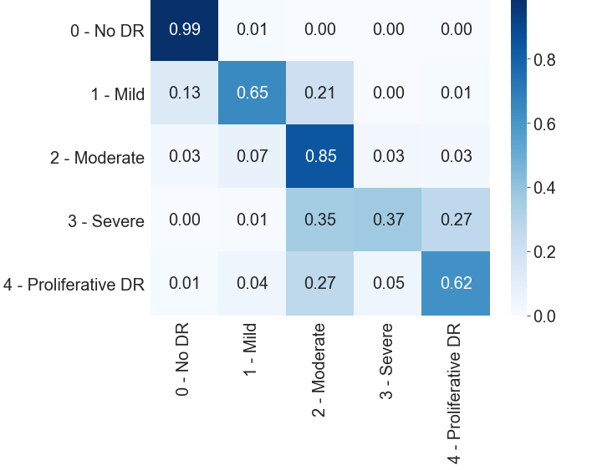
Figure 17 - EfficientNetB5 Confusion Matrix
The misclassification of the Severe grade of the disease in the past experimental model has been reduced and enhanced in this experimental model and better accuracy has been achieved.

Logistic Regression Results:
The Logistic Regression is to be trained also in this experiment on the same dataset, but the difference is fine-tuning of the dataset through PCA for feature extraction and SMOTE for balancing the Dataset across all given classes. The results are defined as the following:
Table 5 - LR Before Fine-tuning Table 6 - LR After fine-tuning
Logistic Regression Results of Evaluation (Before Fine-Tuning)
Precision | 33%
Recall | 32%
F-Score | 32%
Accuracy | 51%

Logistic Regression Results of Evaluation (After Fine-Tuning)
Precision | 93%
Recall | 95%
F-Score | 93%
Accuracy | 93%
The model has been tested for efficiency through passing randomly selected data and plotting a Confusion Matrix to see the difference. The Confusion Matrices are as follows:
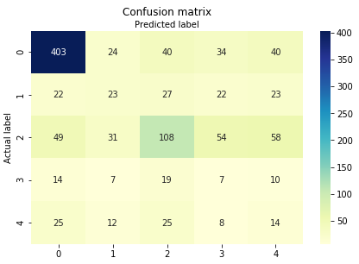
Figure 18 - LR Confusion Matrix before fine-tuning

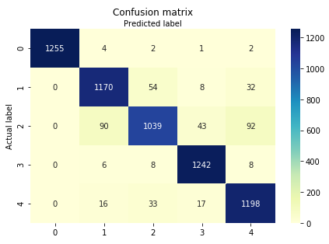
Figure 19 - LR Confusion Matrix after fine-tuning

The model training phase has been massively improved after the fine-tuning part was added to asses the training phase. The prediction of image sets proves that the model is not overfitting nor underfitting as the given images for prediction was randomly selected and non of them was processed by the model beforehand.

Discussions:
The results of each model experimented in the previous section was conducted through applying the exact hyperparameters that was stated in the implementation section of each model. The models were as follows: Xception that achieved 97% accuracy in the detection of whether the given image is healthy or affected by Diabetic Retinopathy. Resnet-50 that was experimented in the classification part of the project which achieved 79% test accuracy of the given retinal images and through the results, it was concluded that there was a huge misclassification in the Severe class with the moderate class. EfficientNetB5 was also experimented on the classification part of the project which achieved test accuracy of 85% on the given retinal images with enhanced misclassification from the Resnet-50 model. The last model experimented in this study was a machine learning model that termed Logistic Regression which achieved the highest test accuracy of 93% as it was enhanced with PCA in the feature extraction phase, SMOTE for over sampling the dataset and balancing and “ovr” attribute that allows the model to simplify each class given to Binary classification problem to achieve the best accuracy possible. All results can be visualized as:
Table 7 - Results Comparison
Model | Precision | Recall | F-Score | Accuracy
Xception | 100% | 100% | 100% | 97%
Resnet-50 | 54% | 67% | 55% | 79%
EfficientNetB5 | 70% | 75% | 72% | 85%
Logistic Regression | 93% | 95% | 93% | 93%

Conclusions and Future Work

Summary
In this study, the Diabetic Retinopathy disease is evaluated through trained deep learning model to detect and identify the disease from given retinal images. Dataset imbalance was an issue that has been solved in this study through data augmentation regarding the CNN models and SMOTE over sampling regarding the machine learning model. However, new pre-processing method was introduced that has been used from the winner of the Kaggle competition to enhance the experimented models’ accuracy in identifying and classifying the given retinal images. The models that conducted in this experiment was Xception, Resnet-50, EfficientNetB5 and Logistic Regression model. Moreover, each model has been optimized in a different way according to its layers and how the model extraction the features from the given dataset. The hyperparameters optimization played a vital role in improving the model’s performance through adding layers, configuring the Learning Rate, reducing the batch size and epochs, setting specific activation function to give the best accuracy the mentioned above models could get. The enhancement was achieved by the Logistic Regression model in the multiclass classification section as it reached 93% test accuracy and reduced the misclassification.

Future Work
In this study, memory and processing power was a huge factor regarding the limitation of running and experimenting the previously explained models. Models such as the EfficientNetb5 and Logistic Regression used massive memory allocation, processing power and time to train such models. The processing power and hardware limitation can be surpassed by using more powerful hardware to train such models thus reducing the time of training phase and improving the memory allocation. The imbalance of the dataset was also considered one of the limitations in this experiment throughout training every model as data augmentation is not precise enough as the images of new patients affected with different grades of the disease. The dataset imbalance limitation can be solved by using another benchmarked dataset that contains more samples of patients for each grade of the disease. This study of experimenting deep learning model for training on identifying or classification of Diabetic Retinopathy disease grades can be improved through mentioned above limitations solutions and through different deep learning models that requires more hardware processing power such as EfficientNetB7 which surpassed in its evaluation in comparison to other models as stated in [28].

References
[1] ALBAWI, S., Abed MOHAMMED, T., & AL-ZAWI, S. (2017). Understanding of a Convolutional Neural Network. International Conference on Engineering and Technology(ICET), (pp. 1-6). Antalya, Turkey .
[2] Bodapat, J. D., Naralasetti, V., Shareef, S. N., Hakak, S., Bilal, M., Maddikunta, P. K., & Jo, O. (2020). Blended Multi-Modal Deep ConvNet Features forDiabetic Retinopathy Severity Prediction. electronics. doi:10.3390/electronics906091
[3] Bravo, M. ́., & Arbel ́aez, P. A. (2017). Automatic Diabetic Retinopathy Classification. Universidad de los Andes.
[4] Chawla, N. V., Bowyer, K. W., Hall, L. O., & Kegelmeyer, W. P. (2002). SMOTE: Synthetic Minority Over-sampling Technique. Journal of Artificial Intelligence Research, 321–357.
[5] Chollet, F. (2017). Xception: Deep Learning with Depthwise Separable Convolutions. Computer Vision and Pattern Recognition.
[6] Dekhil, O., Naglah, A., Shaban, M., Ghazal, M., Taher, F., & Elbaz, A. (2019). Deep Learning Based Method for Computer AidedDiagnosis of Diabetic Retinopathy. IEEE International Conference on Imaging Systems and Techniques(IST) (pp. 1-4). IEEE Instrumentation and Measurement Society. doi:10.1109/ist48021.2019.9010333
[7] Deng, G., & Cahill, L. W. (1993). An Adaptive Gaussian Filter For Noise Reduction and Edge Detection. IEEE Conference Record Nuclear Science Symposium and Medical Image Conference, (pp. 1615-1619). Australia. doi:10.1109/nssmic.1993.373563
[8] Dondeti, V., Bodapati, J. D., Shareef, S. N., & Naralasetti, V. (2020). Deep Convolution Features in Non-linear Embedding Space for Fundus Image Classification. Revue d'Intelligence Artificielle, 307-313. doi:10.18280/ria.340308
[9] Dreiseitl, S., Ohno-Machado, L., Kittler, H., Vinterbo, S., Billhardt, H., & Binder, M. (2001). A Comparison of Machine Learning Methods for the Diagnosis ofPigmented Skin Lesions. Journal of Biomedical Informatics, 28-36. doi:10.1006/jbin.2001.10
[10] Fayemiwo , M., Akinboro , S., & Adepegba, O. (2018). Identification and Classification of Diabetic Retinopathy Using Machine Learning. Engineering and Technology, Vol. 1, 245-259.
[11] Hara, K., Saito, D., & Shouno, H. (2015). Analysis of Function of Rectified Linear Unit U sed in Deep learning. International Joint Conference on Neural Networks (IJCNN). doi:10.1109/ijcnn.2015.7280578
[12] He, K., Zhang, X., Ren, S., & Sun, J. (2016). Deep Residual Learning for Image Recognition. Computer Vision Foundation, 770-778.
[13] He, X., Liao, L., & Zhang, H. (2017). Neural Collaborative Filtering. Proceedings of the Twenty-Sixth International Joint Conference on Artificial Intelligence (IJCAI-17), (pp. 3203-3209). China.
[14] Hoffman, J. I. (2019). Logistic Regression Analysis. Basic Biostatistics for Medical and Biomedical Practitioners (Second Edition).
[15] Indolia, S., Goswami, K. A., Mishra, S. P., & Asopa, P. (2018). Conceptual Understanding of Convolutional Neural Network- A Deep Learning Approach. International Conference on Computational Intelligence and Data Science (ICCIDS 2018) (pp. 679–688). Delhi, India: ScienceDirect. doi:10.1016/j.procs.2018.05.069
[16] Ioffe, S., & Szegedy, C. (2015). Batch Normalization: Accelerating Deep Network Training byReducing Internal Covariate Shift. 1-11. doi:arXiv:1502.03167
[17] Karlik, B., & Olgac, A. V. (2010). Performance Analysis of Various Activation Functions in Generalized MLP Architectures of Neural Networks. International Journal of Artificial Intelligence and Expert Systems (IJAE), 1(4), 111 - 122.
[18] KOETTING, C. (2019). THE FOUR STAGES OF DIABETIC RETINOPATHY. ModernOptometry, 1-4.
[19] LeCun, Y., Bottou, L., Bengio, Y., & Haffner, P. (1998). Gradient-Based Learning Applied to Document Recognition. Proc. of IEEE.
[20] Lo, W. W., Yang, X., & Wang, Y. (2019). An Xception Convolutional Neural Network For Malware Classification With Transfer Learning. 2019 10th IFIP International Conference on New Technologies, Mobility and Security (NTMS), (pp. 1-5). doi:10.1109/ntms.2019.8763852
[21] Maaten, L. v., & Hinton, G. (2008). Visualizing Data using t-SNE. Journal of Machine Learning Research 9, 2579-2605.
[22] Macky , T. A., Khater , N., Al-Zamil, M. A., El Fishawy, H., & Soliman, M. M. (2011). Epidemiology of Diabetic Retinopathy in Egypt: A Hospital-Based Study. Ophthalmic Research, 73–78. doi:10.1159/000314876
[23] Mallinis, G., & Koutsias, N. (2008). Spectral and Spatial-Based Classification for Broad-Scale Land Cover Mapping Based on Logistic Regression. Sensors, 8067-8085. doi:10.3390/s8128067
[24] Mo, N., Yan, L., Zhu, R., & Xie, H. (2019). Class-Specific Anchor Based and Context-GuidedMulti-Class Object Detection in High ResolutionRemote Sensing Imagery with a ConvolutionalNeural Network. Remote Sensing. doi:10.3390/rs11030272
[25] Neal, R. M. (1992). Connectionist learning of belief networks. Artificial Intelligence 56, 71-113.
[26] Nwankpa, C. E., Ijomah, W., Gachagan, A., & Marshall, S. (2018). Activation Functions: Comparison of Trends inPractice and Research for Deep Learning. Machine Learning, 1-20. doi:1811.03378v1
[27] Sharma, S., & Mehra, R. (2019). Implications of Pooling Strategies in Convolutional Neural Networks: A Deep Insight. FOUNDATIONS OF COMPUTING AND DECISION SCIENCES, Vol. 44. doi:10.2478/fcds-2019-0016
[28] Tan, M., & Le, Q. V. (2019). EfficientNet: Rethinking Model Scaling for Convolutional Neural Networks. Proceedings of Machine Learning Research.
[29] Tipping, M. E., & Bishop, C. M. (1999). Probabilistic principal component analysis. Journal of the Royal Statistical Society: Series B (Statistical Methodology), 611-622. doi:10.1111/1467-9868.00196
[30] Yamaguchi, K., Sakamoto, K., Akabane, T., & Fujimoto, Y. (1990). A Neural Network for Speaker-Independent Isolated Word Recognition. First International Conference on Spoken Language Processing (ICSLP 90), (pp. 1077-1080). Kobe, Japan.

Appendix 1 – Dataset
The dataset provided in this experiment is publicly available at Kaggle website through the APTOS Competition. The captured retinal images are found to be the most up to date Diabetic Retinopathy dataset as it is dated 2019. The pre-processing method that was applied in this experiment was inspired by the winner of the competition who achieved the top test accuracy of 80%. The dataset files contain a csv file named “train.csv” that define each image’s grade of the disease. The dataset is divided into the five grades of the disease but divided in disproportion which all counts for 3662 images but as the healthy retinal eyes occupy 1805 which is 49.3% of the dataset. The other four Diabetic Retinopathy grades were divided into 999 (27.3%), 370 (10.1%), 295 (8.1%) and 193 (5.3%) for Moderate, Mild, Proliferative and Severe respectively. The dataset can be downloaded through the following link: https://www.kaggle.com/c/aptos2019-blindness-detection

Appendix 2 – Installation guide
Starting with the software used:
The used platform for running this experimental project was Anaconda 3.0 which can be downloaded from: https://www.anaconda.com/
The IDE used in this experiment was Spyder 3.6.6 which is included in the Anaconda 3.0 platform.
The Python version for running this code is 3.7.7.
The most important libraries used to run this project were:
- Tensorflow-GPU 2.1.0
- Keras-preprocessing 1.1.0
- Scikit-learn 0.23.1
- Tornado 4.5.3
- cuDNN 7.6.5
- CUDAtoolKit 10.1.243
- efficientnet 1.1.0
- Numpy 1.18.1
- OpenCV 4.2.0
- Pandas 1.0.3
- Pillow 7.1.2
- Matplotlib 3.1.3
- Seaborn 0.10.1
- Tqdm 4.46.0
Hardware used:
Model: Lenovo Legion Y520 Gaming laptop.
Specs: Core i7-7700HQ CPU @ 2.8GHz 7th Gen, 16GB RAM DDR4, NVIDIA GeForce GTX 1050-Ti.
Operating System: Windows 10 Pro 64bit.

