Homework #2

# Question 1

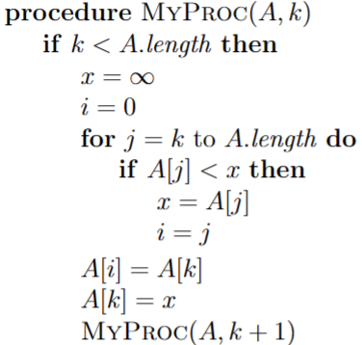

$$T\left(n\right)=\left\{\begin{aligned}c_{1}, &n=1 \\ T\left(n-1\right)+c_{2}(n-1) , &n>1\end{aligned}\right.$$

The time it takes to sort the remaining unsorted elements after the minimum element has been swapped into its proper position is represented by the first term in the recurrence, T(n-1), and the time it takes to scan the unsorted elements to find the next minimum element is represented by the second term, n-1. $c_{1}$ is the runtime during the base case.

# Question 2

$$MergeSort(A, 1, 4)$$

$$MergeSort(A, 1, 2)$$

$$MergeSort(A, 1, 1)$$

$$MergeSort(A, 2, 2)$$

$$MergeSort(A, 3, 4)$$

$$MergeSort(A, 3, 3)$$

$$MergeSort(A, 4, 4)$$

# Question 3

$$Ω\left(g\left(n\right)\right)=\{f\left(n\right):there exist positive constants c and n_{0} such that \\ 0≤c_{1}g\left(n\right)≤f\left(n\right) \\ for all n>n_{1}\}$$

$$O\left(g\left(n\right)\right)=\{f\left(n\right):there exist positive constants c and n_{0} such that \\ 0≤f\left(n\right)≤c_{2}g\left(n\right) \\ for all n>n_{2}$$

Combining both definitions, we get

$$0≤c_{1}g\left(n\right)≤f\left(n\right)≤c_{2}g\left(n\right) for n>max⁡(n1, n2)$$

Since $f\left(n\right)$ is bounded between $c_{1}g(n)$-best case- and $c_{2}g\left(n\right)$-worst case- and the above is the definition of $Θ-notation$

$$∴ the running time of an algorithm is Θ(g\left(n\right)) if and only if its worst-case running time is O(g(n)) and its best-case running time is Ω(g(n)).$$

# Question 4

## Definition

$$O\left(g\left(n\right)\right)=\{f\left(n\right):there exist positive constants c and n_{0} such that \\ 0≤f\left(n\right)≤cg\left(n\right) \\ for all n>n_{0}$$

## Solution

$$3nlg(n)≤cnln(n)$$

Let $c=3$ and $n_{0}=2$ and we observe that $0≤3nlg\left(n\right)≤cnln(n)$ holds for all $n≥n_{0}$

# Question 5

## Definition

$$o\left(g\left(n\right)\right)=\{f\left(n\right):there exist positive constants c>0, there exist a constant n_{0}>0 such that \\ 0≤f\left(n\right)<cg\left(n\right) \\ for all n>n_{0}$$

## Solution

$$100n^{2}<cn^{3}$$

$for all c>0, let n_{0}=\frac{100}{c}+1$ and we observe that $0≤100n^{2}<cn^{3}$ holds for all $n≥n_{0}$