Coursack UI/UX Design Document

1. Branding & Identity
This document outlines the planned UI/UX design system for Coursack, combining a professional, modern, and friendly visual identity.

Color Palette
Primary: #5B21B6
Secondary: #2563EB
Accent: #22C55E
Neutral: #F3F4F6 / #1F2937

Typography
Headings: 32px/24px bold
Body: 16px regular
Small text: 14px

2. Layout System
Grid width: 1200px
Spacing system: 8px grid
Border-radius: 12px
Card padding: 24px
Consistent shadows: 0 4px 20px rgba(0,0,0,0.06)

3. Component Library Overview
This section defines universal UI components: buttons, cards, inputs, navigation bars, tables, and dashboards.

4. Current UI Screenshots
The following screenshots represent the current state of the platform before applying the new design system.
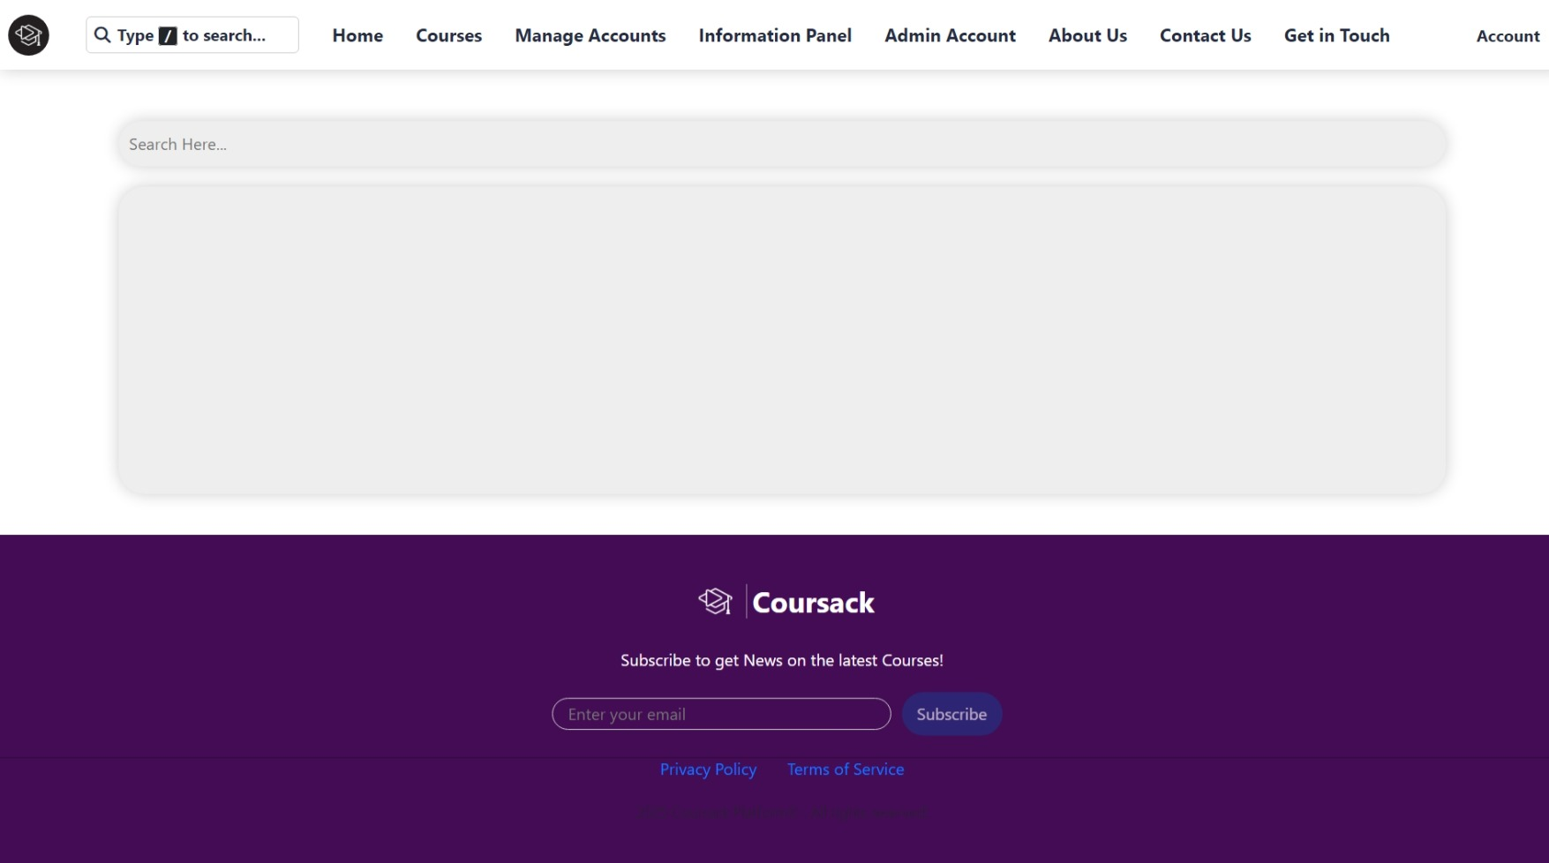
Screenshot_17-11-2025_212710_localhost.jpeg
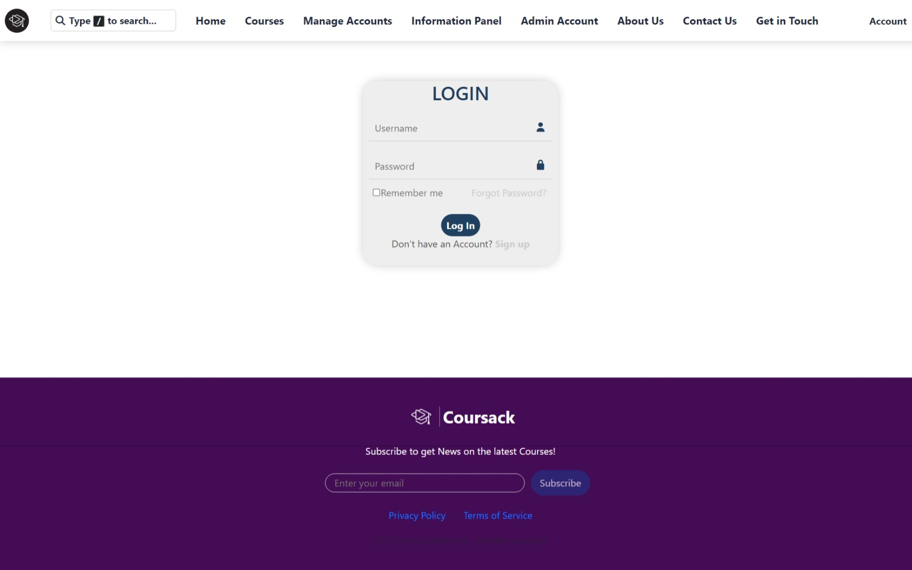
Screenshot_17-11-2025_21270_localhost.jpeg
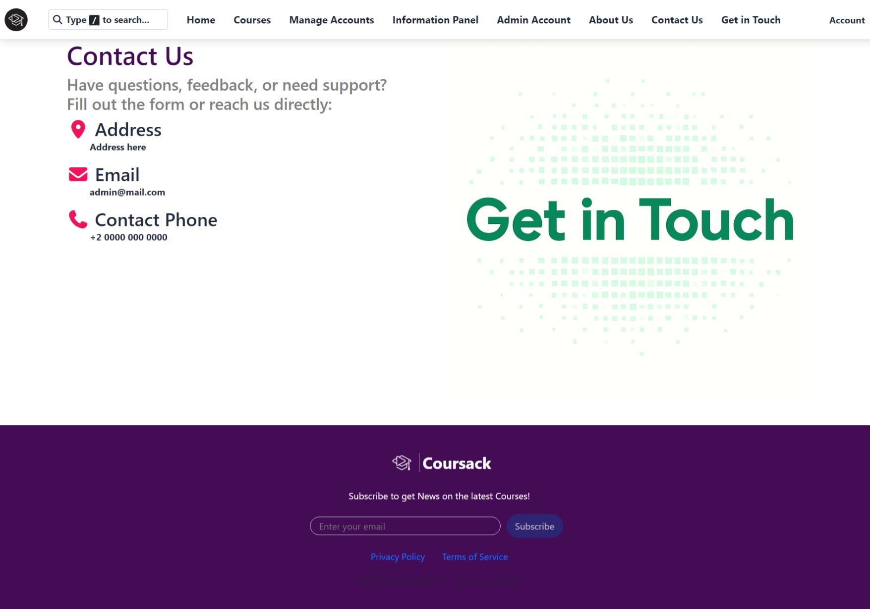
Screenshot_17-11-2025_212651_localhost.jpeg
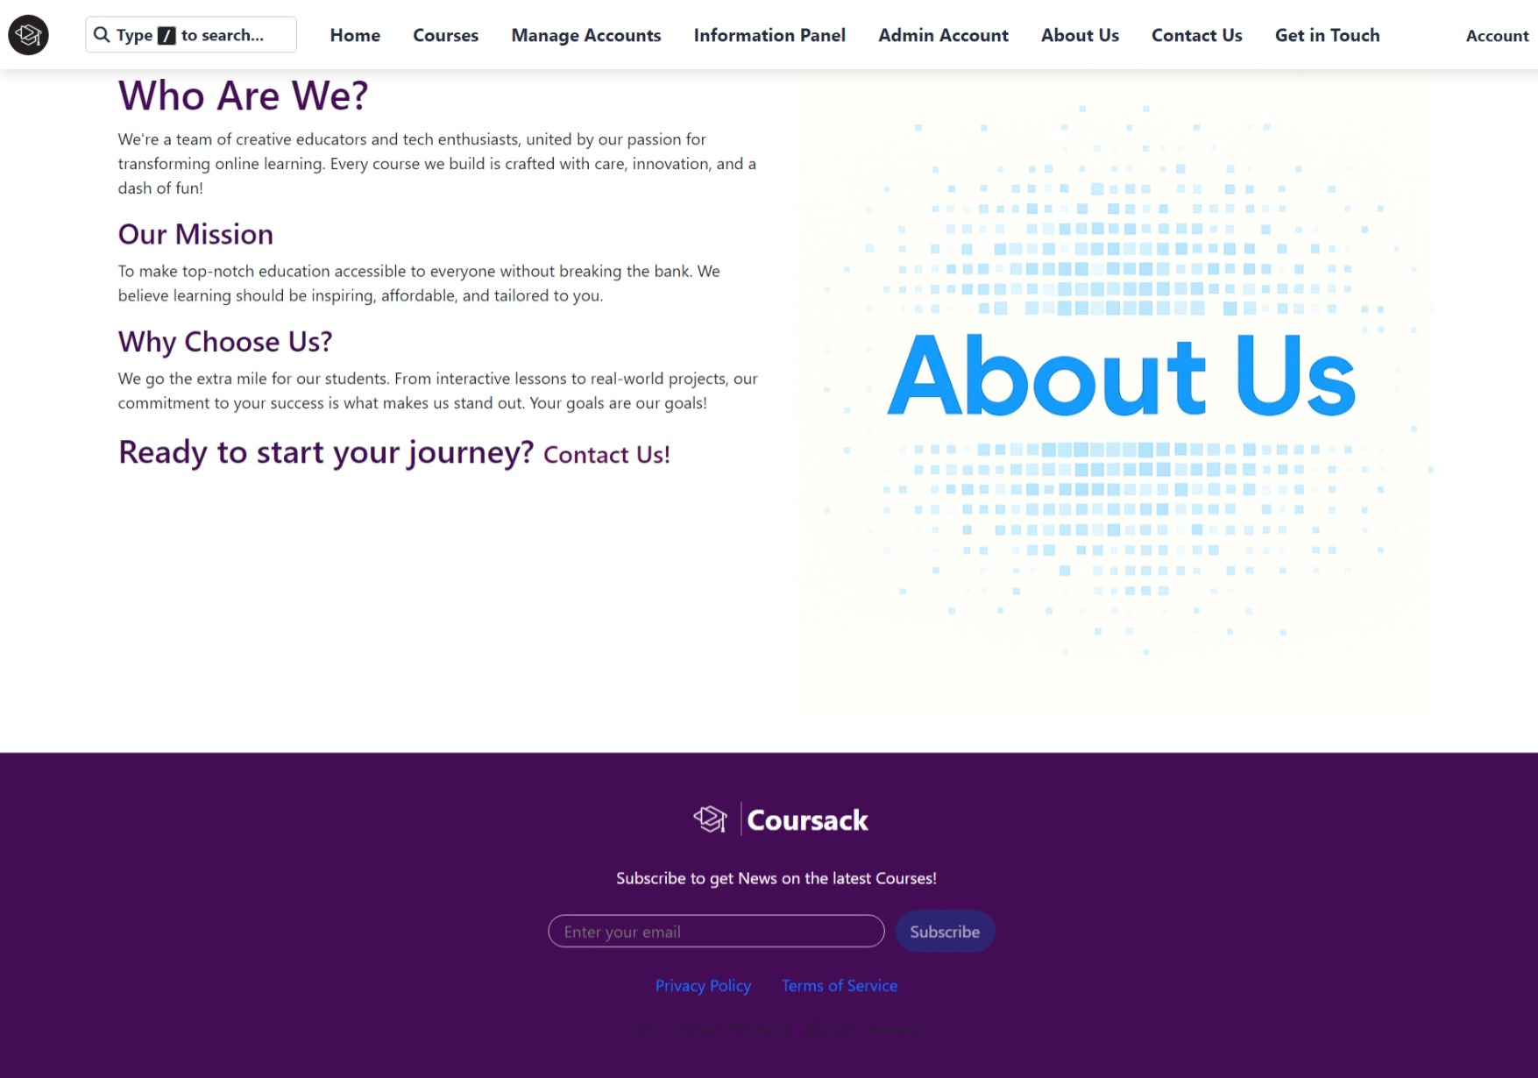
Screenshot_17-11-2025_212624_localhost.jpeg
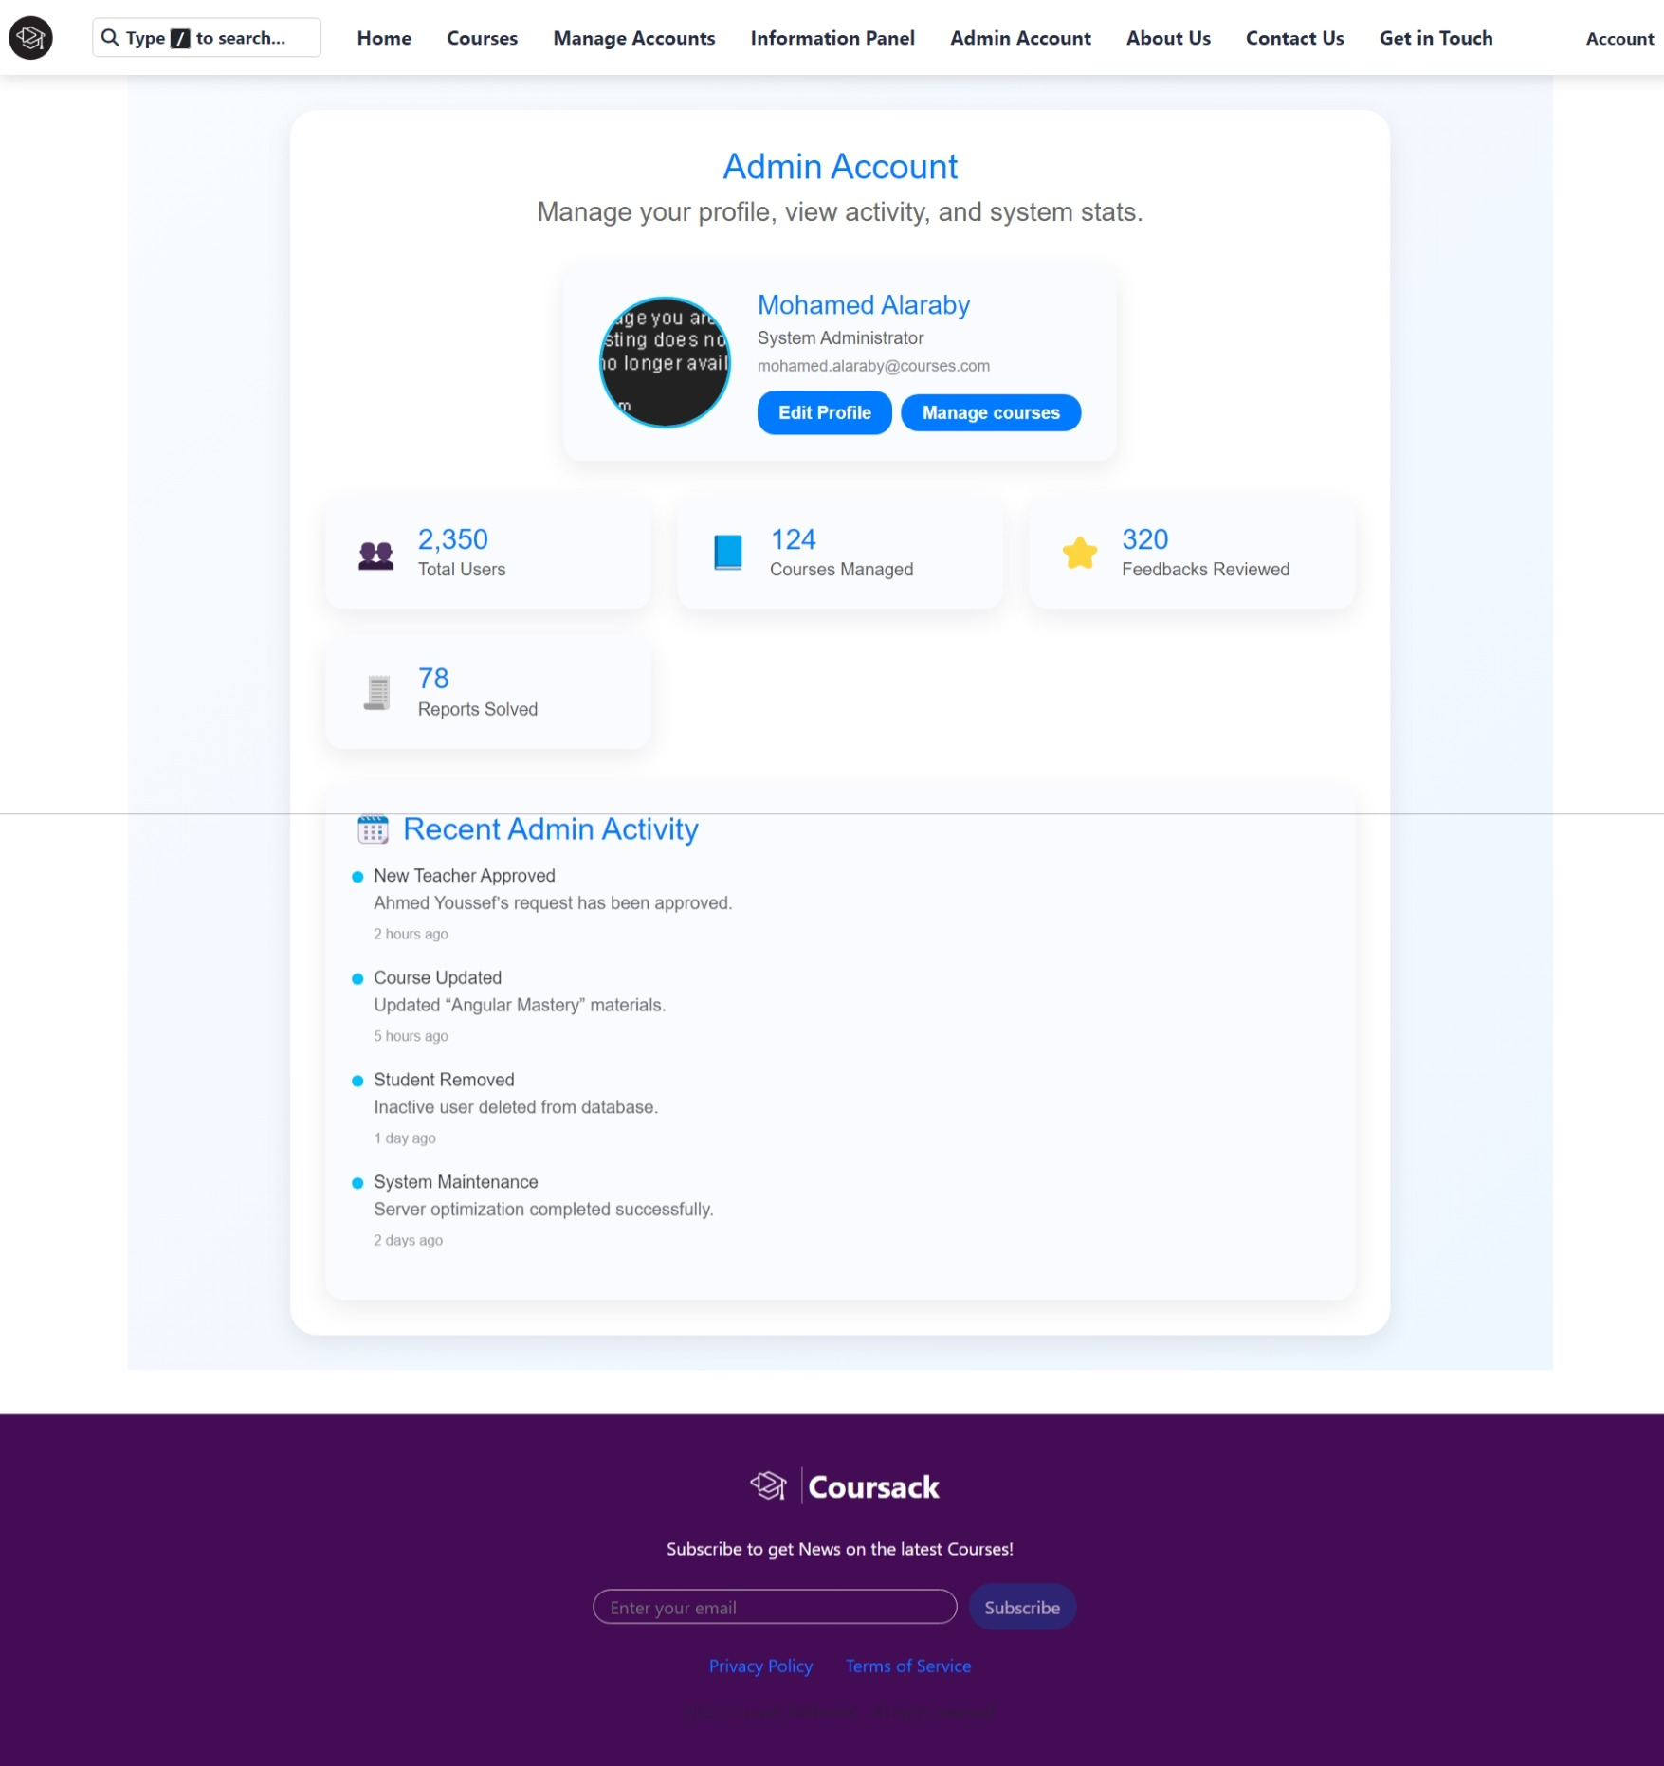
Screenshot_17-11-2025_212613_localhost.jpeg
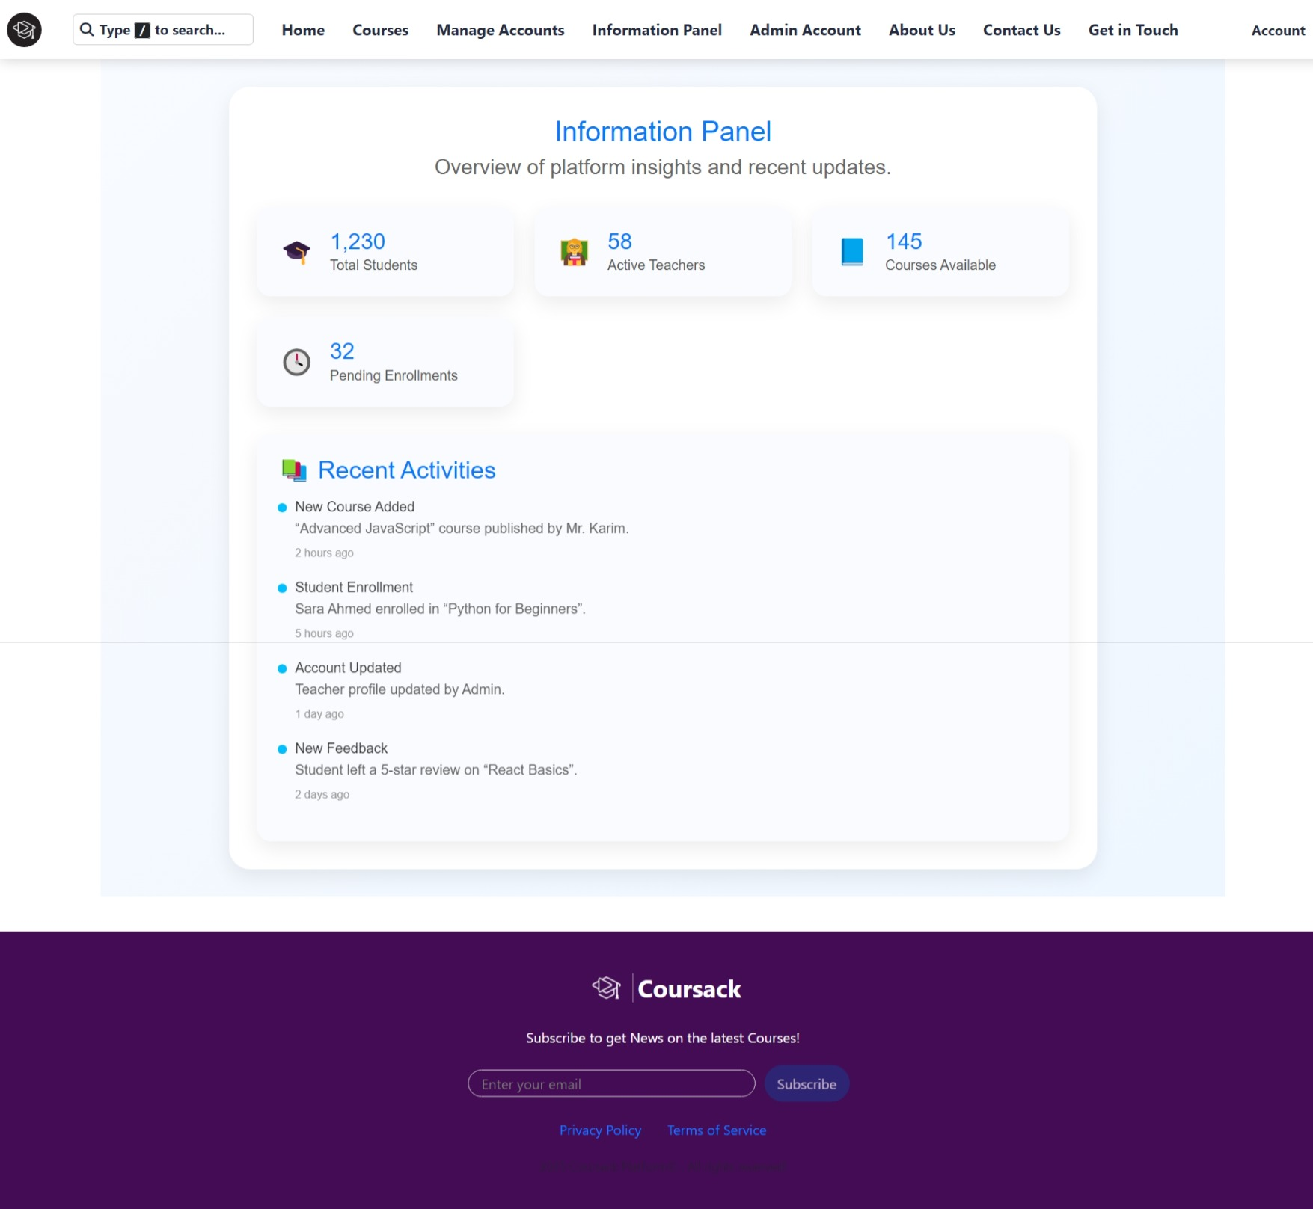
Screenshot_17-11-2025_21262_localhost.jpeg
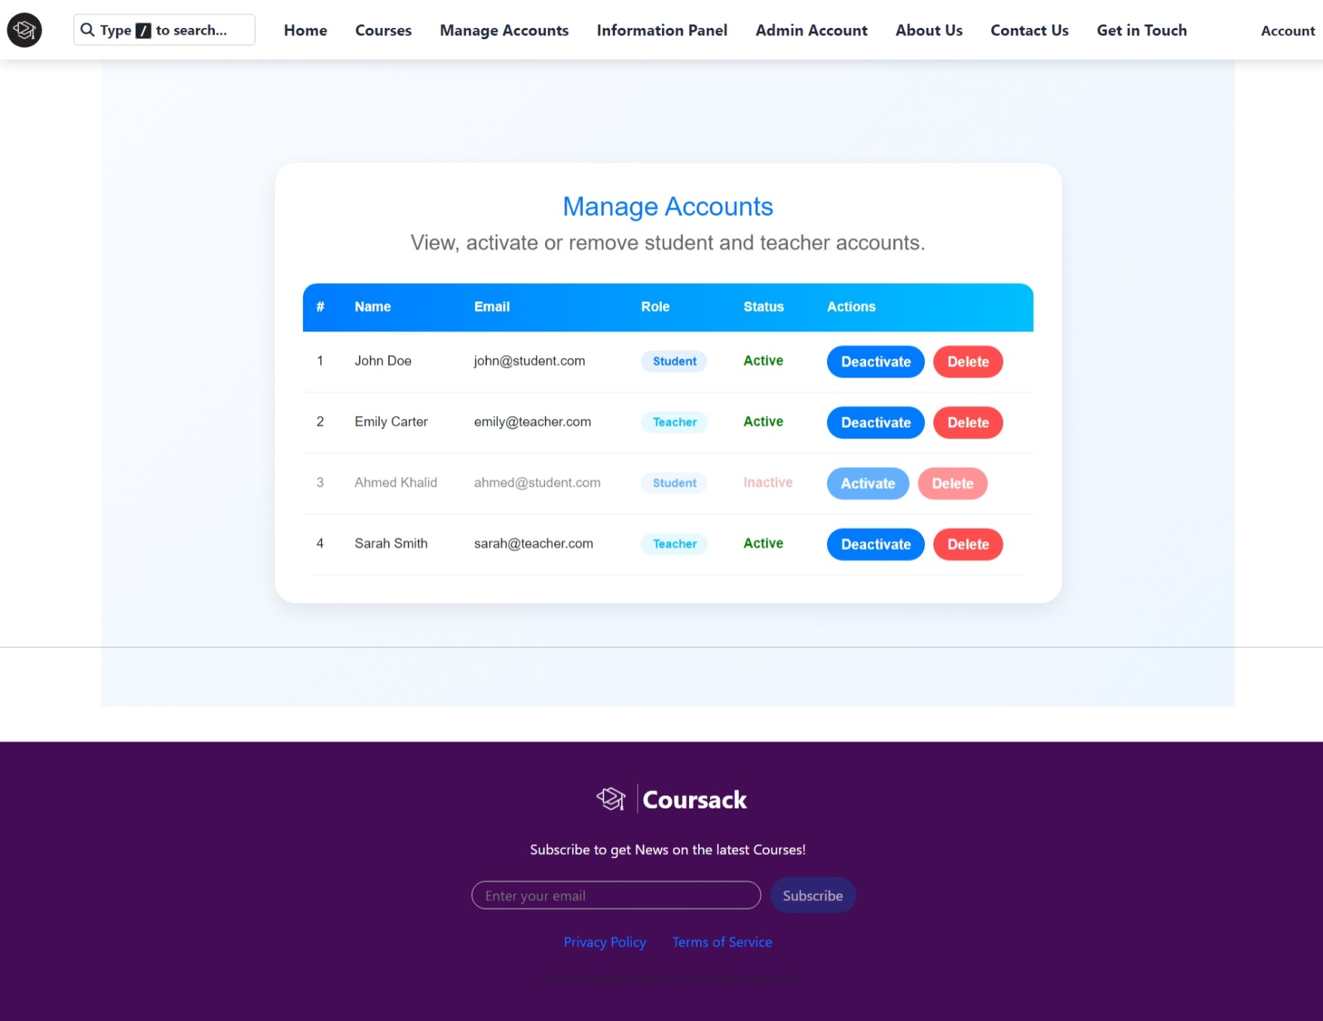
Screenshot_17-11-2025_212548_localhost.jpeg
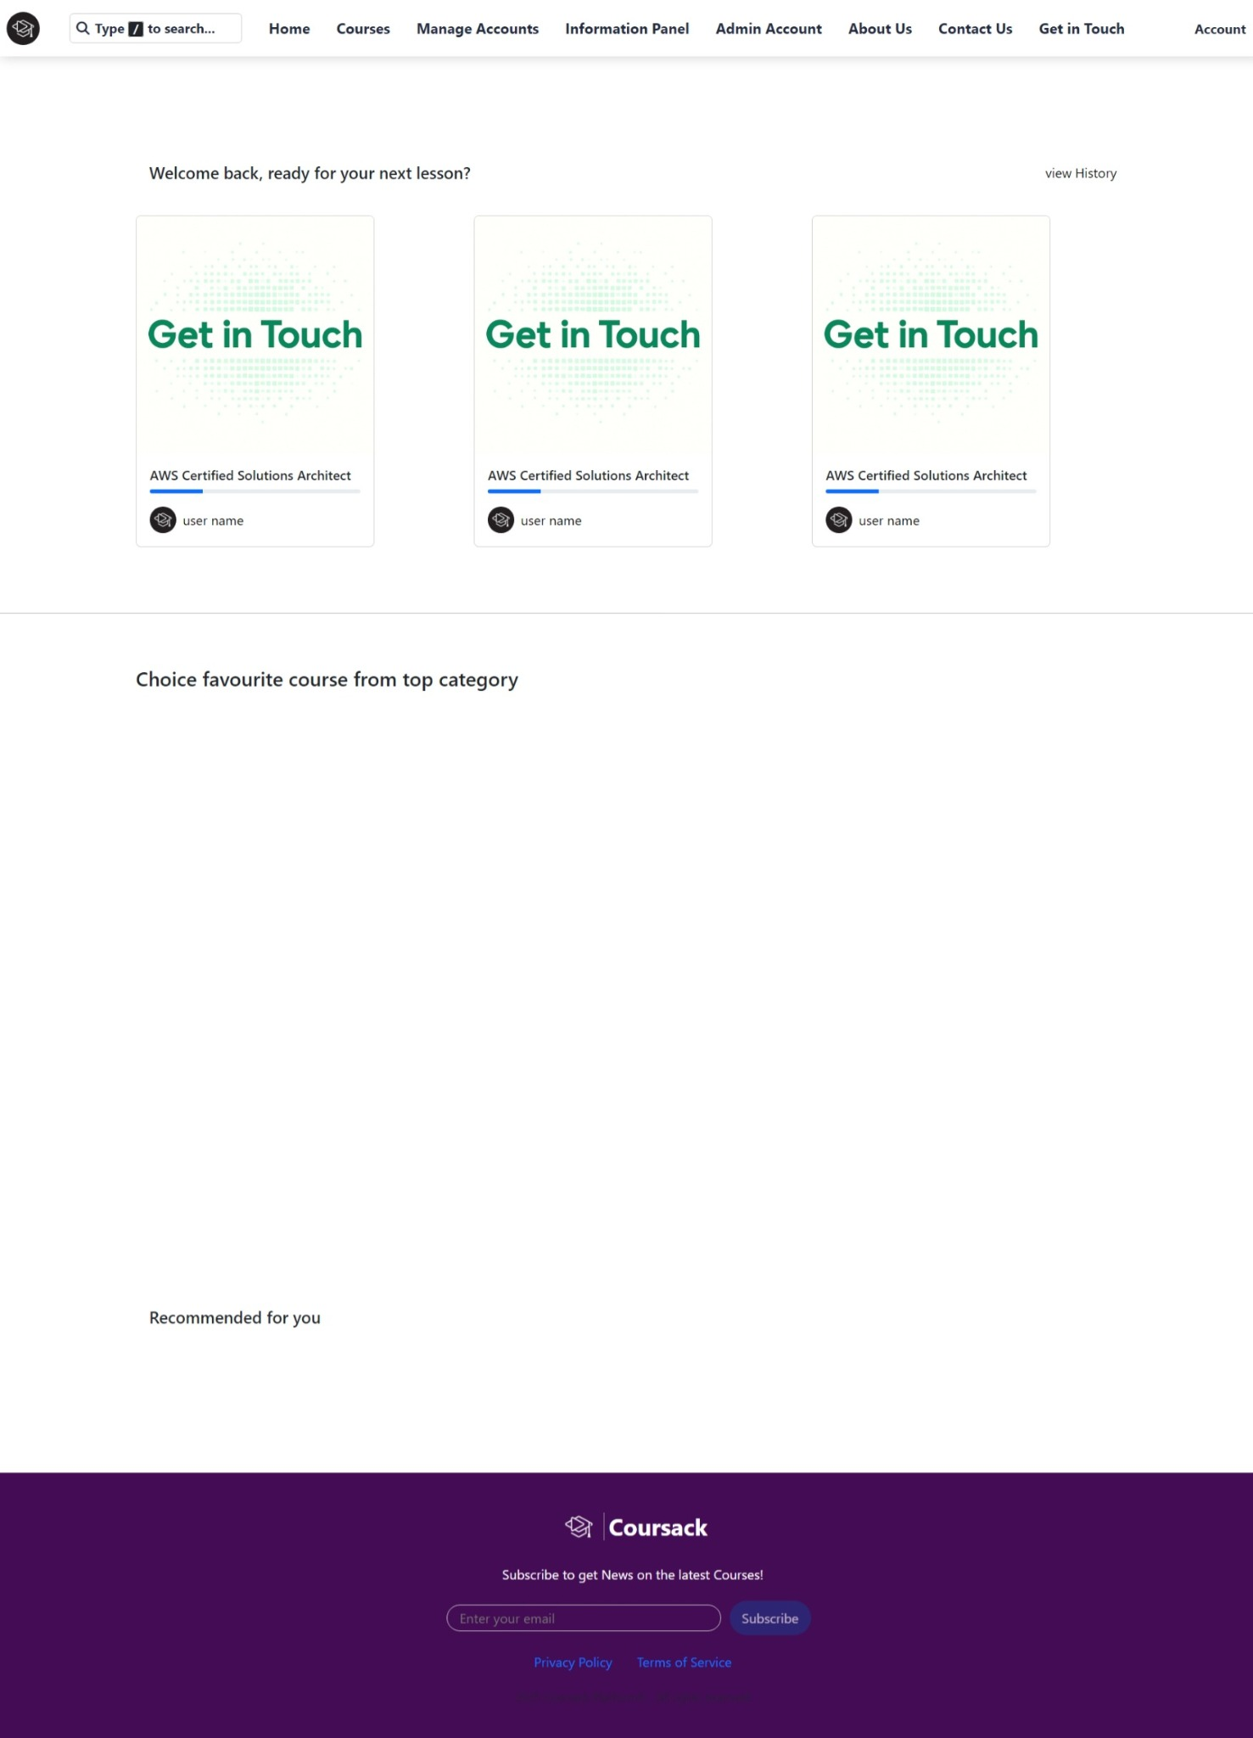
Screenshot_17-11-2025_212537_localhost.jpeg

Screenshot_17-11-2025_212524_localhost.jpeg

5. Wireframe & Redesign Principles
1. Cleaner navigation bar with fewer items.
2. Consistent card style across admin, teacher, and student dashboards.
3. Reduced footer height and unified color usage.
4. Standardized spacing and typography.
5. Improved contrast for forms, buttons, and inputs.

