# Adaptive Passivity Based Controller

x0=[-1 0.5];

tf=30;

lambda=1; %Lambda Square positive definite matrix for lyapanuv Based Controller.

kv=10; %Kv matrix.

L=[0.6 0 0;0 0.1 0;0 0 0.3]; %Symmetric Positive definite matrix

The values of L matrix has been deduced after many iterations to make the parameters error to converge to the original one, however, when I try it using different initial conditions it does not converge to the same extent. Example shown below with different initial state.

# Robust Inverse Dynamics Controller

gama=[10 10 10 10];

p=[1 0;0 1];

B=[0;1];

kp=40;

kd=30;

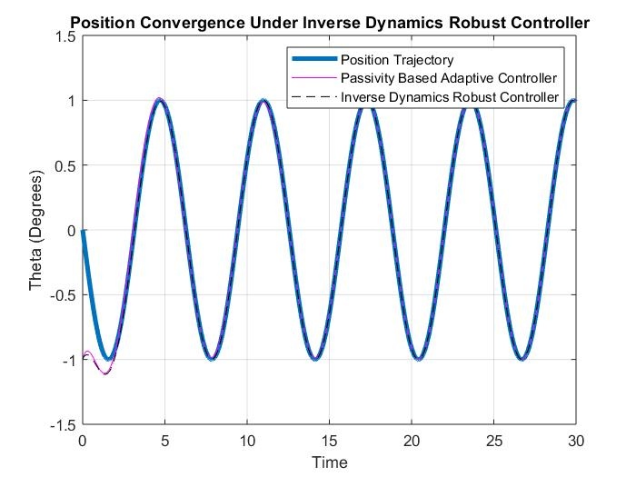

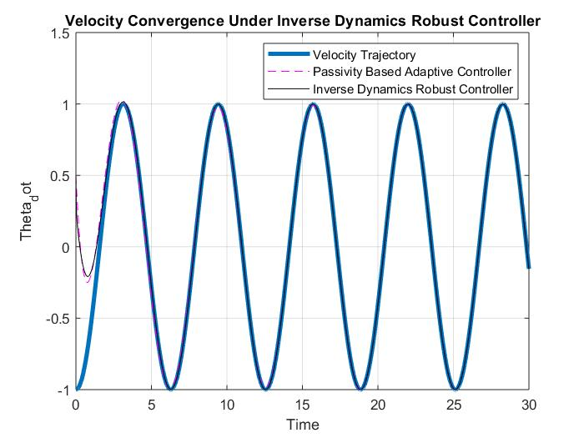

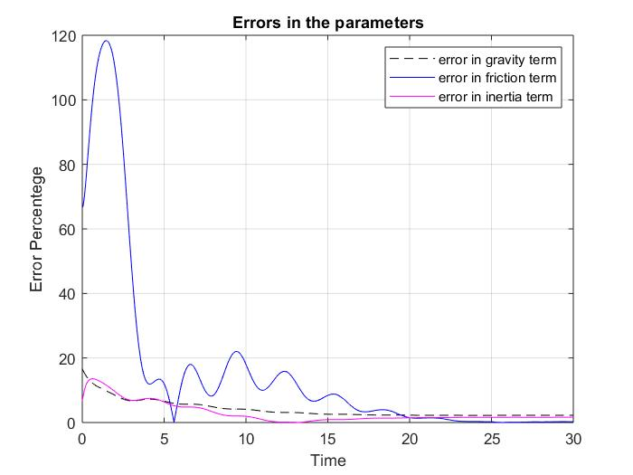

The input torque to the system using the **Adaptive Passivity Based Controller** . (plotted point by point) From a high level, we can observe that the profile goes to be like the desired trajectory which makes sense.

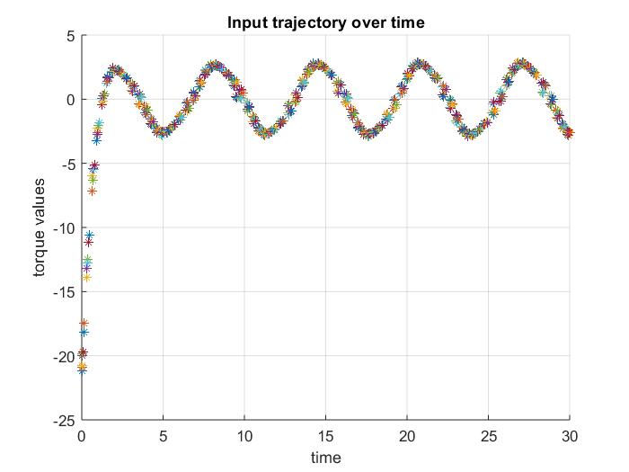

The input torque to the system using the **Robust Inverse Dynamics Controller**.

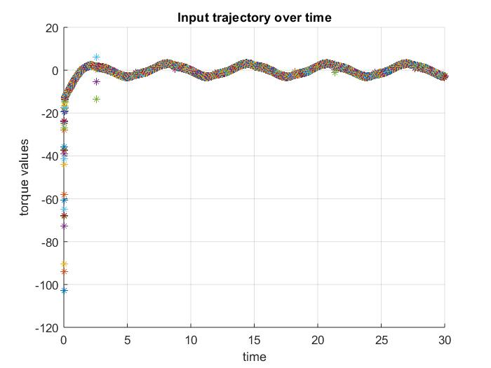

Although we can see here that there are points violating the disturbance bound of the robust controller, it can converge. So it is no a sufficient bound.

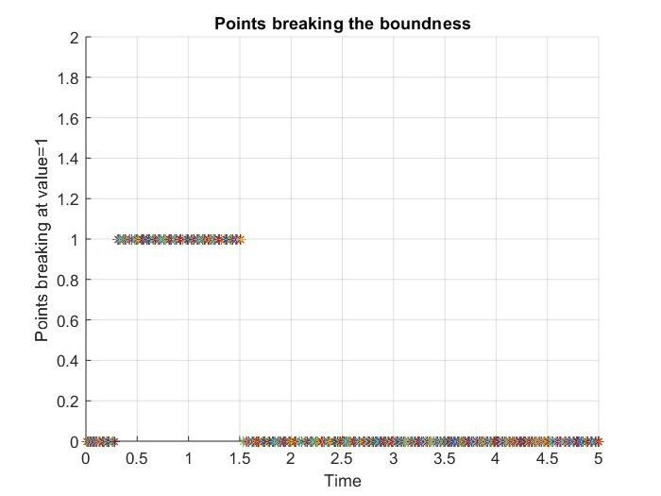

For x0=[-5 0.5];

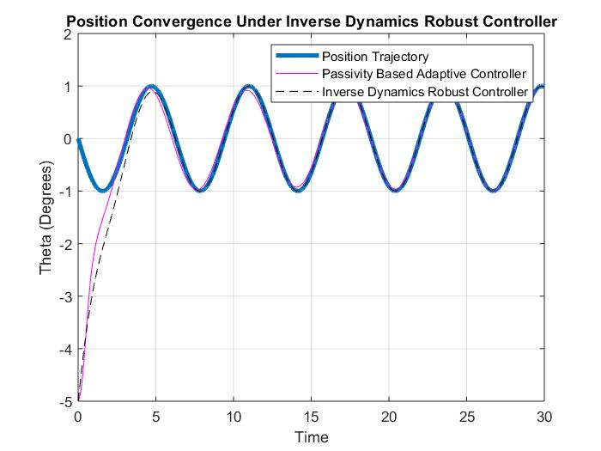

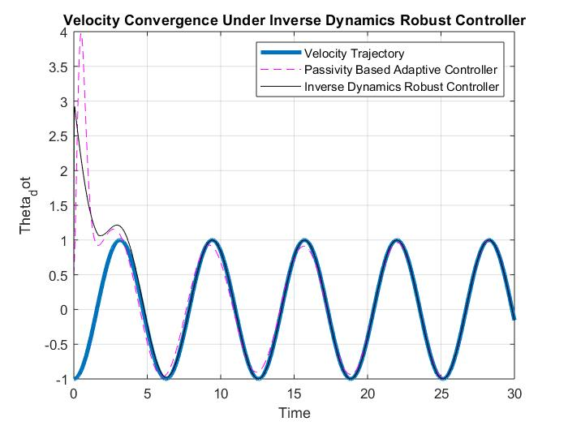

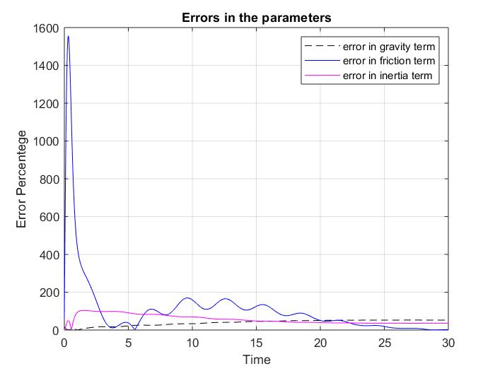

For the input trajectory, the same note: the input is following a sinusoidal trajectory according to the desired trajectory for the Adaptive Passivity Based Controller. We get The same we get for the robust inverse dynamics controller.

