1. Firstly admin should login with valid username and password regarding registered admins in tabled admin in the database.
2. If admin tried to login with invalid username and password, a Login failed message appears to him as shown in next image.

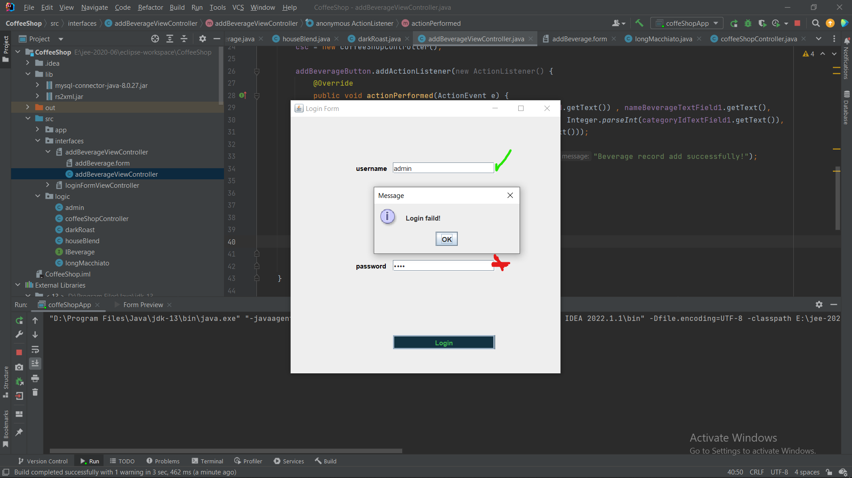

1. If an admin has entered a valid username and password, I have provided a simple case, as will appear to the admin a page which display available beverages with their info such as id, name, price and categoryId, and he can also add more beverages and save them to the database, as shown in next image admin logged in successfully and available beverages displayed to him.

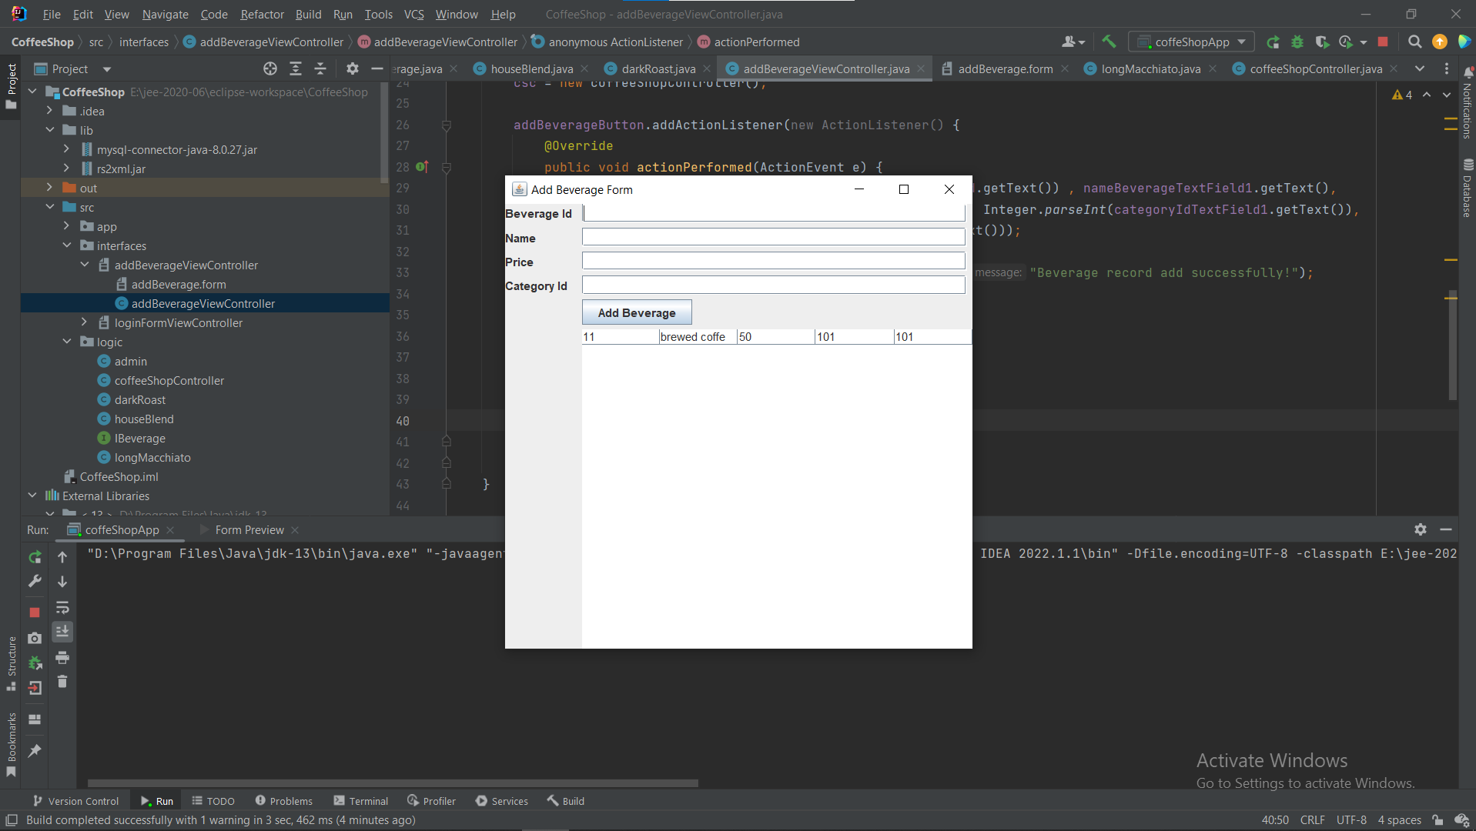

1. Admin can add more beverages with valid data.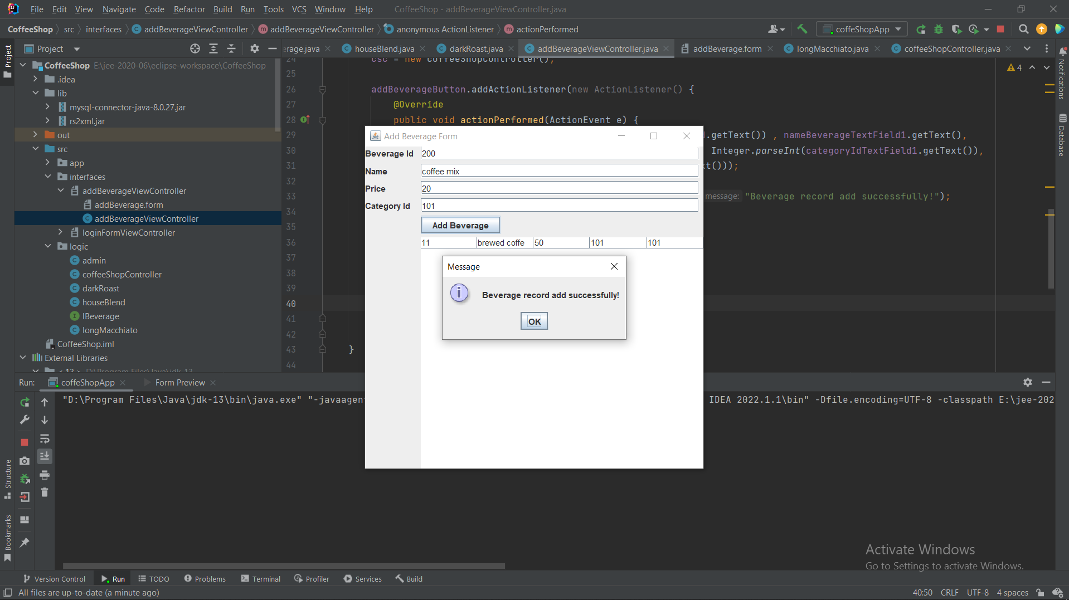
2. Records will be updated successfully.

