Report

**trials**:-

1. first we try the regular CNN model to train our data set with 20 epochs and get nearly 77% accuracy .
2. then as we increase the training picture size (from 50 till reach 150) the accuracy get higher(86%), we conclude that as higher the image size goes the model can learn well from the training data but in cost of the cost of the ram as higher sizes is very consuming in resources .
3. then we try to double the data-set number by using data augmentation but didn't really effect that much on the accuracy(87%) ,we conclude that data augmentation actually increase the accuracy a little bit ,but it's also ram consuming , and the most two affective operation in data augmentation is (zooming and cropping ) .
4. then we tried to train multiple models one continue after one (boosting) but unfortunately didn't also effect that much on the accuracy , we conclude that boosting is very time consuming and doesn't always work .
5. also we used early stopping technique to stop the model when best validation error is reached.
6. And also we plot both training and validation loss and training and validation accuracy to visually help us and to see how the training process goes and also see when the model falls into over fitting , from the plot we conclude that after epoch 25 the model start to over fit the data and the validation accuracy is getting worse.

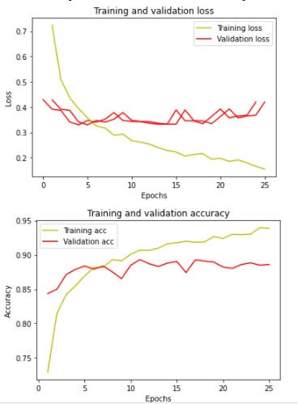

1. then we try to increase the model complexity by increasing the number of channels in each convolution layer and increase the number of layers but didn't improve the accuracy as we get (82%) , so we conclude that the more complex the model gets the more it cannot generalize new data (over fitting).
2. and we also tried to change the optimizer and the loss function but we found that Adam optimizer and categorical cross entropy loss function works well for this problem.

1. and we found that the best splitting percentage of the training data is (80% training 20% validate).
2. we tried to use transfer learning using vgg16 and build a simple model and tuning it with the vgg16 weights and we reach a 90% accuracy with that.

link of the project in google colab:-

https://colab.research.google.com/drive/1MGNXlydcYgFRoAd6NC_EZtLdbv5MM7kk?usp=sharing (the google colab link of the project).

|  |
| --- |
| أحمد كرم زكريا |
| مايكل عهدي بديع |
| مصطفى إبراهيم محمد |
| محمد وليد إبراهيم |
| حسن محمود محمود |