**Facial Pain Detection**

* **Dataset: The data used in this project is UNBC-McMaster shoulder pain expression which consists of** **nearly 48000 thousand frames extracted from videos of** **patient’s facial** **expression during** **treatment,** **it’s labeled from 0 to 10 as a pain scale.**
* **Data preparation process: The dataset** **consists of**

**- 400029 images of label 0 (No pain).**

**-3128 images of label 1.**  
 **-2351 images of label 2.**   
 **-1412 images of label 3.**  
 **-802 images of label 4.**  
 **-242 images of label 5.**  
 **-270 images of label 6.**  
 **-53 images of label 7.**  
 **-78 images of label 8.**  
 **-32 images of label 9.**  
 **-10 images of label 10.**  
 **so** **clearly, it is not balanced data and to balanced it we grouped all the pain images (above 0 label) into one label as1 (8369 images) and cut the no pain**

**images to 8471 images so it can be balanced and trainable, All images**

**resized to 250*250to reduce ram usage during training on colab.**

* **Model used: Regular CNN** **structural used with auto tuning on vgg16 neural network to boost model accuracy which reached 83% classifying 2****classes (Pain or no Pain).**
* **Training and testing time: Training** **Tooks about 30 minute to train on 13** **epochs and testing took about 2 seconds.**
* **Deploying part: The model deployed on desktop application made using Tkinter library with python.**
* **Colab** **notebook link: - https://colab.research.google.com/drive/1YGtCxL9L3EWq9bNehQv-hek71CGnkrWg?usp=share_link.**
* **Screen** **shoots: -**
* Model structural  
    
    
  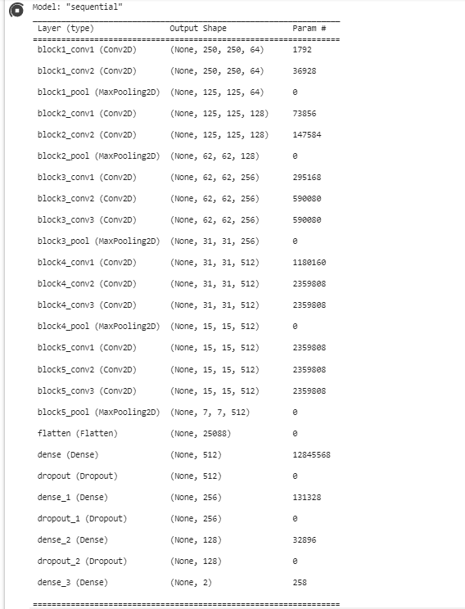
* **Training**

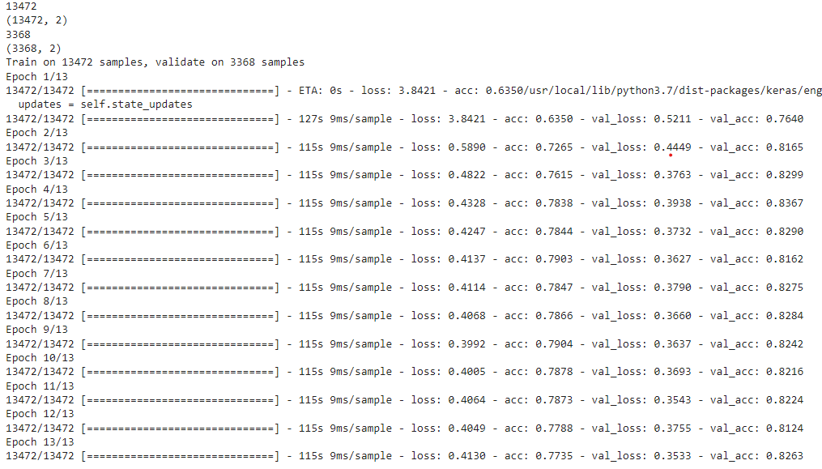

* **Model loss and accuracy**

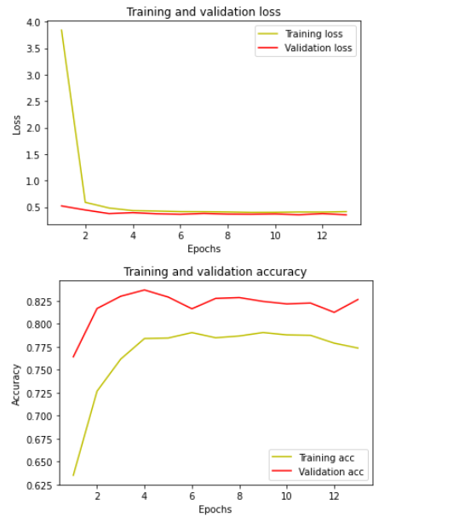

* **How to run** **it**:-  
  -open your visual code, open the project folder and inside your terminal write (pip install -r requirements.txt) to install the required library to run the project.  
    
  -run the UI.py file.
* **NOTES:** to obtain good accuracy the uploaded images and the captured images must be in excellent quality, otherwise the results will be inaccurate and to capture an image press the ‘’q’’ button**.**