Cyber Intelligence Frameworks and Active Cyber Defence
Technical Research Report
Mostafa Hosseini
Fundamentals of Cryptography and Network Security
Spring 2024

Abstract
This report investigates cyber intelligence as a structured way to collect, process and use information for protecting networks against cyber attacks. The work examines how information about a network, an adversary and an attack can be transformed into actionable intelligence, and how that intelligence can support active defence. The report studies the intelligence cycle, the Diamond Model, the Active Cyber Defence cycle, the operational levels of cyber intelligence, the cyber kill chain, and the use of artificial intelligence in intrusion detection and cybercrime defence. A central part of the project is the integration of attacker-focused and defender-focused views into one conceptual framework, so that adversary behaviour, infrastructure, capabilities, assets, incident response and network changes can be considered together.

Contents
1. Cyber intelligence and the intelligence cycle
2. The Diamond Model
3. Active Cyber Defence
4. Integrating the Diamond Model and Active Cyber Defence
5. Operational levels of cyber intelligence
6. Countering cyber attacks
7. Strategic, operational and tactical levels
8. Threat-defence alignment
9. Artificial intelligence for combating cybercrime
10. Conclusion
References

1. Cyber intelligence and the intelligence cycle
Cyber intelligence refers to the use of collected and processed information to understand cyber threats and support decisions before, during and after an attack. The main idea is that raw data is not enough by itself. It must be collected for a clear purpose, processed into a usable form, analysed, and then delivered to the people who need it.
A five-stage intelligence cycle can be described as follows:
1. Planning and direction: determine what information a person or organisation needs in order to achieve a specific objective.
2. Collection: gather the data required by the planning stage.
3. Processing: convert the collected material into a format that can be used and analysed.
4. Analysis and production: interpret the processed information and produce an intelligence product that answers the original questions.
5. Dissemination: deliver the resulting intelligence to the people or teams that need it.
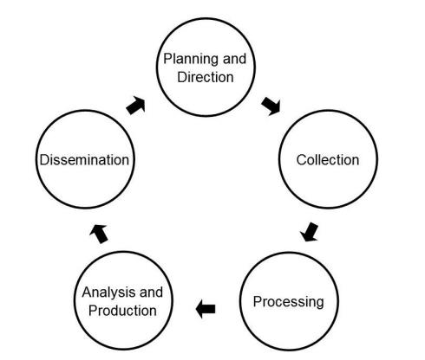
Figure 1. Five-stage intelligence cycle.
The analysis stage can also be shown in more detail. First, the context and the problem are defined. Then a hypothesis is generated, information is acquired and structured, the hypothesis is tested, and an assessment is made. The final assessment is communicated to decision makers. In this way, the process is iterative: if the evidence does not support the hypothesis, it can be refined and tested again.
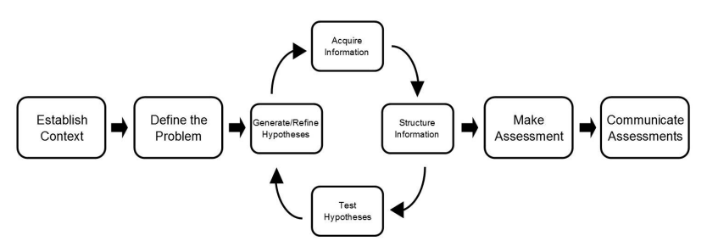
Figure 2. A detailed intelligence analysis process from context definition to communicated assessment.
The relationship between data, information and intelligence is important. Data is collected from the operational environment. Processing and exploitation convert that data into information. Analysis and production then turn the information into intelligence that can support action and decision making.
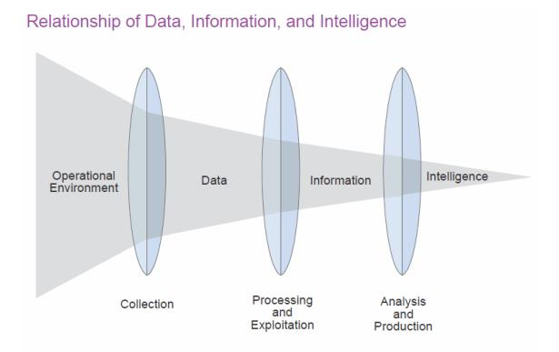
Figure 3. Relationship between the operational environment, data, information and intelligence.

2. The Diamond Model
The Diamond Model is an analytical framework for describing a cyber attack through four core elements: the adversary, capability, infrastructure and victim. These four elements form the vertices of a diamond and represent the main parts of an intrusion event.
The model can also include meta-features such as time, phase, result, direction, methodology and resources. These additional features help analysts connect separate events, identify common behaviour and reconstruct a threat chain. They can also support grouping or clustering of related attacks when several incidents share common features.
A major advantage of the Diamond Model is its flexibility. It can support strategic, operational and tactical analysis and can also be extended to include social and political factors, such as the relationship between the adversary and victim, victimology and the motivation behind an attack.
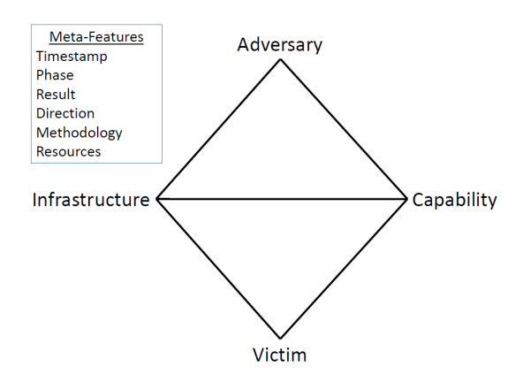
Figure 4. Core structure of the Diamond Model and its meta-features.

3. Active Cyber Defence
Active Cyber Defence provides an operational cycle for protecting a network. It combines several security activities that are often treated separately and places them in one continuous process. The cycle contains four main parts.
1. Asset identification and network security monitoring: understand the network architecture, devices, services and important assets, while monitoring the network for suspicious activity.
2. Threat intelligence consumption: identify threats that may affect the operating environment and use intelligence to understand the adversary.
3. Incident response: define and execute actions when an attack or threat is detected.
4. Threat and environment manipulation: change the environment in a controlled way to reduce the effect of an attack or make further attacker activity more difficult. This can include firewall changes, intrusion detection or prevention rules, malware analysis, and physical or logical changes to the network architecture.
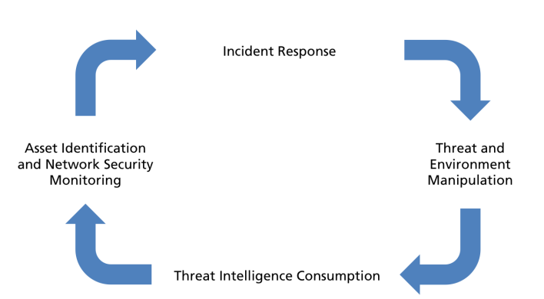
Figure 5. Active Cyber Defence cycle.
The importance of this cycle is that it offers a practical and integrated defensive strategy. It focuses on actions inside the defender's own network, which avoids the legal and national-security problems associated with unauthorised activity inside an attacker's network. It also defines the operational environment more clearly and therefore helps determine what intelligence is actually required.

4. Integrating the Diamond Model and Active Cyber Defence
The Diamond Model and Active Cyber Defence represent two different but complementary views. The Diamond Model is mainly an analytical model centred on the attacker and the relationships among adversary, infrastructure, capability and victim. Active Cyber Defence is centred on the defender and focuses on monitoring, response, threat intelligence and controlled changes to the network environment.
Combining these two views creates a more complete cyber-intelligence framework. The upper half of the diamond represents the intelligence view of the adversary. The lower half represents the operational view of the defender and victim. This allows both attacker behaviour and defensive capabilities to be examined in the same structure.
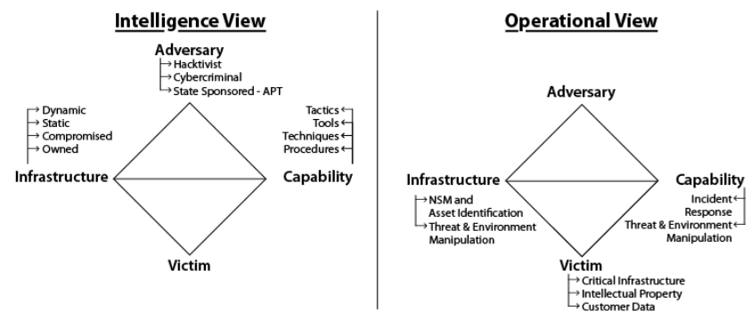
Figure 6. Intelligence view and operational view mapped to the Diamond Model.

4.1 Adversary-side view
On the adversary side, threat intelligence can be used to determine whether infrastructure is owned by the attacker or has been compromised, and whether it is used statically for long periods or changed dynamically to avoid detection. The attacker's capabilities can be described through tactics, techniques, tools and procedures. Social and political information can also be included to help identify likely motivations, such as hacktivism, cybercrime or state-sponsored activity.

4.2 Defender-side view
On the victim or defender side, the focus is on the remaining parts of the Active Cyber Defence cycle. Asset identification ensures that important devices and systems are known and monitored. Threat and environment manipulation may include changing firewall settings, updating intrusion detection or prevention rules, changing network architecture, or using static and dynamic malware analysis. Incident response defines the direct action taken after a threat is detected.
The integrated structure maintains situational awareness of both adversary activity and defensive capability. Infrastructure is viewed from both sides: the attacker may use owned, compromised, static or dynamic infrastructure, while the defender uses network security monitoring and asset identification. Capabilities are also viewed from both sides: the attacker has tactics, tools, techniques and procedures, while the defender has incident response and threat/environment manipulation. The adversary and victim remain the main opposing points of the model.
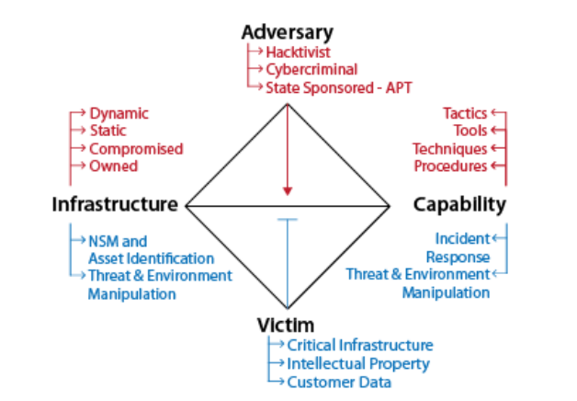
Figure 7. Integrated Diamond Model and Active Cyber Defence structure.

5. Operational levels of cyber intelligence
Cyber intelligence can be considered at strategic, operational and tactical levels. These levels are not fully separate and can overlap, but the distinction is useful for understanding how decisions and activities are organised.
Traditional cyber-security discussions often focus mainly on defensive technologies and reacting to intrusions. However, purely reactive protection is not enough against complex and changing threats. A stronger approach must also monitor the capabilities, intentions and activities of adversaries and use this information early enough to influence defensive decisions.
Cyber intelligence therefore requires three important conditions: a proactive security view, a comprehensive and timely understanding of the threat environment, and commitment to data-based decisions. The information sources can extend beyond the internal network and may include global cyber activity, organisational actions, political or geographic events, and human intelligence.

5.1 Understanding the attack process
A cyber attack can be understood through three general ideas:
- An attack is the result of a process of thought and behaviour that can often be understood and recognised.
- An attack results from interaction among the potential attacker, previous events, current conditions, the environment and the target.
- A key part of threat assessment is identifying behaviours that are related to an attack.
The cyber kill chain is an intelligence-based way of viewing an attack as a sequence of activities that an adversary must complete to create the intended effect. If the chain can be interrupted at any stage, the attacker may fail to achieve the objective. An important defensive goal is therefore to identify the chain early, lengthen the attacker's path, and create more opportunities to detect or stop the operation.
The speed of a cyber attack should not be understood only as the speed of data transmission. Planning may take days or weeks. The attacker must choose a target, select a method, prepare resources and infrastructure, and gather enough information before the attack begins.
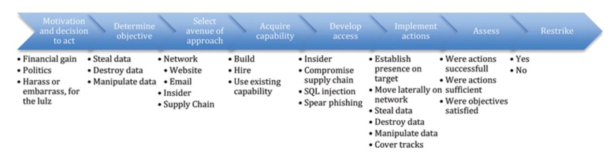
Figure 8. Example attack lifecycle from motivation and objective selection to execution and reassessment.
An intelligent defensive system should try to answer questions such as:
1. Who may attack the network, and what is the motivation?
2. What is the attacker's objective and what capabilities or equipment are available?
3. When may the attack happen?
4. From what point in the network may the attack begin?
5. What is the attacker's likely plan and sequence of actions?
Understanding motivation can support preventive decisions. For example, the motive may be theft of government information, financial gain, political influence, disruption or reputational damage. Defensive actions that anticipate these motives can make an attack more difficult or make another target more attractive to the attacker.

6. Countering cyber attacks
A cyber-defence system can choose different responses depending on the phase of the attack. The main response categories are detect, deny, disrupt, degrade, deceive and destroy. Reactive methods are applied after or during observable attack activity, while proactive methods try to influence the threat before the attacker reaches the final objective.
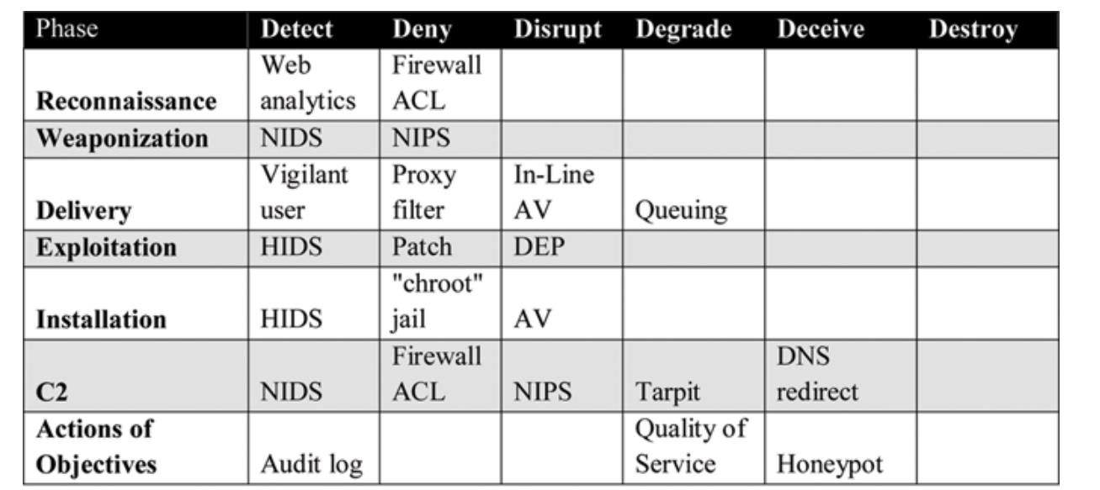
Figure 9. Reactive defensive actions mapped to phases of the cyber kill chain.
Important terms used in this context include:
- Reconnaissance: the pre-attack phase in which the attacker gathers information about the target.
- HIDS (Host-Based Intrusion Detection System): monitors events, messages and activity on a computer or server, logs behaviour and checks for suspicious or unauthorised access.
- NIDS (Network Intrusion Detection System): performs a similar function at network level rather than on a single host.
- C2 (Command and Control): the stage in which the attacker establishes communication with the compromised target.
The proactive defence matrix considers earlier stages such as motivation, objectives, avenue of approach, capability, access, action, assessment and re-strike. Possible responses include open-source intelligence, dynamic defence, insider-threat programmes, role-based access, deception, honeypots and public-relations or policy measures.
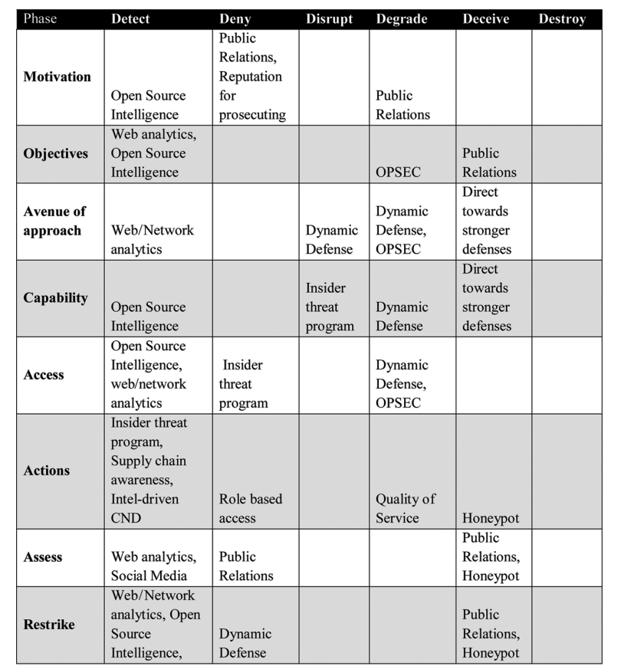
Figure 10. Proactive defensive actions mapped to attacker preparation and execution stages.
A honeypot is an example of a deception method. It attracts attacker attention to a controlled environment, allowing suspicious activity and unauthorised access attempts to be monitored. This can provide useful intelligence while protecting more important systems.

7. Strategic, operational and tactical levels

7.1 Strategic level
The strategic level concerns decisions that define the organisation's general direction, objectives and allocation of resources. Typical starting questions are: What do we have that an attacker may want? How valuable is it? How well is it protected? Network and security managers use these questions to decide what long-term actions are required.

7.2 Operational level
The operational level focuses on understanding how an attacker intends to carry out the attack. The main task is to follow the attacker's path, plan and capability development. Important areas include:
- analysing trends that show how attacker capability is changing;
- identifying the route selected through the target network;
- recognising when an attacker is building capability for a specific exploitation method;
- discovering the attacker's tactics, techniques and procedures;
- understanding the attacker's operational cycle, including decision making, preparation and command-and-control methods;
- identifying technical, social, legal, financial or other weaknesses of the attacker;
- collecting information that allows the defender to influence or disrupt the attack pathway.
The operational level is especially important for CIOs and CISOs. Monitoring should not be passive. It should go beyond detecting an intrusion and also examine the identity of the attacker, the reason for the attack and the method being used, so that an appropriate defence can be selected.

7.3 Tactical level
The tactical level is where plans are arranged and executed in the correct order so that individual actions support the overall objective. In cyber operations, this is the level where both attacker and defender apply their strategies directly. The attacker may collect, steal, delete or modify information, while the defender deploys technical controls and response actions. Much of day-to-day network security currently operates at this level.
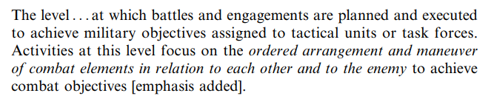
Figure 11. Definition of the tactical level as the ordered arrangement and execution of actions to achieve objectives.

8. Threat-defence alignment
Several frameworks extend the strategic-operational-tactical structure to align threat levels with appropriate defensive approaches. One example is the Cyber PREP model, which defines five threat levels and associates each level with a defensive posture.
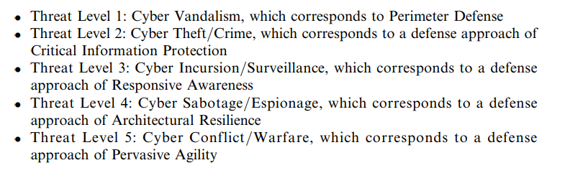
Figure 12. Cyber PREP threat levels and corresponding defensive approaches.
The five levels range from cyber vandalism and perimeter defence to cyber conflict or warfare and highly agile defence. Different organisations may respond differently to the same threat level, depending on assets, risk and operational requirements. Possible actions include changing file formats on public systems, introducing decoy hardware, using firewalls, and partitioning internal and external environments.
Another framework is Ned Moran's early-warning model for politically motivated attacks. It describes a progression from latent tensions to cyber reconnaissance, an initiating event, cyber mobilisation and finally cyber attack.
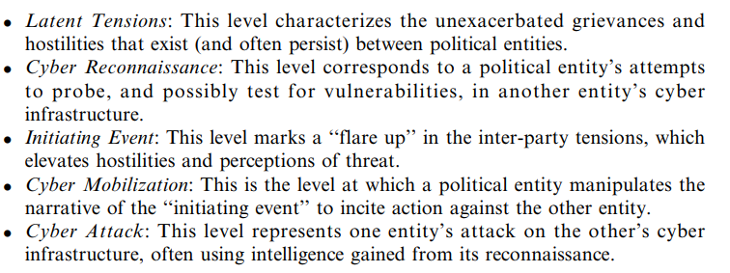
Figure 13. Early-warning stages for politically motivated cyber attacks.

9. Artificial intelligence for combating cybercrime
Traditional security tools such as antivirus software, firewalls, cryptography and secure protocols remain important, but attackers continue to develop new methods. Intrusion Detection and Prevention Systems (IDPS) are used to monitor networks, identify possible intrusions, analyse suspicious behaviour and respond to unauthorised activity.
An effective IDPS should support the following capabilities:
- real-time intrusion detection during an attack or immediately afterwards;
- low false-positive alarm rates;
- reduced need for constant human supervision and reliable continuous operation;
- recovery from accidental or attack-related system crashes;
- self-monitoring to identify attempts to modify or disable the detection system;
- compliance with the security policy of the monitored system;
- adaptation to changes in systems and user behaviour over time.
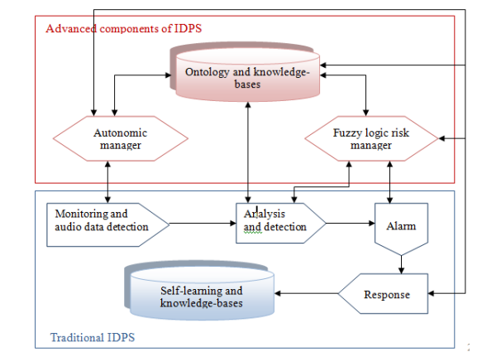
Figure 14. Example architecture combining traditional IDPS functions with autonomous management, knowledge bases and fuzzy risk management.

9.1 Neural networks
Artificial neural networks learn relationships from sample data by adjusting the weights between connected layers. After training, the model can classify new observations or detect patterns that differ from normal behaviour.
Examples reported in the field include NeuroNet, a neural-network-based system that collects and processes distributed information, coordinates key network devices, searches for anomalies and can start defensive actions. Tests reported effectiveness against low-rate TCP distributed denial-of-service attacks.
Other neural-network intrusion-detection systems have been designed to reduce false alerts and improve detection speed. One reported system achieved a similar intrusion-detection rate to existing approaches while detecting DoS attacks considerably faster.

9.2 Intelligent agents
Intelligent agents are autonomous software entities that can communicate, share information and cooperate to plan suitable responses to unexpected events. Their mobility and cooperative behaviour make them useful for distributed cyber-defence tasks.
One example is a multi-agent system designed to detect and contain computer worms in metropolitan networks. The system automatically limits worm propagation, including worms that consume large amounts of bandwidth and can cause router failures. Distributed agent systems have also been proposed for maintaining normal operation, applying security policies and responding to faults, insider threats and attacks in distributed power networks.

9.3 Genetic algorithms and fuzzy sets
Genetic algorithms can be used to learn anomaly detectors by searching for detection rules that distinguish suspicious behaviour from normal activity. Fuzzy systems can also support host-based intrusion detection when system calls and data-mining techniques are used to represent behaviour under uncertainty.
Reported benefits include reduced database size, lower computational complexity and fewer false alarms. More generally, AI-based methods can improve parallel information processing, adaptation, optimisation, distributed learning and the ability to detect complex nonlinear patterns.
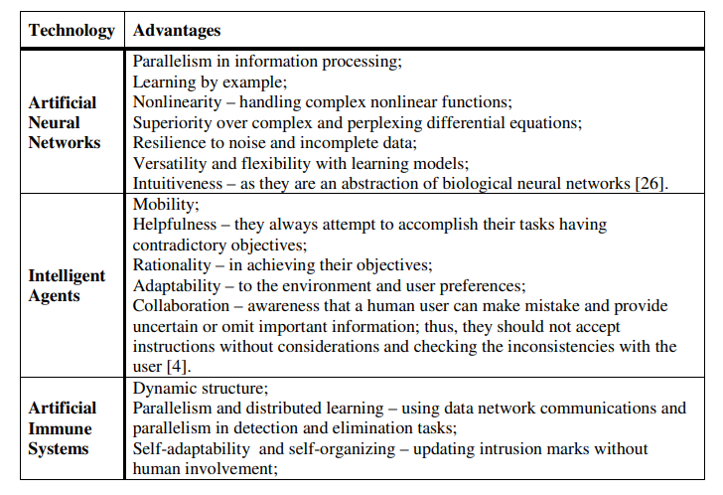
Figure 15. Reported advantages of neural networks, intelligent agents and artificial immune systems in cyber defence.
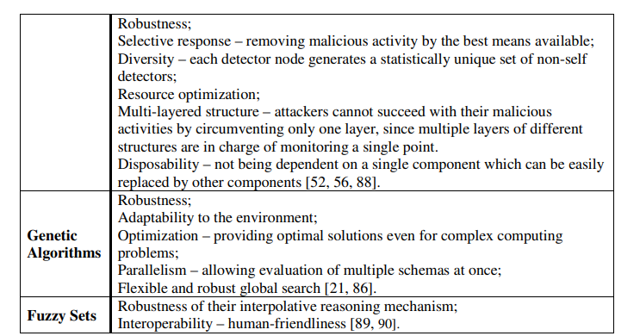
Figure 16. Reported advantages of genetic algorithms and fuzzy sets in cyber defence.

9.4 Limitations
The use of AI in intrusion detection also has practical limitations:
- An anomaly-detection system needs a sufficiently large training set of normal behaviour to learn a reliable model of normal operation.
- In heterogeneous environments, collecting consistent information from different sites and systems can be difficult.
- Intrusion-detection systems must also satisfy real-world legal requirements, security requirements and service-level agreements.

10. Conclusion
This project examined methods for improving cyber defence by turning collected information into actionable cyber intelligence. The most important idea is the timely use of information: intelligence should not only support passive analysis after an incident, but should also help identify threats early and support active defensive decisions.
The work analysed attack and defence from several complementary viewpoints. The intelligence cycle explains how raw data becomes a useful intelligence product. The Diamond Model describes the relationship among adversary, capability, infrastructure and victim. Active Cyber Defence provides an operational cycle for asset monitoring, threat intelligence, incident response and controlled manipulation of the environment.
The project then brought these ideas together into a single conceptual view that connects attacker-focused analysis with defender-focused operations. Strategic, operational and tactical levels were used to organise decisions, while reactive and proactive defence matrices showed how controls can be applied across different phases of an attack. Finally, AI methods such as neural networks, intelligent agents, genetic algorithms and fuzzy systems were examined as tools for intrusion detection and cybercrime defence.
The main conclusion is that strong cyber defence depends on combining technical monitoring with contextual intelligence. A defender should not only detect that an attack is happening, but also try to understand who may be responsible, what the objective is, how the attack is developing and where it can be interrupted.

References
- Mandt, E. J. "Integrating Cyber-Intelligence Analysis and Active Cyber-Defence Operations." Utica College, Utica, New York, USA.
- Mattern, T., Felker, J., Borum, R., and Bamford, G. "Operational Levels of Cyber Intelligence."
- Dilek, S., Çakır, H., and Aydın, M. "Applications of Artificial Intelligence Techniques to Combating Cyber Crimes: A Review."

