Project Documentation
Capacitive Coupling Electrodes: VNA Measurement of Coplanar-Plate Capacitance (0.3-300 MHz)

1. Initial Capacitor Design and Calculations
As the first step of the project, the expected capacitance of coplanar capacitors was estimated using an online calculator. Initially, two coplanar capacitors were used as the two ports. In the final application, these will be replaced by the sensor transmitter and receiver boards, which will be placed in different areas of the body.
The measurements in this document were generally carried out under three conditions:
- Through air.
- Through one hand.
- Through two hands.
Table 1. Estimated capacitance values from the online coplanar-capacitor calculator.
Width | Separation | Length | Permittivity | Capacitance
30 mm | 1 mm | 30 mm | 1 | 9.289×${10}^{-13}$
30 mm | 2 mm | 30 mm | 1 | 8.145×${10}^{-13}$
30 mm | 3 mm | 30 mm | 1 | 7.486×${10}^{-13}$
30 mm | 4 mm | 30 mm | 1 | 7.026×${10}^{-13}$
30 mm | 5 mm | 30 mm | 1 | 6.674×${10}^{-13}$
40 mm | 1 mm | 40 mm | 1 | 1.302×${10}^{-12}$
40 mm | 2 mm | 40 mm | 1 | 1.149×${10}^{-12}$
40 mm | 3 mm | 40 mm | 1 | 1.06×${10}^{-12}$
40 mm | 4 mm | 40 mm | 1 | 9.982×${10}^{-13}$
40 mm | 5 mm | 40 mm | 1 | 9.505×${10}^{-13}$
50 mm | 1 mm | 50 mm | 1 | 1.69×${10}^{-12}$
50 mm | 2 mm | 50 mm | 1 | 1.498×${10}^{-12}$
50 mm | 3 mm | 50 mm | 1 | 1.386×${10}^{-12}$
50 mm | 4 mm | 50 mm | 1 | 1.308×${10}^{-12}$
50 mm | 5 mm | 50 mm | 1 | 1.248×${10}^{-12}$
The following schematic shows the coplanar capacitor geometry used in these measurements.
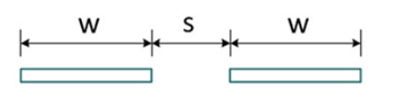
Figure 1. Schematic of the coplanar capacitor geometry used in the measurements.

2. Prototype Fabrication
After obtaining the estimated values, several coplanar-capacitor prototypes were fabricated to measure the actual values using the PicoVNA available in the laboratory. The prototypes are shown below.
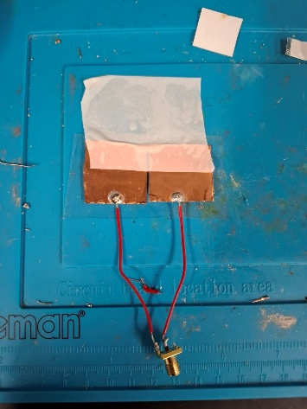 | 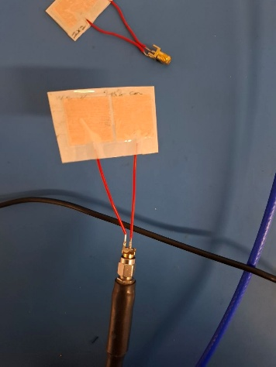 | 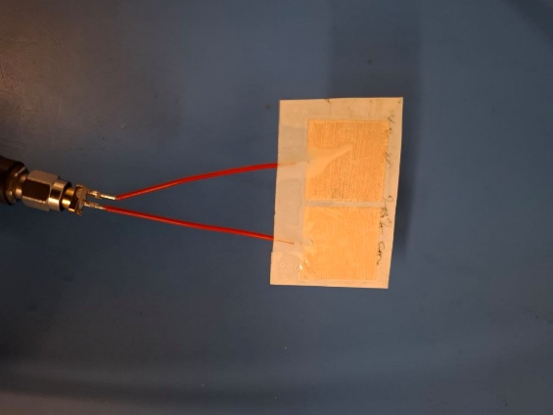
(a) 30 × 30 mm copper layers (thick copper). | (b) 20 × 20 mm copper tape (thin layers). | (c) Copper-foil prototype.
Figure 2. Coplanar capacitor prototypes fabricated in the laboratory.
The wires were soldered to the plates and to the VNA port. A plastic layer was placed over the plates to hold them in position.
Note. All capacitor prototypes were initially intended to be made using copper tape. However, no copper tape wider than 2 cm was available, even on the 7th floor. Therefore, regular copper foil was used to make the 30 × 30 mm plates.

3. VNA Measurements
The measurements were carried out in two groups. First, the capacitance of each prototype was measured using one VNA port. This was done to identify the capacitance and determine the inductance values required for impedance matching in the next step.

3.1 One-Port Measurements
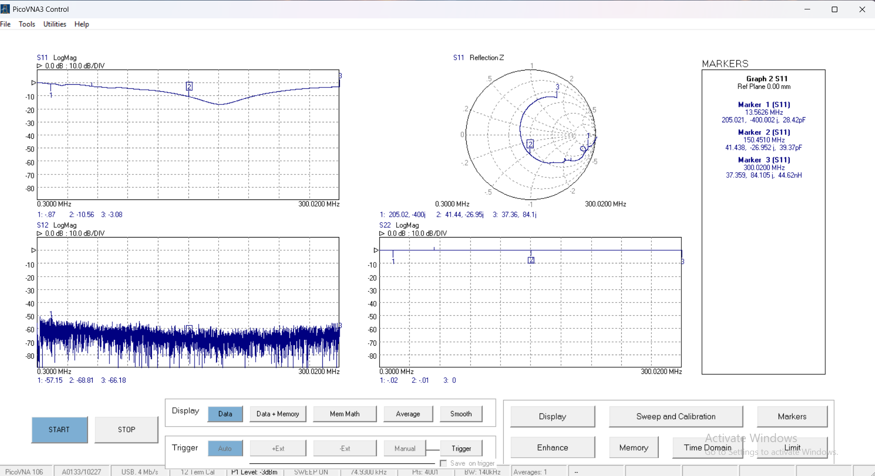 | 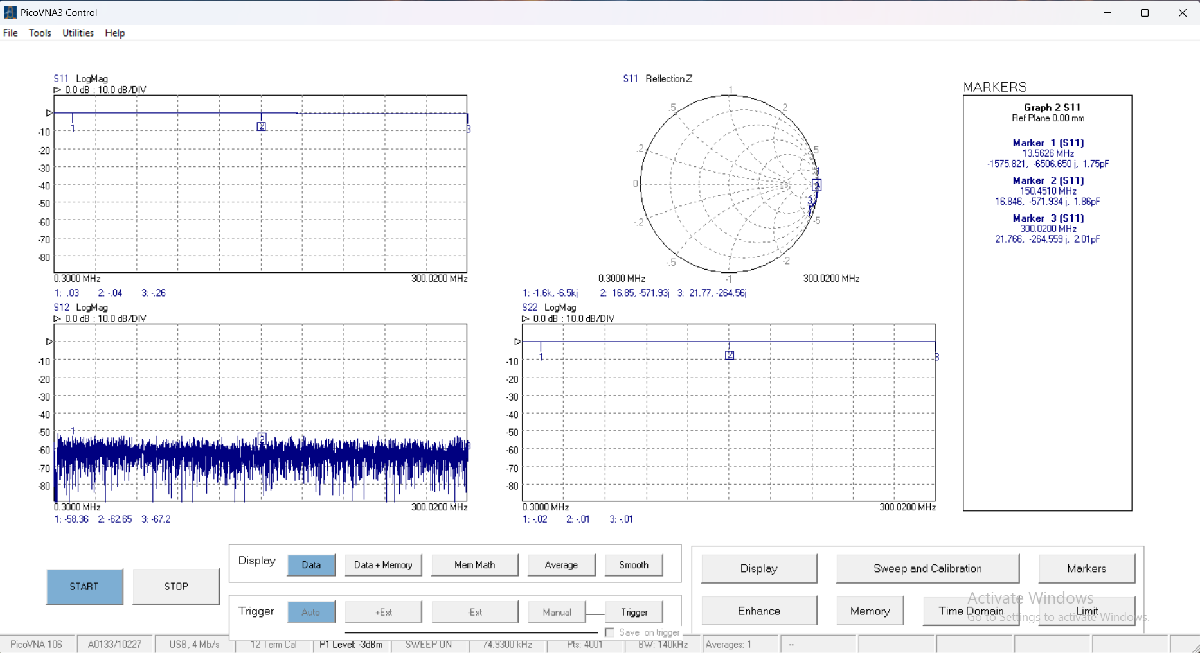
(a) Plates placed on the arm. | (b) Measurement in air.
Figure 3. VNA results for Port 1 using the 20 × 20 mm copper-tape prototype, marked at 13.5 MHz, 150 MHz, and 300 MHz.
The capacitance in air is approximately 2 pF, which is close to the pre-calculated values. After the plates were placed on the skin, the capacitance increased to approximately 30 pF before the response moved into the inductive region of the Smith chart.
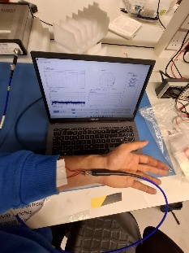 | 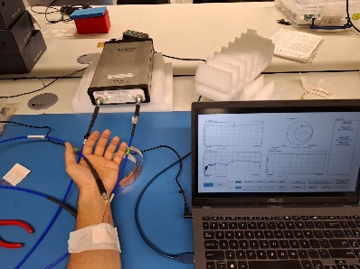
Figure 4. One-port measurement of S11 using 20 × 20 mm plates.
The other prototype, which used thicker copper plates, was also measured using the VNA. The results are shown below.
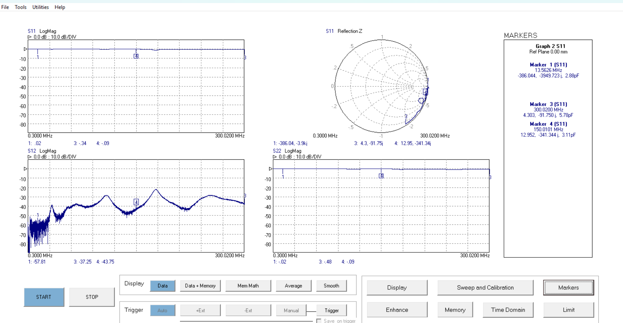 | 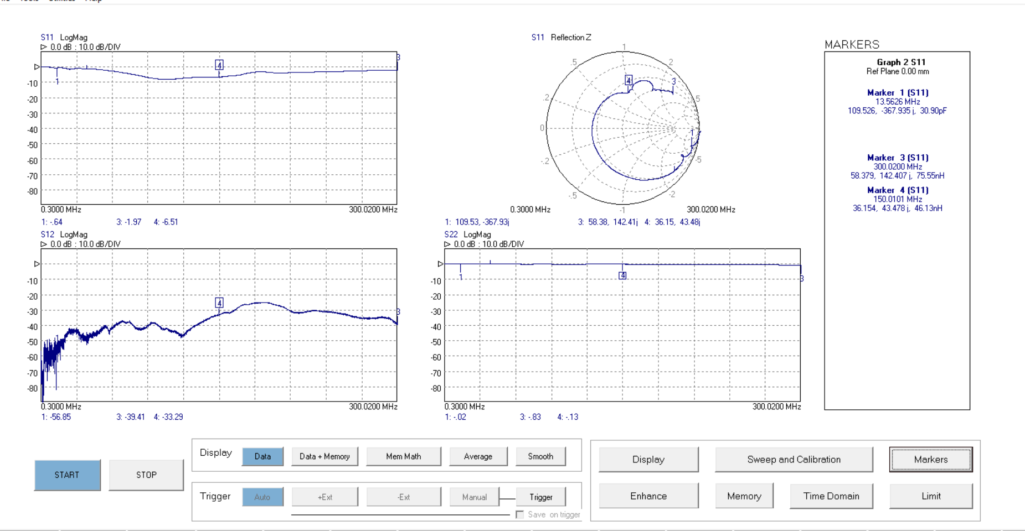
(a) Measurement in air. | (b) Plates placed on the arm.
Figure 5. VNA results for the 30 × 30 mm copper-foil prototype (thicker layer), marked at 13.5 MHz, 150 MHz, and 300 MHz.
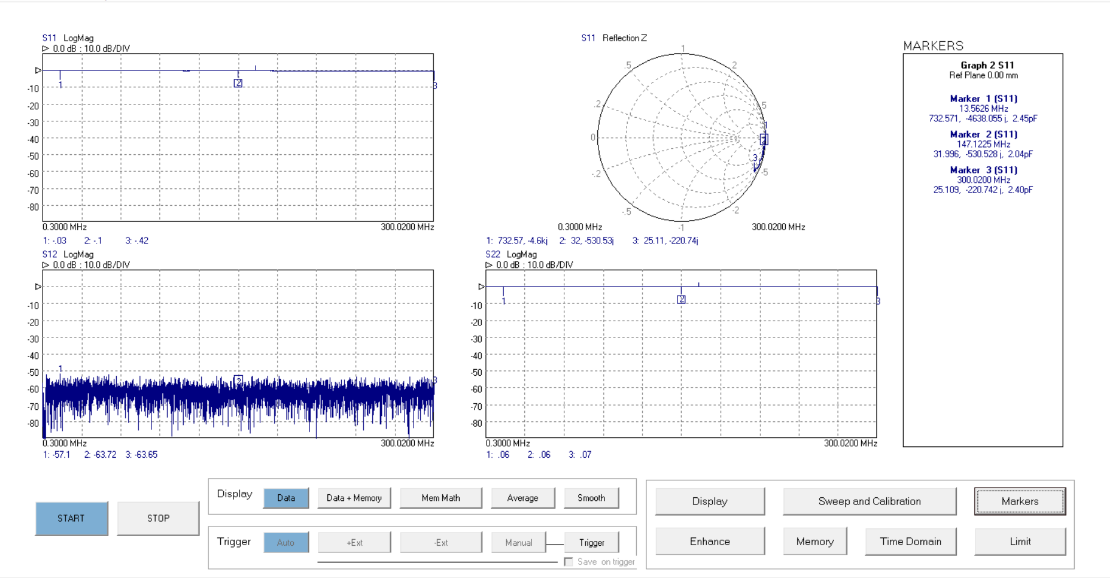 | 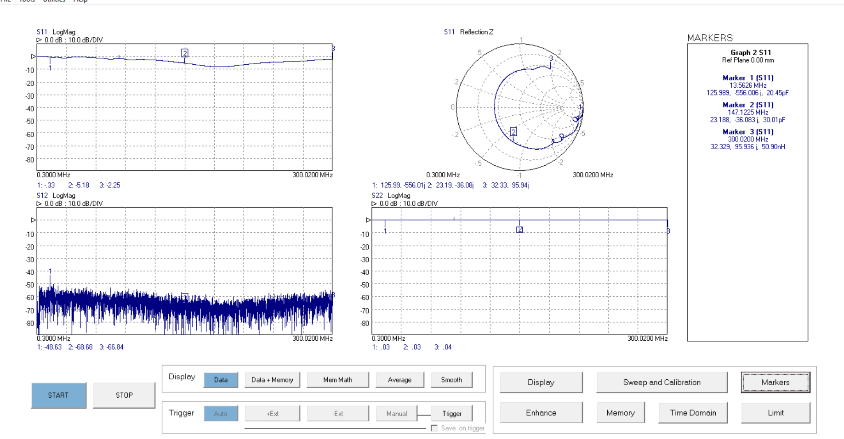
(a) Measurement in air. | (b) Plates placed on the arm.
Figure 6. VNA results for the 20 × 20 mm copper-foil prototype (thicker layer), marked at 13.5 MHz, 150 MHz, and 300 MHz.

4. Two-Port VNA Measurements
An additional copy of the 20 × 20 mm prototype was made to examine the behaviour of the channel between the two electrodes. This was tested in several configurations.
First, the two electrodes were placed on the same hand with a shorter path.
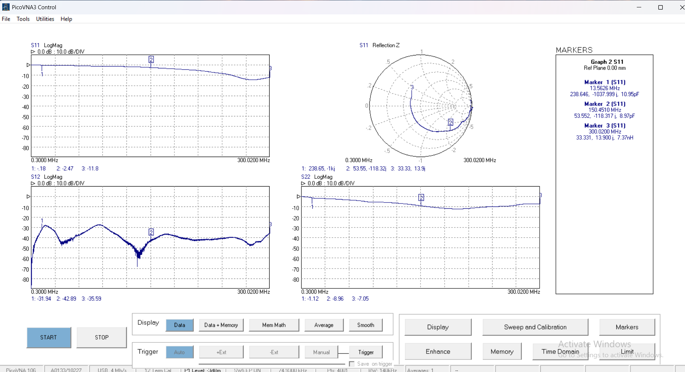 | 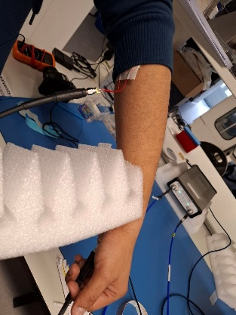
Figure 7. Two identical 20 × 20 mm electrodes placed on the same hand with a shorter path. The S21 measurement shows noticeable power at lower frequencies around 13.5 MHz.
The same configuration was then tested using separate hands with a longer path.
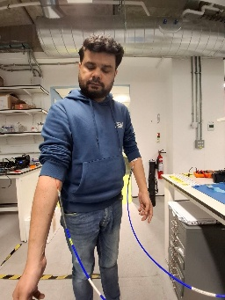 | 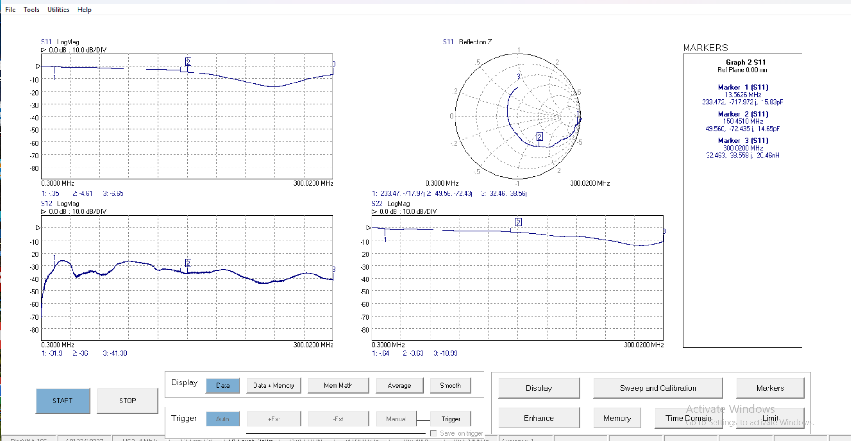
Figure 8. Two identical 20 × 20 mm electrodes placed on separate hands with a longer path. The S21 measurement shows noticeable power at lower frequencies around 13.5 MHz.
The S21 plots show an increase of almost 30 dB, which indicates that the two electrodes are functional, especially at lower frequencies around 13.5 MHz.
Next, the same arrangement was evaluated with the electrodes floating in air, and therefore with a different permittivity.
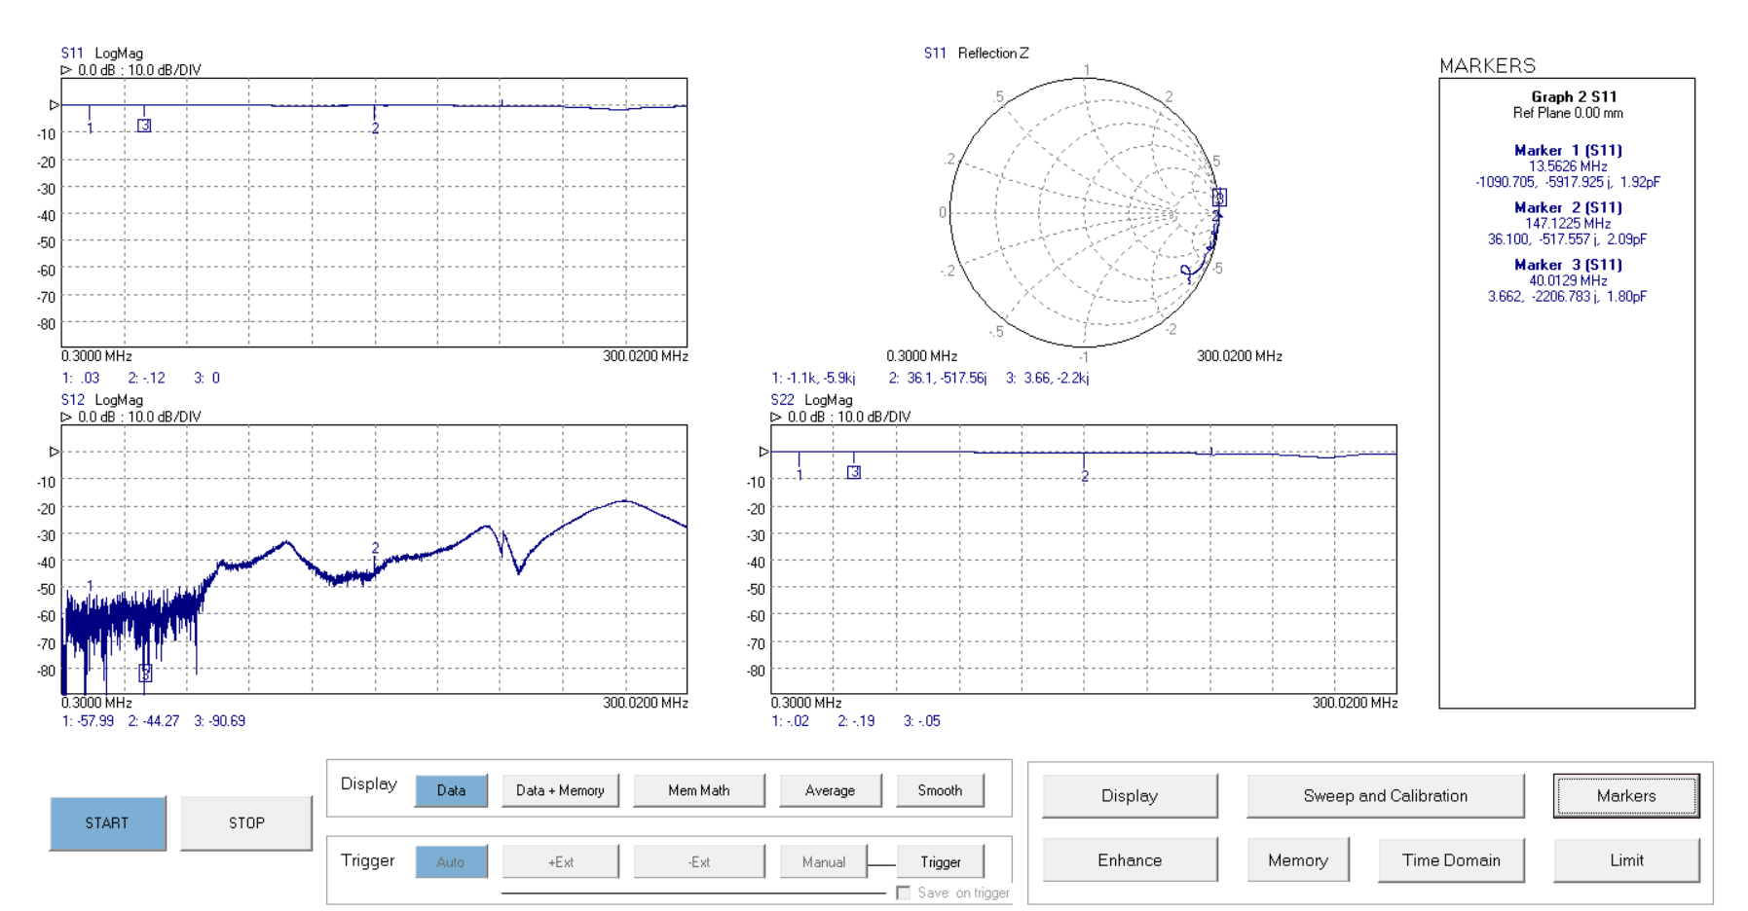
Figure 9. Two identical 20 × 20 mm electrodes floating in air. The S21 measurement has very low power at lower frequencies around 13.5 MHz, showing that contact with the human arm is a noticeably better medium for transmission.
Finally, the plates were placed on the table and the two pairs were pressed using two hands. The result of this measurement is shown below.
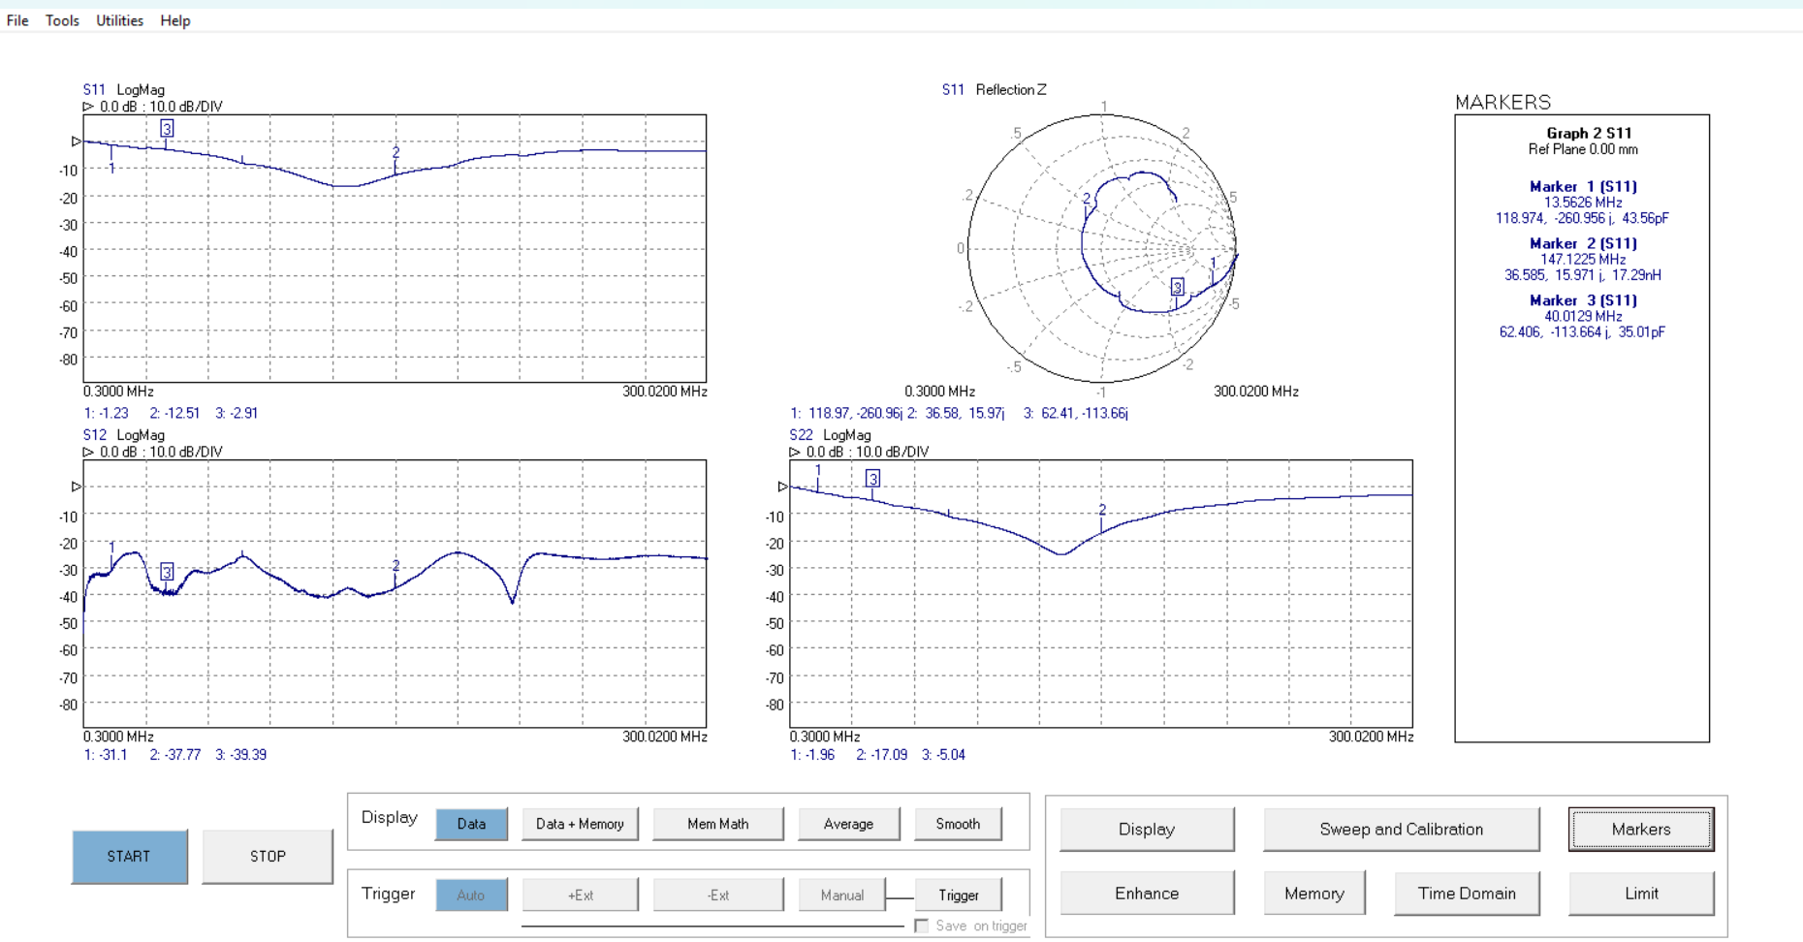
Figure 10. VNA result for the final configuration, with the plates placed on the table and pressed using two hands.

