**A Hybrid Geospatial data clustering Method for Hotspot Analysis**

Mostafa Javideh

Iran University of Science and Technology

[mostafa_javide@comp.iust.ac.ir](mailto:mostafa_javide@comp.iust.ac.ir)

Eynollah Khanjari

Iran University of Science and Technology

[khanjari@iust.ac.ir](mailto:khanjari@iust.ac.ir)

Behrouz Minaei

Iran University of Science and Technology

b_minaei@iust.ac.ir

# Abstract

Leveraging traditional statistical methods for analyzing today’s large volumes of spatial data has high computational burdens. To eliminate the deficiency, relatively modern data mining techniques have been recently applied in different spatial analysis tasks with the purpose of autonomous knowledge extraction from high-volume spatial data. Fortunately, geospatial data is considered a proper subject for leveraging data mining techniques. The main purpose of this paper is presenting a hybrid geospatial data clustering mechanism in order to achieve a high performance hotspot analysis method. The method basically works on 2 or 3-dimensional geographic coordinates of different natural and unnatural phenomena. It uses the systematic cooperation of two popular clustering algorithms: the AGlomerative NEStive, as a hierarchical clustering method and κ-means, as a partitional clustering method. It is claimed that the hybrid method will inherit the *low time complexity* of the κ-means algorithm and also *relative independency* *from user’s knowledge* of the AGNES algorithm. So the proposed method is expected to be faster than AGNES algorithm and also more accurate than κ-means algorithm. Finally, the method has been evaluated by two popular clustering measurement criteria. The first clustering evaluation criterion is inspired from *Fisher’s separability criterion*, and the second one is the popular *minimum total distance* measure. Results of evaluation reveal that the proposed hybrid method has been exposed an acceptable performance. It has a desirable time complexity and also owns a higher cluster quality than its parents (AGNES and κ-means). *Real-time* processing of hotspots demands an efficient approach with low time complexity. So, the problem of time complexity has been taken to account in designing the proposed approach.

**Keywords:**

Geospatial data; Geographical knowledge discovery; Hotspot analysis; Hierarchical clustering; Partitional clustering; Hybrid clustering approach; Earthquake hotspots; Crime mapping

# Introduction

Recently, a growing tendency can be seen among the researchers to apply modern data mining techniques, on geographical data, as one of the most essential steps of KDD (Knowledge discovery from data) process. The reason might be the fact that traditional statistical methods, particularly spatial statistics are confirmatory and require the researcher to have a priori hypotheses, meaning that they cannot discover *unexpected* or surprising information *[1]*.

KDD is the higher level process of obtaining facts through data mining and distilling this information into knowledge or ideas and beliefs about the mini-world described by the data. This generally requires a human-level intelligence to guide the process and interpret the results based on pre-existing knowledge *[2]*. GKD (Geographical Knowledge Discovery) is an extension of the broader trend of KDD and it is based on a belief that there is novel and useful geographic knowledge hidden in the unprecedented amount and scope of digital geo-referenced data *[2]*. Existing methods for exploratory spatial analysis and spatial data mining span across three main groups: *computational*, *statistical*, and *visual* approaches *[3].* The subject of this paper is mainly devoted to the scope of the first group. Computational approaches resort to computer algorithms to search large volumes of data for specific types of patterns such as spatial clusters *[4]*, spatial association rules *[5]* and spatial outliers *[6].*

In general, computational methods are able to search for structures in large datasets with great efficiency but lack the ability to interpret and attach meaning to patterns *[3]*. Statistical methods are rigorous and verifiable but often assume a priorimodel which has been roughly predetermined by the analyzer *[3].*Geospatial *Hotspot analysis* is one of the most vital tasks in the process of GKD which means finding the notable geographical regions of natural/unnatural phenomena according to some interesting measures. The most general techniques available for discovering geospatial hotspots are the *mean center*, *standard deviation distance*, *standard deviation ellipses*, and *geospatial* *data clustering*. All of these techniques except clustering are usually considered as statistical techniques.

Clustering can be defined as dividing/discretizing a dataset – commonly consisting of homogenous objects – into subsets, each of which contains the most similar objects, while every pair of subsets should have the highest contrast. In fact, defining a proper *distance measure* will force similar objects to be placed inside one cluster at the end of the clustering process. Therefore, the label for each cluster will be unknown until the clustering process is finished. Because of that, clustering problems are also known as *unsupervised learning methods*.

Presenting an efficient method for clustering geospatial data collected from diverse sources is a challenging task. This paper mainly discusses the leveraging of a high-performance approach for discovering geospatial hotspots via employing the clustering of 2-D geospatial data. The proposed method utilizes a systematic hybrid approach by combining AGNES as a hierarchical and κ-means as a partitional clustering algorithms. The paper will cover the subject by dissecting two case studies in a practical way. In the first case study, analyzing crime incidents' location data for discovering geospatial crime hotspots has been covered and the second case study spans around seismological hotspot analysis. Eventually, the method has been tested and evaluated through utilizing it on a georeferenced data set containing geographical coordinates (longitude and latitude) of seismic activities in Iran.

This paper is consisted of seven main sections. Section 2 is devoted to prepare a general background on the related works and also recently achieved progresses. Section 3 discusses the most popular methods for spatial data clustering and hotspot analysis as an essential part of *mapping* natural and unnatural phenomena. The fourth section mainly talks about preparing a background to leverage three different clustering techniques for hotspot analysis. The proposed hybrid approach (HAK) will be introduced in section 5. In section 6, some of the most popular evaluation criteria (Fisher’s separability criterion and minimum Total Distance) are introduced, after which the proposed hybrid technique is evaluated on the basis of those criteria. Eventually, the last section is devoted to the conclusion and the authors’ scheduled future works.

# 2. State of the Art

Utilizing spatial/geographical (see the difference in *[2]*) data mining is a rapidly-growing field of study in most industries, enterprises and research areas. Hence, presenting a comprehensive background on the subject requires a complete book chapter. For the sake of briefness we will focus on two geospatial hotspot analysis problem domains: 1) *crime incidents' location spatial analysis* and 2) *earthquake hotspotdiscovery*. Respectively, we will divide this section into two main subjects and dissect these two problems for the rest of the paper.

## Crime Analysis

Recently, traditional crime analysis techniques have lost their popularity in light of the new, less costly, and less time-consuming analytical techniques. Additionally, using computer based analysis of crime data has had an undeniably positive influence on the police force’s human resource management. Generally, nalyzing crime data includes both *behavioral* analysis (see *[7,8,9,10,11]*) and *spatio-temporal* analysis. Due to the subject of the paper we have focused on modern crime hotspot analysis which is considered as a young field of study built upon new data mining techniques.

*Crime mapping* has been thoroughly dissected in *[12]*. In *[13]*,exploiting the spatial analysis for finding the proper place for establishing the new police stations has been discussed in detail. In *[8]* the writers have used association-rule mining for extracting spatio-temporal patterns out of large volumes of crime-related data. *DBSCAN* clustering technique has been utilized to design and implement a spatial data engine and visualization interface for a crime information system in *[15]*. In *[16]* a model, named *STEM,* has been introduced to find frequent rules among *events*, *hotspots* and *time points*. Another interesting spatial clustering method which is called U-Matrix has been discussed in *[17]*.

A dynamic pattern analysis framework, the DPA framework, has been presented in *[18]*. This framework allows users to identify three types of dynamic pattern in spatio-temporal data: 1) Similar spatial patterns at different time points, 2) interactive relationship between two geographical locations as a result of specific reason and 3) frequent association rules related to particular types of events, geographical locations and time points.

*AIM*[1] software system in England *[19]*, benefits from spatial data in order to do *crime matching*. This software depicts the analysis’ results in geographical maps. For example results are shown as offender crime corridors in a particular city map. These corridors are identified by processing the locations’ coordinates of crime incidents which are related to a specific offender.

The United States’ *CrimeStat* software system processes spatio-temporal data according to a statistic-based approach and data mining techniques. Also this system is able to estimate the approximate locations of future crimes. Hotspot analysis is also covered in this software by means of hierarchical nearest neighbor clustering algorithm, κ-means algorithm and also a particular algorithm named STAC[2] *[20]*. Figure 1, depicts the clustering of street robberies in west Baltimore County using the STAC clustering approach. As the results show, there is a considerable concentration of the robberies around one of the main outgoing highways of the city which are colored in green.

The performance of hotspot analysis applications might be depending on doing some efficient optimizations on corresponding hotspot discovering algorithms. In *[21]* writers prove that it is necessary to support an 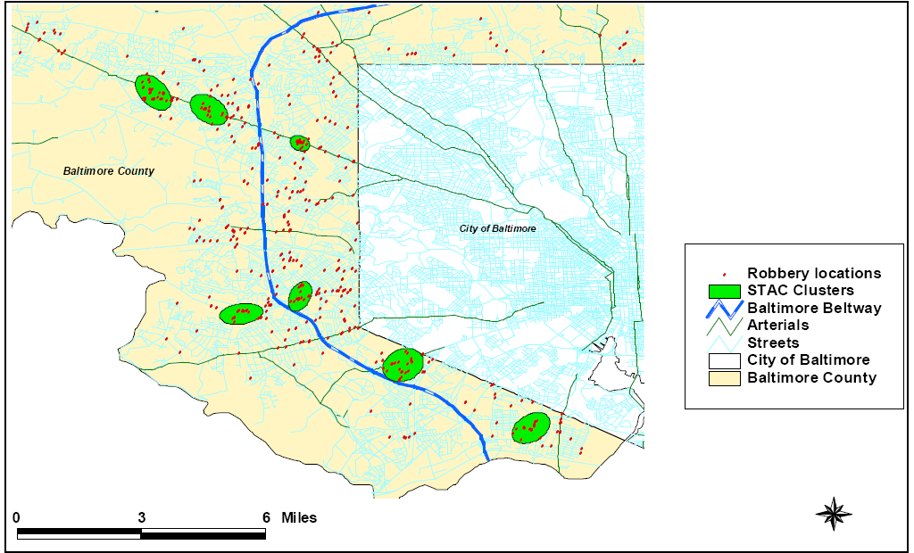

**Fig. 1. Identifying the robbery hotspots using the STAC algorithm in Baltimore County by *CrimeStat* software *[20]***

## optimization strategy –which is introduced as *Join Index*- in a hotspot discovery application for increasing the performance of identification of the hotspots, otherwise this operation may be lasts 2 hours for a dataset size of 15000 crime reports.

## Earthquake Spatial Analysis

Discovering the earthquake hotspots plays an important role in Seismological researches. In fact hotspot identifications can help the researcher to model the seismic activities of the earth in order to predict the approximate locations of the future earthquakes. The mentioned activities facilitate making suitable decisions in the scope of risk management problems. As an example, in *[22]*, a modeling approach for earthquake aftershocks has been presented and tested based on the epidemic type aftershock (ETAS) model introduced thoroughly in *[23]*. This model aims at modeling complex aftershocks sequences and global seismic activity *[24]*, and it has been used to give short-term probabilistic forecast of seismic activity *[24]*, and to describe the temporal and spatial clustering of seismic activity.

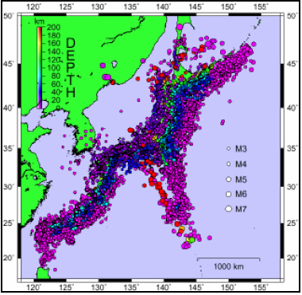

**Fig**. **2. Geospatial hotspot analysis on earthquake events; Japan *[25]***

The authors present a general overview on earthquakes cluster analysis and multi-dimensional visualization of earthquake in *[25]*. The article leverages geospatial hotspot visualization of earthquake events in Japan. Figure 2, visualizes the distribution of earthquake events in Japan. The size of the circles shows the magnitude and different colors show the depth of the earthquakes. *[26,27]* rely onGeospatial hotspot discovery by utilizing spatial clustering methods for achieving their seismological research goals. In section 6, we will evaluate the performance of our proposed method by examining it on a selected geospatial dataset collected by *Geophysics Institute of Tehran University*. The data set contains the accurate coordinates of Iran’s earthquake events which have been collected by seismographs established accros the country.

The next section prepares a background on general geospatial clustering methods by presenting a practical example; crime geospatial hotspot analysis.

# 3. A Practical Example: Overview on popular Methods for Crime hotspot analysis

The geographical coordinates of natural/unnatural phenomena can be considered as the most important kinds of geographical data in geospatial data bases. Hotspot exploration is considered a proper subject for applying clustering techniques. Foundation of crime hotspot analysis and its most popular methods are discussed in the following sub-sections.

Simply stated, the main purpose of hotspot analysis process is to find places where the frequency of crime occurrence is more than other places. Finding these places requires clustering analysis on crime spatial data. Doing hotspot analysis on high-volume crime spatial data, without using computerized clustering process, is almost impossible. Because using manual methods to find hotspots, increases the possibility of occurring unwanted human recognition mistakes, while employing clustering techniques with proper visualization of results leads to an accurate hotspot analysis process. It is considerable that crime hotspots have a dynamic nature and they may change through time, so requires continuous monitoring over time. In the other words, the underlying pattern among the geospatial data might be changed by adding new crime incidents.

As a practical example, robbery occurrence rate is more concentrated in commercial centers and also heavy traffic avenues of the cities. These places can be identified accurately by using hotspot analysis. Predicting location of the next crime, estimating the offender living place, identifying offenders’ crime corridors, optimizing police patrol routes and offering the best place for the establishment of new police stations are other important usages of crime hotspot analysis. These usages are discussed in *[28]* in more details. In the following sub-sections, the most common hotspot analysis methods and their advantages /disadvantages of each method are covered.

## 3.1. Point Maps

Point mapping approach can be considered as one of the most popular methods for analyzing crime hotspots and visualizing results. The popularity of this method is due to its simplicity and also its similarity to the traditional *pins in map* method *[29].* As the method name explains, crime incident’s geographical coordinates are simply marked in a geographical map. The most significant disadvantage of this method is the lack of accuracy in identifying hotspots especially when there are relatively huge numbers of data to be analyzed. Figure 3.a depicts 9314 instances of vehicle crime occurred in London, which are marked by point mapping approach. The figure reveals that not only identifying hot spots by means of this method is a difficult task, but also the quality of analysis is tightly dependent to human recognition, because the method gives no idea about data clustering!

## 3.2. density-based Surface Mapping

Actually, this type of crime mapping utilizes *density-based clustering* methods. The main purpose of this category of clustering techniques can be summarized as gaining an estimation of distribution of crime density across geographical areas and also visualizing the results. The ability of this method in finding clusters with arbitrary shapes affords results that are similar to the real-world distribution of objects. For visualizing the output of this method, a number of different colors should be chosen. Each color represents a range of crime density in corresponding area. Therefore the method will divide the surface to some colored zones with arbitrary shapes. Choosing the number of these colors (zones) has a significant influence on clustering quality, so it should be chosen intelligently. Figure 3.b shows density-based clustering method for robbery crime incidents in London. Realizing crime hotspots is also possible by using other clustering methods like hierarchical or partitional clustering methods.

## 3.3. Geographic Boundary Thematic Mapping

This kind of hotspot analysis is distinct from other methods, because it enters the provincial boundaries or other districts’ geographical boundaries in the analysis process. In this method, every predetermined geographical region is colored according to the crime occurrence rate concentration. Coloring strategy is one of the most important steps for creating maps using this method (see *[30]*). As already mentioned, the number of colors which are chosen to discretize the surface of the map, plays an important role in crime mapping. There are several measurement criteria for discretizing the surface of target area. Using the *standard deviation* or the *ratio of the occurred crimes to the population* of a specific area may be appropriate as crime occurrence concentration criteria. The quality of hot spot analysis process depends on choosing the concentration criteria and also the number of colors for discretizing the surface. Designating the number of colors less than a proper value may result in decreasing the analysis accuracy; on the other hand, choosing a number greater than the proper value will lead to complexity of interpreting the analysis results. Using 5 or 6 different colors/states is almost satisfactory for covering the most hotspot problems *[30]*. Using the geographical boundary thematic 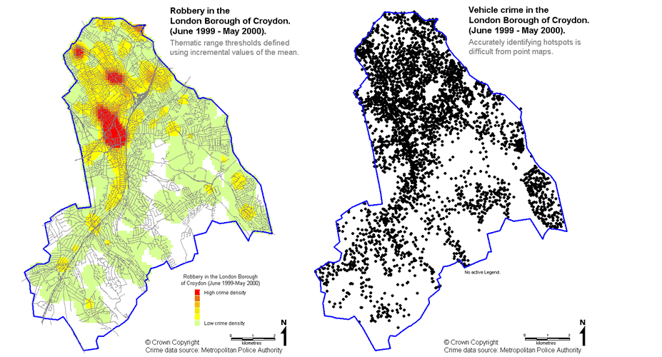

**Fig. 3.b. density-based clustering for robbery Fig. 3.a. non-clustered vehicle crime points in London *[30]***

**in London*[30]***

mapping method is a beneficial approach for accomplishing crime reduction strategies in a specific geographical area. It also aids police services to realize crime management programs. Although, it is worthy to know that this method assigns a constant density value to a relatively vast geographical zone. This behavior results in lack of accuracy and it might be considered as a drawback.

## 3.4. Grid-based Mapping

The foundation of this crime mapping approach is *grid-based clustering* methods. Grid-based clustering is different from other clustering methods in the way it operates on the target data set. Actually rather than discretizing the data set objects, it discretizes the state space in which objects are resident (see *[31]*). Each object is assigned to a state space division according to the parameters of the algorithm. Being independent from the order of the data objects is considered as an important advantage of grid-based clustering method. Simply stated, the crime mapping process using grid-based clustering method has two main steps: the first step is dividing the target geographical surface into some square-shaped cells with equal areas. The next step is assigning each crime incident to appropriate cell according to number of incidents occurred in the corresponding cell surface. This kind of crime mapping usually does well in performance but it suffers from some drawbacks. The followings may be considered some of the most important drawbacks of grid thematic crime mapping:

* Naturally, the shapes of hotspots are irregular due to the distribution of crime incidents in the real-world, but because the method uses square-shaped grids it is not able to generate arbitrary shapes.
* The analysis result extremely depends on the size of cells. So different sizes will result in different hotspot interpretations. Dividing the target surface into a low number of grids will result in loosing details and also dividing the surface into too many cells makes the output uninterpretable.

Figure 4, demonstrates the output of this kind of crime mapping method used for burglary crimes in London by *Metropolitan Police*. If the area of the cells is chosen wisely, it will be expected that the output will be more accurate than geographic boundary mapping output. As it can be seen in the figure there are 4 levels of crime concentration (1 to 5, 5 to 10, 10 to 15 and more than 15).

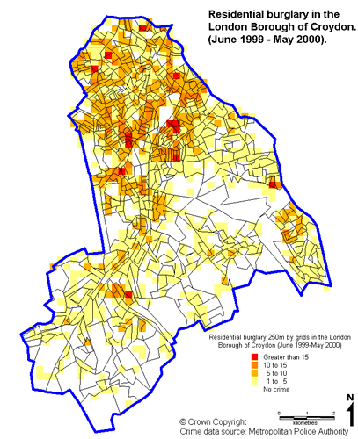

**Fig.4. crime mapping by using grid based method- London*[30]***

# 4. Utilizing Clustering Techniques for Hotspot Discovery

In this section, some advantages and disadvantages of the AGNES method, as a hierarchical clustering method and κ-means, as a partitional clustering method are discussed. As previously mentioned, there are several methods for spatial data clustering. Choosing the proper method can be affected by the problem domain. Also designating a proper *distance measure* is considered as a main prerequisite of all kinds of clustering processes (see *[32]*). As previously mentioned, Geospatial data sets usually contain data objects in the form of 2-dimensional points’ coordinates (X,Y) which can be mapped in a geographical map. Normally, *Euclidian Distance measure* is used for the purpose of crime spatial data clustering. Spatial data clustering is widely used in hotspot analysis of georeferenced data.

## 4.1. Hotspot Analysis Using the AGNES Clustering Algorithm

Hierarchical clustering methods can be divided into two categories *[32]*: 1) methods which are based on *agglomerative* algorithms and 2) Methods based on *divisive* algorithms. In the earliest step of agglomerative algorithms, each data object is considered as a cluster. Then the distance/dissimilarity between each pair of clusters is computed. The two clusters with the most similarity will be merged into one cluster. This sequence of operations will be continued until reach to a predefined number of clusters or a predefined inter-cluster distance. There are multiple strategies for calculating the distance between two clusters. For example, in *centroid* strategy, the distance between two different clusters can be defined as the distance between each cluster’s centroid. Centroid of each cluster is the average of objects’ distances within that cluster. One of the other strategies for calculating inter-cluster distance is the *average* strategy which uses the equation (1) for measuring the distance between two clusters.

$d(C_{i},C_{j})=\frac{1}{n_{i}n_{j}}\sum_{p∈C_{i}}^{ }{\left(\sum_{p^{'}∈C_{j}}{|p-p^{'}|}\right)}$; (1)

In this equation, the distance between cluster $C_{i}$, having *ni* objects within it, and cluster $C_{j}$, having *nj* objects, is defined as the average of the summation of the distances between each object within $C_{i}$ and all objects within $C_{j}$.

Each level of the naive AGNES clustering process *[32]* can be recorded in a hierarchical structure (dendogram) located in memory. So it will be possible to access the process result in each level of executing the algorithm and then choose the better answer according some criteria. In other words, the progression of the clustering process will be visible through using this method. Also it will be possible to use the result of each level in a separate algorithm. Although this is considered as an important benefit of this method in comparison to other clustering algorithms, but it should be noted that saving the clustering hierarchy in memory will result in additional memory consumption. Nevertheless, the other advantage of this algorithm is being relatively independent from human knowledge for initializing the algorithm. For Example, it does not require the user to specify the primary seeds for the algorithm to be initialized.

This method has the time-complexity of *O(n3*). It uses an *n×n* distance matrix (*n* is the number of data objects supposed to be clustered); therefore the algorithm has order of *O(n2)* spatial complexity *[33]*. So the AGNES method is suffering from the relatively high time-space complexity. This behavior causes the method to be practically useless in dealing with high-volume data. Unfortunately, due to the large amount of data which are often used for crime hotspot analysis, exploiting the AGNES method does not seem cost-effective.

## 4.2. Hotspot Analysis Using the κ-means Clustering Algorithm

The most significant feature of partitional clustering algorithms, especially κ-means, is their relatively low time complexity. One of the main reasons for this type of clustering algorithms’ popularity is its adaptability when encounters large volumes of data *[32]*. Nevertheless, convergence of the results of this method to local optimums rather than global optimums is considered as a drawback, in comparison to hierarchical clustering algorithms (see *[33])*. Anyway, κ-means and its newer variations considered as popular methods in hotspot analysis and also other fields of study, nowadays.

The naive κ-means algorithm *[32]*, in the first step, selects some data objects *randomly* as primary seeds which are named as *centroid*. Each centroid represents a cluster. Then the distances between all of the data objects with each of the centroids will be calculated. Each data object will be assigned to the cluster which is containing the nearest centroid. As the next step, the average of the data objects within each cluster will be computed as the new centroid of the corresponding cluster and the mentioned steps repeat until the result of clustering remains with no change or a predefined convergence criterion satisfied. MSE[3] is a common convergence criterion which is calculated by equation (2) *[33]*.

$E=\sum_{i=1}^{k}{\left(\sum_{p∈C_{i}}{{\left|p- m_{i}\right|}^{2}}\right)}$; (2)

In equation (2), $|p- m_{i}|$, represents the distance of object *p* from the centroid of its containing cluster $C_{i}$. *K* is the number of clusters and finally, *E* is the summation of mean squared error of clusters. Using MSE leads to maximizing inter-cluster distance and minimizing intra-cluster distance. The followings are some of the most notable disadvantages of classic κ-means algorithm:

* The algorithm requires a preliminary knowledge to be initialized; specifying the number of clusters or even cluster’s centroids are needed for the algorithm to get started, otherwise the algorithm will choose the centriods randomly.
* The result of clustering is highly dependent to the selected primary centroids; selecting non proper seeds will result in unexpected behavior.
* Computing the data objects *mean* is extremely sensitive to outliers.
* There is not any standard approach for selecting the primary seeds wisely.
* There is no guarantee that algorithm converges to global optimum; sometimes it converges to local optimums.

In spite of the fact that classic κ-means algorithm has many considerable drawbacks, it is a common algorithm because of its low time-space complexity (*Ο(n)*).

# 5. The Proposed Hybrid Method (HAK)

This section is mainly devoted to dissecting the proposed method. The rough idea for combining the parent algorithms can be described as follows: first, *m* iterations of the AGNES algorithm are executed, so some clusters will be found, the execution of the AGNES will be interrupted. As the next step, the result of the AGNES algorithm will be passed to κ-means as its initializing inputs (seeds). Then κ-means algorithm will do the rest of the clustering job.

How many AGNES iterations is enough to be run? The answer will solve a significant sub-problem in the issue of combining two mentioned algorithms. It should be noted that executing too many iterations of the AGNES Algorithm will enforce the hybrid algorithm to behave like a pure hierarchical algorithm and as a result, it has its own mentioned disadvantages. On the other hand, if a too few number of the AGNES iterations is executed, clustering results won’t have desirable quality because of non-proper primary centroids.

#### 5.1. The Proposed Method’s Parameters

According to the previous discussions, it can be realized that specifying the *m* parameter is the key solution of this hybrid approach. *m* is the number of the iterations of the AGNES algorithm. It is also possible to tune *m* parameter indirectly by manipulating the *distance threshold* of the AGNES algorithm (*T*). The AGNES distance threshold is the maximum inter-cluster distance which is considered as a stop value for the most hierarchical algorithms *[32]*. Anyway, using this hybrid method, there is no need to specify the initializing parameter(s) of the classic κ-means algorithm directly. Actually, the proposed method can be manipulated by means of three parameters which are introduced subsequently. Although initializing these parameters is optional but if they are set wisely, the performance will be improved significantly.

1. **Parameter *m*:** Specifies the number of iterations of the AGNES algorithm.
2. **Parameter *T*:** Specifies the AGNES algorithm’s threshold which was defined above.
3. **Parameter *λ*:** Specifies the minimum number of data objects that a cluster should contain to be involved in the κ-means algorithm. In other words, valid clusters must have at least *λ* objects within them.

Actually, the first two parameters will tune the AGNES algorithms and the last one will adjust the κ-means algorithm. Usually, initializing the input parameter of the naive AGNES clustering algorithm requires setting the number of output clusters. The value of this parameter will be equivalent to the difference between the number of entities in dataset and the mentioned parameter *m.* The reason is that the AGNES algorithm will certainly merge two clusters of the dataset in each iteration of execution *[33]*. Some notable guidelines for specifying the parameter *m* are declared in the following sections.

### Identifying the Upper Bound of Parameter *m*

As already discussed, combining the above-mentioned clustering methods, requires finding an upper bound for parameter *m* to limit its domain. If the value for *m* is chosen to be more than a specific threshold, certainly, the proposed method will have more time-space complexity than the classic AGNES algorithm. Identifying an upper bound value for *m* is considered as an essential requirement for obtaining a rational performance justification for the hybrid approach. So it is recommended that the value of *m* do not exceeds a calculable threshold. As a rough estimation, let *n* bethe number of data objects in the target clustering data set. In the case of using the naive AGNES clustering method, with *centroid* inter-cluster distance strategy, running the first iteration of merging the nearest data objects, requires *n(n-1)/2* comparisons. Thus in the second iteration *(n-1)(n-2)/2* comparisons are needed to select the two nearest data objects. As the worst case scenario for the proposed method, suppose a situation in which an entire κ-means algorithm process is executed immediately after finishing each iteration of the AGNES process. Consequently, [*(n)(n-1)* /2]*+ n* comparisons is required in the first iteration of the proposed method. So the following equations can be used as a rough estimation:

Required number of comparisons in the naive AGNES algorithm:

$n\left(n-1\right)+\left(n-1\right)\left(n-2\right)+\left(n-2\right)\left(n-3\right)+…+2×1+1×0=\sum_{k=1}^{n}{k(\left(k-1\right)}$; (3)

Required number of comparisons in hybrid approach (worst case scenario):

1/2 $\left[n\left(n-1\right)+n\right]+\left[ \left(n-1\right)\left(n-2\right)+n\right]+…+ 2×1+n+1×0+n=$

$n^{2}+1/2[n\left(n-1\right)+\left( n-1\right)\left(n-2\right)+…+\left( n-p\right)\left(n-p-1\right)+…+2×1=$

overhead generated by κ-means *n-p+1* iterations of the naive AGNES algorithm

$n^{2}+1/2\sum_{k=1}^{n}{k(k-1)}$ (4)

Equations (3) and (4) are in the form of summation of the products. In equation (3), each product term represents the number of comparisons required in corresponding iteration of the AGNES algorithm. Similarly, in equation (4), each product term represents the number of comparisons needed in the corresponding iteration of proposed hybrid approach. In order to have the computational overhead of the hybrid method be less than the classic AGNES algorithm, a specific number of terms in equation (4) should be computed rather than computing all of the terms. This specific number of terms will be equal to *n-p+1*.

Let the maximum number of AGNES’ iterations be $m_{max}$. As it is obvious in the euation (4),the maximum number of included terms, which is actually equal to the maximum number of iterations($m_{max}$), will be reached, when the value of *P* is minimized. Let this minimum value for *P* be $P_{min}$. This way, the value for $m_{max}$ will be obtained by equation (5).

$m_{max}=n-p_{min}+1$ (5)

Including $n-p_{min}+1$ terms of the equation (4), the overhead which is generated by κ-means will be *(n-p+1)n*. Consequently, the upper bound of parameter *m* is calculated from inequality (6).

$(n-p+1)n +\sum_{k=p}^{n}{\left(\frac{k(k-1)}{2}\right)≤\sum_{k=1}^{n}{\left(\frac{k(k-1)}{2}\right);}}$ (6)

By expanding the inequality (6), we will obtain inequality (7):

$(n-p+1)n ≤ \sum_{k=1}^{p-1}{\left(\frac{k(k-1)}{2}\right)}$*=>*

$\left(n-p+1\right)n≤\frac{1}{2} (\sum_{k=1}^{p-1}{k^{2}-\sum_{k=1}^{p-1}{k}})$*=>*

$\left(n-p+1\right)n≤1/2\left[\frac{\left(p-1\right)\left(p-2\right)\left(2p-3\right)}{6}-\frac{\left(p-1\right)p}{2}\right]$*=>*

$6n\left(n-p+1\right)≤\left(p-1\right)(p^{2}-5p+3)$ (7)

Now, we can determine the minimum value of *p* whichsatisfies the above inequality ${(p}_{min⁡})$. By substituting *n* with a proper integer, $p_{min⁡}$ is obtained and subsequently, ${ m}_{max} will be obtain$ ed by equation (5). It is notable that because of the integer nature of *m*, there is no need to solve the mentioned third-degree inequality. It means that, it will be solved by means of a simple try-and-error approach. As an example, consider a situation in which there are 648 objects in the target data set *(n=648)*. By substituting *n* in the inequality (7) the following will be obtained:

*6×648× (648-p+1) ≤ $\left(p-1\right)\left(p^{2}-5p+3\right);$*

By trying *P=128,* we will obtain: *2025648≤ 1999869*, which does not satisfy the inequality. Similarly, by trying *P=129* we will obtain: *2021760 ≤ 2047104*, which satisfies the inequality. So $p_{min⁡}=129$ is the minimum value for the *P* which satisfies the inequality (7). Subsequently the value of $m_{max}$ can be calculated by the equation (5) as follows: $m_{max}$*= n-p+1= 648-129+1=520.*Actually, this means that in order to have a rational computational complexity, the number of the AGNES iterations in proposed method, must be less than or equal to $m_{max}=520$.

In the other words, if the number of the AGNES algorithm’s iterations is chosen to be lower than 520 (equivalent to 129 clusters), the proposed method’s computational complexity will be also expected to be lower than the AGNES algorithm’s complexity. Although the proposed algorithm will not force the user to select values which are lower than *mmax*, but it is notable that disobeying this rule will cause the algorithm to behave as like as its hierarchical parent AGNES. For example, if *m=647* is selected, then the algorithm will be transformed into the pure AGNES, so it will lose the benefits declared in section 5.1.

### Identifying the Lower Bound of Parameter *m*

It was previously mentioned that the hybrid algorithm is able to interact with the user. This means that a quality evaluation sub-algorithm will be run to determine the clustering result’s quality according to some criteria which will be declared in section 6. If the user is not satisfied with the clustering result, she/he will increase or decrease the value of parameter *m*. It is likely that manipulating the value of parameter *m* leads to a higher quality clustering. Therefore, it is recommended that in the situations when the user has no knowledge about distribution of data, the algorithm be initialized by the starting value of *m=2*. The value will be increased gradually according to a method introduced in the following sub-section. The lower bound of parameter *m* varies for different clustering problems, because it directly depends on the distribution of the data objects. So calculating the lower bound for each different problem seems to be a complicated task, nevertheless, finding an accurate lower bound for parameter *m* is useful to decrease the time complexity of hybrid algorithm. This problem can be the issue for further studies.

# 6. Evaluating the Algorithm

This section is mainly devoted to the comparative performance evaluation of the proposed hybrid method, classic AGNES and κ-means algorithms. Actually, comparing two clustering algorithms is a laborious and complicated task and there are various criteria to accomplish this goal. Some of these criteria have single-purpose usages and some others are widely applicable in different domains. Unfortunately there is not any all-purpose clustering algorithm which satisfies all of the existing criteria. Thus the algorithms which perform well from the point of view of a specific criterion often do not perform well from the point of view of another criterion. In the following sections, a combinational criterion, which has been inspired from *Fisher’s separability* *criterion*, is introduced. *Fisher* criterion is considered as a widely applicable criterion *[34]*. At the end of this section, the parent algorithms (AGNES and κ-means) and the proposed hybrid method will be evaluated.

## 6.1. Preparing the Evaluation Prerequisites

There are two main Prerequisites for evaluating the algorithms: 1) understanding the data set origins and characteristics and 2) a proper clustering evaluation criterion. These two prerequisites are discussed in the following two sub-sections.

### Data Understanding

In order to examine the performance of the previously mentioned mechanism, a dataset containing earthquake phenomena which have occurred in Iran in the year of 2008, was selected from the collection of data sets of *Geophysics Institute of Tehran University* *[35]*. The data set includes a real collection of 2-dimentional earthquake incidents, which contains 648 data objects. The data set contains the accurate coordinates of Iran’s earthquake events which have been collected by seismographs established accros the country. So the dataset is used widely in seismology studies and related experiments. Because the main purpose of this paper is analyzing the 2-dimentional spatial data, only the latitude and longitude of the data objects were involved in hotspot analysis. It should be noticed that none of the outliers was omitted in the data preparation phase to see the algorithm’s behavior in dealing with outliers.

### Introducing the Criteria for Evaluation and Comparison

By inspiring from the simple definition of clustering, it can be mentioned that measuring the amount of maximization of inter-cluster distance and also the amount of minimization of intra-cluster distance for an specific algorithm, seems an efficient clustering quality criterion *[36]*. Actually, a clustering algorithm will support a desired quality, if it is able to satisfy the following two conditions simultaneously:

* The distances between clusters which are determined by the algorithm should be maximized.
* The data objects in a specific cluster should be as compact as possible.

Two popular clustering quality criteria have been referenced in the current research: *Fisher’s separability criterion* and *Minimum Total Distance.* Simplified Fisher’s criterion requires the calculation of *Intra-cluster* and *Inter-cluster variance* as two popular clustering quality measures. These mentioned measures will be calculated as follows:

**1) Intra-cluster variance**: Basically, variance measures the distribution of the data objects within a data set around the mean value of that data set and it can be calculated by equation (8).

$σ^{2}=\frac{1}{N}\sum_{i=1}^{N}{{(x_{i}-μ)}^{2}}$ (8)

In the above equation, *N* represents the number of objects in a data set and $μ$ is the mean of the objects. This criterion is usually used for measuring the distribution of data objects within a cluster. Thus the average of the variance of the data objects within each cluster is considered as the algorithm’s intra-cluster variance. Henceforward, the intra-cluster variance measure will be referenced as *Var*. So if the result of running clustering method *C,* includes *n* clusters, the value of the intra-cluster variancewill be calculated from equation (9).

${Var}_{c}$*= $\frac{1}{n}\sum_{i=1}^{n}{{σ^{2}}_{i}}$* (9)

**2) Inter-cluster variance:** For computing the inter-cluster variance of a specific clustering method’s result, the following algorithm was used;

**a)** The distance between cluster $c_{i}$ and $c_{j}$ is defined as the average distance among all of the data objects within cluster $c_{i}$ and the centroid of cluster ${ c}_{j}$. It can be calculated by equation (10).

$d\left(c_{i},c_{j}\right)=\frac{1}{N}\sum_{i=1}^{N}{{(x_{i}-μ_{j})}^{2}}$ (10)

In this equation, *N* represents the number of objects within *ith* cluster. $μ_{j}$ is the centroid of *Jth* cluster which is obviously obtained by: $μ_{j}=\frac{1}{M}\sum_{k=1}^{M}{X_{k }}$; *M* is the number of data objects in *jth* cluster.

**b**) Step **a** is repeated for all of the clusters which are determined in the clustering results. The distances among each cluster and all of the other clusters are computed. It will result in generation of a *scatter matrix*. Inter-cluster variance for cluster $c_{i}$, which was named as *Dic*, is equal to the average of entries on each row of the matrix and it is calculated by equation (11).

$D_{ic}(c_{i})=\frac{1}{n-1}\sum_{j=1,j≠i}^{n}{d(c_{i},c_{j})}$ (11)

In equation (11), n is the number of objects within $c_{i}$ and {*i,j $∈Z| i,j≤n\}$.* The equation represents how the value of inter-cluster variance for cluster $c_{i}$ is calculated using the previously mentioned scatter matrix. Now, the algorithm’s total inter-cluster variance can be calculated by computing the average of all of the clusters’ *Dic*.

**3) The ratio of inter-cluster variance to intra-cluster variance:** By combining the two mentioned criteria, a more generic criterion is created, which is the simplified form of the Fisher’s criterion. Suppose that the result of the clustering method *C*, contains *k* clusters *(C1,C2,…,Ck)*, Then the mentioned generic criterion can be calculated by equation (12).

$f(C)=\frac{1}{k}\sum_{i=1}^{k}{\left(\frac{D_{ic}(c_{i})}{{Var}_{i}}\right)}$ (12)

In equation (12), ${Var}_{i}$ is the intra-cluster variance of *ith* cluster and $D_{ic}(c_{i})$ is the inter-cluster variance of cluster *i,* which are obtained from the equation (9) and (11). According to this criterion, decreasing the intra-cluster variance will result in decreasing the value of *Vari* and consequently, increasing the value of *f(c)*.

**4) Minimum Total Distance**

In this criterion, we minimize the total of the sum of distances of objects to their cluster centroids and the sum of the distances of the cluster centroids from the global centroid *[36]*. Let a clustering assignment discrete the data set into *m* clusters and *Cj* be one of the clusters. The value for Minimum Total Distance is computed as follows:

$$TD=\sum_{j=1}^{m}{\left(\sum_{R_{i}∈C_{j}}{D\left(R_{i}, C_{jc}\right)}\right)}+ \sum_{j=1}^{m}{D(C_{jc},G_{c})} (13)$$

Where TD is the Minimum Total Distance for a specific clustering assignment, *Ri*is an object in cluster *Cj*, is the centroid of *Jth* cluster, and GC is the global centroid of the data set. Finally $D\left(R_{i}, C_{jc}\right)$ is the distance between $R_{i}$ and $C_{jc }$. It is noteable that unlike the Fisher’s criterion, the better clustering answers expect to have a lower number of TD.

## 6.2. Evaluating the Parent Algorithms

The performance issues of the classic AGNES and κ-means algorithms are discussed in this section. The previously introduced criteria have been applied to accomplish this goal. As already mentioned about test data set, this set contains 648 earthquake incident’s coordinates. Each algorithm has been evaluated by *f(c)* and *TD(c)* measures. The former represents Fisher’s criterion value and the later is the Minimum Total Distance value for the corresponding algorithm.

### 6.2.1. Evaluating the Naive AGNES Algorithm

Table 1, demonstrates the value of Fisher’s criterion (*f(c)*) for the various cluster’s quantities in the AGNES algorithm. The *average-link* strategy has been used as an inter-cluster distance measuring strategy. As the table shows, the maximum value for *f(c)* andthe minimum value for *TD(c)* has been occurred in the relatively low numbers of clusters and moving toward the higher cluster’s quantities has been resulted in reduction of the value for *f(c)* and increase of the value for *TD(c)*. In the other words, the more number of clusters we choose, the worse clustering answer will be gained. It is noteworthy that the outliers are merged in the latest iterations of the AGNES algorithm. Consequently, the existence of the outliers among the objects of target data set, may cause deceptive results due to the increasing of f(c) value.

According to the table 1, it can be realized that there are several clustering results which own a relatively high quality and some of them may be preferred based on the domain expert idea. If there are 648 data objects in the data set, then the number of iterations of the naive AGNES algorithm must be lower than 520 (equivalent to 129 clusters) to have a rational computational complexity (see section 5). The related cell for this value is colored in gray and also underlined in the table 2.

**Table 1. the evaluation of the AGNES algorithm by means of the *f(c) and TD(c)* criteria**

|  |  |  |  |  |  |  |  |  |  |
| --- | --- | --- | --- | --- | --- | --- | --- | --- | --- |
| 10 | 9 | 8 | 7 | 6 | 5 | 4 | 3 | 2 | clusters  quantity  criterion |
| 317.85 | 341.16 | 382.41 | 455.59 | 543.56 | 627.39 | 770.15 | 990.25 | 1274.02 | ***f(c)*** |
| 634.39 | 615.93 | 558.87 | 525.87 | 497.03 | 407.58 | 356.396 | 258.80 | 168.32 | ***TD(c)*** |

|  |  |  |  |  |  |  |  |  |  |
| --- | --- | --- | --- | --- | --- | --- | --- | --- | --- |
| **19** | **18** | **17** | **16** | **15** | **14** | **13** | **12** | **11** | clusters  **q**uantity  criterion |
| 340.71 | 367.36 | 386.27 | 406.63 | 430.92 | 471.95 | 506.93 | 264.20 | 281.75 | ***f(c)*** |
| 1011.45 | 941.13 | 914.84 | 905.73 | 897.90 | 818.29 | 809.60 | 732.95 | 656.19 | ***TD(c)*** |

|  |  |  |  |  |  |  |  |  |  |
| --- | --- | --- | --- | --- | --- | --- | --- | --- | --- |
| 80 | 70 | 60 | 50 | 45 | 40 | 35 | 30 | 25 | clusters quantity  criterion |
| 174.37 | 194.18 | 228.92 | 265.92 | 300.86 | 344.93 | 198.61 | 230.88 | 267.8 | ***f(c)*** |
| 1468.84 | 1420.36 | 1343.88 | 1290.07 | 1256.94 | 1221.47 | 1195.93 | 1093.33 | 1059.29 | ***TD(c)*** |

|  |  |  |  |  |  |  |  |  |  |
| --- | --- | --- | --- | --- | --- | --- | --- | --- | --- |
| 240 | 220 | 200 | 180 | 160 | 140 | 129 | 120 | 100 | clusters quantity  criterion |
| 108.10 | 110.49 | 117.99 | 118.97 | 114.56 | 115.34 | 119.20 | 122.08 | 144.37 | ***f(c)*** |
| 2336.04 | 2243.31 | 2134.66 | 2021.85 | 1907.17 | 1812.19 | 1757.72 | 1694.98 | 1596.77 | ***TD(c)*** |

|  |  |  |  |  |  |  |  |  |  |
| --- | --- | --- | --- | --- | --- | --- | --- | --- | --- |
| **480** | **450** | **420** | **390** | **360** | **330** | **300** | **280** | **260** | clustersquantity  criterion |
| 109.74 | 109.73 | 118.18 | 118.47 | 108.95 | 102.00 | 94.23 | 96.76 | 100.72 | ***f(c)*** |
| 3684.09 | 3548.40 | 3243.98 | 3099.44 | 2962.99 | 2796.93 | 2647.92 | 2538.24 | 2443.92 | ***TD(c)*** |

|  |  |  |  |  |  |  |  |  |  |
| --- | --- | --- | --- | --- | --- | --- | --- | --- | --- |
| **628** | **624** | **620** | **610** | **600** | **580** | **560** | **540** | **510** | clustersquantity  criterion |
| 39.84 | 46.81 | 53.33 | 63.49 | 67.49 | 81.49 | 89.00 | 98.49 | 108.14 | ***f(c)*** |
| 4488.08 | 4468.82 | 4436.79 | 4380.09 | 4328.15 | 4164.75 | 4059.33 | 3964.46 | 3830.88 | ***TD(c)*** |

|  |  |  |  |  |  |  |  |  |  |
| --- | --- | --- | --- | --- | --- | --- | --- | --- | --- |
| **648** | **646** | **644** | **642** | **640** | **638** | **634** | **632** | **630** | clusters  quantitycriterion |
| 0 | 2.68 | 7.99 | 13.93 | 19.19 | 25.13 | 27.65 | 31.50 | 35.14 | ***f(c)*** |
| 4587.76 | 4582.73 | 4573.19 | 4559.94 | 4551.21 | 4538.83 | 4518.87 | 4509.54 | 4502.92 | ***TD(c)*** |

### 6.2.2. Evaluating the Naive κ-means Algorithm

As already mentioned, the classic κ-means algorithm, requires at least the number of primary seeds to be initialized. Because the seeds are often selected randomly, running the algorithm for two times and even with the same number of seeds will result in two different answers. In order to gain the more realistic results for comparative evaluation of this method, each different state was executed for 20 times. The *f(c)* criterion was computed for each state and then the average of the answers (*Avg [f(c)]*) was considered as the final answer for the method. Table 2, shows the value of *Avg[f(c)]* for each cluster number. As the table shows, the maximum value for *Avg[f(c)]* is occurred when the number of primary seeds is chosen to be 5. As a rough realization, it can be mentioned that by increasing the number of clusters *Avg[f(c)]* has been decreased and *Avg[TD(c)]* has been increased. So choosing high number of clusters will result in lower overall cluster quality.

The above results reveal that AGNES has done better from the perspective of Fisher’s criterion but κ-means has a better (lower) total distance.

**Table 2. the changes of the *f(c) and TD(c)* criteria in the κ-means** **algorithm**

|  |  |  |  |  |  |  |  |  |  |
| --- | --- | --- | --- | --- | --- | --- | --- | --- | --- |
| 10 | 9 | 8 | 7 | 6 | 5 | 4 | 3 | 2 | clusters  quantity  criterion |
| 278.38 | 308.81 | 347.08 | 397.17 | 440.02 | 504.93 | 289.08 | 225.03 | 3.43 | ***Avg[f(c)]*** |
| 317.87 | 310.58 | 297.90 | 295.73 | 277.23 | 261.96 | 179.02 | 117.51 | 37.92 | ***Avg[TD(c)]*** |

|  |  |  |  |  |  |  |  |  |  |
| --- | --- | --- | --- | --- | --- | --- | --- | --- | --- |
| **19** | **18** | **17** | **16** | **15** | **14** | **13** | **12** | **11** | clusters  quantity  criterion |
| 157.14 | 164.07 | 172.39 | 182.10 | 192.18 | 205.93 | 218.80 | 235.61 | 255.49 | ***Avg[f(c)]*** |
| 395.90 | 391.29 | 378.53 | 368.50 | 356.95 | 345.64 | 351.63 | 342.84 | 318.78 | ***Avg[TD(c)]*** |

|  |  |  |  |  |  |  |  |  |  |
| --- | --- | --- | --- | --- | --- | --- | --- | --- | --- |
| 80 | 70 | 60 | 50 | 45 | 40 | 35 | 30 | 20 | clusters  quantity  criterion |
| 94.93 | 84.66 | 83.46 | 88.20 | 96.54 | 90.90 | 102.46 | 111.26 | 149.87 | ***Avg[f(c)]*** |
| 830.70 | 770.32 | 705.72 | 623.59 | 612.197 | 588.58 | 519.93 | 508.27 | 409.98 | ***Avg[TD(c)]*** |

|  |  |  |  |  |  |  |  |  |  |
| --- | --- | --- | --- | --- | --- | --- | --- | --- | --- |
| 240 | 220 | 200 | 180 | 160 | 140 | 120 | 100 | 90 | clusters  quantity  criterion |
| 117.75 | 119.55 | 116.00 | 107.30 | 106.11 | 91.87 | 93.00 | 89.86 | 83.70 | ***Avg[f(c)]*** |
| 1810.84 | 1714.89 | 1666.93 | 1455.36 | 1343.00 | 1166.90 | 1048.44 | 934.92 | 865.26 | ***Avg[TD(c)]*** |

|  |  |  |  |  |  |  |  |  |  |
| --- | --- | --- | --- | --- | --- | --- | --- | --- | --- |
| **480** | **450** | **420** | **390** | **360** | **330** | **300** | **280** | **260** | clusters  quantity  criterion |
| 90.35 | 99.34 | 108.78 | 110.89 | 123.46 | 116.75 | 126.44 | 118.41 | 118.47 | ***Avg[f(c)]*** |
| 3472.61 | 3249.74 | 3035.12 | 2869.22 | 2610.29 | 2431.95 | 2254.95 | 2113.59 | 1990.36 | ***Avg[TD(c)]*** |

|  |  |  |  |  |  |  |  |  |  |
| --- | --- | --- | --- | --- | --- | --- | --- | --- | --- |
| **628** | **624** | **620** | **610** | **600** | **580** | **540** | **520** | **510** | clusters  quantity  criterion |
| 12.439 | 14.85 | 16.52 | 24.37 | 29.55 | 43.29 | 59.16 | 73.78 | 75.34 | ***Avg[f(c)]*** |
| 4447.44 | 4430.45 | 4380.86 | 4315.36 | 4245.40 | 4105.21 | 3815.94 | 3762.78 | 3703.86 | ***Avg[TD(c)]*** |

|  |  |  |  |  |  |  |  |  |  |
| --- | --- | --- | --- | --- | --- | --- | --- | --- | --- |
| **646** | **645** | **644** | **642** | **640** | **638** | **636** | **634** | **632** | clusters  quantity  criterion |
| 0.28 | 1.08 | 1.13 | 3.21 | 4.65 | 4.98 | 5.93 | 8.37 | 10.02 | ***Avg[f(c)]*** |
| 4581.25 | 4576.01 | 4568.28 | 4543.51 | 4535.56 | 4528.32 | 4517.10 | 4501.79 | 4486.69 | ***Avg[TD(c)]*** |

## 6.3. Comparative Evaluation

In this section, time and space complexity of proposed hybrid approach are compared to its previously mentioned parents. Finally the results of evaluation are visualized as comparative diagrams. According to the rough estimations which were mentioned in the section 5, if assuming the worst case in which the hybrid algorithm is initialized by *m=2* and also it is allowed to execute *mmax* iterations (*mmax* is obtained by inequality (6) and equation (7)), the algorithm will have the computational complexity equal to the AGNES complexity. In the other situations in which the value of *m* is less than *mmax*, it is expected that the hybrid method’s time complexity is also less than the AGNES complexity. The HAK algorithm has been executed by λ=2 (λ is defined in section 5-2 as a non-essential input parameter of HAK).

### 6.3.1. Comparing HAK with AGNES

Figure 5 illustrates the evaluation results for the AGNES, and the hybrid method (HAK). The horizontal axis of the graph represents the number of AGNES iterations as an independent parameter. The vertical axis represents the values of *f(c)* criterion for each AGNES’ iterations. The areas that own a better clustering quality have been shown in boxes. It is an interesting point that in some cases, the hybrid approach has led to better results than the AGNES algorithm, because it was expected to improve just clustering quality of κ-means!

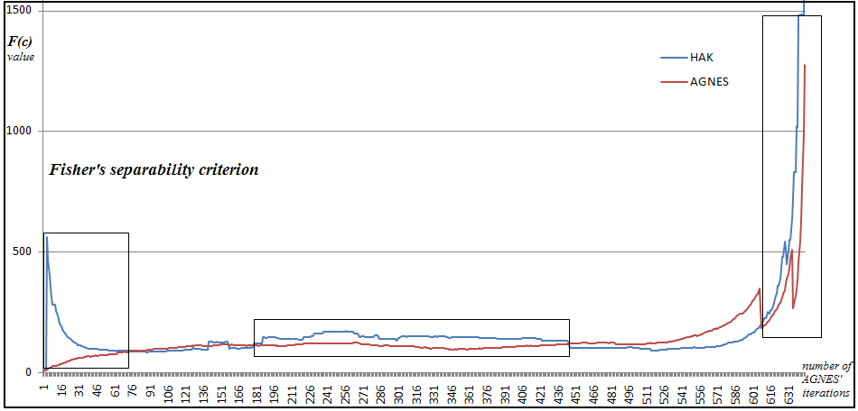

**Fig. 5. Comparing the clustering quality of AGNES and hybrid approach; from Fisher’s criterion perspective**

Figure 6 shows the total distance value for AGNES and HAK algorithm. It seems that moving toward higher numbers of AGNES’ iterations will lead to a lower (better) total distance in both of the algorithm. Fortunately, the value of the proposed hybrid method is always lower than that of AGNES algorithm.

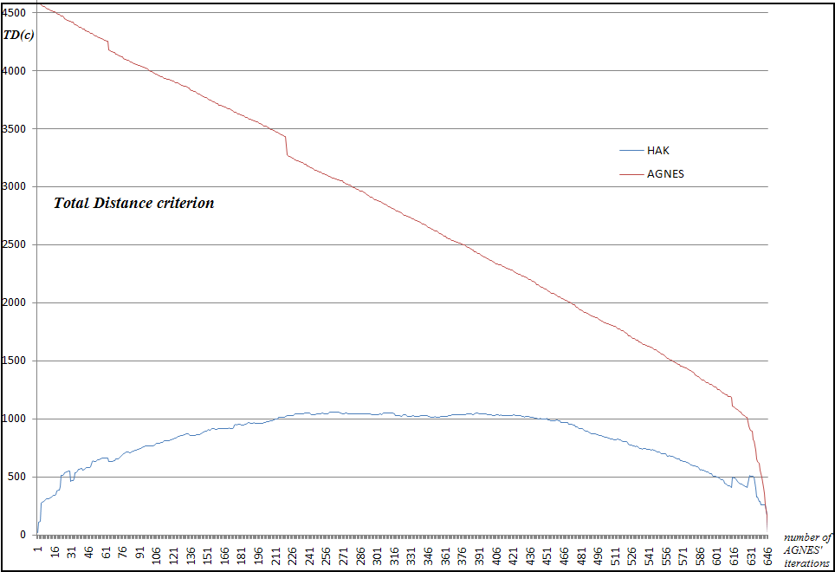

**Fig. 6. Comaparative evaluation of Total Distance criterion for AGNES and HAK**

### 6.3.2. Comparing HAK with κ-means

As figure 7 shows, the values of the hybrid method’s *f(c)* are almost always greater than or equal to the κ-means algorithm’s *f(c)*. Thus as a general rule, it can be mentioned that the hybrid method performs better than the κ-means from the perspective of Fisher’s value. The horizontal axis represents the number of seeds which have been presented for κ-means algorithm.

Unlike κ-means, Fisher’s values for the proposed hybrid method have been shown as discrete points. The reason is that there is more than one fisher value for some number of seeds. It means that there is more than one answer with the same number of seeds during the execution of HAK. The boxes in figure 8 shows the areas that the corresponding total distance value of HAK is less than that of κ-means. In the other words, in most of the cases HAK performs better than κ-means from the perspective of minimum total distance.

# 

**Fig. 7. Comparing clustering quality of κ-means and hybrid approach from the perspective of Fisher’s separability criterion**

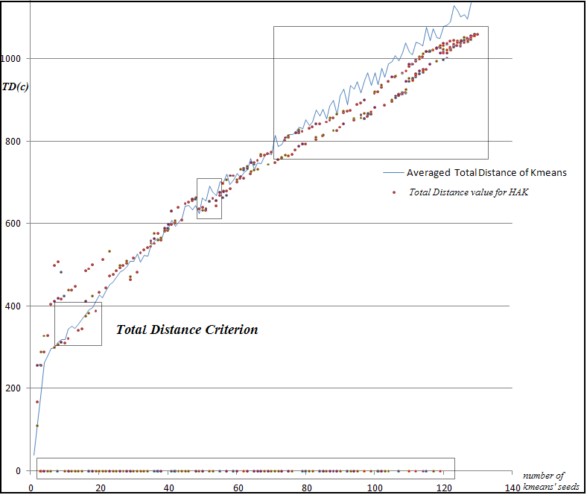

Fig. 8. **Comaparative evaluation of Total Distance criterion for κ-means and HAK; Note that the lower values for *TD(c)* will be *considered to have a better quality*. The area of the boxes shown in the plot, contains the cases that HAK has performed better than κ-means from total distance point of view.**

# 7. Conclusion and Future Works

In this paper, the most important considerations and bottlenecks of using hierarchical and partitional clustering techniques in hotspot analysis were discussed. A hybrid approach, which is named HAK, was proposed by combining the naive AGNES and κ-means clustering methods. The proposed hybrid algorithm represents a better quality of clustering rather than κ-means algorithm. Because the proposed method has a lower time complexity than AGNES algorithm, it is expected to be useful in rela-time clustering processes. Totally, the method improves the κ-means algorithm by using the AGNES clustering method for identifying the primary centroids. It is noteworthy that using *Silhouette coefficients* is another way for improving the κ-means clustering. Comparing HAK with silhouette coefficients approach is planned to be accomplished by the authors as one of the main issues which can improve the research.

The most important motivation for presenting the introduced hybrid approach was generating a moderate method which, unlike the κ-means, does not depend highly on the human user’s knowledge and also has a lower computational complexity than the naive AGNES algorithm. Consequently, the research results reveals that by combining hierarchical and partitional methods, it will be possible to achieve moderate approaches which are more efficient and also do not suffer from their parents’ deficiencies. Obviously, the hybrid approach should also have a relatively desirable clustering quality. According to the results of evaluation, the considerable sensitivity of the proposed hybrid algorithm to the outliers has still remained as an open issue to be dealt with. It seems possible to apply the hybrid method for different types of data (non-spatial data with more dimensions) to test the performance of the method in dealing with discrete variables and also non-numerical data objects.

# References

[1] Miller, H. J. and Han, J. (2001) “Geographic data mining and knowledge discovery: An overview”, in H. J. Miller and J. Han (eds.) Geographic Data Mining and Knowledge Discovery, London: Taylor and Francis, in press, 3-32.

[2] Miller, H. J. (2007) “Geographic Data Mining and Knowledge Discovery”, in J. P. Wilson and A. S. Fotheringham (eds.) Handbook of Geographic Information Science, ISBN: 978-1-4051-0795-2, article No 19.

[3] Guo, D. (2009) “Multivariate Spatial Clustering and Geovisualization“. In Geographic Data Mining and Knowledge Discovery, edited by H. J. Miller and J. Han. London and New York, Taylor & Francis, pp. 325-345.

[4] Han, J. Kamber, M. and Tung. A.K.H (2001) “Spatial clustering methods in data mining: A survey”, In: *Geographic Data Mining and Knowledge Discovery*. H.J. Miller and J. Han, (eds.), London: Taylor & Francis, 33–50.

[5] Han, J. Koperski, K.and Stefanovic, N. (1997), “GeoMiner: A System Prototype for Spatial Data Mining.” ACM SIGMOD International Conference on Management of Data, Tucson, AZ, 553–556.

[6] Shekhar, S., C.T. Lu and P. Zhang (2003), “A unified approach to detecting spatial outliers”. *GeoInformatica*, **7,** 139–166.

[7] Hsinchun Chen,Wingyan Chung, Jennifer Jie Xu, Gang Wang, Yi Qin, Michael Chau*,* (2004), *“Crime Data Mining:* *A General Framework and Some Examples”,* University of Arizona; published by IEEE Computer Society Press  Los Alamitos, CA, USA.

[8] Hsinchun Chen, Wingyan Chung, Yi Qin, Michael Chau, Jennifer Jie Xu, Gang Wang, Rong Zheng,Homa Atabakhsh; (2003), “*Crime Data Mining: An Overview and Case Studies”.*

[9] Hsinchun Chen, Homa Atabakhsh, Tim Petersen, Jenny Schroeder, Ty Buetow, Luis Chaboya, Chris O’Toole, Michael Chau, Tom Cushna, Dan Casey, Zan Huang; (2003), *“COPLINK: Visualization for Crime Analysis”,* Proceedings of The National Conference on Digital Government Research.

[10] Yang Xiang, Michael Chau, Homa Atabakhsh, Hsinchun Chen; (2004), “*Visualizing criminal relationships: comparison of a hyperbolic tree and a hierarchical list”*, University of Arizona.

[11] Thongtae, P., Srisuk, S., (2008) *"An Analysis of Data Mining Applications in Crime Domain,"* citworkshops, pp.122-126, IEEE 8th International Conference on Computer and Information Technology Workshops.

[12] Alberto R.Gonzales, Regina B.Schofield and Sara V.Hart, (2005), *“Mapping Crime: Understanding hotspot.”* U.S. Department of Justice.

[13] Ahmadi, M., Sharifi.A, Valadan M. J., (2003), “*Crime Mapping and Spatial Analysis*”, InterNational institute for geo-information science and earth observation, Enschede, Neatherlands.

[14] Vladimir Estivill-Castro and Ickjai Lee, (2001), “Data Mining Techniques for Autonomous Exploration of Large Volumes of Geo-referenced Crime Data”, 6th International Conference On Geocomputation, Brisbane, Australia.

[15] Michael Wyland, (2008) *“**Design and Implementation of a spatial Data Engine and Visualization Interface for a Crime Information System”*.

[16] Leon Kelvin, Chan Stephen, Ng Vincent, Shiu Simon, (2008), *“**Introduction of STEM: Space-Time-Event Model for crime pattern analysis.”* Asian journal of information technology.

[17] Marcos Aurélio Santos da Silva, Antônio Miguel Vieira Monteiroand José Simeão Medeiros; (2004), “*Visualization of Geospatial data by component plane and U-Matrix”;* Brazil.

[18] Leon Kelvin, Junco Li, Chan Stephen, Ng Vincent, (2009), *“**An Application of the Dynamic Pattern Analysis Framework to the Analysis of Spatial-Temporal Crime Relationships”*, Journal of Universal Computer Science, vol. 15, no. 9.

[19] Richard William Adderley; (2007), “*The use of data mining techniques in crime trend analysis and offender*

*profiling”*, PhD thesis, Publisher: University of Wolverhampton.

[20] Ned Levin; (2004) “*The CrimeStat Program: Characteristics, Use, and Audience”*, Houston, TX.

[21] Pradeep Mohan, Shashi Shekhar, Ned Levine, Ronald E. Wilson, Betsy George, Mete Celik, *“Should SDBMS Support a Join Index?: A Case Study from CrimeStat”*, USA(c) 2008 ACM, ISBN:978-1-60558-323-5.

[22] Helmstetter, A., and D. Sornette (2002), “Subcritical and supercritical regimes in epidemic models of earthquake aftershocks”, *J. Geophys. Res.*, *107*(B10), 2237, DOI:10.1029/2001JB001580.

[23] Kagan,Y.Y. and Knopoff,L. (1987), “Statistical short-term earthquake prediction”, Science 236 (1987), pp. 1563–1567.

[24] Ogata, Y., (1988), “Statistical models for earthquake occurrence and residual analysis for point processes”, *J. Am. stat. Assoc.*, *83*, 9-27.

[25] Dzwinel,W., Yuen, D.A., Boryczko, K., Ben-Zion, Y., Yoshioka .S, Ito, T., (2005), “Cluster Analysis, Data-Mining, Multi-dimensional Visualization of Earthquakes over Space, Time and Feature Space” , Nonlinear Processes in Geophysics. v12. 117-128.

[26] Chen, C.-C., J. B. Rundle, J. R. Holliday, K. Z. Nanjo, D. L. Turcotte, S.-C. Li, and K. F. Tiampo (2005), The 1999 Chi-Chi, Taiwan, earthquake as a typical example of seismic activation and quiescence, *Geophys. Res. Lett.*, *32*, L22315, DOI:10.1029/2005GL023991.

[27] “Earthquake clustering due to stress interactions”, (2008), proceedings of the 2008 science symposium: Advances in Earthquake Forcasting, RMS Special Report 2008, Risk Management Solutions,Inc. ([http://www.rms.com/publications](http://www.rms.com/publications/))

[28] Keyvanpour, M.R., Javideh, M.,.Ebrahimi, M.R., sojoodi, M., (2008), *“Using Geographical information systems for crime prevention”,* National Conference on Crime Prevention, Iran.

[29] Oatley, G.C., Ewart, B.W., Zeleznikow, J., (2006), “Decision Support Systems For Police: Lessons From the Application of Data Mining Techniques To 'Soft' Forensic Evidence”, Journal of Artificial Intelligence and Law, Springer Netherlands, Volume 14, Numbers 1-2, DOI: 10.1007/s10506-006-9023-z.

[30] http://www.crimereduction.homeoffice.gov.uk.

[31] Janet Reno, Daniel Marcus, Laurie Robinson, Noël Brennan, Jeremy Travis, (1999), “*mapping crime principle and practice”*, U.S. Department of Justice.

[32] Han, J. and Kamber,M., (2005) *Data Mining Concepts and Techniques*, second edition, Morgan Kaufmann, November 3.

[33] Gupta, G.K. (2006), *Introduction to Data Mining with Case Studies,* prentice-hall of India, New Delhi.

[34] Xudong Wang Syrmos, (2005), “Optimal cluster selection based on Fisher class separability measure”, [**American Control Conference, IEEE.**](http://ieeexplore.ieee.org/xpl/RecentCon.jsp?punumber=9861)

[35] http://www.geophysics.ut.ac.ir.

[36] Raskutti,B. and Leckie,C., (1999), “An Evaluation of Criteria for Measuring the Quality of Clusters” p. 905 – 910, ISBN:1-55860-613-0, Morgan Kaufmann Publishers Inc.  San Francisco, CA, USA.

1. Action Information Management
2. Spatial and Temporal Analysis of Crime
3. Min Squared Error