

**K.N. Toosi University of Technology**

**Student name:** Mostafa Latifian

**Student ID:** 40122193

**Professor:** Dr. Hamidreza Taghirad

**Course:** Linear Control System

**Research Subject:** Effect of Time Delay on Root Locus

Contents

1.Introduction 3

2.System Without Time Delay 3

3.System With Time Delay 3

4.Padé approximation 4

5.Conclusion 6

1.Introduction

Time delay is a crucial factor in many control systems and usually arises due to signal transmission, actuator dynamics, or computational processing. The presence of delay can substantially alter the stability and performance of a system, especially in the root locus analysis where the placing of poles determines the nature of the system.

in this research we outline how a time delay influences the root locus of a linear control system. We use two approaches:

1. direct placement of the delay term using the exponential function $e^{-Ts}$.
2. a Padé approximation to the delay in order to facilitate the application of standard root locus design techniques.

For conducting this study, MATLAB simulation and analysis will be conducted. MATLAB provides extensive functionality in root locus plotting, stability analysis, and time-domain responses via the Control System Toolbox. Through comparison of direct delay effects and Padé approximations via MATLAB simulations, we aim to create a greater understanding of the influence of time delay on system stability and performance that is critical for practical control design.

2.System Without Time Delay

In this research, to better observe the effect of time delay, an open-loop system as described below was utilized:

$$G\left(s\right)=\frac{1}{s(s+1)(s^{2}+4s+8)}$$

The MATLAB code for this system is as follows:

clc; clear; close

s = tf('s');

G = 1/((s)*(s+1)*(s^2+4*s+8));

figure;

rlocus(G);

title('System Without Delay');

The rlocus result is shown in Figure 1.

3.System With Time Delay

The system equation with the addition of time delay is as follows:

$$G\left(s\right)=\frac{e^{-Ts}}{s(s+1)(s^{2}+4s+8)}$$

Value of T is taken as 2 in all calculations for the sake of convenience.

The presence of $e^{-Ts}$ makes the characteristic equation transcendental, complicating the root locus analysis. The delay can lead to oscillations and instability depending on T.

The MATLAB code for this system is as follows:

clc; clear; close

s = tf('s');

G = (exp(-s))/((s)*(s+1)*(s^2+4*s+8));

figure;

rlocus(G);

title('System With Delay');

When we execute the MATLAB code, we come across an error illustrated in Figure 2. As a result, we need to utilize the Padé approximation.

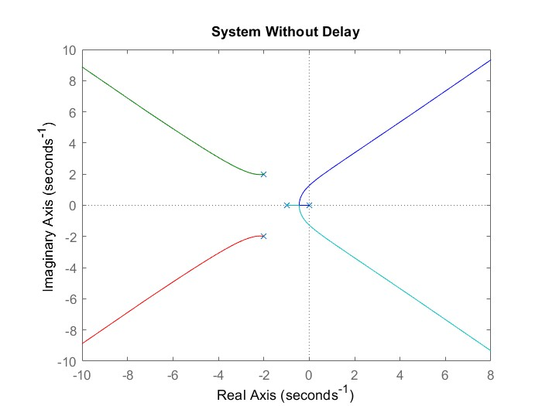

**Fig1.** Root Locus of a without delay system

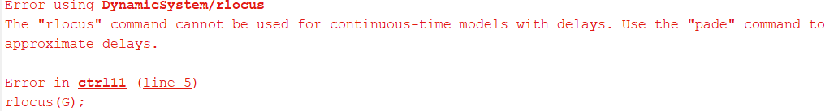

**Fig2.** MATLAB error for system with delay

4.Padé approximation

The Pade approximation represents the delay term $e^{-Ts}$ as a rational transfer function:

$$e^{-Ts}≈\frac{1-\frac{Ts}{2}}{1+\frac{Ts}{2}}$$

Now, the system can be defined as follows:

$$G\left(s\right)=\frac{1-s}{s{\left(s+1\right)}^{2}\left(s^{2}+4s+8\right)}$$

The MATLAB code for this system is provided below, utilizing the `subplot` command to visualize both the time-delay and no-time-delay systems.

clc; clear; close

s = tf('s');

G_without_delay = 1/((s)*(s+1)*(s^2+4*s+8));

subplot(2,1,1)

rlocus(G_without_delay);

title('System Without Delay');

G_with_delay = (1-s)/((s)*((s+1)^2)*(s^2+4*s+8));

subplot(2,1,2)

rlocus(G_with_delay);

title('System With Delay');

The rlocus result is shown in Figure 3.

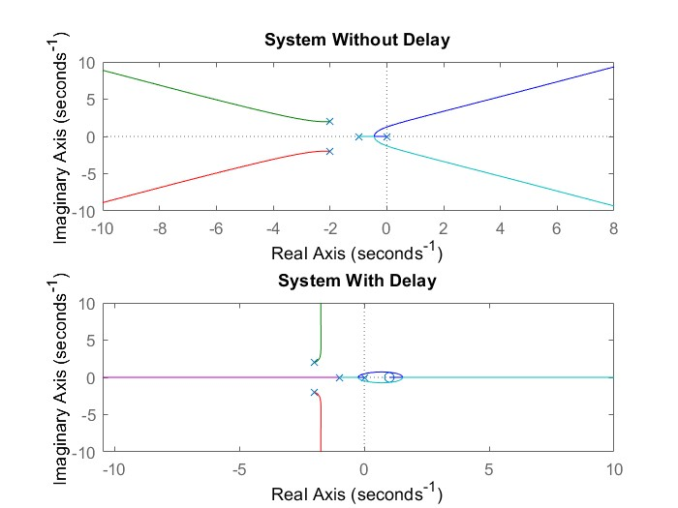

**Fig3.** Root locus of both system

5.Conclusion

By comparing the two systems shown in Figure 3 and Figure 2, we reach the following results, Reducing the stability margin of the system, Create oscillations or instability at reduced gain values, Impact the transient response, resulting in slower or oscillatory behavior and The Padé approximation offers a more manageable approach to analyzing delay, yet it still indicates these adverse effects on stability and performance.