**Lab 2**

**Part 1 (prelab):**

**Solve_circuit.m**

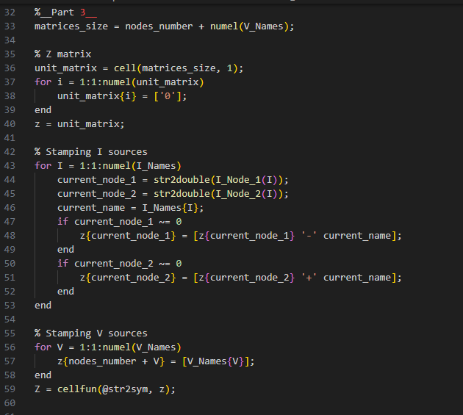

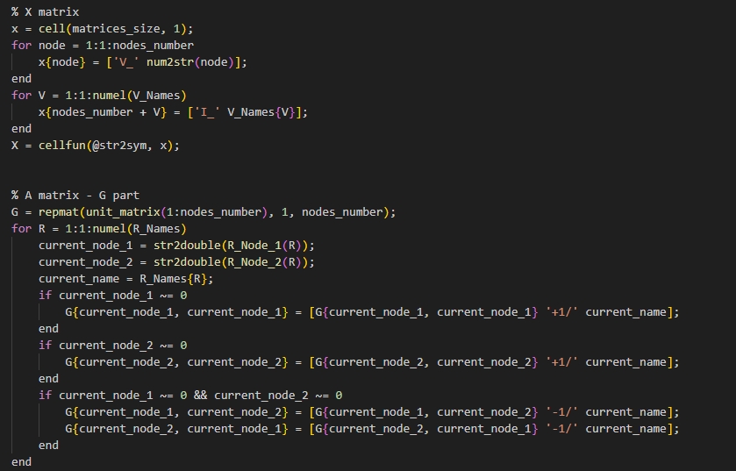

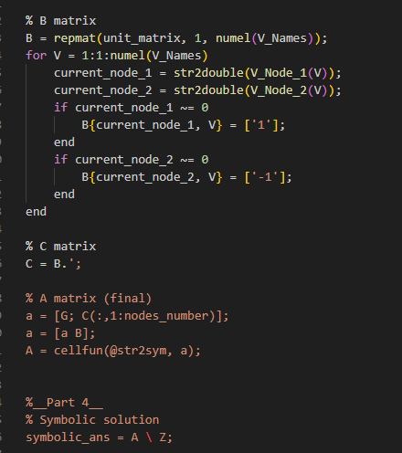

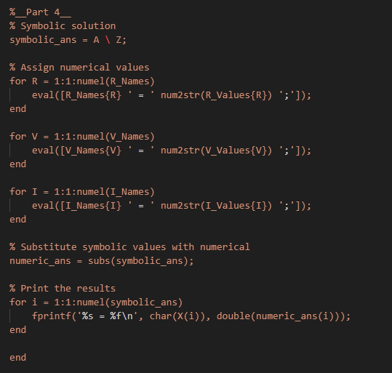

**Solve_Circuit_Example.m**

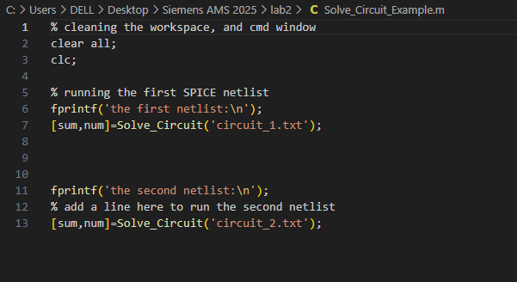

LTSpice output for circuit 1:

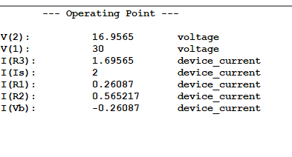

LTSpice output for circuit 2 :

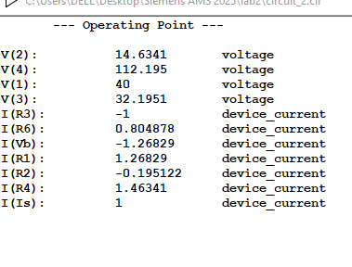

Matlab results :

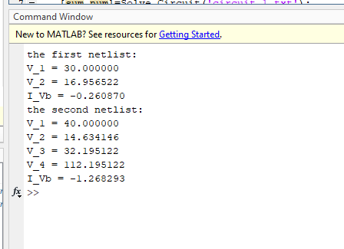

For circuit 1:

|  |  |  |
| --- | --- | --- |
| Result | My simulator | LTSpice |
| V_1 | 30 V | 30 V |
| V_2 | 16.956522 V | 16.9565 V |
| I(Vb) | -0.26087 A | -0.26087 A |

For circuit 2:

|  |  |  |
| --- | --- | --- |
| Result | My simulator | LTSpice |
| V_1 | 40 V | 40 V |
| V_2 | 14.634146 V | 14.6341 V |
| V_3 | 32.195122 V | 32.1951 V |
| V_4 | 122.195122 | 122.195 V |
| I(Vb) | -1.268293 A | -1.26829 A |

We can see that both simulators give the same results with slight more numerical precision for our simulator .

**Part 2:**

**Parameters**

L = 1mH , C= 1uF , f= = 5KHz nearly

damping ratio = R/2 *

|  |  |
| --- | --- |
| Underdamped | * R<63.24 |

|  |  |  |
| --- | --- | --- |
| Critically damped | * R=63.24 |  |

|  |  |  |
| --- | --- | --- |
| Overdamped | * R>63.24 |  |
|  |  |  |

**Modified code with adding L , C stamping and AC Analysis**

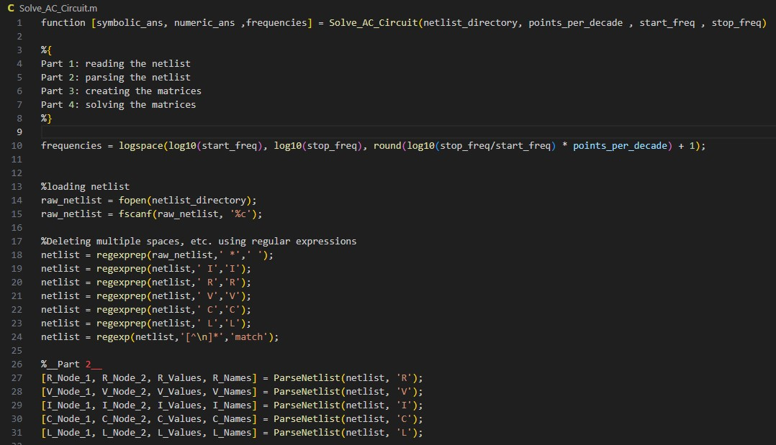

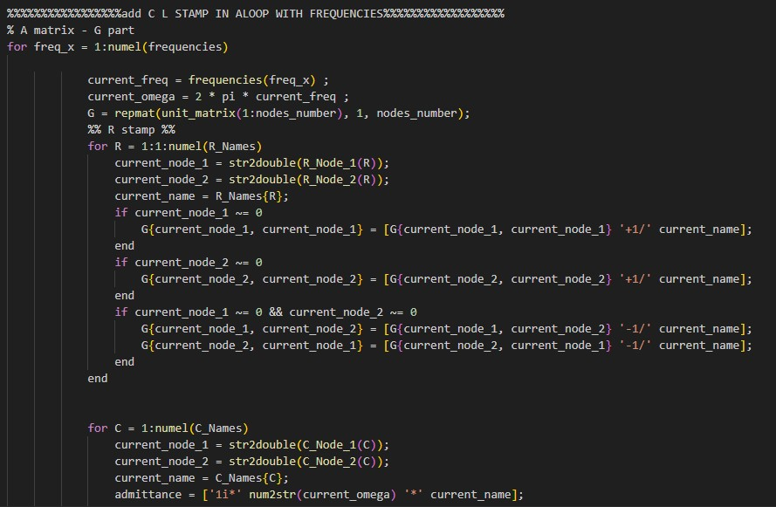

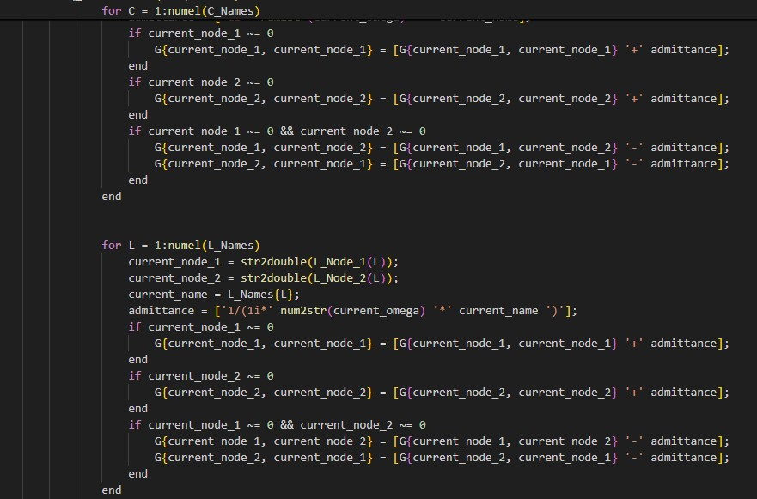

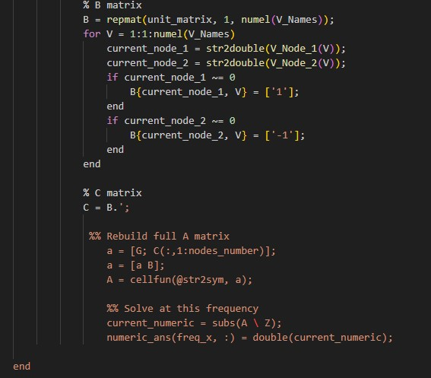

**Solve_AC_Circuit_Example**

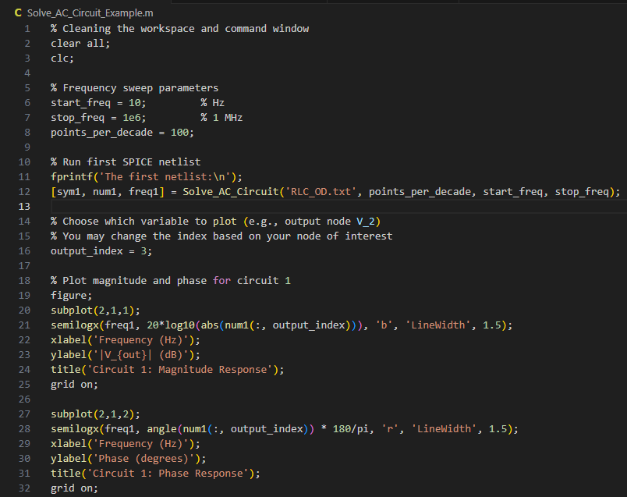

**RLC Overdamped :**

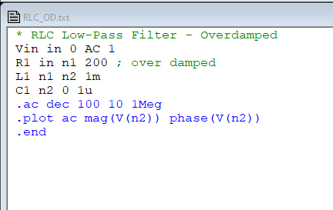

**LTSPICE**

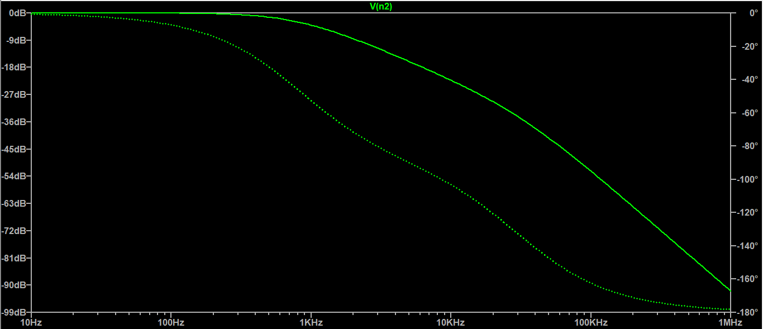

**Matlab results:**

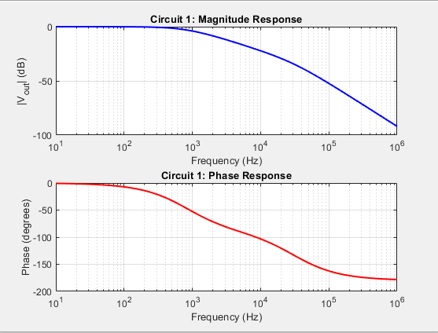

**RLC Critically Damped :**

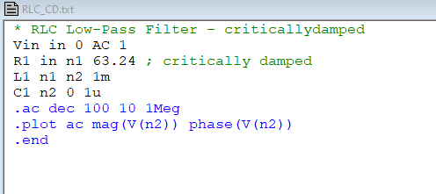

**LTSpice**

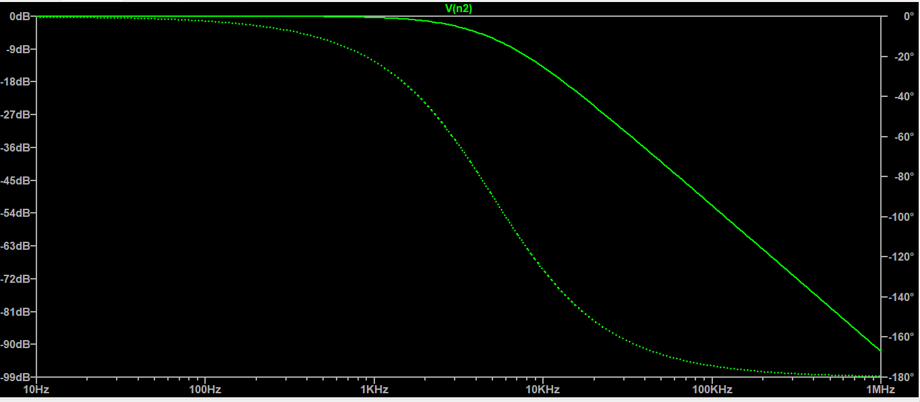

**Matlab results :**

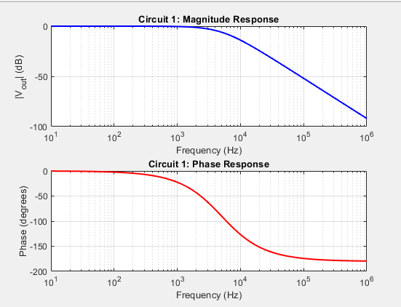

**RLC Underdamped :**

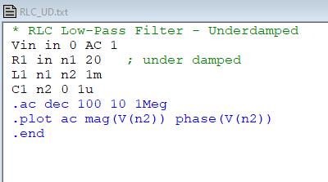

**LTSpice**

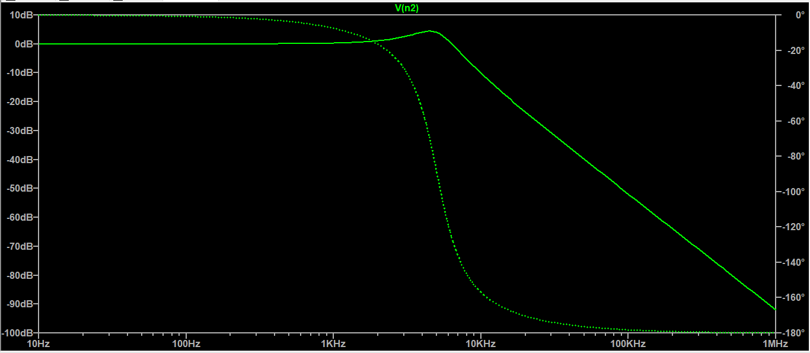

**Matlab results :**

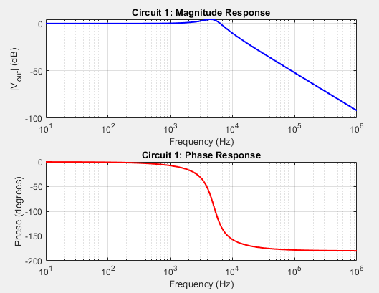

**Comment :**

We can see how similar our simulator’s results to those results from LTSpice and that confirms the correct implementation of AC analysis done by our matlab code after adding support for capacitors and inductors

**Part 3 (OPAMP) :**

**Netlist :**

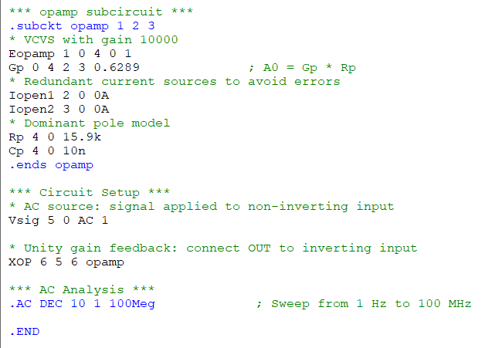

**LTSpice :**

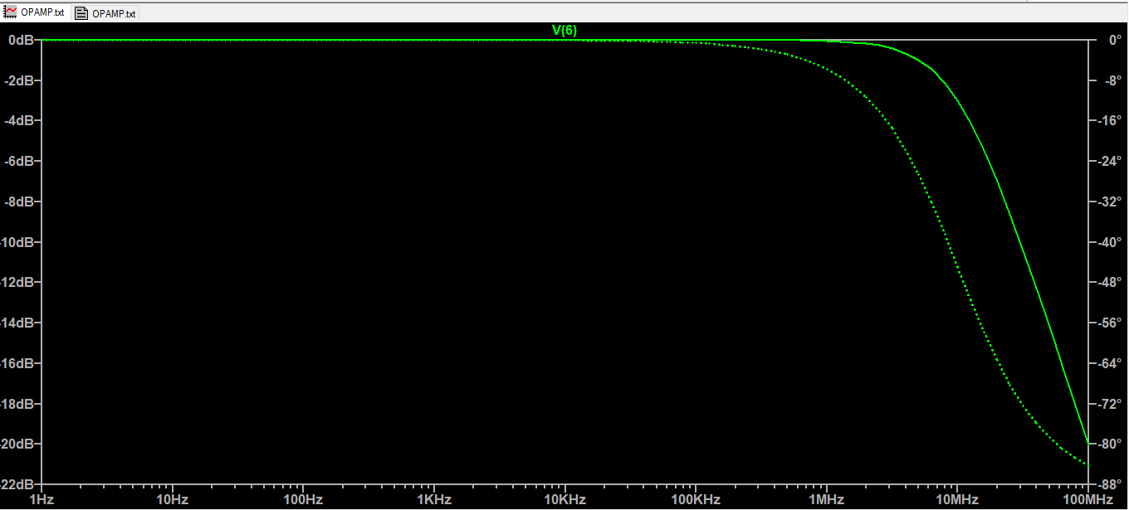

**Parse_netlist.m updates:**

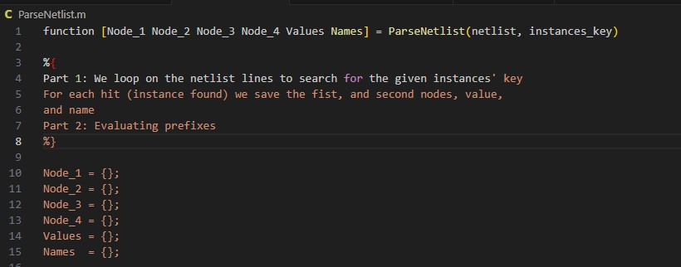

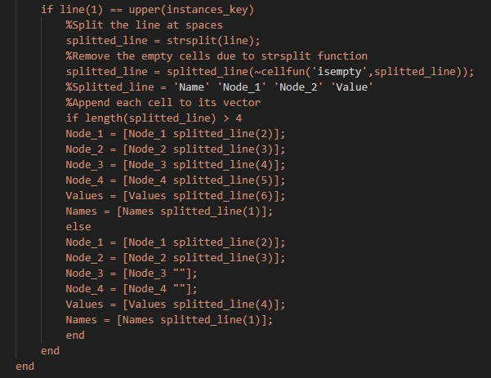

**Code updates to add support for VCCS and VCVS :**

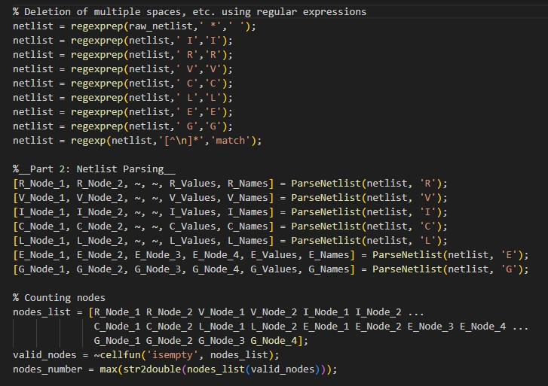

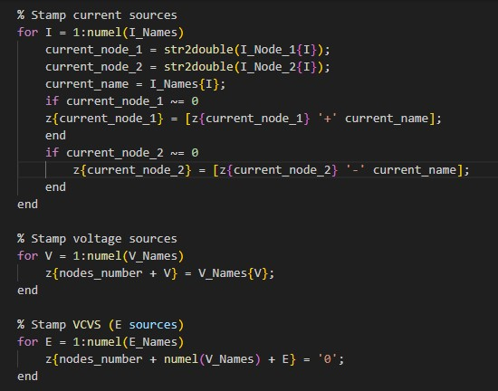

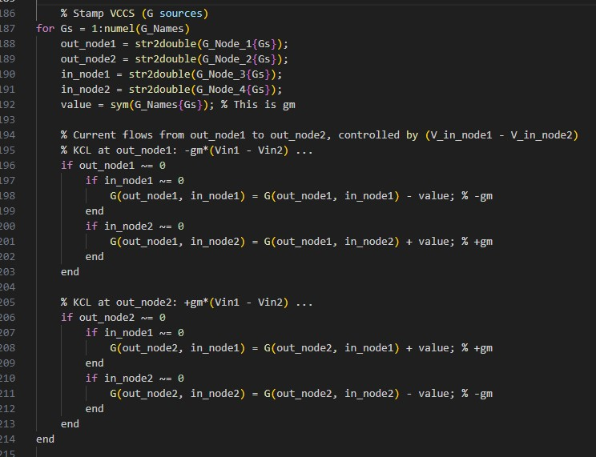

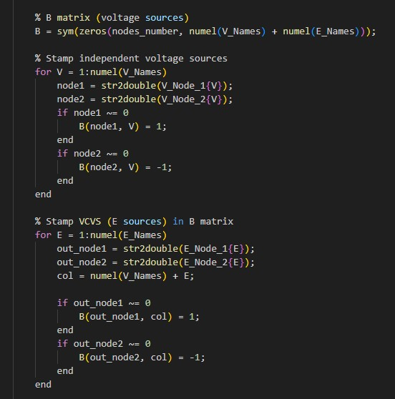

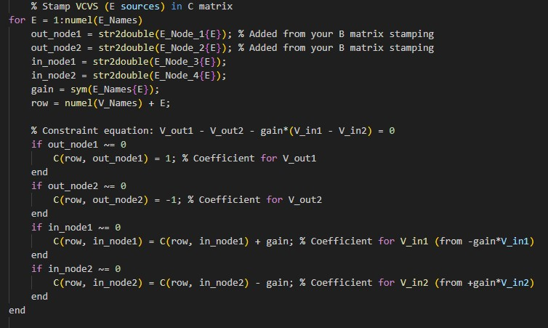

**Matlab results :**

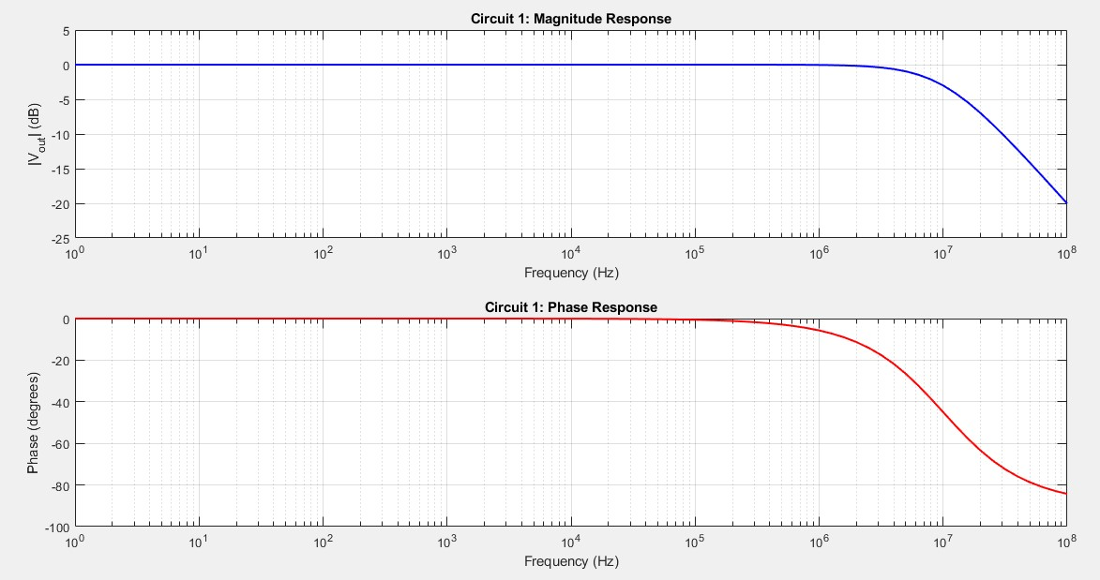

**Comment :**

We can see how similar our simulator’s results to those results from LTSpice and that confirms the correct implementation of AC analysis done by our matlab code after adding support for VCCS and VCVS to represent the behavioral model of Opamp .