**Lab 5**

**PART 1:**

**1-Database generation:**

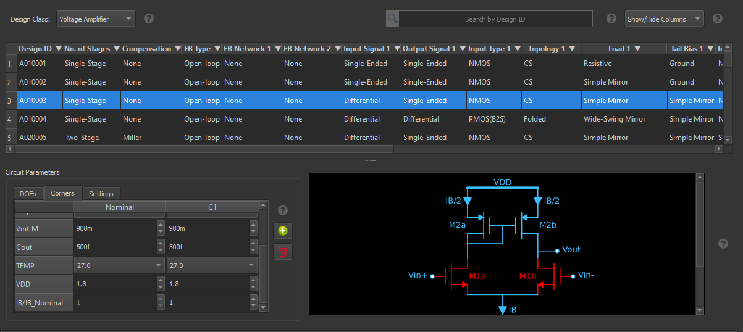

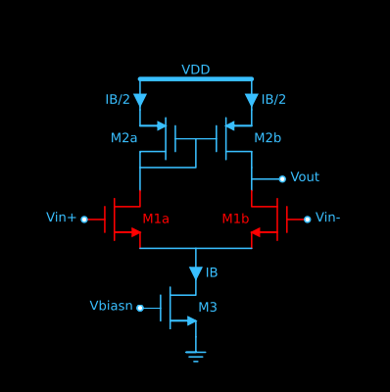

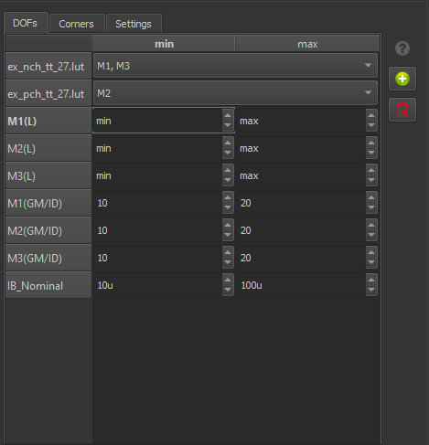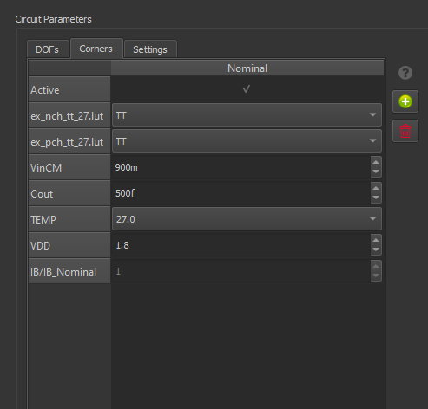

**M1 design :**

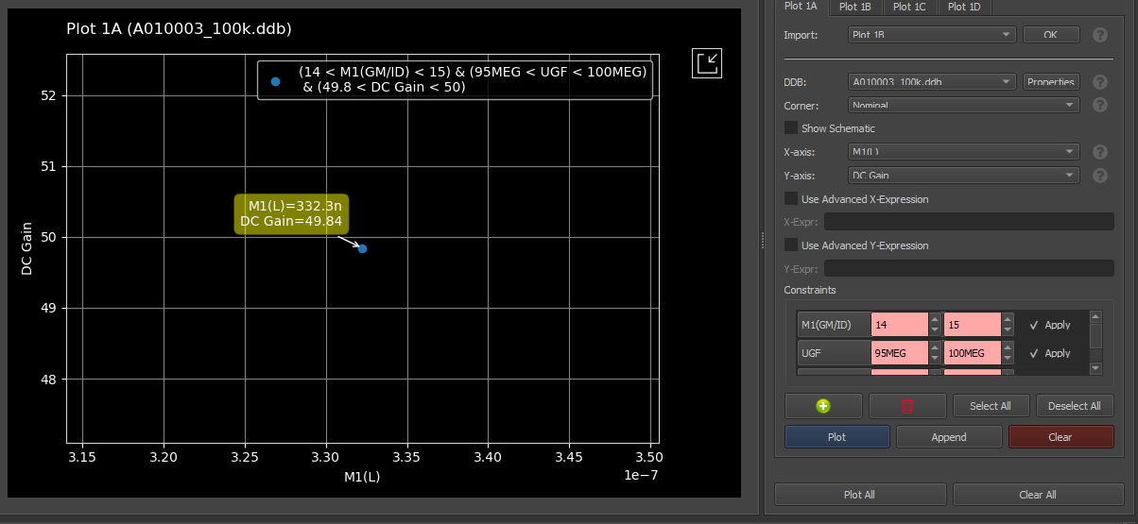

**M2 design :**

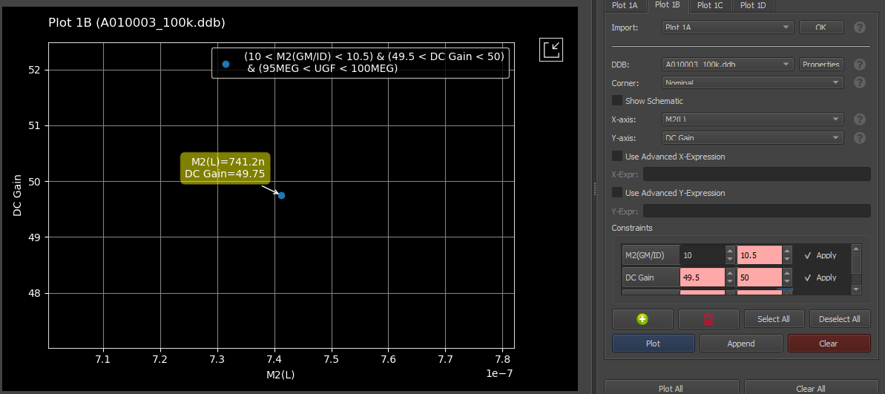

**M3 design :**

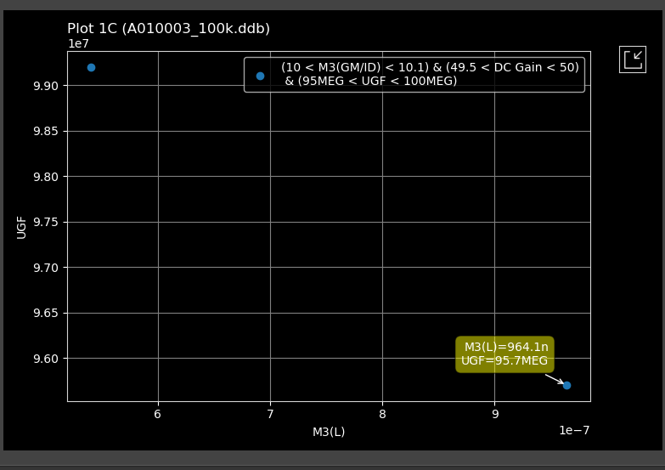

**Tuning results :**

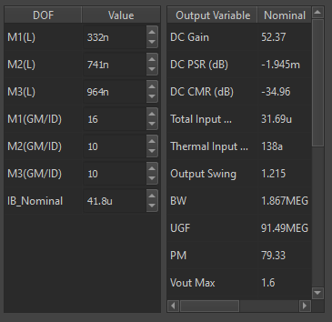

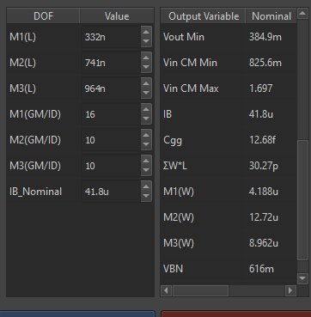

**Plot from ADT for specs :**

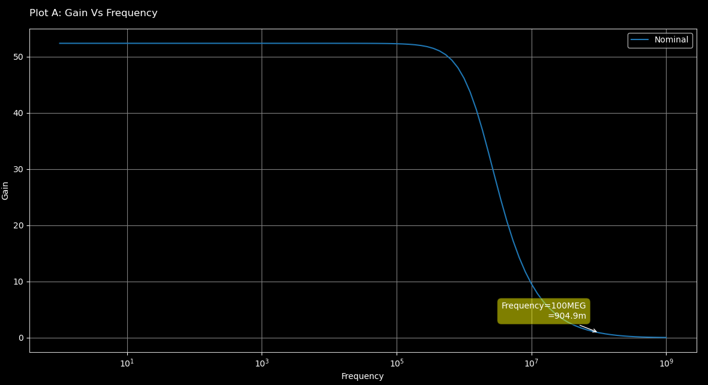

**ADT Design Cockpit :**

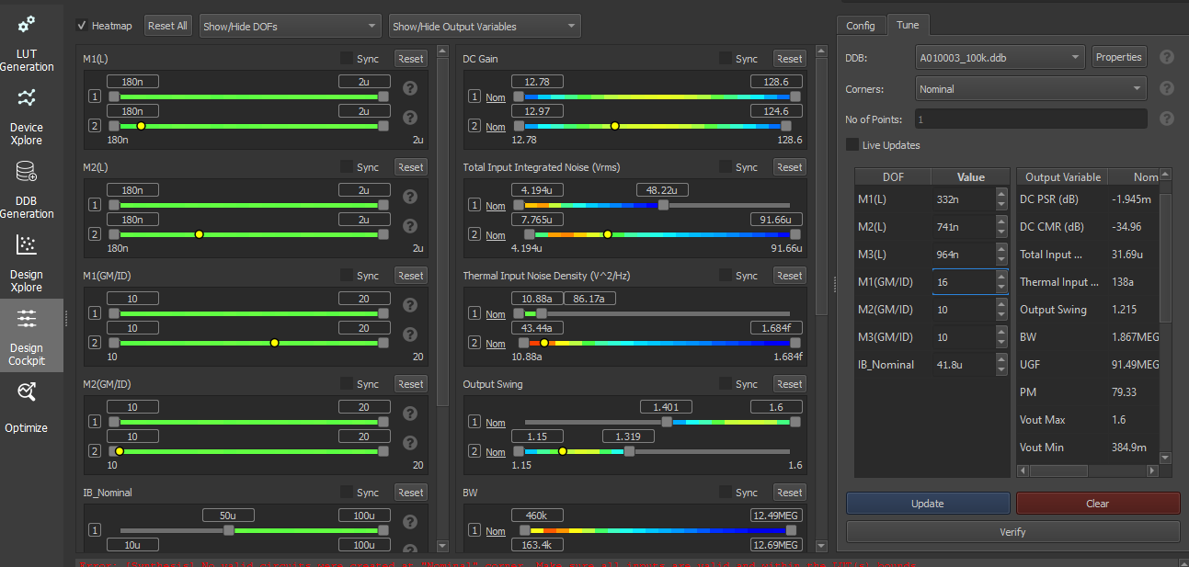

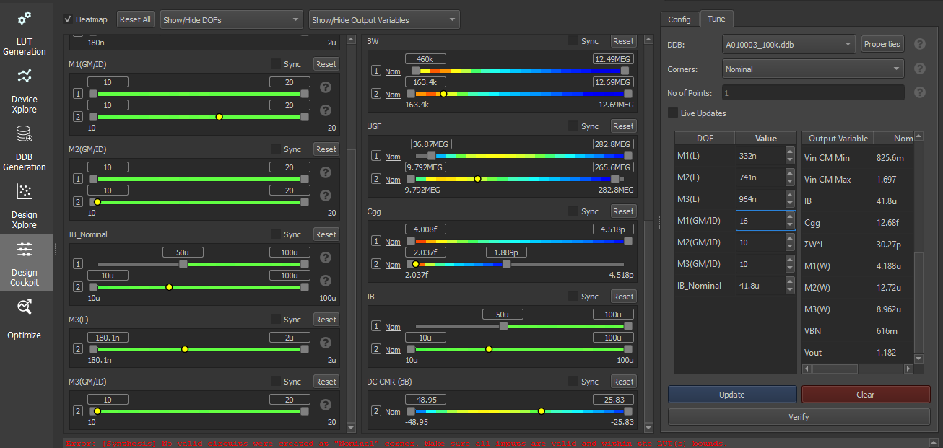

**Local Optimization :**

loptOTA.m

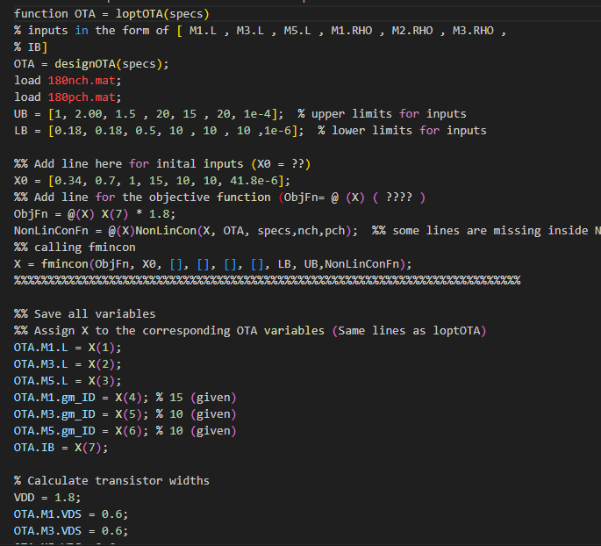

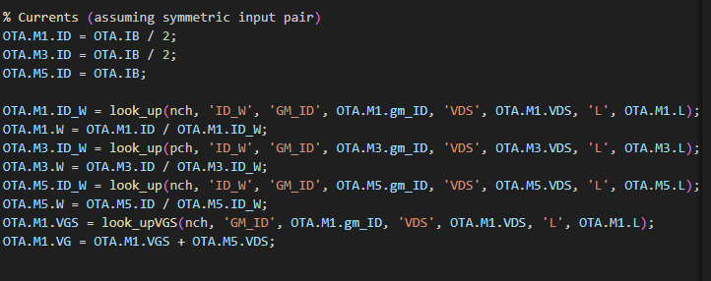

Nonlincon.m

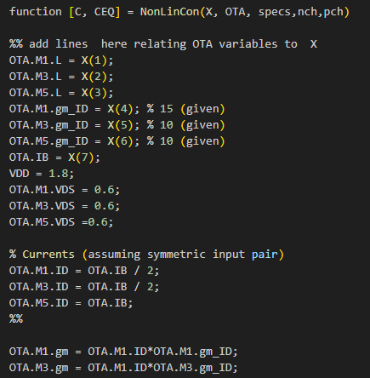

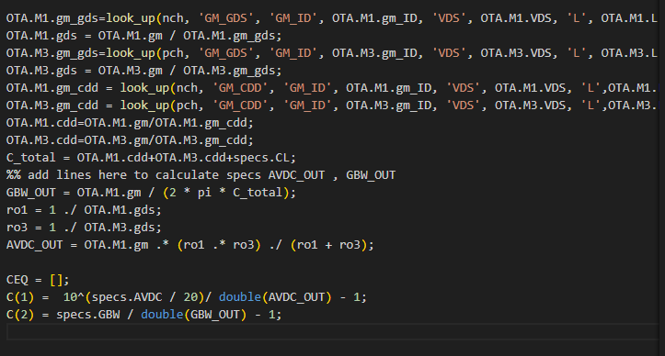

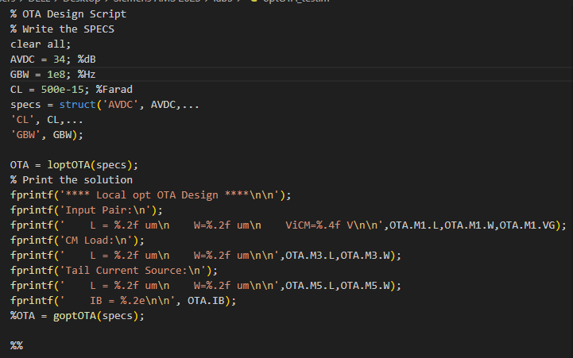

Results:

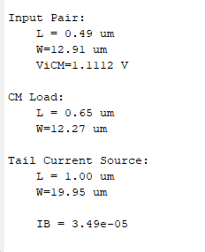

**Glopal Optimization:**

**Nonlinconv.m**

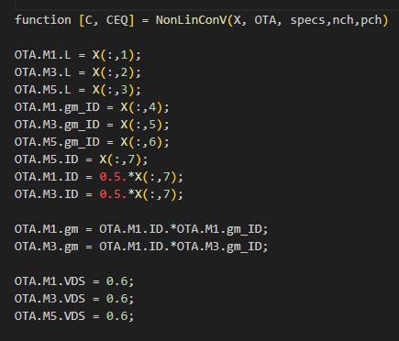

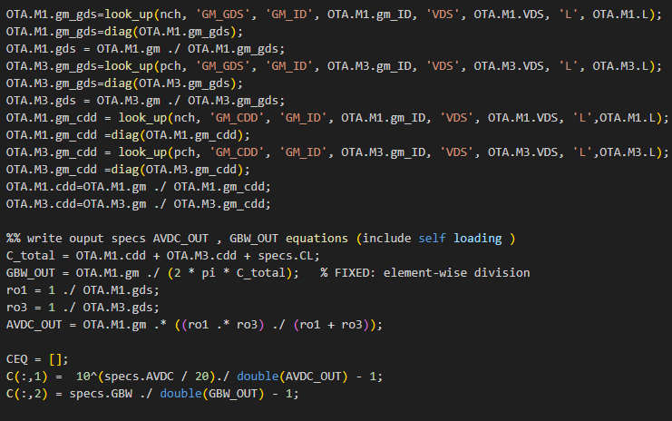

**goptOTA.m**

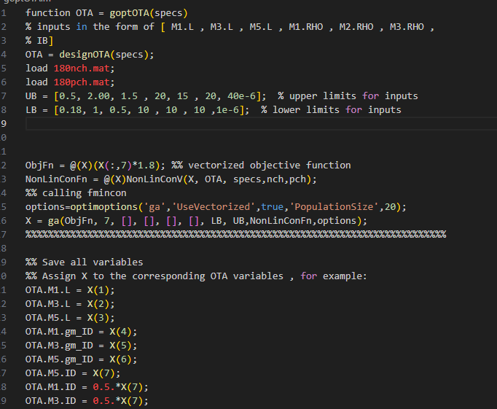

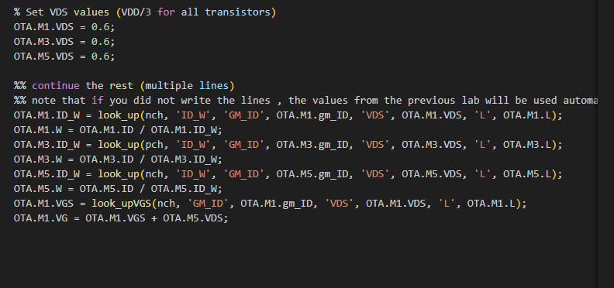

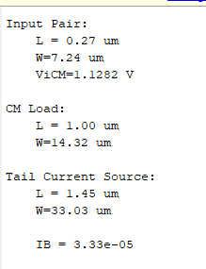

|  |  |  |  |  |
| --- | --- | --- | --- | --- |
| **Parameter** | **ADT Design Xplore.** | **ADT Design Cockpit** | **local optimization** | **Glopal optimization** |
| L1(um) | 0.33 | 0.33 | 0.49 | 0.27 |
| W1(um) | 4.2 | 4.2 | 12.91 | 7.24 |
| L2(um) | 0.74 | 0.74 | 0.65 | 1 |
| W2(um) | 12.72 | 12.72 | 12.27 | 14.32 |
| L3(um) | 0.964 | 0.964 | 1 | 1.45 |
| W3(um) | 8.9 | 8.9 | 19.95 | 33.03 |
| IB(uA) | 41.8 | 41.8 | 35 | 33.3 |

We can see that ADT design Xplore and ADT design Cockpit nearly give the same results and the local optimization gives more power saving by smaller current with some changes in the design parameters while the global optimization gives the best design from the power consumption prespective with the smallest IB

**7-Ltspice :**

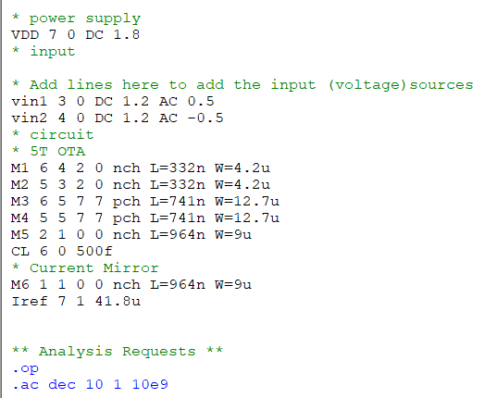

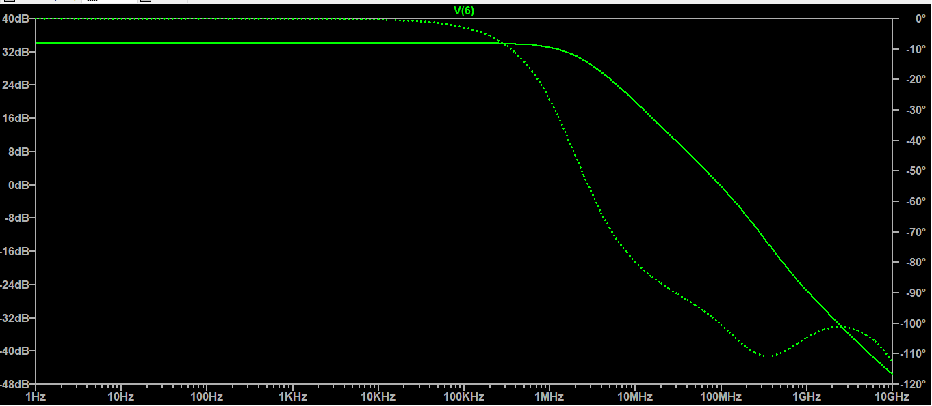

**ADT design**



**Local optimaization design :**



**Global optimaization design:**



|  |  |  |  |
| --- | --- | --- | --- |
| **spec** | **ADT** | **Local opt** | **Global opt** |
| **DC gain = 34 dB** | **34.01 dB** | **35.7 dB** | **33.94 dB** |
| **GBW = 100MHz** | **96.5 MHz** | **101 MHz** | **93.5 MHz** |

The three design criteria nearly achieved the specs with slightly variations because of attempts to minimize power .

**Part 2**

ADT Design Xplore :

Nominal current case :

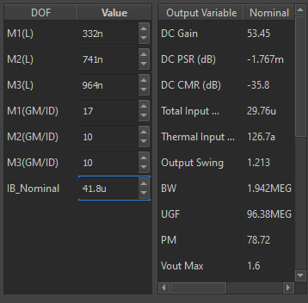

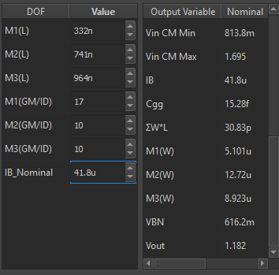

+10% of nominal case :

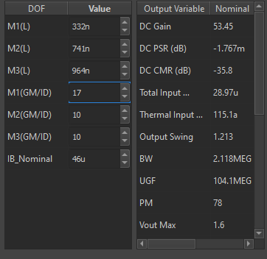

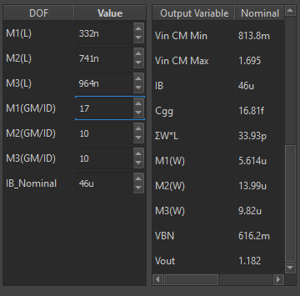

-10% of nominal case :

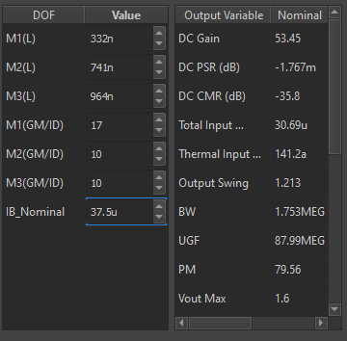

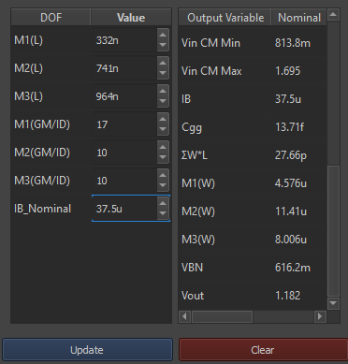

ADT Design Cockpit :

Nominal current case :

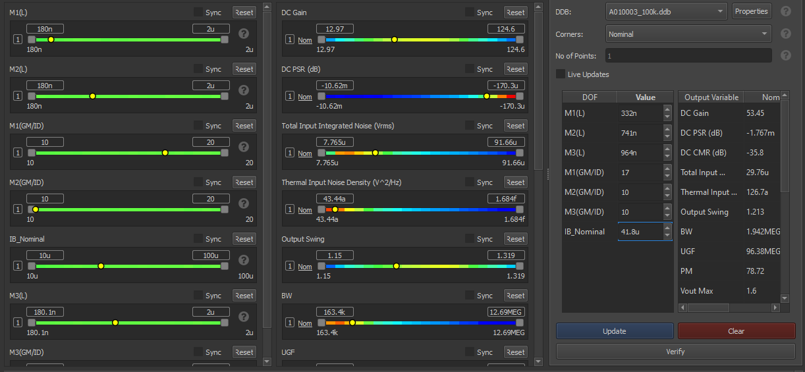

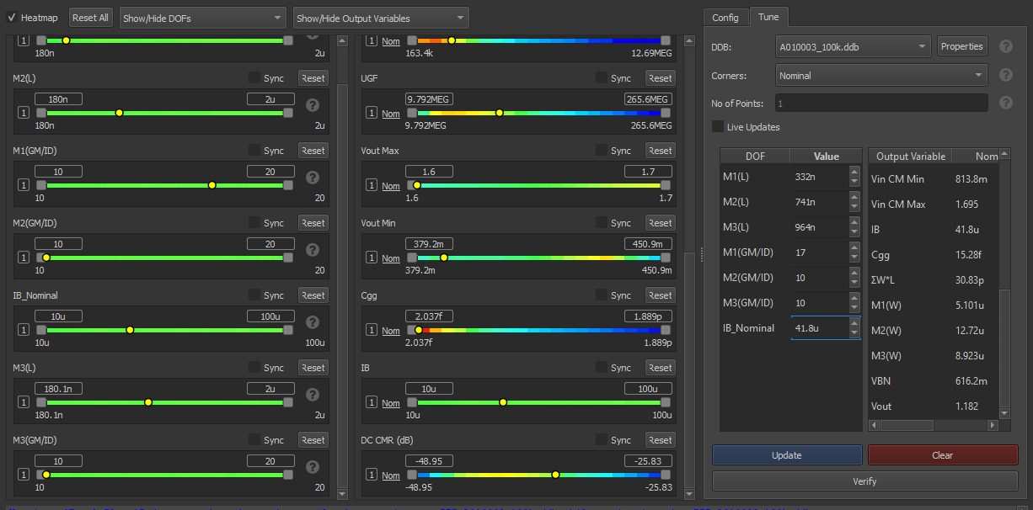

+10% of nominal case :

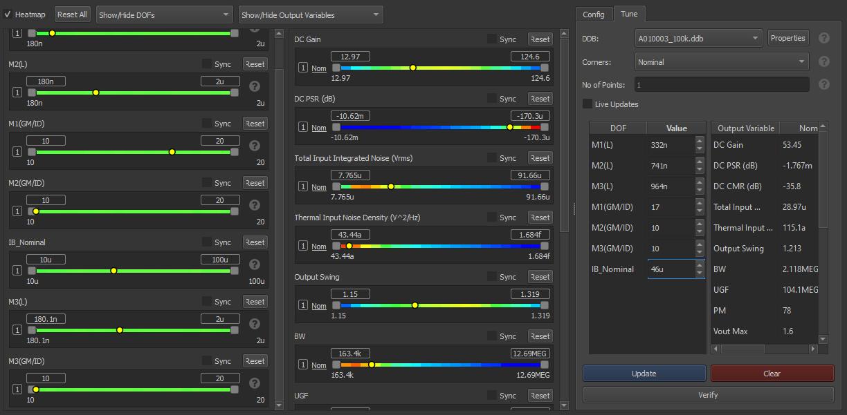

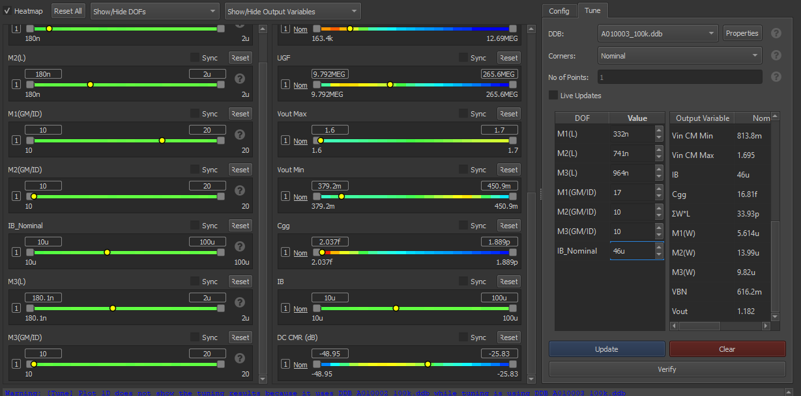

-10% nominal case :

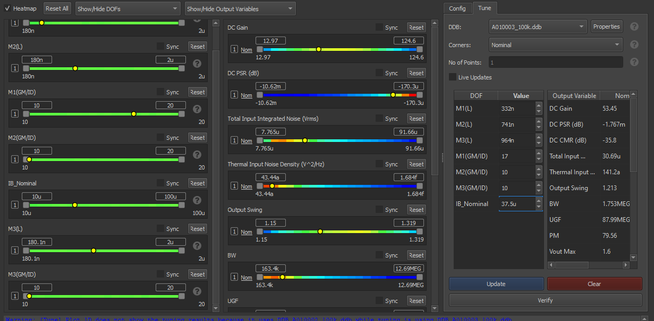

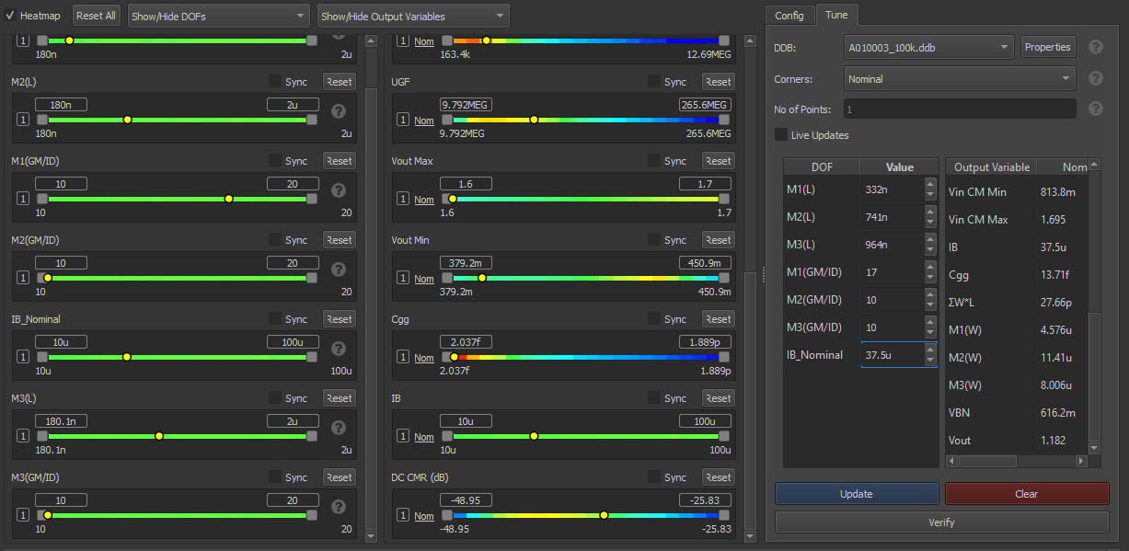

Matlab local optimization:

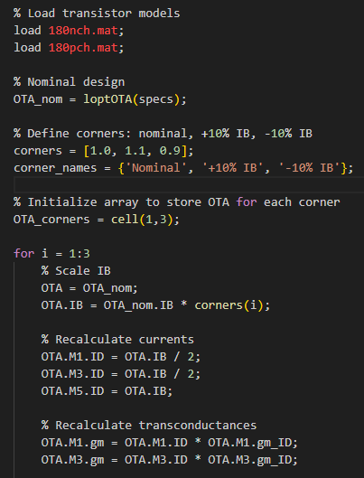

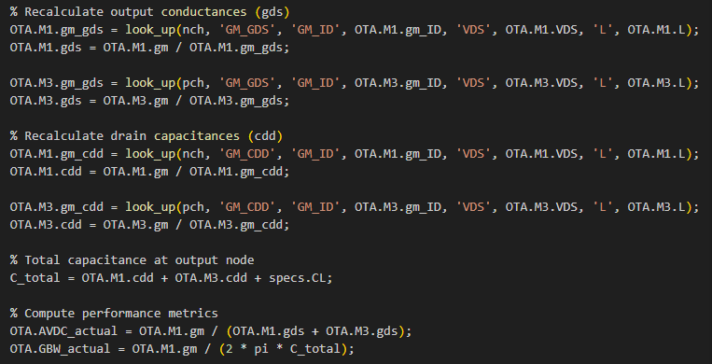

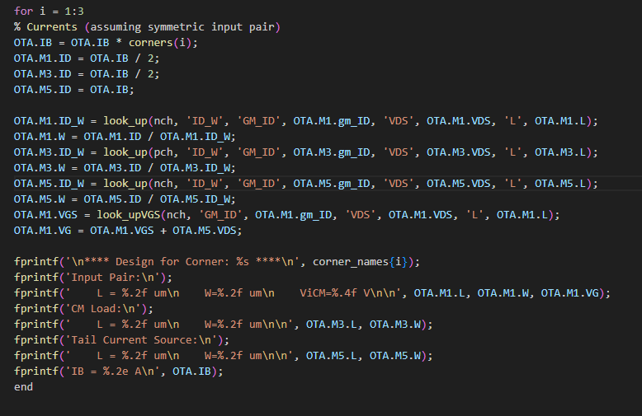

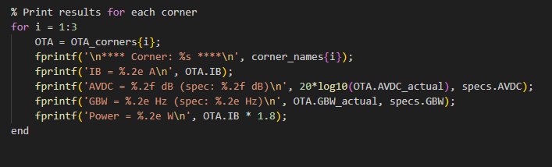

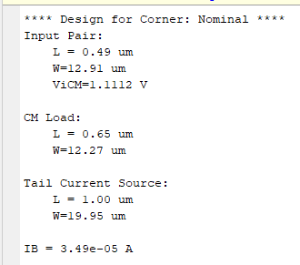

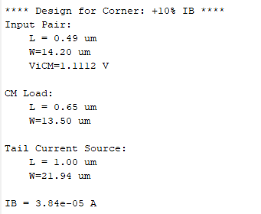

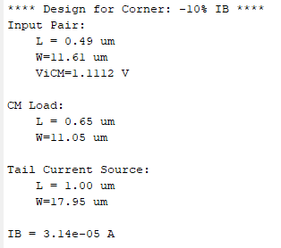

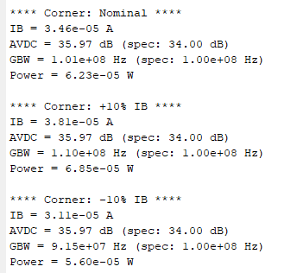

We can see that changing the bias current has a noticeable effect on the GBW spec but nearly no effect on DC Gain

Global optimization :

Modifications :

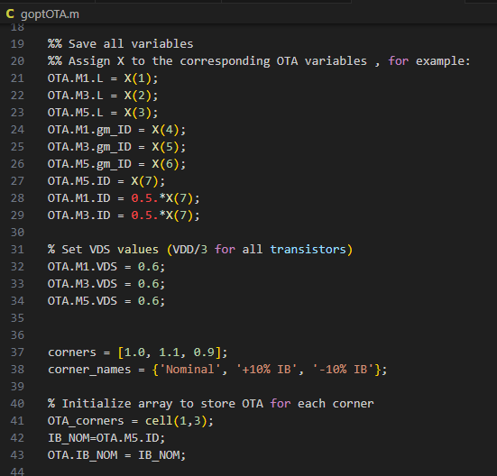

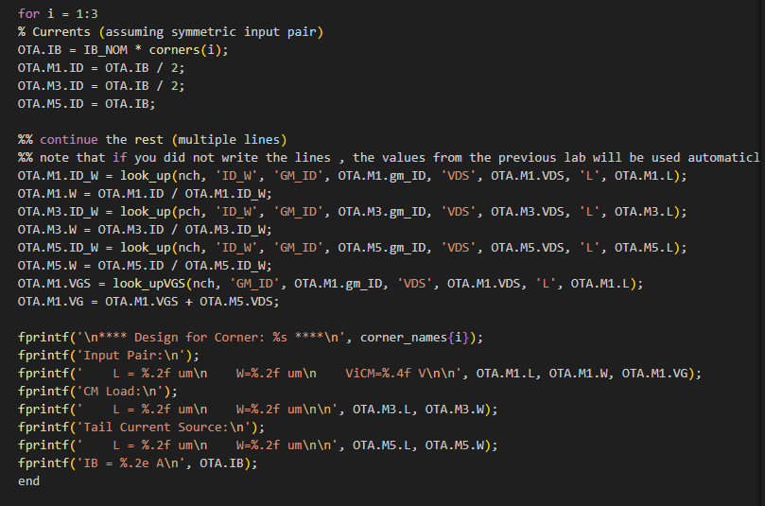

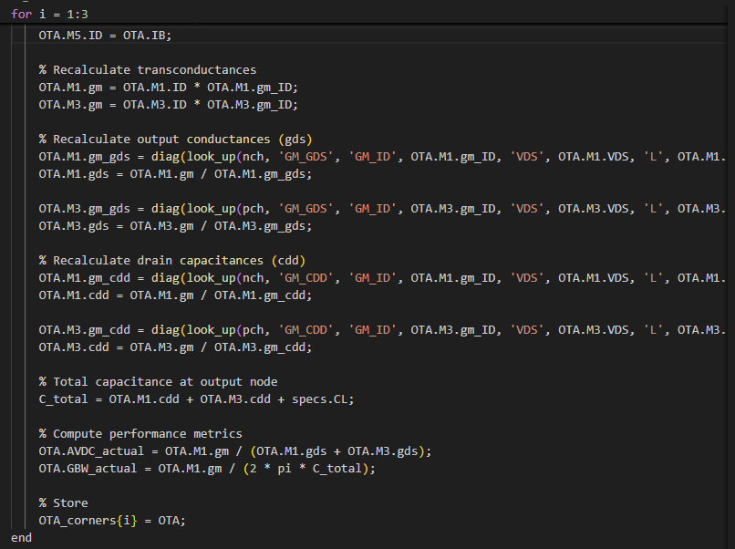

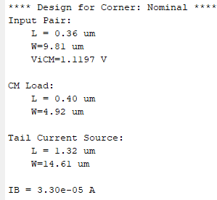

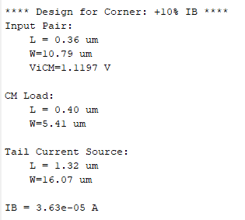

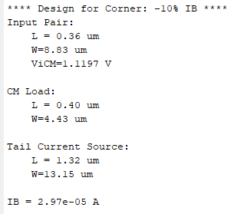

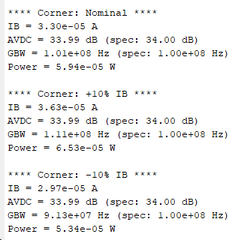

We can see that changing the bias current has a noticeable effect on the GBW spec but nearly no effect on DC Gain

And we are more meeting the specs in this case than in local optimization case